Why we must prepare to protect Earth even from mirror life in Martian dirt

Author: Robert Walker (contact email robert@robertinventor.com)

Preprint DOI …
For latest version of this preprint please visit: (url …)
(This version 3rd January 2023)
[Needs citations added]
Contents
Abstract 1
Paper 2
Selection criteria for this review 21
References 22

Abstract
NASA / ESA plan to return samples from Mars in the 2030s, and China, in the late 2020s. It’s safe for Japan to return unsterilized samples from Phobos because any microbes already withstood ejection from Mars, like our martian meteorites. JAXA warned this doesn’t apply to Mars samples.

NASA incorrectly says any life from Jezero crater can get here faster and better protected in a meteorite. Surface dirt and dust never gets here.

NASA also proposes to contain samples in a Biosafety Level 4 facility. However, the ESF study in 2012 set new size limits beyond a BSL-4’s capability.
We can keep Earth 100% safe by sterilizing samples before they get here with the equivalent of millions of years of Mars surface ionizing radiation. This has virtually no effect on geology, while Perseverance’s 0.7 nanograms per gram forward contamination makes most astrobiology impossible.
We can greatly increase science value with bonus samples in a sterile container returned to a martian gravity centrifuge in an unmanned satellite above GEO, starting Sagan’s “vigorous program of unmanned exobiology”.
This review includes new worst case scenarios of mirror life, to encourage space agencies to ensure Earth’s biosphere is adequately protected when they return samples from Mars.

Paper
This review focuses on NASA’s draft EIS only because it is the first environmental impact statement for a Mars sample return ever published. If NASA and ESA can make mistakes of this order, when they paid so much attention to planetary protection in the past, other space agencies could easily do the same.
Let’s start with the meteorite argument. NASA’s Environmental Impact Statement (EIS) argues that (NASA, 2022: 3-3):
The natural delivery of Mars materials can provide better protection and faster transit than the current MSR mission concept.
However, the NRC Mars Sample Return study in 2009 said, in the section “Martian meteorites, Large-Scale effects and Planetary Protection” (SSB, 2009: 48)

The potential hazards posed for Earth by viable organisms surviving in samples [are] significantly greater with a Mars sample return than if the same organisms were brought to Earth via impact-mediated ejection from Mars

The NRC goes on to say:

... Thus it is not appropriate to argue that the existence of martian meteorites on Earth negate the need to treat as potentially hazardous any samples returned from Mars by robotic spacecraft.

So, how did NASA’s EIS come to such a different conclusion? It reasons that potential Mars microbes would be expected to survive ejection from Mars:
First, potential Mars microbes would be expected to survive ejection forces and pressure (National Academies of Sciences, …, 2019), …

This gets the argument in their cite back to front. It actually says any samples returned from Mars’s innermost moon Phobos must have already survived ejection from Mars as the first of their chain of reasons why there is no need for planetary protection for JAXA’s samples.

However JAXA specifically say their argument does not apply to Mars sample return missions because they will return samples that couldn’t mechanically withstand ejection from Mars. The last of the three reasons they give why their reasoning doesn’t apply to a Mars sample return reads: (SSB, 2019 : 4):

- MSR [Mars Sample Return] material might come from sites that mechanically cannot survive ejection from Mars and thus any putative life-forms would de facto not be able to survive impact ejection and transport to space. Such mechanical limitations do not apply for material collected on Mars Phobos.

Therefore, the committee finds that the content of this report and, specifically, the recommendations presented in it do not apply to future sample return missions from Mars itself.
[The report has a typo as shown, it says “Mars” where “Phobos” was clearly intended.]

Mars surface dust, salts, and dirt couldn’t mechanically survive ejection, as they would burn up in the atmosphere before reaching escape velocity.

NASA’s EIS gets to their conclusion through mistaken citing, as they don’t mention this caveat. They also don’t mention the NRC warning that it is inappropriate to use the meteorite argument for samples returned from Mars.

NASA’s draft EIS does cite research, for instance about the very hardy microbe bacillus subtilis, which survived re-entry on a sounding rocket with a re-entry velocity of 1.2 km / sec (Fajardo-Cavazos et al, 2005). Other experiments have shown that b. subtilis could withstand the shock of ejection from Mars and it is a candidate for a microbe that might be able to get from Mars to Earth in a meteorite (Cockell, 2008).
However, this doesn’t prove all or even any martian life ever got to Earth from Mars, as we don’t know its capabilities, if it exists. What matters for invasive species are the ones that can’t get here. European Barn swallows were in the Americas already. However the European starlings, can’t fly across the Atlantic which is what made it possible for them to become an invasive species in the USA (US DOA, 2017).
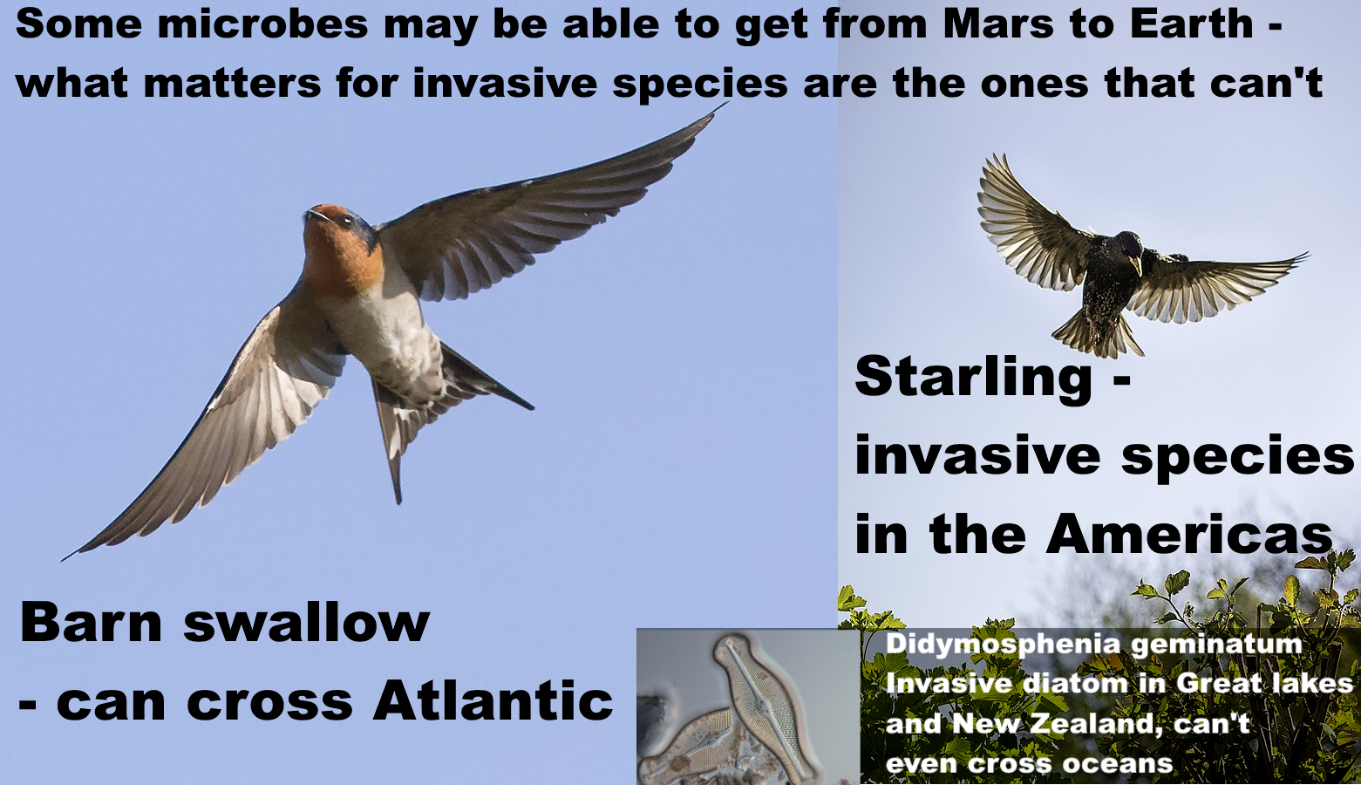
Starling photo from: (Johnstone, 2017)
Barn swallow photo from (Batbander, 2020)
Didymosphenia geminata (Lyngb.) from (Schmidt, n.d.)
For a microbial example, the invasive freshwater diatom "Didymo" (Didymosphenia geminatum) in New Zealand can't get from one freshwater lake to another on the same island without human help (Spaulding et al, 2010). It could never get from Mars to Earth.

Mars might potentially have diatoms surviving in lakes discovered kilometers deep beneath the polar ice (Davis, 2018). If so, these might well be unable to tolerate six months of vacuum or the extreme shock of ejection from Mars, and if so, likely evolved independently from terrestrial diatoms.

Nilton Renno suggests microbes might use biofilms (Pires, 2015) to inhabit brines which Curiosity found form for a few hours in the late evening / early morning in Gale crater (Martin-Torres et al, 2015) and likely also in Jezero crater (Chevrier et al, 2020: figure 7). These brines are far too cold for anything resembling terrestrial life at – 73 C, but otherwise habitable. The surface warms as the day approaches, and may get above 0°C, and as it warms these brines get warm enough for life but get too salty and then dry out completely. But a biofilm could retain the water through to warmer periods.

Microbes often use biofilms in terrestrial deserts (SSB, 2015 :11). Billi et al found that biofilm fragments mixed with regolith only 0.015 to 0.03 mm thick could resist 8 hours of full sunlight in UV, enough to be transported over 100 km (Billi et al, 2019a), (Billi et al, 2019b). They could be transported even further in dust storms which reduce UV levels.

The biofilms, as for the diatoms, could be perfectly adapted to survive and propagate on Mars, and yet would have no evolutionary pressure to withstand extreme shock, vacuum, life below the surface of a rock, and so on. They might have no way ever to get to Earth on a meteorite. For a biofilm fragment, a sealed sample tube is like a miniature spaceship complete with a small amount of martian atmosphere.

Even for microbes that can survive ejection from Mars, they may not be able to survive re-entry to Earth. In a similar experiment to b. subtilis,using an aeroshell re-entering at 7.5 km / sec, Cockell tested whether photosynthetic life would survive the fireball of re-entry, since it typically grows near the surface of rocks. He found not only Chroococcidiopsis but all associated organics were destroyed at a typical growing depth (Cockell, 2008).
JAXA did establish that they can safely return samples from Phobos because their samples will have a similar history to martian meteorites arriving today. (SSB, 2019 : 38 ff). Our martian meteorites last left Mars at least 700,000 years ago (ejection ages between 0.7 and 18.5 million years ago (Udry et al, 2020:table S4) )

JAXA compared two chains of events, their sample return and transfer on a meteorite:

Sample return: Ejection from Mars → Impact on Phobos → Remains in top 10 cm of the Phobos surface for 700,000 years → returned to Earth in the Phobos sample return

Meteorite: Ejection from Mars → spends 700,000 years in space traveling from Mars to Earth → reenters Earths atmosphere and delivered to Earth.

(In their calculations for some reason JAXA round the estimate of 700,000 years up to a million years but this makes no difference to the argument).

For all except the last in the chain of events the amount of sterilization is similar for the meteorites ejected from Mars and the returned samples. At the first stage of ejection, the ejection velocity for meteorites from Mars to Earth is higher than from Mars to Phobos but in both cases a small percentage of the ejecta is only weakly shocked, so this difference has a modest effect.

The main difference is the fireball of re-entry. However, they found that any microbes from Mars would be far more sterilized as a result of the impact on Phobos than the reentry fireball of Earth because only the surface of the rock is heated.

[Here JAXA may have a slight omission for photosynthetic life living on or near the surface of rocks by Cockell’s experiment just mentioned because it would live within the layers destroyed by the fireball of re-entry (Cockell, 2008). But if so, this is a relatively minor issue – because Martian microbes come from at least 3 meters below the surface in the high Southern Uplands (Head et al, 2002:1355), where photosynthetic life is unlikely, or would need to use alternative metabolic pathways in darkness, with no likely preference for surfaces of rocks. The longer version of this paper goes into this in more detail in supplementary information.]

This is the backward contamination version of Greenberg’s “Natural contamination standard” (Greenberg et al, 2001). The reasoning is, if the probability of microbes getting to Earth via the sample return is significantly less than the probability of this happening naturally we are in his view doing no harm.
In short, JAXA established they can return their samples from Phobos because they have already been ejected from Mars and have spent 700,000 years on the surface of Mars exposed to ionizing radiation from solar storms and cosmic radiation.

NASA’s “better protection and faster transit” (NASA, 2022: 3-3) does apply to the JAXA mission. Any microbes from Mars that get to us via samples from Phobos can get here better protected in meteorites, and all the past meteorites from this impact got here faster than JAXA’s samples will get here, after you take account of the 700,000 years JAXA’s samples spent on the surface of Phobos.

We can’t apply JAXA’s reasoning to Perseverance’s samples from the Mars surface. They would get here far faster in sample tubes than any meteorite currently arriving from the impact that formed Zunil crater 700,000 years ago. As for better protected, martian dust and dirt is completely unprotected as it couldn’t survive ejection from Mars at all.

NASA also say that the Martian surface is especially inhospitable for life in Jezero crater, where Perseverance is collecting samples, arguing that the choice of landing site helps keep Earth safe, saying (NASA, 2022: S-4)

Consensus opinion within the astrobiology scientific community supports a conclusion that the Martian surface is too inhospitable for life to survive there today, particularly at the location and shallow depth (6.4 centimeters [2.5 inches]) being sampled by the Perseverance rover in Jezero Crater, … (Rummel et al. 2014, Grant et al. 2018).

NASA’s draft EIS refers to SR-SAG2 (Rummel et al , 2014), but NASA and ESA commissioned a review in 2015, the MEPAG review (SSB, 2015 which modified all the main conclusions that NASA relies on for this statement about Jezero crater. NASA’s draft EIS doesn’t cite this review even though historically they commissioned it.

SR-SAG2 relies on maps like this. This map shows that the equatorial region of Mars including Perseverance’s landing site in Jezero crater has no shallow ice observed or suspected

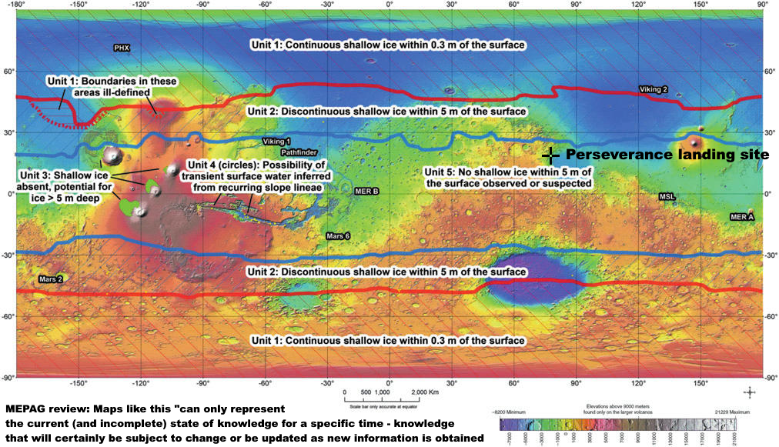
Source: (Rummel et al , 2014 : Fig. 45 ) Colour coding shows elevation.
Perseverance landing site shown at 18.44°N 77.45°E (NASA, 2022)

The 2014 report which NASA’s EIS relies on uses this map and a map of the RSLs (Rummel et al , 2014 : Fig. 47 ) to map out “Special regions” which are defined as regions (SSB, 2015 :6).

“within which terrestrial organisms are likely to propagate, or a region which is interpreted to have a high potential for the existence of extant martian life forms.”

Or rather, they aim to use the maps to map out regions that can’t be special regions since the aim for protection against forward contamination is to avoid them.

The 2015 MEPAG Review of this 2014 report says that such maps can only represent the current (and incomplete) state of knowledge for a specific time (SSB, 2015 :28).

Maps that illustrate the distribution of specific relevant landforms or other surface features can only represent the current (and incomplete) state of knowledge for a specific time—knowledge that will certainly be subject to change or be updated as new information is obtained.

NASA’s draft EIS only cites the 2014 study, SR-SAG2, and not this 2015 review which modified all its main conclusions relevant to Jezero crater.

Jezero crater seems uninhabited from orbit, but dust storms transfer terrestrial life over large distances, with life from the Gobi desert detected in Japan.

The MEPAG review of 2015 says (SSB, 2015 : 12).:

"The SR-SAG2 report does not adequately discuss the transport of material in the martian atmosphere. The issue is especially worthy of consideration because if survival is possible during atmospheric transport, the designation of Special Regions becomes more difficult, or even irrelevant."

The issue here is that if life can be transported from almost anywhere on Mars to almost anywhere it would be impossible to distinguish any particular regions as safe for forward contamination. Even if not special regions themselves, they could be a source to spread forward contamination to special regions elsewhere on Mars.

Since 2015, researchers have found various ways life could potentially be transported in the Martian dust storms, including the biofilm fragments we mentioned which could survive UV for 100 km (Billi et al, 2019a), (Billi et al, 2019b) , and much longer in dust storms, and also bouncing sand grains (Kok, 2010) (Bak et al., 2019). Bak et al found most life is destroyed quickly but some b subtilis spores are still viable after 5 days of bouncing, with the number of viable spores of b. subtilis reduced more than 1000 fold (Bak et al., 2019:4). Based on the saltation particle speed of 3 to 10 meters per second for a particle of 400 microns in diameter (Kok, 2010:fig.3a), a propagule could travel over 1000 kms in principle in that time.

The 2015 MEPAG review also says local microenvironments can be habitable in regions that seem to be uninhabitable on larger scales (SSB, 2015 :12).

Physical and chemical conditions in microenvironments can be substantially different from those of larger scales. Although the SR-SAG2 report considered the microenvironment (Finding 3-10), the implications of the lack of knowledge about microscale conditions was only briefly considered.

Indeed, SR-SAG2 describes seven potential naturally occurring microenvironments on Mars, and several of them are relevant to Jezero crater in

“Vapor-phase water available Vapor or aerosols in planet’s atmosphere; within soil
cavities, porous rocks, etc.; within or beneath spacecraft or spacecraft debris” (Rummel et al , 2014:904).

Microbes can inhabit micropores in salt deposits in deserts when the air is otherwise too dry through spontaneous condensation of water vapour in the micropores (Vítek et al, 2010) (Wierzchos, 2012). Cassie Conley (Conley, 2016) and, separately, Paul Davies (Davies, 2014) have suggested these as potential habitats on present day Mars. Microbes can use micropores in gypsum too, at an external humidity of only 60%. (Wierzchos et al, 2011: figure 1).

Jezero crater doesn’t have the large bright salt deposits of Mount Sharp (Lerner, 2019), but micropores in a small deposit could still be a potential microhabitat for a martian microbe

“Ice-related Liquid or vapor-phase water coming off frost, solid ice, regolith or subsurface ice crystals, glaciers” (Rummel et al , 2014:904).

The ice here would be frosts. That may seem unlikely in Jezero crater, but Viking 2 lander (NASA, 1997) and Phoenix lander (NASA, 2008) both imaged daytime frosts on the surface. Curiosity may have detected frosts in Gale crater a few microns thick (Gough et al., 2020) and Perseverance is trying to detect frosts too (NASA, n.d.).

As dawn approaches, the colder air near the surface could be trapped in a temperature inversion by warmer air above it. Gilbert Levin and his son Ron Levin suggested this might lead to thin films of water that form briefly in the early morning then evaporate. Chris McKay, agrees that this process could form a layer of liquid though it may not last long (Abe, 2001).

This lead to Ramachandran et al to simulate these conditions in Gale crater (Ramachandran et al, 2021). They found that the melting frost formed a pool of water which remained stable for 3.5 to 4.5 hours. This is an example of a way Mars could surprise us, in this case with a microns thick temporary layer of fresh water, at 0 C that may form many times during the year.

“Brine-related Liquid water in deliquescing salts, in channels within ice, on the surface of ice, within salt crystals within halite or other types of ‘rock salt’”

We have already discussed this with the Curiosity brines.

The MEPAG review also discusses how microbes in biofilms modify microhabitats by surrounding themselves with “extrapolymeric substances” - proteins, polysaccharides, lipids, DNA and other molecules. These can make microenvironments far more habitable for microbes and help them cope with environmental stressors (SSB, 2015 :11)
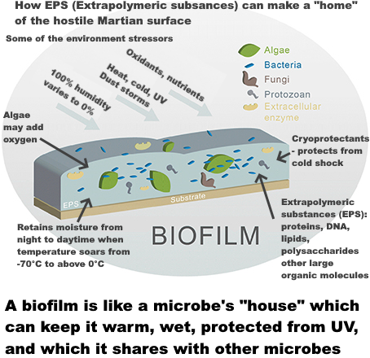
Graphic adapted from figure 2 of (Sabater et al., 2016)

So, life could get to Jezero crater in the dust, also, we can’t know Jezero crater is uninhabitable everywhere without detailed local study looking for microhabitats and biofilms.

The MEPAG and MEPAG review studied forwards rather than backwards contamination.

For backwards contamination we need to consider that any Martian life had millions of years to establish biofilms and to adapt to the dust storms. Mosca et al suggest it doesn’t even need to be able to establish a biofilm from the growth of single cells today, so long as some time in the past biofilms were able to form, propagating ever since then using these broken off fragments (Mosca et al, 2019).

For forwards contamination, the small numbers of microbes on spacecraft sent to Mars so far can’t build up biofilms and the MEPAG Review says whether there are enough terrestrial microbes on a spacecraft to build up a biofilm is a central question in forward contamination (SSB, 2015 :11).

It’s a similar picture for transport in the Martian dust. Martian spores and other propagules could also be much hardier than terrestrial life in the bouncing sand grains.

One of NASA’s major omissions is the European Space Foundation study in 2012 which reduced the size of particle we need to contain at the 1 in a million level from 0.2 microns to 0.01 microns. This was motivated by the discovery of fast horizontal gene transfer to distantly related archaea in sea water via Gene Transfer Agents (GTA) (Ammann et al, 2012:19):

Surprisingly, it is now estimated that GTA transduction rates are more than a million times higher than previously reported for viral transduction rates in marine environments. Clearly, GTAs are a major source of genetic diversity in marine bacteria.

The ESF also said a particle of 0.05 microns or larger shouldn’t be released under any circumstances because of the discovery that ultramicrobacteria remain viable after passing through 0.1 micron nanopores. (Ammann et al, 2012:21):

“the release of a particle larger than 0.05 μm in diameter is not acceptable in any circumstances”

Though the EIS doesn’t cite the ESF study, the sterilizing subcommittee does cite it (Craven et al., 2021:4) but doesn’t mention the update on the limit of size and doesn’t mention the gene transfer agents. Instead they have an extensive discussion of prions, which is not cited to any of the previous planetary protection literature. Prions are not listed as a risk by the ESF study (Ammann et al, 2012) or the NRC study (SSB, 2009).

The ESF study says theirs is the first size limit review since 1999 (Ammann et al, 2012:3) and says the size limit and level of assurance need to be revisited periodically (Ammann et al, 2012:21). The next review may examine research into extremely small early life cells such as ribocells with enzymes made from fragments of RNA instead of proteins. They may reproduce more slowly but the small size and high surface to volume ratio would be an advantage in low nutrient conditions on Mars.

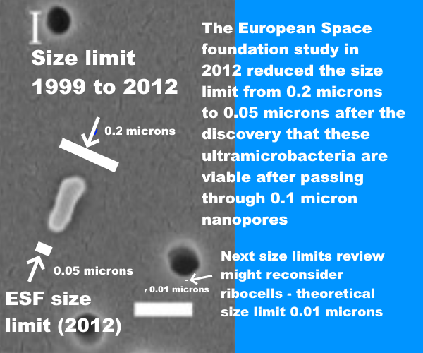

A BSL-4 doesn’t need to contain gene transfer agents, ultramicrobacteria, or hypothetical early life. Recent air filter technology reviews don’t mention any attempts to achieve 100% containment at all sizes above 0.05 microns or a 1 in a million chance of releasing a single particle in the lifetime of a facility at all sizes above 0.01 microns.

NASA’s draft EIS also contradicts the planetary protection literature with its finding of no significant risk of environmental effects for life returned from Mars (NASA, 2022: 3-3):.

The relatively low probability of an inadvertent reentry combined with the assessment that samples are unlikely to pose a risk of significant ecological impact or other significant harmful effects support the judgement that the potential environmental impacts would not be significant.
(NASA, 2022eis: 3-3):

The National Research Council says it is not possible to assess the potential for negative impacts, and says the potential for [even] large-scale negative effects appears to be low but is not demonstrably zero (SSB, 2009 : 48 ).

The committee found that the potential for large-scale negative effects on Earth’s inhabitants or environments by a returned martian life form appears to be low, but is not demonstrably zero
… it is not possible to assess past or future negative impacts caused by the delivery of putative extraterrestrial life, based on current evidence.
(Board et al, 2009: 48)..
This time NASA’s conclusion can be traced back to an assessment by its sterilizing subcommittee. They seems to represent a minority view amongst microbiologists (MacGregor et al, 2001)

First, arguing from many examples of pathogens adapted to humans, their assessment says the risk of a direct pathogen of humans is near-zero (Craven et al., 2021)

Since any putative Martian microorganism would not have experienced long-term evolutionary contact with humans (or other Earth host), the presence of a direct pathogen on Mars is likely to have a near-zero probability.

This omits terrestrial exceptions such as Legionnaire’s disease, a disease of biofilms and protozoa that uses the same methods to infect human lungs. Mars could have diseases of anaerobic protozoa and biofilms on Mars and to them, as for Legionella, human lungs would seem like biofilms, and the macrophages in our lungs like large protozoa.

It also omits opportunistic fungal infections apart from Candida which they do mention, which is adapted to humans (Alves et al., 2010).

They don’t mention the Aspergillus genus which isn’t adapted to a pathogenic lifestyle for any other organism (McCormick et al, 2010). and is accidentally pathogenic. Instead Aspergillus is so well able to infect humans because of adaptations to stressful conditions in the wild (Paulussen et al, 2017)

Aspergillus species are able to utilize a wide range of substrates, highly efficient at acquiring such resources, and can store considerable quantities of nutrients within the cell; all traits which contribute to their energy‐generating capacity and competitive ability
…
Species of Aspergillus are also among the most stress‐tolerant microbes thus far characterized in relation to, for example, low water activity, osmotic stress, resistance to extreme temperatures, longevity, chaotropicity, hydrophobicity and oxidative stress
Interestingly many of its capabilities are also ones that would be valuable for a microbe living on Mars such as rapid recovery from desiccation, absence of oxygen, highly efficient at taking up nutrients and converting it to energy, resistant to rapid temperature changes, and protection from freeze-thawing (Paulussen et al, 2017: table 1) and (Paulussen et al, 2017: table 2),.

There are an estimated 200,000 life-threatening Aspergillus infections a year and the mortality for these is 30% to 95% (Brown et al, 2012) ..

We have specific protections in our immune systems targeting the three main genera of fungi that infect humans, : Candida, Aspergillus, and Cryptococcus with different molecular patterns (PAMPS) specific to each genus (Kumar et al, 2018 : table 1). If we suppose humans only encountered candida and cryptococcus, our immune system would not recognize any of the Aspergillus patterns. This suggests the possibility that we might all be immunocompromised against a new genera of fungi from Mars.

The sterilizing subcommittee report also omits views of some astrobiologists that our immune system might not notice pathogens based on independently evolved life with a different biochemistry. Joshua Lederberg, a key figure in early work on planetary protection (Scharf, 2016) put it like this (Lederberg, 1999b):

“Whether a microorganism from Mars exists and could attack us is more conjectural. If so, it might be a zoonosis [infectious disease that jumps to humans] to beat all others

Lederberg argues our immune system and defenses are keyed to various chemicals produced by Earth life such as peptides and carbohydrates. Mars life might use different chemicals.

Thus, although the hypothetical parasite from Mars is not adapted to live in a host from Earth, our immune systems are not equipped to cope with totally alien parasites: a conceptual impasse."

In the worst case here, our immune system doesn’t recognize the attackers as life, and does nothing to stop them. A modern analogy would be the way our immune system largely ignores microplastics which can access all organs.

Carl Sagan put it like this (Sagan, 1973:162):
"On the one hand, we can argue that Martian organisms cannot cause any serious problems to terrestrial organisms, because there has been no biological contact for 4.5 billion years between Martian and terrestrial organisms. On the other hand, we can argue equally well that terrestrial organisms have evolved no defenses against potential Martian pathogens, precisely because there has been no such contact for 4.5 billion years.
In the same book Carl Sagan wrote (Sagan, 1973)
Because of the danger of back-contamination of Earth, I firmly believe that manned landings on Mars should be postponed until the beginning of the next century, after a vigorous program of unmanned Martian exobiology and terrestrial epidemiology.
…. I, myself, would love to be involved in the first manned expedition to Mars. But an exhaustive program of unmanned biological exploration of Mars is necessary first. The likelihood that such pathogens exist is probably small, but we cannot take even a small risk with a billion lives..
The sterilizing subcommittee report also looks into whether martian life might transform the environment of Earth. It agrees that if there could be invasive Martian species, the effects could be serious, for instance by harming or even displacing photosynthetic bacteria (Craven et al., 2021:6-7):

Photosynthetic bacteria such as Prochlorococcus are among the most abundant organisms on Earth and intensely important for the health of oxygen-respiring organisms, such as humans and animals.

The report then uses examples of extremophiles that can’t live in our normal habitat to argue it’s plausible any martian microbe would not be viable on Earth (Craven et al., 2021:6-7).

There are many described extremophiles that may survive in environments that are extreme to human or animal life (e.g. extremes of temperature or pressure) but do not survive under conditions in our normal habitat … Thus, it is plausible that any Martian microbe, after it arrives on Earth, would not be viable on Earth due to a lack of its required Martian nutritional and environmental conditions.

Yet the temperature ranges on Mars overlap those of Earth, with Perseverance seeing surface temperatures vary from below -70 C to above 15 C in a single day. If there is life on Mars, it’s resistance to dessication, low humidity, low atmospheric pressure, UV and ionizing radiation makes it capable of living in extreme environments but there isn’t any particular reason it would be incapable of living in places without those stresses

Their reasoning omits polyextremophiles that live in a wide range of both extreme and normal environments such as the blue-green algae chroococcidiopsis, a genus which has strains that flourish from Antarctic cliffs to the Atacama desert (Bahl et al, 2011) or from Sri Lankan reservoirs (Magana-Arachchi et al, 2013) to the Chinese sea (Xu et al, 201q26:111). As a prime producer it survives on just rock, water, and light, fixing CO2 and nitrogen from the atmosphere. It is an ancient polyextremophile with numerous alternative metabolic pathways it can utilize, including nitrogen fixation, methanotrophy, sulfate reduction, nitrate reduction etc (KEGG, n.d.), even able to grow in complete darkness using a hydrogen-based lithoautotrophic metabolism with viable populations 750 meters below the Atlantic sea bed (Li et al, 2020).

Some strains of chroococcidiopsis are amongst our best terrestrial candidates to flourish on Mars due to the remarkable ability of some strains to repair even multiple double strand breaks in its DNA.

There is little by way of in depth discussion of scenarios in the planetary protection literature for ways life from Mars could harm humans, our crops or ecosystems – or of scenarios where it can be harmless or beneficial. However, it may help to briefly mention one worst case scenario, to encourage space agencies to treat planetary protection more rigorously. This is the scenario of a mirror-life analogue of Chroococcidiopsis.

We don’t know how terrestrial homochirality evolved, with many proposed mechanisms (Blackmond, 2019). Some experts say it is “luck of the draw” (Brazil, 2015). The theory of punctuated chirality suggests any initial chiral bias could be erased by local self reinforcing chiral networks of chemicals which expand, and flip chirality on an environmental scale, with these flips perhaps frequent in Early Earth. If so, life on Mars could have the opposite chiral bias to Earth (Gleiser et al, 2008):

Our analysis predicts that other planetary platforms in this solar system and elsewhere could have developed an opposite chiral bias.

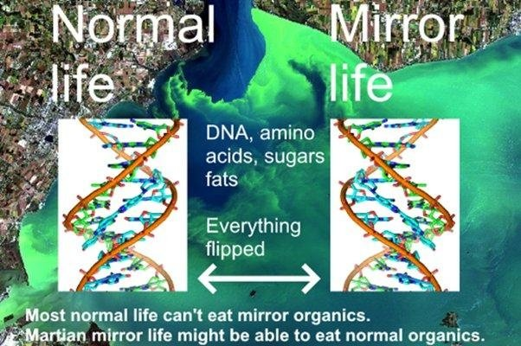
Background image from (NOAA, n.d.), DNA spiral from (Pusey, 2012)
If we could flip a cake in 3D, like reflecting it in a mirror, we might be able to eat it, like artificial sweeteners, but our metabolism couldn’t do anything with the flipped starches or proteins, and many fats would also be inaccessible (Dinan et al, 2007)

Synthetic biologists plan to gradually flip ordinary to mirror life over a period of a decade or so – and will make sure synthetic mirror life is engineered to depend on chemicals only available in the laboratory. They warn escape of mirror life could cause major transformations of the terrestrial biosphere by locking up organics in unusable mirror forms (Bohannon, 2010).

This issue becomes especially acute if mirror life obtains enzymes (isomerases) that transform ordinary organic molecules into their mirror form. A few rare terrestrial microbes can use this method in reveres to eat mirror organics (Pikuta et al, 2016). In the worst case scenario, mirror life consumes ordinary organics, but terrestrial life can’t make anything of the mirror organics. (Bohannon, 2010)..

Kasting “It would quickly consume all the available nutrients. This would leave fewer or perhaps no nutrients for normal organisms.”

The CO₂ in the ocean would get taken up by inedible mirror cells and so draw down CO₂ from the atmosphere. He calculated that in around 300 years half of Earth’s CO₂ would be gone. At that point most land plants couldn’t photosynthesize, including all agricultural crops except corn and cane sugar (which use C-4 photosynthesis which can work with almost no CO₂).

“All agricultural crops other than corn and sugar cane would die,”

… “People might be able to subsist for a few hundred years, but things would be getting pretty grim much more quickly than that.”

At 600 years they envision a new ice age with almost no CO₂ left.

The article continues (Bohannon, 2010):

—both Kasting and Church think mirror predators would evolve, but whatever life existed on Earth by that point wouldn’t include us.

Martian life likely already has the isomerases to metabolize organics of opposite sense, whether it is mirror or normal life - because nearly all organics are either made abiotically locally, or are infall from comets, asteroids and interplanetary dust, with organics of both senses.

Eventually terrestrial microbes likely develop isomerases to metabolize mirror life, but higher life couldn’t evolve so quickly. The outcome is a mix of normal and mirror organics. In Kasting and Church’s worst case scenario mirror life would need to retain the edge over normal life in this evolutionary race.

I think we would survive. We have already designed almost self-sustaining space habitats like the early Russian BIOS-3 based on plants grown for food, and oxygen, which in turn take up carbon dioxide and water from humans which should work in space, a more challenging situation (Salisbury et al, 1997) (Johansson, 2006) .

We could enclose large areas of Earth with its tropical jungles, coral reefs etc, like Biosphere 2 (UA, n.d.). But it would be a severely diminished world to leave to the next generation.

For a closely related scenario, Earth and Mars exchange normal life, but Mars has a shadow biosphere with a different biochemistry that never got here like the hypothesis of a terrestrial shadow biosphere of nanobes (Cleland, 2019, pp 213 - 214) which could co-exist with modern life. Earth doesn’t seem to have one (yet) but small cells have an advantage in an environment with low nutrient concentrations, as they have a larger surface to volume ratio, and so take up nutrients more efficiently. They would also avoid protozoan grazing (Ghuneim et al, 2018).

In this scenario Martian mirror life cells have a less sophisticated biology, but compete in a shadow biosphere on Earth because of their small size, with the extra advantage that they form mirror organics biofilms. These shadow biosphere biofilms are inedible to most terrestrial life and expand.

We may well be able to reduce impacts, perhaps with engineered normal life predators of mirror life or import them from Mars. However, these are scenarios to avoid, with consequences hard to predict.

Zubrin presented these arguments about harmlessness of martian life and the meteorite argument in a non peer reviewed op ed in in 2000 (Zubrin, 2000), with an immediate response in the next edition of the planetary report that it’s like building a house without smoke detectors (Rummel et al., 2000).

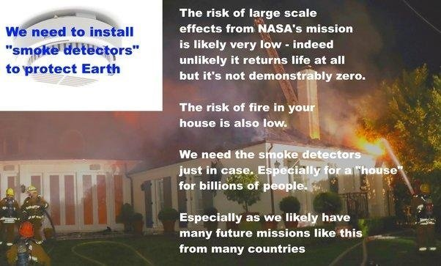

Background graphics:
Smoke detector (Rockmelder, 2007) House on fire (LAFD, 2018)
Another central argument in NASA’s draft EIS is that Mars is lifeless anyway. The draft EIS says “conditions on Mars have not been amenable to supporting life as we know it for millions of years” (NASA, 2022eis: 1-6):

Existing credible evidence suggests that conditions on Mars have not been amenable to supporting life as we know it for millions of years (… National Research Council 2022).

Their most recent source says the opposite of the sentence it’s cited to. See: (Smith et al, 2022: 393)

Section title: “Are There Chemical, Morphological and / or Physiologic / Metabolic or Other Biosignatures in Currently Habitable Environments in the Solar System

The exploration of … Mars (Curiosity, Perseverance) will help establish whether localised habitable regions currently exist within these seemingly uninhabitable worlds.

[Emphasis on “currently” mine]

So again, NASA got to this conclusion through a citing error.

It’s a surprising error given NASA itself was involved in extensive discussions about whether to divert Curiosity away from potential current habitats for terrestrial life in Gale crater (JPL, 2016) because of the potential for forward contamination. After discussion they made a tentative decision that it could approach within a couple of kilometers to image them but not study close up (Witze, 2016) (Dundas et al., 2015) (Vasaveda, 2015).

There’s a wide range of views amongst astrobiologists but few would say definitively that there is no extant life in Jezero crater today, either as spores in the dust or as biofilms in microhabitats. Rummel and Conley, both former planetary protection officers for NASA, put it like this: (Rummel et al , 2014)

"Claims that reducing planetary protection requirements wouldn't be harmful, because Earth life can't grow on Mars, may be reassuring as opinion, but the facts are that we keep discovering life growing in extreme conditions on Earth that resemble conditions on Mars. We also keep discovering conditions on Mars that are more similar—though perhaps only at microbial scales—to inhabited environments on Earth …."

NASA’s draft EIS fails requirements for a valid NEPA Environmental Impact Statement

Agencies shall ensure the professional integrity, including scientific integrity, of the discussions and analyses in environmental impact statements
§ 1502.23

The EIS omits important studies that overturn results it relies on, and uses cites that refute sentences they are attached to without alerting the reader to this discrepancy.
(a) Evaluate reasonable alternatives to the proposed action, and, for alternatives that the agency eliminated from detailed study, briefly discuss the reasons for their elimination.
(b) Discuss each alternative considered in detail, including the proposed action, so that reviewers may evaluate their comparative merits.
§ 1502.14

NASA's EIS doesn't have rigorous analysis of ANY alternative except "no action". Reasonable alternatives include a presterilized sample return or delaying the mission until it can be done safely.
Agencies shall prepare environmental impact statements using an interdisciplinary approach that will ensure the integrated use of the natural and social sciences and the environmental design arts

§ 1507.2
Mars sample return studies emphasize the need to involve the public early on, not just in the USA, but through fora open to representatives from all countries globally because negative impacts could affect countries beyond the ones involved directly in the mission (Ammann et al, 2012:59).

RECOMMENDATION 4
Potential negative consequences resulting from an unintended release could be borne by a larger set of countries than those involved in the programme. It is recommended that mechanisms and fora dedicated to ethical and social issues of the risks and benefits raised by an MSR are set up at the international level and are open to representatives of all countries
The public weren’t involved early on in that way. Not only that, those in the public who did discover NASA’s request for public comment weren't given the opportunity to comment on a scientifically valid EIS.

I hope NASA and other space agencies can ensure a mishap like this never happens again.

This mission can be made 100% safe by sterilizing samples before they reach Earth. The equivalent of 500 million years of surface radiation, 50 megagrays, would reduce amino acids 1000 fold with virtually no impact on geological interest, as Perseverance can't drill to layers protected from surface ionizing radiation.

As for astrobiological interest, Perseverance’s engineers believe they achieved a maximum of 0.7 ppb or 0.7 nanograms per gram for their most abundant biosignatures (Boeder et al, 2020: table 6),

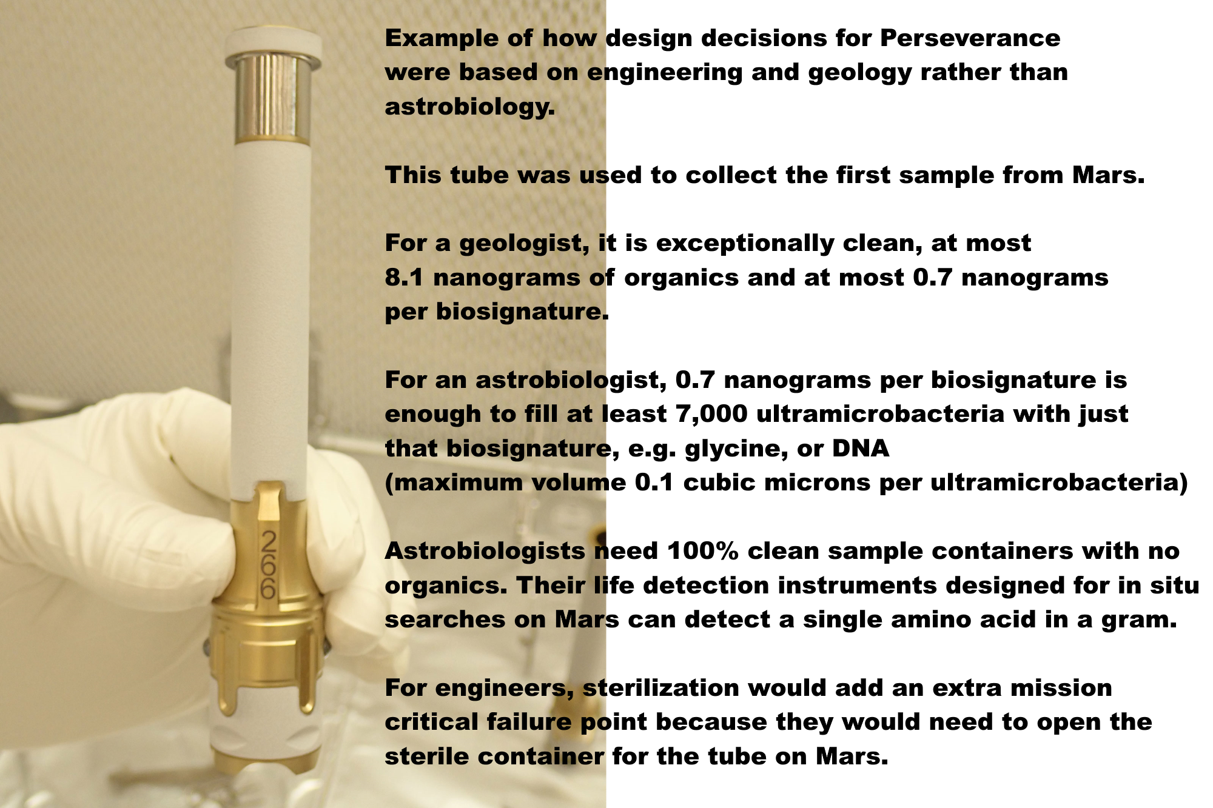

With these levels of forward contamination, Perseverance is unlikely to detect life, past or present, even if by chance it returns it. So, sterilization preserves virtually all geological interest with minimal impact on astrobiological interest.

The NASA draft EIS requires samples to be returned to Earth for “safety testing” but this is guaranteed to find false positives.

Indeed, it’s not possible to do safety testing until we know much more. Even without any contamination, we could destructively test every one of 10,000 grains of dust individually – then the 10,001th grain has a viable microbe. The dust or dirt could have one viable microbe per gram or less. We also couldn’t detect life non destructively by Raman spectroscopy or autofluorescence as a microbe could be inbedded in a crack in a dust grain, or covered in iron oxides.

It might be possible to sterilize samples on the return journey, with nanoscale x-ray emitters, but if not, we can return it to a satellite similar to a geostationary satellite for sterilization. We can use minimal energy orbits without aerobraking for instance via a Sun Earth L2 halo dovetailed to an Earth Moon L2 halo, then L2, L1, and back to the Laplace plane above GEO. This has been proposed as a disposal orbit for GEO satellites at end of lifetime. Even if the satellites explode or collide or fragment the fragments can’t harm satellites in GEO. It’s where ring particles would orbit if Earth had a ring system. Samples could be returned to, say, 100,000 km above this proposed GEO disposal orbit.

The launch costs wouldn’t be prohibitive for NASA as the Falcon Heavy can already deliver over 25 tons to GEO at a cost of $150 million and launch costs are sure to go down. The satellite could be less than a ton in mass even including the mass of a sterilizer unit.

The mission could be made far more interesting by sending a STERILE container on the ESF fetch rover to return bonus samples of dirt, dust and atmosphere without forward contamination, and a pebble from the Mars surface picked up by a pre-sterilized marscopter – as a technology demo for returning CLEAN rock samples. If we find a crater recently excavated to 2 meters we could add a technology demo to return minimally degraded organics, though without in situ life detection it’s not likely to return recognizable life.

Venus lander studies have shown how to build rovers with instrumentation, batteries, communications, motors, capable of functioning at 300 C using commercial components. A marscopter built to such a spec could be heated to 300 C for a few hours to sterilize it 100%.

These clean samples could be studied above geostationary orbit, in Mars simulation conditions with a centrifuge for artificial martian gravity – which would make it unique as a facility, as we can’t simulate martian gravity accurately on Earth.

This would NOT be a human occupied space station. In the backwards direction, quarantine can’t protect Earth from mirror life or indeed fungal diseases. Two zinnia plants on the ISS died of a fungal disease brought there probably on an astronaut’s microbiome, also an occasional opportunistic pathogen of humans. In the forward direction, an unmanned satellite let’s us study martian life in far cleaner conditions as ultramicrobacteria can get through HEPA filters both ways.

It's the equivalent of one geostationary satellite far above GEO. Humans study the dust, dirt and atmosphere as they would on Mars using in situ instruments designed for end to end sample preparation to analysis - these already exist such as LD chip (antibodies) almost sent on Exomars but descoped, the gene sequencer SETG, astrobionibbler able to detect a single amino acid in a gram, the chiral labelled release, and many others.

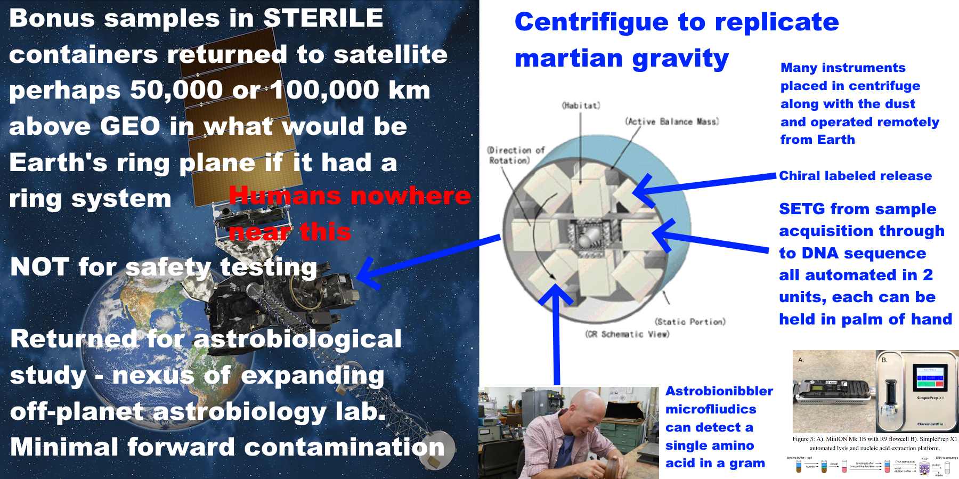
NASA have an opportunity to set a precedent to keep Earth safe. Other countries are likely to follow its example, or indeed, collaborate in a multi-national astrobiology sample handling and pre-processing lab above GEO – in a similar spirit to the ISS but far lower cost.
If we do find life on Mars that can never be returned safely, this may stimulate rather than discourage vigorous space exploration and settlement. The first astronauts to Mars might study the surface remotely in a spectacular orbit that flies near to both poles twice a day and skims in close over a different part of Mars on the opposite sides of the planet twice a day.
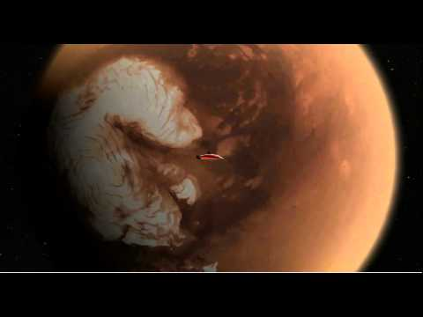

They would operate surface marscopters, rovers and other assets, similarly to avatars in a computer game. We could already make a 100% sterile marscopter by adopting the technology for a Venus lander. Our technology has advanced since the Viking landers which were baked for 112 °C for 30 hours, enough for a million-fold reduction of the originally low population (Beauchamp, 2012).

In the forwards direction, originally planetary protection was based on the idea that life on Mars has to survive long enough to satisfy human curiosity, as Sagan et al put it, (Sagan et al, 1967). zzz

“The desirability of performing a large number of biological experiments on the Martian surface before there is a sizeable probability of contamination”.

In their discussion of issues with forwards contamination of Europa, Greenberg and Tuft looked at the opposite extreme, what they called the “Prime directive” by analogy with Star Trek, that we should make sure there is no risk of forward contamination, and wrote (Greenberg et al, 2001).

“The problem with this principle is that, if rigorously applied, it would likely bring exploration of some of the most interesting moons and planets to a halt.”

However since then we’ve developed the technical capability to make 100% sterile robotic explorers which could explore moons and planets of the solar system with no risk of forward contamination,

Some of this technology was developed for oil wells, aviation and electric cars. We
developed memory devices and processors that can withstand 300 °C of warming to place them close to engines and other heat sources without active cooling (Watson et al, 2012).
NASA took this further with their HOTTECH program for Venus surface exploration (NASA, n.d.) and can now make all the components for a Venus Surface lander able to withstand 60 days at 500 °C with no active cooling (Kremic et al, 2021).

We don’t need to go as high as 500 C to achieve a lander that can be sterilized 100%. At 250 °C the half life of the RNA bases under hydrolysis is between 1 and 35 minutes, going down to seconds at 350 °C (Levy et al, 1998) and eight of the 20 amino acids decompose between (Weiss et al, 2018) 185°C for Q (Glutamine) to 280°C for H (Histamine) (Weiss et al, 2018).

The marscopter might be a good starting point as it is small, doesn’t have so many components as a rover, and is ideal for targeting sensitive sites near a rover. It wouldn’t take much heat at 300 °C to achieve a 100% sterile marscopter. We can go on to develop 100% sterile cave bots, borrowing moles, balloons, miniature planes, probes, and build on those to achieve 100% sterile complete rovers.

This is an option for us as a civilization, if we are prepared to authorize the small % increase in cost of our missions, mainly at the design stage of the first marscopters, probes and rovers. If we find that what we have on Mars is a scenario where it is never safe for humans to land on Mars, we could use “seed factories” on the Martian surface, to make 100% sterile rovers mainly from resources mined locally and controlled from orbit as in the game of civilization.

So, we now have the option to not only keep Earth 100% safe from backwards contamination even for the worst case scenarios such as mirror life. In the last couple of decades our technology has advanced to the point where we can keep other locations in our solar system 100% safe from forwards contamination too, with likely no restrictions on what we can do by way of science studies, and we can do this indefinitely, for as long as we wish to keep these locations free from terrestrial life.

This is now a decision for us as a civilization. It is no longer a case of weighing up whether to do the science at all or to protect the solar system 100%. It is a matter of public choices, priorities, budget and planning. Do we wish to increase funding, perhaps by a few percent, to protect the solar system 100% from both forward and backwards contamination with virtually no impact on science?

If we can never safely send humans to the Martian surface, or decide not to send humans there to protect vulnerable native Martian species, there are many other locations in the solar system that humans can explore as adventurers in person and perhaps set up base, including Mars’s moons Phobos and Deimos, the Venus clouds, the asteroid belt, and first of all the Moon, and later on further afield to places like Jupiter’s Callisto, Saturn’s Titan and beyond.

The longer companion paper goes into this in more detail.
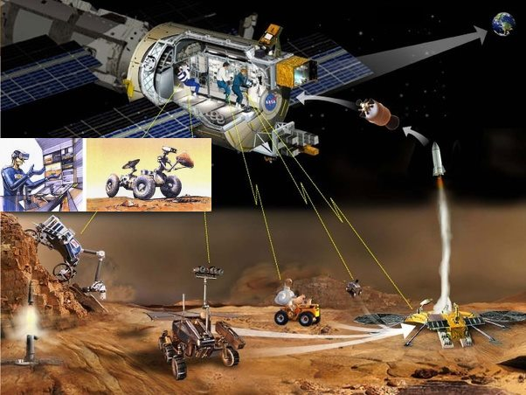
We can explore and exploit Mars without humans on the surface, settling the Martian moons and orbital space habitats, as part of vigorous exploration and perhaps settlement throughout the solar system. Humans and robots work together each doing what it does best. Torrence V. Johnson, Galileo Chief Scientist, put it like this in the foreword to Meltzer’s “Mission to Jupiter” (Meltzer, 2007)

“What we call robotic exploration is in fact human exploration. The crews sitting in the control room at Jet Propulsion Laboratory as well as everyone out there who can log on to the Internet can take a look at what’s going on. So, in effect, we are all standing on the bridge of Starship Enterprise”

My aim with this review is to help make sure voices and concerns of the public are heard. It is to encourage space agencies that are considering a Mars sample return, to do a rigorous scientific review with full public involvement.

Methods and limitations, and selection criteria for this review

This paper is written as a review for the general public to use, legislators, ethicists, decision makers and scientists of other disciplines, so is designed to be maximally accessible. Examples:
- I use the most widely accessible vocabulary available to convey the desired meaning
- I replace technical by non-technical terms when it can be done with no loss of precision
- I use non-scientific terms, non-technical terms generally, and non-mathematical language whenever if it is available with the same precision.

Examples of using non-technical terms when there is no loss of precision:

- Million instead of 10⁶
- “Didymo” instead of Didymosphenia geminate

This paper has to consider research published after 2009 or it would be 13 years out of date. The final draft of the NRC study was finalized in late February 2009 and approved in March 2029 (SSB, 2009: viii), just before the discovery of the droplets on the legs of the Phoenix lander which was first announced on 17th March 2009 (Renno et al, 2009) and a lot has happened since then.

The selection criterion was to select research for its relevance to the main mistakes in NASA’s draft EIS, treated as representative of mistakes other space agencies are likely to make. A longer companion paper expands on this in detail focusing on highlights from the last 13 years of special interest to space agencies, (Walker, …).

Both of these papers select topics and papers to cover from a much vaster literature for the purposes of illustration, and should NOT be used in lieu of a comprehensive review. I hope that NASA and ESA consider commissioning a new review as an urgent first priority if they still intend to return unsterilized samples to Earth.

This paper includes new worst case scenarios. These shouldn’t be seen as likely. We need to look at those is for the same reason that we look at the scenario of a house fire when we design or install a smoke detector.

This paper covers some views from the planetary protection literature in depth such as Carl Sagan’s view that we shouldn’t take even a small risk with a billion lives, and Lederberg’s two papers arguing that our immune systems might not recognize an alien pathogen. That’s because NASA’s draft EIS doesn’t mention them. However this paper is not the place to advocate for or against any of those views. That is for public debate and for legislators and decision makers to look into.

It is the same also for the proposed alternative actions of a sterilized sample return, and of returning bonus samples to above GEO. This paper argues that these two options should be considered by space agencies, amongst reasonable alternatives. It needs to be determined if they are indeed ways to keep Earth 100% safe with minimal impact on science return and even increased science value with the bonus samples.

If those conclusions are valid, this is something the public and decision makers need to know when making their decision. It is also important that the public are fully involved in such decisions, given how highly the general public values the environment and the integrity of Earth’s biosphere.

References

Abbasrezaee, P. and Saraaeb, A., 2021. System Analysis and Design of the Geostationary Earth Orbit All-Electric Communication Satellites. Journal of Aerospace Technology and Management, 13.

“The total mass budget for 8 and 12 kW EOL electric power subsystem calculated 283.14 and 439.8 kg, respectively”

Beatty, J.T., Overmann, J., Lince, M.T., Manske, A.K., Lang, A.S., Blankenship, R.E., Van Dover, C.L., Martinson, T.A. and Plumley, F.G., 2005. An obligately photosynthetic bacterial anaerobe from a deep-sea hydrothermal vent. Proceedings of the National Academy of Sciences, 102(26), pp.9306-9310.

Birnbach, I., 1997. Newly Imposed Limitations on Citizens' Right to Sue for Standing in a Procedural Rights Case. Fordham Envtl. LJ, 9, p.311.
Fajardo-Cavazos, Patricia, Lindsey Link, H. Jay Melosh, and Wayne L. Nicholson, 2005,. "Bacillus subtilis spores on artificial meteorites survive hypervelocity atmospheric entry: implications for lithopanspermia." Astrobiology 5, no. ; 726-736.

Johansson, M., Living in Space, Comparative Study of one Conventional Life Support System and two Biological Systems

Kim, H.J., Kim, H.N., Raza, H.S., Park, H.B. and Cho, S.O., 2016. An intraoral miniature X-ray tube based on carbon nanotubes for dental radiography. Nuclear Engineering and Technology, 48(3), pp.799-804.,
The dose rate of the X-ray at 3-cm apart from the miniature X-ray tube in air was 8.19 Gy/min at 0° when the X-ray tube was operated at 50 kV with the emission beam current of 140 μA..
[This corresponds to 7 watts of power output]
X-rays are almost perfectly blocked when the thickness of the copper collimator is 3 mm
Rennó, N.O., Bos, B.J., Catling, D., Clark, B.C., Drube, L., Fisher, D., Goetz, W., Hviid, S.F., Keller, H.U., Kok, J.F. and Kounaves, S.P., 2009. Possible physical and thermodynamical evidence for liquid water at the Phoenix landing site. Journal of Geophysical Research: Planets, 114(E1).
See also first announcement before the paper was published: Michigan Engineering, 2009 (March 25), Liquid saltwater is likely present on Mars, new analysis shows and earlier in Astronomy magazine on March 17th. Liquid saltwater is likely present on Mars, Astronomy magazine
US DOA, 2017, European Starling.

