Why we must be able to protect Earth from even mirror life in Martian dirt
Author: Robert Walker (contact email robert@robertinventor.com)

Preprint DOI …
For latest version of this preprint please visit: (url …)
(This version 3rd January 2023)
[Needs citations added]
Contents
Abstract 2
Review of central results in the recent planetary protection literature for Mars Sample Return missions for attention of space agencies 3
No, life on Mars can't get to Earth faster and better protected in meteorites than in a sample tube - the 2009 NRC sample return study warns against this argument as does the 2019 Phobos sample return study that the EIS itself cites - martian surface brines, ice, salts, dirt and dust can't get to Earth at all 3
Potential scenario of martian life adapted to live in surface dust or dirt that can’t get to Earth on a meteorite – what matters for invasive species are the ones that can’t get here by themselves 5
It is safe for Japan to return its unsterilized samples without any special precautions because any life that got to Phobos from Mars already survived ejection from Mars 7
2015 (overturning results from 2014): Jezero crater seems uninhabited from orbit – but so do terrestrial Mars analogue deserts – NASA should have cited the 2015 MEPAG review which drew attention to transport of life in dust storms, microhabitats, and biofilms that can make deserts locally more habitable - and overturned all the conclusions they rely on from 2014 9
2015: MEPAG2 review draws attention to potential for viable life transported through the atmosphere (for instance in dust storms) 11
2015: the MEPAG2 review draws attention to the potential for local microenvironments to provide habitats for life that can’t be detected in large scale surveys – and illustrative examples of micropores in salts or gypsum, fresh water from melting layers of frost a few microns thick, and Curiosity’s salty brines 12
2015: MEPAG review also draws attention to biofilms that microbes may need to use to create conditions favourable to them in otherwise uninhabitable microniches – this reduces the risk for forward contamination for spacecraft with low bioloads – however this argument doesn’t work for backwards contamination – such niches could be inhabited by Martian life that already lives in biofilms 15
Martian life could be more capable of coping with Martian conditions than terrestrial life – e.g. survive better in dust storms or cope better with cold temperatures and rapid temperature and humidity changes 16
Draft EIS says “Existing credible evidence suggests that conditions on Mars have not been amenable to supporting life as we know it for millions of years” – their main cite says “exploration of Mars … will establish whether localised habitable regions currently exist” – another conclusion based on a citing error 17
Astrobiologists have a range of views on whether current habitats for terrestrial life exist on Mars – and we keep finding new microhabitats on Mars or new ways that life can grow in extreme conditions 18
2012: The European Space Foundation study reduced the size of particle to contain from 0.2 microns to 0.01 microns at the one in a million threshold, and added that it is not acceptable to release a particle of 0.05 microns or larger in any circumstances – this is well beyond the capabilities of NASA’s proposed BSL-4 19
NASA’s draft EIS says there is no significant risk of environmental effects – yet the NRC study in 2009 warned there isn’t even a demonstrably zero risk of large scale harm to human health and the environment – and also said the potential for negative impacts can’t be assessed – this is due to limitations in scope of the literature review by their sterilizing subcommittee 22
The sterilizing subcommittee report argues that plausibly any martian life would not be viable on Earth and that it has a near zero chance to harm humans based on arguments only previously presented in an op. ed. by Zubrin in 2000 – planetary protection experts found many errors and said it was like a recommendation to build a house without smoke detectors 23
Example to show that a martian pathogen doesn’t need long term evolutionary contact to harm us - Legionnaires’ disease is adapted to biofilms but opportunistically infects human lungs 24
Methods and limitations, and selection criteria for this review 40
References 41

Abstract
NASA / ESA plan to return samples from Mars in the 2030s, and China, in the late 2020s. It’s safe for Japan to return unsterilized samples from Phobos because any microbes already withstood ejection from Mars, like our martian meteorites. JAXA warned this doesn’t apply to Mars samples.

NASA incorrectly says any life from Jezero crater can get here faster and better protected in a meteorite. Surface dirt and dust never gets here.

NASA also proposes to contain samples in a Biosafety Level 4 facility. However, the ESF study in 2012 set new size limits beyond a BSL-4’s capability.
We can keep Earth 100% safe by sterilizing samples before they get here with the equivalent of millions of years of Mars surface ionizing radiation. This has virtually no effect on geology, while Perseverance’s 0.7 nanograms per gram forward contamination makes most astrobiology impossible.
We can greatly increase science value with bonus samples in a sterile container returned to a martian gravity centrifuge in an unmanned satellite above GEO, starting Sagan’s “vigorous program of unmanned exobiology”.
This review includes new worst case scenarios of mirror life, to encourage space agencies to ensure Earth’s biosphere is adequately protected when they return samples from Mars.

Review of central results in the recent planetary protection literature for Mars Sample Return missions for attention of space agencies
This review focuses on NASA’s draft EIS only because it is the first environmental impact statement for a Mars sample return ever published. If NASA and ESA can make mistakes of this order, when they paid so much attention to planetary protection in the past, other space agencies could easily do the same. This is a shorter version of a longer review that goes into more detail on many of the points here, and also covers many additional points, currently available as a preprint (Walker, 2022). This review is written to be widely accessible to the public. For instance it use the ordinary language equivalent of a scientific term so long as it doesn’t lead to any loss of precision.

No, life on Mars can't get to Earth faster and better protected in meteorites than in a sample tube - the 2009 NRC sample return study warns against this argument as does the 2019 Phobos sample return study that the EIS itself cites - martian surface brines, ice, salts, dirt and dust can't get to Earth at all
Let’s start with the meteorite argument. NASA’s Environmental Impact Statement (EIS) argues that (NASA, 2022: 3-3):
The natural delivery of Mars materials can provide better protection and faster transit than the current MSR mission concept.
However, the NRC Mars Sample Return study in 2009 said, in the section “Martian meteorites, Large-Scale effects and Planetary Protection” (SSB, 2009: 48)

The potential hazards posed for Earth by viable organisms surviving in samples [are] significantly greater with a Mars sample return than if the same organisms were brought to Earth via impact-mediated ejection from Mars

The NRC goes on to say:

... Thus it is not appropriate to argue that the existence of martian meteorites on Earth negate the need to treat as potentially hazardous any samples returned from Mars by robotic spacecraft.

So, how did NASA’s EIS come to such a different conclusion? It reasons that potential Mars microbes would be expected to survive ejection from Mars:
First, potential Mars microbes would be expected to survive ejection forces and pressure (National Academies of Sciences, …, 2019), …

This gets the argument in their source back to front. It wasn’t about all potential microbes on Mars. The committee were only interested in the specific scenario of microbes still viable on Phobos after ejection from Mars, impact on Phobos and exposure to the desiccating effect of a vacuum and hundreds of thousands of years of ionizing radiation on the surface of Phobos. First they tried to show that the risk of a viable microbe in the samples is less than 1 in a million. They found too many uncertainties to get to that conclusion (SSB, 2019 : 38).

So instead, they compared the chain of events for martian meteorites and samples returned from Phobos. They argue that ejection from Mars to Phobos is similar to ejection from Mars to Earth, and so, a similar population of viable microbes would be ejected towards Earth and eventually get here in our martian meteorites, but with much less material returned in the samples. That’s explained in detail in chapter 3 (SSB, 2019: 59)

JAXA specifically say their argument does not apply to Mars sample return missions because

- Many surface materials couldn’t mechanically withstand ejection from Mars.
- The samples would also be selected on the surface for scientific interest which makes them different from martian meteorites which weren’t selected for science interest before ejection.
- The samples wouldn’t be sterilized by ejection, impact on Phobos or by exposure to ionizing radiation on the surface of Phobos for hundreds of thousands of years before collection.

This is summarized on page 4 (SSB, 2019 : 4): and explained in more detail in Chapter 3 (SSB, 2019 : 43). The third point in more detail says (split the sentences into bullet points):

- The material will be gently sampled and returned directly to Earth.
- The sample may well come from an environment that mechanically cannot become a Mars meteorite.
- The microbes may not be able to survive impact ejection and transport through space.
- Samples with current liquid water and recent ice seem especially fragile to natural transport to Earth.

Finding: The committee finds that the content of this report and, specifically, the recommendations in it do not apply to future sample return missions from Mars itself.

Mars surface dust, salts, and dirt couldn’t mechanically survive ejection, as they would burn up in the atmosphere before reaching escape velocity. Also there’s no reason why a microbe adapted to live on the surface of Mars would be able to survive ejection and the dessicating effect of vacuum.
NASA’s draft EIS gets to its conclusion of “better protection and faster transit” in martian meteorites through incomplete citing, as it misses this caveat. It also misses the NRC warning that it is inappropriate to use the meteorite argument for samples returned from Mars (SSB, 2009: 48)

Example scenario of martian life adapted to live in surface dust or dirt but unable to get to Earth on a meteorite - and terrestrial examples of invasive starlings in the USA and of the invasive diatom Didymo in New Zealand – for backwards contamination the main focus needs to be on the potential for life that CAN’T get to Earth by itself

To back up their argument, NASA’s draft EIS cites research on panspermia, transfer of life between planets. One of their cites is to an experiment that found that the very hardy microbe bacillus subtilis survived re-entry in a rock attached to a sub-orbital sounding rocket with a re-entry velocity of 1.2 km / sec (Fajardo-Cavazos et al, 2005). B. subtilis is indeed a candidate for a microbe that might be able to get from Mars to Earth in a meteorite, and other evidence showed that b. subtilis could withstand the shock of ejection from Mars (Cockell, 2008).
However,
- for panspermia all that is needed is for a viable microbe in one species to get from Mars to Earth at least once in the last over 4 billion years and survive and grow here.
- for invasive species what matters are any species that can’t get here.
For a valid backwards contamination argument we need to be sure that there is no risk for any species of invasive life returned from Mars, not just an example species that couldn’t be invasive. So we need viable microbes in all potential species that could get here in a sample return to have equal or better opportunities to get here on meteorites than in a sample tube.
An analogy with terrestrial life may help. European Barn swallows were in the Americas already. However the European starlings, can’t fly across the Atlantic which is what made it possible for them to become an invasive species in the USA (US DOA, 2017).
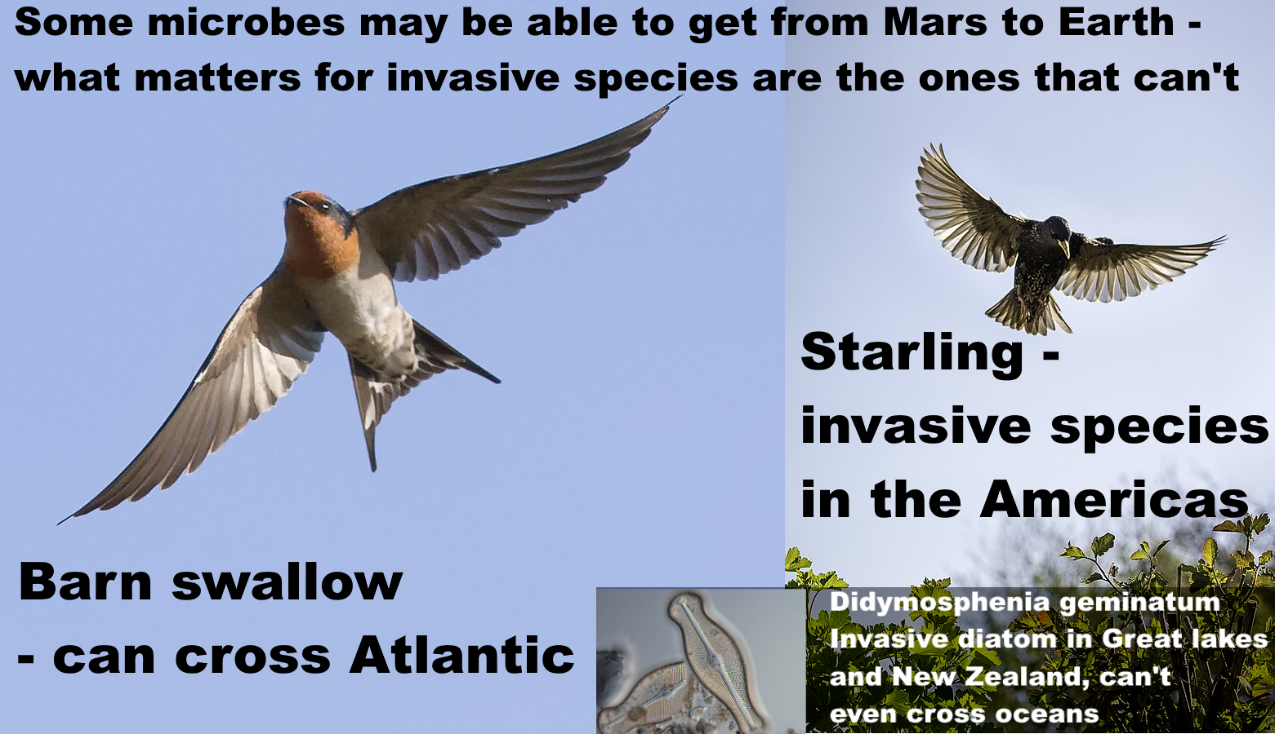
Starling photo from: (Johnstone, 2017)
Barn swallow photo from (Batbander, 2020)
Didymosphenia geminata (Lyngb.) from (Schmidt, n.d.)
We have microbial examples of this too, for instance, the invasive freshwater diatom "Didymo" (Didymosphenia geminatum) in New Zealand can't get from one freshwater lake to another on the same island without human help (Spaulding et al, 2010). It could never get from Mars to Earth.

We are not likely to find diatoms in Jezero crater. But Curiosity did find salty brines that last for a few hours in the late evening / early morning in Gale crater (Martin-Torres et al, 2015) and likely even longer in Jezero crater (Chevrier et al, 2020: figure 7). They are far too cold for terrestrial life at – 73°C, but otherwise habitable. As the day progresses, the surface brines get warm enough for life but too salty, then dry out completely.
Terrestrial life often uses biofilms to inhabit Mars analogue deserts and the 2015 MEPAG review suggested life on Mars may do the same (SSB, 2015 :11). Nilton Renno suggests microbes might use biofilms (Pires, 2015) to inhabit these brines. The biofilm would likely be a mix of many species working together for extra resilience like the grit crust in the Atacama desert (Jung et al, 2020). Such a biofilm would face many challenges, but it seems not impossible that they could be habitable for life evolved to live in martian conditions.
Perseverance doesn’t have the DAN instrument Curiosity used to detect these brines (Chevrier et al, 2020), but Curiosity detected brines on the surface (0 cm) through to the southern hemisphere spring, see Martin-Torres et al, 2015:fig 3b) and through to 6 am on the last day it detected them. On the same day, daytime surface temperatures reached a high point of 288 °K = 15 °C (Martin-Torres et al, 2015:fig 2a).
Billi et al found biofilm fragments mixed with regolith 0.015 to 0.03 mm thick could resist the UV equivalent to 8 hours of full martian sunlight. That gives fragments enough time to travel over 100 km in light martian winds of 5 meters per second (Billi et al, 2019a), (Billi et al, 2019b).

The biofilms, as for diatoms, could be perfectly adapted to survive and propagate on Mars, and yet have no evolutionary pressure to withstand extreme shock, vacuum, life below the surface of a rock, and so on. Some or all of species that make up biofilms might have no way to get to Earth on a meteorite. For a biofilm fragment, a sealed sample tube is like a miniature spaceship complete with a small amount of martian atmosphere.

If we do find a familiar terrestrial species in the sample, that’s like the swallow in the Americas, this will only show that that one species crossed between the planets. To drop planetary protection, we need to continue to look for the starlings in this analogy. We need to show all species we might return from Mars are either harmless for some other reason or already get here on meteorites.

It is safe for Japan to return its unsterilized samples without any special precautions because any life that got to Phobos from Mars already survived ejection from Mars
JAXA did establish that they can safely return samples from Phobos because their samples will have a similar history to martian meteorites arriving today. (SSB, 2019 : 38 ff). Our martian meteorites last left Mars at least 700,000 years ago (ejection ages between 0.7 and 18.5 million years ago (Udry et al, 2020:table S4) )

JAXA compared two chains of events, their sample return and transfer on a meteorite:

Sample return: Ejection from Mars → Impact on Phobos → Remains in top 10 cm of the Phobos surface for 700,000 years → returned to Earth in the Phobos sample return

Meteorite: Ejection from Mars → spends 700,000 years in space traveling from Mars to Earth → reenters Earths atmosphere and delivered to Earth.

(In their calculations for some reason JAXA round the estimate of 700,000 years up to a million years but this makes no difference to the argument).

For all except the last in the chain of events the amount of sterilization is similar for the meteorites ejected from Mars and the returned samples. At the first stage of ejection, the ejection velocity for meteorites from Mars to Earth is higher than from Mars to Phobos but in both cases a small percentage of the ejecta is only weakly shocked, so this difference has a modest effect. (SSB, 2019: 59)

The main difference is the fireball of re-entry. However, they found that any microbes from Mars would be far more sterilized by the shock of an impact into Phobos than a reentry fireball to Earth because only the surface of the rock is heated (SSB, 2019: 40)

[Here JAXA may have a slight omission for photosynthetic life living on or near the surface of rocks by Cockell’s experiment just mentioned because it would live within the layers destroyed by the fireball of re-entry (Cockell, 2008). But if so, this is a relatively minor issue – because Martian microbes come from at least 3 meters below the surface in the high Southern Uplands (Head et al, 2002:1355), where photosynthetic life is unlikely, or would need to use alternative metabolic pathways in darkness, with no likely preference for surfaces of rocks. The longer version of this paper goes into this in more detail in supplementary information.]

This is the backward contamination version of Greenberg’s “Natural contamination standard” (Greenberg et al, 2001). The reasoning is, if the probability of microbes getting to Earth via the sample return is significantly less than the probability of this happening naturally we are in his view doing no harm.
In short, JAXA established they can return their samples from Phobos because they have already been ejected from Mars and have spent 700,000 years on the surface of Mars exposed to ionizing radiation from solar storms and cosmic radiation.

NASA’s “better protection and faster transit” (NASA, 2022: 3-3) does apply to the JAXA mission. Any microbes from Mars that get to us via samples from Phobos can get here better protected in meteorites, and all the past meteorites from this impact got here faster than JAXA’s samples will get here, after you take account of the 700,000 years JAXA’s samples spent on the surface of Phobos.

We can’t apply JAXA’s reasoning to Perseverance’s samples from the Mars surface. They would get here far faster in sample tubes than any meteorite currently arriving from the impact that formed Zunil crater 700,000 years ago. As for better protected, martian dust and dirt is completely unprotected as it couldn’t survive ejection from Mars at all.

2015 (overturning results from 2014): Jezero crater seems uninhabited from orbit – but so do terrestrial Mars analogue deserts – NASA should have cited the 2015 MEPAG review which drew attention to transport of life in dust storms, microhabitats, and biofilms that can make deserts locally more habitable - and overturned all the conclusions they rely on from 2014

NASA also say that the Martian surface is especially inhospitable for life in Jezero crater, where Perseverance is collecting samples, arguing that the choice of landing site helps keep Earth safe, saying (NASA, 2022: S-4)

Consensus opinion within the astrobiology scientific community supports a conclusion that the Martian surface is too inhospitable for life to survive there today, particularly at the location and shallow depth (6.4 centimeters [2.5 inches]) being sampled by the Perseverance rover in Jezero Crater, … (Rummel et al. 2014, Grant et al. 2018).

NASA’s draft EIS refers to SR-SAG2 (Rummel et al , 2014), but NASA and ESA commissioned a review in 2015, the MEPAG review (SSB, 2015 which modified all the main conclusions that NASA relies on for this statement about Jezero crater. NASA’s draft EIS doesn’t cite this review even though it’s one that NASA themselves commissioned.

SR-SAG2 relies on maps like this. This map shows that the equatorial region of Mars including Perseverance’s landing site in Jezero crater has no shallow ice observed or suspected

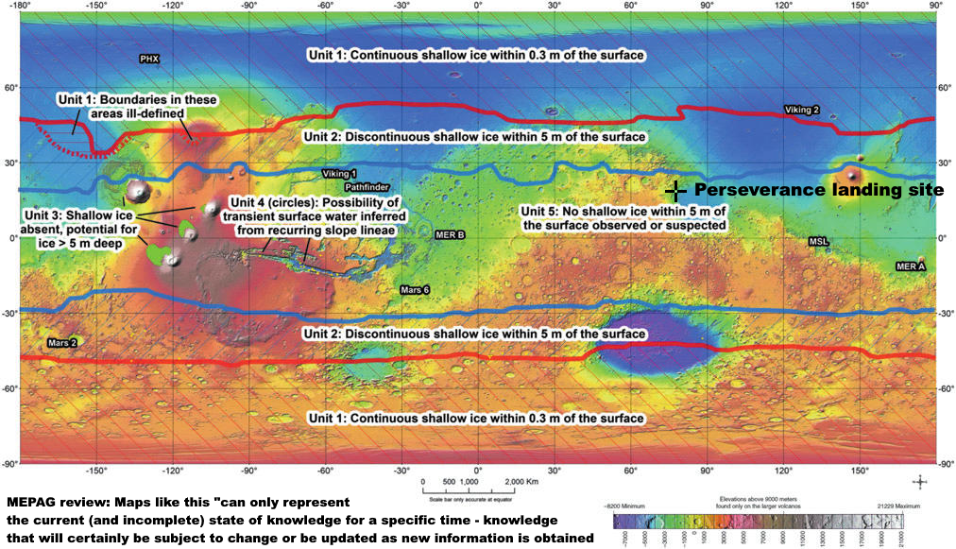
Source: (Rummel et al , 2014 : Fig. 45 ) Colour coding shows elevation.
Perseverance landing site shown at 18.44°N 77.45°E (NASA, 2022)

It then maps out the Recurrent Slope Linea (RSLs) (Rummel et al , 2014 : Fig. 47 ). These grow down slopes in spring, broaden through the summer and fade away in the autumn on sun facing slopes on Mars (McEwen, 2011). At the time the favoured explanation was that they were the indirect result of subsurface brine seeps which could be potentially habitable (McEwen, 2011).

More recent research strongly suggests they are caused by dust flows though this is not yet proven. The way the RSLs grow in spring may be because of seasonal variations in wind speed, direction, and turbulence (Stillman et al., 2021). They may be supplied by bouncing sand grains and triggered by dust devils, but this can’t be verified as many won’t leave tracks detectable from orbit (McEwen et al, 2021). We probably can’t resolve this from orbit and need in situ observations (Stillman et al., 2021). The debate illustrates the issues with use of maps to detect habitability on the ground and their habitability remains unknown though much less favoured than with the science of 2011.

The 2014 report which NASA’s EIS relies on these two maps to identify “Special regions” for spacecraft to avoid in case terrestrial life might propagate there. “Special regions” on Mars are defined as regions (SSB, 2015 :6).

“within which terrestrial organisms are likely to propagate, or a region which is interpreted to have a high potential for the existence of extant martian life forms.”

The recommendation from SR-SAG2 is to use maps like these to help our rovers avoid regions where terrestrial life could propagate.

The 2015 MEPAG Review of this 2014 report says that such maps can only represent the current (and incomplete) state of knowledge for a specific time (SSB, 2015 :28).

Maps that illustrate the distribution of specific relevant landforms or other surface features can only represent the current (and incomplete) state of knowledge for a specific time—knowledge that will certainly be subject to change or be updated as new information is obtained.

NASA’s draft EIS only cites the 2014 study, SR-SAG2, and not this 2015 review which modified all its main conclusions relevant to Jezero crater.

Jezero crater seems uninhabited from orbit, but that doesn’t mean there is no life there.

2015: MEPAG2 review draws attention to potential for viable life transported through the atmosphere (for instance in dust storms)

One way life could get to Jezero crater is in the dust. Dust storms transfer terrestrial life over large distances, with life from the Gobi desert detected in Japan.

The MEPAG review of 2015 says (SSB, 2015 : 12).:

The SR-SAG2 report does not adequately discuss the transport of material in the martian atmosphere. The issue is especially worthy of consideration because if survival is possible during atmospheric transport, the designation of Special Regions becomes more difficult, or even irrelevant.

The issue is that if life can be transported from almost anywhere on Mars to almost anywhere, then depending on how easily this can happen, it might become difficult or even impossible to distinguish particular regions as safer than other regions of Mars for forward contamination. Even if they are not special regions themselves, they could be a source to spread forward contamination to special regions elsewhere on Mars. This is especially relevant for any future human landings, since they would have higher bioloads and would be likely to introduce biofilms to Mars.

Since 2015, researchers have found various ways life could potentially be transported in the Martian dust storms, including the biofilm fragments we mentioned which could survive UV for 100 km (Billi et al, 2019a), (Billi et al, 2019b) , and much longer in dust storms, and also bouncing sand grains (Kok, 2010) (Bak et al., 2019). Bak et al found most life is destroyed quickly but some b subtilis spores are still viable after 5 days of bouncing, with the number of viable spores of b. subtilis reduced more than 1000 fold (Bak et al., 2019:4). Based on the saltation particle speed of 3 to 10 meters per second for a particle of 400 microns in diameter (Kok, 2010:fig.3a), a b. subtilis spore could in principle remain viable after travelling over 1000 kms.

Perchlorates in the dust may make this more challenging for terrestrial life because UV has been shown to reduce the survival times, at least for b. subtilis, perhaps by converting them to the more reactive chlorates and chlorites. However, this is not tested for polyextremophiles that may be more resilient (Wadsworth et al, 2017). Also, dust storms would reduce UV reducing this effect and increase the survival times for individual microbes. Billi et al.’s biofilm fragment mixed with regolith would also shelter microbes within it from the effects of reactive chemicals produced by the UV. Also, Martian microbes would have had the opportunity to evolve to become more resilient to the martian conditions.

Also the winds continue at night. The Insight lander measured night time wind speeds of over 5 meters per second for most of the night, which could transport Billi et al.s biofilm over a hundred kilometers each night, with no UV exposure, with wind speed peaks around 3 am and 10 pm, and another broader peak in the middle of the day (Viúdez‐Moreiras et al., 2020: figure 5). The dust storms could transport a biofilm fragment even further. Curiosity measured a thirty-fold fall in the UV levels for three weeks at the start of the 2018 global dust storm which could be enough for Billi et al’s biofilm to remain viable after transport for thousands of kilometers (Smith, 2019:fig. 5). The Insight lander measured lower wind speeds at night during this dust storm of 3 meters per second which might be enough to keep a light biofilm moving at night too (Viúdez‐Moreiras et al., 2020: figure 5).

2015: the MEPAG2 review draws attention to the potential for local microenvironments to provide habitats for life that can’t be detected in large scale surveys – and illustrative examples of micropores in salts or gypsum, fresh water from melting layers of frost a few microns thick, and Curiosity’s salty brines

The 2015 MEPAG review also says local microenvironments can be habitable in regions that seem to be uninhabitable on larger scales (SSB, 2015 :12).

Physical and chemical conditions in microenvironments can be substantially different from those of larger scales. Although the SR-SAG2 report considered the microenvironment (Finding 3-10), the implications of the lack of knowledge about microscale conditions was only briefly considered.

Indeed, SR-SAG2 describes seven potential naturally occurring microenvironments on Mars, and several of them are relevant to Jezero crater in

“Vapor-phase water available Vapor or aerosols in planet’s atmosphere; within soil
cavities, porous rocks, etc.; within or beneath spacecraft or spacecraft debris” (Rummel et al , 2014:904).

Microbes can inhabit micropores in salt deposits in deserts when the air is otherwise too dry through spontaneous condensation of water vapour in the micropores (Vítek et al, 2010) (Wierzchos, 2012). Cassie Conley (Conley, 2016) and, separately, Paul Davies (Davies, 2014) have suggested these as potential habitats on present day Mars. Microbes can use micropores in gypsum too, at an external humidity of only 60%. (Wierzchos et al, 2011: figure 1).

Jezero crater doesn’t have the large bright salt deposits of Mount Sharp (Lerner, 2019). The orbital measurements suggest that it has salts almost everywhere, along with other minerals that form through interaction with water, but only at levels of at most a few percent, suggesting water flowed there only briefly in the past (Wiens et al., 2022).

However these salts are likely to be patchy rather than uniformly mixed. Perseverance has found micropatches of gypsum (calcium sulfate) already along with perchlorates. However unlike the perchlorates found in Gale crater, the white features here fill gaps in the rock, likely as the result of processes involving water (Scheller et al., 2022:2).

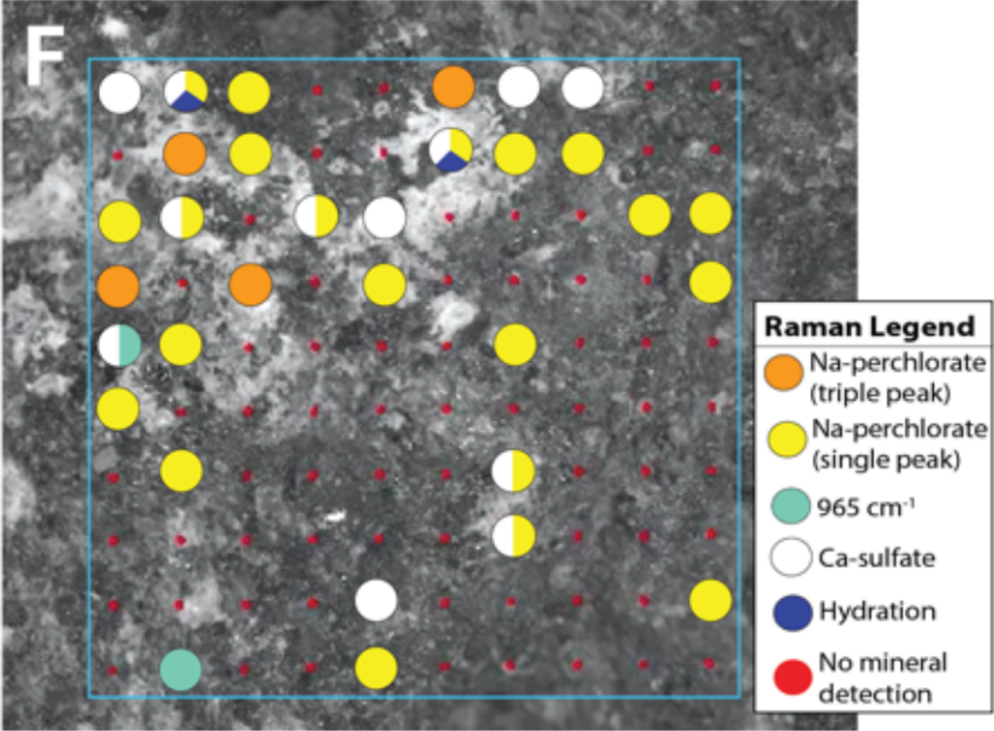
(Scheller et al., 2022: Fig. 1)

This is the region sampled, the Raman target is the square shown in white, less than 1 cm across, so these deposits are millimeter scale.

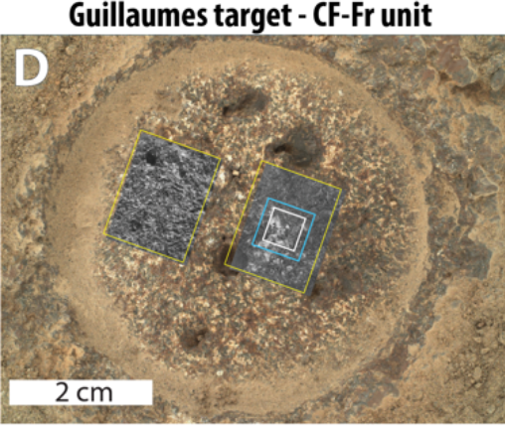
(Scheller et al., 2022: Fig. 1)

Even small deposits of gypsum or other salts could have micropores which could be a potential microhabitat for martian microbes

“Ice-related Liquid or vapor-phase water coming off frost, solid ice, regolith or subsurface ice crystals, glaciers” (Rummel et al , 2014:904).

The ice here would be frosts. That may seem unlikely in Jezero crater, but Viking 2 lander (NASA, 1997) and Phoenix lander (NASA, 2008) both imaged daytime frosts on the surface. Curiosity may have detected frosts in Gale crater a few microns thick (Gough et al., 2020) and Perseverance is trying to detect frosts too (NASA, n.d.).

As dawn approaches, the colder air near the surface could be trapped in a temperature inversion by warmer air above it. Gilbert Levin and his son Ron Levin suggested this might lead to thin films of water that form briefly in the early morning then evaporate. Chris McKay, agrees that this process could form a layer of liquid though it may not last long (Abe, 2001).

This lead to Ramachandran et al to simulate these conditions in Gale crater (Ramachandran et al, 2021). They found that the melting frost formed a pool of water which remained stable for 3.5 to 4.5 hours. This is an example of a way Mars could surprise us, in this case with a microns thick temporary layer of fresh water, at 0 C that may form many times during the year.

2015: MEPAG review also draws attention to biofilms that microbes may need to use to create conditions favourable to them in otherwise uninhabitable microniches – this reduces the risk for forward contamination for spacecraft with low bioloads – however this argument doesn’t work for backwards contamination – such niches could be inhabited by Martian life that already lives in biofilms

The MEPAG review discusses how microbes in biofilms modify microhabitats by surrounding themselves with “extrapolymeric substances” - proteins, polysaccharides, lipids, DNA and other molecules. They describe how these can make microenvironments far more habitable for microbes and help them cope with environmental stressors (SSB, 2015 :11)
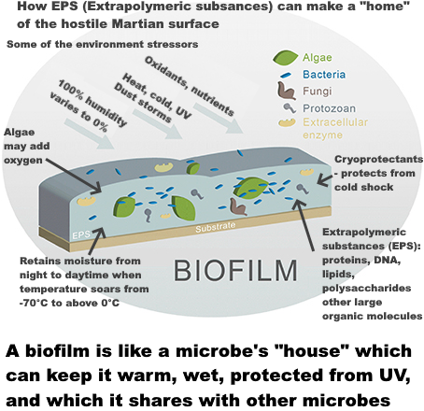
Graphic adapted from figure 2 of (Sabater et al., 2016)

This is relevant to all the microhabitats. The Curiosity brines are an example here as we discussed above (Martin-Torres et al, 2015), which could be made more habitable using biofilms biofilms (Pires, 2015). This relates to another of the seven potential microscale habitats in SR-SAG2:

“Brine-related Liquid water in deliquescing salts, in channels within ice, on the surface of ice, within salt crystals within halite or other types of ‘rock salt’” (Rummel et al , 2014:904).

The upshot from the MEPAG review, applied to Jezero crater is that we need to ask if life could get to Jezero crater in the dust, also, we can’t know Jezero crater is uninhabitable everywhere without detailed local study looking for microhabitats and biofilms.

Martian life could be more capable of coping with Martian conditions than terrestrial life – e.g. survive better in dust storms or cope better with cold temperatures and rapid temperature and humidity changes

Forward contamination studies such as the SR-SAG2 or MEPAG reviews don’t consider how terrestrial life could adapt to Martian conditions over timescales of millions or billions of years. In a scenario with native Martian life, it has had billions of years to adapt. It would be likely to be adapted at the community level as well as at the individual species level.

We can use the Atacama grit crust as a terrestrial Mars analogue. This is a mix of species that forms biofilms and can photosynthesize with the lowest amount of water known for any such community worldwide (Jung et al, 2022).

The gritcrust can also respond to rapid wetting by fogs which is usually lethal in other desert biofilm communities (Jung et al, 2020). It is tolerant to high UV, and adapted to rapid changes of temperature and humidity. It is made up of a mix of blue-green algae (similar to chroococcidiopsis), green algae such as chlorella, black rock inhabiting fungi, lichens such as Pleopsidium chlorophanum and other microbes. The climate in the Atacama desert has been stable for at least 150 million years giving time for the Atacama gritcrust to evolve to adapt to it. (Jung et al, 2022).

Mosca et al suggest that we could find biofilms on Mars even if it doesn’t have suitable conditions to establish a biofilm from the growth of single cells today. A biofilm could form in more habitable conditions millions of years ago. From then on it could propagate in broken off biofilm fragments resilient enough to get transported in the dust (Mosca et al, 2019). The most successful biofilm fragments would include organisms that cooperate well with each other for mutual support.

We need to consider microhabitats that might take many millennia to slowly colonize in the very cold martian conditions. it takes 1,000 to 10,000 years for microbes to successfully colonize granite in the McMurdo dry valleys and it might reproduce too slowly to be considered in the 500 year time frame used for SR-SAG2 (Rummel et al , 2014:894) (Sun et al, 1999).
Spores are protected from reactive chemicals by multiple coat and crust layers (Cortesão et al, 2019). This makes them far more resistant to oxidizing agents, bactericidal agents, chlorites, hypochlorites etc than vegetative cells (Sella et al, 2014). One strain of terrestrial spore was still viable after 28 hours of simulated direct UV radiation in Mars simulation surface conditions (Galletta et al, 2010). Adapted to such extreme conditions, Martian spores could have more layers of protection than terrestrial spores and resist UV for even longer than those 28 hours.
Martian life might develop colonial ways of surviving in dust storms in the larger clusters or aggregates of microbes like the terrestrial analogues described by the MEPAG review (SSB, 2015 :12). Martian microbial life could have evolved larger bacterial fruiting bodies similarly to those of the myxobacteria. These have some bacteria that altruistically develop into non reproductive cells to protect the spores inside (Muñoz-Dorado et al, 2016).

It could also be adapted to use cold brines below the temperature range of terrestrial life with novel biochemistry (Schulze-Makuch et al, 2010a) (Houtkooper et al, 2006), or use the abundant martian “chaotropic agents” such as the perchlorates, which speed up a cell’s chemical processes at low temperatures and can reduce the lowest temperatures for cell division for many microbial species (Rummel et al , 2014:897).

Draft EIS says “Existing credible evidence suggests that conditions on Mars have not been amenable to supporting life as we know it for millions of years” – their main cite says “exploration of Mars … will establish whether localised habitable regions currently exist” – another conclusion based on a citing error

Another central argument in NASA’s draft EIS is that Mars is lifeless anyway. The draft EIS says “conditions on Mars have not been amenable to supporting life as we know it for millions of years” (NASA, 2022eis: 1-6):

Existing credible evidence suggests that conditions on Mars have not been amenable to supporting life as we know it for millions of years (… National Research Council 2022).

However their cite says the opposite. See: (Smith et al, 2022: 393)

Section title: “Are There Chemical, Morphological and / or Physiologic / Metabolic or Other Biosignatures in Currently Habitable Environments in the Solar System

The exploration of … Mars (Curiosity, Perseverance) will help establish whether localised habitable regions currently exist within these seemingly uninhabitable worlds.

[Emphasis on “currently” mine]

So again, NASA got to this conclusion through a citing error.

It’s a surprising error since NASA itself was involved in extensive discussions about whether to divert Curiosity away from potential RSLs for terrestrial life in Gale crater, those streaks that form in spring, widen in summer and fade away in autumn, because of the potential for forward contamination (JPL, 2016) (Witze, 2016) (Dundas et al., 2015) (Vasaveda, 2015). Although the RSLs are looking increasingly unlikely to be candidates for habitats themselves (McEwen et al, 2021) (Stillman et al., 2021), we can’t directly test for humidity near the surface, as the effects on the atmosphere would be too small to detect with current capabilities (Kurokawa et al., 2022). If they are not habitable, there are many other potential habitats on Mars for terrestrial life and even more so for possibly better adapted martian life.

Astrobiologists have a range of views on whether current habitats for terrestrial life exist on Mars – and we keep finding new microhabitats on Mars or new ways that life can grow in extreme conditions

Astrobiologists have a wide range of views, but most of the published statements are on the lines that current habitats suitable for terrestrial life likely do exist on Mars. Many say habitats are more likely underground, in the deep subsurface or in caves, but others say there could be microhabitats for life over much of the surface of Mars, especially associated with salts.

Also the situation is very dynamic as they keep discovering new life in extreme conditions on Earth that resemble conditions on Mars, as well as conditions on Mars that are similar to terrestrial conditions at least on the microscale.

Rummel and Conley, both former planetary protection officers for NASA, put it like this: (Rummel et al , 2014)

"Claims that reducing planetary protection requirements wouldn't be harmful, because Earth life can't grow on Mars, may be reassuring as opinion, but the facts are that we keep discovering life growing in extreme conditions on Earth that resemble conditions on Mars. We also keep discovering conditions on Mars that are more similar—though perhaps only at microbial scales—to inhabited environments on Earth …."

The most favoured surface environments are ices and salts – and caves that may be open to the surface.

[2020] In the 2020 conference “Mars extant life: what's next?” a significant fraction of the participants thought that there is a possibility Mars has extant life (Carrier et al, 2020:Abstract):.

Based on our existing knowledge of Mars, conference participants highlighted four potential martian refugium (not listed in priority order): Caves, Deep Subsurface, Ices, and Salts.

Also later in the report (Carrier et al, 2020:804):
A significant subset of the actively publishing Mars science community who are experts in various disciplines of relevance to interpreting habitability and astrobiology concluded that there exists a realistic possibility that Mars hosts indigenous microbial life and that there are testable hypotheses for seeking it.

It singles out surface and near surface salts as one of the priority targets for future rover missions because of the potential of finding extant life, including life that uses the sunlight for energy, phototrophs (Carrier et al, 2020:797)

2012: The European Space Foundation study reduced the size of particle to contain from 0.2 microns to 0.01 microns at the one in a million threshold, and added that it is not acceptable to release a particle of 0.05 microns or larger in any circumstances – this is well beyond the capabilities of NASA’s proposed BSL-4

The draft EIS says they would use many of the basic principles of a Biosafety level 4 facility (BSL-4): (NASA, 2022: S-4)

The draft EIS doesn’t mention that the European Space Foundation study in 2012 reduced the size of the smallest particle we need to contain at the 1 in a million level from 0.25 ± 0.05 microns to 0.01 microns (Ammann et al, 2012:19). All larger particles would also have to be contained at the 1 in a million level. Also they made it clear that this means a 1 in a million chance of release of a single particle in the entire lifetime of the facility. This is well beyond the capabilities of a BSL-4.

The ESF study reached this conclusion after finding how rapidly Gene Transfer Agents (GTAs) can wrap up a fragment of a microbe’s DNA in a small package and inject it into distantly related species of marine bacteria (Ammann et al, 2012:19):

Surprisingly, it is now estimated that GTA transduction rates are more than a million times higher than previously reported for viral transduction rates in marine environments. Clearly, GTAs are a major source of genetic diversity in marine bacteria.

The ESF base this on research that showed that archaea can readily transfer novel capabilities to other distantly related species of archaea overnight in sea water (Maxmen, 2010) (McDaniel, 2010).
The ESF also said a particle of 0.05 microns or larger shouldn’t be released under any circumstances because of the discovery that the smallest known microbes, the ultramicrobacteria, can still be viable, able to grow, after passing through 0.1 micron nanopores. (Ammann et al, 2012:21):

“the release of a particle larger than 0.05 μm in diameter is not acceptable in any circumstances”

The EIS doesn’t cite the ESF study. The report by the sterilizing subcommittee does cite it (Craven et al., 2021:4) but doesn’t mention the update on the limit of size and doesn’t mention the gene transfer agents. Instead they have an extensive discussion of prions. Prions are not listed as a risk by the ESF study (Ammann et al, 2012) or the NRC study (SSB, 2009).

The ESF study said theirs was the first size limit review since 1999 (Ammann et al, 2012:3) and said that the size limit and level of assurance need to be revisited periodically (Ammann et al, 2012:21).

Amongst other things, there have been major advances since then in research into extremely small early life cells such as ribocells with enzymes made from fragments of RNA instead of proteins (Kun, 2021). They may reproduce more slowly but the small size and high surface to volume ratio would be an advantage in low nutrient conditions on Mars and seem likely to be considered in a new size limit review. Steven Benner and Paul Davies say the small 0.01 micron diameter structures in the martian meteorite ALH84001 are consistent with RNA world cells (Benner et al, 2010: 37). Panel 4 for the 1999 workshop estimated a minimum size of 12 nm in diameter and 120 nanometers in length for early life RNA world cells, if there is an efficient mechanism for packing its RNA (SSB, 1999: 117).

This is a visual comparison of the change in the size limit. The 0.01 microns bar is shown as the potential theoretical size limit a future review might decide on to contain early life ribocells. This is also the size limit for the GTAs for the one in a million threshold.

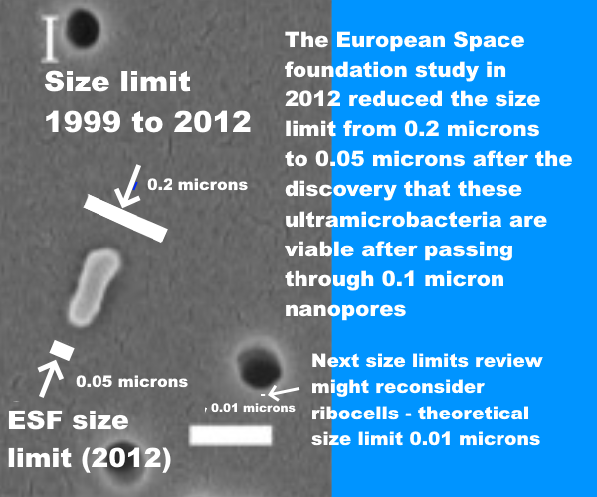

A BSL-4 doesn’t need to contain gene transfer agents, ultramicrobacteria, or hypothetical early life cells.

A decade after the ESF study we surely need a new size limit review before we can assess the filters to see if they meet the requirements.

The standards for a biosafety class III cabinet for a BSL-4 laboratory do include an option to use an air incinerator instead of the second HEPA filter (Richmond et al, 2000:37), which might potentially be a way to contain very small cells. The NIH guidelines for research involving recombinant or synthetic nucleic acid molecules specifies that they are tested against a challenge aerosol of b. subtilis spores var niger, or b. stearothermophilus spores (Meyer et al., 2019).

However,
- These incinerators aren’t designed or tested to contain ultramicrobacteria at 0.05 microns or GTAs at 0.01 microns
- The standards require more than a 100 billion fold reduction in spores – but this might not be the same as 100% assurance that it won’t release a single particle of 0.05 microns and a 1 in a million chance of release of a single particle at 0.01 microns in the facility lifespan, or whatever the updated requirements are.
- The incinerators must also be maintained and replaced in a way that complies with those containment requirements

It also has to contain potential Martian life potentially more resilient than b. subtilis var niger or b. stearothermophilus after millions of years of evolution in the extreme conditions on Mars. It may have:

- evolved to resist perchlorates, hydrogen peroxide, UV, ionizing radiation, low pressure and low humidity,
- spores may have evolved additional protective layers that make it more resilient to incineration.
- Martian microbes in the samples may be already imbedded in Martian dust grains which would give extra protection.

Perhaps this could be developed into a suitable standard for a Mars sample return, but it isn’t one yet.

As for a second HEPA filter instead of an incinerator, this is nowhere near the capabilities needed.

A HEPA filter is
- only required to filter out 97% at 0.3 microns size (WHO, 2003:35).
- not tested below 0.1 microns in the US, or the maximum penetrating size in Europe (Zhou et al, 2007) (EMW n.d.).
- Even ULPA level 17 filters don’t achieve 100% filtration and aren’t tested below 0.12 microns (BS, 2009:8).

Also there is no suggestion in recent air filter technology reviews of any attempts to develop 100% filtration at 0.05 microns (or indeed even at larger particle sizes) or figures as low as a one in a million chance of release of any particle above 0.01 microns in the lifetime of the facility (Borojeni et al, 2022:7) and (Todea et al, 2020: fig 1).

NASA’s draft EIS says there is no significant risk of environmental effects – yet the NRC study in 2009 warned there isn’t even a demonstrably zero risk of large scale harm to human health and the environment – and also said the potential for negative impacts can’t be assessed – this is due to limitations in scope of the literature review by their sterilizing subcommittee
NASA’s draft EIS also contradicts the planetary protection literature with its finding of no significant risk of environmental effects for life returned from Mars (NASA, 2022: 3-3):.

The relatively low probability of an inadvertent reentry combined with the assessment that samples are unlikely to pose a risk of significant ecological impact or other significant harmful effects support the judgement that the potential environmental impacts would not be significant.
(NASA, 2022eis: 3-3):

The National Research Council says it is not possible to assess the potential for negative impacts, and says the potential for [even] large-scale negative effects appears to be low but is not demonstrably zero (SSB, 2009 : 48 ).

The committee found that the potential for large-scale negative effects on Earth’s inhabitants or environments by a returned martian life form appears to be low, but is not demonstrably zero
… it is not possible to assess past or future negative impacts caused by the delivery of putative extraterrestrial life, based on current evidence.
(Board et al, 2009: 48).

The sterilizing subcommittee report argues that plausibly any martian life would not be viable on Earth and that it has a near zero chance to harm humans based on arguments only previously presented in an op. ed. by Zubrin in 2000 – planetary protection experts found many errors and said it was like a recommendation to build a house without smoke detectors
This time NASA’s conclusion can be traced back to an assessment by its sterilizing subcommittee. They seems to represent a minority view amongst microbiologists (MacGregor et al, 2001). Their report gets to its conclusion through limitations in the scope of their literature review, which didn’t turn up many counterexamples to their arguments in other papers or in the NRC report in 2009.

The basic arguments for the sterilizing sub committee are

- that Martian life didn’t co-evolve with humans so it can’t harm us
- that Martian life would be extremophile, only able to survive in the extreme conditions on Mars

We will see both these arguments miss out important exceptions, such as diseases such as tetanus and legionnaires’ disease from microbes that didn’t co-evolve with humans or other higher life, and polyextremophiles such as chroococcidiopsis as well as many other candidates for terrestrial life to survive on Mars, that can survive in multiple extreme conditions and many can also survive in more normal conditions.

The sterilizing subcommittee doesn’t cite any previous planetary protection study that used these arguments. The only previous source I found is a non peer reviewed op. ed. by the space engineer and Mars colonization proponent Robert Zubrin, who presented identical arguments in 2000 (Zubrin, 2000).
It is the same for the meteorite argument that we began this article with. It occurs in Zubrin’s op ed but not in the planetary protection literature for Mars, which warns against its use (except for the JAXA mission which is a different situation).

John Rummel, NASA’s planetary protection officer at the time, gave several counter examples to Zubrin’s arguments, and wrote: (Rummel et al., 2000).

NASA ' s current policy, as recommended by the US National Research Council, is not extreme. Rather, it is based on the sound principle that a sample from Mars should be contained until scientists find it does not contain a biohazard …

Still, he insists that Mars life unrelated to Earth organisms couldn't possibly cause harm. How does he know, when we have precisely zero experience with life unrelated to Earth life? … How ought others judge the cost-benefit ratio of Mars exploration if we don't take simple precautions to avoid potentially harmful consequences? Harshly, I suspect.

Margaret Race said we do need to take care and that his proposal to drop planetary protection is like building a house without smoke detectors (Rummel et al., 2000).
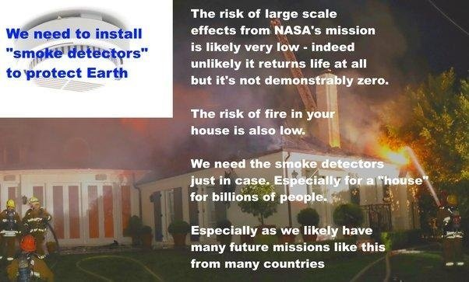

Background graphics:
Smoke detector (Rockmelder, 2007) House on fire (LAFD, 2018)

Example to show that a martian pathogen doesn’t need long term evolutionary contact to harm us - Legionnaires’ disease is adapted to biofilms but opportunistically infects human lungs
First, arguing from many examples of pathogens adapted to humans, the report of the sterilizing subcommittee says the risk of a direct pathogen of humans is near-zero (Craven et al., 2021)

Since any putative Martian microorganism would not have experienced long-term evolutionary contact with humans (or other Earth host), the presence of a direct pathogen on Mars is likely to have a near-zero probability.

This paragraph about the risk of direct pathogens of humans has no cites to previous studies of the topic, not even the section in the NRC study about it, which they don’t discuss. A broader literature survey would have turned up many exceptions to their examples. Indeed, the NRC study by contrast concludes its section on the potential for large scale negative pathogenic effects on humans by saying (SSB, 2009: 46) :
“… It follows that, since the potential risks of pathogenesis [disease causing infection of humans] cannot be reduced to zero, a conservative approach to planetary protection will be essential, with rigorous requirements for sample containment and testing protocols of life forms that are pathogenic to humans.

The sterilizing subcommittee do have a quote from an earlier part of this section in a different paragraph earlier in the report (Craven et al., 2021:4) but not in this discussion of human pathogens. Somehow the report misses the discrepancy between its conclusion and the conclusion of the NRC study.
They mention two diseases that humans catch as a result of handling diseased animals,
- Ebola (from handling a bat or non human primate) (CDC, n.d.)
- HIV (from hunting chimpanzees) (CDC, n.d.).
They also mention two diseases that infect humans via mosquitoes,
- malaria (most variants are an obligate parasite of humans) (CDC, n.d.)
- yellow fever (a viral disease of monkeys that also infects humans) (CDC, n.d.).
They also mention
- Kaposi sarcoma, a cancer caused by an infection with a virus called human herpesvirus 8 (Mayo clinic, n.d.)
- Schistosomiasis also known as bilharzia, a parasitic worm transmitted from freshwater snails in tropical conditions (CDC, n.d.).
We can agree on this, none of these are credible analogues for a pathogen from Mars.
They give two other examples which are less convincing. They use the example of Escherichia coli strain 0157:H, a microbe that harms us through expressing Shiga’s toxin, to show that microbes that co-exist with humans can take on a new mutation that leads to them expressing a toxin that harms humans (Craven et al., 2021:6).

Existing microorganisms that coexist with humans over long periods of time can also cause new diseases when the organism takes on new pathogenicity, such as the Escherichia coli strain 0157:H7 that acquired a gene for Shiga toxin, …
This is part of their reasoning towards the conclusion of a near zero probability of harm to human health. But a new microbe from Mars could take on new mutations, and is a change in Earth’s biosphere, not just for us but for future generations too.
The 2009 NRC review which they mentioned on page 4 (Craven et al., 2021:4) actually adds a relevant example (SSB, 2009: 46) of hydrothermal vent organisms (SSB, 2009: 46). It’s about two deep sea vent strains of the class epsilon-Proteobacteria, (Nakagawa et al, 2007) now reclassified as Epsilonbacteraeota (Waite et al, 2017). Though not pathogenic themselves, these organisms share many virulence genes with pathogenic relatives Helicobacter, which can cause stomach ulcers and Campylobacter which can cause acute gastrointestinal disease in humans (Cornelius et al, 2012). The suggestion is that these microbes may have gained virulence genes for humans through adaptations to hydrothermal vents.

Actually there’s a similar possibility for Shiga’s toxin too. E. coli might not have evolved this toxin by coexisting with us.
Łoś et al hypothesize that e. coli strain 0157:H evolved Shiga’s toxin to defend against protozoan grazing. They argue that this strain doesn’t spread much human to human and the toxin works better in biofilms. In humans, Shiga’s toxin kills the e. coli bacteria that produces it – and only benefits other e. coli altruistically by destroying the white blood cells (phagocytes) that attack it. The same toxin doesn’t seem to kill e. coli in biofilms (Łoś et al, 2013). Experiments since then led to conflicting results (Sun et al, 2018) but Łoś et al’s hypothesis is still considered a possibility, that e. coli strain 0157:H evolved its virulence in biofilms to resist protozoan grazing (Sun et al, 2018):
In conclusion, evolution of mechanisms that allow for survival within protozoa may have selected for traits that also allow bacteria to escape that harmful effects of phagocytes [in humans].

However there are much clearer examples in the planetary protection literature of microbes that harm us indirectly through secreting accidental toxins that were not the result of co-evolution with humans or any other higher lifeforms. Examples include tetanus, and botulism, (Warmflash, 2007).

Even with tetanus vaccines widely available, neonatal tetanus still kills thousands of children every year in weaker economies (WHO, n.d.) . Tetanus is a common anaerobic (non oxygen using) soil bacteria, and tetanus toxin is made by a plasmid (pE88), a small self-contained circular DNA molecule it got from somewhere else, but its origins are unclear as it seems to be unique to Cloristidium tetani (Brüggemann et al., 2003).

Warmflash et al. also mention ergot disease, a disease of some crops that accidentally harms humans (Warmflash, 2007). This isn’t a very close analogue, as ergot alkaloids are produced by fungi in the Claviceps genus (Miedaner et al, 2015) which are specialized to infect ovaries of grasses (Miedaner et al, 2015).
However one of the most widespread mycotoxins in food from molds is Aspergillus which is an opportunistic pathogen in both plants and animals.
Warmflash used Legionnaires’ disease to challenge whether there is a need for human pathogens to co-evolve with us (Warmflash, 2007). This is a disease of biofilms and protozoa that uses the same methods to infect human lungs (Alberts et al 2002). For any disease of anaerobic protozoa and biofilms on Mars, as for Legionella, human lungs would seem like biofilms, and the macrophages in our lungs like large protozoa.
The report also only mentions one of the three main genera of opportunistic fungal infections, Candida, which is adapted to humans (Alves et al., 2010).

They don’t mention the Aspergillus genus which isn’t adapted to a pathogenic lifestyle for any other organism (McCormick et al, 2010). and is accidentally pathogenic. Aspergillus is so well able to infect humans because of adaptations to stressful conditions in the wild (Paulussen et al, 2017)

Aspergillus species are able to utilize a wide range of substrates, highly efficient at acquiring such resources, and can store considerable quantities of nutrients within the cell; all traits which contribute to their energy‐generating capacity and competitive ability
…
Species of Aspergillus are also among the most stress‐tolerant microbes thus far characterized in relation to, for example, low water activity, osmotic stress, resistance to extreme temperatures, longevity, chaotropicity, hydrophobicity and oxidative stress
Interestingly many of its capabilities are also ones that would be valuable for a microbe living on Mars such as rapid recovery from desiccation, absence of oxygen, highly efficient at taking up nutrients and converting it to energy, resistant to rapid temperature changes, and protection from freeze-thawing (Paulussen et al, 2017: table 1) and (Paulussen et al, 2017: table 2).

There are an estimated 200,000 life-threatening Aspergillus infections a year and the mortality for these is 30% to 95% (Brown et al, 2012) ..

We have specific protections in our immune systems targeting the three main genera of fungi that infect humans: Candida, Aspergillus, and Cryptococcus with different molecular patterns (PAMPS) specific to each genus (Kumar et al, 2018 : table 1). If we suppose humans only encountered candida and cryptococcus, our immune system would not recognize any of the Aspergillus patterns. This suggests the possibility we might all be immunocompromised against a new genus of fungi from Mars.

Fungi don’t just infect higher lifeforms, they also infect microbial hosts too. Most fungal pathogens found in freshwater and sea water belong to the chytrid phylum, (Comeau et al, 2016) Cyanobacteria defend themselves from the chytrids with microcystins, microviridins, or anabaenopeptins. One example chytrid strain can’t infect the wild type cyanobacteria Planktothrix while it can infect mutants genetically engineered to remove just one of these classes of antifungals (Rohrlack et al., 2013). This suggests a possibility that not only higher life is at risk from fungi from a new genus or phylum on Mars. Even cyanobacteria could be in effect immunocompromised.
The sterilizing subcommittee report also didn’t review papers by some astrobiologists that argue that our immune system might not function at all if it encounters pathogens based on independently evolved life with a different biochemistry. Joshua Lederberg, a key figure in early work on planetary protection (Scharf, 2016) put it like this (Lederberg, 1999b):

“Whether a microorganism from Mars exists and could attack us is more conjectural. If so, it might be a zoonosis [infectious disease that jumps to humans] to beat all others

Lederberg argues our immune system and defenses are keyed to various chemicals produced by Earth life such as peptides and carbohydrates. Mars life might use different chemicals.

Thus, although the hypothetical parasite from Mars is not adapted to live in a host from Earth, our immune systems are not equipped to cope with totally alien parasites: a conceptual impasse."

In the worst case here, our immune system doesn’t recognize the attackers as life, and does nothing to stop them. A modern analogy would be the way our immune system largely ignores microplastics which can access all organs.

Carl Sagan put it like this (Sagan, 1973:162):
"On the one hand, we can argue that Martian organisms cannot cause any serious problems to terrestrial organisms, because there has been no biological contact for 4.5 billion years between Martian and terrestrial organisms. On the other hand, we can argue equally well that terrestrial organisms have evolved no defenses against potential Martian pathogens, precisely because there has been no such contact for 4.5 billion years.
In the same book Carl Sagan wrote (Sagan, 1973)
Because of the danger of back-contamination of Earth, I firmly believe that manned landings on Mars should be postponed until the beginning of the next century, after a vigorous program of unmanned Martian exobiology and terrestrial epidemiology.
…. I, myself, would love to be involved in the first manned expedition to Mars. But an exhaustive program of unmanned biological exploration of Mars is necessary first. The likelihood that such pathogens exist is probably small, but we cannot take even a small risk with a billion lives..
The sterilizing subcommittee report agrees that planetary protection must consider not just human health but the entire biota of Earth. It agrees that if an invasive Martian species is possible, it could have serious effects, for instance it could potentially harm or even displace photosynthetic bacteria (Craven et al., 2021:6-7):

Photosynthetic bacteria such as Prochlorococcus are among the most abundant organisms on Earth and intensely important for the health of oxygen-respiring organisms, such as humans and animals. … Planetary protection must consider
not just human health directly, but the entire biota of Earth.

In its response to this, the report uses examples of extremophiles that can’t live in our normal habitat to argue it’s plausible any martian microbe would not be viable on Earth (Craven et al., 2021:6-7).

There are many described extremophiles that may survive in environments that are extreme to human or animal life (e.g. extremes of temperature or pressure) but do not survive under conditions in our normal habitat … Thus, it is plausible that any Martian microbe, after it arrives on Earth, would not be viable on Earth due to a lack of its required Martian nutritional and environmental conditions.

Yet the temperature ranges on Mars overlap those of Earth. Perseverance often measures surface temperatures that vary from below -70 °C to above 15°C in a single day. Examples

- sol 361 varied from -74.33 °C to 16.96 °C (198.82 °K to to 290.11 °K)
Later in the martian autumn it found even warmer temperatures:
- sol 380 varied from -65.05 °C to 18.84 °C (208.1°K to 291.99 °K).

For details see the companion paper.

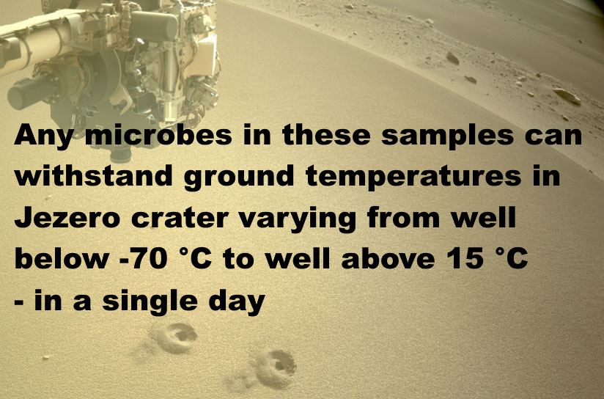
Location photo of Perseverance’s two regolith samples (NASA, 2022).

If there is life on Mars, its resistance to dessication, low humidity, low atmospheric pressure, UV and ionizing radiation surely makes it capable of living in extreme environments. However there isn’t any particular reason it would be incapable of living in places without those stressors.

Their reasoning omits polyextremophiles that live in a wide range of both extreme and normal environments. Indeed, we now have a wide range of candidate microbes and even higher organisms such as lichens that could potentially survive and even grow in various candidate microhabitats on Mars with some tested for their ability to survive in Mars simulation conditions complete with ionizing radiation using the BIOMEX experiment on the exterior of the ISS (Sielaff et al., 2019).

One of the top candidates for a terrestrial microbe that may be able to survive on Mars is the blue-green algae chroococcidiopsis, a genus which has strains that flourish from Antarctic cliffs to the Atacama desert (Bahl et al, 2011) . As a prime producer it survives on just rock, water, and light, fixing CO2 and nitrogen from the atmosphere. It is an ancient polyextremophile with numerous alternative metabolic pathways (KEGG, n.d.), even able to grow in complete darkness using a hydrogen-based lithoautotrophic metabolism with viable populations 750 meters below the Atlantic sea bed (Li et al, 2020). Some of the strains have remarkable abilities to repair multiple double strand breaks of DNA, such as chroococcidiopsis sp. ASB-02, a species isolated from the Urad Middle Banner desert in inner Mongolia which did well in the BIOMEX experiment on the exterior of the ISS (Li et al, 2022).

Perhaps a detailed scenario of large scale harm to Earth’s environment by martian life may help to encourage space agencies to treat planetary protection more rigorously. Let’s look at the scenario of a mirror-life analogue of Chroococcidiopsis.

We don’t know how terrestrial homochirality evolved, with many proposed mechanisms (Blackmond, 2019). Some experts say it is “luck of the draw” (Brazil, 2015).

The theory of punctuated chirality suggests any initial chiral bias could be erased by local self reinforcing chiral networks of chemicals which expand, and flip chirality on an environmental scale, with these flips perhaps frequent in Early Earth. If so, life on Mars could have the opposite chiral bias to Earth (Gleiser et al, 2008):

Our analysis predicts that other planetary platforms in this solar system and elsewhere could have developed an opposite chiral bias.

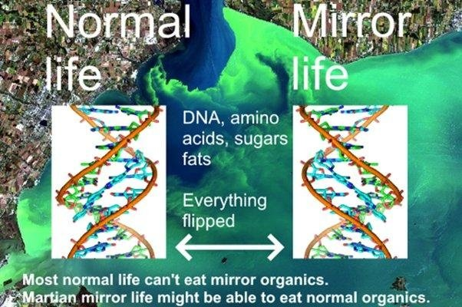
Background image from (NOAA, n.d.), DNA spiral from (Pusey, 2012)
If we could flip a cake in 3D, like reflecting it in a mirror, we might be able to eat it, like artificial sweeteners, but our metabolism couldn’t do anything with the flipped starches or proteins, and many fats would also be inaccessible (Dinan et al, 2007)

Synthetic biologists plan to gradually flip ordinary to mirror life over a period of a decade or so – and will make sure synthetic mirror life is engineered to depend on chemicals only available in the laboratory. They warn escape of mirror life could cause major transformations of the terrestrial biosphere by locking up organics in unusable mirror forms (Bohannon, 2010).

This issue becomes especially acute if mirror life obtains enzymes (isomerases) that transform ordinary organic molecules into their mirror form. A few rare terrestrial microbes can use this method in reveres to eat mirror organics (Pikuta et al, 2016). In the worst case scenario, mirror life consumes ordinary organics, but terrestrial life can’t make anything of the mirror organics. (Bohannon, 2010)..

Kasting “It would quickly consume all the available nutrients. This would leave fewer or perhaps no nutrients for normal organisms.”

The CO₂ in the ocean would get taken up by inedible mirror cells and so draw down CO₂ from the atmosphere. He calculated that in around 300 years half of Earth’s CO₂ would be gone. At that point most land plants couldn’t photosynthesize, including all agricultural crops except corn and cane sugar (which use C-4 photosynthesis which can work with almost no CO₂).

“All agricultural crops other than corn and sugar cane would die,”

… “People might be able to subsist for a few hundred years, but things would be getting pretty grim much more quickly than that.”

At 600 years they envision a new ice age with almost no CO₂ left.

The article continues (Bohannon, 2010):

—both Kasting and Church think mirror predators would evolve, but whatever life existed on Earth by that point wouldn’t include us.

Martian life likely already has the isomerases to metabolize organics of opposite sense, whether it is mirror or normal life - because nearly all organics are either made abiotically locally, or are infall from comets, asteroids and interplanetary dust, with organics of both senses.

Eventually terrestrial microbes likely develop isomerases to metabolize mirror life, but higher life couldn’t evolve so quickly. The outcome is a mix of normal and mirror organics. In Kasting and Church’s worst case scenario mirror life would need to retain the edge over normal life in this evolutionary race.

I think we would survive. We have already designed almost self-sustaining space habitats like the early Russian BIOS-3 based on plants grown for food, and oxygen, which in turn take up carbon dioxide and water from humans which should work in space, a more challenging situation (Salisbury et al, 1997) (Johansson, 2006) .

We could enclose large areas of Earth with its tropical jungles, coral reefs etc, like Biosphere 2 (UA, n.d.). But it would be a severely diminished world to leave to the next generation.

For a closely related scenario, Earth and Mars exchange normal life, but Mars has a shadow biosphere with a different biochemistry that never got here like the hypothesis of a terrestrial shadow biosphere of nanobes (Cleland, 2019, pp 213 - 214) which could co-exist with modern life. Earth doesn’t seem to have one (yet) but small cells have an advantage in an environment with low nutrient concentrations, as they have a larger surface to volume ratio, and so take up nutrients more efficiently. They would also avoid protozoan grazing (Ghuneim et al, 2018).

In this scenario Martian mirror life cells have a less sophisticated biology, but compete in a shadow biosphere on Earth because of their small size, with the extra advantage that they form mirror organics biofilms. These shadow biosphere biofilms are inedible to most terrestrial life and expand.

We may well be able to reduce impacts, perhaps with engineered normal life predators of mirror life or import them from Mars. However, these are scenarios to avoid, with consequences hard to predict.

NASA’s draft EIS fails requirements for a valid NEPA Environmental Impact Statement

Agencies shall ensure the professional integrity, including scientific integrity, of the discussions and analyses in environmental impact statements
§ 1502.23

The EIS omits important studies that overturn results it relies on, and uses cites that refute sentences they are attached to without alerting the reader to this discrepancy.
(a) Evaluate reasonable alternatives to the proposed action, and, for alternatives that the agency eliminated from detailed study, briefly discuss the reasons for their elimination.
(b) Discuss each alternative considered in detail, including the proposed action, so that reviewers may evaluate their comparative merits.
§ 1502.14

NASA's EIS doesn't have rigorous analysis of ANY alternative except "no action". Reasonable alternatives include a presterilized sample return or delaying the mission until it can be done safely.
Agencies shall prepare environmental impact statements using an interdisciplinary approach that will ensure the integrated use of the natural and social sciences and the environmental design arts

§ 1507.2
Mars sample return studies emphasize the need to involve the public early on, not just in the USA, but through fora open to representatives from all countries globally because negative impacts could affect countries beyond the ones involved directly in the mission (Ammann et al, 2012:59).

RECOMMENDATION 4
Potential negative consequences resulting from an unintended release could be borne by a larger set of countries than those involved in the programme. It is recommended that mechanisms and fora dedicated to ethical and social issues of the risks and benefits raised by an MSR are set up at the international level and are open to representatives of all countries
The public weren’t involved early on in that way. Not only that, those in the public who did discover NASA’s request for public comment weren't given the opportunity to comment on a scientifically valid EIS.

I hope NASA and other space agencies can ensure a mishap like this never happens again.

This mission can be made 100% safe by sterilizing samples before they reach Earth. The equivalent of 500 million years of surface radiation, at 100 milligrays a year, or 50 megagrays, would reduce amino acids 1000 fold (by (Kminek et al, 2006:4) 100 megagrays would reduce most amino acids a million-fold so 50 megagrays would reduce them 1000 fold).

This would have virtually no impact on geological interest, as by the same figure of a 1000 fold reduction every 500 million years, 3 billion years of surface radiation would reduce a gram of organics to an attogram, or a billionth of a billionth of a gram.

As for astrobiological interest, Perseverance’s engineers believe they achieved a maximum of 0.7 ppb or 0.7 nanograms per gram for their most abundant biosignatures (Boeder et al, 2020: table 6),

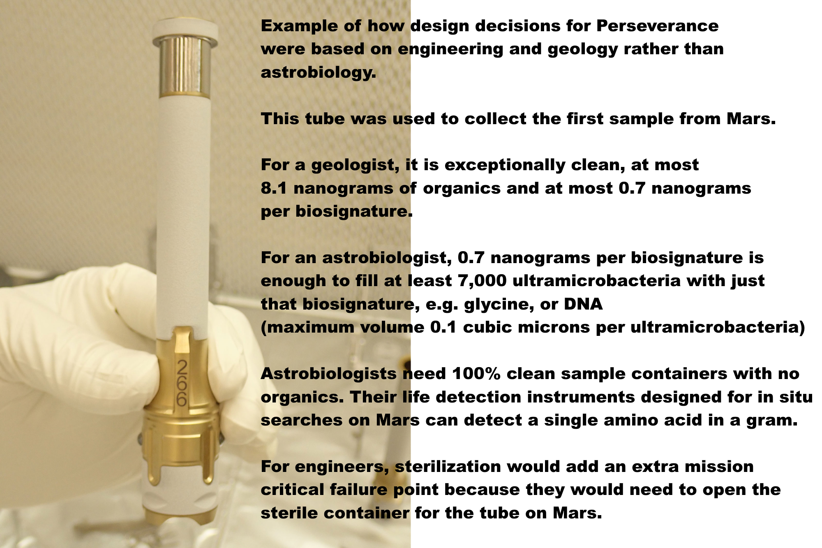

With these levels of forward contamination, Perseverance is unlikely to detect life, past or present, even if by chance it returns it. So, sterilization preserves virtually all geological interest with minimal impact on astrobiological interest.

The NASA draft EIS requires samples to be returned to Earth for “safety testing” but this is guaranteed to find false positives because of the forward contamination.

Even without any contamination, we could destructively test every one of 10,000 grains of dust individually – then the 10,001th grain has a viable microbe. The dust or dirt could have one viable microbe per gram or less. We also couldn’t detect life non destructively by Raman spectroscopy or autofluorescence as a microbe could be inbedded in a crack in a dust grain, or covered in iron oxides.

It might be possible to sterilize samples on the return journey, with nanoscale x-ray emitters, but if not, we can return it to a satellite similar to a geostationary satellite for sterilization. We can use minimal energy orbits without aerobraking using the Earth Entry Vehicle’s ion thruster for low energy ballistic transfer, through flybys of Earth and the Moon leading to a lunar retrograde orbit orbit (actually a prograde orbit around Earth but retrograde around the Moon) which requires a delta v of only 100 meters per second for capture (Lock et al, 2014)..

From the lunar retrograde orbit, we can transfer it to the Earth Moon L2 (Ming, 2009),, the gravitational point of balance between the Earth and the Moon’s gravity on the far side of the Moon, then L1 on the near side, then back to the Laplace plane above GEO. This is an orbit angled to GEO, where ring particles would orbit if Earth had a ring system. It’s been proposed as a disposal orbit for GEO satellites at end of lifetime, as even large light fragments of cladding from the satellites stay trapped well away from GEO, through the balance of the light pressure from the sun and gravity (Rosengren et al, 2013). The samples could be returned to, say, 100,000 km above this proposed GEO disposal orbit.

The launch costs wouldn’t be prohibitive for NASA as the Falcon Heavy can already deliver over 25 tons to GEO at a cost of $150 million and launch costs are sure to go down. The satellite could be less than a ton in mass even including the mass of a sterilizer unit. There is very little delta v difference to transfer to a higher orbit at say 100,000 km. I’ve done an online calculator to show how it works (Walker, n.d.)

With this option, NASA has the extra cost of the sterilizing satellite, but save on several other costs including the cost of a sample receiving facility on Earth, estimated at $471 million in 2015 dollars (Mattingly, 2010:20) based on the 1999 size limit.

The mission could be made far more interesting by sending a STERILE container on the ESF fetch rover to return bonus samples of dirt, dust and atmosphere without forward contamination, and a pebble from the Mars surface picked up by a pre-sterilized marscopter – as a technology demo for returning CLEAN rock samples. If we find a crater recently excavated to 2 meters we could add a technology demo to return minimally degraded organics, though without in situ life detection it’s not likely to return recognizable life.

Venus lander studies have shown how to build rovers with instrumentation, batteries, communications, motors, capable of functioning at 300 C using commercial components. A marscopter built to such a spec could be heated to 300 C for a few hours to sterilize it 100%.

These clean samples could be studied above geostationary orbit, in Mars simulation conditions with a centrifuge for artificial martian gravity – which would make it unique as a facility, as we can’t simulate martian gravity accurately on Earth.

This would NOT be a human occupied space station. In the backwards direction, quarantine can’t protect Earth from mirror life or indeed fungal diseases. Two zinnia plants on the ISS died of a fungal disease brought there probably on an astronaut’s microbiome, also an occasional opportunistic pathogen of humans. In the forward direction, an unmanned satellite let’s us study martian life in far cleaner conditions as ultramicrobacteria can get through HEPA filters both ways.

It's the equivalent of one geostationary satellite far above GEO. Humans study the dust, dirt and atmosphere as they would on Mars using in situ instruments designed for end to end sample preparation to analysis - these already exist such as LD chip (antibodies) almost sent on Exomars but descoped, the gene sequencer SETG, astrobionibbler able to detect a single amino acid in a gram, the chiral labelled release, and many others.

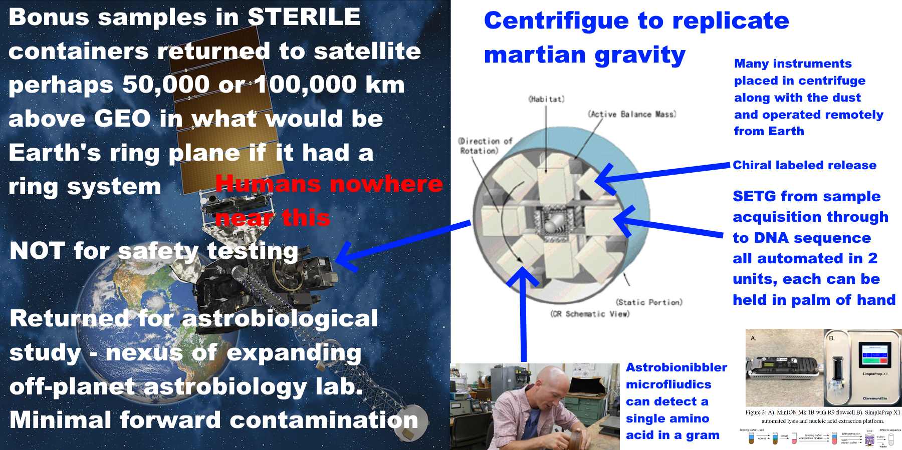
NASA have an opportunity to set a precedent to keep Earth safe. Other countries are likely to follow its example, or indeed, collaborate in a multi-national astrobiology sample handling and pre-processing lab above GEO – in a similar spirit to the ISS but far lower cost.
If we do find life on Mars that can never be returned safely, this may stimulate rather than discourage vigorous space exploration and settlement. The first astronauts to Mars might study the surface remotely in a spectacular orbit that flies near to both poles twice a day and skims in close over a different part of Mars on the opposite sides of the planet twice a day.
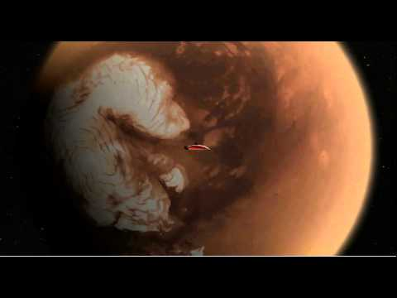

They would operate surface marscopters, rovers and other assets, similarly to avatars in a computer game. We could already make a 100% sterile marscopter by adopting the technology for a Venus lander. Our technology has advanced since the Viking landers which were baked for 112 °C for 30 hours, enough for a million-fold reduction of the originally low population (Beauchamp, 2012). Some of this technology was developed for oil wells, aviation and electric cars. We
developed memory devices and processors that can withstand 300 °C of warming to place them close to engines and other heat sources without active cooling (Watson et al, 2012). NASA took this further with their HOTTECH program for Venus surface exploration (NASA, n.d.) and can now make all the components for a Venus Surface lander able to withstand 60 days at 500 °C with no active cooling (Kremic et al, 2021). A few minutes at 300 °C would be enough to sterilize a lander or rover for Mars based on the temperatures for destroying RNA bases (Levy et al, 1998) and eight of the 20 amino acids (Weiss et al, 2018)..

The marscopter might be a good starting point for a 100% sterile probe, as it is small, doesn’t have so many components as a rover, and could potentially travel far enough to reach sensitive sites near a rover which can’t go up to them itself. For instance if it had a 100% sterile Marscopter, Curiosity could us it to inspect the potential RSLs close up. It wouldn’t take much heat at 300 °C to achieve a 100% sterile marscopter. It could then be used to collect contamination free samples for return for analysis in the automated lab above GEO.

We can go on to develop 100% sterile cave bots, borrowing moles, balloons, miniature planes, probes, and build on those to achieve 100% sterile complete rovers. In 2001, Greenberg et al. wrote about the idea that we should protect life 100% in the forwards direction (Greenberg et al, 2001):

“The problem with this principle is that, if rigorously applied, it would likely bring exploration of some of the most interesting moons and planets to a halt.”

However, this is no longer the case. We don’t have to weigh up whether to do the science at all or to protect Earth and the solar system 100% in either the forward or the backward direction. It is a matter of public choices, priorities, budget and planning. If we wish to protect both Earth and Mars 100% in both directions, this is something we now have the capacity to do as a civilization.
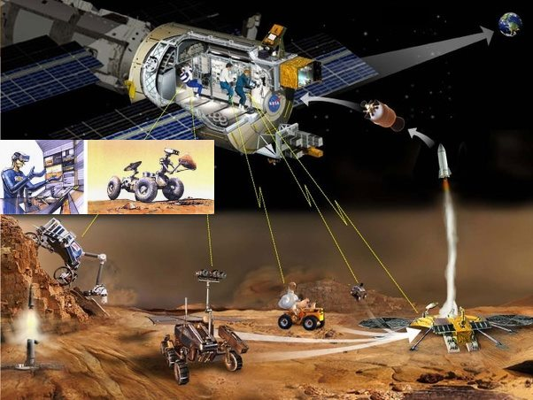
We can explore and exploit Mars without humans on the surface, settling the Martian moons and orbital space habitats, as part of vigorous exploration and perhaps settlement throughout the solar system. Humans and robots work together each doing what it does best. Torrence V. Johnson, Galileo Chief Scientist, put it like this in the foreword to Meltzer’s “Mission to Jupiter” (Meltzer, 2007)

“What we call robotic exploration is in fact human exploration. The crews sitting in the control room at Jet Propulsion Laboratory as well as everyone out there who can log on to the Internet can take a look at what’s going on. So, in effect, we are all standing on the bridge of Starship Enterprise”

My aim with this review is to help make sure voices and concerns of the public are heard. It is to encourage space agencies that are considering a Mars sample return, to do a rigorous scientific review with full public involvement.

The companion paper, at around 70,000 words [check] goes into much more detail on these points and many other points not covered here.

Methods and limitations, and selection criteria for this review

This paper is written as a review for the general public to use, legislators, ethicists, decision makers and scientists of other disciplines, so is designed to be maximally accessible. Examples:
- I use the most widely accessible vocabulary available to convey the desired meaning
- I replace technical by non-technical terms when it can be done with no loss of precision
- I use non-scientific terms, non-technical terms generally, and non-mathematical language whenever if it is available with the same precision.

Examples of using non-technical terms when there is no loss of precision:

- Million instead of 10⁶
- “Didymo” instead of Didymosphenia geminate

This paper has to consider research published after 2009 or it would be 13 years out of date. The final draft of the NRC study was finalized in late February 2009 and approved in March 2029 (SSB, 2009: viii), just before the discovery of the droplets on the legs of the Phoenix lander which was first announced on 17th March 2009 (Renno et al, 2009) and a lot has happened since then.

The selection criterion was to select research for its relevance to the main mistakes in NASA’s draft EIS, treated as representative of mistakes other space agencies are likely to make. A longer companion paper expands on this in detail focusing on highlights from the last 13 years of special interest to space agencies, (Walker, …).

Both of these papers select topics and papers to cover from a much vaster literature for the purposes of illustration, and should NOT be used in lieu of a comprehensive review. I hope that NASA and ESA consider commissioning a new review as an urgent first priority if they still intend to return unsterilized samples to Earth.

This paper includes new worst case scenarios. These shouldn’t be seen as likely. We need to look at those is for the same reason that we look at the scenario of a house fire when we design or install a smoke detector.

This paper covers some views from the planetary protection literature in depth such as Carl Sagan’s view that we shouldn’t take even a small risk with a billion lives, and Lederberg’s two papers arguing that our immune systems might not recognize an alien pathogen. That’s because NASA’s draft EIS doesn’t mention them. However this paper is not the place to advocate for or against any of those views. That is for public debate and for legislators and decision makers to look into.

It is the same also for the proposed alternative actions of a sterilized sample return, and of returning bonus samples to above GEO. This paper argues that these two options should be considered by space agencies, amongst reasonable alternatives. It needs to be determined if they are indeed ways to keep Earth 100% safe with minimal impact on science return and even increased science value with the bonus samples.

If those conclusions are valid, this is something the public and decision makers need to know when making their decision. It is also important that the public are fully involved in such decisions, given how highly the general public values the environment and the integrity of Earth’s biosphere.

References

Abbasrezaee, P. and Saraaeb, A., 2021. System Analysis and Design of the Geostationary Earth Orbit All-Electric Communication Satellites. Journal of Aerospace Technology and Management, 13.

“The total mass budget for 8 and 12 kW EOL electric power subsystem calculated 283.14 and 439.8 kg, respectively”

Beatty, J.T., Overmann, J., Lince, M.T., Manske, A.K., Lang, A.S., Blankenship, R.E., Van Dover, C.L., Martinson, T.A. and Plumley, F.G., 2005. An obligately photosynthetic bacterial anaerobe from a deep-sea hydrothermal vent. Proceedings of the National Academy of Sciences, 102(26), pp.9306-9310.

Birnbach, I., 1997. Newly Imposed Limitations on Citizens' Right to Sue for Standing in a Procedural Rights Case. Fordham Envtl. LJ, 9, p.311.
Fajardo-Cavazos, Patricia, Lindsey Link, H. Jay Melosh, and Wayne L. Nicholson, 2005,. "Bacillus subtilis spores on artificial meteorites survive hypervelocity atmospheric entry: implications for lithopanspermia." Astrobiology 5, no. ; 726-736.

Johansson, M., Living in Space, Comparative Study of one Conventional Life Support System and two Biological Systems

Kim, H.J., Kim, H.N., Raza, H.S., Park, H.B. and Cho, S.O., 2016. An intraoral miniature X-ray tube based on carbon nanotubes for dental radiography. Nuclear Engineering and Technology, 48(3), pp.799-804.,
The dose rate of the X-ray at 3-cm apart from the miniature X-ray tube in air was 8.19 Gy/min at 0° when the X-ray tube was operated at 50 kV with the emission beam current of 140 μA..
[This corresponds to 7 watts of power output]
X-rays are almost perfectly blocked when the thickness of the copper collimator is 3 mm
Rennó, N.O., Bos, B.J., Catling, D., Clark, B.C., Drube, L., Fisher, D., Goetz, W., Hviid, S.F., Keller, H.U., Kok, J.F. and Kounaves, S.P., 2009. Possible physical and thermodynamical evidence for liquid water at the Phoenix landing site. Journal of Geophysical Research: Planets, 114(E1).
See also first announcement before the paper was published: Michigan Engineering, 2009 (March 25), Liquid saltwater is likely present on Mars, new analysis shows and earlier in Astronomy magazine on March 17th. Liquid saltwater is likely present on Mars, Astronomy magazine
US DOA, 2017, European Starling.

