Open letter to NASA: please listen to your own experts and take more care to protect Earth's biosphere from any extraterrestrial microbes in samples you return from Mars in the 2030s - MID EDIT NOT FOR SHARING YET
Dear NASA planetary protection office and other interested parties.
[Please forward to your point of contact for comments on the draft EIS]
This is about your Environmental Impact Statement (EIS) for samples you plan to return from Mars in the early 2030s. The Council on Environmental Quality advises says if our concerns aren’t resolved during public comments on the EIS, we need to contact the agency:
Your first line of recourse should be with the individual that the agency has identified as being in charge of this particular process. (page 28 of A citizen’s guide to the NEPA: Having your voice heard.)
I tried an email to your office on December 18, 2022, and got no reply. This is an open letter, which I will post to the internet and archive, and I will email a link to you together with a video presentation. I am expecting a reply as per the CEQ advice.
NASA has been world-leading in its protection of Mars from forwards contamination by terrestrial life, to protect Mars from any terrestrial life that might get there and proliferate in any habitats in the Martian desert landscape that we can’t see from orbit.
You have also been world-leading in your literature on a Mars sample return.
But sadly your current EIS is not world-leading.
I end this post with a suggestion on how you can move forward from this EIS with a new approach that would
- retain your world-leading role in planetary protection,
- be an excellent example that’s easy for other space agencies and private space to follow to keep Earth 100% safe
- with a suggestion for small bonus samples gathered by the ESF rover that would greatly enhance the science return for astrobiology.
My literature survey and these recommendations are covered in more detail in my preprint, which also has new example scenarios to help motivate space agencies to protect Earth, such as mirror life, see link below.
- PREPRINT: NASA must protect Earth's biosphere even if Mars samples hold mirror life – a survey of recent planetary protection research plus new scenarios – for attention of space agencies and commercial space – with option to keep Earth 100% safe
This is a short summary of some of the main points in my preprint. I will also use this page and the graphics as the basis for the video presentation. For citations in this open letter I just give the title in brackets hyperlinked to the paper.

TITLES ARE LIKE MINI ABSTRACTS
The title of each section also summarizes its main conclusions similarly to an abstract. You can get a good first idea of this open letter by just reading the titles of sections - and looking at any graphics.

JOHN RUMMEL (FORMER NASA PLANETARY PROTECTION OFFICER): “WE DO NOT KNOW EVERYTHING WE WANT TO KNOW ABOUT MARS … WE DO NEED TO BE CAREFUL”
John Rummel, forward planetary protection officer puts it like this as interviewed by Scientific American in 2022 after the first round of public comments on your proposals:
“In the first place, we don’t know everything we want to know about Mars. That’s why we want the samples.
We keep finding Earth organisms doing new things that are quite interesting from the standpoint of potential life elsewhere. So why don’t we think we need to be careful? The answer is that we do need to be careful, as repeatedly emphasized by the National [Academies]....
People have to have some kind of respect for the unknown. If you have that respect, then you can do a credible job, and the public is well-served by your caution.”
(Controversy Grows Over whether Mars Samples Endanger Earth)

CASSIE CONLEY (FORMER NASA PLANETARY PROTECTION OFFICER): WE ARE GOING TO CONTAIN THE SAMPLES AS IF THEY WERE THE MOST HAZARDOUS EARTH ORGANISMS WE KNOW ABOUT
Cassie Conley, former NASA planetary protection officer: “that means we are going to contain the samples as if they were the most hazardous Earth organisms that we know about, Ebola virus.”
at 1:02 into this NASA video
Of course, we won’t find Ebola on Mars, it’s just an example to show how deadly the worst case could be. But in the worst case, we may find diseases of humans that are just as deadly.

DISEASES NOT ADAPTED TO HUMANS LIKE TETANUS STILL KILL THOUSANDS OF UNVACCINATED NEWBORNS EVERY YEAR
There are several diseases not adapted to humans or any higher life mentioned in the planetary protection literature. Tetanus still kills thousands of newborns every year who miss out on vaccination and is not adapted to humans and Legionnaires disease is an example of a disease of biofilms which infects human lungs opportunistically because it resembles a biofilm and is sometimes deadly.
I added another example of Aspergillus fumigatus, a fungus not adapted to humans with 200,000 cases of invasive aspergillosis a year and a 30% to 95% fatality rate, with characteristics that may well be shared by martian fungi. See my open letter to the CDC
. Open letter to CDC (draft) - MIDEDIT (PLEASE DON’T SHARE WIDELY, READY SOON)

MANY CANDIDATE TERRESTRIAL MICROBES COULD LIVE ON MARS WITH A SOURCE OF SALTY OR FRESH WATER - SUGGESTING SIMILAR MARS ANALOGUES COULD LIVE IN EARTH’S OCEANS OR SOILS
There are many proposed Mars analogue organisms that survive in Mars simulation chambers including lichens, mosses, fungi, various bacteria, and algae. See: (Habitability of Mars: How Welcoming Are the Surface and Subsurface to Life on the Red Planet?)
This includes Chroococcidiopsis, a highly resilient blue-green algae which does well in Mars simulation conditions (Protection and Damage Repair Mechanisms Contributed To the Survival of Chroococcidiopsis sp. Exposed To a Mars-Like Near Space Environment).
This algae can be found almost everywhere on Earth from tropical reservoirs and oceans to cold dry deserts and even in complete darkness in gabbro 10 -750 meters below the Atlantic sea bed using an alternative metabolic pathway with hydrogen as a source of energy (Recycling and metabolic flexibility dictate life in the lower oceanic crust). Gabbro and basalt are amongst the most common rocks on both Mars and Earth.
Chroococcidiopsis is a pioneer “prime producer” that doesn’t depend on any other life and can find all its requirements in seawater, or rocks such as basalt, so long as it also has access to water and a source of energy such as sunlight. Strains of chroococcidiopsis do well in both hot deserts and very cold Mars analogue deserts in Antarctica (Ancient origins determine global biogeography of hot and cold desert cyanobacteria ), and also in warm wet conditions up to human body temperature, for instance in the upper throat behind the nose (Nasopharyngeal Microbiota as an early severity biomarker in COVID-19 hospitalised patients)

NEPA REQUIRES AGENCIES TO ENSURE SCIENTIFIC INTEGRITY - BUT PUBLIC COMMENTS ARE THE ONLY MECHANISM THEY REQUIRE TO ENSURE THIS - SO I’M ASKING FOR A RESPONSE
As John Rummel said, we need respect for the unknown. NEPA requires agencies to ensure scientific integrity of the discussions and analyses in the EIS.
Agencies shall ensure the professional integrity, including scientific integrity, of the discussions and analyses in environmental impact statements
§ 1502.23 [Links directly to the legal text]
However, they have no mechanism to ensure scientific integrity except public comments. I commented on your first round of public comments on May 16. The draft EIS didn’t mention many serious issues I raised with your plans. I commented on the second round on November 28th, December 5th, December 13th and December 20th. These raise very serious issues with the scientific integrity of the EIS.
I emailed your point of contact Dr Alvin L,. Smith II on 18th December. I got no response.

MY PRELIMINARY SURVEY OF THE RECENT LITERATURE - LAST SAMPLE RETURN REVIEW WAS COMPLETED IN 2009 JUST BEFORE THE ANNOUNCEMENT OF THE PHOENIX LANDER LEG DROPLETS - GENERALLY AGREED NOW TO BE COLD SALTY WATER
Since my unanswered email to you on 18th December, I’ve been working on a preliminary survey of the recent literature. This builds on research for a paper about planetary protection for NASA’s Mars sample return mission which was almost ready to send to academic journals at the time of my public comments last year.
The last thorough review is the NRC study, published in March 2009, just before the Phoenix team first published their observations of possible droplets of salty water on the Phoenix lander’s legs, later confirmed in simulation experiments as likely the first direct confirmation of (very cold) surface salty water on Mars. These are the droplets they simulated, coloured in green.
Possible droplets on the legs of the Phoenix lander – they appeared to merge and sometimes fall off. In this sequence of frames, the rightmost of the two droplets grows and seems to do so by taking up the water from its companion to the left, which shrinks - highlighted in green in this black-and-white photo from Mars (Liquid Water from Ice and Salt on Mars).
When Nilton Renno’s team successfully simulated these droplets in a Mars simulation chamber in 2014 he put it like this:
This is a small amount of liquid water. But for a bacteria, that would be a huge swimming pool – a little droplet of water is a huge amount of water for a bacteria. So, a small amount of water is enough for you to be able to create conditions for Mars to be habitable today. And we believe this is possible in the shallow subsurface, and even the surface of the Mars polar region for a few hours per day during the spring.
, How liquid water forms on Mars, (transcript from 1:48 onwards)
This discovery lead to many more indirectly detected or proposed salty brines on Mars, some of which may be habitable to Martian life.

MY LITERATURE SURVEY IDENTIFIED MANY TOPICS TO COVER IN DEPTH IN AN UPDATED MARS SAMPLE RETURN REVIEW BEFORE ANY AGENCY CAN DO A THOROUGH ENVIRONMENTAL IMPACT STATEMENT
The science has moved forward so much in the 14 years since 2009, including many proposed martian microhabitats, the surprising resilience of terrestrial microbes in Mars simulation chambers, new experiments in the transport of microbes and fragments of microbial biofilms in Martian winds, and new discoveries about terrestrial microbes living in Mars analogue cold dry deserts.
My preliminary literature survey identified many areas for review in an update of the 2009 study. I also added new illustrative backward contamination scenarios such as mirror life, to help focus attention of space agencies on the need to protect Earth.
See:
- PREPRINT: NASA must protect Earth's biosphere even if Mars samples hold mirror life – a survey of recent planetary protection research plus new scenarios – for attention of space agencies and commercial space – with option to keep Earth 100% safe
Almost none of this literature is mentioned in the EIS. NASA needs to review it before it is feasible to do a thorough EIS for a Mars sample return. This open letter is another attempt to contact you with the main outlines of the literature survey in place.

CARL SAGAN WOULD CONTACT YOU IF ALIVE TODAY
I am a long-term admirer of NASA since before Apollo and my views on planetary protection are similar to those of Carl Sagan, one of my heroes.
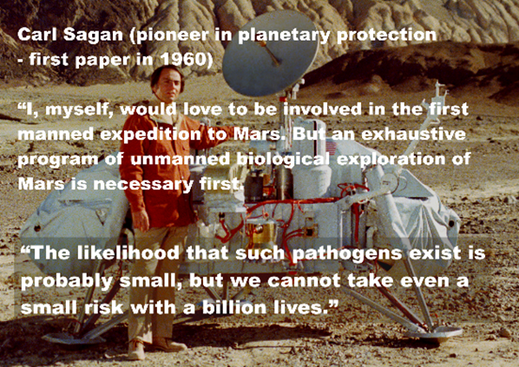
Text on graphic: Carl Sagan (pioneer in planetary protection - first paper in 1960)
[Biological contamination of the Moon]
“I, myself, would love to be involved in the first manned expedition to Mars. But an exhaustive program of unmanned biological exploration of Mars is necessary first.
“The likelihood that such pathogens exist is probably small, but we cannot take even a small risk with a billion lives.”
From: [The Cosmic Connection – an Extraterrestrial Perspective]
[Text transcribed from graphics in this open latter for visually impaired readers]
It’s strange to be writing this to you but there doesn’t seem to be anyone in the public playing the role of Carl Sagan today. I am sure he would make a similar response to your EIS, though at an earlier stage, and he would have been listened to.

YOU DON’T SUPPLY CREDIBLE EVIDENCE THAT MARS HAS BEEN UNINHABITABLE FOR MILLIONS OF YEARS - Could be used mistakenly to drop all precautions to protect Earth
This is one of three arguments in the EIS of central importance as precedent because others could use it to reason in good faith, but mistakenly, that we already know there is no life on Mars and so, that it is safe to drop all precautions to protect Earth’s biosphere from Mars samples.
You say
Existing credible evidence suggests that conditions on Mars have not been amenable to supporting life as we know it for millions of years (… National Research Council 2022).
. MSR DRAFT EIS 1–6

EVEN YOUR OWN MOST RECENT CITATION FOR “EXISTING CREDIBLE EVIDENCE” IS THE OPPOSITE OF EVIDENCE, IT DESCRIBES SEARCHES FOR CURRENT HABITATS ON MARS!
Your most recent citation for “existing credible evidence” is about a search for current habitats on Mars!
“The exploration of … Mars … will help establish whether localised habitable regions currently exist within these seemingly uninhabitable world”.
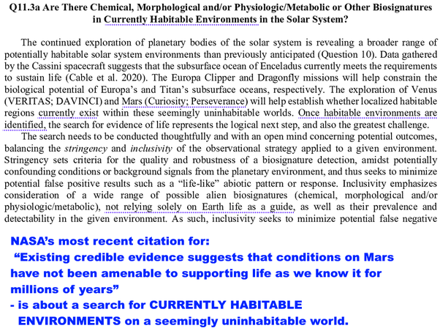
NASA’s most recent citation for “Existing credible evidence suggests that conditions on Mars have not been amenable to supporting life as we know it for millions of years” is about a search for CURRENTLY HABITABLE ENVIRONMENTS on a seemingly uninhabitable world.
See: page 393 [Click on the X to close the splash to go straight to page 393]

ONE OF NASA’S MAIN GOALS FOR MARS EXPLORATION IS TO SEARCH FOR PRESENT DAY LIFE THERE (SECOND HALF OF GOAL 1)
But one of your own science goals has the search for present-day life and habitats as the second part of Goal 1!
Goal 1: Determine if Mars ever supported or still supports, life,
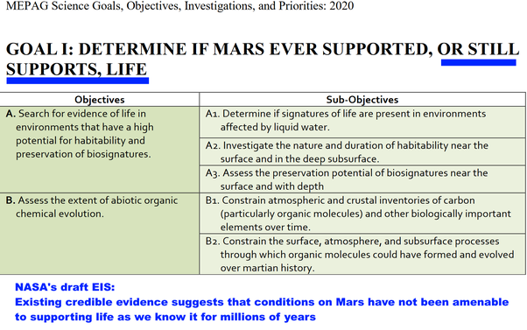
See page 9 of: MEPAG Science Goals, Objectives, Investigations, and Priorities (2020)

ONE OF NASA’S MAIN GOALS FOR SAMPLES RETURNED FROM JEZERO CRATER IS ALSO TO SEARCH FOR PRESENT DAY LIFE IN RETURNED SAMPLES, OBJECTIVE 2.3
It is also objective 2.3 for the Mars samples, to test to see if there is any evidence for present-day life - in the very samples Perseverance is caching .
2.3 Modern biosignatures: Assess the possibility that any lifeforms detected are still alive or were recently alive.
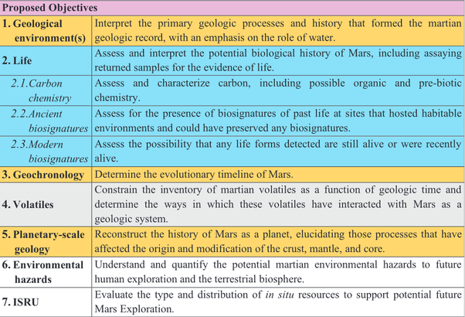
Table 2 of (Planning implications related to sterilization-sensitive science investigations associated with Mars Sample Return (MSR))

NASA PLAN TO TEST RETURNED SAMPLES FROM JEZERO CRATER FOR MICROBIAL RESPIRATION AND TEST FOR ANY MARTIAN-LIFE ABLE TO GROW OR MOVE AROUND IN CULTURE MEDIA
This table is based on the conclusions of the iMOST team (International MSR Objectives and Samples Team). [MSR = Mars Sample Return]
In more detail, the iMOST team put it like this:
The probability of discovering extant life at the Martian surface (including by means of MSR) is generally considered to be low. However, its discovery would be so profound that it would shake the pillars of science. It would yield insight into the very fundamentals of life such as what are the basic universal properties of living systems … and how life evolves
Page 86 (The potential science and engineering value of samples delivered to Earth by Mars sample return: International MSR Objectives and Samples Team (iMOST) )
They go on to say why they find present day life on Mars plausible, because of (pages 86–7)
- discoveries that suggest liquid water may flow on Mars on the surface or below it
- evidence some terrestrial life can metabolize and grow in Mars simulation conditions.
- Some Mars analogue locations in Antarctica have active microbial communities, and others have evidence of life but not metabolic activity. This suggests Earth life may be able to grow in a Mars-like environment but it nears the limits of survivability
They conclude that native life on Mars may be able to adapt and evolve to the local conditions.
However, for life exposed to the martian environment for eons, it may be able to adapt and evolve, suggesting that life on Mars may be possible.
Page 87 (iMOST)
The iMOST team detailed seven measurements searching for present day life. They divide it into three sub-strategies.
First, to look for molecules characteristic of recent or present day life, which are destroyed quickly. · -
- Investigation Strategy 2.3A: As part of developing a complete inventory of the organic molecules present, assess the presence and characteristics of molecules that are diagnostic of organisms that are either alive, or were recently alive.
  - Measure the presence of biochemical species, especially pigments, proteins, DNA, RNA, lipids, etc.
Then they plan to look for evidence of native martian microbes in the samples that can use organics and exhale gases like many terrestrial microbes. The Viking lander added samples of Martian dirt to a culture medium with organics labeled with carbon 13. They didn’t need the Martian life to colonize the organics, just to make use of it, and produce gases such as methane or carbon dioxide.
Both Viking landers found that when they added the dirt to the organics it gave off gases rich in carbon 13, and not just immediately but for the duration of the experiment This would prove the presence of life if these were samples from Earth.
However, we found such different conditions on Mars, most astrobiologists think the Viking labelled gases were produced by exotic complex surface chemistry on Mars. If it is complex chemistry, it is not yet fully understood. If it is life, this also is not yet fully understood.
The iMOST report proposes doing a similar experiment but using isotopes to label not only carbon but also nitrogen and hydrogen (using Carbon 13, Nitrogen 15 and deuterium), and then test for evolved gases that would show the organics are being metabolized. They could also use a much wider variety of organics to test than Viking could use. This leads to:

- Investigation Strategy 2.3B: Assess the possibility of metabolism and respiration
  - Measure the abundance of isotopes, isotopologues, and isotopomers.
[i.e. molecules containing the isotopes (isotopologues), as well as molecules with the same formula but differing in structure (isotopomers)]
  - Extract and sequence DNA.
  - Identify and measure evidence for cellular growth, metabolism, and respiration
This would be a major advance over Viking which couldn’t even detect if the evolved gas was methane or carbon dioxide, or something else.
Then finally they would attempt to get any Martian life to replicate. If they do succeed in this, they would study the cells and look also for any structures they might be using to move around (this would include the flagella, long filaments that which terrestrial microbes often use to swim).
- Investigation Strategy 2.3C: Assess the possibility that organisms within the sample are capable of reproduction in culture experiments.
  - Measure cell size, shape, and structure.
  - Evaluate morphological indications of replication and specialized features like motility structures
They conclude:
Success in cultivating organisms from Martian samples would be the ultimate proof of extant life. On Earth we can only culture a few percent of all environmental microorganisms because it is difficult to predict and reproduce conditions amenable to growth. We expect that Martian organisms would be no less recalcitrant. Therefore, it is critical that growth experiments be conducted under conditions present at the sample site.

WAS THERE A LACK OF COMMUNICATION BETWEEN THE LIFE DETECTION TEAM FOCUSING ON PRESENT-DAY LIFE ON MARS AS THEIR BEST CASE, AND ENGINEERS AND MISSION PLANNERS FOCUSING ON AN UNINHABITABLE MARS AS A WAY THE MISSION COULD BE ACCOMPLISHED MOST EASILY? WHATEVER THE CAUSE WE NEED TO FIX THIS FOR FUTURE EIS’S
So - going back to NASA’s sentence in the EIS:
Existing credible evidence suggests that conditions on Mars have not been amenable to supporting life as we know it for millions of years
How did the EIS come to have a sentence like this which isn’t consistent with the tests for present day life in NASA’s life detection goals for the mission? A couple of possibilities. It might be a simple communications break down, or it might be because of optimism about the potential for achieving a low cost mission for planetary protection.
If it is a simple communications breakdown, it reminds me of mix-ups that led to the loss of the Mars Climate Orbiter.
- commands were sent to the spacecraft using units of pounds, feet and seconds (force unit of pound seconds),
- the spacecraft was programmed using the metric units of kilograms, meters and seconds (force unit of Newton seconds)
- so it fired its engines at the wrong thrust levels and crashed into Mars.
See: (In Depth | Mars Climate Orbiter – NASA Solar System Exploration)
Such communication issues can be very hard to spot.
- For Mars Climate Orbiter, the issue was traced to a small program called SM_FORCES that output a file called AMD in English units, which was then used by modelers who assumed AMD was in metric units. (Mars Climate Orbiter Mishap Investigation Board Phase I Report November 10, 1999)
Or maybe it is optimism about achieving a low-cost mission. For scientists devising experiments to look for life, the most interesting outcome by far is present-day life. So the iMOST authors prepared optimistically for present-day life, and they recommend NASA to test for it even if it may be unlikely, because it would be such a major discovery.
For engineers and mission planners preparing protocols to protect Earth, the less the risk, the lower the cost of the mission. So, authors optimistically write that existing credible evidence says Mars is uninhabitable for millions of years, as this will likely reduce the cost of the mission and make mission planning simpler.
If that is what it is, it is a natural inclination for mission planners to want to reduce costs. However, if we take the protection of Earth seriously it is important to look at worst-case as well as best-case scenarios.
We can then look at reasonable alternatives in detail and the costs and benefits for each proposal. The costs there need to include the costs (financial and otherwise) of the worst-case outcomes if we fail to protect Earth.
They don’t need to be trade-offs either. I end this open letter with a “win win win” proposal that
- Probably costs less overall for NASA - and certainly has less upfront cost.
- Leads to more science return.
- And keeps Earth 100% safe.
Whatever the reason for the many mishaps in the EIS, it seems important to find a way to guard against similar mishaps in future environmental impact statements for Mars sample return missions.

WE NEED TO GET THIS RIGHT - ESPECIALLY BECAUSE OF NASA’S (USUALLY DESERVED) REPUTATION FOR SCIENTIFIC INTEGRITY - CHINA, SPACEX OR ANOTHER ENTITY COULD USE YOUR EIS IN GOOD FAITH TO DROP ALL PRECAUATIONS
This is one of three arguments in the EIS of central importance as precedent. Though you don’t use it this, way, another country or private space might use this statement to argue in good faith, but mistakenly, that Mars is as uninhabitable as the Moon. They might then see no need to take any precautions to protect Earth.
This is of especial importance because of the high regard NASA enjoys internationally for scientific integrity and rigour – normally a well-deserved reputation.
China plans to return samples from Mars in 2031 (Tianwen-3: China’s Mars sample return mission). SpaceX wishes eventually to send their “Starship” to Mars and backed, first unmanned and then with crew (SpaceX - Mars and Beyond)
So you need to get this right. WE DO NOT KNOW THAT MARS IS UNINHABITABLE at this moment in time, and your own citation contradicts your conclusion.

NASA NEED TO BE VERY SURE THAT MICROBES FROM MARS CAN GET HERE WITH BETTER PROTECTION AND FASTER TRANSIT IN A METEORITE - Could be used mistakenly to drop all precautions to protect Earth
This is the second of your main arguments that others could use to drop protection of Earth’s biosphere. They could use your reasoning to argue in good faith, but mistakenly, that we know any life in their samples got here already. So NASA needs to be very sure to get this right.
You say in the EIS that any life in Jezero crater will get here faster and better protected in a meteorite than in a sample tube.
The natural delivery of Mars materials can provide better protection and faster transit than the current MSR mission concept. …. potential Mars microbes would be expected to survive ejection forces and pressure (National Academies of Sciences, Engineering, and Medicine and the European Science Foundation 2019),
. MSR DRAFT EIS 3–3

MOST TERRESTRIAL MICROBES COULDN’T GET FROM MARS TO EARTH - AND THE SURFACE DUST, DIRT, SALT AND BRINES MECHANICALLY COULDN’T GET INTO A METEORITE
This is not credible. To get here in a meteorite a microbe has to get into it first. Large meteorites hit Mars every few hundred thousand years and the ejected rocks we have from Mars come from at least 3 meters below the surface.
- It was a remarkable discovery at the turn of the century that b. subtilis might be able to get from Mars to Earth on rare occasions.
- Surface dust, dirt, salts, and the very cold brines found by Curiosity can never get to Earth in a meteorite
- Mars could have microbes whose life cycle is restricted to the surface layers. These would have no way to physically get into a meteorite.
Mileikowsky et al., author of a seminal paper on modern lithopanspermia (transfer of microbes between planets inside rocks), put it like this
Whereas this harsh environment sets a definite barrier for most microorganisms known, some have developed survival strategies, by transforming into a dry state, the so-called anhydrobiosis ..., or by producing spores, the dormant state of certain bacteria
Concomitantly with their resistance to the adverse effects of drying, microorganisms in anhydrobiosis or spore stage are resistant to the effects of freezing to very low temperatures, elevated temperatures for brief periods, and the effects of ionizing. These characteristics make spores and anhydrobiotic bacteria especially prepared for coping with the extreme conditions of space
Page 401 of: (Natural transfer of viable microbes in space: 1. From Mars to Earth and Earth to Mars)

YOUR OWN CITATION FOR “POTENTIAL MARS MICROBES WOULD BE EXPECTED TO SURVIVE EJECTION FORCES AND PRESSURE” SAYS SAMPLES MIGHT COME FROM “SITES THAT MECHANICALLY CANNOT SURVIVE EJECTION FROM MARS“ AND SAYS ITS RECOMMENDATIONS DO NOT APPLY TO SAMPLES FROM MARS
Your own citation for "potential Mars microbes would be expected to survive ejection forces and pressure" makes this very point. It says that potential Mars microbes in some surface materials (like dust and dirt and salt) would NOT even get into a meteorite.
"MSR [Mars Sample Return] material might come from sites that mechanically cannot survive ejection from Mars and thus any putative life-forms would de facto not be able to survive impact ejection and transport to space"
There is a minor typo on this page, “Mars” for “Phobos” which could conceivably partly explain the confusion, and why this was selected as a citation for the EIS statement?
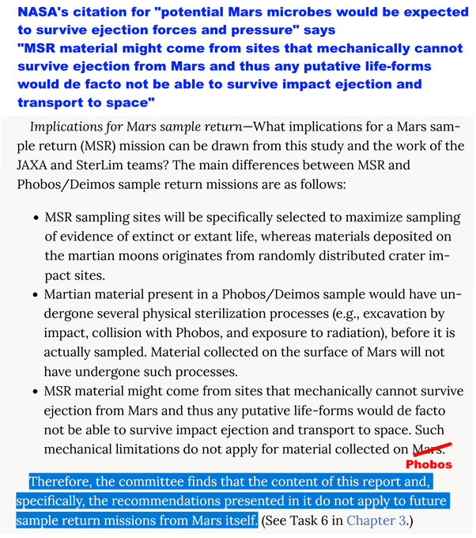
NASA's citation for "potential Mars microbes would be expected to survive ejection forces and pressure" says "MSR material might come from sites that mechanically cannot survive ejection from Mars and thus any putative life-forms would de facto not be able to survive impact ejection and transport to space"
The Phobos sample return study covers this reasoning in more detail on page 44-5. On the last point they say:
The reasoning regarding natural flux does not apply directly to samples returned from the Mars surface.
    - The material will be gently sampled and returned directly to Earth.
    - The sample may well come from an environment that mechanically cannot become a Mars meteorite.
    - The microbes may not be able to survive impact ejection and transport through space.
Samples with current liquid water and recent ice seem especially fragile to natural transport to Earth.
Finding: The committee finds that the content of this report and, specifically, the recommendations in it do not apply to future sample return missions from Mars itself.
[Added bullet points to the original text]
In short, your citation says it shouldn’t be used to support the very argument you use it as a citation for. The EIS doesn’t alert the reader to this discrepancy.

TO PROVE NO POTENTIAL INVASIVE MICROBES IN OUR SAMPLES WE NEED TO PROVE ALL (NOT JUST SOME) SPECIES CAN GET HERE ON A METEORITE - ANALOGY: STARLING IS AN INVASIVE SPECIES IN THE USA BUT THE SWALLOW IS NOT BECAUSE IT CAN CROSS THE OCEAN

We
- most terrestrial microbes can’t get from Mars to Earth
So, it’s not very plausible that
- in ALL possible scenarios for Martian life, ALL species of martian microbes would be able to get from Mars to Earth
Yet that’s what would be needed to prove we can’t have invasive species from Mars in the samples.
I give the example of swallows and starlings in my preprint.
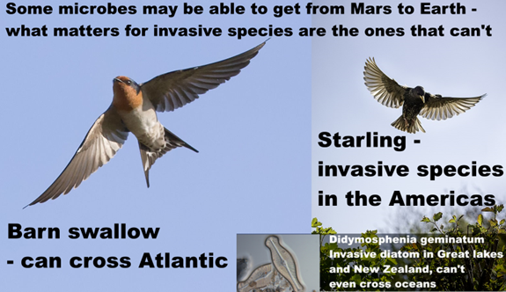
Text on graphic: Some microbes may be able to get from Mars to Earth – what matters for invasive species are the ones that can’t.
Barn swallow - can cross Atlantic
Starling - invasive species in the Americas
Didymosphenia geminatum invasive diatom in Great Lakes and New Zealand, can’t even cross oceans
Not necessarily all species will be invasive in harmful way but if a species can’t cross the Atlantic it has potential to be invasive.

IT’S THE SAME PICTURE FOR MICROBES - MANY CROSS OCEANS AND ARE NOT INVASIVE - BUT FRESH WATER DIATOMS CAN’T CROSS OCEANS AND HAVE BEEN INVASIVE IN THE GREAT LAKES AND ARE INVASIVE TODAY IN NEW ZEALAND
Didymo in that illustration is an invasive species of fresh water diatom in New Zealand. A few decades back the Great Lakes had many problems with non indigenous invasive diatoms that clogged up water treatment plants and caused bad smells in drinking water which shows that microbial life can be invasive too.
Just as it’s microbes that can’t cross oceans that have some potential to be invasive on Earth, it’s any microbes that can’t cross the cold and vacuum of space and can’t survive ejection from Mars or get into a meteorite that are the ones that have some potential to be invasive introductions to Earth’s biosphere.
This again is of central importance.. Another country or private space might use your statement to argue in good faith, but mistakenly, that any life from Mars has already got to Earth.
The natural delivery of Mars materials can provide better protection and faster transit than the current MSR mission concept.
. MSR DRAFT EIS 3–3
They might then see no need to take any precautions to protect Earth.
Again WE DO NOT KNOW THIS and your own citation says it shouldn’t be used for this argument.

THE EIS FOCUSES ON BEST-CASE SCENARIOS - INDEED SAMPLES CAN BE HARMLESS IN MANY WAYS - BUT NEVER MENTIONS WORST-CASE SCENARIOS - LIKE DESIGNING A SMOKE DETECTOR WITHOUT CONSIDERING WORST CASE OF A HOUSE FIRE
Your EIS considers a best-case where
- Mars has been uninhabitable for millions of years AND
- Mars life can’t be transferred in dust storms AND
- Martian life can’t live in Jezero Crater AND
- If there is life in Jezero crater, all the species able to harm us already got to Earth in meteorites, AND
- All species of Martian life depend on nutrients they only find on Mars or are unable to live in terrestrial conditions, AND
- If species on Mars get to Earth and spread here they will be harmless to humans AND
- If life does get here, NASA will contain it in a BSL-4, AND
- Although you can do virtually all geological science with sterilized samples, NASA has to return unsterilized samples to Earth for safety testing
- NASA will do safety testing before any samples are released from the labs.
None of these are supported by your citations. The EIS doesn’t alert the reader to many ways these assumptions could be invalid.
It’s a curious argument because if any of those assumptions were true there would be no need to consider the rest.
E.g. we know the Moon is uninhabitable, and that is enough to be sure there is no risk for samples returned from the Moon. So we don’t need to look at whether life on the Moon could get here on meteorites, or to contain the samples or do anything to protect Earth.
If this is not challenged, other space countries and private space may well use your arguments to infer in good faith there is no need to take ANY precautions for samples returned from Mars.
There are lots of ways that the sample returned from Jezero crater COULD be harmless.
However, despite the statements in your EIS, we do NOT KNOW ANY OF THESE THINGS.
Margaret Race, a biologist working on planetary protection and Mars sample return for the SETI Institute and specialist in environmental impact analysis used the analogy of a smoke detector in response to similar non-peer-reviewed suggestions by the space colonization enthusiast and leader of the Mars Society Robert Zubrin:
If he were an architect, would he suggest designing buildings without smoke detectors or fire extinguishers?
Hazardous Until Proven Otherwise, in: "Opinion: No Threat? No Way",
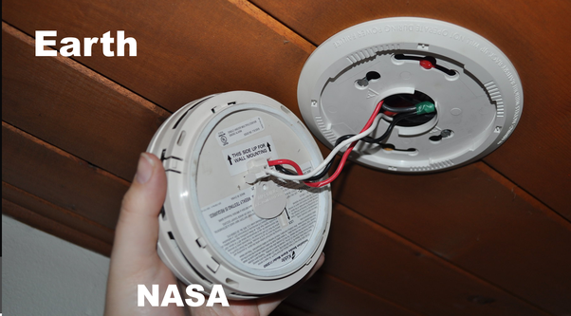
Hand installing smoke detector labelled “NASA” and wooden ceiling of a house labelled “Earth”
(Smoke detector graphic from The EnergySmart Academy)

GENERAL PUBLIC FOCUS MORE ON RISKS; MISSION PLANNERS ON MISSION REQUIREMENTS - A PRE-STERILIZED RETURN SATISFIES BOTH
Margaret Race made a relevant point in another paper. To summarize her main points she says scientists are likely to focus on
- technical details
- mission requirements
- engineering details
- costs of the space operations and hardware
So it is natural for you to focus on those.
The general public are likely to focus on
- risks and accidents
- whether NASA and other institutions can be trusted to do the mission
- worst case scenarios
- whether the methods of handling the sample, quarantine and containment of any Martian life are adequate
See: , Planetary Protection, Legal Ambiguity, and the Decision-Making Process for Mars Sample Return
We see the results of this different focus in the report.
Let’s look at another example:

THE EIS IS INCORRECT WHEN IT SUGGESTS JEZERO CRATER IS BIOLOGICALLY ISOLATED FROM THE REST OF MARS - FRAGMENTS OF MICROBIAL BIOFILMS ARE STILL VIABLE AFTER BLOWN HUNDREDS OR EVEN THOUSANDS OF KILOMETERS IN EXPERIMENTAL TESTS
NASA: If there is life on Mars it can’t get into Perseverance's samples in Jezero crater:
“Consensus opinion within the astrobiology scientific community supports a conclusion that the Martian surface is too inhospitable for life to survive there today, particularly at the location and shallow depth (6.4 centimeters [2.5 inches]) being sampled by the Perseverance rover in Jezero Crater, which was chosen as the sampling area because it could have had the right conditions to support life in the ancient past, billions of years ago.”
.. MSR DRAFT EIS 1–6
NASA and ESA commissioned a review in 2015 (MEPAG2) which found serious knowledge gaps in the 2014 SR-SAG2 review which you rely on here.
It found that SR-SAG2 doesn’t adequately discuss the transport of material in the Mars atmosphere [e.g. in dust storms] see page 12.
This is indeed a knowledge gap. Amongst several relevant discoveries, later research found that small fragments of biofilm, thin layers of a microbial colony three hundredths of a millimeter thick, can travel 100 kilometers in daylight in the light Martian winds before it is sterilized.
See A desert cyanobacterium under simulated Mars-like conditions in low Earth orbit: implications for the habitability of Mars
Your EIS doesn’t cite the MEPAG2 review in 2015 which found knowledge gaps in SR-SAG2 about transport of life in the atmosphere and habitats even in places like Jezero Crater that may be impossible to see from orbit.
Billi et al’s paper on biofilm transport doesn’t take account of the effect of UV on perchlorates in the biofilm, but in my paper I find
- martian night time winds are also strong enough to transport the biofilm fragments
- they could also travel much further in dust storms which block out UV.
Also Wadsworth et al who highlighted the biocidal effect of perchlorates activated to cholorates and chlorites by UV only tested b. subtilis and remark that terrestrial extremophiles could be more resilient. Mars could have native evolved Martian microbes more resilient than the b. subtilis tested by Wadsworth et al..
It found that SR -SAG2 only briefly discussed the implications of our lack of knowledge of microenvironments. :12 That’s been the subject of many research papers since then which the EIS doesn’t discuss, for instance about micropores in salt and gypsum, or discussing whether life could use melting micron-thick layers of frost in a temperature inversion in regions like Jezero crater.
It also drew particular attention on page 11 to the capability of microbes to use biofilms to make regions habitable that wouldn’t be otherwise [the Atacama gritcrust would be an example here.
For scientific integrity you need to cite the 2015 review and discuss what it says.

YOUR STERILIZATION WORKING GROUP’S CONCLUSION THAT MARTIAN LIFE HAS NEAR-ZERO PROBABILITY OF HARM FOR HUMANS IS NOVEL AND CONTRADICTS PREVIOUS PEER-REVIEWED LITERATURE ON MARS SAMPLE RETURN
Your sterilization working group comes to a conclusion that is not found in any previous peer-reviewed study on Mars sample return backward contamination.
“Since any putative Martian microorganism would not have experienced long-term evolutionary contact with humans (or other Earth host), the presence of a direct pathogen on Mars is likely to have a near-zero probability.”
(Biological safety in the context of backward planetary protection and Mars Sample Return: conclusions from the Sterilization Working Group: page 6)
They reach this conclusion by only examining diseases adapted to humans.
They don’t cite this to any previous study, and I have not been able to find any precedent except a non peer reviewed op ed. by Robert Zubrin (Contamination From Mars: No Threat) which was strongly criticised by experts including your planetary protection officer at the time John Rummel:
John Rummel: How ought others judge the cost-benefit ratio of Mars exploration if we don't take simple precautions to avoid potentially harmful consequences? Harshly, I suspect.
Margaret Race: If he were an architect, would he suggest designing buildings without smoke detectors or fire extinguishers?
("Opinion: No Threat? No Way")
Zubrin makes all three of the main arguments used in the EIS - NONE OF THESE OCCUR IN THE PEER REVIEWED PLANETARY PROTECTION LITERATURE
- that Mars is uninhabitable
- that if there is life on Mars it got here already
- that if life from Mars gets here it won’t be able to live here and won’t be adapted to humans
It is a striking similarity. There is no reason to suppose the sterilization working group was influenced by Zubrin’s non peer reviewed op ed. and they don’t cite it. But there may be a common background, which I discuss in my preprint, such as enthusiasm for physical exploration and pushing through frontiers, a focus on the mission objectives, a keenness to send astronauts to Mars, and a pre-existing optimism, possibly inspired by science fiction, that if there is anything on Mars it can’t harm us.
However in the worst case scenario we find interesting life on Mars that is harmful to Earth and can never be returned to Earth. This is currently a possible scenario. It could envigorate space exploration and lead to more rather than less public interest and enthusiasm for astronauts in space.

THE PLANETARY PROTECTION LITERATURE ALREADY MENTIONS TETANUS - SOMETIMES ACCIDENTALLY DEADLY FOR UNVACCINATED NEWBORNS - AND LEGIONNAIRES’ DISEASE - THAT SEES THE LUNGS AS SIMILAR TO A MICROBIAL BIOFILM AND IS SOMETIMES DEADLY - NEITHER ADAPTED TO HIGHER LIFE OR HUMANS
The sterilization working group doesn’t discuss the illustrative examples from the 2009 paper: Assessing the Biohazard Potential of Putative Martian Organisms for Exploration Class Human Space Missions
Indeed the passage discussing the potential for martian microbes to infect humans on page 6 has no citations for any of the diseases or to the planetary protection literature.
In this way they missed:
- Legionnaires’ disease (a disease of microbial biofilms not adapted to infect lungs, sometimes fatal)
- Tetanus - not adapted to infect any organism, accidental poison, still kills thousands of newborns a year who haven’t been vaccinated
The sterilization working group doesn’t alert the reader to the existence of such diseases.

STERILIZATION WORKING GROUP DISCUSSES CANDIDAS - A FUNGAL INFECTION ADAPTED TO HUMANS - DOESN’T SEARCH FOR OTHER FUNGAL INFECTIONS NOT ADAPTED TO US
The sterilization working group does discuss Candidas, a fungal infection that they correctly say has adapted to humans over long periods of time.
As with the other diseases, the passage gives no citations for their statement about Candidas. I was able to confirm that experts say it is adapted to humans. But the natural next question for someone looking for worst-case scenarios rather than best-case scenarios is - what about other fungal infections of humans? Are they adapted to us?
I can’t find previous discussions of fungal infections in the Mars sample return literature, so needed to do my own research into this. To date, the planetary protection literature hasn’t tried to be comprehensive and only looks at a few illustrative examples.
Following up this example I found an example new to the planetary protection literature (as far as I know).

200,000 LIFE THREATENING CASES OF INVASIVE ASPERGILLIOSIS MORTALITY RATES 30% TO 95%, 400,000 OF THE PROGRESSIVE DISEASE ALLERGIC PULMONARY ASPERGILLIOSIS AND 4.8 MILLION WITH ASTHMA TRIGGERED BY ASPERGILLUS FUMIGATUS
The two most deadly fungal infections for humans are Candidas and Aspergillus. Aspergillus fumigatus is NOT adapted to humans. We get an estimated 200,000 life threatening invasive aspergillosis infections a year with mortality rates varying from 30 to 95%. This disease affects people who are immunocompromised mainly.
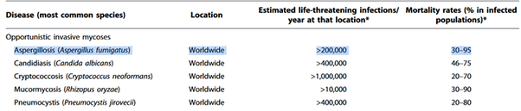
. Hidden killers: human fungal infections.
The progressive and very serious disease of chronic pulmonary aspergillosis (CPA) affects around 400,000 globally and only occurs in people who are not immunocompromised with symptoms of “weight loss, profound fatigue, productive cough, significant shortness of breath, and life-threatening hemoptysis [spitting out of blood from the lungs]”.
Then allergic bronchopulmonary aspergillosis affects 2.5% of patients with asthma, and an estimated 4.8 million people globally. All three diseases are different manifestations of the same fungus, Apergillus fumigatus (with a couple of other aspergillus species also involved in some cases). For details, see:
. Global burden of allergic bronchopulmonary aspergillosis with asthma and its complication chronic pulmonary aspergillosis in adults

ASPERGILLUS FUMIGATUS AS A NEW ILLUSTRATIVE EXAMPLE FOR A PLAUSIBLE ANALOGUE OF A NEW FUNGAL GENUS FROM MARS
To help focus attention I’ve added this as a new illustrative planetary protection example. It turns out to be a plausible analogue of a new fungal genus from Mars
- Not adapted to infect any organisms.
- Harms humans due to adaptations that a martian microbe might well have such as:
- tolerance of low oxygen in lungs,
- rapid hydration from extreme dessication,
- fast growing branching filaments,
- able to take up nutrients rapidly and store energy, etc.
- highly tolerant of low temperatures and oxidative stress.
[the Mars surface has strong oxidants like perchlorates, activated by UV to chlorates and chlorites, also hydrogen peroxide]
(Ecology of aspergillosis: insights into the pathogenic potency of Aspergillus fumigatus and some other Aspergillus species)

IF OUR IMMUNE SYSTEM IS FACED WITH A NOVEL FUNGAL GENUS FROM MARS IT NEVER SAW BEFORE - IT MIGHT BE MYSTIFIED AND MOUNT NO DEFENSE, AS FOR INVASIVE ASPERGILLIOSIS OR IT MIGHT OVERREACT AS FOR ALLERGIC PULMONARY ASPERGILLIOSIS OR ASTHMA
Our immune system has evolved over millions of years to defend us against Aspergillus. Many parts of the immune system work together to
- Detect it
- Respond to it
- Dampen down overreactions to it.
When our immune system doesn’t spot it or responded to it then we get allergic aspergillosis, a very serious disease.
But when our immune system does spot it, it has to clear the aspergillus microbes from our lungs, but at the same time it has to avoid over-reacting in a harmful inflammatory response. Otherwise we may get asthma, or worse, allergic pulmonary aspergilliosis.
Techy details: Our immune system detects fungi using its pathogen-associated molecular patterns (PAMPs). It likely uses pattern recognition receptors (PRRs) which trigger the immune response. There are different patterns for each of the main fungal genera that affect humans: Candida, Aspergillus and Cryptococcus table 1 of (Antifungal immune responses: emerging host–pathogen interactions and translational implications)
Then to dampen down the inflammation when it’s not needed - this is a complex finely tuned reaction that involves the inflammation dampening Treg cells and many T-helper cells.
The most important ones for our adaptive immune response to aspergillus that we use to avoid over-reacting are the Th1, Th17, Th22, Th2, Th9, Treg, and Tr1 cells (The multifaceted role of T-helper responses in host defense against Aspergillus fumigatus)
It is a major challenge for our immune system to achieve this finely tuned response to a novel fungal genus it’s never seen before. For instance, suppose an alternative evolutionary history where our immune system has only ever encountered Cryptococcus, and we return Aspergillus from another planet. It wouldn’t yet be able to see Aspergillus fumigatus. It would have none of those PAMPs from the techy details.
While if it had encountered Candidas on Earth, it would have some but not all of the PAMPs needed for the introduced Aspergillus. And then if it does recognize Aspergillus the T-helper and T-reg responses are unlikely to achieve the fine balance to avoid overreacting with an allergic reaction.
It might be a similar situation if we introduce a novel fungal genus from Mars to Earth’s biosphere.

EXAMPLE OF MIRROR LIFE TO HELP FOCUS ATTENTION
I mentioned earlier on that the blue-green algae Chroococcidiopsis is one of our top candidates for a terrestrial life form that could live on Mars if there is water available for it to use.
We don’t know that Martian life is related to us.
Astrobiologists tell us that life on Mars may well be independently evolved. If so, one of the top candidates for an alternative form of biology is mirror life, which everyone agrees is biologically plausible, evolved from scratch from the mirror images of the chemicals used by terrestrial life.
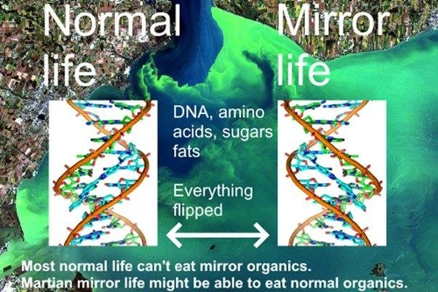
Text on graphic: Normal life, Mirror life, DNA, amino acids, sugars, fats, everything flipped. Most normal life can’t eat mirror organics. Martian mirror life might be able to eat normal organics.
If we could flip a cake in 3D, like reflecting it in a mirror, all the way down to its molecules, we might be able to eat it, like artificial sweeteners, but our metabolism couldn’t do anything with the flipped starches or proteins, and many fats would also be inaccessible (An adventure in stereochemistry: Alice in mirror image land)
According to the theory of punctuated chirality, early on as life was just starting to evolve, there were patches of chemicals that worked together with each other in chiral networks which expand converting a non chiral substrate into chiral organics and where two chiral networks of opposite chirality meet there are ways for them to slowly convert each other to the opposite chirality.
There would be many such patches, some of one chirality some the opposite, and they would expand and flip each other back and forth in chirality on an environmental scale, with these flips perhaps frequent in Early Earth (Gleiser et al., 2008a), until one of them got established as the basis for the evolution of life. If so, depending on how the flips went on Mars, life could easily have evolved from chemicals with the opposite chiral bias to Earth life
Our analysis predicts that other planetary platforms in this solar system and elsewhere could have developed an opposite chiral bias.
They predict that in the universe as a whole if an organic is found in a large sample of independently evolved forms of life it should occur in both forms
As a consequence, a statistically large sampling of extraterrestrial stereochemistry would be necessarily racemic on average
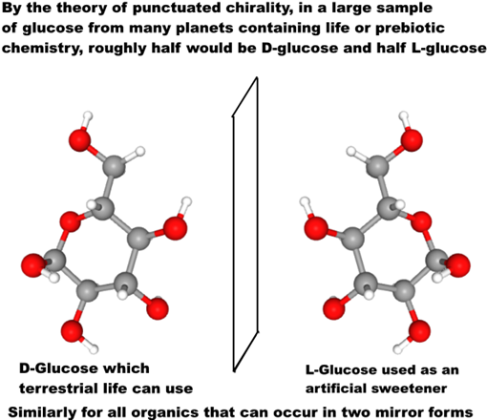
Text on graphic: By the theory of punctuated chirality, in a large sample of glucose from many planets containing life or prebiotic chemistry, roughly half would be D-glucose and half L-glucose
D-Glucose which terrestrial life can use
L-Glucose used as an artificial sweetener
Similarly for all organics that can occur in two mirror forms
Graphic for L-glucose and D-glucose by reflecting the graphic horizontally. Grey: Carbon, Red: oxygen, white: Hydrogen.

WORST CASE SCENARIO HERE IS THAT MIRROR LIFE RETURNED FROM MARS GRADUALLY FLIPS NEARLY ALL TERRESTRIAL ORGANICS INTO INDIGESTIBLE MIRROR ORGANICS OVER TIMESCALES OF DECADES OR CENTURIES - THE LEVEL OF ASSURANCE WE NEED TO PREVENT SUCH A SCENARIO, IF IT IS POSSIBLE - IS A MATTER FOR WIDER DISCUSSION AND CAN’T BE SETTLED FOR THE REST OF HUMANITY BY NASA MISSION PLANNERS
Synthetic biologists plan to gradually flip ordinary to mirror life over a period of a decade or so – and will make sure synthetic mirror life is engineered to depend on chemicals only available in the laboratory. They warn escape of mirror life could cause major transformations of the terrestrial biosphere by locking up organics in unusable mirror forms. See: (Mirror-image cells could transform science-or kill us all)
Martian life likely already has the isomerases to metabolize organics of opposite sense, whether it is mirror or normal life - because nearly all organics are either made abiotically locally, or are infall from comets, asteroids and interplanetary dust, with organics of both senses.
Eventually terrestrial microbes likely develop isomerases to metabolize mirror life, but higher life couldn’t evolve so quickly. The outcome is a mix of normal and mirror organics. In Kasting and Church’s worst case scenario mirror life retains the edge over normal life in this evolutionary race and eventually there is little left except mirror organics and life that can use it. They suggest humans could go extinct in this worst case scenario (Mirror-image cells could transform science-or kill us all)
In this worst case I don’t think humans would go extinct even on the centuries timescale. We could enclose large areas of Earth with its tropical jungles, coral reefs etc, in habitats similarly to Biosphere 2.
And there might well be things see can do to help terrestrial microbes win the evolutionary race with the imported mirror life.
But it’s far better not to do the experiment.
We will only know if we are in the scenario of a Mars with mirror life if we go look for it and find it.
If we are in that scenario, then we would likely decide as a civilization that we must never return the Martian mirror life back to Earth.
So, to help focus attention on the potential for adverse effects on the environment, the very worst case we could return microbes that could transform Earth’s biosphere in ways we can’t predict.

THIS IS A WORST CASE SCENARIO - ASTROBIOLOGISTS BELIEVE THE POTENTIAL FOR LARGE SCALE EFFECTS IS LIKELY VERY LOW - BUT AS FOR A HOUSE FIRE WE DO NEED TO BE PREPARED FOR WORST CASES SCENARIOS - EVEN IF VERY UNLIKELY
These are worst cases not likely cases.
But as with house fires, and smoke detectors we do need to look at worst cases. We can’t protect Earth properly if we only look at the most optimistic scenarios.
We can’t rely on the same risk-benefit calculus for release of SARS and for release of mirror life.
Some synthetic biologists say we need a level of assurance for synthetic biology far higher than for any biosafety laboratory. Schmidt said:
… maybe [1 in 100,000,000,000,000,000,000] is more than enough …
The probability also needs to reflect the potential impact, in our case the establishment of an XNA ecosystem in the environment, and how threatening we believe this is.
The most important aspect, however, is that the new safety mechanism should be several orders of magnitude safer than any contemporary biosafety mechanism
(Xenobiology: a new form of life as the ultimate biosafety tool.)
[In this quote XNA refers to life based on a different informational polymer from DNA. Similar remarks would apply to mirror life]
The same precautions may be needed for returning alien biology from another planet.
This is NOT something that NASA mission planners can decide for the rest of humanity. This is NOT something we can decide using the scientific method.
We need a wider discussion here to work out the necessary level of assurance if there is indeed a potential for returning mirror life from Mars. This is one of the NEPA’s central requirements for a valid EIS.
Agencies shall prepare environmental impact statements using an interdisciplinary approach that will ensure the integrated use of the natural and social sciences and the environmental design arts … The disciplines of the preparers shall be appropriate to the scope and issues identified in the scoping process
§ 1507.2 [links directly to legal text]
Mars sample return studies emphasize the need to involve the public early on, not just in the USA, but through fora open to representatives from all countries globally because negative impacts could affect countries beyond the ones involved directly in the mission (Ammann et al, 2012:59)
RECOMMENDATION 3
Potential risks from an MSR are characterised by their complexity, uncertainty and ambiguity, as defined by the International Risk Governance Committee’s risk governance framework. As a consequence, civil society, the key stakeholders, the scientific community and relevant agencies’ staff should be involved in the process of risk governance as soon as possible.
In this context, transparent communication covering the accountability, the benefits, the risks and the uncertainties related to an MSR is crucial throughout the whole process. Tools to effectively interact with individual groups should be developed (e.g. a risk map).
RECOMMENDATION 4
Potential negative consequences resulting from an unintended release could be borne by a larger set of countries than those involved in the programme. It is recommended that mechanisms and fora dedicated to ethical and social issues of the risks and benefits raised by an MSR are set up at the international level and are open to representatives of all countries
(Mars Sample Return backward contamination–Strategic advice and requirements)
The public weren’t involved early on in that way. Not only that, the few in the public who did discover NASA’s request for public comment weren't given the opportunity to comment on a scientifically valid EIS.
We can’t rely on the same risk-benefit calculus for release of SARS and for release of mirror life, without legislative / executive / public involvement to decide if this is what we should do.
The theologian Richard Randolph put it like this, from a Christian perspective:
The risk of back contamination is not zero. There is always some risk. In this case, the problem of risk – even extremely low risk – is exacerbated because the consequences of back contamination could be quite severe. Without being overly dramatic, the consequences might well include the extinction of species and the destruction of whole ecosystems. Humans could also be threatened with death or a significant decrease in life prospects
In this situation, what is an ethically acceptable level of risk, even if it is quite low? This is not a technical question for scientists and engineers. Rather it is a moral question concerning accepting risk
(Chapter 15, God’s preferential option for life: a Christian perspective on astrobiology)

THE MAIN CONCERN OF THE GENERAL PUBLIC IN THEIR COMMENTS ON THE EIS WAS RISK OF HARM TO HUMAN HEALTH AND EARTH’S ENVIRONMENT - 50 OUT OF 63 COMMENTS IN THE FINAL EIS
Several dozen distinct members of the public expressed views that suggest they would be in support of Sagan’s quote, on a not very widely publicised EIS. Nine commentators specifically mention unprecedented harm.
This figure of 50 out of 63 shouldn’t be read as a percentage of the public as it is not a poll. But it does show that at least several dozen of the members of the public who were reached in the not very well publicized second round of comments had concerns similar to Sagan. These are all the comments with the ones expressing comments similar to Sagan’s view in bold.
- stop mission, unprecedented harm – test first – study in separate module attached to ISS – test first – stop mission
- stop mission – test first – test first, unprecedented harm – Study in space or not at all, keep Earth 100% safe, our efforts to contain the samples may seem lax a generation from now –test first
- stop mission – need clarity about security measures – off topic – alternative design - keep Earth 100% safe
- unprecedented harm – stop mission, unprecedented harm – alternative design – test first – test first
- test first – unprecedented harm – test first – Test first– Don’t return unless 100% safe – or sterilize first
- Don’t return – don’t return until 100% safe – test first – test first–test first
- ISS first – test first – test first – unknown risk, test first–sterilize first
- extra precautions for EES reentry - sterilize first – sterilize first – sterilize in space station first–sterilize first
- do not return – do not return – do not return – send to Russia first– issues with disinfection of earth entry site
- test first– support EIS– study in situ or space lab or sterilize first – fully support, suggests more samples – – off topic (future missions need to be designed for reeuse)
- multiple cautious measures – support EIS – support EIS– test or sterilize first – sterilize first
- test in situ or don’t return – do not return – unprecedented harm, test first – unprecedented harm, return to space station
Some of the comments were very detailed with attachments.
Thomas Dehel quoting from an interview he did with Gill Levin who died shortly before the start of the EIS process
"I believe people will realize, especially after the Covid-19 catastrophe, that even if there’s only a small chance that something could be contagious and pathogenic, coming from a foreign planet, I don’t think it’s worth taking that chance….you don’t take unnecessary chances where the risk-to-benefit ratio is almost infinite.”
. Comment posted December 13th
Barry DiGregario quoting from an interview he did with Carl Woese when he was alive
“When the entire biosphere hangs in the balance, it is adventuristic to the extreme to bring Martian life here. Sure, there is a chance it would do no harm; but that is not the point. Unless you can rule out the chance that it might do harm, you should not embark on such a course”
. Comment posted December 5th
Chester Everline, co-author of your handbook on probabilistic risk assurance:
If the MSR Campaign can convincingly demonstrate that material returned to Earth by MSR will be
subjected to more severe conditions than those transported by natural processes, then MSR poses
no greater risk to Earth than we would expect from the next Mars meteorite. However, if this
cannot be convincingly demonstrated [IT CAN’T AS WE SAW] the MSR Campaign should seriously consider not returning samples using the technology described in the PEIS (i.e., transition to a deferred return campaign option).
. Comment posted December 20th
My own final comment, in 14 points ending:
Let's make this an even better mission and SAFE for Earth.
. Comment posted December 20th

THE LANGUAGE “APPEARS TO BE LOW BUT IS NOT DEMONSTRABLY ZERO” AND ”NEAR-ZERO PROBABILITY OF ENVIRONMENTAL EFFECTS” SEEMS SMALL BUT HAS MAJOR LEGAL EFFECTS - REMOVING NEARLY ALL THE GUARD RAILS TO PROTECT EARTH’S BIOSPHERE
National Research Council in 2009. This is for large scale harm to humans and the envioronment.
The committee found that the potential for large-scale negative effects on Earth’s inhabitants or environments by a returned martian life form appears to be low, but is not demonstrably zero
Page 6 of: (Biological safety in the context of backward planetary protection and Mars Sample Return: conclusions from the Sterilization Working Group)
The difference between “appears to be low, but is not demonstrably zero” and “near-zero probability” may seem subtle but it has major legal consequences. This is what the sterilization working group said:
Since any putative Martian microorganism would not have experienced long-term evolutionary contact with humans (or other Earth host), the presence of a direct pathogen on Mars is likely to have a near-zero probability.
All previous studies have said numerous laws to protect Earth’s environment would be triggered by a Mars sample return and other agencies such as the CDC, Department of Agriculture, most recently, from 2019. Updating Planetary Protection Considerations and Policies for Mars Sample Return (with your former planetary protection officer Cassie Conley as co-author)
NASA themselves are mandated to consider such matters as:
● impact on the environment,
● impact on the oceans,
● impact on the great lakes,
● escape of invasive species,
● lab biosecurity against theft
See: page 3–3 of NASA Facilities Design Guide
Yet there is no discussion of these matters in your draft EIS, only on environmental effects in the immediate area where the sample capsule hits the Earth.
Just by omission, that these things are not considered, it shows that authors of the EIS are of the view that “near - zero” means there is no need to consider wider environmental effects even under these direct obligations for NASA as a government agency under numerous executive orders.

ONCE POTENTIAL FOR LARGE-SCALE GLOBAL ENVIRONMENTAL EFFECTS AND HARM TO HUMANS IS RECOGNIZED IN THE EIS, MANY US AGENCIES WILL NEED TO DECLARE AN INTEREST
US agencies that would get involved include:
- CDC (for potential impact on human health),
- Department of Agriculture (for potential impact on livestock and crops),
- NOAA (for potential impact on oceans and fisheries after a splashdown in the sea)
- Occupational Safety and Health Administration, to consider questions of quarantine if a scientist or technician gets contaminated by a sample
- Department of the Interior - the steward for public land and wild animals - since these could be affected by release of Martian microbes
- Fish and Wildlife Service for the DoI who maintain an invasive species containment program and may see back contamination as a possible source of invasive species

ESA ARE CLOSELY INVOLVED AS THEY FETCH THE SAMPLES FROM MARS TO THE MARS ASCENT ORBITER, AND RETURN THEM FROM MARS ORBIT TO THE SURFACE OF EARTH - SO THE LEGISLATION OF THE EU, UK AND OTHER MEMBER STATES MAY APPLY - ALSO THE ESPOO CONVENTION
This is a joint ESA / NASA mission. The papers I found don’t go into this. But ESA are closely involved as they are responsible for fetching the samples from Mars and returning them to Earth.
So, the legislation of ESA member states would seem relevant. That includes the UK, the EU and other member states and cooperating states. Se (Member States & Cooperating States )
With the EU involved,
- Directive 2001/42/EC might apply (Directive 2001/42/EC of the European Parliament and of the Council of 27 June 2001 on the assessment of the effects of certain plans and programmes on the environment)
Also the UK and many other member states of ESA are parties to the Espoo convention. List of parties: UNTC
Under that convention they would need to consult with each other on all major projects that can have an effect outside of their own boundaries - which would certainly apply to a Mars sample return release of life that transformed the biosphere (Environmental Assessment - Espoo Convention)

INTERNATIONAL ORGANIZATIONS MAY GET INVOLVED LIKE THE FAO FOR POTENTIAL FOR LARGE SCALE EFFECTS ON FOOD AND AGRICULTURE, THE WHO BECAUSE OF POTENTIAL FOR LARGE SCALE EFFECTS ON HUMAN HEALTH ETC
It seems unlikely worst case scenarios would be ignored as the legal proceedings continue. So, for any Mars sample return mission for any country, at some stage, international agencies may get involved like
- Food and Agriculture Organization , because of potential impact of large scale changes such as mirror life on agriculture and fisheries and global food supplies,
- World Health Organization because of potential of large scale impacts on human health globally if a new organism is returned that can harm humans and spread to other countries.
Many international treaties and domestic laws of other countries are also likely to be relevant. Race and Urhan et al summarize some of these potential legal ramification see:
- (Updating Planetary Protection Considerations and Policies for Mars Sample Return)
- (Planetary Protection, Legal Ambiguity, and the Decision Making Process for Mars Sample Return)
In the USA, the Environmental Protection Agency partners with the United Nations Environment Program (UNEP), and Arctic Council, so they’d likely get involved.

A WORST CASE SCENARIO OF MIRROR LIFE HELPS FOCUS ATTENTION ON OUR RESPONSIBILITIES AS ALMOST ALL ASPECTS OF HUMAN LIFE ARE POTENTIALLY AFFECTED - JUST AS THE SCENARIO OF A HOUSE FIRE HELPS FOCUS ATTENTION ON RESPONSIBILITIES TO INSTALL A SMOKE DETECTOR PROPERLY
Indeed, with mirror life from Mars as an example worst case scenario, there would be few aspects of human life not relevant in some way in discussions of the very worst-case scenarios.
In this way, a scenario of mirror life can help focus attention on our responsibilities to protect Earth’s biosphere. This doesn’t happen if we focus exclusively on best case scenarios with no harm or near zero possibility of harm to humans or Earth’s environment, even if the best case scenarios may indeed be likely ones. Returning to what John Rummel said:
People have to have some kind of respect for the unknown. If you have that respect, then you can do a credible job, and the public is well-served by your caution.”
(Controversy Grows Over whether Mars Samples Endanger Earth)
I suggest in this case respect for the unknown should involve considering the scenario of mirror life, for as long as it remains an astrobiologically plausible scenario for Mars.
The analogy of a house fire helps again. If we pay close attention to a scenario of a house fire it helps us install smoke detectors properly. If we think a house fire is impossible, we might leave smoke detectors out altogether.
As the legal process continues, surely there would be open public debate about these scenarios, and if the discussion expands in this way, potentially it might lead to much wider involvement in the international community. It would be necessary to convince the public, and interested experts in all these agencies that this is a safe mission and that all their concerns have been answered.
In short, great care is taken to make sure Earth is kept safe.

NASA’S PLAN TO USE BIOSAFETY LEVEL 4 CONTAINMENT RELIES ON SAMPLE RETURN RECOMMENDATIONS FROM 1999 - THE ESF REDUCED THE SIZE LIMIT 20-FOLD IN 2012 AND ADDED A NEW REQUIREMENT OF 100% CONTAINMENT AT 0.05 MICRONS BECAUSE OF ADVANCES IN OUR KNOWLEDGE OF VERY SMALL ORGANISMS AND GENE TRANSFER
The draft EIS says they would use many of the basic principles of a Biosafety level 4 facility (BSL-4):
Nevertheless, out of an abundance of caution and in accordance with NASA policy and regulations, NASA would implement measures to ensure that the Mars material is fully contained (with redundant layers of containment) so that it could not be released into Earth’s biosphere and impact humans or Earth’s environment.…
The material would remain contained until examined and confirmed safe or sterilized for distribution to terrestrial science laboratories. NASA and its partners would use many of the basic principles that Biosafety Level 4 (BSL-4) laboratories use today to contain, handle, and study materials that are known or suspected to be hazardous.
S 2–4 of (MSR Campaign Programmatic EIS, DRAFT Mars Sample Return (MSR) Campaign Programmatic Environmental Impact Statement)
But the ESF set requirements well beyond an BSL-4 in 2012
RECOMMENDATION 7:
The probability that a single unsterilised particle of 0.01 μm diameter or greater is released into the Earth’s environment shall be less than [one in a million]
…
The release of a single unsterilized particle larger than 0.05 μm is not acceptable under any circumstances
This is how the 2012 ESF report explained its decision at the time study (Ammann et al, 2012:3):
The value for the maximum particle size was derived from the NRC-SSB 1999 report ‘Size Limits of Very Small Microorganisms: Proceedings of a Workshop’, which declared that 0.25 ± 0.05 μm was the lower size limit for life as we know it (NRC, 1999). However, the past decade has shown enormous advances in microbiology, and microbes in the 0.10–0.15 μm range have been discovered in various environments. Therefore, the value for the maximum particle size that could be released into the Earth’s biosphere is revisited and re-evaluated in this report. Also, the current level of assurance of preventing the release of a Mars particle is reconsidered.
So NASA’s BSL-4 recommendation goes back to the science of 1999 and a lot has changed in our understanding since then
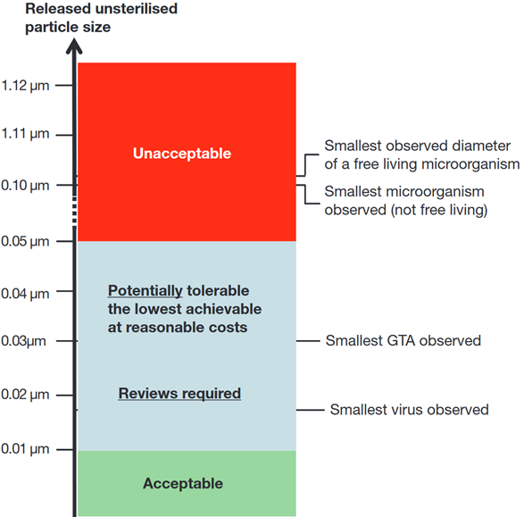

WE DON’T YET HAVE THE TECHNOLOGY TO CONTAIN STARVED ULTRAMICROBACTERIA STILL VIABLE AFTER PASSING THROUGH 0.1 MICRON NANOPORES - A LIKELY SCENARIO FOR MARS - EVEN INDEPENDENTLY EVOLVED ULTRAMICROBACTERIA COULD TRANSFORM OUR BIOSPHERE OR HARM HUMANS - E.G MIRROR LIFE
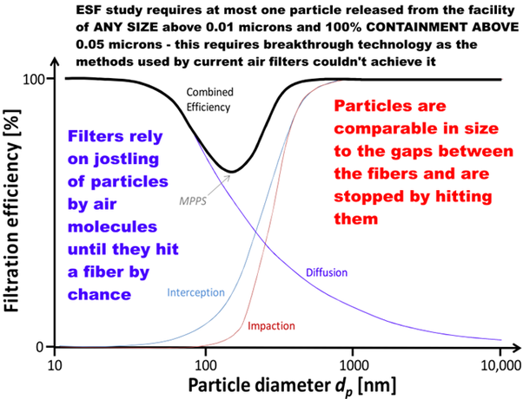
Text on graphic: ESF study requires at most one particle released from the facility of ANY SIZE above 0.01 microns and 100% CONTAINMENT ABOVE 0.05 microns - this requires breakthrough technology as the methods used by current air filters couldn't achieve it
Below maximum penetrating particle size: Filters rely on jostling of particles by air molecules until they hit a fiber by chance.
Above MPPS: Particles are comparable in size to the gaps between fibers and are stopped by hitting them.
Recent air filter technology reviews don’t mention any attempts to achieve 100% containment above any size. Also they don’t mention anything approaching 1 in a million chance of releasing a single particle in the lifetime of a facility at all sizes above 0.01 microns. See: (Application of Electrospun Nonwoven Fibers in Air Filters)
The 100% requirement would seem to need some new breakthrough technique rather than incremental changes such as more layers of filters or varying the spacing as those couldn’t get it all the way to 100% containment of such small particles.

WE ALSO NEED TO CONTAIN GENE TRANSFER AGENTS AT 0.01 MICRONS ABLE TO TRANSFER NOVEL CAPABILITIES OVERNIGHT IN SEAWATER AND AFTER A SIZE LIMIT UPDATE - MAY NEED TO BE PREPARED FOR A SCENARIO OF MIRROR-LIFE RIBOCELLS SIMILAR IN SIZE TO GENE TRANSFER AGENTS - AND NONE OF THE STUDIES MENTION PRIONS
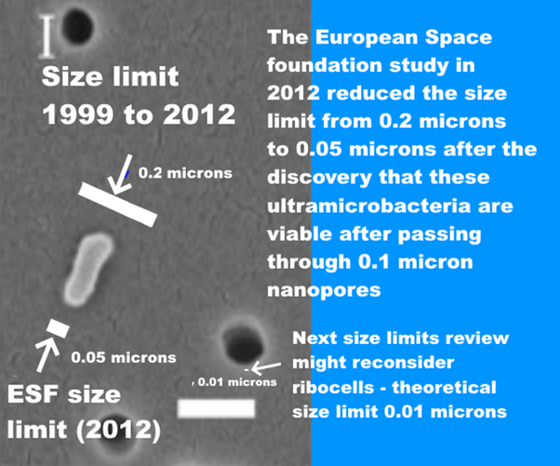
Text on graphic: Size limit 1999 to 2012: 0.2 microns
ESF Size limit (2012): 0.05 microns
The European Space Foundation study in 2012 reduced the limit from 0.2 microns to 0.05 microns after the discovery that these ultramicrobacteria are viable after passing through 0.1 micron nanopores
Next size limits review might reconsider ribocells – theoretical size limit 0.01 microns
SEM of a bacterium that passed through a 100 nm filter (0.1 microns), larger white bar is 200 nm in length
A self contained viable mirror cell from Mars might potentially be as small as a ribocell. Research since 2012 has made this seem increasingly plausible.

NASA MIGHT BE ABLE TO USE AN AIR-FLOW INCINERATOR AT 500°C IN THE FINAL EIS - HOWEVER, THIS IS NOT THE SAME AS HEATING ESCAPED PARTICLES TO 500°C AND MAINTAINING THEM AT THAT TEMPERATURE FOR MINUTES AND WOULD NEED TO BE DEVELOPED AS A NEW PROTOCOL BEFORE IT COULD BE USED FOR THE VERY SMALL ULTRAMICROBACTERIA AND EXTRATERRESTRIAL LIFE
This is a suggestion by NASA astrobiologist Chris McKay (private communication). Everyone agrees extraterrestrial life from Mars would be sterilized by a few minutes of heating to 500°C. Here for instance is a summary by Rummel et al.
If there were a life-form on Mars based on other than carbon-containing molecules, the energies holding such molecules together would not be much different than those for proteins and polynucleotides.
Hence, bond breakage by heat or gamma radiation should be similar for Earth and Mars life forms, and sterilization conditions for Earth microorganisms should eradicate microorganisms of similar size from Mars.
There is no absolutely optimal approach to decontamination under these circumstances, but enough is known about the relationships among organism size, repair mechanisms, and survivability, that the maximum survivability of any martian organisms can be estimated with some confidence.
Page 10 of (A draft test protocol for detecting possible biohazards in Martian samples returned to Earth)
This idea is similar but it’s to use an air-flow incinerator instead of an oven. Would an air incinerator be sufficient to contain the very small ultramicrobacteria, possibly ribocells, and extraterrestrial biology?
The standards for a biosafety class III cabinet for a BSL-4 laboratory do include an option to use an air incinerator instead of the second HEPA filter. See page 37 of (Primary containment for biohazards: selection, installation and use of biological safety cabinets)
These might be effective as a way to contain very small cells, but we need to be aware that they are not rated as such or tested to do this. We have never had to contain ultramicrobacteria in any biosafety laboratory and we have no technology designed to do this.
If NASA with to explore this, it still needs a new EIS.
- NASA needs to acknowledge that the worst-case scenario is a risk of large-scale impact on the environment and human health and that any solution has to satisfy experts in all relevant agencies and internationally.
- This will ensure that any proposal is considered carefully outside NASA.
- In any new EIS, NASA needs to compare it with the reasonable alternative of sterilizing the samples before they come to Earth. This maintains 100% safety for Earth's biosphere more simply, at lower cost and with no potential failure modes.
- We need to develop the specifications first - experts need to look into the size limit and the level of assurance needed, both of which need regular review according to the ESF in 2012. This review has not yet been done.
Once we know what needs to be achieved, NASA need to look into technology.
- failure modes,
- repair,
- improve the methods used to test HEPA filters for such small sizes of particles,
- how to safely change or maintain the air incinerator
Then, I think once it goes through WHO, CDC etc there may well be:
- a requirement for end-of-life sterilization of the facility as well. We don’t know that the samples will eventually be proven to be safe for Earth and we need to be prepared for the possibility that we find that our samples include viable mirror life for as long as this remains a biologically plausible scenario for martian life.
It is too soon to propose a new technology before we know the requirements or the testing methods or who will evaluate it and how. However we can look briefly at some of the issues we would need to consider.

MARTIAN LIFE MAY BE SIGNIFICANTLY MORE RESILIENT TO HIGH TEMPERATURES THAN TERRESTRIAL LIFE - PERHAPS AN AIR INCINERATOR COULD WORK - BUT IT NEEDS TO BE EVALUATED IN A PROPER PROCESS JUST AS THE BSL-4 STANDARDS WERE
The NIH guidelines for research involving recombinant or synthetic nucleic acid molecules specifies that these air incinerators need to be tested against a challenge aerosol of hardy spores, either b. subtilis var niger spores, or b. stearothermophilus spores (NIH guidelines April 2019).
However, for a Mars sample return, it also has to contain potential Martian life potentially more resilient than terrestrial life after millions of years of evolution in the extreme conditions on Mars. It may have:
- evolved to resist UV, ionizing radiation, oxidant stress from perchlorates, chlorates and chlorites, hydrogen peroxide, low pressure and low humidity,
- spores may have evolved additional protective layers against these stressors that would make them more resilient to incineration.
Then in addition
- Even small dust grains could give extra protection from air incineration to microbes imbedded in a crack in the grain.
By the ESF requirement, it has to contain
- ALL microbes down to ultramicrobacteria at 0.05 microns
– these air incinerators aren’t tested for ultramicrobacteria.
- Have only a 1 in a million chance of releasing a single viable Gene Transfer Agent at 0.01 microns for the lifetime of the facility
– these incinerators are not tested for the very numerous GTAs which can transfer novel capabilities to unrelated life overnight in seawater.
Then Martian microbes could use a more resilient backbone than DNA for its informational biopolymer. In one experimental test of PNA heated for 150 to 200 ms
- All RNA – RNA base pairs are UNSTABLE beyond 350°C
- All PNA – PNA base pairs are STABLE up to 420°C
See : Fig 10 of (Thermal stability of peptide nucleic acid complexes)
In a test of melting for 200 ms,
- Nearly all RNA – RNA strands separate at 340 C
- Almost none of the PNA – PNA strands separate at 340 C
See : Fig 4 of (Thermal stability of peptide nucleic acid complexes)
Mars could have more stable informational polymers through an accident of evolution, or through adaptation to ionizing radiation, or adaptation to high temperatures or both. Mars had subsurface hydrothermal systems in the recent past, and they may well be present today as well, and may well be a refuge for surface life at times when the surface is less hospitable.
- Some Mars life may be resilient to very high temperatures. Mars could have surface life like the terrestrial geobaccilus spores which do best in hydrothermal vents but they are found in surprisingly large numbers almost everywhere researchers look, including in cool soils and cool ocean floors (The Geobacillus paradox: why is a thermophilic bacterial genus so prevalent on a mesophilic planet?)
- Mars had hydrothermal conditions less than 20 million years ago in the rootless cones (without a magma chamber) (Interactions between Athabasca Valles Flood Lavas and the Medusae Fossae Formation (Mars): Implications for Lava Emplacement Mechanisms and the Triggering of Steam Explosions).
- There is some evidence suggesting recent volcanic activity as recently as 53 to 210 thousand years ago which may also suggest Mars could be geologically active today (Evidence for geologically recent explosive volcanism in Elysium Planitia). Mars could have caves that vent to the surface even today. See page 788 of (Mars Extant Life: What's Next? Conference Report)
- the ionizing radiation and the desiccation and oxidants of the surface would favour life that has especially resilient double-strand bonds.
In short, an airflow incinerator may be part of a future solution, but it couldn’t be added in at the last minute in an ad hoc way to “fix” the draft EIS.
There would be a lot of preliminary work needed before it could be considered as a solution. The EIS would need to restart with a new technology review based on examining whether such technology could be used to contain an alien biology to the required level of assurance. There seem to be many things that such a review would need to consider.
The standards would need to be developed with the same level of care that was used to develop the standards for BSL-4 facilities and Biosafety class III cabinets.

UNDER THE NEPA REQUIREMENTS NASA SHOULD COMPARE USE OF AIRFLOW INCINERATORS WITH THE REASONABLE ALTERNATIVE TO STERILIZE THE SAMPLES BEFORE THEY REACH EARTH WHICH SEEMS FAR EASIER AND WITH NO POTENTIAL FAILURE MODES
Perhaps this will be an option in the future. However, it is not clear why we would do this for NASA’s mission, since there is a far easier approach, to sterilize the samples before they are returned to Earth.
If NASA do pursue this approach of an air-flow incinerator, they should by NEPA requirements also consider reasonable alternatives such as presterilizing samples before they return to Earth.

NASA’S MISSION CAN BE MADE 100% SAFE FOR EARTH BY STERILIZING SAMPLES BEFORE THEY REACH EARTH
However you CAN turn this into a mission that is 100% safe for Earth and that achieves all the same science objectives and indeed achieves far more, by sterilizing all Perseverance's samples before they reach Earth. 8 commentators suggested this in the first round of public comments but you haven't considered it in the draft EIS. I suggest it deserves attention.
Sterilization will have virtually no impact on the geological science studies as you yourself concluded. As for astrobiological studies, even past organics with 100 parts per billion as in our least exposed Martian meteorites would have that reduced to 0.1 parts per billion of recognizable organics after just 20 million years of surface exposure. The organics aren't destroyed in this process but bonds are broken and reformed to the extent that they are unrecognizable. Perseverance can't detect the exposure age of the rocks it samples, and has virtually no chance of returning samples with interesting evidence of past life organics.

THIS IS AN EASY WAY TO MAINTAIN YOUR WORLD-LEADING ROLE IN PLANETARY PROTECTION - TO STERILIZE SAMPLES BEFORE THEY RETURN TO EARTH - WHICH MAINTAINS VIRTUALLY ALL SCIENCE RETURN FOR THIS MISSION - AND ALSO GIVES AN EASY PRECEDENT FOR OTHERS TO FOLLOW
You have another option here to maintain your world-leading role in planetary protection, with no risk of harm to Earth and to provide an example for other space agencies to follow.
This is the option of a pre-sterilized sample return. This is a simple way of keeping Earth 100% safe that other space agencies and private space can copy easily. Your draft EIS didn’t even look at this option although I and several others recommended it in the first round of public comments.
NEPA requires you to look at reasonable alternatives.
(a) Evaluate reasonable alternatives to the proposed action, and, for alternatives that the agency eliminated from detailed study, briefly discuss the reasons for their elimination.
(b) Discuss each alternative considered in detail, including the proposed action, so that reviewers may evaluate their comparative merits.
§ 1502.14 [links directly to legal text]
The samples can be sterilized in a satellite resembling those in Geostationary Earth Orbit but in a higher orbit with no risk of contamination of either Earth or the satellites in GEO. Other missions could use the same satellite for sterilization for their missions too. The sample tubes wouldn’t need to be opened, just sterilize the whole sample.
This will have minimal impact on geology. From your own EIS you don’t expect any present-day life.
I and seven others made this suggestion in the first round of public comments. But you didn’t look at it.

YOUR PERMITTED LEVELS OF FORWARD CONTAMINATION WILL COMPLETELY OVERWHELM ANY TRACES OF PAST ORGANICS WITH SURFACE EXPOSURE AGES AS YOUNG AS 6 MILLION YEARS - CURIOSITY’S CUMBERLAND MUDSTONE IS 80 MILLION YEARS AND PERSEVERANCE CAN’T MEASURE EXPOSURE AGES
Meanwhile, it turns out your permitted forward contamination will make it impossible to detect biosignatures of past life even in samples with only 6 million years of surface exposure. That is enough to reduce recognizable biosignatures from 100 ppb as found in a Mars meteorite with only 2 million years of ionizing radiation exposure to 0.1 ppb (not destroyed, but broken up and transformed into other usually short molecule organics).
See: . Rapid Radiolytic Degradation of Amino Acids in the Martian Shallow Subsurface: Implications for the Search for Extinct Life
That is below your 0.7 ppb per biosignature of forward contamination by terrestrial life which you think you have achieved.
That is far less than the 80 million years exposure age of the Curiosity Cumberland mudstone sample. Though it’s possible Jezero crater has samples with younger exposure ages than that, Perseverance doesn’t have the capability to measure exposure ages in situ.
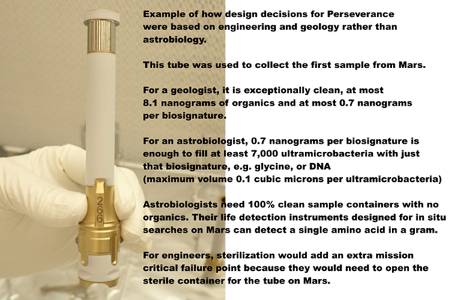
Text on image: Example of how design decisions for Perseverance were based on engineering and geology rather than astrobiology.
This tube was used to collect the first sample from Mars.
For a geologist, it is exceptionally clean, at most 8.1 nanograms of organics and at most 0.7 nanograms per biosignature.
For an astrobiologist, 0.7 nanograms per biosignature is enough to fill at least 7,000 ultramicrobacteria with just that biosignature, e.g. glycine, or DNA (maximum volume 0.1 cubic microns per ultramicrobacteria)
Astrobiologists need 100% clean sample containers with no organics. Their life detection instruments designed for in situ searches on Mrs can detect a single amino acid in a gram.
For engineers, sterilization would add an extra mission critical failure point because they would need to open the sterile container for the tube on Mars.

STERILIZING SAMPLES IN SPACE ELIMINATES ISSUES OF PUBLIC OPPOSITION - WITH VIRTUALLY NO IMPACT ON SCIENTIFIC RETURN
Sterilizing the samples in situ eliminates the risk of the general public being opposed and conspiracy theories. It also eliminates the issue of the presidential directive on large-scale effects or legal challenges to the EIS.
It makes no difference to cost as it removes the cost of a new biosafety laboratory that NASA doesn’t have - and it adds the cost of a small robotic satellite similar to the ones in GEO to sterilize samples before they return to Earth which is roughly similar in cost.
Also it removes the need for a heavy aeroshell, so it turns out to have almost no difference on the return mission too.
Also, as we saw, it has likely virtually no impact on science return.

WE CAN ENHANCE THE MISSION WITH BONUS SAMPLES COLLECTED WITHOUT FORWARD CONTAMINATION IN A CLEAN CONTAINER SENT IN THE ESA FETCH ROVER AND RETURN THEM TO A SMALL CENTRIFUGE MARS SIMULATION CHAMBER ABOVE GEO
I also make suggestions for a way to greatly increase the science return by returning samples of the surface dust, dirt, atmosphere, and pebbles in a CLEAN container sent there in the ESF fetch rover.
This would be returned not to Earth but for remote study in the same satellite above GEO that we have for sterilizing the Perseverance samples.
We would study the bonus samples using instruments already designed for in situ searches for life biosignatures and processes on Mars. In this way also we build up a capability in space to anlayse future samples returned from Mars and elsewhere in the solar system.
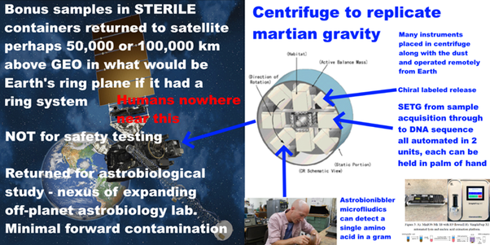
This would be minimal cost for NASA as the instruments would be funded by universities.
Humans go nowhere near the satellite (human quarantine can’t keep out mirror life or fungal pathogens of crops or fungal diseases that only affect some people).
We can return subsamples of the dirt, dust, and pebbles to Earth but we would do 100% sterilization of those samples. We can’t do safety testing to a high level of assurance even for samples in a clean container. Destructively test 10,000 grains of sand and the 10,001th grain could have a microbe imbedded in a crack that we never noticed.
We would study unsterilized samples in a safe orbit above GEO until we understand what’s in the samples very well, then it is for us to assess whether to continue to keep them in orbit. It may take multiple missions to Mars before we understand it well enough to be sure that samples can be returned unsterilized.
We do need to be prepared for the possibility of a discovery of great interest, such as mirror life, that would mean we can NEVER return uncontained unsterilized samples to Earth. That is why we do all this. Because there is a significant, likely small possibility that Earth DOES need to be protected.

MY FINAL COMMENT TO YOUR DRAFT EIS SUMMARIZES THESE MAIN POINTS
I cover the main points in my final comment to your draft EIS
I recommend this draft Environmental Impact Statement is stopped, and a new one prepared after doing the necessary size limits review, and fixing whatever led to its many errors.
1. The BSL-4 recommendation in this EIS is out of date, based on science of 1999.
2. This EIS does not mention the most recent Mars Sample Return study from 2012 by the European Space Foundation which reduced the 1999 size limit from 0.2 microns to 0.05 microns to contain ultramicrobacteria and required 100% containment at that size.
3. A BSL-4 is not designed to this standard. In recent reviews of filter technology, I find NO AIR FILTERS with that capability – and no evidence anybody is working on them. Air filters for larger particles remove some of these very small particles kicked out of the airstream by jostling of air molecules by Brownian motion but can't remove all. It is an unusual requirement.
4. NASA haven't responded to my comment in May which alerted them to this omission. They still don't cite the ESF study. Also, the ESF said their limit needs to be updated periodically. An update is certainly due a decade later.
5. The EIS has an overnarrow scope in the Purpose and Need section - it requires samples to be returned unsterilized to terrestrial labs for "safety testing". This won’t work. NASA believe they reduced the most abundant biosignatures to 0.7 nanograms per gram of returned rock sample – this guarantees a positive test. There will be no way to know if tubes contain safe terrestrial life or potentially unsafe martian life.
6. This narrow scope improperly excludes the reasonable alternative of presterilizing samples before they reach Earth's biosphere - which achieves virtually the same science return and keeps Earth 100% safe. By a 1997 case in the 7th circuit this alone probably invalidates the EIS.
7. The high levels of forward contamination make astrobiology almost impossible. I recommend bonus samples of dirt, dust and atmosphere collected in a STERILE container with no terrestrial organics, brought to Mars especially on the ESA fetch rover.
8. I recommend returning these bonus astrobiology samples to a safe orbit above GEO where they can be tested for life
9. The EIS’s reasoning for no significant environmental effects contradicts the conclusion of the NRC study from 2009 which they do cite, which says the risk of even large-scale impacts on human health or environment is likely low but not demonstrably non zero. It also warns against the meteorite argument that they use. I found multiple errors in my analysis.
10. Returned life COULD be harmful. Example, fungi kill crops, other life and sometimes immunocompromised humans. Botulism, ergot disease, tetanus, all are the results of exotoxins not adapted to the lifeforms they kill, similarly some algal blooms kill dogs and cows that eat them. BMAA misincorporated for L-serine causes protein misfolding and is a neurotoxin implicated in some cases of the disease that affected Steven Hawking - an alternative biochemistry may have many different amino acids similar enough to terrestrial amino acids to be misincorporated. Or perhaps martian life evolved from scratch from mirror chemicals as mirror life - the effect on our biosphere can't be predicted. I give many such examples in my preprint. Or it could be harmless like microbes from a terrestrial desert, or indeed beneficial. But we DON'T KNOW. So we need to find out first.
11. What matters for invasive species are the ones that can’t ‘get here, like starlings that can't cross the Atlantic rather than barn swallows. The freshwater diatom Didymo is invasive in New Zealand and can't get from one freshwater lake to another without humans. A microbe adapted to briny seeps on Mars and to spreading in dust storms shielded from UV, may well not get to Earth in a meteorite, while a sealed sample tube including Martian atmosphere, at Mars atmospheric pressure, is like a mini spaceship.
12. Quarantine of humans can’t keep out a fungal disease of crops, mirror life etc.
13. So any unsterilized samples will need to be studied remotely via telerobotics which also greatly reduces forwards contamination (issues with filtering ultramicrobacteria will go both ways).
14. astrobiologists now have tiny instruments that can go from sample preparation to life detection, even to a gene sequence[r], operated remotely on Mars. They could send hundreds of these in each 7 ton payload of the Ariane 5 to above GEO.
Let's make this an even better mission and SAFE for Earth.
Thanks!
. Comment posted December 20th

