Open letter to NASA: please listen to your own experts and take more care to protect Earth's biosphere from any extraterrestrial microbes in samples you return from Mars in the 2030s - MID EDIT NOT FOR SHARING YET
Dear NASA planetary protection office and other interested parties.
[Please forward to your point of contact for comments on the draft EIS]
This is about your Environmental Impact Statement (EIS) for samples you plan to return from Mars in the early 2030s. The Council on Environmental Quality advises the public that if our concerns aren’t resolved during comments on the EIS, we need to contact the agency:
Your first line of recourse should be with the individual that the agency has identified as being in charge of this particular process. (page 28 of A citizen’s guide to the NEPA: Having your voice heard.)
I tried an email to your office on December 18, 2022, and got no reply. This is an open letter, which I will post to the internet and archive, and I will email a link to you together with a video presentation. I am expecting a reply as per the CEQ advice.
NASA has been world-leading in its protection of Mars from forward contamination – from any terrestrial life that might get there and proliferate in any habitats that might exist in the Martian desert landscape.
You have also been world-leading in your literature on a Mars sample return.
But sadly your current EIS is not world-leading.
I end this post with a suggestion on how you can move forward from this EIS with a new approach that would
- retain your world-leading role in planetary protection,
- be an excellent example that’s easy for other space agencies and private space to follow to keep Earth 100% safe
- has less upfront cost this decade
- adds the cost of a small satellite in a safe orbit above GEO in the 2030s (when launch cost to GEO will likely be greatly reduced)
- with a suggestion for small bonus samples gathered by the ESF rover in a clean container that would greatly enhance the science return for astrobiology.
My literature survey and these recommendations are covered in more detail in my preprint, which also has new example scenarios to help motivate space agencies to protect Earth, such as mirror life, see link below.
- PREPRINT: NASA must protect Earth's biosphere even if Mars samples hold mirror life – a survey of recent planetary protection research plus new scenarios – for attention of space agencies and commercial space – with option to keep Earth 100% safe
This is a short summary of some of the main points in my preprint. I will also use this page and the graphics as the basis for the video presentation. For citations in this open letter I just give the title in brackets hyperlinked to the paper.

TITLES ARE LIKE MINI ABSTRACTS
The title of each section also summarizes its main conclusions similarly to an abstract. You can get a good first idea of this open letter by just reading the titles of sections - and looking at any graphics.

JOHN RUMMEL (FORMER NASA PLANETARY PROTECTION OFFICER): “WE DO NOT KNOW EVERYTHING WE WANT TO KNOW ABOUT MARS … WE DO NEED TO BE CAREFUL”
John Rummel, NASA planetary protection officer from 1986–1993, puts it like this as interviewed by Scientific American in 2022 after the first round of public comments on your proposals:
“In the first place, we don’t know everything we want to know about Mars. That’s why we want the samples.
We keep finding Earth organisms doing new things that are quite interesting from the standpoint of potential life elsewhere. So why don’t we think we need to be careful? The answer is that we do need to be careful, as repeatedly emphasized by the National [Academies]....
People have to have some kind of respect for the unknown. If you have that respect, then you can do a credible job, and the public is well-served by your caution.”
(Controversy Grows Over whether Mars Samples Endanger Earth)
(Curriculum Vitae John D. Rummel) [for his dates as NASA planetary protection officer]

CASSIE CONLEY (FORMER NASA PLANETARY PROTECTION OFFICER): WE ARE GOING TO CONTAIN THE SAMPLES AS IF THEY WERE THE MOST HAZARDOUS EARTH ORGANISMS WE KNOW ABOUT
Cassie Conley, former NASA planetary protection officer from 2006 - 2018:
“that means we are going to contain the samples as if they were the most hazardous Earth organisms that we know about, Ebola virus.”
at 1:02 into this NASA video
(Dr. Catharine Conley) [for her dates as NASA planetary protection officer]
Of course, we won’t find Ebola on Mars, it’s just an example to show how deadly the worst case could be. But in the worst case, we may find diseases of humans that are just as deadly. There are many illustrative examples in the planetary protection literature.

DISEASES NOT ADAPTED TO HUMANS LIKE TETANUS STILL KILL THOUSANDS OF UNVACCINATED NEWBORNS EVERY YEAR
The planetary protection literature mentions several diseases not adapted to humans or any higher life such as:
- Tetanus still kills thousands of newborns every year who miss out on vaccination, and it is not adapted to humans.
- Legionnaires disease, is a disease of microbial biofilms which infects human lungs opportunistically because lungs resembles a biofilm and is sometimes deadly
(Assessing the Biohazard Potential of Putative Martian Organisms for Exploration Class Human Space Missions)
As a result of following up on the Candidas example given by the sterilization working group, I’ve added another illustrative example
- Aspergillus fumigatus, a fungus not adapted to humans with 200,000 cases of invasive aspergillosis a year and a 30% to 95% fatality rate (Hidden killers: human fungal infections) with characteristics that may well be shared by martian fungi (Ecology of aspergillosis: insights into the pathogenic potency of Aspergillus fumigatus and some other Aspergillus species).
I cover these examples and more in my open letter to the CDC which I plan to send to them to help raise awareness in other US agencies.
. Open letter to CDC (draft) - MIDEDIT (PLEASE DON’T SHARE WIDELY, READY SOON)
As we’ll see later, the CDC are one of numerous agencies that the sample return studies say need to look at the plans once one agrees that there is a possibility of impact on human health in worst case scenarios (Assessment of planetary protection requirements for Mars sample return missions : Pages 67–8).
But so far NASA are not liaising with the CDC to make sure their Sample Receiving Facility protocols are adequate for alien life from anoner planet - at least they say nothing about doing so in the EIS.

MANY CANDIDATE TERRESTRIAL MICROBES COULD LIVE ON MARS WITH A SOURCE OF SALTY OR FRESH WATER - SUGGESTING SIMILAR MARS ANALOGUES COULD LIVE IN EARTH’S OCEANS OR SOILS
We now have many terrestrial organisms that do well in Mars simulation chambers including lichens, mosses, fungi, various bacteria, and algae. See: (Habitability of Mars: How Welcoming Are the Surface and Subsurface to Life on the Red Planet?)
This includes Chroococcidiopsis, a highly resilient blue-green algae which does well in Mars simulation conditions (Protection and Damage Repair Mechanisms Contributed To the Survival of Chroococcidiopsis sp. Exposed To a Mars-Like Near Space Environment).
This algae can be found almost everywhere on Earth from tropical reservoirs and oceans to cold dry deserts and even in complete darkness in gabbro 10 -750 meters below the Atlantic sea bed using an alternative metabolic pathway with hydrogen as a source of energy (Recycling and metabolic flexibility dictate life in the lower oceanic crust). Gabbro and basalt are amongst the most common rocks on both Mars and Earth.
Chroococcidiopsis is a pioneer “prime producer” that doesn’t depend on any other life and can find all its requirements in seawater, or rocks such as basalt, so long as it also has access to water and a source of energy such as sunlight. Strains of chroococcidiopsis do well in both hot deserts and very cold Mars analogue deserts in Antarctica (Ancient origins determine global biogeography of hot and cold desert cyanobacteria ), and also in warm wet conditions up to human body temperature, for instance in the upper throat behind the nose (Nasopharyngeal Microbiota as an early severity biomarker in COVID-19 hospitalised patients)
If Mars has an analogue of Chroococcidiopsis, a photosynthetic lifeform that lives in basalt and uses sunlight as an energy source it may already be adapted to survive on Earth and to proliferate and spread widely as it evolves to terrestrial habitats.

NEPA REQUIRES AGENCIES TO ENSURE SCIENTIFIC INTEGRITY - BUT PUBLIC COMMENTS ARE THE ONLY MECHANISM THEY REQUIRE TO ENSURE THIS - I’M ASKING FOR A RESPONSE TO HELP ENSURE NASA MAINTAINS SCIENTIFIC INTEGRITY IN THIS REPORT
As John Rummel said, we need respect for the unknown. NEPA requires agencies to ensure scientific integrity of the discussions and analyses in the EIS.
Agencies shall ensure the professional integrity, including scientific integrity, of the discussions and analyses in environmental impact statements
§ 1502.23 [Links directly to the legal text]
However, they have no mechanism to ensure scientific integrity except public comments. I commented on your first round of public comments on May 16. The draft EIS didn’t mention many serious issues I raised with your plans. I commented on the second round on November 28th, December 5th, December 13th and December 20th. These raise very serious issues with the scientific integrity of the EIS.
I emailed your point of contact Dr Alvin L,. Smith II on 18th December. I got no response.

MY PRELIMINARY SURVEY OF THE RECENT LITERATURE - THE LAST SAMPLE RETURN REVIEW WAS COMPLETED IN 2009 JUST BEFORE THE ANNOUNCEMENT OF THE PHOENIX LANDER LEG DROPLETS - IT’S GENERALLY AGREED NOW THAT THE PHOENIX LANDER TEAM OBSERVED DROPLETS OF COLD SALTY WATER
Since my unanswered email to you on 18th December, I’ve been working on a preliminary survey of the recent literature. This builds on research for a paper about planetary protection for NASA’s Mars sample return mission which was almost ready to send to academic journals at the time of my public comments last year.
The last thorough review is the NRC study, published in March 2009, just before the Phoenix team first published their observations of possible droplets of salty water on the Phoenix lander’s legs, later confirmed in simulation experiments as likely the first direct confirmation of (very cold) surface salty water on Mars. These are the droplets they simulated, coloured in green.
Possible droplets on the legs of the Phoenix lander – they appeared to merge and sometimes fall off. In this sequence of frames, the rightmost of the two droplets grows and seems to do so by taking up the water from its companion to the left, which shrinks - highlighted in green in this black-and-white photo from Mars (Liquid Water from Ice and Salt on Mars).
When Nilton Renno’s team successfully simulated these droplets in a Mars simulation chamber in 2014 he put it like this:
This is a small amount of liquid water. But for a bacteria, that would be a huge swimming pool – a little droplet of water is a huge amount of water for a bacteria. So, a small amount of water is enough for you to be able to create conditions for Mars to be habitable today. And we believe this is possible in the shallow subsurface, and even the surface of the Mars polar region for a few hours per day during the spring.
, How liquid water forms on Mars, (transcript from 1:48 onwards)
This discovery lead to many more indirectly detected or proposed salty brines on Mars, some of which may be habitable to Martian life.

MY LITERATURE SURVEY IDENTIFIED MANY TOPICS TO COVER IN DEPTH IN AN UPDATED MARS SAMPLE RETURN REVIEW BEFORE ANY AGENCY CAN DO A THOROUGH ENVIRONMENTAL IMPACT STATEMENT
The science has moved forward so much in the 14 years since 2009, including many proposed martian microhabitats, the surprising resilience of terrestrial microbes in Mars simulation chambers, new experiments in the transport of microbes and fragments of microbial biofilms in Martian winds, and new discoveries about terrestrial microbes living in Mars analogue cold dry deserts.
My preliminary literature survey identified many areas for review in an update of the 2009 study. I also added new illustrative backward contamination scenarios such as mirror life, to help focus attention of space agencies on the need to protect Earth.
See:
- PREPRINT: NASA must protect Earth's biosphere even if Mars samples hold mirror life – a survey of recent planetary protection research plus new scenarios – for attention of space agencies and commercial space – with option to keep Earth 100% safe
Almost none of this literature is mentioned in the EIS. One of the conclusions of my preprint is that NASA needs to commission another planetary protection back contamination review before it is feasible to do a thorough EIS for an unsterilized Mars sample return. If space agencies are serious about protecting Earth, they need to take account of the many new developments as a result of 14 years of research since 2009.
It would be possible to return samples sterilized before they reach Earth without such a review.
This open letter is another attempt to contact you with the main outlines of my preliminary literature survey in place.

CARL SAGAN WOULD CONTACT YOU IF ALIVE TODAY
I am a long-term admirer of NASA since before Apollo and my views on planetary protection are similar to those of Carl Sagan, one of my heroes.
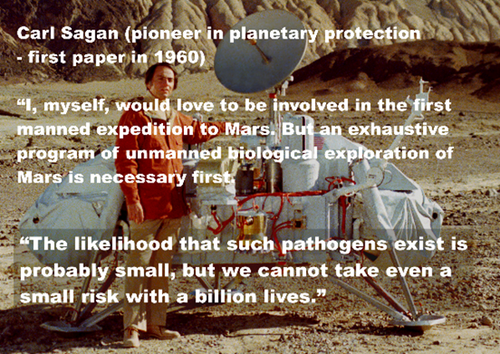
Text on graphic: Carl Sagan (pioneer in planetary protection - first paper in 1960)
[his first paper is (Biological contamination of the Moon)]
“I, myself, would love to be involved in the first manned expedition to Mars. But an exhaustive program of unmanned biological exploration of Mars is necessary first.
“The likelihood that such pathogens exist is probably small, but we cannot take even a small risk with a billion lives.”
[quote from: (The Cosmic Connection – an Extraterrestrial Perspective)]
[I provide text captions for the graphics in this open latter for visually impaired readers]
It’s strange to write this to you, as a long-term admirer of NASA, but there doesn’t seem to be anyone in the public playing the role of Carl Sagan today. I am sure he would make a similar response to your EIS, though at an earlier stage, and he would have been listened to.

YOU DON’T SUPPLY CREDIBLE EVIDENCE THAT MARS HAS BEEN UNINHABITABLE FOR MILLIONS OF YEARS - Could be used mistakenly to drop all precautions to protect Earth
This is one of three arguments in the EIS of central importance as precedent because others could use it to reason in good faith, but mistakenly, that we already know there is no life on Mars and so, that it is safe to drop all precautions to protect Earth’s biosphere from Mars samples.
You say
Existing credible evidence suggests that conditions on Mars have not been amenable to supporting life as we know it for millions of years (… National Research Council 2022).
(Mars Sample Return DRAFT EIS : 1–6)

EVEN YOUR OWN MOST RECENT CITATION FOR “EXISTING CREDIBLE EVIDENCE” IS THE OPPOSITE OF EVIDENCE, IT DESCRIBES SEARCHES FOR CURRENT HABITATS ON MARS!
Your most recent citation for “existing credible evidence” is about a search for current habitats on Mars!
“The exploration of … Mars … will help establish whether localised habitable regions currently exist within these seemingly uninhabitable world”.
(Origins, Worlds, and Life: A Decadal Strategy for Planetary Science and Astrobiology : page 393 [Click on the X to close the splash to go straight to page 393])
This is a screenshot of that page (for video presentation).
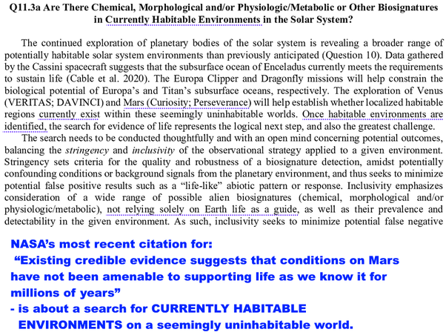
NASA’s most recent citation for “Existing credible evidence suggests that conditions on Mars have not been amenable to supporting life as we know it for millions of years” is about a search for CURRENTLY HABITABLE ENVIRONMENTS on a seemingly uninhabitable world.

ONE OF NASA’S MAIN GOALS FOR MARS EXPLORATION IS TO SEARCH FOR PRESENT DAY LIFE (SECOND HALF OF GOAL 1)
But one of your own science goals has the search for present-day life and habitats as the second part of Goal 1 in your 2020 update of the Mars exploration program science goals!
Goal 1: Determine if Mars ever supported or still supports, life,
(MEPAG Science Goals, Objectives, Investigations, and Priorities : page 9)
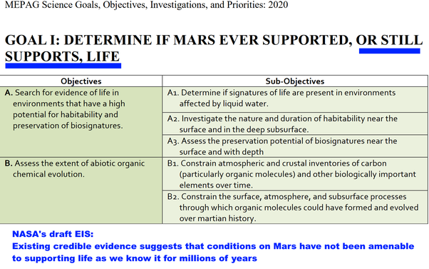

ONE OF THE MAIN GOALS FOR THESE VERY SAMPLES IS TO SEARCH FOR PRESENT DAY LIFE, OBJECTIVE 2.3
It is also objective 2.3 for the Mars samples, to test to see if there is any evidence for present-day life - in the very samples Perseverance is caching and that you plan to return with this mission in the 2030s.
2.3 Modern biosignatures: Assess the possibility that any lifeforms detected are still alive or were recently alive.
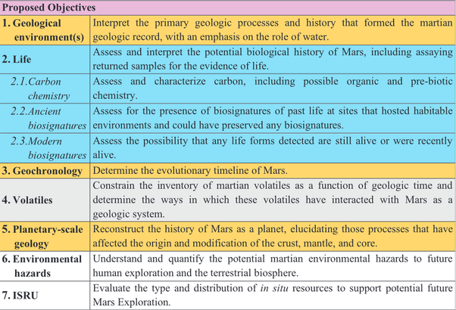
Table 2 of (Planning implications related to sterilization-sensitive science investigations associated with Mars Sample Return (MSR))
This table is based on the conclusions of the iMOST team (International MSR Objectives and Samples Team). [MSR = Mars Sample Return]

NASA PLAN TO DO MANY TESTS TO TRY TO FIND PRESENT-DAY LIFE IN THE RETURNED SAMPLES INCLUDING TESTS FOR MICROBIAL RESPIRATION AND TO SEE IF THEY CAN GET ANY MARTIAN LIFE TO GROW IN CULTURE MEDIA
The objectives described by iMOST are now NASA official policy for the returned samles - the iMOST conclusions were adopted in the final report the Mars Sample Return Science Planning Group in 2022.
The scientific objectives of MSR are comprehensively described by iMOST
(Final Report of the Mars Sample Return Science Planning Group 2 (MSPG2) : page S-21)
The iMOST team say the probability of discovering present-day life at the Martian surface is considered to be low, but it would be such a profound discovery we need to look for it.
The probability of discovering extant life at the Martian surface (including by means of MSR) is generally considered to be low. However, its discovery would be so profound that it would shake the pillars of science. It would yield insight into the very fundamentals of life such as what are the basic universal properties of living systems … and how life evolves
(The potential science and engineering value of samples delivered to Earth by Mars sample return: International MSR Objectives and Samples Team (iMOST) : Page 86)
The iMOST team find present-day life on Mars plausible, because of (pages 86–7)
- discoveries that suggest liquid water may flow on Mars on the surface or below it
- evidence some terrestrial life can metabolize and grow in Mars simulation conditions.
- Some Mars analogue locations in Antarctica have active microbial communities, and others have evidence of life but not metabolic activity. This suggests Earth life may be able to grow in a Mars-like environment but it nears the limits of survivability
They conclude that native life on Mars may be able to adapt and evolve to the local conditions. See (iMOST : page 87)
To search for present day life they will
- lInvestigation Strategy 2.3A: As part of developing a complete inventory of the organic molecules present, assess the presence and characteristics of molecules that are diagnostic of organisms that are either alive, or were recently alive.
  - Measure the presence of biochemical species, especially pigments, proteins, DNA, RNA, lipids, etc.
[See page 91 of (iMOST)]
NASA would then use a similar strategy to the Viking labeled release. Add some of the samples to a growth medium and see if there is any sign of microbes that use the organics and produce evolved gases like CO2 or methane. They would do that by replacing some of the carbon with Carbon 13, nitrogen with Nitrogen 15 and hydrogen with deuterium so they can keep track of what happens with the atoms in the growth medium.
- Investigation Strategy 2.3B: Assess the possibility of metabolism and respiration
  - Measure the abundance of isotopes, isotopologues, and isotopomers.
[i.e. molecules containing the isotopes (isotopologues), as well as molecules with the same formula but differing in structure (isotopomers)]
  - Extract and sequence DNA.
  - Identify and measure evidence for cellular growth, metabolism, and respiration
This would be a major advance over Viking which couldn’t even detect if the evolved gas was methane or carbon dioxide, or something else.
[See page 92 of (iMOST)]
Then finally they would attempt to get any Martian life to replicate. If they do succeed in this, they would study the cells and look also for any structures they might be using to move around (this would include the flagella, long filaments that which terrestrial microbes often use to swim).
- Investigation Strategy 2.3C: Assess the possibility that organisms within the sample are capable of reproduction in culture experiments.
  - Measure cell size, shape, and structure.
  - Evaluate morphological indications of replication and specialized features like motility structures
They conclude:
Success in cultivating organisms from Martian samples would be the ultimate proof of extant life. On Earth we can only culture a few percent of all environmental microorganisms because it is difficult to predict and reproduce conditions amenable to growth. We expect that Martian organisms would be no less recalcitrant. Therefore, it is critical that growth experiments be conducted under conditions present at the sample site.
[See page 93 of (iMOST)]
So, though the iMOST team think the chance of present day life is likely low, they recommended that NASA do extensive tests to try to find present-day Martian life in the samples.
NASA’s draft EIS does refer to the iMOST team objectives (Mars Sample Return DRAFT EIS : 1–11) saying:
The science potential of samples delivered from Mars was most recently re-evaluated by the international MSR Samples and Objectives Team (iMOST), which was active from 2017 to 2018
However, it doesn’t mention the interest in searching for present day life.

WAS THERE A LACK OF COMMUNICATION BETWEEN THE LIFE DETECTION TEAM FOCUSING ON PRESENT-DAY LIFE ON MARS AS THEIR BEST CASE, AND ENGINEERS AND MISSION PLANNERS FOCUSING ON AN UNINHABITABLE MARS AS A WAY THE MISSION COULD BE ACCOMPLISHED MOST EASILY? WHATEVER THE CAUSE WE NEED TO FIX THIS FOR FUTURE EIS’S
So - going back to NASA’s sentence in the EIS:
Existing credible evidence suggests that conditions on Mars have not been amenable to supporting life as we know it for millions of years
(Mars Sample Return DRAFT EIS : 1–6)
A more accurate statement would be
The probability of discovering extant life at the Martian surface is generally considered to be low, but there is enough of a chance of life in the Perseverance samples that NASA plans to test for living organisms in it.
(iMOST : page 86)
Why doesn’t your draft EIS mention that NASA plans to test the returned samples to see if there is any present-day Martian life in them?
It could be a simple lack of communication between the engineering team and the life detection scientists. Such things happen, like the mix-up that led to the loss of the Mars Climate Orbiter which crashed into Mars in 1999 (In Depth | Mars Climate Orbiter – NASA Solar System Exploration).
- Some scientists in JPL used the English units of pounds, feet and seconds and others used the metric units of kilograms, meters and seconds.
- A small file called AMD was saved in English units when its specification said it should have been saved in metric units.
- Modelers assumed the file used the correct units and that lead to the crash (Mars Climate Orbiter Mishap Investigation Board Phase I Report November 10, 1999)
Or maybe it is optimism about their respective goals.
For scientists devising experiments to look for life, the most interesting outcome by far is present-day life. The iMOST authors recommend NASA to test for present-day life even if it may be unlikely, because it would be such a major discovery.
For engineers and mission planners preparing protocols to protect Earth, the less the risk, the lower the cost of the mission. So, it is natural for optimistic planners to find it more plausible that Mars has been uninhabitable for millions of years, as this will likely reduce the cost of the mission and make mission planning simpler.

LOOKING TO THE FUTURE WE NEED MORE FUNDING FOR PLANETARY PROTECTION - THOUGH FOR THIS MISSION WE’LL FIND THERE IS A WIN WIN WIN SOLUTION TO CONSIDER THAT SAVES ON COSTS, INCREASES SCIENCE RETURN AND KEEPS EARTH 100% SAFE
Whatever the reason, if we take the protection of Earth seriously it is important to look carefully at worst-case as well as best-case scenarios. If we do that, just look clearly at the data as it is, we can get surprises. We may find a “win win win” solution that optimizes all our goals at once.
I end this open letter with exactly such a proposal (with bonus samples) as mentioned in the intro to this open letter
- Costs less for NASA this decade
- Adds the cost of a satellite above GEO in the 2030s
- Leads to MUCH MORE science return.
- And keeps Earth 100% safe.
We need to look at costs not just to NASA but to the Earth for the worst-case scenario where Earth’s biosphere or human health is harmed. Perhaps this needs extra legislation to mandate NASA to spend extra if necessary to protect Earth? It’s understandable that NASA mission planners are motivated above all by the need to reduce cost for their missions. But I’d argue that in this case - AND in the forwards direction - the world is better saved by a space agency that has extra funding to ensure it does planetary protection properly. It seems perverse for NASA to have strong financial incentives to skimp on planetary protection.
My conclusions were that it seems that this mission can likely be made 100% safe at no extra cost with more science return. However, in the larger picture we may need more funding for planetary protection.
The Viking mission cost an extra 10% in order to protect Mars from terrestrial contamination (Cost of Planetary Protection Implementation : page 3) (Review and Assessment of Planetary Protection Policy Development Processes : page 35) which seems an appropriate figure, for missions that need it.
No mission since then has allocated anything like 10% of its funding to protect against forward contamination. Typical planetary protection costs range from 0.4% to 1.1% (Cost of Planetary Protection Implementation : page 3). We surely need a % at least as large available to protect against backwards contamination IF IT IS NEEDED. It could be an extra ring-fenced budget at 10% per mission that can be drawn on as needed for planetary protection.
That is a matter for public debate.
Meanwhile, as a matter of scientific integrity, it seems important to find a way to guard against similar mishaps in future environmental impact statements for Mars sample return missions and an EIS will need to look at reasonable alternatives that keep Earth 100% safe. If any proposals that would be safer for Earth’s biosphere are rejected for reasons of cost, this needs to be explained to the public.

WE NEED TO GET THIS RIGHT - ESPECIALLY BECAUSE OF NASA’S (USUALLY DESERVED) REPUTATION FOR SCIENTIFIC INTEGRITY - CHINA, SPACEX OR ANOTHER ENTITY COULD USE YOUR EIS IN GOOD FAITH TO DROP ALL PRECAUTIONS
This is one of three arguments in the EIS of central importance as precedent. Though you don’t use it this, way, another country or private space might use the statement in your EIS to argue in good faith, but mistakenly, that Mars is as uninhabitable as the Moon. They might then see no need to take any precautions to protect Earth.
This is of especial importance because of the high regard NASA enjoys internationally for scientific integrity and rigour – normally a well-deserved reputation.
- China plans to return samples from Mars in 2031 (Tianwen-3: China’s Mars sample return mission).
- SpaceX wishes eventually to send their “Starship” to Mars and backed, first unmanned and then with crew (SpaceX - Mars and Beyond)
So you need to get this right. WE DO NOT KNOW THAT MARS IS UNINHABITABLE at this moment in time, and your own citation and your own mission objectives for the samples returned from Mars contradicts your conclusion.

NASA NEED TO BE VERY SURE THAT MICROBES FROM MARS CAN GET HERE WITH BETTER PROTECTION AND FASTER TRANSIT IN A METEORITE - Could be used mistakenly to drop all precautions to protect Earth
This is the second of your main arguments that others could use to drop protection of Earth’s biosphere. Other space agencies and private space could use your reasoning to argue in good faith, but mistakenly, that we know any life in their samples got here already. So NASA needs to be very sure to get this right.
You say in the EIS that any life in Jezero crater will get here better protected and faster in a meteorite than in a sample tube.
The natural delivery of Mars materials can provide better protection and faster transit than the current MSR mission concept. …. potential Mars microbes would be expected to survive ejection forces and pressure (National Academies of Sciences, Engineering, and Medicine and the European Science Foundation 2019),
. MSR DRAFT EIS 3–3

MOST TERRESTRIAL MICROBES COULDN’T GET FROM MARS TO EARTH - AND THE SURFACE DUST, DIRT, SALT AND BRINES MECHANICALLY COULDN’T GET INTO A METEORITE
It is not credible that most microbes could get here better protected and faster in a meteorite. To get here in a meteorite a microbe has to get into it first. Large meteorites hit Mars every few hundred thousand years and the ejected rocks we have from Mars come from at least 3 meters below the surface.
- It was a remarkable discovery at the turn of the century that b. subtilis might be able to get from Mars to Earth on rare occasions.
- Surface dust, dirt, salts, and the very cold brines found by Curiosity can never get to Earth in a meteorite
- Mars could have microbes whose life cycle is restricted to the surface layers. These would have no way to physically get into a meteorite.
Mileikowsky et al., authors of a seminal paper on modern lithopanspermia (transfer of microbes between planets inside rocks), say most microorganisms known wouldn’t be able to travel through space:
Whereas this harsh environment sets a definite barrier for most microorganisms known, some have developed survival strategies, by transforming into a dry state, the so-called anhydrobiosis ..., or by producing spores, the dormant state of certain bacteria
Concomitantly with their resistance to the adverse effects of drying, microorganisms in anhydrobiosis or spore stage are resistant to the effects of freezing to very low temperatures, elevated temperatures for brief periods, and the effects of ionizing. These characteristics make spores and anhydrobiotic bacteria especially prepared for coping with the extreme conditions of space
(Natural transfer of viable microbes in space: 1. From Mars to Earth and Earth to Mars : page 401)
For unrelated life, we can’t assume any of it ever got here. The iMOST team said:
We cannot predict with any accuracy life's form and characteristics, … or whether it shares a common ancestor with life on Earth. (iMOST : Page 88)
…
A subset of the investigations will only be successful at detecting Mars life if it shares a common ancestor with Earth life due to travel on meteorites or space debris, whereas other suggested investigations are based on more general characteristics of living entities. (iMOST : Page 89)
As for getting here faster, the most recent opportunity for any life to get from Mars to Earth was after the impact that formed the Zunil crater on Mars around a million years ago (direct crater count suggests 700,000 years ago) (Hartmann et al, 2010).
Any samples returned by Perseverance will get here in far less time than the approximately 700,000 years since the last meteorite was ejected from Mars to Earth.

YOUR OWN CITATION FOR “POTENTIAL MARS MICROBES WOULD BE EXPECTED TO SURVIVE EJECTION FORCES AND PRESSURE” SAYS SAMPLES MIGHT COME FROM “SITES THAT MECHANICALLY CANNOT SURVIVE EJECTION FROM MARS“ AND SAYS ITS RECOMMENDATIONS DO NOT APPLY TO SAMPLES FROM MARS
Your own citation for "potential Mars microbes would be expected to survive ejection forces and pressure" makes this very point. It is a study of planetary protection requirements for Mars’s moon Phobos. Any life in samples from Phobos has already survived ejection from Mars. But samples from Mars are in a very different situation.
It says that potential Mars microbes in some surface materials (like dust and dirt and salt) would NOT even get into a meteorite.
"MSR [Mars Sample Return] material might come from sites that mechanically cannot survive ejection from Mars and thus any putative life-forms would de facto not be able to survive impact ejection and transport to space"
(Planetary protection classification of sample return missions from the Martian moons : page 5 [use X to close splash])
There is a minor typo on this page, “Mars” for “Phobos” which could conceivably partly explain the confusion, and why this was selected as a citation for the EIS statement?
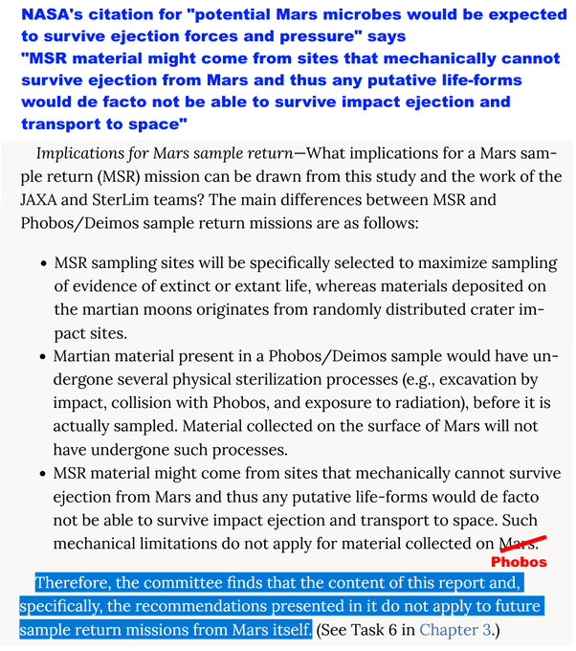
NASA's citation for "potential Mars microbes would be expected to survive ejection forces and pressure" says "MSR material might come from sites that mechanically cannot survive ejection from Mars and thus any putative life-forms would de facto not be able to survive impact ejection and transport to space"
The Phobos sample return study covers this reasoning in more detail on page 44-5. On the last point they say:
The reasoning regarding natural flux does not apply directly to samples returned from the Mars surface.
- The material will be gently sampled and returned directly to Earth.
- The sample may well come from an environment that mechanically cannot become a Mars meteorite.
- The microbes may not be able to survive impact ejection and transport through space.
Samples with current liquid water and recent ice seem especially fragile to natural transport to Earth.
Finding: The committee finds that the content of this report and, specifically, the recommendations in it do not apply to future sample return missions from Mars itself.
[Added bullet points to the original text]
(Planetary protection classification of sample return missions from the Martian moons : page 43 [use X to close splash])
The meteorites from the Zumil impact arriving today are better protected than Phobos samples, because any materials on the Phobos surface had the extra sterilization stage of the impact on the surface of Phobos which the team worked out is more sterilizing than the fireball of re-entry to Earth’s atmosphere.
The meteorites from Zumul crater also get here faster than any materials in samples from Phobos because the most recent samples in the Phobos samples were ejected from Mars by the same impact and have been sitting on the surface of Phobos subject to cosmic radiation sterilization ever since.
This would be a more accurate summary of NASA’s citation:
The natural delivery of Mars materials can provide better protection and faster transit than the Japan’s samples from the top 2 cms of the surface of Phobos but this reasoning does NOT apply to samples from Mars
… potential Mars microbes could be in habitats that can’t mechanically get into meteorites or unable to survive ejection forces and pressure or transfer through space.
(National Academies of Sciences, Engineering, and Medicine and the European Science Foundation 2019)
In short, NASA’s citation is a planetary protection study for samples returned from Mars’s moon Phobos and says clearly that it shouldn’t be used to support a meteorite argument for samples from Mars itself. It says it shouldn’t be used to support the very argument you use it as a citation for.
This is a particularly clear case. To use it in this way without alerting the reader to the discrepancy fails NEPA requirements for scientific integrity.
The EIS doesn’t alert the reader to this discrepancy.

TO PROVE NO POTENTIAL INVASIVE MICROBES IN OUR SAMPLES WE NEED TO PROVE ALL (NOT JUST SOME) SPECIES CAN GET HERE ON A METEORITE - ANALOGY: STARLING IS AN INVASIVE SPECIES IN THE USA BUT THE SWALLOW IS NOT BECAUSE IT CAN CROSS THE OCEAN
Since most terrestrial microbes can’t get from Mars to Earth, it’s not very plausible that in ALL possible scenarios for Martian life, ALL species of martian microbes would be able to get from Mars to Earth - yet that’s what would be needed to prove we can’t have invasive species from Mars in the samples.
I give the example of swallows and starlings in my preprint. The barn swallow is not an invasive species as it was already here, because it can fly across the Atlantic. However, European starlings can’t fly across the Atlantic, which is how they could become an invasive species in the USA. The Department of Agriculture estimates that starlings cost the US economy $1 billion a year for agricultural damage alone.
Starling damage reported to the USDA’s Wildlife Services program averages less than $2 million per year, but this is a fraction of all starling damage. Agricultural damage alone is estimated currently at $1 billion per year. Other damage, such as costs for cleaning and maintaining city centers near roosts, veterinary care and loss of production at CAFOs, and public health care, are unknown. A complete inventory of all economic damage likely would show that the starling is the most economically harmful bird species in the United States
(European Starling : 16).
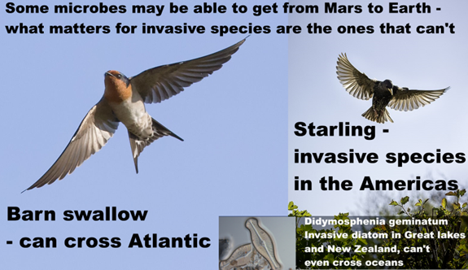
Text on graphic: Some microbes may be able to get from Mars to Earth – what matters for invasive species are the ones that can’t.
Barn swallow - can cross Atlantic
Starling - invasive species in the Americas
Didymosphenia geminatum invasive diatom in Great Lakes and New Zealand, can’t even cross oceans
This doesn’t mean that all European birds would be invasive in a harmful way. Introductions can often be beneficial (The potential conservation value of non‐native species).
But if a species can’t cross the Atlantic it has the potential to be invasive.

IT’S THE SAME PICTURE FOR MICROBES - MANY CROSS OCEANS AND ARE NOT INVASIVE - BUT FRESH WATER DIATOMS CAN’T CROSS OCEANS AND HAVE BEEN INVASIVE IN THE GREAT LAKES AND ARE INVASIVE TODAY IN NEW ZEALAND
Didymo in the illustration in the last section is an invasive species of fresh water diatom in New Zealand. A few decades back the Great Lakes had many problems with non indigenous invasive diatoms that clogged up water treatment plants and caused bad smells in drinking water which shows that microbial life can be invasive too (Diatoms as non-native species)
Just as it’s microbes that can’t cross oceans that have some potential to be invasive on Earth, it’s any microbes that can’t cross the cold and vacuum of space and can’t survive ejection from Mars or get into a meteorite that are the ones that have some potential to be invasive introductions to Earth’s biosphere.
This again is of central importance.. Another country or private space might use NASA’s statement to argue in good faith, but mistakenly, that any life from Mars has already got to Earth.
The natural delivery of Mars materials can provide better protection and faster transit than the current MSR mission concept.
. MSR DRAFT EIS 3–3
They might then see no need to take any precautions to protect Earth.
WE DO NOT KNOW THAT ANY SPECIES ON MARS HAVE EVER BEEN TRANSFERRED TO EARTH IN A METEORITE and as we saw, your own citation says it shouldn’t be used for this argument (Planetary protection classification of sample return missions from the Martian moons : page 5 and page 43 [use X to close splash])

THE EIS FOCUSES ON BEST-CASE SCENARIOS - INDEED SAMPLES CAN BE HARMLESS IN MANY WAYS - BUT NEVER MENTIONS WORST-CASE SCENARIOS - LIKE DESIGNING A SMOKE DETECTOR WITHOUT CONSIDERING THE WORST CASE OF A HOUSE FIRE
Your EIS considers a best-case where
- Mars has been uninhabitable for millions of years AND
- Martian life can’t be transferred in dust storms AND
- Martian life can’t live in Jezero Crater AND
- If there is life in Jezero crater, all the species able to harm us already got to Earth in meteorites, AND
- All species of Martian life depend on nutrients they only find on Mars or are unable to live in terrestrial conditions, AND
- If species on Mars get to Earth and spread here there is a near-zero chance to harm humans AND
- If life does get here, we can contain it in a BSL-4 laboratory,
I will show in this open letter that NONE of these statements are supported by your citations. The EIS doesn’t alert the reader to many ways these assumptions could be invalid.
If this is not challenged, other space countries and private space may well use your arguments to infer in good faith there is no need to take ANY precautions for samples returned from Mars.
There are lots of ways that the sample returned from Jezero crater COULD be harmless.
However, despite the statements in your EIS, we DO NOT KNOW ANY OF THESE THINGS.
Margaret Race, a biologist working on planetary protection and Mars sample return for the SETI Institute and specialist in environmental impact analysis used the analogy of a smoke detector in response to similar non-peer-reviewed suggestions by the space colonization enthusiast and leader of the Mars Society Robert Zubrin:
If he were an architect, would he suggest designing buildings without smoke detectors or fire extinguishers?
Hazardous Until Proven Otherwise, in: "Opinion: No Threat? No Way",
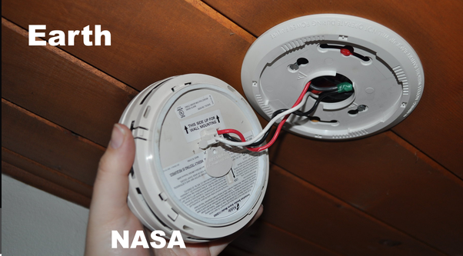
Hand installing smoke detector labelled “NASA” and wooden ceiling of a house labelled “Earth”
(Smoke detector graphic from The EnergySmart Academy)

GENERAL PUBLIC FOCUS MORE ON RISKS; MISSION PLANNERS ON MISSION REQUIREMENTS - A PRE-STERILIZED RETURN SATISFIES BOTH
Margaret Race made a relevant point in another paper. To summarize her main points she says scientists are likely to focus on
- technical details
- mission requirements
- engineering details
- costs of the space operations and hardware
So it is natural for you to focus on those.
The general public are likely to focus on
- risks and accidents
- whether NASA and other institutions can be trusted to do the mission
- worst case scenarios
- whether the methods of handling the sample, quarantine and containment of any Martian life are adequate
(Planetary Protection, Legal Ambiguity, and the Decision-Making Process for Mars Sample Return : page 348)
We see the results of this different focus in the report.
Let’s look at another example:

THE EIS IS INCORRECT WHEN IT SUGGESTS JEZERO CRATER IS BIOLOGICALLY ISOLATED FROM THE REST OF MARS - FRAGMENTS OF MICROBIAL BIOFILMS ARE STILL VIABLE AFTER BLOWN HUNDREDS OR EVEN THOUSANDS OF KILOMETERS IN EXPERIMENTAL TESTS
NASA: (paraphrase) If there is life on Mars it can’t get into Perseverance's samples in Jezero crater:
“Consensus opinion within the astrobiology scientific community supports a conclusion that the Martian surface is too inhospitable for life to survive there today, particularly at the location and shallow depth (6.4 centimeters [2.5 inches]) being sampled by the Perseverance rover in Jezero Crater, which was chosen as the sampling area because it could have had the right conditions to support life in the ancient past, billions of years ago. (Rummel et al. 2014, …)”
.. MSR DRAFT EIS 1–6
Your EIS doesn’t cite the MEPAG2 review in 2015 which found knowledge gaps in SR-SAG2 about transport of life in the atmosphere and a potential for habitats even in places like Jezero Crater that may be impossible to see from orbit.
Rummel et al. is the 2014 SR-SAG2 review (A new analysis of Mars “special regions”: findings of the second MEPAG Special Regions Science Analysis Group (SR-SAG2)) [Their second source for this sentence, Grant et al, is just a cite for the selection criteria for Jezero crater]
SR-SAG2 uses maps to map out uncertain regions that may contain “Special regions” which are defined as regions (SSB, 2015 :6).
“within which terrestrial organisms are likely to propagate, or a region which is interpreted to have a high potential for the existence of extant martian life forms.”
(Review of the MEPAG report on Mars special regions :6).
It doesn’t discuss the potential for Martian life so that already is a limitation for backwards contamination since Martian life might conceivably be capable, for instance, be able to live in cold salty water beyond the limits for terrestrial life. It just says:
At present there are no Special Regions defined by the existence of extant martian life, and this study concentrates only on the first aspect of the definition.
(SR-SAG2 : 888)
NASA and ESA commissioned a review in 2015 by the Space Studies Board, ESSC and NASEM, which found serious knowledge gaps in the 2014 SR-SAG2 review which you rely on here and especially the way it relies on maps from orbit.
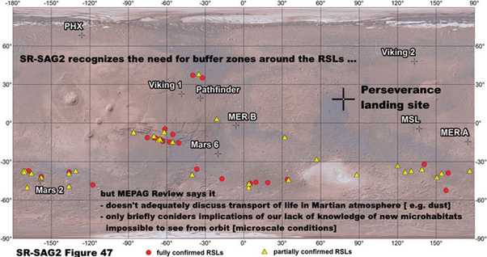
Text on graphic: SR-SAG2 recognizes the need for buffer zones around the RSLs …
but MEPAG Review says it
- doesn’t adequately discuss transport of life in Martian atmosphere [ e.g. dust]
- only briefly considers implications of our lack of knowledge of new microhabitats impossible to see from orbit [microscale conditions]
[paraphrases (Review of the MEPAG report on Mars special regions :11 - 12) ]
Map from: (A new analysis of Mars “special regions”: findings of the second MEPAG Special Regions Science Analysis Group (SR-SAG2) : Fig. 47 )
Perseverance landing site marked
NASA and ESA were planning independent reviews and finding both had the same concerns combined it in a single review. They commissioned this review partly out of concerns that MEPAG is not independent from NASA.
There were two reasons why both agencies [NASA and ESA] took the seemingly unusual step of independently commissioning reviews of a review paper that was to be published in a peer-reviewed journal.
First, there is the perception in some circles that MEPAG is not independent and that its views are too closely aligned with NASA’s Mars Program Office.
(Review of the MEPAG report on Mars special regions: xi – xii).
[by the Space Studies Board, the European Space Sciences Committee and the National Academies of Sciences, Engineering, and Medicine]
This review found that SR-SAG2 doesn’t adequately discuss the transport of material in the Mars atmosphere [e.g. in dust storms] see page 12.
This is indeed a knowledge gap. Amongst several relevant discoveries, later research found that small fragments of biofilm, thin layers of a microbial colony three hundredths of a millimeter thick, can travel 100 kilometers in daylight in the light Martian winds before it is sterilized.
See A desert cyanobacterium under simulated Mars-like conditions in low Earth orbit: implications for the habitability of Mars
Billi et al’s paper on biofilm transport doesn’t take account of the effect of UV on perchlorates in the biofilm, but in my paper I find
- martian night time winds are also strong enough to transport the biofilm fragments
- they could also travel much further in dust storms which block out UV.
Also Wadsworth et al who highlighted the biocidal effect of perchlorates activated to cholorates and chlorites by UV only tested b. subtilis and remark that terrestrial extremophiles could be more resilient. Mars could have native evolved Martian microbes more resilient than the b. subtilis tested by Wadsworth et al..
The 2015 Space Studies Board review also found that SR -SAG2 only briefly discussed the implications of our lack of knowledge of microenvironments.
(Review of the MEPAG report on Mars special regions : 12 )
SR-SAG2 gave a useful list of these microenvironments by type:·
- Vapor-phase water available Vapor or aerosols in planet’s atmosphere; within soil
cavities, porous rocks, etc.; within or beneath spacecraft or spacecraft debris
- Ice-related Liquid or vapor-phase water coming off frost, solid ice, regolith or subsurface ice crystals, glaciers
- Brine-related Liquid water in deliquescing salts, in channels within ice, on the surface of ice, within salt crystals within halite or other types of ‘‘rock salt’’
- Aqueous films on rock or soil grains Liquid water on regolith particles of their components such as clay minerals, on surface of ice, on and within rocks, on surfaces of spacecraft
- Groundwater and thermal springs (macroenvironments) Liquid wate
- Places receiving periodic condensation or dew Liquid water on regolith particles of their components such as clay minerals, on surface of ice, on and within rocks, on surfaces of spacecraft
- Water in minerals Liquid water bound to minerals
(A new analysis of Mars “special regions”: findings of the second MEPAG Special Regions Science Analysis Group (SR-SAG2): page 204)
However, it doesn’t discuss them much further. These potential microenvironments on Mars have been the subject of many research papers which the EIS doesn’t discuss.
To take an example, that may be relevant to Jezero crater, terrestrial microbes can exploit water that condenses in micropores in salt or gypsum in deserts when the rest of the desert air is far too dry for life. Your former planetary protection officer Cassie Conley suggested that the same thing might happen on Mars. (Going to Mars Could Mess Up the Hunt for Alien Life) as did Paul Davies (The key to life on Mars may well be found in Chile) and Wierzchos et al. (Microbial colonization of Ca‐sulfate crusts in the hyperarid core of the Aacama Desert: implications for the search for life on Mars).
The SSB review also drew particular attention on page 11 to the capability of microbes to use biofilms to make regions habitable that wouldn’t be otherwise.
The Atacama gritcrust would be an example here (The grit crust: A poly-extremotolerant microbial community from the Atacama Desert as a model for astrobiology)
For scientific integrity your Environmental Impact Statement needs to cite the 2015 review and discuss what it says. This is especially important since the 2014 SR-SAG2 was seen as too closely aligned with the aims of NASA’s Mars Program Office, as one of the two main reasons for the 2015 review.
Also it needs to recognize that these weren’t backwards contamination studies and didn’t consider the question of what might count as a habitat for an alien biology. In all these examples we need to bear in mind that if there is Martian life, it has adapted to those conditions for billions of years and may be based on a different biochemistry with capabilities terrestrial biochemistry doesn’t have.

YOUR STERILIZATION WORKING GROUP’S CONCLUSION THAT MARTIAN LIFE HAS NEAR-ZERO PROBABILITY OF HARM FOR HUMANS IS NOVEL AND CONTRADICTS PREVIOUS PEER-REVIEWED LITERATURE ON MARS SAMPLE RETURN
Your sterilization working group comes to a conclusion that is not found in any previous peer-reviewed study on Mars sample return backward contamination.
“Since any putative Martian microorganism would not have experienced long-term evolutionary contact with humans (or other Earth host), the presence of a direct pathogen on Mars is likely to have a near-zero probability.”
(Biological safety in the context of backward planetary protection and Mars Sample Return: conclusions from the Sterilization Working Group: page 6)
They reach this conclusion by only examining diseases adapted to humans.
They don’t cite this to any previous study, and I have not been able to find any precedent except a non peer reviewed op ed. by Robert Zubrin (Contamination From Mars: No Threat) which was strongly criticised by experts including your planetary protection officer at the time John Rummel:
John Rummel: How ought others judge the cost-benefit ratio of Mars exploration if we don't take simple precautions to avoid potentially harmful consequences? Harshly, I suspect.
Margaret Race: If he were an architect, would he suggest designing buildings without smoke detectors or fire extinguishers?
("Opinion: No Threat? No Way")
Zubrin makes all three of the main arguments used in the EIS - NONE OF THESE OCCUR IN THE PEER REVIEWED PLANETARY PROTECTION LITERATURE
- that Mars is uninhabitable
- that if there is life on Mars it got here already
- that if life from Mars gets here it won’t be able to live here and won’t be adapted to humans
It is a striking similarity. There is no reason to suppose the sterilization working group was influenced by Zubrin’s non peer reviewed op ed. and they don’t cite it. But there may be a common background, which I discuss in my preprint, such as enthusiasm for physical exploration and pushing through frontiers, a focus on the mission objectives, a keenness to send astronauts to Mars, and a pre-existing optimism, possibly inspired by science fiction, that if there is anything on Mars it can’t harm us.
However in the worst case scenario we find interesting life on Mars that is harmful to Earth and can never be returned to Earth. This is currently a possible scenario. It could envigorate space exploration and lead to more rather than less public interest and enthusiasm for astronauts in space.

THE PLANETARY PROTECTION LITERATURE ALREADY MENTIONS TETANUS - SOMETIMES ACCIDENTALLY DEADLY FOR UNVACCINATED NEWBORNS - AND LEGIONNAIRES’ DISEASE - A DISEASE OF MICROBIAL COMMUNITIES THAT SEES THE LUNGS AS SIMILAR TO A MICROBIAL BIOFILM AND IS SOMETIMES DEADLY TO US - NEITHER ADAPTED TO HIGHER LIFE OR HUMANS
The sterilization working group doesn’t discuss the illustrative examples from the 2009 paper: Assessing the Biohazard Potential of Putative Martian Organisms for Exploration Class Human Space Missions
Indeed the passage discussing the potential for martian microbes to infect humans on page 6 has no citations for any of the diseases or to the planetary protection literature.
In this way they missed:
- Legionnaires’ disease (a disease of microbial biofilms not adapted to infect lungs, sometimes fatal)
- Tetanus - not adapted to infect any organism, accidental poison, still kills thousands of newborns a year who haven’t been vaccinated
The sterilization working group doesn’t alert the reader to the existence of such diseases.

STERILIZATION WORKING GROUP DISCUSSES CANDIDAS - A FUNGAL INFECTION ADAPTED TO HUMANS - BUT DOESN’T ASK IF THERE ARE OTHER FUNGAL INFECTIONS THAT ARE NOT ADAPTED TO US
The sterilization working group does discuss Candidas, a fungal infection that they correctly say has adapted to humans over long periods of time.
As with the other diseases, the passage gives no citations for their statement about Candidas. I was able to confirm that experts say it is adapted to humans. But the natural next question for someone looking for worst-case scenarios rather than best-case scenarios is - what about other fungal infections of humans? Are they adapted to us?
I can’t find previous discussions of fungal infections in the Mars sample return literature, so needed to do my own research into this. To date, the planetary protection literature hasn’t tried to be comprehensive and only looks at a few illustrative examples.
Following up this example I found an example new to the planetary protection literature (as far as I know).

A SEARCH FOR FUNGAL DISEASES NOT ADAPTED TO HUMANS FINDS ASPERGILLUS - WITH 200,000 CASES A YEAR OF OF INVASIVE ASPERGILLIOSIS MORTALITY 30% TO 95%, 400,000 CASES OF ALLERGIC PULMONARY ASPERGILLIOSIS AND 4.8 MILLION CASES OF ASTHMA TRIGGERED BY ASPERGILLUS FUMIGATUS
The two most deadly fungal infections for humans are Candidas and Aspergillus. Aspergillus fumigatus is NOT adapted to humans. We get an estimated 200,000 life threatening invasive aspergillosis infections a year with mortality rates varying from 30 to 95%. This disease affects people who are immunocompromised mainly.
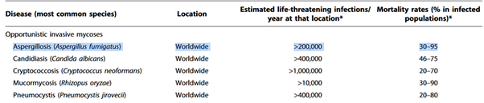
. Hidden killers: human fungal infections.
The progressive and very serious disease of chronic pulmonary aspergillosis (CPA) affects around 400,000 globally and only occurs in people who are not immunocompromised with symptoms of “weight loss, profound fatigue, productive cough, significant shortness of breath, and life-threatening hemoptysis [spitting out of blood from the lungs]”.
Then allergic bronchopulmonary aspergillosis affects 2.5% of patients with asthma, and an estimated 4.8 million people globally. All three diseases are different manifestations of the same fungus, Apergillus fumigatus (with a couple of other aspergillus species also involved in some cases). For details, see:
. Global burden of allergic bronchopulmonary aspergillosis with asthma and its complication chronic pulmonary aspergillosis in adults

ILLUSTRATIVE WORST CASE EXAMPLE OF A NEW INVASIVE FUNGAL DISEASE USING ASPERGILLUS FUMIGATUS AS A PLAUSIBLE ANALOGUE OF A NEW FUNGAL GENUS FROM MARS
To help focus attention I’ve added a new fungal genus as a new illustrative planetary protection example. Aspergillus turns out to be a plausible analogue for a new fungal genus from Mars that might be a serious invasive disease of humans.
- Not adapted to infect any organisms.
- Harms humans due to adaptations that a martian microbe might well have such as:
- tolerance of low oxygen in lungs,
- rapid hydration from extreme dessication,
- fast growing branching filaments,
- able to take up nutrients rapidly and store energy, etc.
- highly tolerant of low temperatures and oxidative stress.
[the Mars surface has strong oxidants like perchlorates, activated by UV to chlorates and chlorites, also hydrogen peroxide]
(Ecology of aspergillosis: insights into the pathogenic potency of Aspergillus fumigatus and some other Aspergillus species)
It’s also an example of something else. Our immune system might also overreact to a novel fungal genus from Mars. This idea of an allergic reaction to life from Mars seems to be new to the planetary protection literature. I followed it up as a result of discovering that many serious effects from Aspergillus in patients with a competent immune system are due to their immune system over-reacting to it.

IF OUR IMMUNE SYSTEM IS FACED WITH A NOVEL FUNGAL GENUS FROM MARS IT NEVER SAW BEFORE - IT MIGHT BE MYSTIFIED AND MOUNT NO DEFENSE, AS FOR INVASIVE ASPERGILLIOSIS OR IT MIGHT OVERREACT AS FOR ALLERGIC PULMONARY ASPERGILLIOSIS OR ASTHMA TRIGGERED BY ASPERGILLUS
Our immune system has evolved over millions of years to defend us against Aspergillus. Many parts of the immune system work together to
- Detect it
- Respond to it
- Dampen down overreactions to it.
When our immune system doesn’t spot Aspergillus or responded to it we get invasive aspergillosis, a very serious disease with high mortality as we saw.
When our immune system does spot it, it has to clear the aspergillus microbes from our lungs. However, at the same time it has to avoid over-reacting in a harmful inflammatory response. Otherwise we may get asthma, or worse, allergic pulmonary aspergillosis. I will indent a summary of how this works as “Techy details”
Techy details: Our immune system detects fungi using its pathogen-associated molecular patterns (PAMPs). It likely uses pattern recognition receptors (PRRs) which trigger the immune response. There are different patterns for each of the main fungal genera that affect humans: Candida, Aspergillus and Cryptococcus table 1 of (Antifungal immune responses: emerging host–pathogen interactions and translational implications)
To dampen down the inflammation when it’s not needed - this is a complex finely tuned reaction that involves the inflammation dampening Treg cells and many T-helper cells.
The most important ones for our adaptive immune response to aspergillus that we use to avoid over-reacting are the Th1, Th17, Th22, Th2, Th9, Treg, and Tr1 cells (The multifaceted role of T-helper responses in host defense against Aspergillus fumigatus)
If our immune system faces a novel fungal genus it’s never seen before in all of terrestrial evolution, it will be a major challenge to mount such a finely tuned response
For instance, as a thought experiment, suppose an alternative evolutionary history where our immune system has only ever encountered Cryptococcus. Now we return Aspergillus from another planet. Our immune system won’t be able to see Aspergillus fumigatus (it will have none of those PAMPs from the techy details above).
Now lets try this thought experiment again, Aspergillus is new as before, but our immune system already encountered Candidas on Earth. Now it has some but not all of the PAMPs needed for the introduced Aspergillus.
If it does recognize Aspergillus the T-helper and T-reg responses are unlikely to achieve the fine balance to avoid overreacting with an allergic reaction.
It might be a similar situation to one or other of these scenarios, if we introduce a novel fungal genus from Mars to Earth’s biosphere which has the capability to grow in the environmental conditions it finds inside or on humans.

YES ON SOME SCENARIOS, MARTIAN LIFE FROM MARS WILL BE ABLE TO LIVE ON EARTH - WE HAVE EXAMPLES OF SPECIES THAT LIVE IN THE PERMAFROST THAT CAN ALSO GROW AT HUMAN BODY TEMPERATURES
Here some people will argue that any Martian life will be unable to live at human body temperatures. The sterilization working group argues that terrestrial life wouldn’t be able to survive on Earth at all.
There are many described extremophiles that may survive in environments that are extreme to human or animal life (e.g. extremes of temperature or pressure) but do not survive under conditions in our normal habitat (Merino et al. 2019) … Thus, it is plausible that any Martian microbe, after it arrives on Earth, would not be viable on Earth due to a lack of its required Martian nutritional and environmental conditions.
[bolding added for the two examples in brackets]
This has a major omission, polyextremophiles that live in a wide range of extreme environments and can often also live in normal environments. Their own citation, Merino et al., includes one remarkable polyextremophile, amongst many extremophiles that can only tolerate a narrow range of conditions. Planococcus Halocryophilus has a salinity range 0 to 19% and temperature range -15 °C to 37 °C
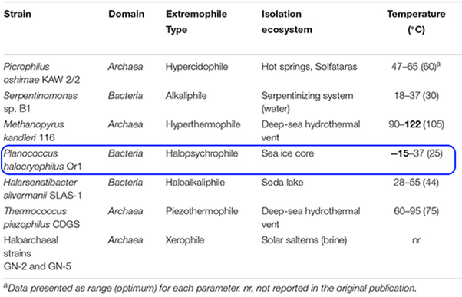
(Living at the extremes: extremophiles and the limits of life in a planetary context.: table 3)
p. Halocryophilus Or1 was actually isolated from Canadian permafrost (Planococcus halocryophilus sp. nov., an extreme sub-zero species from high Arctic permafrost), likely grows in sub-zero brine veins around soil particles at an ambient temperature of around -16°C. The researchers found it has an optimal growth temperature of 25°C and can continue to grow right up to 37 °C (human blood temperature) tested (Bacterial growth at− 15 C; molecular insights from the permafrost bacterium Planococcus halocryophilus Or1).
The -15 °C in that table isn’t likely to be the lowest limit for growth as p. Halocryophilus Or1 shows metabolic activity down to at least -25 °C which is the lowest temperature tested (Bacterial growth at− 15 C…). . It’s hard to study growth at low temperatures, as it takes 1,000 to 10,000 years for microbes to successfully colonize granite in the McMurdo dry valleys (Growth on geological time scales in the Antarctic cryptoendolithic microbial community). So it’s certainly possible that p. Halocryophilus can grow colonies extremely slowly at −25 °C. It might be able to grow at even lower temperatures as that’s the lowest tested for metabolic activity. So it is a reasonable an analogue for a Martian microbe for temperature tolerance.

ILLUSTRATIVE WORST CASE EXAMPLE OF MIRROR LIFE TO HELP FOCUS ATTENTION ON NEED TO PROTECT EARTH’S BIOSPHERE AS A WHOLE
I mentioned earlier on the blue-green algae Chroococcidiopsis is one of our top candidates for a terrestrial life form that could live on Mars if there is water available for it to use.
We don’t know Martian life is related to us.
Astrobiologists, including the teams that were gathered by NASA to advise them on the sample return mission tell us life on Mars may well be independently evolved.
There is a distinct need for novel techniques specialized for biochemical systems that do not share a chemical heritage with life on Earth.
(Final Report of the Mars Sample Return Science Planning Group 2 (MSPG2) : page S-21)
Also from iMOST:
Page 88: We cannot predict with any accuracy life's form and characteristics, … or whether it shares a common ancestor with life on Earth.
…
Page 89: A subset of the investigations will only be successful at detecting Mars life if it shares a common ancestor with Earth life due to travel on meteorites or space debris, whereas other suggested investigations are based on more general characteristics of living entities.
…
Page 91: The short-term survivability of nucleic acids means that its detection would be strong evidence of recent life. This investigative avenue is feasible only if life on Mars and Earth share a common origin and thus share DNA/RNA as genetic material.
(The potential science and engineering value of samples delivered to Earth by Mars sample return: International MSR Objectives and Samples Team (iMOST) )
So what could we find by way of an alternative biology on Mars? There are many ideas, but one of the top candidates for an alternative form of biology is mirror life, which everyone agrees is biologically plausible, evolved from scratch from the mirror images of the chemicals used by terrestrial life.
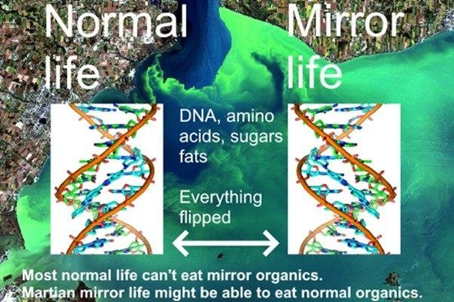
Text on graphic: Normal life, Mirror life, DNA, amino acids, sugars, fats, everything flipped. Most normal life can’t eat mirror organics. Martian mirror life might be able to eat normal organics.
When a molecule can occur in two mirror forms, like your hands, it’s called chiral - the word chiral is derived from the Greek word χειρ (kheir) for hand. Terrestrial life is homochiral, which means that nearly all of its asymmetrical (chiral) molecules occur in only one of its two mirror forms. Also terrestrial life for the most part can’t use any mirror organics it finds and just ignores them.
If we could flip a cake in 3D, like reflecting it in a mirror, all the way down to its molecules, we might be able to eat it, like artificial sweeteners, but our metabolism couldn’t do anything with the flipped starches or proteins, and many fats would also be inaccessible (An adventure in stereochemistry: Alice in mirror image land)
According to one modern theory - punctuated chirality - it’s a 50 - 50 chance that independently evolved life on Mars uses mirror organics.
According to this theory, early on as life was just starting to evolve, there were patches of chemicals that worked together with each other in chiral networks which expand converting a non chiral substrate into chiral organics and where two chiral networks of opposite chirality meet there are ways for them to slowly convert each other to the opposite chirality.
There would be many such patches, some with the same chirality as terrestrial life and some with mirror organics. According to this theory, these patches would expand and flip each other back and forth in chirality on an environmental scale, with the chirality reset multiple times in Early Earth even if it didn’t go extinct (Punctuated chirality : 6) until one of them got established as the basis for the evolution of life.
If so, depending on how the flips went on Mars, life could easily have evolved from chemicals with the opposite chiral bias to Earth life
Our analysis predicts that other planetary platforms in this solar system and elsewhere could have developed an opposite chiral bias.
(Punctuated chirality : 7)
They predict that in the universe as a whole if an organic is found in a large sample of independently evolved forms of life it should occur in both forms
As a consequence, a statistically large sampling of extraterrestrial stereochemistry would be necessarily racemic on average
(Punctuated chirality : 7)
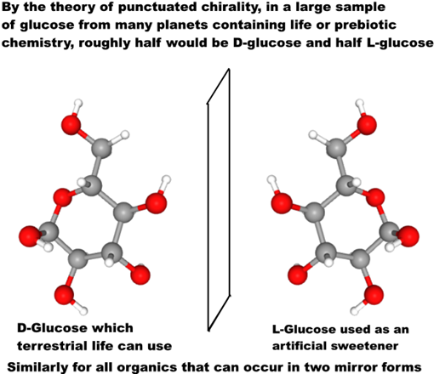
Text on graphic: By the theory of punctuated chirality, in a large sample of glucose from many planets containing life or prebiotic chemistry, roughly half would be D-glucose and half L-glucose
D-Glucose which terrestrial life can use
L-Glucose used as an artificial sweetener
Similarly for all organics that can occur in two mirror forms
Graphic for L-glucose and D-glucose by reflecting the graphic horizontally. Grey: Carbon, Red: oxygen, white: Hydrogen.

WORST CASE SCENARIO HERE IS THAT MIRROR LIFE RETURNED FROM MARS GRADUALLY FLIPS NEARLY ALL TERRESTRIAL ORGANICS INTO INDIGESTIBLE MIRROR ORGANICS OVER TIMESCALES OF DECADES OR CENTURIES - THE LEVEL OF ASSURANCE WE NEED TO PREVENT SUCH A SCENARIO, IF IT IS POSSIBLE - IS A MATTER FOR WIDER DISCUSSION AND CAN’T BE SETTLED FOR THE REST OF HUMANITY BY NASA MISSION PLANNERS
Synthetic biologists plan to gradually flip ordinary to mirror life over a period of a decade or so – and will make sure synthetic mirror life is engineered to depend on chemicals only available in the laboratory. They warn escape of mirror life could cause major transformations of the terrestrial biosphere by locking up organics in unusable mirror forms. See: (Mirror-image cells could transform science-or kill us all)
Martian life likely already has the isomerases to metabolize organics of opposite sense, whether it is mirror or normal life - because nearly all organics are either made abiotically locally, or are infall from comets, asteroids and interplanetary dust, with organics of both senses.
Eventually terrestrial microbes likely develop isomerases to metabolize mirror life, but higher life couldn’t evolve so quickly. The outcome is a mix of normal and mirror organics. In Kasting and Church’s worst case scenario mirror life retains the edge over normal life in this evolutionary race and eventually there is little left except mirror organics and life that can use it. They suggest humans could go extinct in this worst case scenario at least in the natural ecosystems (Mirror-image cells could transform science-or kill us all)
—both Kasting and Church think mirror predators would evolve, but whatever life existed on Earth by that point wouldn’t include us.
In this worst case I don’t think humans would go extinct even on the centuries timescale. We could enclose large areas of Earth with its tropical jungles, coral reefs etc, in habitats similarly to Biosphere 2.
And there might well be things see can do to help terrestrial microbes win the evolutionary race with the imported mirror life.
But it’s far better not to do the experiment.
We will only know if we are in the scenario of a Mars with mirror life if we go look for it and find it.
If we are in that scenario, then we would likely decide as a civilization that we must never return the Martian mirror life back to Earth.
So, to help focus attention on the potential for adverse effects on the environment, the very worst case we could return microbes that could transform Earth’s biosphere in ways we can’t predict.

THIS IS A WORST CASE SCENARIO - ASTROBIOLOGISTS BELIEVE THE POTENTIAL FOR LARGE SCALE EFFECTS IS LIKELY VERY LOW - BUT AS FOR A HOUSE FIRE WE DO NEED TO BE PREPARED FOR WORST CASES SCENARIOS - EVEN IF VERY UNLIKELY
These are worst cases not likely cases.
But as with house fires, and smoke detectors we do need to look at worst cases. We can’t protect Earth properly if we only look at the most optimistic scenarios.
We can’t rely on the same risk-benefit calculus for release of SARS and for release of mirror life.
Some synthetic biologists say we need a level of assurance for synthetic biology far higher than for any biosafety laboratory. Schmidt said:
… maybe [1 in 100,000,000,000,000,000,000] is more than enough …
The probability also needs to reflect the potential impact, in our case the establishment of an XNA ecosystem in the environment, and how threatening we believe this is.
The most important aspect, however, is that the new safety mechanism should be several orders of magnitude safer than any contemporary biosafety mechanism
(Xenobiology: a new form of life as the ultimate biosafety tool.)
[In this quote XNA refers to life based on a different informational polymer from DNA. Similar remarks would apply to mirror life]
The same precautions may be needed for returning alien biology from another planet.
This is NOT something that NASA mission planners can decide for the rest of humanity. This is NOT something we can decide using the scientific method.
We need a wider discussion here to work out the necessary level of assurance if there is indeed a potential for returning mirror life from Mars. This is one of the NEPA’s central requirements for a valid EIS.
Agencies shall prepare environmental impact statements using an interdisciplinary approach that will ensure the integrated use of the natural and social sciences and the environmental design arts … The disciplines of the preparers shall be appropriate to the scope and issues identified in the scoping process
§ 1507.2 [links directly to legal text]
Mars sample return studies emphasize the need to involve the public early on, not just in the USA, but through fora open to representatives from all countries globally because negative impacts could affect countries beyond the ones involved directly in the mission (Ammann et al, 2012:59)
RECOMMENDATION 3
Potential risks from an MSR are characterised by their complexity, uncertainty and ambiguity, as defined by the International Risk Governance Committee’s risk governance framework. As a consequence, civil society, the key stakeholders, the scientific community and relevant agencies’ staff should be involved in the process of risk governance as soon as possible.
In this context, transparent communication covering the accountability, the benefits, the risks and the uncertainties related to an MSR is crucial throughout the whole process. Tools to effectively interact with individual groups should be developed (e.g. a risk map).
RECOMMENDATION 4
Potential negative consequences resulting from an unintended release could be borne by a larger set of countries than those involved in the programme. It is recommended that mechanisms and fora dedicated to ethical and social issues of the risks and benefits raised by an MSR are set up at the international level and are open to representatives of all countries
(Mars Sample Return backward contamination–Strategic advice and requirements)
The public weren’t involved early on in that way. Not only that, the few in the public who did discover NASA’s request for public comment weren't given the opportunity to comment on a scientifically valid EIS.
We can’t rely on the same risk-benefit calculus for release of SARS and for release of mirror life, without legislative / executive / public involvement to decide if this is what we should do.
The theologian Richard Randolph put it like this, from a Christian perspective:
The risk of back contamination is not zero. There is always some risk. In this case, the problem of risk – even extremely low risk – is exacerbated because the consequences of back contamination could be quite severe. Without being overly dramatic, the consequences might well include the extinction of species and the destruction of whole ecosystems. Humans could also be threatened with death or a significant decrease in life prospects
In this situation, what is an ethically acceptable level of risk, even if it is quite low? This is not a technical question for scientists and engineers. Rather it is a moral question concerning accepting risk
(Chapter 15, God’s preferential option for life: a Christian perspective on astrobiology)

THE MAIN CONCERN OF THE GENERAL PUBLIC IN THEIR COMMENTS ON THE EIS WAS RISK OF HARM TO HUMAN HEALTH AND EARTH’S ENVIRONMENT - 50 OUT OF 63 COMMENTS IN THE FINAL EIS
Several dozen distinct members of the public expressed views that suggest they would be in support of Sagan’s quote that I use at the start of this open letter, on a not very widely publicised EIS.
“The likelihood that such pathogens exist is probably small, but we cannot take even a small risk with a billion lives.”
(The Cosmic Connection – an Extraterrestrial Perspective)
Nine commentators specifically mention unprecedented harm and 50 out of 63 made comments that make it clear they would agree with Sagan’s view.
This figure of 50 out of 63 shouldn’t be read as a percentage of the public as it is not a poll. But it does show that at least several dozen of the members of the public who were reached in the not very well publicized second round of comments had concerns similar to Sagan.
These are all the comments. Many are short and succint but clear in what they intend to say. The ones that would surely agree with Sagan are highlighted in bold.
- stop mission, unprecedented harm – test first – study in separate module attached to ISS – test first – stop mission
- stop mission – test first – test first, unprecedented harm – Study in space or not at all, keep Earth 100% safe, our efforts to contain the samples may seem lax a generation from now –test first
- stop mission – need clarity about security measures – off topic – alternative design - keep Earth 100% safe
- unprecedented harm – stop mission, unprecedented harm – alternative design – test first – test first
- test first – unprecedented harm – test first – Test first– Don’t return unless 100% safe – or sterilize first
- Don’t return – don’t return until 100% safe – test first – test first–test first
- ISS first – test first – test first – unknown risk, test first–sterilize first
- extra precautions for EES reentry - sterilize first – sterilize first – sterilize in space station first–sterilize first
- do not return – do not return – do not return – send to Russia first– issues with disinfection of earth entry site
- test first– support EIS– study in situ or space lab or sterilize first – fully support, suggests more samples – – off topic (future missions need to be designed for reeuse)
- multiple cautious measures – support EIS – support EIS– test or sterilize first – sterilize first
- test in situ or don’t return – do not return – unprecedented harm, test first – unprecedented harm, return to space station
Those are 56 comments so far that would agree with Sagan.
Four more comments were very detailed with attachments making the same point.
Thomas Dehel quoting from an interview he did with Gill Levin who died shortly before the start of the EIS process
"I believe people will realize, especially after the Covid-19 catastrophe, that even if there’s only a small chance that something could be contagious and pathogenic, coming from a foreign planet, I don’t think it’s worth taking that chance….you don’t take unnecessary chances where the risk-to-benefit ratio is almost infinite.”
. Comment posted December 13th
Barry DiGregario quoting from an interview he did with Carl Woese when he was alive
“When the entire biosphere hangs in the balance, it is adventuristic to the extreme to bring Martian life here. Sure, there is a chance it would do no harm; but that is not the point. Unless you can rule out the chance that it might do harm, you should not embark on such a course”
. Comment posted December 5th
Chester Everline, co-author of your handbook on probabilistic risk assurance:
If the MSR Campaign can convincingly demonstrate that material returned to Earth by MSR will be
subjected to more severe conditions than those transported by natural processes, then MSR poses
no greater risk to Earth than we would expect from the next Mars meteorite. However, if this
cannot be convincingly demonstrated [IT CAN’T AS WE SAW] the MSR Campaign should seriously consider not returning samples using the technology described in the PEIS (i.e., transition to a deferred return campaign option).
. Comment posted December 20th
My own final comment, in 14 points ending:
Let's make this an even better mission and SAFE for Earth.
. Comment posted December 20th

THE LANGUAGE “POTENTIAL FOR LARGE-SCALE NEGATIVE EFFECTS APPEARS TO BE LOW BUT IS NOT DEMONSTRABLY ZERO” AND ”NEAR-ZERO PROBABILITY OF [ANY] ENVIRONMENTAL EFFECTS” SEEMS SMALL BUT HAS MAJOR LEGAL EFFECTS - REMOVING NEARLY ALL THE GUARD RAILS TO PROTECT EARTH’S BIOSPHERE
National Research Council in 2009. This is for large scale harm to humans and the envioronment.
The committee found that the potential for large-scale negative effects on Earth’s inhabitants or environments by a returned martian life form appears to be low, but is not demonstrably zero
Page 6 of: (Biological safety in the context of backward planetary protection and Mars Sample Return: conclusions from the Sterilization Working Group)
This is what the sterilization working group said:
Since any putative Martian microorganism would not have experienced long-term evolutionary contact with humans (or other Earth host), the presence of a direct pathogen on Mars is likely to have a near-zero probability.
The difference between “appears to be low, but is not demonstrably zero” and “near-zero probability” may seem subtle. But we need to notice that the “appears to be low” is for large-scale negative effects. The “near -zero” is for ANY environmental effects.
This difference has major legal consequences.
All previous studies have said numerous laws to protect Earth’s environment would be triggered by a Mars sample return and other agencies such as the CDC, Department of Agriculture, most recently, from 2019. Updating Planetary Protection Considerations and Policies for Mars Sample Return (with your former planetary protection officer Cassie Conley as co-author)
If there is even a low potential for large scale negative effects, NASA themselves are mandated to consider such matters as:
● impact on the environment,
● impact on the oceans,
● impact on the great lakes,
● escape of invasive species,
● lab biosecurity against theft
See: page 3–3 of NASA Facilities Design Guide
Yet there is no discussion of the potential for large-scale effects on the great lakes, or oceans, or environment or other such matters in your draft EIS.

DRAFT EIS FOCUSES DETAILED DISCUSSION OF ENVIRONMENTAL EFFECTS ALMOST ENTIRELY ON THE UTTR SOUTH RANGE LANDING SITE - WITH ALMOST NO DISCUSSION OF EFFECTS OF ACCIDENTAL RELEASE FROM THE SAMPLE CONTAINMENT FACILITY - THE MAIN FOCUS OF PREVIOUS SAMPLE RETURN STUDIES
NASA only discuss environmental effects in the immediate area where the Earth Entry system (EES) with aeroshell and containing the sample capsule hits the Earth and similarly for transport of the samples and the sample receiving facility.
The risk here is very low as terminal velocity is quite low, 90 miles an hour and it’s not hard to design a capsule that won’t break after impact at 90 miles an hour even on a hard surface and this is soft sand. For the landing site they say that they expect the impact to make an impact crater 0.5 meters deep and 1.2 meters wide (Mars Sample Return DRAFT EIS : 3–18).
They plan to decontaminate the landing site with chlorine dioxide such as is used in drinking water and aldehyde (Mars Sample Return DRAFT EIS : 3-35), saying:
The standard decontamination of biohazards in soil typically involves applying chemical sterilants as liquid or fumigants (such as chlorine dioxide or aldehyde) in place (EPA 2017).
…
NASA believes these types of decontaminates would be effective given the assumption that any putative Mars life forms would be similar to “life as we know it” with a water-mediated carbon-based biochemistry, and that there would not be any “unique” biohazards associated with the Mars samples
(Mars Sample Return DRAFT EIS : 3-35)
From their cite , this shows the effect of 24 hours of high concentrations of CLO2. It has almost no effect on top soil below a depth of one inch below the surface.
It is much more effective on clay or sand with a 100 million fold reduction. So it might work well in a desert. But this is only for colony forming units and it’s not of course certified for use with a scenario of martian spores that may be far more resilient to oxidants than terrestrial spores given how oxidising the surface of Mars is.
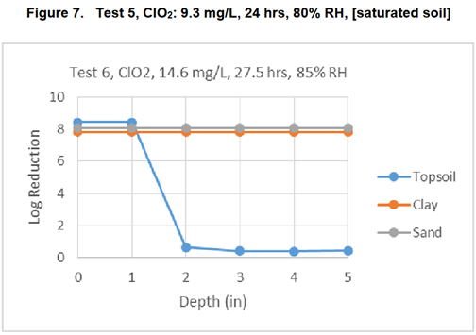
(Assessment of the Decontamination of Soil Contaminated with Bacillus anthracis Spores Using Chlorine Dioxide Gas, Methyl Bromide, or Activated Sodium Persulfate)
But this is a minor point as the main issue is for containment in a BSL-4 after the samples are removed from the landing site. They don’t seem to discuss this at all, which is the main focus of attention in previous Mars sample return studies.
This is all I can find about environmental effects of accidental release of Martian life from a BSL-4.
By applying the BSL-4 framework, NASA is able to identify and analyze reasonably foreseeable environmental impacts of its Proposed Action (e.g., the air emissions from a representative existing BSL-4 facility) and evaluate, from a programmatic perspective, whether the environmental effects may be significant. This programmatic analysis can be utilized to guide SRF type and location planning, as well as analyses once these aspects have been identified and proposed.
(Mars Sample Return DRAFT EIS : EIS : 2-12)
To paraphrase, they are saying “nothing to look at here, will just handle it like any other sample in a BSL-4”.
All this is legally simple for as long as effects are local. But their plans would need to be examined in great detail by other agencies if there is potential for large-scale effects.
Just by omission, that these things are not considered, it shows that authors of the EIS are of the view that “near - zero” means there is no need to consider wider environmental effects.
They clearly feel they have no need to consider them even udner these direct obligations for NASA as a government agency under numerous executive orders from past presidents of the USA.

NATIONAL RESEARCH COUNCIL (2009): NASA NEEDS TO WORK WITH BIOSECURITY AGENCIES LIKE THE CDC AS WITH THE INTERNATIONAL COMMITTEE FOR BACK CONTAMINATION FOR THE APOLLO MISSION (BASED ON POTENTIAL FOR LARGE-SCALE NEGATIVE EFFECTS)
The 2009 sample return study by the National Reserch Council says
As already noted, the design, construction, and operation of an SRF (Sample Receiving Facility) will require the coordination and work of multiple teams of experts, comprising a decade or more of planning. It will be important for various layers of scientific and technical oversight to be in place early in the planning process to ensure continuity through the lenthy and complex Mars sample return planning process.
In addition to the establishment of a body to provide scientific and technical advice relating to an SRF, there is also a need for higher-level oversight of all planetary protection requirements associated with Mars sample return. It is clear to the committee that NASA will need to obtain continuing interagency advice (e.g. from the Centers for Diseas Control and Prevention and relevant biosecurity agencies and organizations) on planetary proteciton policies and compliance, similar to the functional role played by the Interagency Committee on Back Contamination (ICBC) during the Apollo program..
(Assessment of planetary protection requirements for Mars sample return missions : Pages 67–8)
NASA don’t mention any proposal to set up technical advice or to work with other agencies while developing the Sample Receiving facility. Also it is too late to do this with the timetable set up in the 2009 report for a sample returned in 2033. They should have started long ago or would need to postpone the sample return significantly to contain the samples with this level of thoroughness.
Instead NASA just plan a normal internally managed BSL-4 with no oversight from anyone else.

ONCE POTENTIAL FOR LARGE-SCALE EFFECTS IS RECOGNIZED, MANY US AGENCIES WILL NEED TO DECLARE AN INTEREST - SUCH AS CDC, DOA, OSHA, DOI ETC
US agencies that would get involved include:
- CDC (for potential impact on human health),
- Department of Agriculture (for potential impact on livestock and crops),
- NOAA (for potential impact on oceans and fisheries after a splashdown in the sea)
- Occupational Safety and Health Administration, to consider questions of quarantine if a scientist or technician gets contaminated by a sample
- Department of the Interior - the steward for public land and wild animals - since these could be affected by release of Martian microbes
- Fish and Wildlife Service for the DoI who maintain an invasive species containment program and may see back contamination as a possible source of invasive species

ESA ARE CLOSELY INVOLVED AS THEY FETCH THE SAMPLES FROM MARS TO THE MARS ASCENT ORBITER, AND RETURN THEM FROM MARS ORBIT TO THE SURFACE OF EARTH - SO THE LEGISLATION OF THE EU, UK AND OTHER MEMBER STATES MAY APPLY - ALSO THE ESPOO CONVENTION
This is a joint ESA / NASA mission. The papers I found don’t go into this. But ESA are closely involved as they are responsible for fetching the samples from Mars and returning them to Earth.
So, the legislation of ESA member states would seem relevant. That includes the UK, the EU and other member states and cooperating states. Se (Member States & Cooperating States )
With the EU involved,
- Directive 2001/42/EC might apply (Directive 2001/42/EC of the European Parliament and of the Council of 27 June 2001 on the assessment of the effects of certain plans and programmes on the environment)
Also the UK and many other member states of ESA are parties to the Espoo convention. List of parties: UNTC
Under that convention they would need to consult with each other on all major projects that can have an effect outside of their own boundaries - which would certainly apply to a Mars sample return release of life that transformed the biosphere (Environmental Assessment - Espoo Convention)

INTERNATIONAL ORGANIZATIONS MAY GET INVOLVED LIKE THE FAO FOR POTENTIAL FOR LARGE SCALE EFFECTS ON FOOD AND AGRICULTURE, THE WHO BECAUSE OF POTENTIAL FOR LARGE SCALE EFFECTS ON HUMAN HEALTH ETC
It seems unlikely worst case scenarios would be ignored as the legal proceedings continue. So, for any Mars sample return mission for any country, at some stage, international agencies may get involved like
- Food and Agriculture Organization , because of potential impact of large scale changes such as mirror life on agriculture and fisheries and global food supplies,
- World Health Organization because of potential of large scale impacts on human health globally if a new organism is returned that can harm humans and spread to other countries.
Many international treaties and domestic laws of other countries are also likely to be relevant. Race and Urhan et al summarize some of these potential legal ramification see:
- (Updating Planetary Protection Considerations and Policies for Mars Sample Return)
- (Planetary Protection, Legal Ambiguity, and the Decision Making Process for Mars Sample Return)
In the USA, the Environmental Protection Agency partners with the United Nations Environment Program (UNEP), and Arctic Council, so they’d likely get involved.

A WORST CASE SCENARIO OF MIRROR LIFE HELPS FOCUS ATTENTION ON OUR RESPONSIBILITIES AS ALMOST ALL ASPECTS OF HUMAN LIFE ARE POTENTIALLY AFFECTED - JUST AS THE SCENARIO OF A HOUSE FIRE HELPS FOCUS ATTENTION ON RESPONSIBILITIES TO INSTALL A SMOKE DETECTOR PROPERLY
Indeed, with mirror life from Mars as an example worst case scenario, there would be few aspects of human life not relevant in some way in discussions of the very worst-case scenarios.
In this way, a scenario of mirror life can help focus attention on our responsibilities to protect Earth’s biosphere. This doesn’t happen if we focus exclusively on best case scenarios with no harm or near zero possibility of harm to humans or Earth’s environment, even if the best case scenarios may indeed be likely ones. Returning to what John Rummel said:
People have to have some kind of respect for the unknown. If you have that respect, then you can do a credible job, and the public is well-served by your caution.”
(Controversy Grows Over whether Mars Samples Endanger Earth)
I suggest in this case respect for the unknown should involve considering the scenario of mirror life, for as long as it remains an astrobiologically plausible scenario for Mars.
The analogy of a house fire helps again. If we pay close attention to a scenario of a house fire it helps us install smoke detectors properly. If we think a house fire is impossible, we might leave smoke detectors out altogether.
As the legal process continues, surely there would be open public debate about these scenarios, and if the discussion expands in this way, potentially it might lead to much wider involvement in the international community. It would be necessary to convince the public, and interested experts in all these agencies that this is a safe mission and that all their concerns have been answered.
In short, great care is taken to make sure Earth is kept safe.

NASA’S PLAN TO USE BIOSAFETY LEVEL 4 CONTAINMENT RELIES ON SAMPLE RETURN RECOMMENDATIONS FROM 1999 - THE ESF REDUCED THE SIZE LIMIT 20-FOLD IN 2012 AND ADDED A NEW REQUIREMENT OF 100% CONTAINMENT AT 0.05 MICRONS BECAUSE OF ADVANCES IN OUR KNOWLEDGE OF VERY SMALL ORGANISMS AND GENE TRANSFER
The draft EIS says they would use many of the basic principles of a Biosafety level 4 facility (BSL-4):
Nevertheless, out of an abundance of caution and in accordance with NASA policy and regulations, NASA would implement measures to ensure that the Mars material is fully contained (with redundant layers of containment) so that it could not be released into Earth’s biosphere and impact humans or Earth’s environment.…
The material would remain contained until examined and confirmed safe or sterilized for distribution to terrestrial science laboratories. NASA and its partners would use many of the basic principles that Biosafety Level 4 (BSL-4) laboratories use today to contain, handle, and study materials that are known or suspected to be hazardous.
(MSR Campaign Programmatic EIS, DRAFT Mars Sample Return (MSR) Campaign Programmatic Environmental Impact Statement : S2–4)
But the ESF set requirements well beyond an BSL-4 in 2012
RECOMMENDATION 7:
The probability that a single unsterilised particle of 0.01 μm diameter or greater is released into the Earth’s environment shall be less than [one in a million]
…
The release of a single unsterilized particle larger than 0.05 μm is not acceptable under any circumstances
(Mars Sample Return backward contamination–Strategic advice and requirements : 48)
This is how the 2012 ESF report explained its decision at the time of the study:
The value for the maximum particle size was derived from the NRC-SSB 1999 report ‘Size Limits of Very Small Microorganisms: Proceedings of a Workshop’, which declared that 0.25 ± 0.05 μm was the lower size limit for life as we know it (NRC, 1999). However, the past decade has shown enormous advances in microbiology, and microbes in the 0.10–0.15 μm range have been discovered in various environments. Therefore, the value for the maximum particle size that could be released into the Earth’s biosphere is revisited and re-evaluated in this report. Also, the current level of assurance of preventing the release of a Mars particle is reconsidered.
(Mars Sample Return backward contamination–Strategic advice and requirements : 3)
So NASA’s BSL-4 recommendation goes back to the science of 1999 and a lot has changed in our understanding since then
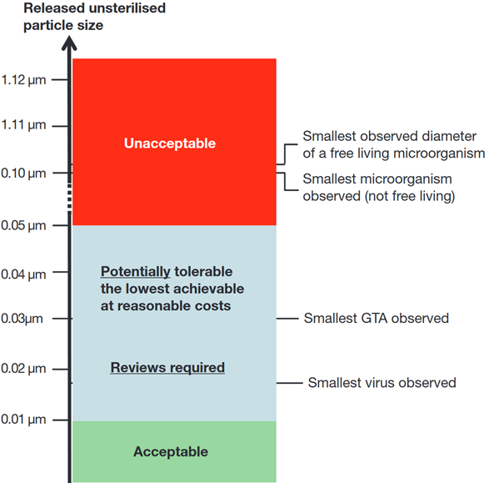

WE DON’T YET HAVE THE TECHNOLOGY TO CONTAIN STARVED ULTRAMICROBACTERIA STILL VIABLE AFTER PASSING THROUGH 0.1 MICRON NANOPORES - A LIKELY SCENARIO FOR MARS - EVEN INDEPENDENTLY EVOLVED ULTRAMICROBACTERIA COULD TRANSFORM OUR BIOSPHERE OR HARM HUMANS - E.G MIRROR LIFE
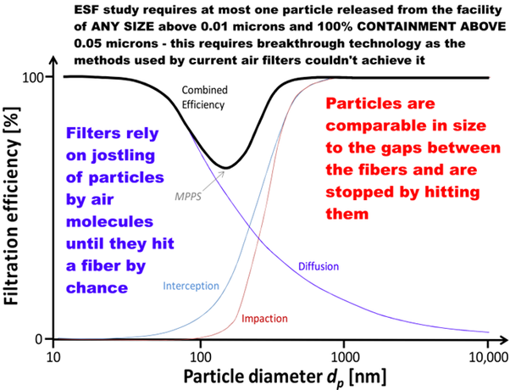
Text on graphic: ESF study requires at most one particle released from the facility of ANY SIZE above 0.01 microns and 100% CONTAINMENT ABOVE 0.05 microns - this requires breakthrough technology as the methods used by current air filters couldn't achieve it
Below maximum penetrating particle size: Filters rely on jostling of particles by air molecules until they hit a fiber by chance.
Above MPPS: Particles are comparable in size to the gaps between fibers and are stopped by hitting them.
(Application of Electrospun Nonwoven Fibers in Air Filters : Figure 1)
Recent air filter technology reviews don’t mention any attempts to achieve 100% containment above any size. Also they don’t mention anything approaching 1 in a million chance of releasing a single particle in the lifetime of a facility at all sizes above 0.01 microns. See: (Application of Electrospun Nonwoven Fibers in Air Filters)
The 100% requirement would seem to need some new breakthrough technique rather than incremental changes such as more layers of filters or varying the spacing as those couldn’t get it all the way to 100% containment of such small particles.

WE ALSO NEED TO CONTAIN GENE TRANSFER AGENTS AT 0.01 MICRONS ABLE TO TRANSFER NOVEL CAPABILITIES OVERNIGHT IN SEAWATER AND AFTER A SIZE LIMIT UPDATE - MAY NEED TO BE PREPARED FOR A SCENARIO OF MIRROR-LIFE RIBOCELLS SIMILAR IN SIZE TO GENE TRANSFER AGENTS - AND NONE OF THE STUDIES MENTION PRIONS
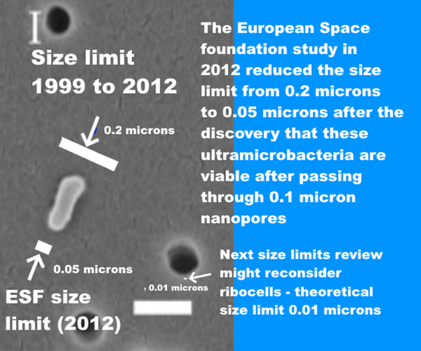
Text on graphic: Size limit 1999 to 2012: 0.2 microns
ESF Size limit (2012): 0.05 microns
The European Space Foundation study in 2012 reduced the limit from 0.2 microns to 0.05 microns after the discovery that these ultramicrobacteria are viable after passing through 0.1 micron nanopores
Next size limits review might reconsider ribocells – theoretical size limit 0.01 microns
Background graphic: SEM of a bacterium that passed through a 100 nm filter (0.1 microns), larger white bar is 200 nm in length (Passage and community changes of filterable bacteria during microfiltration of a surface water supply)
A self contained viable mirror cell from Mars might potentially be as small as a ribocell. Research since 2012 has made this seem increasingly plausible.

THE ESF STUDY IN 2012 SAID THE SIZE LIMIT AND LEVEL OF ASSURANCE NEEDS TO BE REVIEWED ON A REGULAR BASIS (AND MORE OFTEN THAN ONCE A DECADE) - THIS HAS NOT BEEN DONE AND NASA DOESN’T DISCUSS THIS RECOMMENDATION
NASA hasn’t mentioned this recommendation in the EIS - given all the other omissions it is possible the authors of the EIS never noticed it.
RECOMMENDATION 8: Considering that (i) scientific knowledge as well as risk perception can evolve at a rapid pace over the time, and (ii) from design to curation, an MSR mission will last more than a decade, the ESF-ESSC Study Group recommends that values on level of assurance and maximum size of released particle are re-evaluated on a regular basis
(Mars Sample Return backward contamination–Strategic advice and requirements : 21)
They mention the need for review since the MSR mission will last more than a decade. This is already a decade since that study in 2012 and the samples won’t return until more than two decades after the ESF review. A new size limit review is definitely required under their Recommendation 8. It also needs to look at levels of assurance, is 1 in a million enough at any level of containment, and if so at what levels of containment?

NASA MIGHT BE ABLE TO USE AN AIRFLOW INCINERATOR AT 500°C IN THE FINAL EIS - HOWEVER, THIS IS NOT THE SAME AS HEATING ESCAPED PARTICLES TO 500°C AND MAINTAINING THEM AT THAT TEMPERATURE FOR MINUTES AND WOULD NEED TO BE DEVELOPED AS A NEW PROTOCOL BEFORE IT COULD BE USED FOR THE VERY SMALL ULTRAMICROBACTERIA AND EXTRATERRESTRIAL LIFE
This is a suggestion by NASA astrobiologist Chris McKay (private communication). Everyone agrees extraterrestrial life from Mars would be sterilized by a few minutes of heating to 500°C.
Here for instance is a summary by Rummel et al. saying that the sterilizing effects of heat or ionizing radiation would be broadly the same for extraterrestrial life as for terrestrial life.
If there were a life-form on Mars based on other than carbon-containing molecules, the energies holding such molecules together would not be much different than those for proteins and polynucleotides.
Hence, bond breakage by heat or gamma radiation should be similar for Earth and Mars life forms, and sterilization conditions for Earth microorganisms should eradicate microorganisms of similar size from Mars.
There is no absolutely optimal approach to decontamination under these circumstances, but enough is known about the relationships among organism size, repair mechanisms, and survivability, that the maximum survivability of any martian organisms can be estimated with some confidence.
(A draft test protocol for detecting possible biohazards in Martian samples returned to Earth : Page 10)
Chris McKay’s idea is to use an air-flow incinerator instead of an oven, which researchers do use sometimes. The standards for a biosafety class III cabinet for a BSL-4 laboratory do include an option to use an air incinerator instead of the second HEPA filter. See page 37 of (Primary containment for biohazards: selection, installation and use of biological safety cabinets)
Would an air incinerator be sufficient to contain the very small ultramicrobacteria, possibly ribocells, and extraterrestrial biology?
These might be effective as a way to contain very small cells, but we need to be aware that they are not rated as such or tested to do this. We have never had to contain ultramicrobacteria in any biosafety laboratory and we have no technology designed to do this.
If NASA with to explore this, it still needs a new EIS.
- NASA needs to acknowledge that the worst-case scenario is a risk of large-scale impact on the environment and human health and that any solution has to satisfy experts in all relevant agencies and internationally.
- This will ensure that any proposal is considered carefully outside NASA.
- In any new EIS, NASA needs to compare it with the reasonable alternative of sterilizing the samples before they come to Earth. This maintains 100% safety for Earth's biosphere more simply, at lower cost and with no potential failure modes.
- We need to develop the specifications first - experts need to look into the size limit and the level of assurance needed, both of which need regular review according to the ESF in 2012. This review has not yet been done.
Once we know what needs to be achieved, NASA need to look into technology.
- failure modes,
- repair,
- improve the methods used to test HEPA filters for such small sizes of particles,
- how to safely change or maintain the air incinerator
Then, I think once it goes through WHO, CDC etc there may well be:
- a requirement for end-of-life sterilization of the facility as well. We don’t know that the samples will eventually be proven to be safe for Earth and we need to be prepared for the possibility that we find that our samples include viable mirror life for as long as this remains a biologically plausible scenario for martian life.
It is too soon to propose a new technology before we know the requirements or the testing methods or who will evaluate it and how. However we can look briefly at some of the issues we would need to consider.

MARTIAN LIFE MAY BE SIGNIFICANTLY MORE RESILIENT TO HIGH TEMPERATURES THAN TERRESTRIAL LIFE - PERHAPS AN AIR INCINERATOR COULD WORK - BUT IT NEEDS TO BE EVALUATED IN A PROPER PROCESS JUST AS THE BSL-4 STANDARDS WERE
The NIH guidelines for research involving recombinant or synthetic nucleic acid molecules specifies that these air incinerators need to be tested against a challenge aerosol of hardy spores, either b. subtilis var niger spores, or b. stearothermophilus spores (NIH guidelines April 2019).
However, for a Mars sample return, it also has to contain potential Martian life potentially more resilient than terrestrial life after millions of years of evolution in the extreme conditions on Mars. It may have:
- evolved to resist UV, ionizing radiation, oxidant stress from perchlorates, chlorates and chlorites, hydrogen peroxide, low pressure and low humidity,
- spores may have evolved additional protective layers against these stressors that would make them more resilient to incineration.
Then in addition
- Even small dust grains could give extra protection from air incineration to microbes imbedded in a crack in the grain.
By the ESF requirement, it has to contain
- ALL microbes down to ultramicrobacteria at 0.05 microns
– these air incinerators aren’t tested for ultramicrobacteria.
- Have only a 1 in a million chance of releasing a single viable Gene Transfer Agent at 0.01 microns for the lifetime of the facility
– these incinerators are not tested for the very numerous GTAs which can transfer novel capabilities to unrelated life overnight in seawater.
Then Martian microbes could use a more resilient backbone than DNA for its informational biopolymer. In one experimental test of PNA heated for 150 to 200 ms
- All RNA – RNA base pairs are UNSTABLE beyond 350°C
- All PNA – PNA base pairs are STABLE up to 420°C
See : Fig 10 of (Thermal stability of peptide nucleic acid complexes)
In a test of melting for 200 ms,
- Nearly all RNA – RNA strands separate at 340 C
- Almost none of the PNA – PNA strands separate at 340 C
See : Fig 4 of (Thermal stability of peptide nucleic acid complexes)
Mars could have more stable informational polymers through an accident of evolution, or through adaptation to ionizing radiation, or adaptation to high temperatures or both. Mars had subsurface hydrothermal systems in the recent past, and they may well be present today as well, and may well be a refuge for surface life at times when the surface is less hospitable.
- Some Mars life may be resilient to very high temperatures. Mars could have surface life like the terrestrial geobaccilus spores which do best in hydrothermal vents but they are found in surprisingly large numbers almost everywhere researchers look, including in cool soils and cool ocean floors (The Geobacillus paradox: why is a thermophilic bacterial genus so prevalent on a mesophilic planet?)
- Mars had hydrothermal conditions less than 20 million years ago in the rootless cones (without a magma chamber) (Interactions between Athabasca Valles Flood Lavas and the Medusae Fossae Formation (Mars): Implications for Lava Emplacement Mechanisms and the Triggering of Steam Explosions).
- There is some evidence suggesting recent volcanic activity as recently as 53 to 210 thousand years ago which may also suggest Mars could be geologically active today (Evidence for geologically recent explosive volcanism in Elysium Planitia). Mars could have caves that vent to the surface even today. See page 788 of (Mars Extant Life: What's Next? Conference Report)
- the ionizing radiation and the desiccation and oxidants of the surface would favour life that has especially resilient double-strand bonds.
In short, an airflow incinerator may be part of a future solution, but it couldn’t be added in at the last minute in an ad hoc way to “fix” the draft EIS.
There would be a lot of preliminary work needed before it could be considered as a solution. The EIS would need to restart with a new technology review based on examining whether such technology could be used to contain an alien biology to the required level of assurance. There seem to be many things that such a review would need to consider.
The standards would need to be developed with the same level of care that was used to develop the standards for BSL-4 facilities and Biosafety class III cabinets.

UNDER THE NEPA REQUIREMENTS NASA SHOULD COMPARE ANY ALTERNATIVE SUCH AS USE OF AIRFLOW INCINERATORS WITH THE REASONABLE ALTERNATIVE TO STERILIZE THE SAMPLES BEFORE THEY REACH EARTH WHICH SEEMS FAR EASIER AND WITH NO POTENTIAL FAILURE MODES
Perhaps this will be an option in the future. However, it is not clear why we would do this for NASA’s mission, since there is a far easier approach, to sterilize the samples before they are returned to Earth.
If NASA do pursue this approach of an air-flow incinerator, they should by NEPA requirements also consider reasonable alternatives such as presterilizing samples before they return to Earth.

NASA’S MISSION CAN BE MADE 100% SAFE FOR EARTH BY STERILIZING SAMPLES BEFORE THEY REACH EARTH - WITH VIRTUALLY NO EFFECT ON THE SCIENCE
However you CAN turn this into a mission that is 100% safe for Earth and that achieves all the same science objectives and indeed achieves far more, by sterilizing all Perseverance's samples before they reach Earth.
The EIS only briefly considers the suggestion to sterilize samples before they reach Earth. They say that this would compromise some of the scientific goals and discuss it no further. But if protecting Earth is our top priority we need to look a little closer, what scientific goals are compromised and by how much?.
Consideration of techniques to assess samples and for sterilization prior to returning to Earth:
.,..
Sterilizing the entirety of the material returned from Mars would compromise specific scientific goals, as outlined in the discussion of sterilization-sensitive science by Meyer et al. (2022) in the “Final Report of the Mars Sample Return Science Planning Group 2 (MSPG2)”
(MSR Campaign Programmatic EIS, DRAFT Mars Sample Return (MSR) Campaign Programmatic Environmental Impact Statement : 4–2)
The studies that are most sensitive are the ones that are relevant to the search for PRESENT DAY LIFE or recent life in Jezero crater. Those naturally are very sensitive to sterilization. We already saw that only 1 out of 7 types of measurement can be done after sterilization.
However, Perseverance is not targeting a site on Mars with a high chnance to have present-day life. The chance of returning present-day life is probably low since Perseverance isn’t designed to try to find it.
If Peseverance does return present-day life, it will be accidental. If we look at its main astrobiological science objective, to search for past life, almost half the measurements can be still be done.
A corollary of Finding SS-1 is that the other (up to almost) half of the measurements described by iMOST for investigation into the presence of (mainly molecular) biosignatures of ancient life (Objective 2.2) in returned martian samples are sterilization-tolerant
(Planning implications related to sterilization-sensitive science investigations associated with Mars Sample Return (MSR) : Table 2)
Three out of 10 searches for carbon chemistry and past life, and 13 out of 25 of the searches for ancient life are sterilization insensitive according to iMOST.
Meanwhile as NASA themselves conclude, virtually all the geology can be done with sterilized samples. 115 out of 160 measurements are sterilization insensitive for geology.
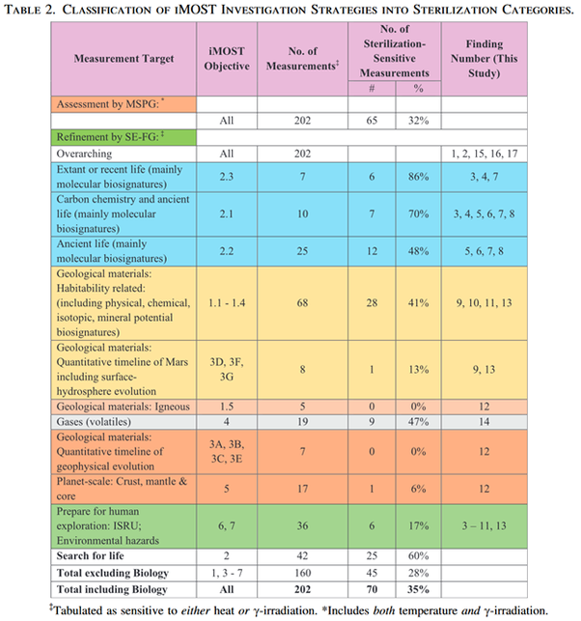
(The potential science and engineering value of samples delivered to Earth by Mars sample return: International MSR Objectives and Samples Team (iMOST) : Table 2)
If these were unaltered samples of past life protected from surface conditions for billions of years, we could still do past life science, but the materials would be potentially very sensitive.
We could do geology after sterilization but 15 of the experiments would be impacted.
But the samples have been exposed to millions of years of ionizing radiation indeed the youngest Curiosity mudstone exposure ages are 80 million years. This is enough for them to be thoroughly sterilized - and to lose nearly all past organics!
Perseverance can't detect the exposure age of the rocks it samples, and has virtually no chance of returning samples with interesting evidence of past life organics.
We will find that in reality, there is a near certainty that NASA won’t be able to do ANY of these studies for past or present day life.
That’s because of another mishap similar to the mishap that saw the authors of the EIS say that existing credible evidence says Mars is uninhabitable while another team is planning to look for present day life.
In a similar way, we’ll find that
- returned Mars samples are required to have no more than 10 ppb of terrestrial organics contamination and 1 ppb per biosignature
[NASA engineers]
- even samples of recently exposed rocks are likely to have far less than 1 ppb of recognizable past organics because they get transformed by ionizing radiation (indeed some research suggests less than 0.1 ppb recognizable after only 6 million years surface exposure)
[Astrobiologists]
- This is why I suggest small bonus samples in a 100% clean sample tube sent on the ESA fetch rover, for a first step in searching for trace organics from both past life and any current life or interesting surface chemistry in the samples – we have the technology to do this and it would be comparatively easy for a simple scoop of dirt or a few pebbles - see below
Again this seems to be a case of two teams not talking to each other, not unlike the Mars Climate Orbiter mishap that we mentioned before.
Sterilization will have virtually no impact on the geological science studies as you yourself concluded, and especially once you add in the exposure age, so long as we use ionizing radiation.
But because of forwards contamination sterilization will have no impact on studies for past life either as there won’t be any recognizable traces of past life. That leaves present day life but well see that also will most likely be unrecognizable amongst the contamination unless the samples have tens or hundreds of thousands of ultramicrobacteria per gram (assuming very small microbes ijn nutrient poor conditions).
Perseverance could spot a biofilm probably. It couldn’t spot a few spores in the dust. This also makes the safety testing impossible too.

THIS IS AN EASY WAY TO MAINTAIN YOUR WORLD-LEADING ROLE IN PLANETARY PROTECTION - TO STERILIZE SAMPLES BEFORE THEY RETURN TO EARTH - WHICH MAINTAINS VIRTUALLY ALL SCIENCE RETURN FOR THIS MISSION - AND ALSO GIVES AN EASY PRECEDENT FOR OTHERS TO FOLLOW
You have another option here to maintain your world-leading role in planetary protection, with no risk of harm to Earth and to provide an example for other space agencies to follow.
This is the option of a pre-sterilized sample return. This is a simple way of keeping Earth 100% safe that other space agencies and private space can copy easily. Your draft EIS didn’t even look at this option although I and several others recommended it in the first round of public comments.
NEPA requires you to look at reasonable alternatives.
(a) Evaluate reasonable alternatives to the proposed action, and, for alternatives that the agency eliminated from detailed study, briefly discuss the reasons for their elimination.
(b) Discuss each alternative considered in detail, including the proposed action, so that reviewers may evaluate their comparative merits.
§ 1502.14 [links directly to legal text]
The samples can be sterilized in a satellite resembling those in Geostationary Earth Orbit but in a higher orbit with no risk of contamination of either Earth or the satellites in GEO. Other missions could use the same satellite for sterilization for their missions too. The sample tubes wouldn’t need to be opened, just sterilize the whole sample.
This will have minimal impact on geology. From your own EIS you don’t expect any present-day life.
I and seven others made this suggestion in the first round of public comments.

NASA’S 8.1 PPB CONTAMINATION OF THE SAMPLES BY TERRESTRIAL ORGANICS WILL MASK THE 0.1 PPB OF MARTIAN ORGANIC LEFT AFTER ONLY 6 MILLION YEARS SURFACE IONIZING RADIATION - PERSEVERANCE CAN’T MEASURE EXPOSURE AGES AND CURIOSITY’S YOUNGEST RELEVANT SAMPLE HAD ~80 MILLION YEARS EXPOSURE
Meanwhile, it turns out your permitted forward contamination by organics from terrestrial life will make it impossible to detect biosignatures of past life even in samples with only 6 million years of surface exposure. That is enough to reduce recognizable biosignatures from 100 ppb as found in a Mars meteorite with only 2 million years of ionizing radiation exposure to 0.1 ppb.
The rest of the original 100 ppb is not destroyed. But it is broken up and transformed into other usually short molecule organics. It is no longer possible to distinguish it from other forms of organics exposed in the same way.
(Rapid Radiolytic Degradation of Amino Acids in the Martian Shallow Subsurface: Implications for the Search for Extinct Life)
Perseverance’s engineers believe they achieved contamination levels for returned rock samples of
- 0.7 ppb for their most abundant biosignatures.
- 8.1 ppb total organics
(Mars 2020: mission, science objectives and build. In Systems Contamination: Prediction, Control, and Performance 2020 : table 6)
That 0.1 ppb is for less than a tenth of the 80 million years exposure age of the Curiosity Cumberland mudstone sample. At 80 million years at 1000 fold reduction every 6 million years there would be almost nothing recognizable.
Though it’s possible Jezero crater has samples with younger exposure ages than that, Perseverance doesn’t have the capability to measure exposure ages in situ.
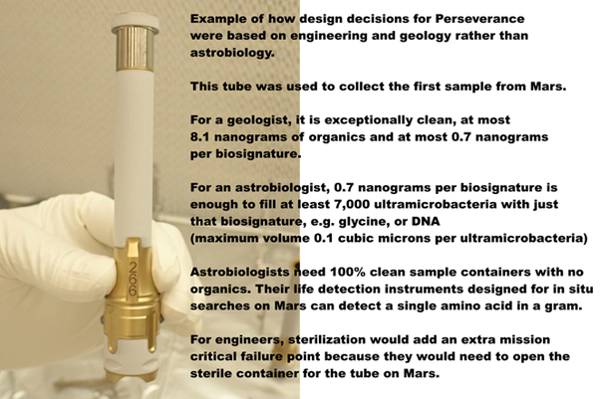
Text on image: Example of how design decisions for Perseverance were based on engineering and geology rather than astrobiology.
This tube was used to collect the first sample from Mars.
For a geologist, it is exceptionally clean, at most 8.1 nanograms of organics and at most 0.7 nanograms per biosignature.
For an astrobiologist, 0.7 nanograms per biosignature is enough to fill at least 7,000 ultramicrobacteria with just that biosignature, e.g. glycine, or DNA (maximum volume 0.1 cubic microns per ultramicrobacteria)
Astrobiologists need 100% clean sample containers with no organics. Their life detection instruments designed for in situ searches on Mrs can detect a single amino acid in a gram.
For engineers, sterilization would add an extra mission-critical failure point because they would need to open the sterile container for the tube on Mars.

SAFETY TESTING IS IMPOSSIBLE - WE CAN’T ACHIEVE EVEN A LOW LEVEL OF SAFETY ASSURANCE FOR THE PERSEVERANCE SAMPLES BECAUSE OF FORWARDS CONTAMINATION AND WITH CURRENT TECHNOLOGY - A MAJOR CHALLENGE EVEN WITH CLEAN SAMPLES TO ACHIEVE A LESS THAN 1 IN 2 CHANCE OF ONE VIABLE MARTIAN MICROBE IN A SAMPLE - NEAR CERTAINTY ALL THE PRESERVERANCE SAMPLES ARE SENT TO “HOLD AND CRITICAL REVIEW” AND ONLY RELEASED STERILIZED
This depends on the desired level of assurance. But if we require a high level of assurance that there is nothing in the sample that can harm Earth then it’s impossible to achieve this with current technology even for samples returned in a clean container with no forward contamination.
Kmineck et al agreed that it is not possible to prove safety by trying to predict effects of any life found.
During the Working Group’s deliberations, it became clear that a comprehensive assessment to predict the effects of introducing life in new environments or ecologies is difficult and practically impossible, even for terrestrial life and certainly more so for unknown extraterrestrial life.
The only way to prove safety is to prove that there is no life in the sample. This citation goes on to discuss how to test for life by checking for biosignatures.
This can achieve a level of safety assurance so long as the samples were free from forward contamination.
If we find no biosignatures we can be reasonably sure we haven’t sampled a biofilm, or a rock sample inhabited by a colony of Martian life. But we can’t rule out viable spores or propagules or other viable life in the dirt or dust brought to Jezero crater in the wind from distant or nearby places - or indeed, accidentally sampling only the edge of a patch of viable life.
So, if we wish to have a very high level of confidence that there is no life in the samples, there is no way in practice to achieve this by looking for biosignatures unless we destructively test most of the sample.
However, by Perseverance’s permitted levels of forward contamination, they are guaranteed to generate false positives for all the samples tested. So we can’t even achieve the rather lower bar they aimed for here.
The next stage is that the samples all go to “hold and critical review”.
This citation doesn’t say what would happen next.
(COSPAR Sample Safety Assessment Framework (SSAF))
Kmink et al agree with previous studies that it is not likely to be useful to cultivate putative organisms to try to show they are safe, or use attempts to challenge plants and animal species or tissues (Kminek et al., 2022).
The SSAF is in agreement with the position of the NRC Committee on Mars Sample Return Issues and Recommendations that “Attempts to cultivate putative organisms, or to challenge plant and animal species or tissues, are not likely to be productive” (NRC, 1997)
The major limitations of this approach are
- that cultivation is not even possible for most terrestrial organisms and challenge tests are typically tailored to one or a few targets of interest.
- In addition, it is not considered advisable to multiply viable organisms that could have unknown and potentially harmful consequences.
Therefore, cultivation is not considered a diagnostic tool used by the SSAF. As an indirect consequence and due to the limited diagnostic scope that covers the potential avenues of causing harm, animal and plant inoculation are ruled out as well.
[Bullet points added]
(COSPAR Sample Safety Assessment Framework (SSAF) : page )
Another caveat here. Even if we find life as familiar as chroococcidiopsis, the question still arises – is it terrestrial or is it evidence of panspermia? We’d need to study it closely to see if it is sufficiently identical to any terrestrial strain.
We currently have no way to reliably distinguish terrestrial from potential martian biosignatures. We could recognize familiar life like chroococcidiopsis which we already cultivate and have already sequenced. However, the vast majority of microbial species haven’t been characterized or sequenced or cultivated in the laboratory; the problem of “microbial dark matter” (The search for microbial dark matter)
Hendrickson did an attempt at a genetic catalogue using 98 swabs from the floors of the clean room that would be used to assemble the Perseverance rover before assembly started.
However,
- Out of 54 identified genera, only 8 were spore forming
- 1196 out of 1250 genera didn’t have enough reads to be identified properly.
- 36 out of 49 spore forming species (not genera) were only found in one of the 98 swabs
- 4 of the identified species weren’t close to any known terrestrial species (< 98.7% similarity to the most similar relative).
(Clean room microbiome complexity impacts planetary protection bioburden)
This is not unusual, indeed this is expected and normal.
They could be sure that these four new species in the Perseverance swabs didn’t closely resemble any known life just from that one short sequence, because the 16S RNA ribosome subunit is very stable, and is the basis for the modern classification method for microbes and other organisms due to Carl Woese (Sapp et al., 2013). It is a short section of RNA which gets mixed with proteins to make up the structure of the ribosome used to translate RNA into proteins.
We are just about certain to detect many novel sequences like this after taking them to Mars and back. So we will get many genetic sequence false positives, and it will be impossible to prove they aren’t martian.
We can’t actually achieve a high level of assurance even with clean samples.
If we destructively test 10,000 grains of sand and the 10,001th grain could have a microbe imbedded in a crack that we never noticed. There isn’t any non destructive way to reliably test for even terrestrial life in a grain of sand. Raman spectroscopy for instance depends on the microbe being visible and won’t detect life hidden in a grain of sand.
To achieve a 1 in 10,000 chance of a single viable microbe in 10 grams of sample we’d need to destroy all except one milligram of that sample.
Realistically we are not likely to destructively test half the sample. So to get less than a 1 in 2 chance of a single viable microbe will be challenging.
With some assumptions, we can do better. If we can assume 999 out of 1000 microbes are not viable we could destructively test 10 milligrams to return one milligram unsterilized with a 1 in 10,000 chance of a viable martian microbe, and so on, assuming our tests are able to detect a single microbe, and some of the experiments we could send to Mars certainly could.
Once we know more about the samples we may be able to prove they are sae. But at an early stage this will be very challenging even for samples in clean containers if we want a high level of assurance.

STERILIZING SAMPLES IN SPACE ELIMINATES ISSUES OF PUBLIC OPPOSITION - WITH VIRTUALLY NO IMPACT ON SCIENTIFIC RETURN
Sterilizing the samples in situ eliminates the risk of the general public being opposed and conspiracy theories. It also eliminates the issue of the presidential directive on large-scale effects or legal challenges to the EIS.
Also it removes the need for a heavy aeroshell, so it may have almost no difference on the return mission costs.
It saves on the cost of a sample-receiving facility. However this may not be large compared to the total budget.
In 2009 this was estimated at $121 million in real world dollars based on the 1999 requirements (Planning considerations for a Mars sample receiving facility: Summary and interpretation of three design studies : table 2).
However, this comes from a time when the idea was to test the samples in animals. Safety testing in terrestrial organisms is now not thought to be feasible. They say.
If a future version of the test protocol eliminates this requirement in accordance with state-of-the-art practices and refinements at the time the final protocol is implemented, the SRF design would potentially be simpler.
(Planning considerations for a Mars sample receiving facility: Summary and interpretation of three design studies : page 756)
Also, as we saw, it has likely virtually no impact on science return.

WE CAN ENHANCE THE MISSION WITH BONUS SAMPLES COLLECTED WITHOUT FORWARD CONTAMINATION IN A CLEAN CONTAINER SENT IN THE ESA FETCH ROVER AND RETURN THEM TO A SMALL CENTRIFUGE MARS SIMULATION CHAMBER ABOVE GEO
I also make suggestions for a way to greatly increase the science return by returning samples of the surface dust, dirt, atmosphere, and pebbles in a CLEAN container sent there in the ESF fetch rover.
This would be returned not to Earth but for remote study in the same satellite above GEO that we have for sterilizing the Perseverance samples.
We would study the bonus samples using instruments already designed for in situ searches for life biosignatures and processes on Mars. In this way also we build up a capability in space to anlayse future samples returned from Mars and elsewhere in the solar system.
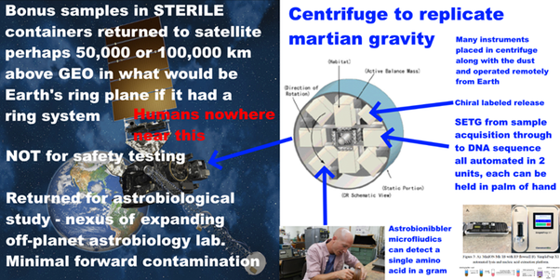
This would be minimal cost for NASA as the instruments would be funded by universities.
Humans go nowhere near the satellite (human quarantine can’t keep out mirror life or fungal pathogens of crops or fungal diseases that only affect some people).
We can return subsamples of the dirt, dust, and pebbles to Earth but we would do 100% sterilization of those samples.
We would study unsterilized samples in a safe orbit above GEO until we understand what’s in the samples very well, then it is for us to assess whether to continue to keep them in orbit. It may take multiple missions to Mars before we understand it well enough to be sure that samples can be returned unsterilized.
We do need to be prepared for the possibility of a discovery of great interest, such as mirror life, that would mean we can NEVER return uncontained unsterilized samples to Earth. That is why we do all this. Because there is a significant, likely small possibility that Earth DOES need to be protected.

MY FINAL COMMENT TO YOUR DRAFT EIS SUMMARIZES THESE MAIN POINTS
I cover the main points in my final comment to your draft EIS - the results of my literature survey since then adds many more details but hasn't lead to any changes in those main points:
I recommend this draft Environmental Impact Statement is stopped, and a new one prepared after doing the necessary size limits review, and fixing whatever led to its many errors.
1. The BSL-4 recommendation in this EIS is out of date, based on science of 1999.
2. This EIS does not mention the most recent Mars Sample Return study from 2012 by the European Space Foundation which reduced the 1999 size limit from 0.2 microns to 0.05 microns to contain ultramicrobacteria and required 100% containment at that size.
3. A BSL-4 is not designed to this standard. In recent reviews of filter technology, I find NO AIR FILTERS with that capability – and no evidence anybody is working on them. Air filters for larger particles remove some of these very small particles kicked out of the airstream by jostling of air molecules by Brownian motion but can't remove all. It is an unusual requirement.
4. NASA haven't responded to my comment in May which alerted them to this omission. They still don't cite the ESF study. Also, the ESF said their limit needs to be updated periodically. An update is certainly due a decade later.
5. The EIS has an overnarrow scope in the Purpose and Need section - it requires samples to be returned unsterilized to terrestrial labs for "safety testing". This won’t work. NASA believe they reduced the most abundant biosignatures to 0.7 nanograms per gram of returned rock sample – this guarantees a positive test. There will be no way to know if tubes contain safe terrestrial life or potentially unsafe martian life.
6. This narrow scope improperly excludes the reasonable alternative of presterilizing samples before they reach Earth's biosphere - which achieves virtually the same science return and keeps Earth 100% safe. By a 1997 case in the 7th circuit this alone probably invalidates the EIS.
7. The high levels of forward contamination make astrobiology almost impossible. I recommend bonus samples of dirt, dust and atmosphere collected in a STERILE container with no terrestrial organics, brought to Mars especially on the ESA fetch rover.
8. I recommend returning these bonus astrobiology samples to a safe orbit above GEO where they can be tested for life
9. The EIS’s reasoning for no significant environmental effects contradicts the conclusion of the NRC study from 2009 which they do cite, which says the risk of even large-scale impacts on human health or environment is likely low but not demonstrably non zero. It also warns against the meteorite argument that they use. I found multiple errors in my analysis.
10. Returned life COULD be harmful. Example, fungi kill crops, other life and sometimes immunocompromised humans. Botulism, ergot disease, tetanus, all are the results of exotoxins not adapted to the lifeforms they kill, similarly some algal blooms kill dogs and cows that eat them. BMAA misincorporated for L-serine causes protein misfolding and is a neurotoxin implicated in some cases of the disease that affected Steven Hawking - an alternative biochemistry may have many different amino acids similar enough to terrestrial amino acids to be misincorporated. Or perhaps martian life evolved from scratch from mirror chemicals as mirror life - the effect on our biosphere can't be predicted. I give many such examples in my preprint. Or it could be harmless like microbes from a terrestrial desert, or indeed beneficial. But we DON'T KNOW. So we need to find out first.
11. What matters for invasive species are the ones that can’t ‘get here, like starlings that can't cross the Atlantic rather than barn swallows. The freshwater diatom Didymo is invasive in New Zealand and can't get from one freshwater lake to another without humans. A microbe adapted to briny seeps on Mars and to spreading in dust storms shielded from UV, may well not get to Earth in a meteorite, while a sealed sample tube including Martian atmosphere, at Mars atmospheric pressure, is like a mini spaceship.
12. Quarantine of humans can’t keep out a fungal disease of crops, mirror life etc.
13. So any unsterilized samples will need to be studied remotely via telerobotics which also greatly reduces forwards contamination (issues with filtering ultramicrobacteria will go both ways).
14. astrobiologists now have tiny instruments that can go from sample preparation to life detection, even to a gene sequence[r], operated remotely on Mars. They could send hundreds of these in each 7 ton payload of the Ariane 5 to above GEO.
Let's make this an even better mission and SAFE for Earth.
Thanks!
. Comment posted December 20th

