We must contain any life in Mars dirt that can’t get into meteorites

Author: Robert Walker (contact email robert@robertinventor.com)

Preprint DOI …
For latest version of this preprint please visit: (url …)
(This version 3rd January 2023)
[Needs citations added]
NASA / ESA, and separately, China plan to return samples from the Mars surface. Japan plan to return samples from Phobos. We need to protect Earth from any martian microbes.

JAXA categorized their samples from Phobos as an unrestricted sample return, needing no precautions, as they withstood ejection from Mars and then similar conditions to the journey inside a meteorite to Earth from the last impact on Mars 700,000 years ago.

JAXA warn their conclusion doesn’t apply to samples collected on the Mars surface. NASA’s draft EIS didn’t notice this caveat. NASA also plan to return unsterilized samples to a BSL-4. This can’t comply with the 2012 ESF size limit review.

We can keep Earth 100% safe with virtually no loss of science by adding the equivalent of a few hundred million years of Mars surface ionizing radiation before they reach our biosphere. Then bonus samples returned in a sterile container to a martian gravity centrifuge in an unmanned satellite above GEO can start Sagan’s “vigorous program of unmanned exobiology.

This is a short review of central results in the planetary protection literature to encourage space agencies to ensure Earth’s biosphere is adequately protected when they return samples from Mars.
This review focuses on NASA’s draft EIS only because it is the first environmental impact statement for a Mars sample return ever published. If NASA and ESA can make mistakes of this order, when they paid so much attention to planetary protection in the past, other space agencies could easily do the same.
NASA haven’t responded to attempts to alert them to these issues via email or via public comments on the draft EIS.
Let’s start with the meteorite argument. NASA argues that:
The natural delivery of Mars materials can provide better protection and faster transit than the current MSR mission concept.
However, the NRC Mars Sample Return study in 2009 48 said:

“The potential hazards posed for Earth by viable organisms surviving in samples [are] significantly greater with a Mars sample return than if the same organisms were brought to Earth via impact-mediated ejection from Mars"

The NRC goes on to say, in its discussion of large scale effects:

"... Thus it is not appropriate to argue that the existence of martian meteorites on Earth negate the need to treat as potentially hazardous any samples returned from Mars by robotic spacecraft."

So, how did NASA come to such a different conclusio?

NASA’s EIS reasons:
First, potential Mars microbes would be expected to survive ejection forces and pressure (National Academies of Sciences, …, 2019), …

This cite is a study of planetary protection for the Japanese space agency JAXA mission to return samples from Phobos. It does indeed conclude there is no need to take special precautions because (amongst other reasons) their samples will have already survived ejection from Mars.

However JAXA specifically say their argument does not apply to Mars sample return missions. :5)

MSR material might come from sites that mechanically cannot survive ejection from Mars and thus any putative life-forms would de facto not be able to survive impact ejection and transport to space. Such mechanical limitations do not apply for material collected on Mars.

Therefore, the committee finds that the content of this report and, specifically, the recommendations presented in it do not apply to future sample return missions from Mars itself.

Martian surface dust, salts, and dirt couldn’t mechanically survive ejection, as they would burn up in the atmosphere before reaching escape velocity.

NASA’s EIS seems to get their conclusion through mistaken citing, as they don’t mention this caveat. They also don’t mention the NRC statement.

Their cites do say that some very hardy terrestrial microbes such as b. subtilis might rarely survive transfer from Mars to Earth in a meteorite. But this doesn’t prove all or even any martian life got to Earth from Mars. We don’t know capabilities of martian life, if it exists. European Barn swallows in the Americas didn’t make it okay to introduce starlings, an invasive species in the USA which can’t fly across the Atlantic.
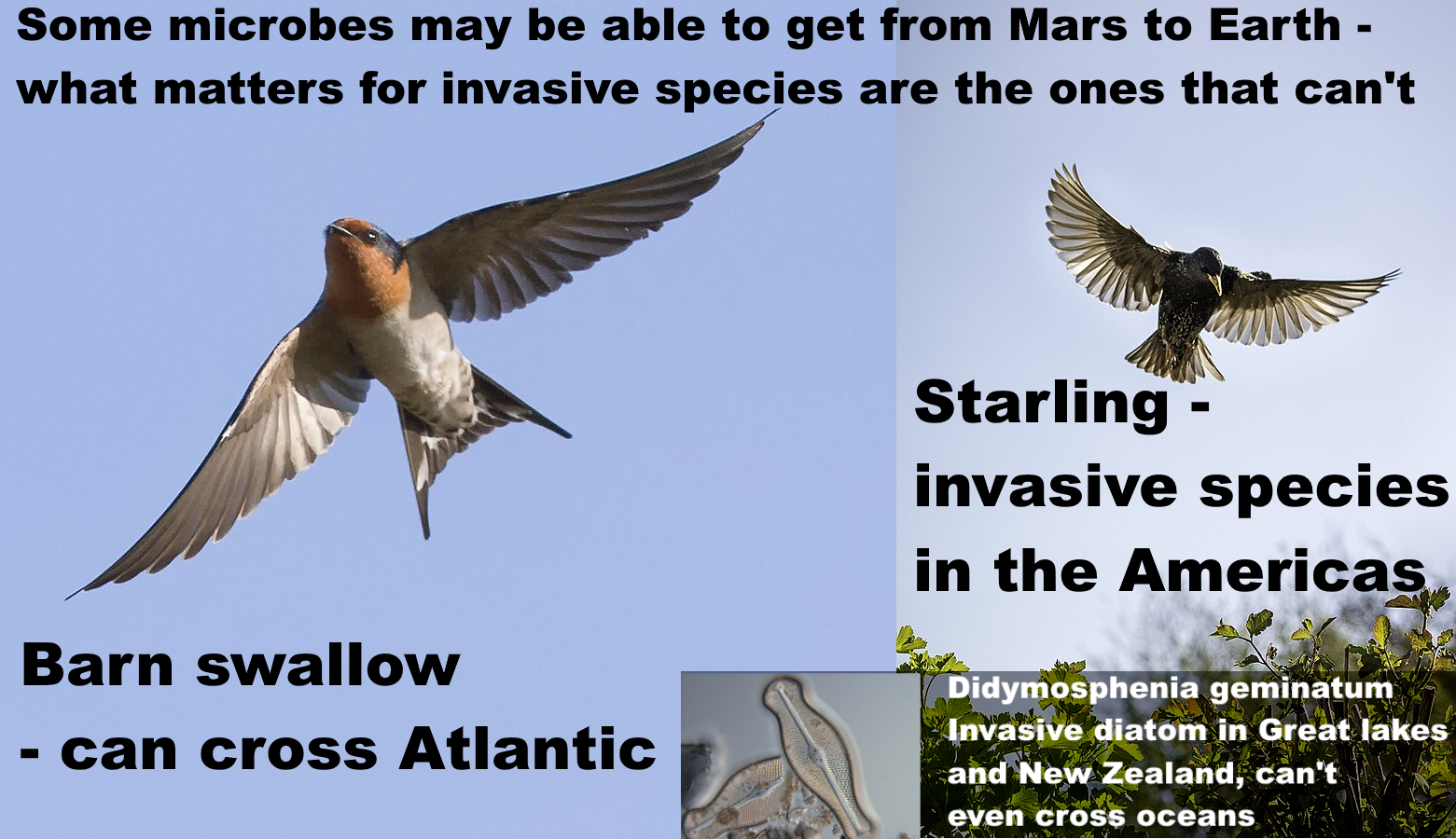
For a microbial example, the invasive freshwater diatom "Didymo" (Didymosphenia geminatum) in New Zealand can't get from one freshwater lake to another on the same island without human help. It could never get from Mars to Earth. If there are diatoms on Mars, perhaps in the lakes beneath the polar ice, they evolved independently from terrestrial diatoms.

Mars might have microbes perfectly adapted to biofilms in ephemeral brines which form in the late evening / early morning in Gale crater and likely also in Jezero crater. They might rarely transfer to other seeps in dust storms for protection from UV, perhaps succeeding every few millennia. Similarly to diatoms, they would have no evolutionary pressure to withstand extreme shock, vacuum, life below the surface of a rock, and so on, leaving no way to get to Earth on a meteorite. For them, a sealed sample tube is like a miniature spaceship complete with a small amount of martian atmosphere.

JAXA did establish it is safe to return their samples from Phobos because

- our martian meteorites left Mars at least 700,000 years ago for the most recent impact. See table S4 of (Udry et al, 2020)
- material from the top few centimeters on Phobos had similar levels of ionizing radiation to meteorites currently arriving at Earth from that last impact.
- Meanwhile life that survives ejection from Mars and travels directly to Earth is protected from the fireball of re-entry so long as it isn't in the surface layers.

JAXA’s analysis may have a slight oversight on that last point, as they argue microbe ejected from Mars wouldn’t need to be far below the surface of the rock to survive the re-entry fireball. This is normally a valid argument but it doesn't work exactly as stated for photosynthetic life which tends to live on or near the surface of rocks.

The astrobiologist Charles Cockell found that not only chroococcidiopsis but all associated organics were destroyed on re-entry, when he attached it at a typical growing depth on a re-entry aeroshell. He concluded

... Thus, the planetary exchange of photosynthesis might not be impossible, but quite specific physical situations and/or evolutionary innovations are required to create conditions where a photosynthetic organism happens to be buried deep within a rock during ejection to survive atmospheric transit.

However, our martian meteorites were thrown into space by glancing collisions into the high altitude southern uplands (Tornabene et al, 2006), where the thin atmosphere makes ejection to Earth easier. They also come from at least 3 meters below the surface (Head et al, 2002:1355), and anywhere below 12 centimetres has a uniform temperature of around -73°C (Möhlmann, 2005:figure 2). Perhaps life is possible there in rare geothermal hot spots. If so, it wouldn’t be using photosynthesis. There’s one possible exception, life using the thermal radiation from a hydrothermal vent for photosynthesis (Beatty et al, 2005), but it’s an unlikely case for Mars.

This may need closer attention but it seems the JAXA argument is valid for at least as back to when our earliest meteorites left Mars, and then life deposited on Phobos over 18 million years ago has had about [ 24% calc] of its amino acids destroyed, so the analysis seems correct with this minor tweak to account for photosynthetic life.

By a similar argument it may be safe to send astronauts to Phobos so long as they sterilize any materials they contact deep below the surface as there may be viable life buried after ancient larger impacts.

However, we can't say the same about the Martian surface at this time. Jezero crater seems uninhabited from orbit, but polyextremophiles in terrestrial Mars analogue deserts live in biofilms and microhabitats that you only discover by close examination. Also dust storms transfer terrestrial life over large distances, with life from the Gobi desert detected in Japan.

The MEPAG review of 2015 raises these issues:

"The SR-SAG2 report does not adequately discuss the transport of material in the martian atmosphere. The issue is especially worthy of consideration because if survival is possible during atmospheric transport, the designation of Special Regions becomes more difficult, or even irrelevant."

“Special regions” means regions where forwards terrestrial contamination is possible with viable life that could propagate on Mars.

NASA’s draft EIS refers to SR-SAG2, the 2014 study, but they don't cite this 2015 review which modified all its main conclusions relevant to Jezero crater.

The 2015 MEPAG review also says local microenvironments can be habitable in regions that seem to be uninhabitable on larger scales.

Physical and chemical conditions in microenvironments can be substantially different from those of larger scales. Although the SR-SAG2 report considered the microenvironment (Finding 3-10), the implications of the lack of knowledge about microscale conditions was only briefly considered.

It also discusses how microbes in biofilms modify microhabitats by surrounding themselves with “extrapolymeric substances” - proteins, polysaccharides, lipids, DNA and other molecules.

These can make microenvironments far more habitable for microbes and help them cope with environmental stressors 11:

So, we can’t know Jezero crater is uninhabitable everywhere without detailed local study looking for microhabitats and biofilms.

The MEPAG and MEPAG review studied forwards rather than backwards contamination. Extant martian life may be more capable than terrestrial life after billions of years of evolution to survive transit in dust storms.

One of NASA’s major omissions is the European Space Foundation study in 2012 which reduced the size of particle we need to contain at the 1 in a million level from 0.2 microns to 0.01 microns. This was motivated by the discovery of fast horizontal gene transfer to distantly related archaea in sea water via Gene Transfer Agents (GTA) Page 19

Surprisingly, it is now estimated that GTA transduction rates are more than a million times higher than previously reported for viral transduction rates in marine environments. Clearly, GTAs are a major source of genetic diversity in marine bacteria.

The ESF also said a particle of 0.05 microns or larger shouldn’t be released under any circumstances because of the discovery that ultramicrobacteria remain viable after passing through 0.1 micron nanopores. Page 21

“the release of a particle larger than 0.05 μm in diameter is not acceptable in any circumstances”

The ESF study says theirs is the first size limit review since 1999 and needs to be revisited periodically. The next review may examine research into extremely small early life cells such as ribocells with enzymes made from fragments of RNA instead of proteins. They may reproduce more slowly but the small size and high surface to volume ratio would be an advantage in low nutrient conditions on Mars.

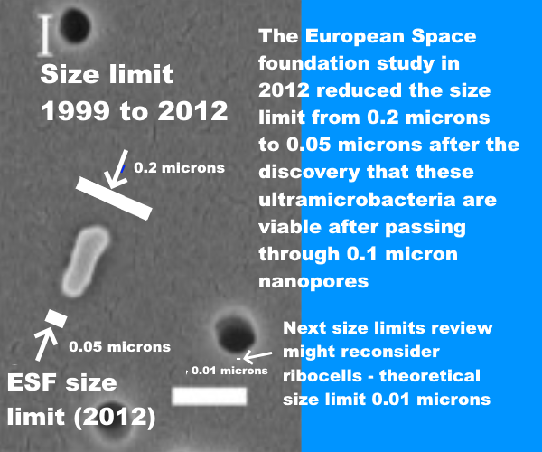

A BSL-4 doesn’t need to contain gene transfer agents, ultramicrobacteria, or hypothetical early life. Recent air filter technology reviews don’t mention any attempts to achieve 100% containment at all sizes above 0.05 microns or a 1 in a million chance of releasing a single particle in the lifetime of a facility at all sizes above 0.01 microns.

NASA’s draft EIS also contradicts the planetary protection literature with its finding of no significant risk of environmental effects for life returned from Mars.

relatively low probability of an inadvertent reentry combined with the assessment that samples are unlikely to pose a risk of significant ecological impact or other significant harmful effects support the judgement that the potential environmental impacts would not be significant.
(NASA, 2022eis: 3-3):

The National Research Council says it is not possible to assess the potential for negative impacts, and says the potential for [even] large-scale negative effects appears to be low but is not demonstrably zero.

The committee found that the potential for large-scale negative effects on Earth’s inhabitants or environments by a returned martian life form appears to be low, but is not demonstrably zero
… it is not possible to assess past or future negative impacts caused by the delivery of putative extraterrestrial life, based on current evidence.
(Board et al, 2009: 48)..
NASA’s conclusion can be traced back to an assessment by its sterilizing subcommittee. This seems to represent a minority view amongst microbiologists (MacGregor et al, 2001)

First, arguing from many examples of pathogens adapted to humans, this assessment says the risk of a direct pathogen of humans is near-zero (Craven et al., 2021)

Since any putative Martian microorganism would not have experienced long-term evolutionary contact with humans (or other Earth host), the presence of a direct pathogen on Mars is likely to have a near-zero probability.

This omits terrestrial exceptions such as Legionnaire’s disease, a disease of biofilms and protozoa that uses the same methods to infect human lungs. Mars could have diseases of anaerobic protozoa and biofilms on Mars and to them, as for Legionella, human lungs would seem like biofilms, and the macrophages in our lungs like large protozoa.

It also omits opportunistic fungal infections. We have specific protections in our immune systems targeting three main genera of fungi that infect humans such as Aspergillus. These kill 1.5 million immunocompromised people a year. We might all be immunocompromised against a new genera of fungi from Mars.

It also omits views of some astrobiologists that our immune system might not notice pathogens based on independently evolved life with a different biochemistry. Joshua Lederberg, a key figure in early work on planetary protection (Scharf, 2016) put it like this (Lederberg, 1999b):

“Whether a microorganism from Mars exists and could attack us is more conjectural. If so, it might be a zoonosis [infectious disease that jumps to humans] to beat all others

Lederberg argues our immune system and defenses are keyed to various chemicals produced by Earth life such as peptides and carbohydrates. Mars life might use different chemicals.

Thus, although the hypothetical parasite from Mars is not adapted to live in a host from Earth, our immune systems are not equipped to cope with totally alien parasites: a conceptual impasse."

In the worst case here, our immune system doesn’t recognize the attackers as life, and does nothing to stop them. A modern analogy would be the way our immune system largely ignores microplastics which can access all organs.

Carl Sagan put it like this (Sagan, 1973:162):
"On the one hand, we can argue that Martian organisms cannot cause any serious problems to terrestrial organisms, because there has been no biological contact for 4.5 billion years between Martian and terrestrial organisms. On the other hand, we can argue equally well that terrestrial organisms have evolved no defenses against potential Martian pathogens, precisely because there has been no such contact for 4.5 billion years.
In the same book Carl Sagan wrote (Sagan, 1973)
Because of the danger of back-contamination of Earth, I firmly believe that manned landings on Mars should be postponed until the beginning of the next century, after a vigorous program of unmanned Martian exobiology and terrestrial epidemiology.
…. I, myself, would love to be involved in the first manned expedition to Mars. But an exhaustive program of unmanned biological exploration of Mars is necessary first. The likelihood that such pathogens exist is probably small, but we cannot take even a small risk with a billion lives..
The sterilizing subcommittee also looks into whether martian life might transform the environment of Earth and uses examples of extremophiles that can’t live in our normal habitat to argue it’s plausible any martian microbe would not be viable on Earth.

There are many described extremophiles that may survive in environments that are extreme to human or animal life (e.g. extremes of temperature or pressure) but do not survive under conditions in our normal habitat … Thus, it is plausible that any Martian microbe, after it arrives on Earth, would not be viable on Earth due to a lack of its required Martian nutritional and environmental conditions.

This omits polyextremophiles that live in a wide range of both extreme and normal environments such as the blue-green algae chroococcidiopsis, which can flourish from Antarctic cliffs to the Atacama desert (Bahl et al, 2011) or from Sri Lankan reservoirs (Magana-Arachchi et al, 2013) to the Chinese sea (Xu et al, 201q26:111). As a prime producer it survives on just rock, water, and light, fixing CO2 and nitrogen from the atmosphere. It is an ancient polyextremophile with numerous alternative metabolic pathways it can utilize, including nitrogen fixation, methanotrophy, sulfate reduction, nitrate reduction etc (KEGG, n.d.), even able to grow in complete darkness using a hydrogen-based lithoautotrophic metabolism with viable populations 750 meters below the Atlantic sea bed (Li et al, 2020). Chroococcidiopsis is one of the best terrestrial candidates to flourish on Mars due to its remarkable ability to repair even multiple double strand breaks in its DNA.

I found little by way of in depth discussion of scenarios and many new ways life from Mars could harm humans, our crops or ecosystems – as well as many ways it can be harmless or beneficial. These are for a future paper (Walker, ) However, it may help to briefly mention one worst case scenario, to encourage space agencies to treat planetary protection more rigorously. A mirror-life analogue of Chroococcidiopsis.

We don’t know how terrestrial homochirality evolved, with many proposed mechanisms (Blackmond, 2019). Some experts say it is “luck of the draw” (Brazil, 2015). The theory of punctuated chirality suggests any initial chiral bias could be erased by local self reinforcing chiral networks of chemicals which expand, and flip chirality on an environmental scale, with these flips perhaps frequent in Early Earth. If so, life on Mars could have the opposite chiral bias to Earth (Gleiser et al, 2008):

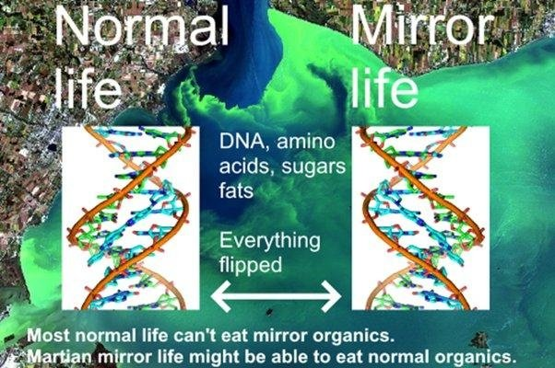

If we could flip a cake in 3D, like reflecting it in a mirror, our metabolism couldn’t do anything with the flipped carbohydrates, proteins or sugars.

Synthetic biologists plan to gradually flip ordinary to mirror life over a period of a decade or so – and will make sure synthetic mirror life is engineered to depend on chemicals only available in the laboratory. They warn escape of mirror life could cause major transformations of the terrestrial biosphere by locking up organics in unusable mirror forms.

This issue becomes especially acute if mirror life obtains enzymes (isomerases) that transform ordinary organic molecules into their mirror form. A few rare terrestrial microbes can use this method in reveres to eat mirror organics (Pikuta et al, 2016). In the worst case scenario, mirror life consumes ordinary organics, but terrestrial life can’t make anything of the mirror organics.

Kasting “It would quickly consume all the available nutrients,” he says. “This would leave fewer or perhaps no nutrients for normal organisms.” …. As the CO₂ in the ocean was incorporated into inedible mirror cells, they would “draw down” CO₂ from the atmosphere … in about 300 years the bugs would suck down half of Earth’s atmospheric CO₂. Photosynthesis of most land plants would fail. “All agricultural crops other than corn and sugar cane would die,” … “People might be able to subsist for a few hundred years, but things would be getting pretty grim much more quickly than that.” After 600 years, we’d be in the midst of a global ice age. It would be a total evolutionary reboot—both Kasting and Church think mirror predators would evolve, but whatever life existed on Earth by that point wouldn’t include us..

If there is life on Mars, mirror or normal, it likely has isomerases to metabolize organics of opposite sense - because nearly all organics are either made abiotically locally, or are infall from comets, asteroids and interplanetary dust, with organics of both senses.

Eventually terrestrial microbes likely develop isomerases but higher life couldn’t evolve so quickly. The outcome is a mix of normal and mirror organics. Kasting and Church’s worst case scenario is that mirror life retains the edge over normal life in this evolutionary race.

I think we would survive. We have already designed almost self-sustaining space habitats like the early Russian BIOS-3. We could enclose large areas of Earth with its tropical jungles, coral reefs etc (like the confusingly similarly named Biosphere II). But it would be a severely diminished world to leave to the next generation.

For a closely related scenario, Earth and Mars exchange normal life, but Mars has a shadow biosphere with a different biochemistry that never got here like the hypothesis of a terrestrial shadow biosphere of nanobes (Cleland, 2019, pp 213 - 214) which could co-exist with modern life. Earth doesn’t seem to have one (yet) but small cells have an advantage in an environment with low nutrient concentrations, as they have a larger surface to volume ratio, and so take up nutrients more efficiently. They would also avoid protozoan grazing (Ghuneim et al, 2018).

In this scenario Martian mirror life cells have a less sophisticated biology, but compete in a shadow biosphere on Earth because of their small size, with the extra advantage that they form mirror organics biofilms. These shadow biosphere biofilms are inedible to most terrestrial life and expand.

We may well be able to reduce impacts, perhaps with engineered normal life predators of mirror life or import them from Mars. However, these are scenarios to avoid, with consequences hard to predict.

Zubrin presented these arguments about harmlessness of martian life and the meteorite argument in a non peer reviewed op ed in in 2000 (Zubrin, 2000), with an immediate response in the next edition of the planetary report that it’s like building a house without smoke detectors (Rummel et al., 2000).
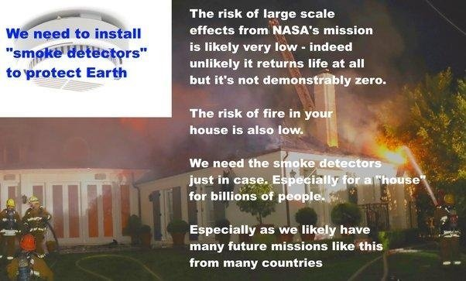

Another central argument in NASA’s draft EIS is that Mars is lifeless anyway. The draft EIS says “conditions on Mars have not been amenable to supporting life as we know it for millions of years” (NASA, 2022eis: 1-6):

Existing credible evidence suggests that conditions on Mars have not been amenable to supporting life as we know it for millions of years (… National Research Council 2022).

Their most recent source says the opposite of the sentence it’s cited to. See: (Smith et al, 2022: 393)

Section title: “Are There Chemical, Morphological and / or Physiologic / Metabolic or Other Biosignatures in Currently Habitable Environments in the Solar System

The exploration of … Mars (Curiosity, Perseverance) will help establish whether localised habitable regions currently exist within these seemingly uninhabitable worlds.

[Emphasis on “currently” mine]

So again, NASA got to this conclusion through a citing error.

There’s a wide range of views amongst astrobiologists but few would say definitively that there is no life in Jezero crater today, either as spores in the dust or as biofilms in microhabitats.

NASA’s draft EIS fails requirements for a valid NEPA Environmental Impact Statement

Agencies shall ensure the professional integrity, including scientific integrity, of the discussions and analyses in environmental impact statements
§ 1502.23

The EIS omits important studies that overturn results it relies on, and uses cites that refute the sentences they are attached to without alerting the reader to this discrepancy.
(a) Evaluate reasonable alternatives to the proposed action, and, for alternatives that the agency eliminated from detailed study, briefly discuss the reasons for their elimination.
(b) Discuss each alternative considered in detail, including the proposed action, so that reviewers may evaluate their comparative merits.
§ 1502.14

NASA's EIS doesn't have rigorous analysis of ANY alternative except "no action". Reasonable alternatives include a presterilized sample return or delaying the mission until it can be done safely.
Agencies shall prepare environmental impact statements using an interdisciplinary approach that will ensure the integrated use of the natural and social sciences and the environmental design arts

§ 1507.2
Mars sample return studies emphasize the need to involve the public early on, not just in the USA, but through fora open to representatives from all countries globally because negative impacts could affect countries beyond the ones involved directly in the mission (Ammann et al, 2012:59).

This wasn’t done and the public weren't given the opportunity to comment on a scientifically valid EIS. I hope NASA can ensure a mishap like this never happens again.

This mission can be made 100% safe by sterilizing samples before they reach Earth. The equivalent of 500 million years of surface radiation, 50 megagrays, would reduce amino acids 1000 fold with virtually no impact on geological interest, as Perseverance can't drill to layers protected from surface ionizing radiation.

As for astrobiological interest, Perseverance’s engineers believe they achieved a maximum of 0.7 ppb or 0.7 nanograms per gram for their most abundant biosignatures (Boeder et al, 2020: table 6),

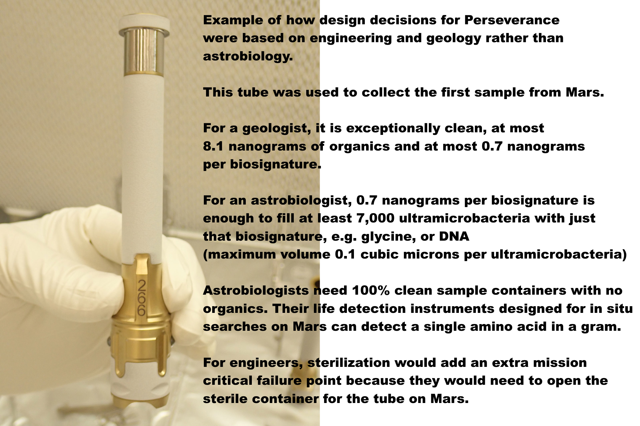

With these levels of forward contamination, Perseverance is unlikely to detect life, past or present, even if by chance it returns it. So, sterilization preserves virtually all geological interest with minimal impact on astrobiological interest.

The NASA draft EIS requires samples to be returned to Earth for “safety testing” but this is guaranteed to find false positives.
Indeed, it’s not possible to do safety testing until we know much more. Even without any contamination, we could destructively test every one of 10,000 grains of dust individually – then the 10,001th grain has a viable microbe. The dust or dirt could have one viable microbe per gram or less. We also couldn’t detect life non destructively by Raman spectroscopy or autofluorescence as a microbe could be inbedded in a crack in a dust grain, or covered in iron oxides.

It might be possible to sterilize samples on the return journey, with nanoscale x-ray emitters, but if not, we can return it to a satellite similar to a geostationary satellite for sterilization. We can use minimal energy orbits without aerobraking for instance via a Sun Earth L2 halo dovetailed to an Earth Moon L2 halo, then L2, L1, and back to the Laplace plane above GEO. This has been proposed as a disposal orbit for GEO satellites at end of lifetime. Even if the satellites explode or collide or fragment the fragments can’t harm satellites in GEO. It’s where ring particles would orbit if Earth had a ring system. Samples could be returned to, say, 100,000 km above this proposed GEO disposal orbit.

The launch costs wouldn’t be prohibitive for NASA as the Falcon Heavy can already deliver over 25 tons to GEO at a cost of $150 million and launch costs are sure to go down. The satellite could be less than a ton in mass even including the mass of a sterilizer unit.

The mission could be made far more interesting by sending a STERILE container on the ESF fetch rover to return bonus samples of dirt, dust and atmosphere without forward contamination, and a pebble from the Mars surface picked up by a pre-sterilized marscopter – as a technology demo for returning CLEAN rock samples. If we find a crater recently excavated to 2 meters we could add a technology demo to return minimally degraded organics, though without in situ life detection it’s not likely to return recognizable life.

Venus lander studies have shown how to build rovers with instrumentation, batteries, communications, motors, capable of functioning at 300 C using commercial components. A marscopter built to such a spec could be heated to 300 C for a few hours to sterilize it 100%.

These clean samples could be studied above geostationary orbit, in Mars simulation conditions with a centrifuge for artificial martian gravity – which would make it unique as a facility, as we can’t simulate martian gravity accurately on Earth.

This would NOT be a human occupied space station. In the backwards direction, quarantine can’t protect Earth from mirror life or indeed fungal diseases. Two zinnia plants on the ISS died of a fungal disease brought there probably on an astronaut’s microbiome, also an occasional opportunistic pathogen of humans. In the forward direction, an unmanned satellite let’s us study martian life in far cleaner conditions as ultramicrobacteria can get through HEPA filters both ways.

It's the equivalent of one geostationary satellite far above GEO. Humans study the dust, dirt and atmosphere as they would on Mars using in situ instruments designed for end to end sample preparation to analysis - these already exist such as LD chip (antibodies) almost sent on Exomars but descoped, the gene sequencer SETG, astrobionibbler able to detect a single amino acid in a gram, the chiral labelled release, and many others.

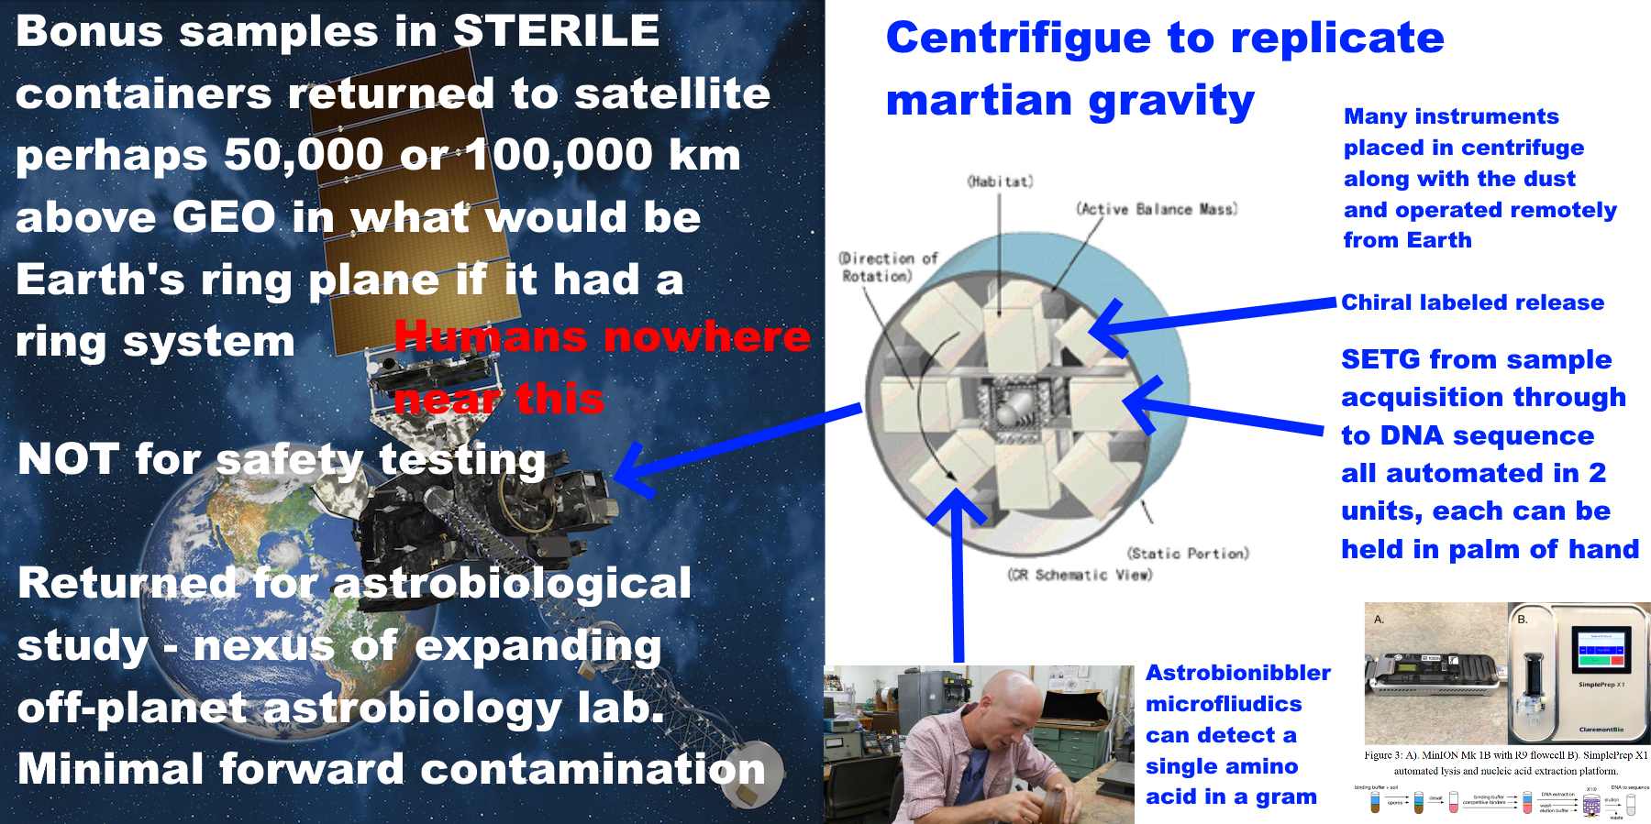
NASA have an opportunity to set a precedent to keep Earth safe. Other countries are likely to follow its example, or indeed, collaborate in a multi-national astrobiology sample handling and pre-processing lab above GEO – in a similar spirit to the ISS but far lower cost.
If we do find life on Mars that can never be returned safely, this may stimulate rather than discourage vigorous space exploration and settlement. The first astronauts to Mars might study the surface remotely in a spectacular orbit that flies near to both poles twice a day and skims in close over a different part of Mars on the opposite sides of the planet twice a day.
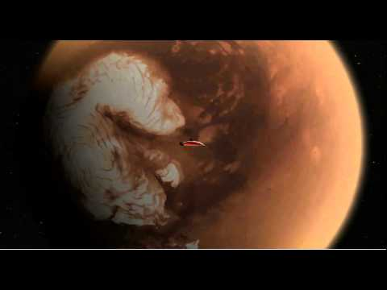

They would operate surface marscopters, rovers and other assets, similarly to avatars in a computer game, and eventually make 100% sterile rovers in surface factories controlled as in the game of civilization.
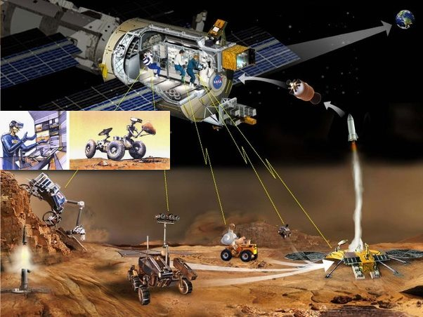
We can explore and exploit Mars without humans on the surface, settling the Martian moons and orbital space habitats, as part of vigorous exploration and perhaps settlement throughout the solar system. Humans and robots work together each doing what it does best. Torrence V. Johnson, Galileo Chief Scientist, put it like this in the foreword to Meltzer’s “Mission to Jupiter” (Meltzer, 2007)

“What we call robotic exploration is in fact human exploration. The crews sitting in the control room at Jet Propulsion Laboratory as well as everyone out there who can log on to the Internet can take a look at what’s going on. So, in effect, we are all standing on the bridge of Starship Enterprise”

Abbasrezaee, P. and Saraaeb, A., 2021. System Analysis and Design of the Geostationary Earth Orbit All-Electric Communication Satellites. Journal of Aerospace Technology and Management, 13.

“The total mass budget for 8 and 12 kW EOL electric power subsystem calculated 283.14 and 439.8 kg, respectively”

Beatty, J.T., Overmann, J., Lince, M.T., Manske, A.K., Lang, A.S., Blankenship, R.E., Van Dover, C.L., Martinson, T.A. and Plumley, F.G., 2005. An obligately photosynthetic bacterial anaerobe from a deep-sea hydrothermal vent. Proceedings of the National Academy of Sciences, 102(26), pp.9306-9310.

Birnbach, I., 1997. Newly Imposed Limitations on Citizens' Right to Sue for Standing in a Procedural Rights Case. Fordham Envtl. LJ, 9, p.311.

Johansson, M., Living in Space, Comparative Study of one Conventional Life Support System and two Biological Systems

Kim, H.J., Kim, H.N., Raza, H.S., Park, H.B. and Cho, S.O., 2016. An intraoral miniature X-ray tube based on carbon nanotubes for dental radiography. Nuclear Engineering and Technology, 48(3), pp.799-804.,
The dose rate of the X-ray at 3-cm apart from the miniature X-ray tube in air was 8.19 Gy/min at 0° when the X-ray tube was operated at 50 kV with the emission beam current of 140 μA..
[This corresponds to 7 watts of power output]
X-rays are almost perfectly blocked when the thickness of the copper collimator is 3 mm

