For a worst case backwards scenario, we need to allow for a ribocell like nanobe that has also adapted to Martian conditions to repair its RNA when damaged by ionizing radiation, and over billions of years has developed robust base pair molecules possibly more robust and harder to damage than DNA base pairs.

60 million years equivalent of surface ionizing radiation will reduce amino acids 1000 fold in the presence of the silica in basalt and other volcanic rocks, converted to other organics, and even faster in presence of water molecules or salts – and

Also let’s look at amino acids, since there is a fair bit of research into this. Recent research shows that amino acids are far more damaged by ionizing radiation in the presence of:
- Water (H₂O) because it splits the water which reacts with the DNA damaging it, or similarly for
- silica (SiO₂), which varies from 45% to over 65% for volcanic rocks, lowest figures for basalt and gabbro, highest figures for granite and rhyolite (Perkins, 2020 : 6.1.1)

Scientists would not want to expose the samples to air at atmospheric pressure or to a vacuum before returning to Earth. So we need to look at the effects of ionizing radiation on samples in a sample tube sealed with a small amount of martian air. So the main factor here would be the silica.

This is like the double strand breaks. It is not about conversion of the amino acids to water vapour and carbon dioxide which is a much slower process. This is about alteration of the amino acids to other organics, first broken up to shorter chain organics. The smaller organics tend to evaporate easily but they might combine again in different ways to make larger molecules again. The main thing is the result will no longer be recognizable as amino acids. This is a much faster process. It would also break up larger molecules such as proteins which are made up of amino acids.
By modelling, for dry pure amino acids, (Pavlov et al, 2012) calculated that it would depend on the size of the molecule. For larger molecules, atomic mass 500, protected by 5 cm of regolith, it would take 200 million years to reduce them 1000 fold. For smaller molecules atomic mass 100, similar to many amino acids they would be reduced a thousand fold every billion years. (Pavlov et al, 2012: Figure 3). This is based on 50 megagrays exposure every billion years so this corresponds to 500 million years at 100 milligrays per year.
(amino acids vary in atomic mass from 57 for glycine, 71 for alanine, 115 for aspartic acid, to 237 for pyrrolysine (UWPR, n.d.) those figures rounded to the nearest unit). This assumes 50 megagrays per billion years at a depth of 5-10 cms and 500 megagrays at 0-2 cms
It would be a similar process for the primary nucleobases which range from 111 for cytosine to 151 for guanine (Adenine (135), Cytosine (111), Guanine (151), Thymine (126) and Uracil (112)), but amino acids are the focus of the research I found.
For dry amino acids, based on Pavlov et al’s dose of 50 megagrays for a 1000 fold reduction, the dose x in megagrays for an n-fold reduction is
x = 50 * log(n) / log(1000) = 50 * log(n) / 3

For example, a 4-fold reduction in amino acids needs around 10 megagrays or around 200 million years of surface radiation.

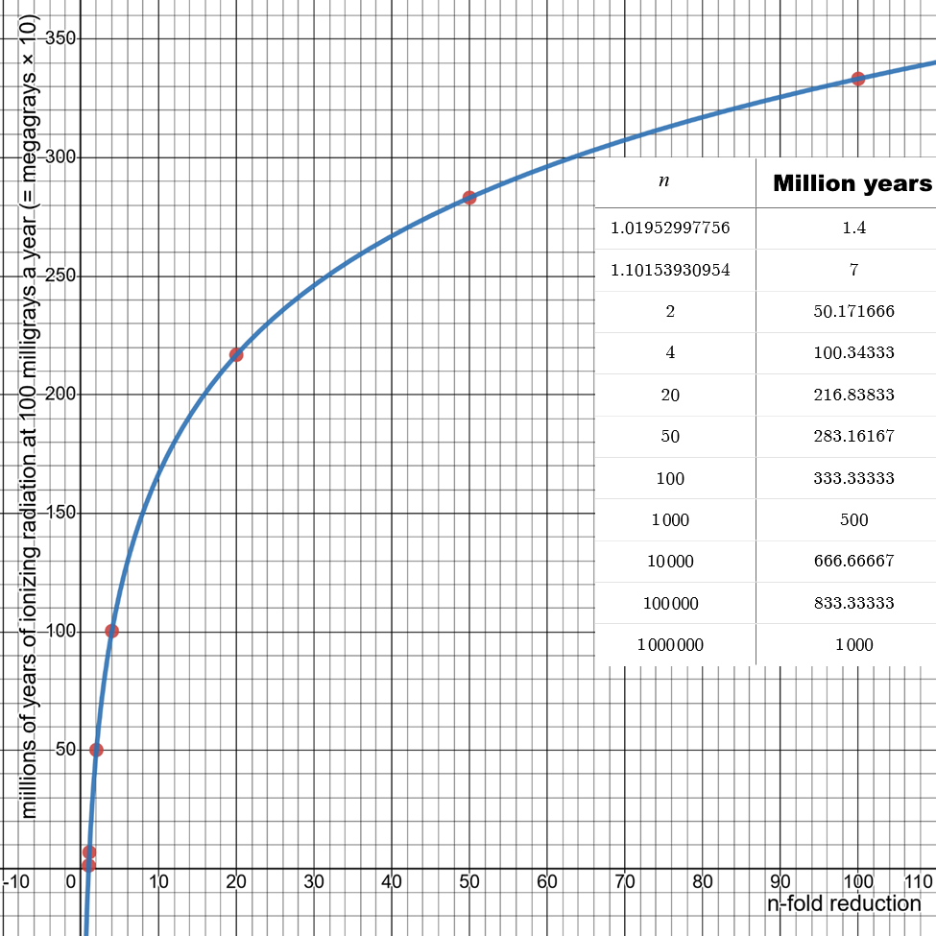

Figure 44: Dots show:
reduction: timescale
1.02: 1.4 million years (radiodurans)
1.1: 7 million years (5 times more hardy)
2: 50 million years
4: 100 million years
20: 217 million years
50: 283 million years
100: 333 million years
Graph and data for the dots available online from Desmos here
To destroy half the amino acids needs only 10 megagrays.

That might be more than enough since the number of viable

Radiodurans microbes is reduced a million fold at 0.14 megagrays when it is at its most resilient, desiccated and frozen (Horne et al, 2022). This works out as an approximately 1.01 fold reduction in amino acids, destroying around 1% of the amino acids if the situation can be compared. But even dessicated and frozen there would be a fair bit of water so it’s likely more than 1% destroyed.

Mileikowsky et al suggested considering a hypothetical five times more resistant microbe on Mars for their modelling (Mileikowsky et al., 2000: p 401).
Using a simpler approach than they used, just to show how it works, a five times more resistant microbe would need 0.7 megagrays to reduce it a millionfold. That works out as a 1.05 fold reduction destroying about 5% of amino acids.
However this is not a realistic situation. If there is present day life on Mars it would have at least some water content, though likely mixed in with the rock too. Before settling on a figure for sterilizing the samples we would need to show it would also sterilize present day biofilms and spores and for microbes embedded in various materials including the grains of dust.
Silica with parts per million of organics is a reasonable analogue of Martian regolith and rocks (Pavlov et al, 2022: 1107). In the presence of silica or water vapour amino acids are reduced much faster.
When mixed with silica amino acids are reduced 10 fold every 2 megagrays with slight variation depending on the amino acid (Pavlov et al, 2022: figure 4), which would mean it would take only 6 megagrays or about 60 million years to reduce the amino acids a thousand fold.
Radiodurans
Many martian rocks also contain perchlorates or water molecules as part of the rock structure. In the presence of water the reduction is even faster, their most resilient amino acid had a 5-fold reduction after half a megagray. This means it takes only 3 megagrays or 30 million years to reduce the amino acids 1000 fold.
So 10 megagrays corresponding to 100 million years of surface ionizing radiation would destroy almost all the amino acids and break up any RNA or DNA into sequences only 29 base pairs long.
So, if our aim is to sterilize samples to return to Earth, and we don’t expect detectable traces of past organics in them, just 10 megagrays would sterilize any organics that are mixed with silica.
It would be for experts to consider what level of dose is needed to sterilize even unknown exobiology and there doesn’t seem to be a thorough study of this in the literature.

For the purposes of this paper we’ll use a value of 5 megagrays, or 50 million years worth of ionizing radiation, but that’s not intended as a recommendation. It’s just for purposes of illustration. It is more than ten times the 0.3 megagrays value used by (Allen et al, 1999) above:

- NEW: Sterilization with 30 million years equivalent of surface ionizing radiation will have virtually no effect on geological studies

It’s more than 5 timers the dose for a hypothetically 5 times more radioresistant microbe than radiodurans.

5 megagrays would be enough to reduce viability of the hypothetical microbe 5 times more radioresistant than radiodurans effectively to zero. Theoretically 4.9 megagrays would reduce a population of microbes five times more radioresistant than radiodurans ${10}^{42}$ fold. But maybe no microbe could be viable after losing half its amino acids. There might be a cut-off point that makes it impossible.

If experts think extraterrestrial life could be exceptionally hardy we can use 50 megagrays to reduce them 1000-fold, equivalent to half a billion years of Mars surface radiation. Or achieve a million-fold reduction with 100 megagrays equivalent to a billion years of surface ionizing radiation. Even these high doses would likely have virtually no effect on the geological studies since the rocks have had much higher levels of ionizing radiation already.

Using high levels of sterilization for the samples would reduce the amounts of past organics left in the sample, but they will be undetectable anyway. There is likely so little left of past organics after 3 billion years of surface ionizing radiation that even a small amount of forward contamination will overwhelm it.

Meanwhile, if we are serious about starting a search for present day life in Jezero crater, we need to return samples without the forward contamination. We also need to return them for remote study in a high orbit far from Earth’s biosphere. See:

On the remote chance we return present day life from Mars in the Perseverance samples it’s not going to be easy to recognize or study it.

NOTE: We can also calculate the n-fold reduction from the dose as
n = 10^(3*x/50)
and the % destroyed for the dose x in megagrays as

100 – 100/ n.

This also gives a way to calculate the figure for the sterilization dose for JAXA samples. Any that got to Phobos over 18.5 million years ago had a dose of over 1.85 megagrays, so at least 22.5% of many of their amino acids have been destroyed since then. This calculation is referred to in:

- New: extending the JAXA analysis to photosynthetic life on or near the surface of any Martian meteorites

The 2009 study makes an argument that it is not necessary to use ionizing radiation doses more than life would experience on a meteorite traveling from Mars to Earth (SSB, 2009 : 46).

The preceding section in this chapter argued that if there are Mars organisms sufficiently robust to survive a realistic sterilization treatment in the quarantine facility, then some of these resistant organisms also would have survived transit to Earth in meteorites, and our planet already has been infected by them. Thus sample certification as “effectively sterilized” is appropriately based on verifying that the treatment used kills the most resistant known terrestrial organisms, and that the treatment is at least as harsh as that experienced by recent meteorites in Mars to Earth transit. Being substantially harsher than this will not be necessary.

However this is not a valid argument as we saw in the discussion of the JAXA mission.

- Example scenario of martian life adapted to live in surface dust or dirt but unable to get to Earth on a meteorite - with terrestrial analogy of invasive starlings in the USA and the invasive diatom Didymo in New Zealand – it’s life that CAN’T get to Earth by itself that matters for backwards contamination

A microbe on Mars might be able to resist sterilization during the journey back. But that doesn’t prove that it can also withstand the
- desiccation of complete vacuum
- shock of ejection

Then if it can withstand both of those, there’s also the issue that the materials it lives in may never get to Earth.

If a microbe typically lives in surface dust, dirt, salts or ice and depends on photosynthesis, then it is possible that it
- never gets into a rock sufficiently far below the surface to get to Earth, for instance if it relies on sunlight it may never or rarely get into the subsurface.

If it gets below the crust of a rock that is ejected from Mars it may be
- sterilized by the fireball of exit from the Martian atmosphere or the fireball of re-entry into Earth’s atmosphere

So we need to ensure that any sterilization will destroy all viable life. It is not enough to supply sterilization levels equivalent to the journey from Mars to Earth in a meteorite.

