The original plans for the Perseverance rover included a dust sample but this capability was later removed. The current paper recommends that the ESA fetch rover takes an extra sample tube to collect dust. Or better, it could use a rotary air sampler to collect and compress a sample of air.

A dust sample is of interest for human missions too, to have a sample of Martian dust to test with terrestrial spores to check the potential for terrestrial life to spread in Martian dust storms - for forward contamination risk evaluation. It is also useful to study chemical hazards in the dust that could impact on astronauts such as the chlorites, chlorates and perchlorates.

Such a sample also has some geological interest as a random sampling of wind-eroded rock fragments from distant parts of Mars.

See the sections of my paper:

- Recommendation: Extra sample of air and airfall dust to search for Martian life, assess forward contamination issues for terrestrial microbes, dust dangers for astronauts, and to return a random sample of wind-eroded rock from distant parts of Mars
- Proposal: magnets could be used to enhance dust collection
- Proposal: to use the sample return capsule as a dust collector – keep it open to the atmosphere before adding the sample tubes

The plans for Perseverance also originally included an atmospheric sample, another capability later dropped from the mission. Dust collection can be combined with an atmospheric sample which would be valuable for studying trace gases in the atmosphere.

As a capability dropped by Perseverance, it is in the scope of the mission. An atmospheric sample can’t be added to Perseverance now, but it can still be added to the ESA fetch rover or the Mars Ascent Vehicle.

Perserverance’s In Situ Resource Utilization experiment Moxie collects carbon dioxide in the air to split it into oxygen, which may be useful for fuel on Mars in the future. To collect the carbon dioxide it uses an atmospheric compressor

Jakovsky et al propose sending a similar atmospheric compressor for Mars to the one already on Perseverance, but this time use it to collect an atmospheric sample and a dust sample to return to Earth. Jakovsky et al suggested sampling the Martian atmosphere in a 100 cc container containing 10 liters of the Martian atmosphere compressed 100 fold with a compressor similar to the one mounted on Moxie on Perseverance (Jakovsky et al, 2021).
Alternatively a compressor could compress the Martian air more than for Moxie, all the way to Earth's atmospheric pressure. That’s enough for two grams of martian atmosphere equivalent to about 136 liters of atmosphere at their assumed sampling pressure of 7.36 mbar.
This experiment could return enough atmosphere to detect trace amounts of methane and ethane with accuracies of parts per trillion and would also return enough atmosphere for carbon isotope measurements (Jakovsky et al, 2021). Jakosky et al say that it is not possible to analyze the Martian atmosphere with this sensitivity using gas incidentally collected in Perseverance's sample tubes, because Perseverance doesn't have a getter to remove material outgassed from the walls of the tubes before the sample collection.
So, this proposal adds significantly to the science return for the ESA fetch rover.
Jakosky et al suggest that their experiment could be used to collect dust as well, by running the gas through a filter as it is compressed. The result is a combined dust collection device and atmospheric sample return. A sample of Martian dust would also help with understanding the atmospheric chemistry.
They propose that large quantities of dust can be returned to Earth for analysis by adding an extra exit valve with a second dust filter to continue collecting dust after the primary gas sample is collected (Jakovsky et al, 2021).
Airborne dust also could be collected with addition of 3 valves and a dust filter [their figure 6]. After gas reservoir is filled and reservoir valves closed, large volumes of Mars air would be pumped through filter to collect and trap dust and its valves closed.
This shows how it works (Jakovsky et al, 2021)
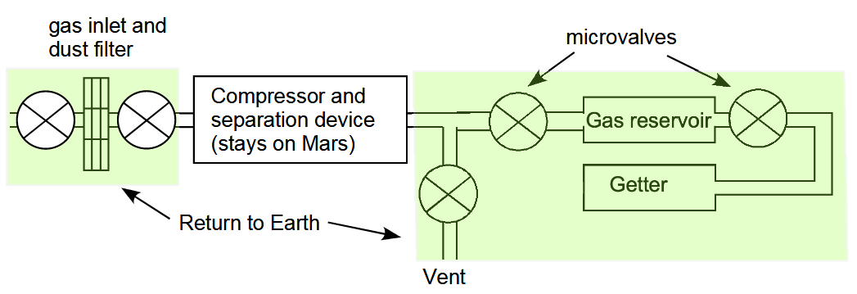
a.
1. To clean the chamber, the outside vent is kept closed, other microvalves kept open, and this vents materials from the walls of the gas reservoir into the getter.
.2. the microvalve to the getter is closed and air from the Martian atmosphere is compressed into the gas reservoir. .
3. finally, the microvalve leading into the gas reservoir is also closed (once it is full) and the vent is opened.
Martian air continues to flow out of the vent – and dust continues to accumulate in the input dust filter
- at this point it works like an air sampler sampling the dust which gets collected in the input dust filter.
(Jakovsky et al, 2021: Fig 6)
Assuming a volume of, say, 50 cc of dust, and a dust density of 0.5 grams per cc that could return up to 25 grams of dust.
This is enough to detect life at around one cell per gram or less. This is also a useful first upper bound of the amount of life in the dust if none is returned.

See the section of my paper:

- Searching for distant inhabited habitats on Mars through presence or absence of one originally living cell per gram – a rough first estimate assuming uniform mixing throughout Mars for a first estimate requires life to cover between 114,000 and 1,140 square kilometers with densities of life in the dust similar to an Antarctic RSL analogue in cell count, but less than a tenth of a square kilometer if any reach a billion cells per gram – these figures can be higher if any source habitats with high densities of cells are closer to the rover with uneven mixing
Suggestion: In the dust collection phase this dust collector could be switched on for a few minutes several times in each season of the year. It could also be switched on for a short while at the start, in the middle and at the end of a dust storm for the best chance to collect any spores that may be generated seasonally or in response to the storms.
They present four options. Of their four options, two are of special interest here which I’ll label A and B to avoid confusion (Swindle et al, 2021):
- Collecting gas in a newly-designed, valved, sample-tube-sized vessel
They propose flying this customized sample-tube-sized vessel to Mars on the sample fetch rover.
- Adding a larger (50-100 cc) dedicated gas sampling volume to the Orbiting Sample container (OS) that can be filled with compressed martian atmosphere.
These are of special interest since the sample-tube-sized vessel or the dedicated gas sampling volume can be 100% sterilized in advance making it possible to return a dust sample of far greater interest for astrobiology than one with large amounts of permitted biosignatures.
For details see the section of my paper:
- Proposal: by Jakovsky et al from the 2020 NASA decadal survey to combine a dust sample with a compressed sample of the Martian atmosphere
My paper also recommends modifications to the ESA fetch rover to add an extra sample of dirt since this is of special interest to astrobiologists. Ideally this would include the brine layers at a temperature of -73°C (200°K) observed indirectly by Curiosity, which form in sand dunes at night - which might perhaps shed light on the puzzling Viking observations.

These brines could potentially be habitable to a native Martian biofilm if it can retain the liquid through to the warmer daytime temperatures, which reach temperatures above 0°C, to modify habitability of the layers at a microscale.

Another way they could be habitable to Martian life is if it can tolerate lower temperatures than terrestrial life using chaotropic agents such as the Martian perchlorates or chlorides to speed up metabolic processes by disrupting hydrogen bonding, or ice binding agents to keep the water liquid at higher temperatures, or novel biochemistry adapted to lower temperatures than terrestrial life.

See the section of my paper:

- How Martian life could make perchlorate brines habitable when they only have enough water activity at -70 °C – biofilms retaining water at higher temperatures - chaotropic agents permitting normal life processes at lower temperatures – and novel biochemistry for ultra low temperatures

A sample of dirt could also be of interest for novel chemistry in the Martian conditions.

This shows the sample collection tool for the ESA fetch rover and shows how it resembles the digging tool for Viking and could be adapted to take a sample of dirt from the surface after it has already picked up and stored the geological samples.

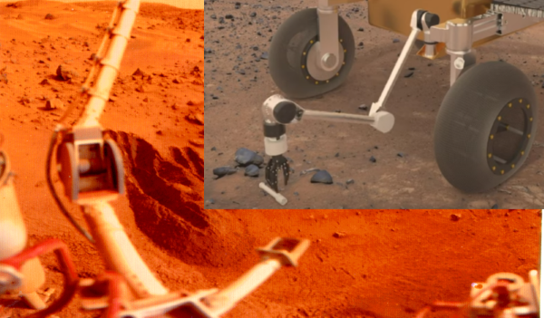
Figure 44: The digging tool, lower center, was used by Viking to scoop up material from the surface soil for the Viking experiments (NASA, 2015).
Inset: Frame at 17 seconds from video of an artist’s impression of the ESA fetch rover collecting a sample left on the surface by Perseverance (ESA, 2020)
If this is feasible, then ESA’s Sample Fetch Rover could grab a small amount of dirt from the region around the Mars Ascent Vehicle (ESA, 2018), to a depth of five or ten centimeters or so and load it into the return container after adding the samples from Perseverance’s cache.
The sample tubes are sealed, so the dirt could just be poured directly into the capsule container on top of them and around them. Another possibility might be to place a horizontal plate on top of the container after inserting the sample tubes, then place a small scoop of dirt in the center of it before adding the enclosing lid.
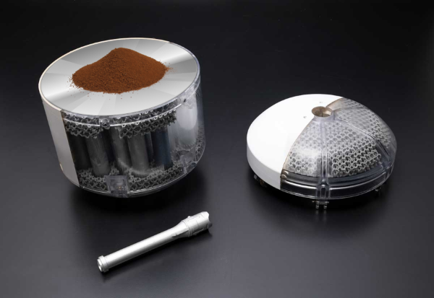
Figure 45: Added proposal for extra dust sample to concept design for the Orbiting Sample Container
- there seems to be space between the top of the sample tubes and the cover. Perhaps an extra circular plate could be added.
Then a sample of dirt dug from the nearby soil loaded onto the center of the plate before enclosing the capsule for launch.
Analysing this extra sample may help resolve questions about the Viking results and if Viking did find life, it could return that life for study.
Image combines the NASA graphic (NASA, 2020msros) with an photograph of a small pile of Martian regolith simulant JSC MARS-1A (ZZ2, 2014), and a clipart image of a CD (OpenClipArt, n.d.)
This suggestion to grab some dirt and load it onto the sample container at the end is similar to a suggestion for a minimal sample return mission once made by Chris McKay to just “grab a sample of dirt” (McKay, 2015).
However it would need to be loaded into a 100% sterile container to be of astrobiological interest.
So perhaps there can be room for a small 100% sterile container between the sample tubes and the lid of the sample return container.
See the section of my paper:

- Recommendation: modify ESA's sample fetch rover to grab a sample of the near surface temporary brine layers from sand dunes - perhaps Perseverance may be able to do this too with its regolith bit

