Dear space colonization enthusiast (Open letter) – why we are legally mandated to protect Earth’s ecosystems from alien species and why space explorers need to know as soon as possible if there is life on Mars and what it’s capabilities are
Dear Space Colonization Enthusiast
I am not writing this to win any arguments. I think we need constructive dialog instead. We have many different perspectives but in the process we need to work together towards a consensus legal position amongst space colonization enthusiasts (I count myself as one too) , also with NASA, and consulting with other agencies such as the CDC, WHO, Department of Homeland Security, NOAA, Department of Agriculture and Fisheries, etc BEFORE thelegal process starts.
We also need to bring along everyone in the general public too. Otherwise it is likely to take far longer.
You might expect compromise and an intermediate solution in a consensus position - perhaps-some protection but not as much as the astrobiologists and planeteary protection officres want.
However in this case I propose for discussion an even stronger form of planetary proteciton, 100% protection. Then the idea is to work towards a very fast exploration of Mars with human exploers in spectacular orbits around Mars as an important part of the solution.
Our laws to protect the environment mandate us to protect Earth’s ecosystems from alien invasive species and that includes species that are not just alien to a particular country but also ones that are alien to the Earth as a whole. These protections are all new since Apollo. NEPA itself started the year after the Apollo 11 landing. We have to comply with them irrespective of any text in the outer space treaty.
I think working together for the highest possible level of protection of Earth and Mars actually benefits space exploration, settlement and perhaps eventually colonization.
We saw how quickly public interest waned after Apollo which was presented as largely a “flag and footsteps” mission. That approach does lead to huge initial interest but after the first flag and the first footprints that is it over as far as the public are concerned, follow up missions are like the second team to reach the summit of Everest. Everyone has heard of Hillary and Tenzing, but who outside of Switzerland has heard of Schmied, Marmet, Reist and von Gunten?
I believe that there is a way forward focused on maintining the interest of Mars to the highest degree possible. This may seem counterinutitive at first but I hope after reading my aarguments that you will see some interest in it.
I don’t expect you to agree, but it may be a good starting point that may lead to more constructive dialog than the subject has had before. I believe there is much in the proposal here to interest a space engineer and colonization enthusiast and that would benefit from your ingenious solutions to space engineering issues, which you have applied already to ideas for rapid exploration of the Moon and of Mars.
There’s a french phrase
"Du choc des idées naît la lumière"
Which I understand translated means
"From the clash of ideas springs forth light."
The result is not a compromise between the ideas, often something completely new.
This suggestion is based on my preprint:
. NASA and ESA are likely to be legally required to sterilize Mars samples to protect the environment through to 2039, or until proven safe – technology doesn't yet exist to comply with ESF study's requirement to contain viable starved ultramicrobacteria, and legal process followed by build and training of technicians takes at least 17 years - proposal to study samples remotely in a safe high orbit above GEO with miniature life detection instruments – and immediately return sterilized subsamples to Earth

TITLES OF SECTIONS LIKE MINI ABSTRACTS - SUMMARIZE WHAT THEY SAY IN THE TITLE
I write titles of sections like mini abstracts - you can get a first idea of the article by reading just the titles and looking at the graphics - then drill into any section of special interest.

SHORT FORM FOR INLINE CITES LINKING DIRECTLY TO THE ONLINE PAPER
I will mention a selection of some of the cites I use in the preprnt. For these I will give just the author name, date, and linked title to the paper. For the full cites see the preprint. I will also sometimes link directly to pages on the internet via the text.

WE HAVE MANY EXAMPLES OF INVASIVE SPECIES ON EARTH THAT CAUSE PROBLEMS - FOR EXAMPLE BARN SWALLOWS CAN FLY FROM EUROPE TO THE AMERICAS BUT STARLINGS ARE AN INVASIVE SPECIES
We have many examples of invasive species on Earth. Perhaps some species have got to Earth from Mars or got from Earth to Mars (the most recent time a species could have got from Earth to Mars is after the Chicxulub impact that ended the dinosaur era). We don’t have any examples yet, but maybe some day we find a familiar terrestrial species on Mars and prove it got to Earth from Mars.
But that’s not enough to show that Martian life is safe on Earth. For instance many birds fly from Europe to the Americas. Examples include barn swallows and Arctic terns. But starlings don’t. so the European starling is an invasive bird in the Americas.
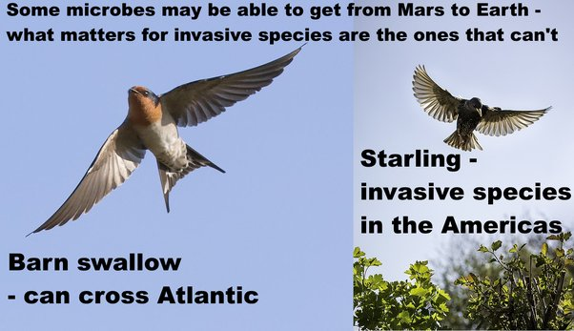
Some microbes may be able to get from Mars to Earth - what matters for invasive species are the ones that can’t.
Barn swallow - can cross Atlantic
Starling - invasive species in the Americas
Starling photo from: Starling - Flickr - TrotterFechan.
Barn swallow photo from A Barn Swallow in Flight
So, in your analogy, although all birds can fly, not all can cross the Atlantic, and birds too can be an invasive species.
As an example, in 2012, starlings caused $189 million in damage to crops of blueberries, wine grapes, apples, sweet cherries and tart cherries in the USA.
Starlings also eat cattle feed and 1000 starlings can represent a loss of $200 to $400 in cattle feed. They can also transmit many diseaes to cattle via the feeding troughs and their excrement corrodes iron structures inclding motor vehicles and iron roofs. They are also involved in thousands of bird strikes.
. European Starlings
I am saying this not to discourage space exploration and colonization, but rather to suggest we need to know what we have on Mars before we can make the best decisions about what to do next. Those starling problems are actually quite good analogues for some of the potential risks from Martian microbes.
It’s possible that Martian life is harmless. But if it is harmful, microbes from Mars don’t have to harm humans directly. They could harm our crops, ecosystems, animals, or produce accidental toxins. It is also possible that they could harm us directly. Legionnaire’s disease is a disease of biofilms and of protozoa that uses the same methods to infect human lungs and isn’t adapted to us. Many molds and fungi are harmful to immunocompromised patients and can kill them, and it could be that we are essentially all immunocompromised to an alien Martian biology., I will go into this in more detail later in this post.
Or it could be that none of these things happen. But we need to know, before we return life from Mars to Earth.
Other similar analogies include the American mink which competes with otters and kills water rats in Europe, or rats, pigs and starlings in the USA or rabbits in Australia. The starlings and the rabbits were even transferred deliberately, also the minks accidentally, while rats came along for the ride unintentionally with human explorers.

MICROBES CAN BE INVASIVE TOO - INVASIVE DIATOMS THAT CAUSE BAD ODORS AND CLOG UP TREATMENT PLANTS IN THE GREAT LAKES AND INVASIVE DIATOMS IN NEW ZEALAND
Microbes are similar, some can cross oceans and some can’t. It’s far harder for a microbe that can only survive in fresh water to cross an ocean.
We have invasive diatoms in the Great Lakes, at least one of which is a nuisance species that clogs water works and introduces foul odours into the water, Stephanodiscus binderanus, and invasive diatoms in New Zealand lakes such as Didymosphenia geminata, probably brought there from the northern hemisphere damp sports equipment,
. Spaulding et al., 2010, Diatoms as non-native species

NATIONAL RESEARCH COUNCIL SAID THEY COULDN’T RULE OUT THE POSSIBILITY THAT MARTIAN LIFE CAUSED PAST EXTINCTION EVENTS ON EARTH
The National Research Council looked into the question of whether Martian life transferred to Earth by panspermia could have caused extinction events in the past.
They concluded
"Despite suggestions to the contrary, it is simply not possible, on the basis of current knowledge, to determine whether viable Martian life forms have already been delivered to Earth. Certainly in the modern era, there is no evidence for large-scale or other negative effects that are attributable to the frequent deliveries to Earth of essentially unaltered Martian rocks. However the possibility that such effects occurred in the distant past cannot be discounted.”
They didn’t give any examples here. But there are many past extinction events that aren’t fully explained yet.

MY OWN EXAMPLE SCENARIO - MIGHT MARTIAN LIFE BE THE REASON FOR THE GREAT OXYGENATION EVENT?
Amongst those is the Great Oxygenation Event. Why did terrestrial life only develop photosynthetic life half a billion years ago? Why haven’t we had it since soon after life began on this planet?
This suggestion is from my preprint so hasn’t been peer reviewed and I’m interested in comments on it for feedback.
The blue green algae Chroococcidiopsis is an amazing survivor which we can find almost anywhere on Earth, from the cliffs of Antarctica to warm tropical reservoirs in Sri Lanka, from the deserts of Arizona to 170 meters below the sea bed in the Atlantic. It has such a diversity of metabolic pathways it can grow without any light at all.
This is one of our top candidates for a terrestrial microbe that may be able to survive on present day Mars if there are suitable habitats for it, in cracks in rocks or below a thin layer of dust to protect from UV, and has been tested in Mars analogue environments on the exterior of the ISS.
It’s also remarkably resistant to ionizing radiation and UV.
Pavlov et al suggested that perhaps it developed its ability to self heal from ionizing radiation damage on Mars.
Pavlov, et al, 2006. Was Earth ever infected by Martian biota? Clues from radioresistant bacteria.
That’s a minority view. Cyanobacteria originated in the Precambrian era. It could have developed these mechanisms back then, when, with no oxygen in the atmosphere, there was no ozone layer to shield out UV radiation.
QUOTE Since cyanobacteria originated in the Precambrian era, when the ozone shield was absent, UVR has presumably acted as an evolutionary pressure leading to the development of different protection mechanisms (Rahman et al., 2014) including avoidance, the scavenging of ROS by antioxidant systems, the synthesis of UV-screening compounds, and DNA repair systems for UV-induced DNA damage and protein resynthesis (Rastogi et al., 2014a).
Casero, et al., 2020. Response of endolithic Chroococcidiopsis strains from the polyextreme Atacama Desert to light radiation.
But for the sake of illustration, supposing it did come from Mars. Then it could have been responsible for the Great Oxygenation Event.

THE GREAT OXYGENATION EVENT WAS GREAT FOR US - BUT IT MIGHT BE THE LARGEST EXTINCTION EVENT IN EARTH’S HISTORY - AND WHETHER OR NOT - IS CERTAINLY AN EXAMPLE OF A LARGE SCALE TRANSFORMATION OF EARTH’S BIOSPHERE
There’s a lot of debate about whether this really was an extinction event. Lane suggested it wasn’t and anaerobes just retreated to habitats that were still suitable for them, and there are many of those:
"Microbes are not equivalent to large animals: their population sizes are enormously larger, and they pass around useful genes (such as those for antibiotic resistance) by lateral transfer, making them very much less vulnerable to extinction. There is no hint of any microbial extinction even in the aftermath of the Great Oxygenation Event. The 'oxygen holocaust', which supposedly wiped out most anaerobic cells, can't be traced at all; there is no evidence from either phylogenetics or geochemistry that such an extinction ever took place. On the contrary, anaerobes prospered." ane, 2015. The vital question: energy, evolution, and the origins of complex life.page 49.
However there is some evidence for exceptionally large sulfur-oxidizing bacteria before the event which may have been driven extinct. They were, 20 to 265 µm in size, occasionally also in short chains of cells. This may be part of a diverse ecosystem that predated the GOE
“And this discovery is helping us reveal a diversity of life and ecosystems that existed just prior to the Great Oxidation Event, a time of major atmospheric evolution.”
Czaja, et al, 2016. Sulfur-oxidizing bacteria prior to the Great Oxidation Event from the 2.52 Ga Gamohaan Formation of South Africa
Whether or not this was an extinction event - and whether or not the cyanobacteria came from Mars - this shows a way that life from another planet could in principle transform the terrestrial biosphere.

APPROACHING THE DIVERSITY OF WHAT WE MAY FIND ON MARS WITH SCENARIOS- IN THE COLLISION OF THE TWO BIOSPHERES- WITH SOME SCENARIOS MARTIAN LIFE IS DEVASTATING TO EARTH’S BIOSPHERE - WITH SOME TERRESTRIAL LIFE IS DEVASTATING TO MARTIAN LIFE - AND IN OTHERS THE TWO FORMS OF LIFE ARE HARMLESS TO EACH OTHER OR MUTUALLY BENEFICIAL - WE NEED TO KNOW WHAT WE HAVE ON MARS AS TOP PRIORITY
I use another example in my preprint of mirror life - like ordinary life just flip everything so that the DNA spirals the other way, and all biochemicals occur in their mirror form. This suggestion is not yet peer reviewed and I haven’t seen mirror life discussed in the literature on a Mars sample return.
However the idea that mirror life could cause large-scale changes to our biosphere is mainstream - it’s a reason for taking great care with our experiments in synthetic mirror biology. Synthetic biologists can engineer their microbes to be only able to replicate in laboratory conditions, for instance dependent on an nutrient they can’t find in the wild. For a discussion, see:
Bohannon, 2010. Mirror-image cells could transform science-or kill us all
What I did in my preprint is to just combine that idea with the suggestion that mirror life is a viable alternative biology, that is not impossible for Mars.
If Mars currently has mirror life, it could lead to modifications of Earth’s biosphere as extensive as the Great Oxygenation Event, If there is mirror life on mars, there is no reason particularly why mirror life would be especially hardy or be able to get here via meteorite transfer. So this seems to be a real possibility. I’ll go into that in more detail soon.
In my preprint I use a method of scenarios. Some scenarios for what we find on Mars such as mirror life would mean it is never safe to land humans on Mars or to return life from Mars to Earth.
In other scenarios it is safe for Earth to land on Mars but we risk making native Martian life extinct - that’s especially so if Mars has early life similar to whatever predated terrestrial life. After all we have no examples of pre-DNA life on Earth, so, whatever it was, DNA based life made it extinct. Some suggestions such as Woese’s “transformable cells” would be very vulnerable to terrestrial life - the genes compete but the cells don’t, with all the cells freely exchanging genetic material with each other. Once terrestrial life infects a habitat like that, Martian life mightn’t last long.
In other scenarios Martian life is safe for Earth. I give the example of the archaea there. That’s an entire domain of life that is largely beneficial in ecosystems and for humans. It’s possible the archaea have a role in toothache, along with other organisms, but they are largely harmless and beneficial with no infectious diseases that are caused by archaea.
They may also be beneficial. On Earth, invasive species aren’t always harmful. Indeed most species are beneficial.
Schlaepfer, et al., 2011. The potential conservation value of non‐native species
That’s for higher lifeforms. I tried sketching out some ways that new microbial species from Mars could be beneficial to Earth.
This again is from my preprint and not yet peer reviewed.
- Terrestrial photosynthesis is inefficient - it can’t adapt to make optimal use of low light levels, and most of it rejects green light - more efficient photosynthesis from Mars could increase the rate of sequestration of CO₂ in the sea and on land, improve soil organic content, and perhaps help with reduction of CO₂ levels in the atmosphere
- Martian life could be better at nitrogen fixation, and phosphorous and iron mobilization and so improve our soils - and also inhabit areas such as the ocean far from the shore, which are desert areas for terrestrial life
- Martian life could increase species richness and transfer new capabilities to terrestrial life by horizontal gene transfer.
- Martian life could produce beneficial bioactive molecules as part of the human microbiome. These could include molecules that are antiviral, antibacterial, antifungal, insecticides, molecules that kill cancer cells, immunosuppressants, and antioxidants - we get all of those from beneficial microbes that are already in our microbiome.
(see: Borges et al, 2009. Endophytic fungi: natural products, enzymes and biotransformation reactions)
Though of course those could also cause problems, like the blooms that lead to eutrophic zones in the oceans, or the toxic algal blooms in the great lakes that can kill cows and dogs that eat them.
So we have to be careful here. Most likely they would be mixed, beneficial in some ways, maybe even most of the time in most ecosystems, but harmful in other ways.
I cover this in the preprint in the section:
Enhanced Gaia - could Martian life be beneficial to Earth’s biosphere?

CHROOCOCCIDIPOSIS COULDN’T GET HERE ON A MARTIAN METEORITE FROM MODERN MARS - IT WOULD BE DESTROYED BY THE SHOCK OF EJECTION
If a microbe is to get from Mars, its first challenge is the shock of ejection. It gets suddenly accelerated from rest to escape velocity in a fraction of a second. This can destroy it through cell rupture or by DNA damage. All cells of Chroococcidiopsis are killed at 10 GPa of shock. See:
Nicholson, 2009, Ancient micronauts: interplanetary transport of microbes by cosmic impacts.
ALH84001 experienced a shock of ejection of ∼35 − 40 GPa. The Nahkalites were least shocked at 15 to 25 GPa. This is still too much for Chroococcidiopsis. See:
Nyquist et al., 2001 Ages and geologic histories of Martian meteorites.
More shock resistant microbes can survive better. Of the order of 1 in 10,000 of microbes of b. subtilis and the photobiont and microbiont partners in the lichen X Elegans could survive 40 to 50 GPa.
However for Earth to be safe from invasive species from Mars we need ALL species that are there to get to Earth. In the invasive birds and mammals metaphor, Barn Swallows and Arctic terns can cross the Atlantic, Arctic terns even also fly through Australia, but sparrows, rabbits, pigs, rats and mink can’t cross the Altantic or the Pacific oceans by themselves.
We don’t know if any Martian life has got to Earth from Mars. We don’t know the capabilities of Martian life and it could be that none of it can withstand the shock of ejection or the many other challenges. But if some of them can get here it won’t show that all Martian life is safe for Earth.

MARTIAN ROCKS COME FROM THE SOUTHERN UPLANDS WHERE THE AIR IS TOO THIN FOR EVEN EXTREMOPHILE LIFE - BECAUSE THE THIN AIR MAKES IT EASIER FOR IMPACTS TO SEND ROCKS TO EARTH - AND THEY ALSO COME FROM AT LEAST 3 METERS BELOW THE SURFACE - UNLIKELY LOCATION FOR LIFE EXCEPT IN VERY RARE GEOTHERMAL HOT SPOTS (SO FAR NONE FOUND ON MARS) AND LESS THAN A METER IN DIAMETER
The rocks we get from Mars all come from regions of Mars which is especially unlikely to have present day life.
First they all come from high altitude regions.
- All except ALH84001 were probably thrown up into space after glancing collisions into young volcanic flows in the Elysium Planitia or Tharsis regions, high altitude southern uplands. See McSween, 2002, The rocks of Mars, from far and near
Most likely came from the Elysium Planitia region see page 22 of Tornabene et al, 2006,. dentification of large (2–10 km) rayed craters on Mars in THEMIS thermal infrared images: Implications for possible Martian meteorite source regions
ALH84001 may well come from Gratter crater in the Memnonia Fossae which may have the older Noachian age surface materials needed for this meteorite - though it may also come from material that was thrown up from older deeper layers by a previous impact and then sent to Earth. Again see page page 22 of Tornabene et al, 2006,. dentification of large (2–10 km) rayed craters on Mars in THEMIS thermal infrared images: Implications for possible Martian meteorite source regions
They all also come from at least 3 meters below the surface.
- They also all come from at least 3 meters below the surface and we have candidate impact craters for some of them, so this is well established science.
- The temperature below about 12 cms is a near constant 200 °K or -73 °C. See figure 2 of Möhlmann, 2005, Adsorption water-related potential chemical and biological processes in the upper Martian surface units are multiples of 4.4 cms).

NOT IMPOSSIBLE THAT A LUCKY STRIKE COULD THROW UP LIFE FROM A SUBSURFACE CAVE OR EVEN A GEOTHERMAL VENT ON THE SLOPES OF OLYMPUS MONS -WHICH WAS VOLCANICALLY ACTIVE AND HAD MOVING GLACIERS 4 MILLION YEARS AGO - BUT FOR SAMPLES RETURNED TO BE SAFE FOR EARTH WE NEED ALL MARTIAN SPECIES TO GET TO EARTH NOT JUST A FEW LUCKY SPECIES
It is not totally impossible life could get into the Martian meteorites, but would require a high measure of luck. Some Martian volcanoes have been active in the geologically recent past, as recent as 2 million years ago. Olympus Mons shows signs of glacial activity as recent as four million years ago which suggests it likely has ice protected beneath the dust on its slopes.
A lucky asteroid impact on Mars could throw up material from a subsurface cave, or a geothermal hot spot, or fumarole. But such events would surely be rare.
See Neukam et al., 2004, . Recent and episodic volcanic and glacial activity on Mars revealed by the High Resolution Stereo Camera.
So, it’s possible that some exceptionally hardy life has got here, even in geologically recent times. Perhaps life from geothermal vents after a lucky strike of a meteorite into a geologically active geothermal system on the flanks of Olympus Mons.
It’s not impossible that a lucky asteroid impact could send back life from Mars from a cave or a geothermal vent just below the surface, but most wouldn’t send any life this way.
But just as there are many species on Earth that could never get to Mars on a meteorite, there are likely to be many species on Mars that could never get to Earth that way.

PERSEVERANCE COULD RETURN LIFE IN DUST OR BRINES - WE HAVE NO SAMPLES OF THESE FROM MARS ON EARTH AS THEY COULDN’T SURVIVE EJECTION FROM MARS OR RE-ENTRY TO EARTH’S ATMOSPHERE - IF VIKING DID FIND LIFE IN THE MARTIAN DIRT IN THE 1970S, THIS DIRT COULDN’T GET TO EARTH AFTER A METEORITE IMPACT
Perseverance is not likely to return life from the southern uplands. You mentioned the possibility that Viking discovered life on Mars in the 1970s. If it did, it might have come from dust storms from distant parts of Mars, protected from UV by the iron oxides in the dust, or it could be native Martian life, perhaps in biofilms adapted to use ultra cold brines found by Curiosity that form at times of close to 100% humidity at night. Mars adapted biofilms could retain the water through to the warmer daytime conditions.
We don't have any samples of Martian dust on Earth, or of those brine layers. Even with very large impacts, Martian dust and salts couldn't survive the journey from Mars to Earth. If they traveled fast enough to get through the atmosphere, they would burn up like shooting stars on ejection from Mars and on reentry to Earth.
We might also find photosynthetic live in cracks in rocks, or in a layer just below the surface of rocks as cryptoendoliths for protection from the UV, or else protected by thin layers of dust. But these would be destroyed by the fusion crust of re-entry to Earth.

INTERIORS OF MARTIAN METEORITES DIDN’T HEAT UP - BUT THE FUSION CRUSTS DID HEAT UP AND NO PHOTOSYNTHETIC LIFE WOULD BE LIKELY TO SURVIVE
The interior of some of our Martian meteorites didn't warm up significantly. However, like all meteorites they have fusion crusts which life couldn't survive and this would destroy any cryptoendoliths living just below the surface of any rocks sent from Mars to Earth.
Some Martian photosynthetic life could survive in cracks below the surface but the plasma of the reentry fireball would penetrate those cracks, break up the meteorite and sterilize life in cracks too. This is backed up by an experiments with materials attached toa re-entry heat shield.

MAXIMUM SIZE OF MARS METEORITES BEFORE THEY HIT EARTH’S ATMOSPHERE OF A FEW TENS OF CENTIMETERS
Fragments are less than a meter in diameter before they hit Earth’s atmosphere. This is a model of the fragments ejected from Zunil crater, a plausible source crater for some of the Sherghoti meteorites.
QUOTE Zunil is an excellent candidate for one of two source craters for the known basaltic shergottites with emplacement ages of 165–177 Ma and ejection ages of ∼1.5 and ∼2.7 Ma
In this figure, compression and strain independently constrain the maximum fragment size so for a rock fragment to reach Earth, it has to be within both those sizes and above the ejection velocity curve. The maximum size for this crater is 0.7 cm.
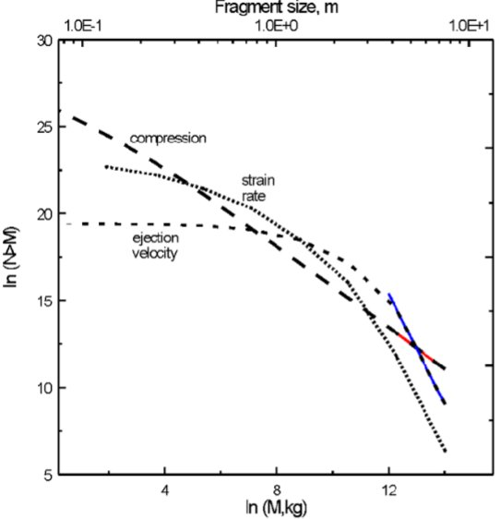
Page 366 of The rayed crater Zunil and interpretations of small impact craters on Mars

NUMBER OF MARTIAN METEORITES THAT HIT US PER YEAR FROM AN IMPACT ON MARS
This figure shows the percentage of meteorites that reach Earth over the first two million years. It’s a near constant rate for the faster ejection velocities.
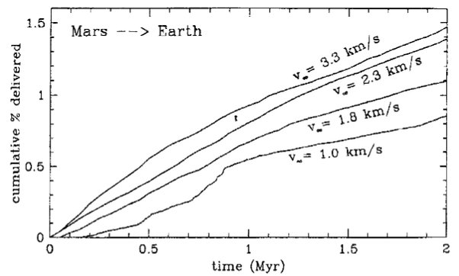
Figure from Mileikowsky et al, 2000, Natural Transfer of Viable Microbes in Space
They find that the meteorite reach Earth at a near constant rate for 10 million years and over that time 0.6% of the ejected fragments hit Eaarth.
Mileikowsky et al calculate (page 399) that
- 15 Martian meteroties hit Earth every year (based on observed numbers found in Antarctica)
- These come mainly from three impacts on Mars in the last 10 million years
- The flux is roughly constant for 10 million years after an impact (then falls off rapidly)
- So this estimate based on observed Antarctic meteorites gives ane estimate of a billion fragments per impact
[This will be an over estimate as there are fragments from older impacts as well]
- Scaling theory suggests 20 million fragments per impact (60 million total of which many don’t escape Mars but fall back)
- Taking an intermediate figure of 100 million fragments in 10 million years.
- 0.6% works out at 600,000 fragments in 10 million years
- Or about 6 fragments hit Earth every century
The Antarctic ice estmate increases that to 60 per century. The scalling theory estimate reduces it to a little over 1 fragment per century.

STERILIZATION BY COSMIC RADIATION - MOST SAMPLES WE GET WILL BE STERILIZED BUT SOME COULD SURVIVE AFTER THE SHORTEST JOURNEYS
Cockell looked closely at whether photosynthetic life could get to Earth from Mars. Cockell summarizing the literature says that tests with Bacillus Subtilis spores (which are very radioresistant though not quite as resistant as radiodurans) find that they can survive
- Up to one million years shielded by 1 meter of rock
- Up to 300,000 years behind 10 cm of rock
- Up to 100,000 years behind 3 cm of rock
Most photosynthetic life grows mms or cms below the surface
See
Cockell, 2008. The Interplanetary Exchange of Photosynthesis
Cockell concludes:
Thus, even if one assumed that near surface-dwelling photosynthetic organisms
somehow survived the dispersal filter of atmospheric transit during planetary ejection and
arrival at the destination planet, in most cases they would be effectively killed by cosmic
radiation during interplanetary transit, which, unlike UV radiation, will effectively penetrate
to depths of a few millimetres or centimetres where such organisms would normally grow.

MOST PHOTOSYNTHETIC LIFE WOULD ALSO BE DESTROYED BY THE SHOCK OF THE SUDDEN ACCELERATION OF EJECTION FROM MARS
Another big issue is the shock of ejection. The rocks have to accelerate suddenly from at rest to escape velocity in a fraction of a second. Cockell found that most terrestrial photosynthetic life can't withstand the shock of ejection from Mars.
Larger asteroid impacts reduce the shock in the spall layer and he found that it's not impossible that some photosynthetic life got to Earth from Mars especially during the larger impacts in the early solar system when it also had the northern hemisphere seas. For instance after the impact crater that formed the Hellas basin.

WE DON’T KNOW IF ANY LIFE GOT FROM MARS TO EARTH - THIS DEPENDS ON ITS CAPABILITIES TO WITHSTAND VACUUM AND SUDDEN SHOCKS, FIREBALL OF EXIT FROM MARS AND ENTRY TO EARTH’S ATMOSPHERE AS WELL AS IONIZING RADIATION
However we don't know for sure that any life has got from Mars to Earth. These experients are all based on terrestrial biology as that’s all we have.
We don’t know the capabilities of the Martian life. It doesn't need to withstand vacuum conditions to survive on Mars and it doesn't need to be able to withstand sudden shock.
Most terrestrial life including just about all higher forms of life wouldn't be able to get here on a meteorite from Mars.
Of those that could get here, most would be destroyed by the fireballs of exit from Mars or re-entry to Earth and ionizing radiation on the journey for all except the very shortest crossings or deep within very large rocks

MARTIAN LIFE WOULD LIKELY SURVIVE ON EARTH - LIKE BLUE-GREEN ALGAE FROM ANTARCTIC CLIFFS
Martian life would be likely to be able to survive on Earth. The Martian brines are highly oxidising, with perchlorates and hydrogen peroxides. They are so oxidizing that many terrestrial life forms would find hard to tolerate them. Recent research by Stamenković suggests the cold brines on Mars may be oxygenated too, even with the very low levels of oxygen, in the very cold conditions since oxygen is more soluble in cold water.
Then, though Mars gets very cold at night, in daytime it can sometimes reach above 20°C.
Microbes returned from Mars to Ear may be able to settle in on Earth as a "home from home" even more habitable for them than Earth.
An example here is Chroococcidiopsis, a blue-green algae found in Antarctic cliffs, also in the Arizona desert near JPL, but also is ubiquitous through Earth, found in the sea, in tropical water supplies, both wet, dry, hot, cold, it's a polyextremophile that has numerous metabolic pathways that let it survive almost everywhere, and it is one of the top candidates for a form of life that could survive on Mars.
Once it was well established, other mirror life could build up a microbial ecosystem based on this and in this way mirror life could start to spread through our ecosystems.

BEST CASE SCENARIOS - ARCHAEA AS A DOMAIN OF LIFE LARGELY BENEFICIAL -
In the best case scenario, Martian life is harmless to us. It might be an alien biology that is completely mystified by our biology. It might be unable to survive here. It might be a vulnerable early form of life that can’t compete. There may be no life, only chemistry. Or it might be able to survive here but be almost entirely beneficial to humans and to our ecosytems. The archaea give a good example here of an entire domain from the tree of life that causes no sickness in humans, except possibly contributing to tooth decay and seems to be largely beneficial everywhere.
However we can also devise worst case scenarios where it’s never safe to return Martian life to Earth.

EXAMPLE WORST CASE SCENARIOS FOR ECOSYSTEMS, MIRROR LIFE NANOBES - AND FOR ASTRONAUTS - ALIEN BIOLOGY MOLDS THAT WE ARE ALL IMMUNOCOMPROMISD TOWARDS
My clearest example here is chroococcidiopsis but flipped as in a mirror, DNA spirals the other way and all the organics are mirrored. Some terrestrial microbe can use mirror organics but no known multicellular life can subsist on mirror organics.
If Mars has mirror life, it’s bound to develop the isomers that let it digest ordinary organics too because of the constant rain of organics from comets, asteroids and interplanetary dust.
Return that to Earth and it will gradually turn all the organics throughout all the ecosystems it inhabits into indigestible mirror organics.

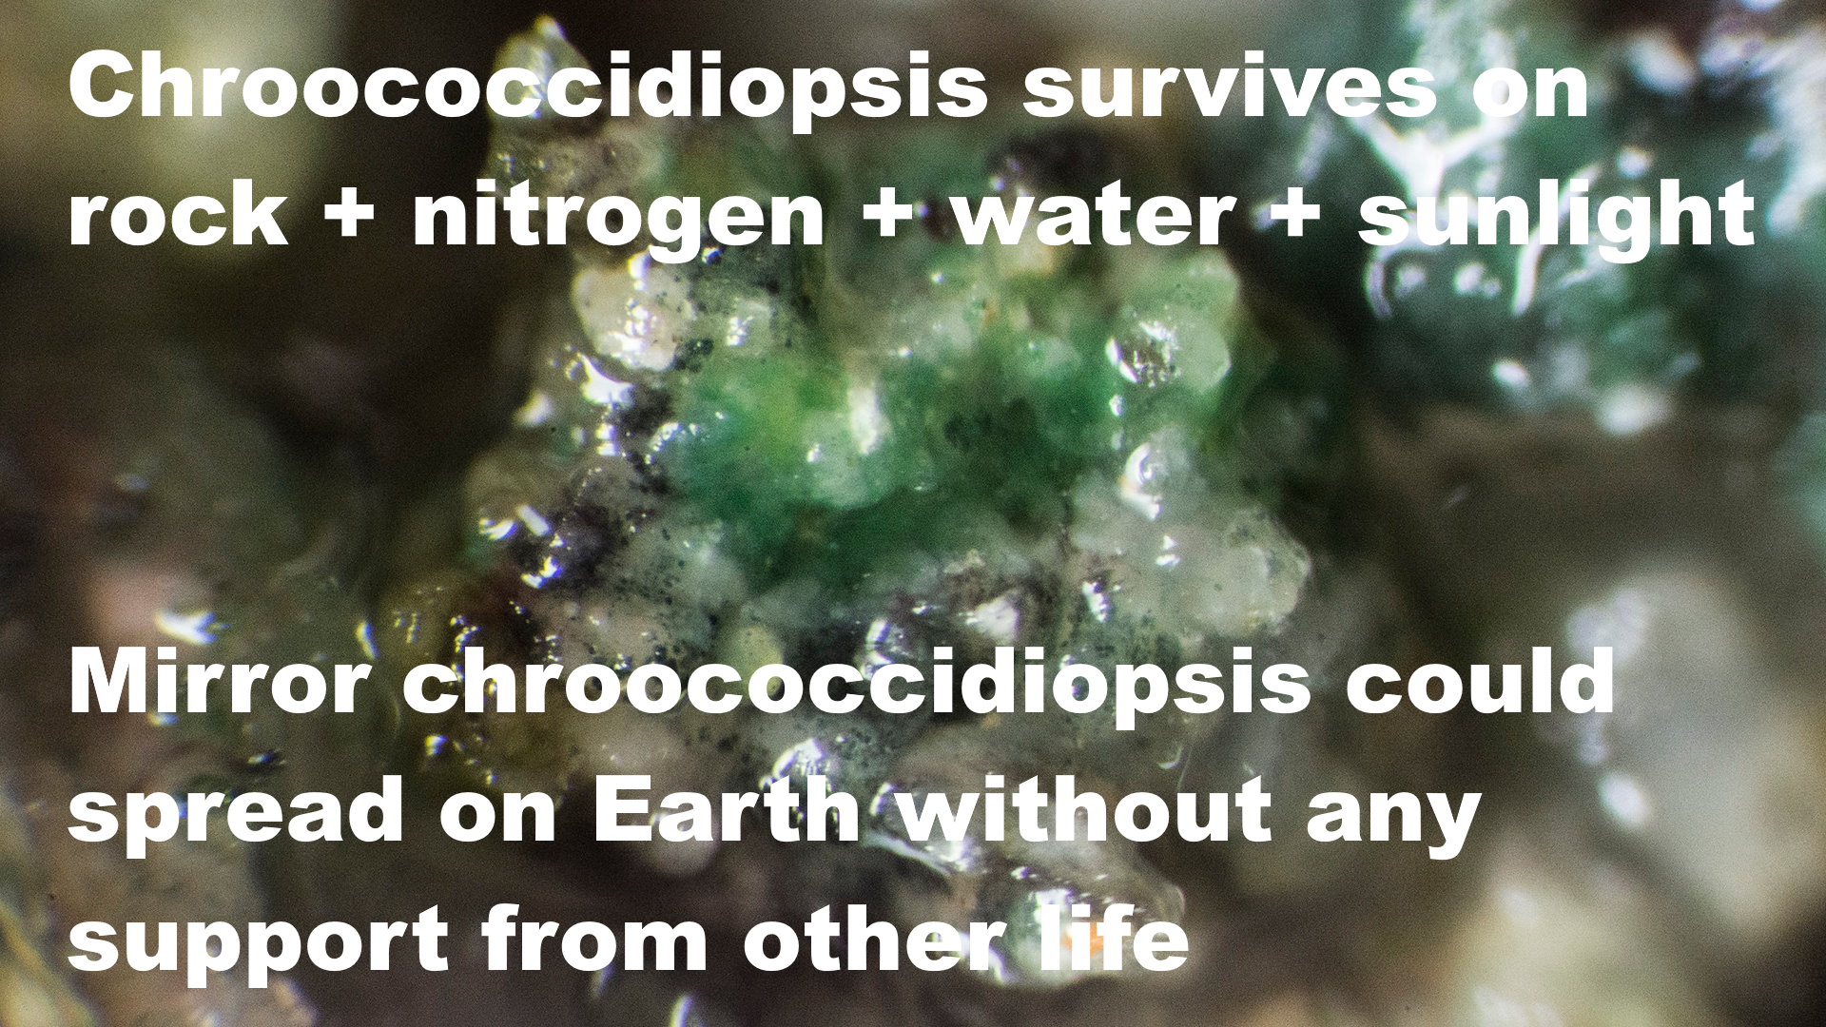

Chroococcidioopsis survives on rock + nitrogen + water + sunlight

Mirror chroococcidiopsis could spread on Earth without any support from other life.

Photograph shows chroococcidiopsis in a cave at Ares Station, Cantabria in the Iberian peninsula – with a transparent covering of other microbes – it can live on its own or in colonies with other life and it can also live inside rocks. Photo by Proyecto Agua on Flickr
Humans would survive, and the process would likely take centuries, but we’d not be able to stop it and eventually would need to protect all our ecosystems in greenhouses and similar undersea habitats with the mirror life kept out as far as possible as well as mirror organics.
Then for a worst case for impacts on humans, some of our candidates for Mars are opportunistic human pathogens. I give a number of examples in my preprint including S. liquefaciens which has caused eye infections, urinary tract infections, bloodstream infections, abscesses, septic arthritis, and fatal meningoencephalitis amongst other effects.
. Serratia infections: from military experiments to current practice.
These are most hazardous to immunocompromised. But experts like Joshua Lederberg said that though in the best case they might be mystified by our biology, in the worst case, we might all be essentially immunocompromised to a Martian organism with an unfamiliar biology that no terrestrial life has ever encountered in its evolutionary history.
. Paradoxes of the host-parasite relationship

WE NEED TO FIND OUT WHICH SCENARIO WE FACE ON MARS TO GUIDE DECISIONS
There is simply no way to find out which scenario we face on Mars by hypothetical reasoning. We don’t have enough information, with not even one other example of alien biology from a terrestrial planet. Instead we need to find out, we need the experimental data.

WORST CASE SCENARIOS FOR HUMAN SETTLEMENT ON THE MARS SURFACE MAY EVEN BE BEST CASE SCENARIOS FOR HUMAN SETTLEMENT ELSEWHERE IN THE SOLAR SYSTEM - AND MARS COULD STILL BE EXPLOITED FROM ORBIT AS WELL AS STUDIED SCIENTIFICALLY
These worst case scenarios for astronauts on the surface of Mars wouldn’t be a reason to give up on space settlement. The opposite. If we do find even one of those worst case scenarios like mirror life on Mars, though we could never return it to Earth, the interest in Mars as a planet would be huge
Human explorers and settlers would have a very importatn role to play in orbit around Mars using robotic avatars on the surface rather similarly to characters in a computer game.
There are many other places we can settle including the two moons of Mars, the asteroid belt, closer at home the Moon, or in orbit around Mars, and further afield Jupiter’s Callisto and Saturn’s Titan are of especial interest. Titan is so cold that we may have no planetary protection issues there except to keep microbes clear of cryovolcanic eruptions if there are any.
If we work together on this we can reach a conclusion quickly which may need a rapid survey of Mars from orbit.
In the worst case in the forward directon we may also need to protect vulnerable Early life from terrestrial microbes, but again this can be an opportunity for space settlement.
We need to bring the public along in a much wider ranging mission. And I think myself that updates from humans living in a settlement on Mars with the same ochre skies and the same scene outside their window with occasional trips in rovers will not sustain interest for long .While if we find interesting life on Mars, and we can keep it free from terrestrial life as we study it - then there would be great interest - also far more economic benefit to Earth too. Byproducts from extremophiles already sustain a billion dollars a year industry and the economic benefits from novel life from Mars could be huge, so long as we protect both Mars and Earth in the process.
I believe if there is a risk of humans making Martian life extinct, we can best sustain scientific interest, public interest, and the economic value of Mars by protecting Mars, at least in the early stages of exploration.

DECISION WON’T BE MADE BY AUTHORS OF BLOG POSTS OR ARTICLES FOR THE POPULAR PRESS BUT AS A RESULT OF AN EXTENSIVE LEGAL PROCESS AND SUBMISSIONS BY SCIENTIFIC EXPERTS IN INDEPENDENT UNINVOLVED AGENCIES AND REVIEW BOARDS - AND POSSIBLY PRIVATE LEGAL ACTIONS BY OBJECTORS IF THE GENERAL PUBLIC AREN’T FULLY ENGAGED FROM THE START
The literature on the legal process for a Mars sample return is small but there are two articles by Urhan et al and by Race? These are the main ones I found:
- Race, M. S., 1996, Planetary Protection, Legal Ambiguity, and the Decision Making Process for Mars Sample Return
- Uhran, et al, 2019. Updating Planetary Protection Considerations and Policies for Mars Sample Return.
Also the article by Rummel et al. on the steps needed to prepare before the legal process starts
- Rummel, et al, 2002. A draft test protocol for detecting possible biohazards in Martian samples returned to Earth.
From these it is clear the legal process will be very extensive. It’s also clear we need a consensus position that brings the public along with us BEFORE the legal process starts, or there are likely to be many delays.
These are peer reviewed, and written by mainstream authors. Rummel and Conley are both former NASA planetary protection officers and Race is a biologist working on planetary protection and Mars sample return at the SETI institute,
Also, everything they said checks out. If there is anything I’m missing here, by relying on them, do please say.
Based on Rummel et al’s recommendations, we should also involve the experts of other uninvolved agencies.

NEED FOR NEW MARS SAMPLE RETURN STUDY BEFORE INITIATING NEPA PROCESS - AS 2012 STUDY IS OUT OF DATE
I believe we also need a new Mars Sample Return study as there were major changes between the 2009 study by the National Research Council in the USA and the 2012 study by the European Space Foundation in Europe.
- National Research Council. 2009. Assessment of Planetary Protection Requirements for Mars Sample Return Missions (Report)
- Ammann, et al, 2012. Mars Sample Return backward contamination–Strategic advice and requirements (ESF-ESSC Study Group on MSR Planetary Protection Requirements)
The 2012 study stresses the importance of regular review (page 21 of Amman et al, 2012).
Based on our current knowledge and techniques (especially genomics), one can assume that if the expected minimum size for viruses, GTAs or free-living microorganisms decreases in the future, and this is indeed possible, it will be at a slower pace than over the past 15 years
However, no one can disregard the possibility that future discoveries of new agents, entities and mechanisms may shatter our current understanding on minimum size for biological entities. As a consequence, it is recommended that the size requirement as presented above is reviewed and reconsidered on a regular basis.
[bolding as in original cited text]
The minimum size requirement for filters to contain Martian biology was reduced from 0.25 microns to 0.05 microns / 0.01 microns in just three years from 2009 to 2012.
By 2020, eight years later, another review is certainly required.
If the legal process is started without a new sample return study I don’t think it will withstand legal challenges on the basis of inadequate analysis in an EIS - that the agency either failed to consider some of the impacts or failed to fully consider the weight of the impacts they did review.
Plaintiffs can’t claim damages, but the court can remand the case to the agency for further proceedings and may specify what those proceedings must include
- Congressional Research Service, 2021, National Environmental Policy Act: Judicial Review and Remedies

HARD TO SEE HOW THE PROCESS CAN BE COMPLETED IN TIME FOR A RECEIVING FACILITY IN THE EARLY 2030S, AND IT MAY EASILY TAKE THROUGH TO THE 2040S OR 2050S
As I worked through the timescales and the requirements of the ESF sample return study in 2012 for 100% effective filters at 0.05 microns, I don’t see how the process can be completed in time to have a receiving facility ready by the early 2030s, and highly unlikely the legal process itself completes before 2030. The legal process itself would most likely continue into the 2030s and then the time to create the facility and certify it as ready for samples would take throuugh to the 2040s or 2050s assuming it starts in earnest only once the final requirements are known at the end of the legal process.
Again do say if I miss anything here. So far nobody I’ve contacted has seen any mistake in this analysis.

TWO PROPOSED SOLUTIONS - 100% EFFECTIVE CONTAINMENT ON EARTH NOT BASED ON FILTERS - PROTECTED BY A HIGH TEMPERATURE OIL SUMP - AND RETURN TO A STABLE ORBIT ABOVE GEO
I found two possible solutions. One is to design a 100% effective containment facility on Earth that doesn’t depend on filters but instead uses a high temperature oil sump to protect it, a technology we have already. The studies would have to be done telerobotically. I’d be interested in thoughts from engineers as to whether this is feasible. This might permit a very fast legal process that would only take 6–7 years as it would hopefully be clear to everyone that it will be safe. The build of the facility could be started right away with confidence that it will be considered suitable when finished. Congress would need to approve the build as it does with all major funding requirements. But it likely would.
The other solution involves returning to a safe orbit outside of Earth’s biosphere. This involves minimal legal process similar to the sample returns from comets or asteroids.
This assume that the samples are of biological interest. If not the simplest solution is simply to sterilize them.

SADLY THE PERESEVERANCE SAMPLES ARE NOT STERILIZED SUFFICIENTLY TO DETECT LIFE IN LOW CONCENTRATIONS - AND THEY ARE SAMPLING ROCKS - NOT MUCH DIRT OR DUST EXCEPT ONE REGOLITH SAMPLE - WE COULD HOWEVER ADD A 100% STERILE CONTAINER TO RETURN A SIMPLE SCOUP OF DIRT IN THE SAMPLE FETCH LANDER
Some think there is a high chance Viking in the 1970s did discover life and if not I think it was very interesting chemistry. But sadly the current Mars sample return won’t return a sample of the dust or dirt or the sub surface brines that Viking may well have sampled. Also the sample tubes aren’t adequately sterilized to be able to prove that there is no life in them or to detect low levels of life - there is enough organics by my calculation for tens of thousands of ultramicrobacteria per tube and tens of millions of simpler RNA world nanobes (which could be hazardous to Earth as mirror life nanobes). In my literatue survey I found warnings from experts that insufficient sterilization can lead to false positives which could make it impossible to release the samples from contanment without sterilization and this seems likely to happen for Perseverance’s samples.
So I suggest the sample fetch lander is modified to return a sample of the dirt, just collected using a scoop as for Viking, and collected into a 100% sterile container. The reason this wasn’t done for Perseverance is that engineers worried that with their complex drilling machinery the container wouldn’t open on Mars. But with geological samples already collected and a simple scoop collection method I think we could aim higher for a 100% contamination free sample of dirt, and I think we should also similarly have a 100% contamination free sample of the Martian atmosphere and of dust from dust storms.
If I see any mistakes in this do say!

EARTH WILL BE KEPT SAFE - AS A RESULT OF AN EXTENSIVE LEGAL PROCESS AND EXPERTS FROM MANY DIFFERENT AGENCIES - AND THE PUBLIC ALSO INVOLVED
The papers by Urhan et al and Race are peer reviewed and everything in them checked out. Urhan et al’s second author is Cassie Conley, former NASA planetary protection officer. If what they say is correct, these things will be looked at very thoroughly.
They have to go through a legal process which for a complex case like this will be at least 6 years likely far more - it's not up to NASA.
Numerous US agencies will make sure it is safe - who have nothing invested in the success of the space program - including the
- Department of Homeland Security,
- CDC (for potential impact on human health),
- Department of Agriculture (for potential impact on livestock and crops),
- Occupational Safety and Health Administration - for any rules about quarantine for technicians working at the facility
- Department of the Interior which is the steward for public land and wild animals which could be affected by release of Martian microbes
- Fish and Wildlife Service for the DoI who maintain an invasive species containment program and may see back contamination as a possible source of invasive species
- National Oceanic and Atmospheric Administration (NOAA)'s fishery program for sea landing in case it could affect marine life and NOAA fisheries
- Integrated Consortium of Laboratory Networks (ICLN)

INTERNATIONAL ORGANIZATIONS LIKE THE WHO, FAO, AND OTHERS WOU.D ALSO BE INVOLVED AS WELL AS INTERNATIONAL TREATIES
Also several international organizations are likely to be involved such as the WHO (for potential impacts on human health globally if a new organism is returned that can be spread to other countries). If the worst case scenarios such as mirror life are seen as credible this would surely also involve the Food and Agrictulture organization for potential impacts on global food supply and so on.
Race (Race, 1996) says that experts will have challenges deciding in advance whether the sample should be classified as potentially:
• an infectious agent
• an exotic species outside its normal range
• a truly novel organism (as for genetic engineering)
• a hazardous material
The choices here would change which laws and agencies would be involved.
There are numerous treaties conventions and international agreements relating to environmental protection or health that could apply.
Including those to do with (Race, 1996)
• protection of living resources of the sea
• air pollution (long range pollution that crosses country boundaries)
• world health, etc
She also writes that many interntaional treaties would be involved based on work by George Robinson.
Meanwhile, since this is a joint NASA / ESA mission, it involves ESA. Most of the ESA member states are in the EU (ESA, n.d.) so the EU will get involved.
This leads to a separate legal process in Europe, starting with the Directive 2001/42/EC (EU, 2001). I haven’t located any academic reviews for the European process, but as for the case in the USA, this would spin off other investigations which would involve the European Commission (Race, 1996).
In 1969, for Apollo 11, NEPA didn't exist. NASA did set up an interagency panel but their recommendations were kept secret and not made public before the mission. This panel asked NASA modify its plans, to keep Earth safe, but NASA vetoed them and all this happened in private discussions with no public involvement.
None of this would be permitted today. Today, NASA has no veto.
Any objections by the agencies would be made public and If any of these agencies think that NASA’s plans don’t keep Earth safe they can require NASA to change its plans or just stop the mission.
If I am correct in the paper I’m working on, then they will be legally required to sterilize the samples until 2039 as minimum, to complete the process for an unsterilized return, so I expect them to sterilize the samples - but whatever they do it will be sure to keep Earth safe

FEW THINGS COULD SUSTAIN INTEREST PUBLIC INTEREST MORE THAN LIFE ON MARS - OR END IT MORE QUICKLY IF WE MAKE THAT LIFE ACCIDENTALLY EXTINCT - FOOTPRINTS AND FLAGS ARE OF ONLY SHORT TERM INTEREST THAT FADES IN WEEKS
As you know there was huge public interest in the first footprints on the surface of the Moon, and the first flags. But after that the public moved on, "been there done that". I believe that the same would happen on Mars unless there is more to it than watching humans living on another planet with different coloured skies, and otherwise resembling a terrestrial desert.
I believe the more interesting Mars turns out to be, for humans, the more likely we can sustain human interest and funding. If we find life on Mars, especially life that is novel and of different biology from Earth life, that would sustain the most public interest of any discovery we could make there.

MARTIAN LIFE RETURNED TO EARTH COULD POTENTIALLY BE MORE LIKE INVASIVE AMERICAN MINK IN EUROPE, AND TERRESTRIAL LIFE ON MARS MORE LIKE INVASIVE RABBITS IN AUSTRALIA OR RATS, PIGS AND EUROPEAN STARLINGS IN THE AMERICAS
We do have candidate microbes that could survive on Mars such as chroociccidiopsis, a blue-green algae and a similar microbe on Mars could survive on Earth. We’ll also find that chroococcidiopsis couldn’t get here on a meterorite from Mars.
We do have invasive microbial species such as invasive diatoms in New Zealand lakes such as Didymosphenia geminata , probably brought there from the northern hemisphere damp sports equipment, and many invasive diatoms in the Great lakes including Stephanodiscus binderanus which clogs water treatment systems and creates foul tastes and odours in the water (see for example, Diatoms as non-native species)

WE NEED TO LOOK CLOSELY AT POSSIBLE SCENARIOS FOR MARS
So it is important to look closely at many different scenarios of what we can find on Mars. If there is a potential for Martian life, we need to know if it is at risk from terrestriial life brought from Earth. Also we need to be very confident that both the Earth and human astronauts are safe after a mission to Mars.

WE HAVE NOT ONLY A RESPONSIBILITY BUT A LEGAL OBLIGATION TO PROTECT EARTH’S BIOSPHERE THROUGH MANY LAWS THAT DIDN’T EXIST AT THE TIME OF APOLLO - NOT THE OUTER SPACE TREATY
If there is even a small risk of returned life harming Earth’s biosphere, we not only have a responsibility but are legally required to protect Earth. This is based on many laws to protect Earth’s environment and doesn’t depend on the Outer Space Treaty.
According to the best analyses I’ve seen, the legal process will take many years and any plans will be scrutinized by independent experts in all the affected agencies in the USA, also international treaties and the domestic laws of other countries will be involved too. We can’t follow the streamlined procedures of the Apollo years any more because the law has moved on since then.
For details see Updating Planetary Protection Considerations and Policies for Mars Sample Return
So we don’t need to have any concern on an individual level of risk to Earth’s biosphere. Earth will be protected. But I think there is a risk of expensive mistakes in planning for space missions that don’t take account of this legal complexity, perhaps based on the very different legal situation for the Apollo missions. As far as I can tell, by adding up the timelines, we couldn’t complete the legal process in time to return an unsterilized sample from Mars before 2039. But there may be ways to speed this up, by returning a sample to a safe orbit outside of Earth or possibly a very safe sample return to Earth.

NEED TO BRING SCIENTISTS, THE PUBLIC AND SPACE COLONIZATION ENTHUSIASTS TOGETHER
I believe we need to bring the scientists, the public, and the space colonization enthusiasts together. There is a large constituency of space colonization enthusiasts on Mars and we can accomplish much more if we can go forward working together with each other to solve the many problems for human exploration of Mars.
I will go into your arguments in a moment, but first I will outline my vision for the future, which I hope is an inspiring alternative to the ideas of the Mars society and SpaceX for the near future.

MY VISION FOR THE FUTURE WHICH I BELIEVE WILL LEAD TO FAR MORE SUSTAINED INTEREST IN SPACE EXPLORATION AND SETTLEMENT - STARTING WITH EVEN MORE AMBITIOUS PLANETARY PROTECTION EXPLORING MARS FROM ORBIT IN THE SPECTACULAR HERRO ORBIT - EVEN MORE INTERSTING THAN THE ISS ORBIT AROUND EARTH
I suggest we start with missions from Earth doing in situ exploration of Mars, followed by humans exploring Mars from orbit in a very rapid astrobiological survey - similar to the one you vision but done with 100% sterile rovers. They would explore in orbit by telepresence.
As you’ll know, this is an idea that’s come up often in the Mars exploration literature:
Buzz Aldrin’s plan:
- Aldrin et al, 2013. Mission to Mars (p. 173).
The Boeing “Stepping stones to Mars” mission:
- Hopkins et al, 2011, September. Comparison of Deimos and Phobos as destinations for human exploration, and identification of preferred landing sites
- Kwong, et al., 2011, September. Stepping stones: exploring a series of increasingly challenging destinations on the way to mars. In AIAA Space 2011 Conference, Long Beach, CA (pp. 27-29).
The HERRO mission
- Oleson, et al., 2013. HERRO mission to Mars using telerobotic surface exploration from orbit
- Valinia, et al., 2012. Low-Latency Telerobotics from Mars Orbit: The Case for Synergy Between Science and Human Exploration.
And Mars Base Camp
- Cichan et al, 2017. Mars Base Camp: An Architecture for Sending Humans to Mars
The easiest of all of these in terms of delta v. is the HERRO mission which could be the earliest, a sun synchronous near polar Mars orbit that’s easty to get to from Earth.
The HERRO orbit is a spectacular one, comes in close to the poles of Mars twice a day, near to each pole, then skims the surface than away again until Mars recedes to a small disk in the distance and then repeats. The astronauts get a few hours every day of close telepresence exploring the surface directly via robots that work like avatars in a computer game.
This is what it might look like from inside the spacecraft
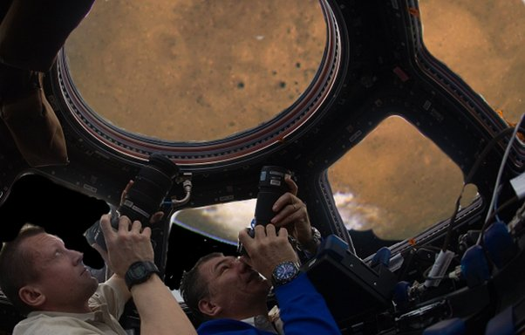
Composite of photo from the Cupola of the ISS (Coleman, C, 2011) and Hubble photo of Mars (Hubble, 2003
In this video, I use a futuristic spacecraft called the “Delta Flier” in Orbiter as that was the easiest way to do it in the program I used to make the video. Apart from that, it is the same as the orbit suggested for HERRO.
https://www.youtube.com/embed/BftmbvBd5m4?feature=oembed
Video: One Orbit Flyby, Time 100x: Mars Molniya Orbit Telerobotic Exploration in HERRO Mission
I think an orbital mission like HERRO is of far greater sustained interest both for the public and for the astronauts than a surface colony where you see the same view from your window every day - with not even much by way of changes, very little even by way of weather, and it takes hours to put on a spacesuit if you do it safely, to get out of doors. The first footprints and the first flag would be of interest but there is a limit to how much interest there is in seeing the same landscape outside the module window every day of the year, with the monotony only relieved by occasional dust storms or dust devils.
But the HERRO orbit would be much like the ISS, where the astronauts see constantly changing landscapes outside of their windows. This greatly adds to the public interest of the ISS.
The HERRO orbit is a bit like the lunar gateway polar orbit but approaches Mars twice a day instead of once every 7 days as for the Moon.

THEN SETTING UP A BASE ON PHOBOS, DEIMOS OR BOTH AS WITH BUZZ ALDRIN’S “MISSION TO MARS”
Humans could also explore Phobos and Deimos which also have ISS like orbits around Mars. There again, they see a different view every time they look out of their windows towards Mars.
This would be like Buzz Aldrin’s plan - from his “Mission to Mars” book.
As he summarized it briefly in this interview
There are a lot of things really should be done before the first
people go down and it is so much more efficient without going into details ... A project manager said what they did in five years could have been done in one week if we had human intelligence in orbit so that we could control things with a second time to life instead of 15 minutes
From his book, Aldrin and David, 2013. Mission to Mars (p. 173).
Phobos is a way station, a perfect perch that becomes the first sustainable habitat on another world. From that mini-world, crews on Phobos can run robotic vehicles on Mars more directly, in a much shorter communication delay time than commands sent from faraway Earth. Robotic stand-ins for astronauts will ready the habitats and other hardware on the Martian surface, in preparation for the first human crew to arrive on Mars. That’s my judgment. My theory right now is that somebody piecing together hardware on Mars through telerobotics on Phobos is the right person to later lead the first landing mission on the red planet.
Phobos and Deimos are, in a sense, offshore islands of Mars, discovered in 1877 by Asaph Hall at the U.S. Naval Observatory in Washington, D.C. They were tagged with names from Greek mythology: Phobos means “fear,” Deimos, “terror.” In the future these Martian moons are likely to symbolize just the opposite: courage and security.
By placing a crew-occupied laboratory/control station on either Phobos or Deimos, an assortment of probes, penetrators, and rovers can be controlled on Mars. Far more of the planet can be reconnoitered, more so than a landed crew could achieve. After all, Mars is vast. It’s a huge planet with a lot of real estate, some of it very hazardous in terms of crevasses, caves, steep hills, giant canyons, and high mountains. Better to lose a robot or two than have a person face a deadly predicament.
On one hand, robots are able to cope with the surly climes of Mars while carrying out boring, risky, or dull jobs. On the other hand, humans bring perception, speed and mobility, dexterity, and an inquisitive nature. Combining the two is opening up a new paradigm in space exploration. “Telepresence” makes use of low-latency communication links that can put human cognition on other worlds. Low-latency yields the appearance of “being there” in a way that is near real-time believable. The ability to extend human cognition to the moon, Mars, near-Earth objects, and other accessible bodies helps limit the challenges, cost, and risk of placing humans on perilous surfaces or within deep gravity wells.

MAINTAINING THE BIOLOGICAL VALUE AND INTEREST OF MARS WITH 100% STERILE ROVERS - MADE FEASIBLE BY ENGINEERING STUDIES FOR VENUS
Then I believe that to maintain the biological value and interest of Mars in early stages of exploration, we need 100% sterile rovers, We have that technology developed for Venus landers, a complete rover made with modern heat tolerant electronics that can run indefinitely at 300 C with active cooling. these electronics are widely used in electric cars, to monitor furnaces, for some jet engine parts and so on so they are well understood and robust.
For our Mars missions we could heat the rover for months during the journey to Mars then operate it at normal temperatures on Mars. There would be initial expense in the design, sourcing components for it and so on, but much of the work is already done for Venus and once done there would be little overhead after that. The expense of heat tolerant alternatives for all the components would be small compared to the overall cost of a space mission.
So, I actually advocate a far higher level of planetary protection than we have today. Hopefully you may find these ideas interesting even though you are not likely to agree with them initially.

PERHAPS EARTH LIFE ORIGINATED FROM MARS - IF SO IT’S NOT IMPOSSIBLE THAT PHOTOSYNTHETIC LIFE FROM MARS CAUSED WHAT MIGHT BE THE GREATEST MASS EXTINCTION EVER - THE GREAT OXYGENATION EVENT
Although we have no evidence of any transfer of life from Mars, one suggestion is that terrestrial life originated from Mars brought here perhaps on huge impacts in the early solar system.
If so Martian life helped form the Earth we have today and is even our distant cousin. But that doesn't prevent it causing mass extinctions here.
Suppose that photosynthetic life came to Earth from Mars half a billion years ago. It could have caused the great oxygenation event, which was hugely beneficial for our form of life. We don't know, but it's possible that it also made many previous species extinct, adapted to a world without oxygen.

IF LIFE HAS GOT TO EARTH FROM MARS IT DOESN’T MEAN ALL MARTIAN LIFE GOT HERE - FILTERED TO THE LIFE ABLE TO SURVIVE THE TRANSIT
Also if life has got to Earth from Mars, it doesn't mean that ALL Martian forms of life have got here. Instead it would be filtered to whatever is able to withstand the journey from Mars to Earth.
Martian life unable to get here could still be very hazardous if they did get to Earth.

EXAMPLE OF A MIRRORLIFE NANOBE - CHEMISTRY REFLECTED IN A MIRROR - LIKELY TO BE ABLE TO METABOLIZE BOTH FORMS OF LIFE BUT ONLY PRODUCE MIRROR ORGANICS
Let's take the example of a mirror life nanobe. This is identical to terrestrial life but with all the chemistry reflected as in a mirror, DNA and RNA spiral the opposite direction and so on.
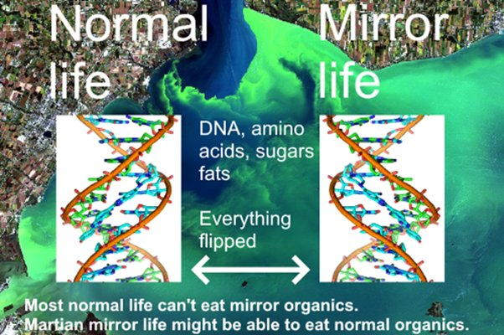
Normal life, Mirror life, DNA, amino acids, sugars, fats, everything flipped. Most normal life can’t eat mirror organics. Martian mirror life might be able to eat normal organics. Background image from NOAA, DNA spiral from Pusey et al, 2012, cites in preprint
We don’t know why terrestrial life allhas DNA spiraling the same way and most organics in only one form and not its mirror. It may just be chance andn if so Martian life could have life with the DNA spiraling the opposite way - or both forms of life.
[This is my own idea from the preprint - for some reason it doesn’t seem to have been discused yet in the planetary protection literature - if anyone knows of a previous discussion, do let me know - but mirror life is often discussed in the context of synthetic life]
The Martian surface conditions would rapidly destroy organics from life over timescales of millions of years and most of the organics are likely to be from infall from space, in form of comets, asteroids, interplanetary dust and so on. So the organics are likely to occur in both forms, ordinary and mirror.
Some terrestrial microbes have the capability to metabolize mirror life but this very rare and no higher lifeforms can do this.
Life from Mars, whether the same symmetry as terrestrial life or mirror life, is likely to be able to metabolize both forms of organics as that would double the amount of organic material it can consume.
So - this is quite a plausible scenario, mirror nanobes that are able to metabolize both forms of organics and turn them into mirror organics.

IT COULD ALSO BE MIRROR RNA WORLD NANOBES - SIMILAR IN SIZE TO A SARS-COV2 VIRUS - AS FOR THE SHADOW BIOSPHERE HYPOTHESIS
Then it could be RNA life, which could permit very small nanobes similar in size to the SARS CoV2 virus which causes COVID or smaller. Indeed we have DNA based ultramicrobacteria which can pass through 0.1 micron filters, only double the diameter of the SARS - CoV2 virus. There was a lot of interest at one point in a shadow biosphere of RNA nanobes that could co-exist with terrestrial life. It would have some advantages, protean grazing would ignore it as too small, and the high surface to volume ratio is an advantage in nutrient poor environments.
We never found that shadow biosphere. But early terrestrial life has to have been much simpler than DNA. Probably we did have early much simpler forms of life that could survive as much smaller nanobes than for terrestrial life, but terrestrial life made it extinct.
However we can't guarantee that terrestrial life would out compete mirror nanobes from Mars, after all it was a viable hypothesis for a shadow biosphere for Earth.

MIRROR LIFE NANOBES MIGHT BE ABLE TO PASS THROUGH FILTERS NOT MUCH LARGER THAN 0.01 MICRONS OR 10 NANOMETERS - WE HAVE NO FILTERSE WITH ANYTHING LIKE THAT CAPABAILITY - WELL BEYOND HEPA FITLERS
Mirror life nanobes may be able to pass through filters not much larger than 0.01 microns or 10 nanometers.
I did a search of the literature and we don't yet have filters able to filter out individual SARS CoV2 viruses. HEPA filters can filter out the larger droplets but not individual viruses. We do have filters that work under high pressure to filter out such small nanoparticles from water, but they are also delicate and high maintenance.
The 2012 Mars Sample Return study for the European Space Foundation said a mission needs to contain a 0.05 micron particle that not even one such particle should leave the facility.
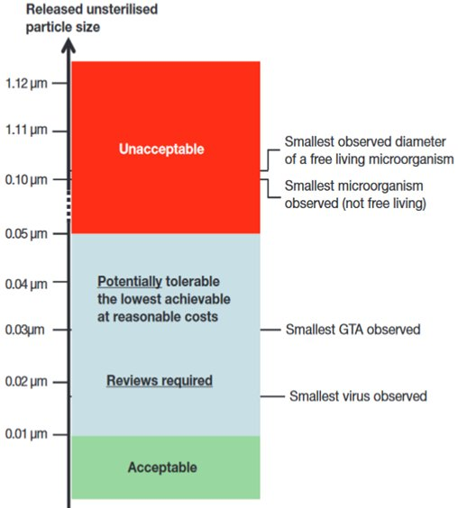
They base this on experimental observation of terrestrial nanobacteria that can pass through 0.1 micron (100 nanometer) filters.
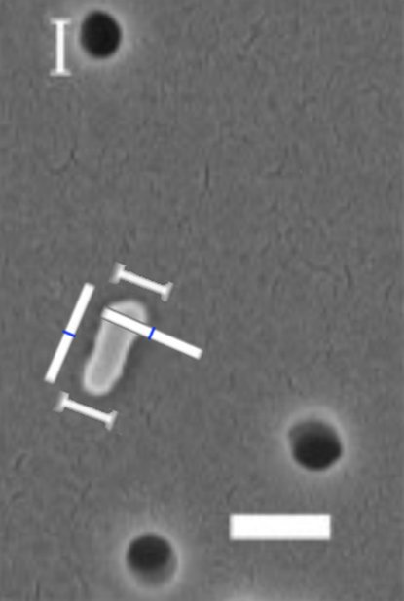
SEM of a bacterium that passed through a 100 nm filter (0.1 microns), large white bar is 200 nm in length (Liu et al, 2019).
The report concluded (Ammann et al, 2012:21)
“the release of a particle larger than 0.05 μm in diameter is not acceptable in any circumstances”
That also is beyond current capabilities to filter out.

EXAMPLE OF MIRROR LIFE NANOBES GRADUALLY TRANSFORMING TERRESTRIAL ORGANICS TO MIRROR ORGANICS - THIS IS A SCENARIO EXPERTS WILL NOT BE ABLE TO IGNORE IN THE LEGAL PROCESS
This is an example of a worst case scenario. But we don't know what we will find on Mars so, until we do, we do need to consider all scenarios. We have no way to assign probabilities to them yet.
In this scenario, the Martian nanobes gradually turn all terrestrial organics to mirror organics. Most terrestrial life doesn't survive. Some prime producers like Chroococcidiopsis do survive as they can grow based on just sunlight, water, and a few elements from rocks. Others survive because they are able to metabolize mirror organics or quickly evolve that capability. Some smaller forms of higher life with short lifespans may be able to evolve the capability to use mirror organics.
But most terrestrial biospheres gradually go extinct. This would likely take centuries but over that time period we would need to gradually paraterraform Earth, cover the land and protected areas of the sea such as coral reefs with enclosures to keep out mirror organics and as much as possible of the mirror life, and artificially ensure that the organics within the ecosystems are of the right symmetry for terrestrial life to use. We might also be able to engineer terrestrial life to use mirror organics.
It's not an extinction scenario for humans but it is severe degradation of the Earth's biosphere in the short term, though long term it is enriched by the diversity of both mirror and non mirror life. Much like the great oxygenation event it would likely result in a more biodiverse world eventually but the short term effects would be very severe and last for millions of years, though we might be able to speed up the transition.
There is no way that experts are going to permit a sample return from Mars if thereis any possibility for such a scenario as this.
We need to prove that it is impossible first.

ASTRONAUTS WHO DISCOVER MIRROR NANOBES ON MARS COULD NEVER RETURN - SO WE NEED TO KNOW BEFORE WE SEND THEM THERE
We couldn't protect against this by quarantine. If astronauts found mirror life on Mars there would be no way to sterilize it from their habitats, or remove mirror life from the human microbiome. They would need to remain on Mars for the indefinite future and there might be no way to bring them back to Earth safely.
So it is important to know the answer to this BEFORE we send humans to the Martian surface.

MARTIAN ASTRONAUTS COULD ALSO BE HARMED BY A DISEASE OF BOFILMS LIKE LEGIONELLA WHICH IS NOT ADAPTED TO HUMANS
Martian life could also be hazardous to astronauts more directly. Yes there is no way that Mars would have diseases adapted to humans, however, legionnaire's disease is often used in the planetary protection literature as an example of a disease of biofilms which isn't adapted to humans. It "sees" our lungs as just another biofilm. It even infects the macrophages that try to eat it, which to legionella must seem like a large amoeba from a biofilm.
Legionella isn't a likely organism to find on Mars as it requires oxygen, though the oxygenated brines may make it more likely. But it's an example to show that diseases from Mars needn't be adapted to human hosts to harm us.

WE COULD ALSO BE HARMED BY FUNGAL DISEASES - ONE OF THE CANDIDATE MICROBES FOR MARS IS AN OPPORTUNISTIC INFECTION OF HUMANS - AND IF WE ARE ALL IMMUNE NAIVE TO MARTIAN LIFE WE MIGHT ESSENTIALLY ALL BE IMMUNOCOMPROMISED FOR A MARTIAN FUNGAL DISEASE
Another example like this, fungal diseases. For most people they are a minor nuisance, athletes foot, fungal toe nails, or the allergic reactions that lead to asthma or allergic rhinitis. But for immunocompromised, some fungi and molds can be deadly.
Our immune system might never have been exposed to anything resembling Martian life. If so we might all be essentially immunocompromised like the patients who sadly die of fungal diseases. One of the candidates for a terrestrial mold that could live on Mars is actually an opportunistic Martian pathogen in the immunocompromised.

WE NEED TO LOOK AT WORST CASE SCENARIOS - BUT MARTIAN LIFE COULD ALSO BE BENEFICIAL - EXAMPLE OF THE ARCHAEA - A WHOLE DOMAIN OF LIFE THAT IS LARGELY BENEFICIAL TO OTHER LIFEFORMS
I don't want to suggest that Martian life inevitably harms terrestrial biospheres. We need to look at that because it's important to consider worst case scenarios when we don't know what's there.
However in other scenarios Martian life is beneficial to Earth's biosphere. A good analogy here is the archaea, a complete domain of life that causes almost no problems for any of our biospheres or terrestrial life. It might be implicated in tooth decay but there is very little by way of archaea caused diseases or harm.
However we need to know what we have on Mars before we send humans there and return it to Earth, accidentally or intentionally.

MARTIAN LIFE COULD ALSO BE AT GREAT RISK FROM EXTINCTION BY TERRESTRIAL LIFE - FOR INSTANCE IN A SCENARIO OF TRANSFORMABLE EARLY LIFE CELLS WITH GENETIC COMPETITION BUT NO COMPETITION AT THE CELLUULAR LEVEL
Then Martian life could be early life that hasn't evolved far, especially if it has evolved recently. One hypothesis is that life may have gone extinct and re-evolve don Mars many times and we might find life there that isonly a few hundred million years old. Another possibility is that early life has survived all the way to the present but has barely changed.
Woese suggested that early life took the form of transformable cells. Their cell walls are essentially permeable to RNA indeed they might share it also via vesicles, and other methods such as are widely used in terrestrial microbes today for horizontal gene transfer. This leads to Lamarckian evolution. This could be very effective in the harsh conditions there with microbes in a biofilm cooperating maximally by sharing all the genetic information they have that could help adapt. It might not have any predators yet.
However such life would be very vulnerable to terrestrial life as the cells never needed to compete with each other and would be just eaten by terrestrial life. The life might be gone before we can study it.

LIFE INTRODUCED TO MARS COULD MAKE IT LESS RATHER THAN MORE HABITABLE - FOR INSTANCE PHOTOSYNTHETIC LIFE BY COOLING MARS COULD MAKE IT LESS HABITABLE - IT IS POSSIBLE THAT THIS ALREADY HAPPENED - HYPOTHESIS OF A SWANSONG GAIA (NOT YET HAD PEER REVIEW)
Another issue is that life we introduce to Mars could make Mars less rather than more habitable for humans, and indeed for native life too. Photosynthetic life on Earth helps keep it cool, by removing CO2. That helps make Earth more habitable but a cooler Mars is the opposite of what life needs there. In my preprint I make a new suggestion. It hasn't had peer review yet, but the suggestion is that photosynthetic life on Mars would help preserve it in a barely habitable state for billions of years.
This assumes that the volcanoes on Mars continue to release enough CO2 to keep it warm enough for liquid water continuously - but that photosynthetic life responds to any cO2 pulse by rapidly spreading over the surface and removing CO2 until it is barely habitable.
Sometimes the atmosphere would thicken and liquid water would be possible, but as soon as this happens life immediately starts removing CO2 bringing it back to its current barely habitable state.
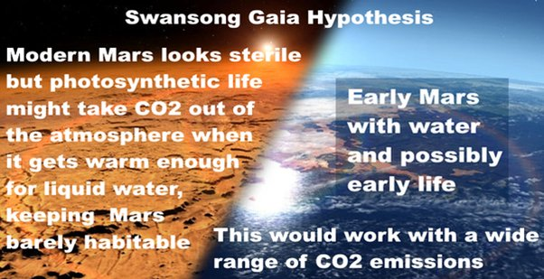
Swansong Gaia hypothesis. Modern Mars looks sterile, but photosynthetic life might take CO₂
out of the atmosphere when it gets warm enough for liquid water, keeping Mars
barely habitable. This would work with a wide range of CO₂ emission scenarios
I call this the swansong Gaia hypothesis. Based on Jack O'Malley-James's idea of a swansong biosphere when a planet loses life but before it is completely extinct,but then a Gaia type feedback that maintains habitability for billions of years,like Gaia, but minimally habitable in a perpetual swansong biosphere state.
The idea itself isnt’ new. The current Martian atmosphere average pressure at 0°C is remarkably close to the triple point for water of 6.1 millibars, the balance of pressure and temperature where ice, liquid water and water vapour can co-exist in equilibrium. In places it is below the triple point, in Hellas basin by one model it is 12.4 millibars and would boil at 10°C. In the Southern Uplands it is well above the triple point.
Perhaps this is not a coincidence.
The literature has several speculations about the idea that the Mars atmosphere could be self-limiting. with excess CO2 sequestered asa carbonates whenever the pressure gets higher. However the literature focuses on formation of carbonates by dissolving in water and other abiotic processes, including a suggestion that abiotic photosynthesis could help keep Mars perpetually in such a state. See for example:
- Kahn, 1985. The evolution of CO₂ on Mars.
- Haberle, et al., 2001. On the possibility of liquid water on present‐day Mars
The only thing new about my suggestion of a self perpetuating Swansong Gaia is my suggestion that ibiotic photosynthesis combined with some other biotic processes such as methanogenesis contributes to the long term stability of the atmosphere, maintaining it at a perpetual almost minimally habitable state for billions of years, with occasional boosts in habitability after a big influx of CO2 and other gases such as hydrogen (which can increase the warmth by collisional)
The strenght of the feedback loop could be amplified when there is open water by native life with carbonate shells such as forams.
I also suggested another feedback that would strengthen the Swansong Giaia effect. Martian life might be like life in terrestrial deserts where nitrogen is returned to the atmosphere by denitfication when conditions are wetter, but in drier conditions in terrestrial deserts there is only nitrogen fixation and no dentrification, so nitrogen is only removed. As the climate gets drier perhaps a small amount of nitrogen fixation may still continue but the ntirogen levels will be low as with the current Martian atmosphere.
Methanogens might give an initial pulse of extra warming as the atmosphere thickens after a pulse of CO₂, for instance from a cometary impact or volcanic eruptions. However the photosyntehtic life would release oxygen to convert the CO₂ to methane and also fix the CO₂.
Then the methanogens might also themselves be self limiting as they retreat underground once the lakes are gone. . A consortium of methane oxidising and sulfate reducing bacteria can convert underground aquifers to calcite through anaerobic oxidation of methane.
- Drake et al, 2015, Extreme 13 C depletion of carbonates formed during oxidation of biogenic methane in fractured granite.
Subsurface methanogens might form layers of calcite that trap the emissions of methane below the surface. If this happens near the surface it could become another feedback that traps more methane the warmer the climate is.

IF MARS DOESN’T HAVE PHOTOSYNTHETIC LIFE THE LAST THING WE WANT IS TO SET UP AN ARTIFICIAL HUMAN CREATED SWANSONG GAIA THAT WOULD MAINTAIN IT PERPETUALLY AS A BARELY HABITABLE PLANET
The Swansong Gaia effect would increase the possibility of present day Mars having life. But it would make terraforming hard because the natural tendency would be for photosynthetic life to remove any CO2 that we try to release into the atmosphere, and for as long as the climate remains dry, the drier deserts over most of the surface mean nitrogen would be removed too.
If Mars is not in a swansong gaia state and if it has never seen photosynthetic life, the last thing we would want to do is to set up an artificial swansong gaia like this. So we might want to hold back on introducing terrestrial photosynthetic life while we work on trying to establish some other different end state artificially.

SOME CONSORTIA OF METHANOGENS CAN CONVERT SUBSURFACE AQUIFERS TO CEMENT
Then, some consortia of methanogens are able to convert subsurface aquifers to cement. This is another way that introduced life on Mars could make it less habitable to terrestrial life and to humans, that maybe a few decades after the first astronauts get there, all the sub surface aquifers calcify and can no longer be easily accessed as source of water - assuming there are subsurface aquifers near localized geothermal hot spots.

THESE ARE SCENARIOS ONLY - WE DON’T KNOW WHAT WE WILL FIND OUT BUT WE CAN GET THE ANSWERS FAST IF SPACE COLONIZATION ENTHUSIASTS, SCIENTISTS, MISSION PLANNERS AND THE PUBLIC ALL COME TOGETHER WITH THE SAME VISION
These are just scenarios, we don't know what we will find on Mars. But we can find out if space colonists and scientists and astronauts all come together to do a rapid astrobiological survey as I suggested.

WE NEED TO START WITH THE MOON AND LEARN HOW TO LIVE THERE - A MAJOR CHALLENGE BUT ONLY 2 DAYS INSTEAD OF OVER 6 MONTHS EVAC AWAY FROM EARTH
The journey from Earth to Mars is very difficult and hazardous. Chris Hadfield has suggested that this is a task for the next generation of astronauts. First we need to show that we can survive on the Moon or in orbit around the Moon. Once we have the capability to send astronauts to the Moon to live there for 3 years with no resupply from Earth - this will make lunar settlement and exploration much lower cost and much easier to do - and then we can consider sending human to Mars.
We could send humans to Mars today but there is a significant risk that everyone dies on the journey there. For instance, after an Apollo 13 type accident as the spacecraft leaves Earth - the only way back wouldn't be just a few days around the Moon but a year or more via Mars.
Also for emergencies, then we have emergency evacuation from the Moon to Earth in 2 days. An EVAC from Mars would take at least six months and longer when the two planets are in unfavourable positions relative to each other.

OUR FIRST PRIORITY SHOULD BE THE MOON WHICH HAS MANY ADVANTAGES INCLUDING SUNLIGHT NEARLY 24/7 AT THE POLES NEAR TO ICE IN THE CRATERS OF PERPETUAL NIGHT
So - I don't think our first priority is to send humans to Mars, our priority should be the Moon which has many advantages including the ice in craters of perpetual darkness and the peaks of almost eternal light at the poles. Heat rejection is much easier at the poles too, and solar power is present almost year round 24/7. and with no dust storms to block it. The vacuum of the Moon is a benefit not a problem. For instance we can make solar panels deposited directly on the surface under vacuum conditions with pressures so low as to be impractical to achieve in commercial factories on Earth.
We don't need the CO2 of the Martian atmosphere for human habitats as CO2 is normally a waste gas. If we import some of our food, and don't grow it all ourselves, the CO2 builds up and has to be scrubbed.

MEANWHILE PREPARE FOR MARS - INCLUDING IN SITU ROBOTIC MISSIONS AND THEN DEEP SPACE MISSIONS LIKE THE HERRO RAPID SURVEY FROM ORBIT AROUND MARS
Meanwhile we prepare for the first human missions to Mars. That includes more in situ robotic missions there and searching for life directly on Mars as you suggest in your article.
Once we have learnt to live on the Moon and are ready for deep space missions we can send humans to the HERRO orbit on Mars where they could greatly accelerate the pace of discovery and discover as much in a year as would take ten years or more from Earth, through telepresence, operating the many assets we would have on the surface by then and bringing more of their own, miniature robots and gliders and hopping bots and marscopters throughout Mars controlled by telepresence from orbit.

PROPOSAL (NOT PEER REVIEWED): WE COULD RETURN A MARS SAMPLE SAFELY TO EARTH WITH PRESENT DAY TECHNOLOGY USING A TITANIUM SPHERE, WHIPPLE SHIELD, BALLUTE, BLACK BOX FLIGHT RECORDER TECHNOLOGY, NUCLEAR BUNKER AND OIL SUMP WITH TEMPERTAURE AND VACUUM STABLE LIGHT OIL KEPT AT 300 C
As for right now, we do need to protect Earth. In my preprint I propose a way we could return samples safely to Earth, and I go into that in my preprint.
There may well be ways to do this that are lower cost and simpler. But this is to show that it is possible, which I believe it is.
This is a sketch of the sample receiving facility for my proposal.
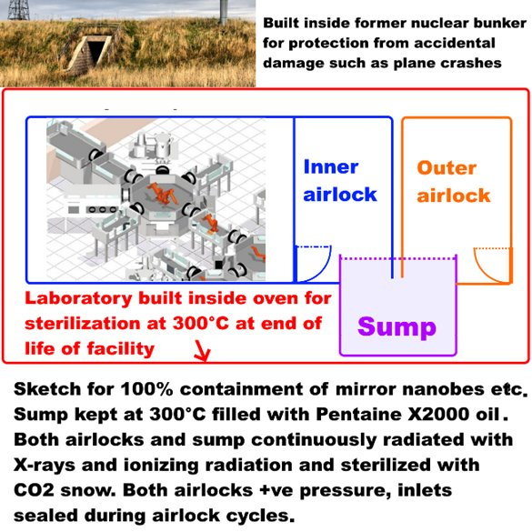
Shows the LAS fully robotic floor plan for a Mars sample receiving facility placed inside an oven for end of laboratory lifetime sterilization of the facility and accessed via two airlocks and a sump for 100% containment of even mirror life nanobes.
Sketch of telerobitic facility Credit NASA / LAS. Hsu, 2009. , Keeping Mars Contained
Photo of Cultybraggan nuclear bunker, Clark, B., 2009, Cultybraggan nuclear bunker
My suggestion, not yet peer reviewed, is to return first in a low energy ballistic transfer to a high orbit above GEO. I suggest in the Laplace plane where the Earth's ring particles would orbit if we had a ring system. This is a very safe orbit, as it turns out that any debris even after an explosion of the spacecraft couldn't reach Earth' surface.
We then enclose the sample in a titanium sphere surrounded by Whipple shields or other micrometeorite shielding - and then in a ballute. The ballute isn't needed for planetary protection but is to achieve a gentle reentry with minimal temperature changes and a soft landing.
This is all done telerobotically, no humans go up there but we see from many missions including deploying the James Webb telescope that we can do very complex missions telerobotically.
It then returns to a terrestrial desert as with the current plans - but then it is enclosed in fireproof material as for a flight recorder black box. The micrometeorite shielding might be able to double as fireproof protection or we add extra layers after the sample container is returned maybe foam protection.
Now we know it's safe even in a helicopter crash. So now we transfer it to a nuclear bunker.
The sample receiving facility would be built inside a giant oven for end of life sterilization - since we have to be ready for the possibility of mirror nanobes that can never be released ot Earth's biosphere even when the facility is decommissioned.
We can keep Earth protected by using a sump for anything moved in or out of the facility - consisting of vacuum and heat stable light oil kept at 300 C when materials are moved in or out, and also with cobalt 60 gamma ray sterilizers in the sump to prevent any possibility of life getting out of the sump when it is in cooler conditions.
We then study it telerobotically inside the facility - the advantage of returning it to Earth is so that we can put heavy machinery inside, even particle accelerators if we wish to.
There are many details would need to be thought through such as how to maintain it while keeping Earth safe. I go into some of this in my preprint.
This is just a suggestion and engineers could surely improve on it or find better ways to do it but I do believe it may be possible to achieve 100% safe sample return to Earth with care.

SIMPLEST WAY TO KEEP EARTH SAFE IS BY STERILIZING THE SAMPLE ON THE RETURN JOURNEY
The simplest way to keep Earth safe is to just sterilize the sample on the journey back from Mars. We could use nanoscale X-ray emitters to do that, from my calculations this could feasibly be powered by solar power.

PROPOSAL (NOT PEER REVIEWED): OR RETURN TO RECEIVING FACILITY IN THE LAPLACE PLANE - WHERE EARTH’S RING SYSTEM WOULD ORBIT IF WE HAD ONE
We could also return the sample to a receiving satellite in the Laplace plane well above GEO and do all the study there.

SADLY THE SAMPLE TUBES ARE NOT SUFFICIENTLY STERILIZED TO EVER PROVE THAT THERE IS NO LIFE IN THE SAMPLES - ENOUGH ORGANICS FOR TENS OF THOUSANDS OF ULTRA MICROBACTERIA PER TUBE AND TENS OF MILIONS OF SIMPLER RNA WORLD NANOBES
Sadly the Mars sample tubes are not sterilized sufficiently for us to ever prove there is no life from Mars in them and it will also be hard to detect Martian life in low concentrations in the samples. There's enough permitted organics for tens of thousands of ultra macrobacteria in each tube [check number] and tens of millions of those hypothetical RNA world Martian nanobes.
I made it that the permitted organic contamination is enough for 81,000 ultramicrobacteria or 160 million hypothetical RNA world mirror nanobes per tube. See the section in my preprint:
Also nearly all organics on Mars are likely to be non life, abiotic, from meteorite and comet infall, so it will be very hard to find the small signal of Martian life there.

PROBLEM OF MICROBIAL DARK MATTER - WE DON’T HAVE A CENSUS EVEN OF ALL THE RNA AND DNA THAT WE SENT TO MARS IN THE PERSEVERANCE SAMPLE TUBES - WHICH LIKELY CONTAIN GENES FROM SPECIES WE HAVEN’T YET SEQUENCED
We don’t have a census of the DNA or RNA in the sample tubes. That’s impossible because of the problem of microbial dark matter. Every time we do a survey of clean rooms the isolates contain numerous RNA sequences and DNA sequences that aren’t recognized as belonging to any known microbe.
This is the problem of Microbial Dark Matter. Yes we would recognize a known sequence, we’d recognize anthraz from Mars, but of course that’s not a likely Martian organism. If we find Chroococcidiopsis on Mars we’d be able to tell if it is a known strain from Earth. But there are many strains of Chroociccidiopsis with differing capabilities. Any microbe in this species from Mars is likely to be adapted in many ways - for instance it might have developed the capability to metabolize mirror organics from meteorites and comets, and it might have developed even greater ionizing radiation resistance than Chroociccidiopsis if it has evolved separately on Mars. It couldn’t have got to Earth in the last 20 milion years and most likley not for tens or hundreds of mllions of years, indeed if it got here at all it probably got here well before the great oxygenation event half a billion years ago since Mars didn’t have much by way of lakes or seas at that time and there woudl be the same prolbem of transfer of surface layers as today.
So - unless it comes from Earth as contamination in our spacecraft, choroococcidiopsis most likely has evolved for many tens or hundreds of millions of years on Mars and so is not likely to be identical to any known strain on Earth and its capabilities would be unknown.
But more than that we have the problem of microbial dark matter. These are microbes that can’t be cultivated in the laboratory for various reasons. I will summarize some of the details from this 2016 overview of the topic.
https://www.sciencedirect.com/science/article/pii/S1369527416300558#bib0360
They may depend on other microbes for their amino acids and even nucleotides, they may not have much by wawy of ribosomes to make proteins and some use strands, phyla to extract nutrients from other bacteria in biofilms.
Others have very long generation times of six months or more, which makes it hard to sequence in a laboratory. This is very relevant to Mars. Others only survive in nutrient poor situations. They do very well in natural conditions but when you put them in a laboratory on an agar solution they die quickly. Some produce hydrogen as a biproduct and they depend on other microbes to remove the hydrogen or they die.

MANY ENTIRE PHYLAE ARE ONLY KNOWN THROUGH A SMALL rRNA FRAGMENT OF THEIR PROTEIN FACTORY - SPECIFICALLY THE rRNA COMPONENT OF THE 16S RBIOSOME SUBUNIT
Many entire phylae of microbes are only known through fragments of RNA from their rigbosomes, specifically from an RNA strand in the smaller of two subunits that fit together to make their protein factory or ribosome. This is used as a marker to get an estimate of the diversity of the phyla of microbes that can’t be cultivated and most of which aren’t yet sequenced.
This shows how the large and small subunits fit together.
The RNA strands are shown in red.
The small unit is called the 16 S subunit in the papers.
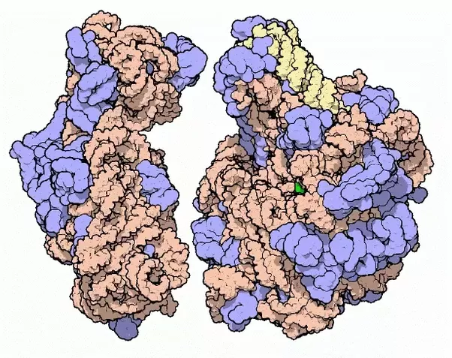
You can see animations of them spinning here PDB101: Learn: Videos: Ribosomal Subunits
Here is a particular view on it which shows the hole that the mRNA enters through as it is translated into proteins.
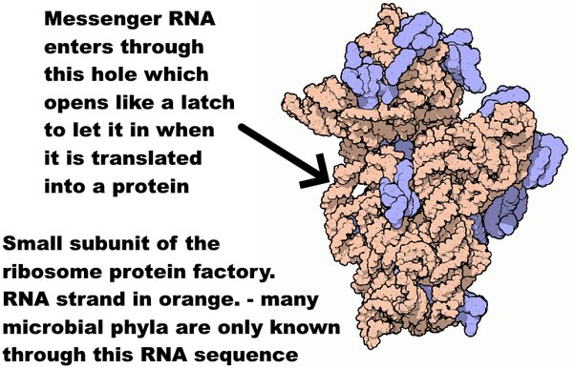
Messenger RNA enters through this hole which opens like a latch to let it in when it is translated into a protein.
Small subunit of the ribosome protein factory.
.RNA strand in orange. - many microbial phyla are only known through this RNA sequence
Graphics and details from here
. Goodsell, D., 2000 PDB101: Molecule of the Month: Ribosomal Subunits
As of 2016 there were at least 89 phyla of bacteria and 20 of archaea that are recognized only by RNA databases of the small ribosome subunit, though the true count of phylae for the bacteria could be far higher with estimates of up to 1,500 bacteria phylae.
. Solden et al., 2016. The bright side of microbial dark matter: lessons learned from the uncultivated majority
Now that we have single cell genomics there are partial and sometimes complete gene sequences for many of the phyla but these represent only a small fraction of the total species in each phyla. We know very little about them and they may use novel metabolic pathways that we haven’t yet studied.
This part of the ribosome is very stable
This remains the situation as of 2022. Most of the microbial biomass hasn’t yet been cutulrured and the genetic sequences can’t be used to characterize them.
The majority of microbial genomes have yet to be cultured, and most proteins identified in microbial genomes or environmental sequences cannot be functionally annotated. As a result, current computational approaches to describe microbial systems rely on incomplete reference databases that cannot adequately capture the functional diversity of the microbial tree of life, limiting our ability to model high-level features of biological sequences.
https://www.nature.com/articles/s41467-022-30070-8#ref-CR4

THE PERESEVERANCE CLEAN ROOM HAD MANY UNCULTIVABLE SPECIES, 36 OUT OF THE 41 SPECIES IDENTIFIED BY THEIR 16S RIBOSOME SUBUNITES WERE FOUND IN ONLY ONE LOCATION - AND 4 HAD RIBOSOMES THAT DIDN’T CLOSELY RESEMBLE ANY PREVIOUSLY KNOWN RIBOSOME
In a 2021 study of clean room samples from the clean room used to assemble Perseverance, , 16 genera could be cultivated and 51 genera could not be culitvated as identified by this ribosome subunit.
They found 49 identified species using 16S mRNA sequencing.
Of those there were 4 novel spcies that had less than 98.7% similarity to any previously sequenced 16S RNA ribosome subunit.
36 of the species were unique, found in only one of their samples.
QUOTE The 130 NSA isolates were represented by 16 bacterial genera, ofwhich 97% were identified as spore-formers via Sanger sequencing. … The 16S rRNA gene-targeted amplicon sequencing detected 51 additional genera not found in the NSA [ASA standard spore assay] method.
Sanger sequencing of the full-length 16S rRNA gene on the NSAisolates from the 98 samples resulted in 130 isolates, be-longing to 16 genera and 49 species
When analyzed spatially, 36 of the 49 identified specieswere not ubiquitous and isolated only once in a givenSAF location
… four isolates representing potentially novel species as they had ≤ 98.7% sequences similarity to the 16S rRNA sequence of any validly described species
Hendrickson et al, 2021, Clean room microbiome complexity impacts planetary protection bioburden.

IF THIS LEVEL OF DIVERSITY CAN BE GENERALIZED TO THE TUBES, EACH SAMPLE TUBE COULD CONTAIN UNIQUE 16S SUBUNITS NOT FOUND IN ANY OF THE OTHER SAMPLE TUBES AND OUT OF 38 SAMPLE TUBES THREE OR FOUR OF THEM MAY CONTAIN SUBUNITS THAT DON’T CLOSELY RESEMBLE ANY RIBOSOMES SO FAR KNOWN ON EARTH, ALTHOUGH ORIGINATING FROM EARTH
This doesn’t mean that these were the only novel species, just the ones they found in that particular survey. Also it doesn’t mean they sequenced them either. All they have is the sequence of the 16S RNA ribosome subunit.
Hendrickson et al, 2021, Clean room microbiome complexity impacts planetary protection bioburden.
So we can be pretty certain that the sample tubes have DNA or RNA from microbes that can’t be cultivated and they may very well have 16S ribosome subunits that don’t closely resemble any ribosomes previously sequenced.
Also the streilization wasn’t sufficient to rule out viable microbes. The requirement was a 0.1% chance of a viable microbe per tube. They believe they achieved a 0.00048% chance of a viable microbe per tube. This would make the chance that at least one tube continas a viable terresterial microbe around 0.02% which would mean that if just one tube yields a viable microbe, it won’t be possible to conclude that it is Martian without futher analysis. 0.02% corresponds to 3.09 sigma which would not be enough to prove life from Mars for a discovery of such importance.

COULD JUST TREAT THIS AS A TECHNOLOGY DEMO - AND STERILIZE THE SAMPLES - AS A PRECURSOR FOR FOLLOW UP IN SITU STUDIES
The chance of finding life seems so small it might be easier to treat this as a technology demo and just sterilize the samples. There is almost no chance of detectable past life either as it would quickly be sterilized beyond recognition by ionizing radiation unless rapidly buried and unearthed just as rapidly.
Astrobiologist have written many papers saying we need in situ exploration and detection of life on Mars and have designed many instruments we can send to Mras to do that.
WAYS TO INCREASE CHANCE OF RETURNING LIFE - LOOKING FOR YOUNG CRATERS RECENTLY EXCAVATED MATERIAL FROM ANCIENT MARES
However there are ways to increase the chance of returning life. First, we can look for young craters that have recently excavated past life on Mars. I suggest we can use the Marscopters to help iwth that. I calculated that there shoudl be craters within easy reach of Perseverance that have happened in the last few tens of thousands of years excavated to a depth of meters. Tehre is even a small chance that we spot such an impact with before and after images during hte mission itself.

FOR PRESENT DAY LIFE - A DUST SAMPLE COMBINED WITH AN AIR SAMPLE - CAPABILITY DROPPED FROM PERSEVERANCE
For present day life - I recommend we add a dust sample - and an atmospheric sample, capabilities dropped from Curiosity.
This is not my own suggestion, but it's a proposal in a paper that doesn't seem to have had much attention that I'd like to highlight.
We already have an atmospheric compressor on Mars for Moxie, compressing air for the test on splitting CO2 to generate oxygen on Mars.
The idea is to first compress Martian air into a sterile container which will let us return a far larger sample than we will have in the sample tubes and let us detect trace concentrations of organics in the Martian atmosphere. This needs a dust filter to keep out the dust, but we then keep it running after collecting the air sample, even through Martian dust storms, just exhausting the ir back to the atmosphere. This could give us a big sample of dust from Mars.
If there is life on Mars it's likely evolved propagules that can spread through the dust storms, and even low concentrations in distant areas of Mars could send detectable propagules to Jezero crater. We detect propagules such as hyphal fragments from the Gobi desert in Japan.

ALSO DUPLICATE VIKING - RETURN A SCOOP OF DIRT - AND IDEALLY ALSO THE BINE LAYERS DISCOVERED INDIRECTLY BY CURIOSITY
Then as a top priority I think we need to duplicate Viking and just scoop up some dirt. we need to try to bring back some of the briny salt layers detected by Curiosity. Whatever Viking found, either biology or complex chemistry - we need to resolve that mystery.
These are capabilities we could add to the spacecraft sent to receive the Mars samples. And - unlike the sample return from Perseverance - these could be designed to be 100% sterile. They are bonus samples. So - we can wrap them up in a covering, which was the main issue with sterilizing the sample tubes 100%. Engineers worried that if it was sterilized and enclosed that they might not be able to open the container on Mars. But with the aim to detect present day life it is top priority to have 100% sterile containers to collect them. We can't do anything about the sample tubes for Perseverance but we can ensure a 100% sterile container for the atmospheric / dust / gas bonus sample and a 100% sterile scoop of soil sample too.
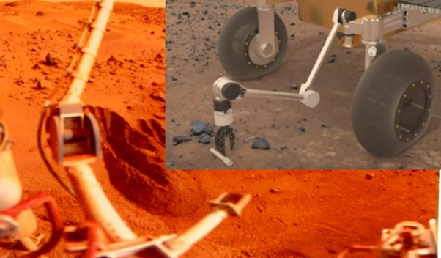
This would greatly increase the astrobiological interest. If we are lucky we strike gold right away - if Viking did indeed discover life. But if it discovered complex chemistry then in this way, we end up with a far better understanding of surface conditions that can help guide future missions.

COCKELL’S SUGGESTION OF UNINHABITED HABITATS - THESE ALSO NEED TO BE PROTECTED AT LEAST INITIALLY AS OUR ONLY OPPORTUNITY WITHIN LIGHT YEARS TO DISCOVER WHAT HAPPENS TO A TERRESTRIAL PLANET AFTER BILLIONS OF YEARS WITHOUT LIFE
Cockell has suggested that Mars may have uninhabited habitats. That could also be the situation on Europa's ocean or Enceladus's ocean. These would be habitable for terrestrial life but there is no life in them because Mars never evolved life.
In that situation - then we still need to protect Mars from terrestrial life. this is our only opportunity within light years to study a planet that started off like Earth but either never developed life or it went extinct.
What we find there may be chemistry yes, but complex chemistry that developed over billions of years. For instance we might find Ostwald crystals, a theory for how RNA might have formed originally. We might find protocells, cell like structures that don't actually have life. We might find cells that can reproduce, but imperfectly, not yet with the accuracy needed to call it life.
Anything like this might be very fragile and easily destroyed by introducing Earth life. I'm not suggesting we keep Mars pristine indefinitely, but that we need to know what is there first and study it. We could easily lose a wonderful opportunity that our descendants could only duplicate once they have the capability to send similar missions to planets orbiting nearby stars.

IF THERE WAS NO POSSIBLIITY OF LIFE ON MARS, WE COULD TREAT IT LIKE THE MOON AND MOST ASTEROIDS BUT THAT DOESN’T SEEM TO BE THE CURRENT SITUATION
If Mars was totally lifeless and no life was possible there like the Moon or most asteroids then we could treat it like the Moon. But at present it doesn't seem to be like that based on the data so far.
NASA in press briefings often seem to be confident that there is no life on the surface of Mars but as you have suggested and many astrobiologists have also said, we don't know this. There is a distinct and significant possibility for life there that is living on the edge, perhaps as I suggested a Swansong Gaia - or maybe recently evolved or it recently got to the surface from below. Or it might be complex chemistry - whatever it is, our top priority is to find out what is there.
Based on that we can then make informed decisions about what we do next.

ONE POSSIBLE FUTURE SCENARIO IS A MARS THAT HUMANS CAN NEVER VISIT WITH NANOBE MIRROR LIFE - PARADOXICALLY THIS MIGHT BE MOST STIMULATING OF ALL FOR SPACE SETTLEMENT AND MAYBE EVENTUAL COLONIZATION IN OUR SOLAR SYSTEM - MANY DESTINATIONS TO LIVE OTHER THAN MARS AND A MARS WITH MIRROR LIFE COULD STILL BE EXPLOITED TELEROBOTICALLY FROM ORBIT
And one scenario for the future is a Mars that humans can never visit, with nanobe mirror life, for instance. In my view this is the most exciting of all. It would stimulate space exploration more than any other with a huge importance for settlements in orbit around Mars to study it. It could also be exploited. We could mine Mars, maybe for mirror organics, maybe for products of life, and export them to orbit sterilized as necessary all done via telerobotics to keep humans and Earth safe.
I think this possibility, would be stimulating for human colonization both int he short and the long term and not as disappointing as it might seem. There are many other places for humans to explore and perhaps colonize, including the moons of Mars.
I suggest that Callisto in the Jupiter system has great potential once we can go further afield, with ice, organics, rock, outside Jupiter's ionizing radiation and protected from solar storms. Saturn's moon Titan is also of great interest. The cold is far easier to protect against than vacuum. Terrestrial life couldn't survive on Titan except perhaps in the water "lava" of cryovolcanoes so it might have minimal planetary protection issues.
Once we have the capability we could perhaps have settlers there too, the only atmosphere in our solar system of similar pressure to Earth, it has more benefits than one expects when you look closely. Then with stand alone space settlement spinning slowly for artificial gravity the whole solar system is habitable with large thin film mirrors out to Pluto and beyond.

BY BEING MORE RIGOROUS ABOUT PLANETARY PROTECTION WE STIMULATE A FUTURE WITH MORE OPPORTUNITIES FOR SPACE COLONIZATION - AND A FUTURE WITH MORE ASSETS ON MARS THAT WE CAN USE IF SPACE COLONIZATION OF MARS IS FEASIBLE
By being even more rigorous about planetary protection we might actually stimulate a future with more opportunities and interest for space colonization than if we try to bypass it and not take those precautions. And if we do end up having human colonization of Mars we would have many assets on the surface already and we would have a much greater understanding of the planet and what ew can and can't do there.

