Why NASA’s Environmental Impact Statement is likely to be challenged in the courts with a significant risk of mission cancellation or injunctions to protect Earth’s environments, as it fails to consider impacts and limits set in the sample return studies by the NRC and ESF, and has made no changes in response to previous comments referring to these studies – and how this can be fixed

Section titles are written like mini-abstracts. For a fast overview, read the headings, and drill down into sections of interest for more details
This contains some sections from the main paper plus several extra sections not yet added as of writing this, about the NASA EIS submission and how it doesn’t adequately address the potential effects of their actions.

Current title for the main paper: NASA and ESA are likely to be legally required to sterilize Mars samples to protect the environment through to 2039, or until proven safe – technology doesn't yet exist to comply with ESF study's requirement to contain viable starved ultramicrobacteria, and legal process followed by build and training of technicians takes at least 17 years - proposal to study samples remotely in a safe high orbit above GEO with miniature life detection instruments – and immediately return sterilized subsamples to Earth

Author: Robert Walker (contact email robert@robertinventor.com)

Preprint DOI 10.31219/osf.io/rk2gd
For latest version of the main paper preprint please visit: (url https://osf.io/rk2gd)
I make several references to the main paper but can’t link to them directly here. Also the paper is work in progress so the page numbers change. So for now I just label them as: See section of my paper (section title)
Colour coding. I use pale blue text for titles of sections in my paper – these are ones I can’t link to as they are in a separate document, also for any quotes from my previous submission for the NASA EIS comments process.
I use orange text for quotes from the NASA draft EIS and associated documents
All other quotes are black. This colour distinction should work for all forms of colourblindness except monochromats who will see both types of text as a pale gray according to this simulator – but they aren’t easily confused with each other.
Table of Contents
This is written by an enthusiast who wants the mission to succeed – with suggestions to transform it into one with minimal risks of litigation 6
Introduction – significant risk the mission is stopped or an injunction issued to NASA to sterilize all samples as a result of an inadequate Environmental Impact Statement 7
First safe alternative to the proposal and simplest solution: sterilize all the samples on the journey from Mars to Earth or captured and sterilized in Earth orbit using ionizing radiation – this is not likely to impact on geological studies, and after sterilization it would still be possible to recognize biosignatures of present day life 10
Current mission has low chance of returning present day life even if there is life in Jezero crater – but NASA’s proposal can be transformed into a mission of far greater interest to astrobiology by enhancing the ESA fetch rover with simple capabilities to take samples of dirt, dust and a compressed sample of gas from the atmosphere to detect even small traces of biologically relevant gases – Perseverance already has an atmospheric gases compressor but it is used for Moxie rather than sample return 11
Second safe alternative to this mission: sterilize samples that contact Earth’s biosphere – and to study unsterilized samples in orbit so that there is no loss of information for astrobiology and viable cells from Mars can be cultivated safely in orbit even in the case of something as risky to Earth’s biosphere as mirror life 13
NASA have made no significant changes in their safety assessments in response to objections in previous requests for comments that highlighted these issues 15
NASA fail to adequately consider the potential for life on the Martian surface – they claim that the Martian surface is too inhospitable for life – but why would they need to take precautions if there is no risk? – it’s not surprising the general public aren’t convinced by these claims and from the comments clearly they are not convinced 17
NASA’s source Rummel et al is about habitability of Mars for terrestrial life not about its habitability for possibly more capable martian life – and it also doesn’t say that the Martian surface is inhospitable for terrestrial life in its entirety 18
Rummel et al’s thesis that it is possible to decide from orbit which regions of Mars are habitable to terrestrial life was overthrown by the 2015 review commissioned due to concerns about the 2014 report which said that a map can only represent our incomplete state of knowledge at a particular time 20
Views of astrobiologists in the planetary protection literature – some think there is a high chance Mars is inhospitable but none go as far as certainty – and others say it may have small niches for microbial life over much of the surface 21
NASA’s summary by comparison – “existing credible evidence suggests that conditions on Mars have not been amenable to supporting life as we know it for millions of years” – is this because they associate life with large amounts of water rather than the minute transient biofilms, droplets and even high humidity without water, all microhabitats that microbes can make use of? Renno’s “Swimming pools foo a bacteria” 25
NASA make statements that contradict important conclusions from previous studies by the National Research Council and others - and as a result fail to properly consider the weight of the impacts under review 30
NASA fail to adequately consider the risks from life that can’t get to Earth on meteorites - in 2009, the National Research Council examined the possibility of life transferred on meteorites said the risk is significantly greater in a sample return mission - and said they can’t rule out the possibility of large scale effects in the past due to life from Mars – NASA’s EIS instead claims microbes will survive transfer from Mars to Earth more easily in a meteorite than in a sample return mission but their sources don’t back this up 32
NRC 2009 report says potential hazards from microbes returned in a sample return mission are significantly greater than hazards from microbes in meteorites and that though there have certainly been no recent large scale effects that could be due to microbes from Mars, the possibility of large scale effects in the distant past can’t be disproved 34
NASA give no quantitative answer to questions from the general public about how low the risk is for large scale effects from a sample return from Mars handled according to the methods they have outlined – is it 1 in thousand or 1 in a million or 1 in a billion? They just say that it is impossible to give a 100% guarantee 35
The draft EIS shows clearly the results of not setting up any advanced planning and oversight agency with experts in legal, ethical and social issues tasked with interfacing NASA decisions and the general public’s questions as the top priority – as recommended in numerous papers on Mars sample return missions 36
The Great Oxygenation Event which transformed Earth’s atmosphere and oceans chemically gives a practical example of a way life from another Mars-like planet could in principle cause large scale changes to an Earth-like planet 37
If Mars has mirror life, returning it could potentially cause a similar large scale transformation of terrestrial ecosystems by gradually converting organics to mirror organics – an example worst case scenario 38
Scenario based approach – in other scenarios life from another planet is harmless or indeed beneficial 40
A single mission can’t resolve this question as it may not return life at all – and life that is safe for Earth may co-exist with other life that can never be returned safely which we could encounter in future missions on a planet with total surface area similar to the land area of Earth – it will take more future missions to resolve this question 41
If we want to conclude from the meteorite evidence that microbial species from Mars are safe for Earth we need ALL Martian species to get to Earth on meteorites – example of barn swallows that can cross the Atlantic and are native to North America, while European starlings can’t and are non native – natural processes can’t transfer the surface dust, dirt, ice and salts of Mars to Earth 42
Chroococcidiopsis as an example of a species that wouldn’t survive transfer by impacts from modern Mars based on an analysis by Charles Cockell 44
A mirror life chroococcidiopsis analogue as a worst case example of a pioneer species that would have adaptations that let it survive almost anywhere on Earth if returned from Mars and that could never be returned safely as it would risk transforming terrestrial organics to mirror organics that most life can’t use 45
NASA fail to consider at all the potential for microhabitats in Jezero crater not detectable from orbit 46
NASA fail to consider at all the potential for dust storms to transfer life to Jezero crater 51
NASA plan to use a biosafety level 4 facility to handle the samples – but how can they know that a BSL-4 facility designed to contain infectious diseases of humans will work to protect Earth’s biosphere from extraterrestrial ultramicrobacteria or the potentially even smaller nanobes such as ribocells that may have preceded terrestrial life? The answer is they don’t – they seem unaware of the recommended size limits set in the 2012 ESF sample return study which make a BSL-4 facility inadequate 53
NASA’s EIS mentions a 0.05 micron size limit – but only for the engineering for the earth entry capsule, not for sample handling facilities – and they don’t mention the ESF study in this section or their list of cites 54
Evidence used by the 2012 ESF study – practical experiments in which starvation limited ultramicrobacteria have been observed to pass through 0.1 nanopore filters and are viable after passing through the filter – later continues to be confirmed with scanning electron microscope images to show the scale of the cells - the cells are about 0.2 microns long but very thin, and presumably less than 0.1 microns in diameter when they pass through the nanopore 55
NASA’s EIS only refers to normal BSL-4 facilities including possibly building a mobile facility since there are only four such in the USA and NASA don’t have them – they show no awareness of the possibility that such a facility might not be considered adequate during assessment of their EIS or that it might be challenged by litigation 56
ESF study: “the release of a particle larger than 0.05 μm in diameter is not acceptable in any circumstances” 59
A BSL-4 facility doesn’t comply with this limit – and the technology to filter out 100% of aerosol particles at 0.05 microns doesn’t yet exist except for nanoparticles in water under high pressure 60
HEPA and ULPA filters are not tested for such small particles as 0.05 microns and not required to contain them 61
Example of best available nanofilter technology from 2020, not yet commercially available, filters out 88% of ambient aerosol particles at 0.05 microns - far short of the ESF requirement to filter out 100% at this size – though this standard can be met with nanoparticles in water under high pressure 61
Challenges for maintenance for future 0.05 micron compliant nanoscale filters – need to be designed for sterilization before any potential extraterrestrial biology is known, and may be easily damaged and hard to replace without risking release of nanoparticles 63
The ESF study says that the size limit needs to be reviewed regularly – at a decade later in 2022 it is definitely necessary to review a limit set in 2012 which dramatically reduced the 0.25 micron limit set in 2009 to 0.05 microns 64
NASA’s Environmental Impact Statement is vulnerable to litigation on the basis that it doesn’t consider impacts of a sample return properly, doesn’t take account of the main issues mentioned by the Sample Return Studies and say things that contradict their conclusions – potential remedies include stopping the mission altogether or an injunction, e.g. to sterilize all samples before they contact Earth’s biosphere 65
The legal process is likely to extend well beyond 6 years with involvement of CDC, DOA , NOAA, OSHA etc., legislation of EU and members of ESA, international treaties, and international organizations like the World Health Organization – NASA don’t seem to be prepared for this or even mention potential international ramifications 66
Uhran et al recommend an advanced planning and oversight agency set up two years before the start of the legal process – similarly Rummel et al recommend it should include experts in legal, ethical and social issues – and the ESF recommends an international framework should be set up, open to representatives from all countries - NASA don’t seem to have done any of this yet 70
The legal process and public debate for NASA’s mission as precedent for China’s mission to return a sample too – perhaps as soon as 2030 – with sterilization a likely solution for a country that wants to be first to return a sample 71
NASA can’t accelerate the legal process to achieve an unsterilized sample return before 2039 – but it could “win” this race with a sterilized return or unsterilized return to a safe orbit with sterilized subsamples returned to Earth – inspiring China and other nations to do the same 73
NASA can greatly increase the astrobiological interest by using 100% sterile sample containers for bonus samples of atmosphere, dust and dirt on the ESA fetch rover 75
Perseverance’s sample tubes weren’t sterilized 100% leading to risk of false positives that may prevent distribution of unsterilized samples from containment – estimated 8.1 nanograms maximum organic contamination per sample tube are equivalent to 81,000 ultramicrobacteria or 160 million hypothetical RNA world mirror nanobes 76
Permitted levels of contamination could make it impossible to prove absence of Martian life in Perseverance’s sample tubes – leading to an unnecessary requirement to sterilize Perseverance’s samples indefinitely 77
Proposals to modify the ESF lander and sample selections to increase potential for returning viable present day or identifiable past life with samples of the dirt, dust from the air during dust storms, and compressed large samples of Martian air collected in 100% sterile containers by the fetch lander – and to use Marscopters to search for freshly excavated young craters for Perseverance to sample 78
References 82

This is written by an enthusiast who wants the mission to succeed – with suggestions to transform it into one with minimal risks of litigation

First, I am writing this as an enthusiast who wants the mission to go ahead. As I’ll show in this contribution, the impact statement is sadly inadequate. It mentions but doesn’t cite the extensive literature on the topic and the statements they make contradict the findings of numerous panels of experts in the Mars sample return studies.

However, I suggest with some changes the proposed action can go ahead in a way that is safe for the environment and maximizes return for astrobiology and geology.

If this EIS is kept “as is” there is a high risk of the mission being stopped altogether or for the courts to say all samples have to be sterilized to protect Earth.

Introduction – significant risk the mission is stopped or an injunction issued to NASA to sterilize all samples as a result of an inadequate Environmental Impact Statement
There is a significant risk that the mission is stopped altogether, or that the decision is made that NASA have to sterilize all samples from Mars to keep humans, other species and Earth’s environments safe.

Amongst other things NASA

- Have not made any changes in response to any of the main objections presented in the first round of comments on their draft proposal.
- Don’t give much consideration to the potential for large scale effects from a sample return highlighted in the National Research Council report from 2009
- Claim that there is a consensus that the Martian surface is too hostile for life to survive there today – none of the major Mars Sample Return studies have come to this conclusion
- Claim that these reports use the evidence of Martian meteorites transferred from Mars to show that a sample return would be harmless – the opposite, they say that transfer by meteorite is different from transfer via a sample return mission and that they can’t rule out the possibility that Martian life in the distant past could have had large scale effects on Earth
- Rely on BSL-4 procedures to contain the samples, despite limits in the most recent study by the European Space foundation in 2012 that far exceed what is possible in a BSL-4 laboratory

Their draft EIS seems to answer these points – but it doesn’t summarize its sources correctly. Any competent academic fact checking it would soon find out what I found with my fact checking of the paper. It only seems to work on a superficial inspection, not if you follow through and check the sources.

So by doing the analysis I am doing here, I am just doing what someone else will do later on as this goes through the legal process. The sooner someone does this the better or the project may be stopped at a later stage when the effects are much greater on NASA Mars science projects.

Example, the draft EIS says (NASA, 2022eis: 3-3):

First, potential Mars microbes would be expected to survive ejection forces and pressure (National Academies of Sciences, Engineering, and Medicine and the European Science Foundation 2019),

When I check through to the cite which is about ejection of materials from Mars to the moons of Mars, not to Earth, it says (Board, 2019 : 26).

The SterLim team did not include any sterilization during Mars ejecta formation in its analysis because such investigations were not requested in its study’s statement of work.

Charles Cockell is one of those who did look at this question. He concludes that though some shock resistant life can be ejected from Mars and survive, that most photosynethetic life can’t, including Chroococcidiopsis, one of the top candidates for a terrestrial microbe that might be able to survive on present day Mars.

See below:
- Chroococcidiopsis as an example of a species that wouldn’t survive transfer by impacts from modern Mars based on an analysis by Charles Cockell
- Mirror life chroococcidiopsis as an example of a pioneer species that would have adaptations that let it survive almost anywhere on Earth if returned from Mars

Their cite for a consensus amongst astrobiologists that the surface is hostile to life , (Rummel et al , 2014) is in fact a study of Mars special regions - where terrestrial life might be able to replicate on Mars, not native life.

This cite can’t be used as a source for the potential for habitats for extant martian life as it doesn’t even discuss the literature on the topic. The issue here is that martian life based on a different biochemistry or even just life that uses other salts internally instead of sodium chloride could be able to tolerate conditions that are not habitable to terrestrial life. This is all the source says (Rummel et al , 2014:888)

Special Regions are regions ‘‘within which terrestrial organisms are likely to replicate’’ as well as ‘‘any region which is interpreted to have a high potential for the existence of extant martian life.’’
…
At present there are no Special Regions defined by the existence of extant martian life, and this study concentrates only on the first aspect of the definition.

It doesn't say that Mars is totally hostile for terrestrial life. I

Also they don't mention that this was immediately followed by the 2015 report which the NASA EIS does NOT cite which found numerous mistakes in the 2014 report. It is a very serious emission to cite the 2014 report and not mention the corrections in the 2015 report.

Similarly they cite the 2009 NRC report on a Mars sample return but don't cite the 2012 ESF report even though there were two very significant new discoveries between the two that greatly reduced the size limits. The minimum size for filters to contain Marian biology was reduced from 0.25 microns to 0.05 microns / 0.01 microns in just three years from 2009 to 2012. NASA are presumably still using the old 0.25 microns figure.

This change was due to the discovery that starvation limited ultramicrobacteria can pass through 0.1 micron nanotubes, a discovery that has been confirmed in many papers since the report, and the discovery that gene transfer agents can transfer novel capabilities to unrelated species of archaea readily in seawater overnight.

For details see the sections below starting with: (internal link):

- NASA have made no significant changes in their safety assessments in response to objections made in previous requests for comments

[Or go back to contents list]

As a result they the proposal seems likely to be very vulnerable to litigation. See:

- NASA’s Environmental Impact Statement is vulnerable to litigation on the basis that it doesn’t consider impacts of a sample return properly, doesn’t take account of the main issues mentioned by the Sample Return Studies and say things that contradict their conclusions – potential remedies include stopping the mission altogether or an injunction, e.g. to sterilize all samples before they contact Earth’s biosphere

That would be a great shame. We can transform it into a mission of far greater interest for astrobiology and at the same time a mission with zero risk to the environment of Earth.

That should be the alternative to the mission. Not “no action” but a safe mission of great astrobiological interest.

Sterilization is the simplest solution. It retains geological interest and some astrobiological interest.

First safe alternative to the proposal and simplest solution: sterilize all the samples on the journey from Mars to Earth or captured and sterilized in Earth orbit using ionizing radiation – this is not likely to impact on geological studies, and after sterilization it would still be possible to recognize biosignatures of present day life

Sterilization is the simplest solution. If present day life is unlikely in the samples and if the past life samples are seriously degraded already by exposure to surface cosmic radiation, we find the extra radiation to sterilize the samples is not likely to impact on geological studies, while any extant life, while not viable, would still be recognizable as such by astrobiologists. As far as extant life is concerned, the mission would then be a technology demonstration, preparing for a future mission that is more likely to return any viable Martian microbes.

From the Mars Sample Return Planning Group 2 MSPG2 (Meyer et al, 2022) most of the Mars Sample Return science could and should be done on samples that are deemed safe.

Summary-3. Most aspects of MSR sample science could, and should, be effectively performed on samples deemed safe (either by test or by sterilization) in uncontained laboratories outside of the SRF. However, other aspects of MSR sample science would be both time-sensitive and sterilization-sensitive, including the search for life, assessment of habitability, and volatile exchange processes, and would need to be carried out in the SRF.

I cover this in my paper under
- Sterilized sample return as aspirational technology demonstration for a future astrobiology mission

This is a possible solution if the samples are believed to be unlikely to be of great astrobiological interest. Sterilizing the samples will have little effect on the geological interest as I cover in my paper under:

- Experimental data on effects of sterilizing doses of gamma radiation – preserves the geological interest of rock samples - need to test effects of X-rays

However I suggest that another alternative is a mission with some changes, mainly design changes to the ESF sample retrieval rover, that would make it of much greater astrobiological interest. Design of this rover is still at an early stage and could be modified.

Current mission has low chance of returning present day life even if there is life in Jezero crater – but NASA’s proposal can be transformed into a mission of far greater interest to astrobiology by enhancing the ESA fetch rover with simple capabilities to take samples of dirt, dust and a compressed sample of gas from the atmosphere to detect even small traces of biologically relevant gases – Perseverance already has an atmospheric gases compressor but it is used for Moxie rather than sample return

NASA’s mission is designed for geology not astrobiology. All the astrobiology papers I have found on the topic say that an astrobiology mission needs to do in situ life detection to make an intelligent choice of the samples to return. Even if there is abundant life on Mars, in condition similar to the harshest terrestrial deserts, most samples may well be lifeless. It is hard to return life when you can’t see it. Astrobiologists have designed numerous miniature life detection instruments that could be sent to Mars.

See the section in my paper:

- Perseverance can’t search for life in situ, which is why we won’t even know if the samples contain life until they get back to Earth.

The geological nature of this mission is most clear in the permitted levels of contamination in the sample tubes which will make it near impossible for astrobiologists to tell if it has traces for past or present day life unless very obvious. The permitted levels of biosignatures are so high that we wouldn't notice if the sample contained tens of thousands of terrestrial ultramicrobacteria or tens of millions of hypothetical minimal RNA world ribocells.

See below: (an internal link to another section of this page)

- Perseverance’s sample tubes weren’t sterilized 100% leading to risk of false positives that may prevent distribution of unsterilized samples from containment – estimated 8.1 nanograms maximum organic contamination per sample tube are equivalent to 81,000 ultramicrobacteria or 160 million hypothetical RNA world mirror nanobes
We also see this in the decisions to not take a compressed atmosphere sample or dust sample, and not to take a sample of the dirt – all materials of high interest to astrobiologists and of less interest to geology. NASA did send an atmospheric compressor to Mars on Perseverance but it is used for Moxie, an independent experiment to test options for creating fuel from the atmosphere, not to compress a sample of atmosphere to return to Earth.
It will be impossible to detect small trace amounts of biologically relevant gases in the atmosphere with their small uncompressed atmospheric sample, and with the high levels of permitted contamination of the tubes.
Also the only dust they plan to collect is any that accidentally gets stuck to the sample tubes. This is not enough dust to have a reasonable chance to return spores or viable propagules even if there are large numbers of them transported every year in the dust storms.
We need a dedicated dust collector, to either collect propagules or to produce a first realistic bound on the amount of material transported in the dust storms in this way and a first bound on the potential for distant habitats on Mars to transport spores to landing sites.
Finally the dirt on Mars is of great interest to astrobiologists, because of the discovery by Curiosity of brines that form in the evening and early morning and the intriguing Viking results not yet fully explained. The Viking results may be complex chemistry rather than astrobiology, but we need to know what is going on there in order to help shape future searches for life on the planet.
I suggest modifications to the ESA fetch rover to rectify these omissions. If not, some other nation, perhaps the Chinese, could return a mission of far more interest to astrobiology at far less expense, just a sample of the dust, atmosphere and a scoop of dirt, and can do it far faster than the USA can.
All of these would need to use sterile containers. For astrobiologists the small risk of a container not opening on Mars is worth it for the very high pay off of avoiding terrestrial contamination of the samples altogether by using enclosed sterilized containers to collect the samples.
These are changes that can be made within the spirit of the mission, not “mission creep”.
See below:
- Proposals to modify the ESF lander and sample selections to increase potential for returning viable present day or identifiable past life with samples of the dirt, dust from the air during dust storms, and compressed large samples of Martian air collected in 100% sterile containers by the fetch lander – and to use Marscopters to search for freshly excavated young craters for Perseverance to sample

With these changes the mission becomes of sufficient biological interest to return the samples unsterilized for study in a high orbit first.

Second safe alternative to this mission: sterilize samples that contact Earth’s biosphere – and to study unsterilized samples in orbit so that there is no loss of information for astrobiology and viable cells from Mars can be cultivated safely in orbit even in the case of something as risky to Earth’s biosphere as mirror life

If the mission is of astrobiological interest, the samples can be returned for preliminary study in a location not connected to Earth's biosphere. This solution is a way to avoid the need to sterilize native life in the sample,
We can then sterilize sub samples which can be returned for immediate study in terrestrial laboratories, while the unsterilized materials are studied in a safe location off-planet until we know what is in them. Future decisions then are made based on what we find in the samples.

This is one of the main topics of my paper.

This is the graphical abstract for my paper which gives an overview of the idea (next page);

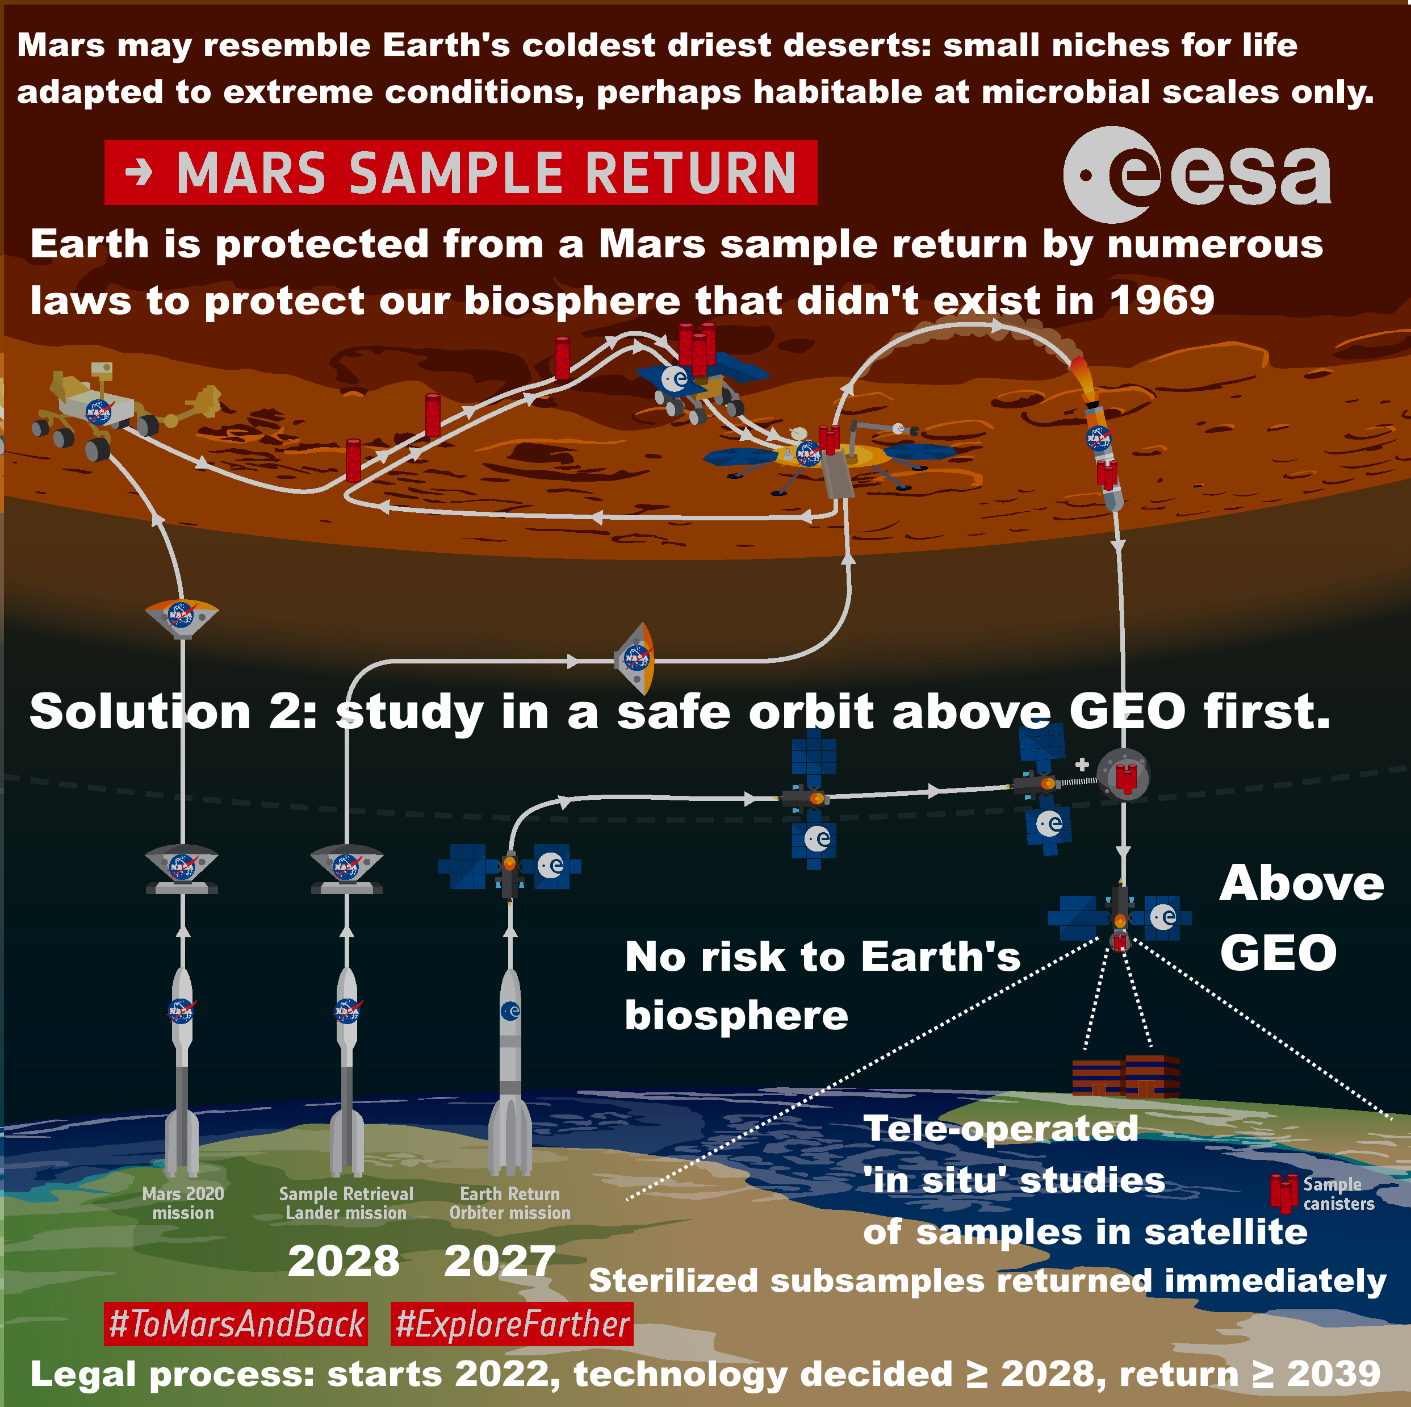
NASA haven't allowed enough time to complete the legal process and build the facility to return unsterilized samples to Earth before 2039.

So we can
1. sterilize all samples or
2. check for life first - to do this, return samples to a safe orbit above GEO to study remotely with miniature instruments like those designed by astrobiologists to search for life on Mars.

With 2. we can return sterilized sub-samples from the orbital facility immediately.

In 2, a return to the ISS doesn't break the chain of containment with Mars and COSPAR decided the Moon must be kept free of contamination for future astronauts and tourists. Above GEO solves both these issues.

1. and 2. both have simple legal processes.

Legal process starts in 2022 with the Environmental Impact Statement. Legal process ≥ 6 years. Final decision on technology ≥ 2028

By NASA regulations, build can't start until technology is decided. Build estimate: 9+ years + 2 years to train technicians.

Earliest date ready: 2028 + 11 = 2039.

Technology doesn't exist yet for ESF requirement of 100% containment of 0.05 micron particles.

Figure 1: Text added to ESA graphic (Oldenburg, 2019) showing current proposed timeline (NASA, 2022mpfs) and time until the facility is ready to receive sample
Text on graphic:
Mars may resemble Earth's coldest driest deserts: small niches for life adapted to extreme conditions, perhaps habitable at microbial scales only. Earth is protected from a Mars sample return by numerous laws to protect Earth's biosphere that didn't exist in 1969. Solution 2: study in a safe orbit above GEO first. Above GEO. No risk to Earth's biosphere. Tele-operated "in situ" studies of sample in satellite.terilized subsamples can be returned immediately. Legal process starts 2022. Technology decided ≥ 2028, return ≥ 2039

I cover this proposal in detail in my paper under this section and following

- Recommendation to return a sample for teleoperated ‘in situ’ study above Geosynchronous Equatorial Orbit (GEO)

My paper also recommends a particular orbit – the orbits in the Laplace Plane where the balance of the pressure of sunlight and of gravity is such as to keep debris from satellites in the same orbit as for a ring plane. I cover this in my paper under

- An orbit within the Laplace plane above GEO contains debris in event of an off nominal explosion or other events

NASA have made no significant changes in their safety assessments in response to objections in previous requests for comments that highlighted these issues

So far NASA don’t seem to have made any modifications of their plans as a result of the comments on the previous round of NEPA comments including my own previous comment and many others.

This latest submission doesn’t include any changes to their assessments of the risks.

Compare the “Safety of MSR” in the Nov 4 project fact sheets
With: MSR Safety Fact Sheet 4-18-22 in the April 18th project fact sheets.

The changes are only cosmetic, minute changes in grammar and phrasing. This is the part I’ll focus on here, which in a short paragraph has many serious omissions that I mentioned in the uploaded paper attached to my previous comment as part of the NEPA process (Walker, 2022). Other commentators there also pointed out some of these omissions.

The one on the left is the one from April 18, the one on the right is from Nov 4.

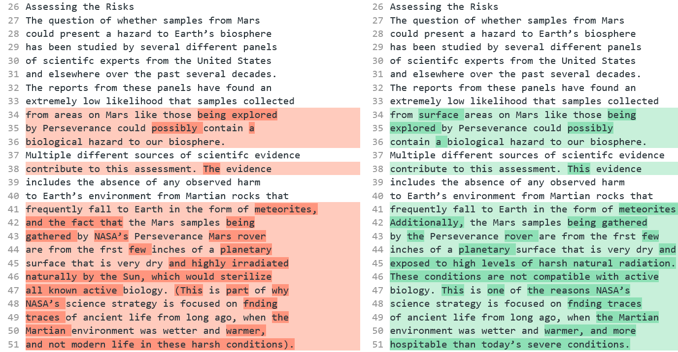
I used the diff tool here to highlight the differences in the text obtained with copy / paste from the pdfs.

In the draft for the Environmental Impact Statement, NASA claim to have addressed all the concerns we raised in the previous round of comments. But they have not, as we’ll see.

If NASA continue ignore objections they will be stopped just as for projects that push through a new pipeline on tribal lands in the USA or any other project where Federal agencies don’t do a proper risk assessment and ignore objections.

The usual way projects are stopped is because (Congressional Research Service, 2021)
- the agency failed to consider some of the impacts
- the agency failed to properly consider the weight of the impacts under review
NASA seem to be failing on both of those.

NASA fail to adequately consider the potential for life on the Martian surface – they claim that the Martian surface is too inhospitable for life – but why would they need to take precautions if there is no risk? – it’s not surprising the general public aren’t convinced by these claims and from the comments clearly they are not convinced

From their NEPA announcement, (NASA, 2022nepa), NASA seem to be of the impression that the consensus amongst scientists is that the Martian surface is too inhospitable for life

“The general scientific consensus is that the Martian surface is too inhospitable for life to survive there today. It is a freezing landscape with no liquid water that is continually bombarded with harsh radiation.”

In the draft EIS itself, they say (NASA, 2022eis: S-4)

Consensus opinion within the astrobiology scientific community supports a conclusion that the Martian surface is too inhospitable for life to survive there today, particularly at the location and shallow depth (6.4 centimeters [2.5 inches]) being sampled by the Perseverance rover in Jezero Crater, which was chosen as the sampling area because it could have had the right conditions to support life in the ancient past, billions of years ago (Rummel et al. 2014, Grant et al. 2018).
…
Nevertheless, out of an abundance of caution and in accordance with NASA policy and regulations, NASA would implement measures to ensure that the Mars material is fully contained (with redundant layers of containment) so that it could not be released into Earth’s biosphere and impact humans or Earth’s environment.

It’s no wonder the general public find this unconvincing. If NASA need to take precautions “out of an abundance of caution” this means there IS a possibility of returning life. That is how most people think.

The two statements contradict each other as ordinarily understood.

From the first 18 comments on the November 4th request, two were off topic and the 16 on topic responses were:

- Test first: 5
- Stop mission: 5
Then one each of
- Study in space or not at all
- Don't return until we know it is 100% safe
- Are you certain the mission is safe?
- Return to above GEO and return sterilized subsamples immediately [my comment]
- Need clarity about security measures

The general public naturally don’t find their statement convincing, and nor should they be. In reality NASA are NOT sure, or they wouldn’t need to take all these elaborate precautions.

So what is the true situation here? Clearly it can’t be literally a zero chance of life on Mars or they wouldn’t need to do anything.

First, the main source there, (Rummel et al , 2014) is study of the Mars special regions which is a concept in forward contamination, a special region is one where rovers need high levels of sterilization due to the risk of contaminating habitats there with terrestrial life.

This is NOT a sample return study. They do cite the NRC study from 2009 in this draft EIS but not for this passage. They don’t cite the more recent ESF sample return study from 2012 at all – the ESF study set much more stringent requirements due to advances in science between 2009 and 2022 (Ammann et al, 2012). It is a very serious omission not to cite it. Both sample return studies are very clear that we do need to take precautions

Their source (Rummel et al , 2014) is not a consensus position. Even as that 2014 report by Rummel et al was in publication, NASA and ESA commissioned a review which overturned many of its findings.

Again it is a very serious omission to cite (Rummel et al , 2014) and not to mention (Board, 2015).

NASA’s source Rummel et al is about habitability of Mars for terrestrial life not about its habitability for possibly more capable martian life – and it also doesn’t say that the Martian surface is inhospitable for terrestrial life in its entirety
NASA don’t give a cite for the “consensus opinion” in this statement. Or at least if Rummel et al is meant as a source then it is falsely summarized.

Consensus opinion within the astrobiology scientific community supports a conclusion that the Martian surface is too inhospitable for life to survive there today, particularly at the location and shallow depth (6.4 centimeters [2.5 inches]) being sampled by the Perseverance rover in Jezero Crater …

Their source (Rummel et al , 2014) doesn’t say this. The study is about “special regions” for forwards contamination and NOT about the locations and capabilities of putative martian life:

“Special Regions on Mars as places where terrestrial organisms might replicate”

Their source (Rummel et al , 2014) goes through many factors that could be a limit for life but find none of them make it totally uninhabitable. In their conclusion Rummel at al say that there are locations with high enough water activity for life, and with a high enough temperature for life, but that it is unknown if terrestrial contamination from missions sent from Earth can use these conditions in this discontinuous fashion: (Rummel et al , 2014:945)

Special Regions on Mars continue to be best determined by locations where both of the parameters (without margins added) of temperature (above 255 K) and water activity (aw ; > 0.60) are attained. There are places/times on Mars where both of these parameters are attained within a single sol, but it is unknown whether terrestrial organisms can use resources in this discontinuous fashion.

Rummel et al’s study is not about backward contamination. Regions with a “high potential for the existence of extant martian life” are classified as “Special regions” but they dismiss this part of the definition of a special region on the basis that we don’t know of any extant martian life.

On that basis they don’t discuss it any further. So this can’t be used as a source for the potential for habitats for extant martian life as it doesn’t even discuss the literature on the topic (Rummel et al , 2014:888)

Special Regions are regions ‘‘within which terrestrial organisms are likely to replicate’’ as well as ‘‘any region which is interpreted to have a high potential for the existence of extant martian life.’’
…
At present there are no Special Regions defined by the existence of extant martian life, and this study concentrates only on the first aspect of the definition.

Other sources have suggested that if there is extant martian life it may be adapted, for instance to be able to use the salty brines there at far lower temperatures, either through use of chaotropic agents or even a different biochemistry that is able to function down to lower temperatures, for instance perhaps with hydrogen peroxide as a component of their biology.

I cover some of the literature on this topic in my paper in the section:

- How Martian life could make perchlorate brines habitable when they only have enough water activity for life at -70 °C – biofilms retaining water at higher temperatures - chaotropic agents permitting normal life processes at lower temperatures – and novel biochemistry for ultra low temperatures

In short, NASA’s source is a study of how regions can be delineated where terrestrial organisms might replicate. It is not a study of regions where extant martian life might replicate. It is NOT a source for a statement that the Martian surface is too inhospitable for life.

Rummel et al’s thesis that it is possible to decide from orbit which regions of Mars are habitable to terrestrial life was overthrown by the 2015 review commissioned due to concerns about the 2014 report which said that a map can only represent our incomplete state of knowledge at a particular time

It is also a controversial source, as the whole concept that it is possible to delineate a special region where no terrestrial life could replicate was called in question by the 2015 report (Board, 2015)

In particular, the 2015 review overturned the suggestion from the 2014 review that areas not of Planetary Protection concern can be delineated using maps, saying a map of RSLs with buffer zones can only represent our incomplete state of knowledge at a particular time (Board, 2015 : Ch 5, p 28)

While it is helpful to provide a general overview of regions that may be favorable for the formation of RSL, it is of limited use in the identification of Uncertain or Special Regions. The same applies to other maps that also may be updated soon.
…
Another potential source of misinterpretation related to the use of maps in Special Region studies is the issue of scale. … (see also the discussion in Chapter 2, “Detectability of Potential Small Scale Microbial Habitats”)
… Maps, which come necessarily at a fixed scale, can only provide information at that scale and are, therefore, generalizations.
…
Maps that illustrate the distribution of specific relevant landforms or other surface features can only represent the current (and incomplete) state of knowledge for a specific time—knowledge that will certainly be subject to change or be updated as new information is obtained.
The reason is that the surface can have microhabitats that can’t be detected from orbit. Also that life can be transported by dust from other parts of Mars, for instance to Jezero crater.
See below:
- NASA fail to consider at all the potential for microhabitats in Jezero crater not detectable from orbit
- NASA fail to consider at all the potential for dust storms to transfer life to Jezero crater

So the correct position here is that we don’t know. Jezero crater could have microhabitats for terrestrial life that haven’t yet been detected, and it could have spores or propagules from other regions of Mars.

Rather than a consensus that the entirety of Mars is hostile to life, I have been unable to find one astrobiologist in the literature who says as definitive things about impossibility of present day life on Mars as NASA do in this EIS.

Views of astrobiologists in the planetary protection literature – some think there is a high chance Mars is inhospitable but none go as far as certainty – and others say it may have small niches for microbial life over much of the surface

Many astrobiologists have expressed a view that present day Mars may well be habitable to terrestrial life in part. This need not mean that there is life there, it could have uninhabited habitats i.e. which life could colonize but with nothing left by way of early Martian life to colonize them (Cockell, 2014). Some astrobiologists do say that Mars has a high chance to be inhospitable but not certainty and many think Mars may have small niches suitable for life, similar to niches found in the soil or rocks of our driest coldest deserts which often have small communities of microbes, even if they are only habitable at microbial scales.

Many astrobiologists also think it could have extant Martian life. A few think there is a possibility that Viking discovered life in the 1970s.

There is no consensus for any of these positions. But so far I haven’t found NASA’s supposed “consensus” as a published point of view of any astrobiologist in any of the papers I’ve looked at. I am interested if anyone knows of such a source from a reputable peer reviewed journal so I can add it to the range of points of view of astrobiologists.

This quote is from a paper about planetary protection in the forwards direction by Rummel and Conley, both former planetary protection officers for NASA (Rummel et al , 2014)

"Claims that reducing planetary protection requirements wouldn't be harmful, because Earth life can't grow on Mars, may be reassuring as opinion, but the facts are that we keep discovering life growing in extreme conditions on Earth that resemble conditions on Mars. We also keep discovering conditions on Mars that are more similar—though perhaps only at microbial scales—to inhabited environments on Earth, which is where the concept of Special Regions initially came from."

Here are a few example statements:

Davila et al. (Davila et al, 2010).

"We argue that the strategy for Mars exploration should center on the search for extant life. By extant life, we mean life that is active today or was active during the recent geological past and is now dormant. As we discuss below, the immediate strategy for Mars exploration cannot focus only on past life based on the result of the Viking missions, particularly given that recent analyses call for a re-evaluation of some of these results. It also cannot be based on the astsumption that the surface of Mars is uniformly prohibitive for extant life, since research contributed in the past 30 years in extreme environments on Earth has shown that life is possible under extremes of cold and dryness."

Westall (Westall , 2013:192)

"This presupposes that the ephemeral surface habitats could be colonized by viable life forms, that is, that a subsurface reservoir exists in which microbes could continue to metabolize and that, as noted above, the viable microbes could be transported into the short-lived habitat

.... Although there are a large number of constraints on the continued survival of life in the subsurface of Mars, the astonishing biomass in the subsurface of Earth suggests that this scenario as a real possibility."

Morozova (Morozova et al, 2006)

"The observation of high survival rates of methanogens under simulated Martian conditions supports the possibility that microorganisms similar to the isolates from Siberian permafrost could also exist in the Martian permafrost"

Crisler et al (Crisler et al, 2012)

Our results indicate that terrestrial microbes might survive under the high-salt, low-temperature, anaerobic conditions on Mars and present significant potential for forward contamination. Stringent planetary protection requirements are needed for future life-detection missions to Mars

Renno (Renno, 2014):

"This is a small amount of liquid water. But for a bacteria, that would be a huge swimming pool - a little droplet of water is a huge amount of water for a bacteria. So, a small amount of water is enough for you to be able to create conditions for Mars to be habitable today'. And we believe this is possible in the shallow subsurface, and even the surface of the Mars polar region for a few hours per day during the spring."

Stamenković (Wall, 2018)

There is still so much about the Martian habitability that we do not understand, and it's long overdue to send another mission that tackles the question of subsurface water and potential extant life on Mars, and looks for these signals

De Vera et al (de Vera et al, 2014)

"This work strongly supports the interconnected notions
(i) that terrestrial life most likely can adapt physiologically to live on Mars (hence justifying stringent measures to prevent human activities from contaminating / infecting Mars with terrestrial organisms);
(ii) that in searching for extant life on Mars we should focus on "protected putative habitats"; and
(iii) that early-originating (Noachian period) indigenous Martian life might still survive in such micro-niches despite Mars' cooling and drying during the last 4 billion years"

Cockell (Deighton, 2016)

Most microbes can grow in different types of extremes and the extremes that we are looking at, things like radiation, perchlorate salts and also sulphate salts (found on Mars), they will grow in that. It’s just a question of trying to determine what the limits are and that’s the work we're doing at the moment. Anywhere where we’ve gone to the deep subsurface (on earth) today, where there is liquid water, there is a high chance that environments are habitable,

Simply because Mars is a planet of volcanic rock, and when volcanic rock weathers that provides an environment for microbes to grow and reproduce, I think we can already say there is a high chance there are habitable environments.

‘At the moment we just don’t know what the origin of life requires, going from simple chemicals to self-replicating microbe,’ Edinburgh’s Prof. Cockell said. ‘If we looked at many planets, many environments and didn’t find life, then that would tell us that life is extremely rare and that early spark was an unusual event.
‘And then we’d have to try and find out exactly why it was, and what happened in those early stages of life that was unusual on the earth.’.

Cabrol (Cabrol, 2021)

Arguably, dispersal does not imply seeding, but it provides the potential for it and, if life started on Mars, odds are that not only is it still there, but it is everywhere it can be where conditions allow dormancy or metabolic activity. Here, terrestrial analogues in extreme environments show that ‘everywhere it can be’ does not, however, mean easy to see. Hidden oases are often measured in centimetres to micrometres, their presence intimately linked to the subtle interplay and feedback mechanisms between living things and their environment.

Bianciardi et al (Bianciardi et al, 2012)

"These analyses support the interpretation that the Viking LR experiment did detect extant microbial life on Mars"

Miller et al (Miller et al, 2002).

"Did Viking Lander biology experiments detect life on Mars? ... Recent observations of circadian rhythmicity in microorganisms and entrainment of terrestrial circadian rhythms by low amplitude temperature cycles argue that a Martian circadian rhythm in the LR experiment may constitute a biosignature."

Levin et al (Levin et al, 2016)

"It is concluded that extant life is a strong possibility, that abiotic interpretations of the LR data are not conclusive, and that, even setting our conclusion aside, biology should still be considered as an explanation for the LR experiment. Because of possible contamination of Mars by terrestrial microbes after Viking, we note that the LR data are the only data we will ever have on biologically pristine martian samples"

In the 2020 conference Mars extant life: what's next? (Carrier et al, 2020) a significant fraction of the participants thought that there is a possibility Mars has extant life.

Primary conclusions are as follows: A significant subset of conference attendees concluded that there is a realistic possibility that Mars hosts indigenous microbial life. A powerful theme that permeated the conference is that the key to the search for martian extant life lies in identifying and exploring refugia (“oases”), where conditions are either permanently or episodically significantly more hospitable than average. Based on our existing knowledge of Mars, conference participants highlighted four potential martian refugium (not listed in priority order): Caves, Deep Subsurface, Ices, and Salts.

NASA’s summary by comparison – “existing credible evidence suggests that conditions on Mars have not been amenable to supporting life as we know it for millions of years” – is this because they associate life with large amounts of water rather than the minute transient biofilms, droplets and even high humidity without water, all microhabitats that microbes can make use of? Renno’s “Swimming pools foo a bacteria”

It is hard to see how NASA can read those statements by astrobiologists and come to such radically different conclusions about what astrobiologists believe. But this is what they say in the draft EIS (NASA, 2022eis: 1-6):

Existing credible evidence suggests that conditions on Mars have not been amenable to supporting life as we know it for millions of years (iMARS Working Group 2008, National Research Council 2011, Beaty et al. 2019, National Research Council 2022). The surface of Mars, particularly for the area/region/middle latitudes being sampled by the Perseverance rover, is too cold (an average surface temperature of -55 degrees Celsius [°C] [-67 degrees Fahrenheit (°F)]) for water to exist in a liquid form in other than optimal circumstances and then often only transiently on or near the surface in isolated pockets.

Let’s look at their most recent cite, the National Research Council Decadal Strategy for Planetary Science and Astrobiology, published in 2022. Since they don’t give page numbers for any of their cites and this is a cite to a book of hundreds of pages it’s impossible to know which page exactly they are referring to there. But this is what they say on page 393 about Mars (Smith et al, 2022: 393):

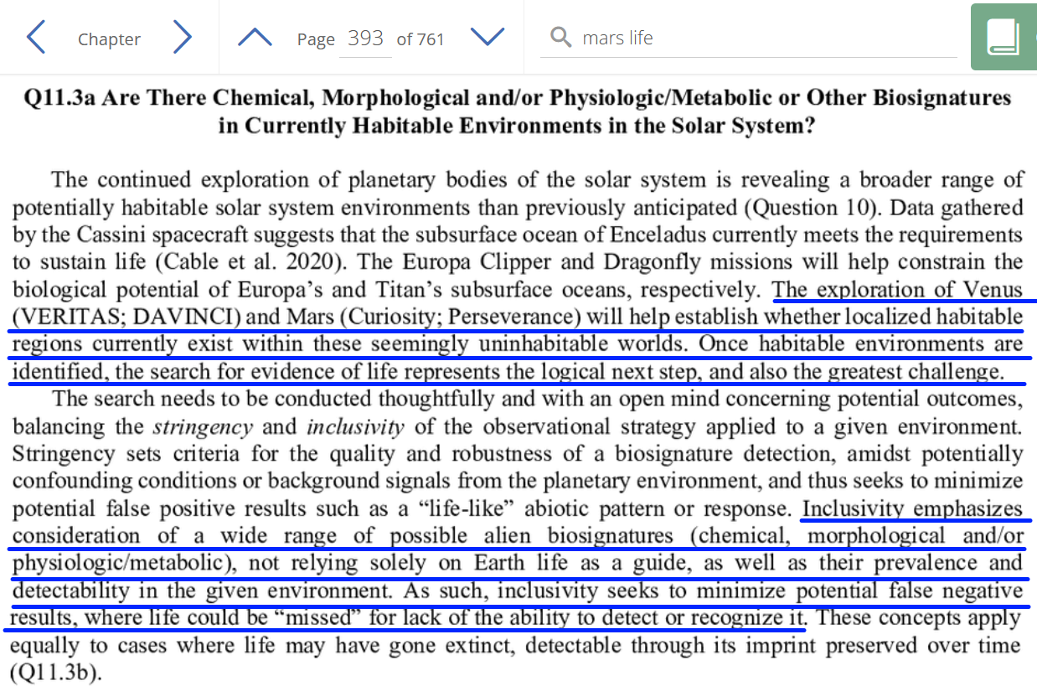

The exploration of … Mars (Curiosity, Perseverance) will help establish whether localised habitable regions currently exist within these seemingly uninhabitable worlds. Once habitable environments are identified, the search for evidence of life represents the logical next step, and also the greatest challenge.
…
Inclusivity emphasizes consideration of a wide range of possible alien biosignatures (chemical, morphological and / or physiologic/ metabolic), not relying solely on Earth life as a guide, as well as their prevalence and detectability in the given environment. As such, inclusivity seeks to minimize potential false negative results where life could be “missed” for lack of the ability to detect or recognize it.

They also warn about biological oases. Since Perseverance isn’t looking for present day life it isn’t trying to map out where these biological oases might be if there is extant life in Jezero crater: (Smith et al, 2022: 396):

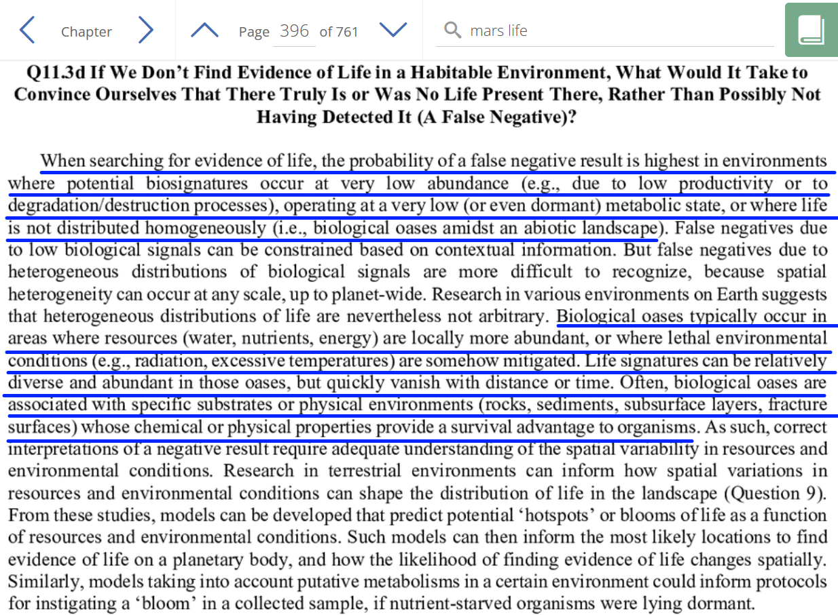

As we’ll see there is some potential for biological oases in Jezero crater especially for extant martian life that might have the capability to use colder brines than terrestrial life.

This is indeed a credible source, of the highest order. But it is missummarized in the NASA draft EIS

NASA’s draft EIS summarizes all this research as (NASA, 2022eis: 1-6):

Existing credible evidence suggests that conditions on Mars have not been amenable to supporting life as we know it for millions of years (iMARS Working Group 2008, National Research Council 2011, Beaty et al. 2019, National Research Council 2022).

How is that possible, to read this and understand it as talking about a planet that hasn’t been amenable to supporting life as we know it for millions of years?

I find it hard to comprehend but it may be to do with the engineer’s mindset?

Perhaps Nilton Renno’s video can help us to understand? This is him reporting on the discovery using the Michigan Mars Environmental Chamber which he helped to develop. Their aim was to understand what appeared to be droplets of liquid that formed on the legs of the Phoenix lander. Nilton Renno was the leader of the team that discovered those droplets (Nilton, n.d.bio).

They came to the conclusion that the higher latitudes with surface ice may be a promising location for microhabitats for present day life. This includes salt lying on ice (Fischer et al., 2014) which can form liquid brines within hours, and could lead to microhabitats throughout the higher latitudes of Mars. This could be an explanation of the droplets seen on the legs of the Phoenix lander which grew, merged, and eventually vanished, believed to have fallen off the leg (Gronstall, 2014)

Figure 33 Possible droplets on the legs of the Phoenix lander - they appeared to merge and sometimes fall off. In this sequence of frames, the rightmost of the two droplets - highlighted in green on this black and white image - grows and seems to do so by taking up the water from its companion to the left, which shrinks (Gronstall, 2014)

In December 2013, Nilton Renno and his team used the Michigan Mars Environmental Chamber (Fischer et al., 2013) to simulate the conditions at the Phoenix landing site. They were able to trigger formation of droplets similar to the ones on the Phoenix lander’s legs. In their experiment, salty brines formed within a few tens of minutes when salt overlaid ice (Fischer et al., 2014). The team concluded that suitable conditions for brine droplets may be widespread in the polar regions

The very minute amounts of water they are talking about there would be useless to higher life like ourselves, or even plants, animals, insects, most macroscopic life. But for a microbe it’s a swimming pool. It is a very different perspective. Renno (Renno, 2014)
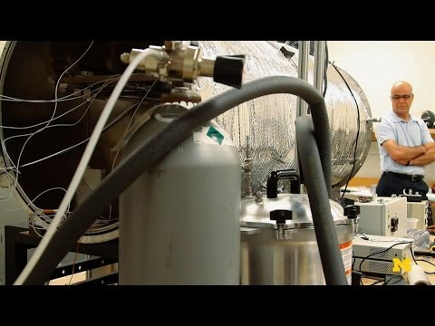

"This is a small amount of liquid water. But for a bacteria, that would be a huge swimming pool - a little droplet of water is a huge amount of water for a bacteria. So, a small amount of water is enough for you to be able to create conditions for Mars to be habitable today'. And we believe this is possible in the shallow subsurface, and even the surface of the Mars polar region for a few hours per day during the spring."

Nilton Renno also runs the REMS weather station on Curiosity and is author of a major review study on the potential for liquid water on the surface of Mars (Renno, 2014). Renno was also the main astrobiologist co-investigator for the Phoenix mission and investigated the water droplets at the time (NASA, n.d.pmm) (Nilton, n.d.bio)

I’m saying all this because NASA said (NASA, 2022eis: 1-6):

Existing credible evidence suggests that conditions on Mars have not been amenable to supporting life as we know it for millions of years

You could hardly have a more credible source on the habitability of present day Mars than Nilton Renno, an astrobiologist who was co-investigator for Phoenix, who runs the Curiosity REMS weather station on Mars, who has written the most comprehensive review there is on the potential for water on Mars and whose team developed and runs the Michigan Mars Simulation Chamber.

I don’t think it is necessary to go into any details to try to find out why the NASA EIS somehow gives this false impression of no credible source. It’s simpler to just present one very credible source to show clearly that their conclusion is mistaken.

NASA make statements that contradict important conclusions from previous studies by the National Research Council and others - and as a result fail to properly consider the weight of the impacts under review

NASA don’t cite the European Space Foundation study from 2012, or the US’s National Research Council study. What’s more, their submitted documents don’t have any cites.

Not only that, the submitted documents make statements that go against the conclusions of the peer reviewed literature on the topic which suggests they haven’t read it or they ignore it.

Example, let’s look at this passage from the MSR safety fact sheet for the h Draft Environmental Impact Statement (NASA, 2022msfs):

The question of whether samples from Mars could present a hazard to Earth’s biosphere has been studied by several different panels of scientific experts from the United States and elsewhere over the past several decades.

[this much is true]

The reports from these panels have found an extremely low likelihood that samples collected from areas on Mars like those being explored by Perseverance could possibly contain a biological hazard to our biosphere.

The most recent of the thorough Mars sample return studies, from the European Space Foundation in 2012:

“The risks of environmental disruption resulting from the inadvertent contamination of Earth with putative martian microbes are still considered to be low. But since the risk cannot be demonstrated to be zero, due care and caution must be exercised in handling any martian materials returned to Earth”

NASA’s MSR Safety fact sheet for the draft EIS again (NASA, 2022msfs):

The evidence includes the absence of any observed harm to Earth’s environment from Martian rocks that frequently fall to Earth in the form of meteorites,

National Research Council report in 2009 said (Board et al, 2009: 48).:
Section: Potential for large scale effects [of a Mars Sample Return]
“The potential hazards posed for Earth by viable organisms surviving in samples is significantly greater with a Mars sample return than if the same organisms were brought to Earth via impact-mediated ejection from Mars

…Certainly in the modern era, there is no evidence for large-scale or other negative effects that are attributable to the frequent deliveries to Earth of essentially unaltered Martian rocks. However the possibility that such effects occurred in the distant past cannot be discounted.”

NASA’s MSR Safety fact sheet for the draft EIS again (NASA, 2022msfs):

and the fact that the Mars samples being gathered by NASA’s Perseverance Mars rover are from the frst few inches of a planetary surface that is very dry and highly irradiated naturally by the Sun, which would sterilize all known active biology.

The Review from 2015: (Board, 2015)

There are many examples of small-scale and microscale environments on Earth … that can host microbial communities, including biofilms, which may only be a few cell layers thick. The biofilm mode of growth, as noted previously, can provide affordable conditions for microbial propagation despite adverse and extreme conditions in the surroundings.
So, let’s go into this in more detail

NASA fail to adequately consider the risks from life that can’t get to Earth on meteorites - in 2009, the National Research Council examined the possibility of life transferred on meteorites said the risk is significantly greater in a sample return mission - and said they can’t rule out the possibility of large scale effects in the past due to life from Mars – NASA’s EIS instead claims microbes will survive transfer from Mars to Earth more easily in a meteorite than in a sample return mission but their sources don’t back this up

Let’s look at the first of these two statements NASA use to support their conclusion that the activity is very low risk, from the MSR safety fact sheet from this page:

The evidence includes the absence of any observed harm to Earth’s environment from Martian rocks that frequently fall to Earth in the form of meteorites,

Then in the draft EIS:

One of the reasons that the scientific community thinks the risk of pathogenic effects from the release of small amounts (less than 1 kilogram [2.2 pounds]) of Mars samples is very low is that pieces of Mars have already traveled to Earth as meteorites.

…

The natural delivery of Mars materials can provide better protection and faster transit than the current MSR mission concept.

They cite the NRC report from 2009 but not on this point. The National Research Council DID look into this question in their "Assessment of Planetary Protection Requirements for a Mars Sample Return". However their conclusion was the opposite of NASA’s draft EIS summary.

They were unable to rule out the possibility that life from Mars could have caused past mass extinctions on Earth

The NRC found that most of the meteorites that get to Mars are sterilized during transit. But about 1% get here within 16,000 years and 0.01 percent within 100 years (note none of the meteoirites we have from Mars left the planet less than hundreds of thousands of years ago)

This is from Earth (Board et al, 2009: 48).

"Transit to Earth may present the greatest hazard to the survival of any microbial hitchhikers. Cosmic-ray-exposure ages of the meteorites in current collections indicate transit times of 350,000 to 16 million years. However theoretical modeling suggests that about 1 percent of the materials ejected from Mars are captured by Earth within 16,000 years and that 0.01 percent reach Earth within 100 years.

NRC continue that survival of organisms in meteorites is plausible. If they can be shown to survive ejection, entry and impact they can be expected to transfer from Mars to Earth (Board et al, 2009: 48)..

“Thus, survival of organisms in meteorites, where they are largely protected from radiation, appears plausible. If microorganisms could be shown to survive conditions of ejection and subsequent entry and impact, there would be little reason to doubt that natural interplanetary transfer of organisms is possible and has, in all likelihood, already occurred.

However that is the big unknown. Can life from present day Mars get onto the meteorites, be ejected from Mars, and then survive the fireball of re-entry to Earth.

The NASA EIS says this (NASA, 2022eis: 3-3):

First, potential Mars microbes would be expected to survive ejection forces and pressure (National Academies of Sciences, Engineering, and Medicine and the European Science Foundation 2019), and, within the interior portions of the rocks, would be protected from elevated radiation levels, and large temperature variations that meteorite surfaces experience during the transit from Mars to Earth (Mileikowsky 2000).

The big hurdles for transfer of life from Mars are the shock of ejection, the fireball of exit from Mars the cold, vacuum and ionizing radiation of the passage to Earth, and the fireball of re-entry.

Their cite on ejection pressures is about transport of materials from Mars to the Martian moons for an assessment of sample return missions from those moons. It does NOT look at sterilization during Mars ejecta formation. This is what they say (Board, 2019 : 26). :

The SterLim team did not include any sterilization during Mars ejecta formation in its analysis because such investigations were not requested in its study’s statement of work.

It also looks at only one impact, the ejection from Zunil crater as any ejection from more than a million year ago would not leave surviving microbes close to the surface of the Martian moons due to the ionizing radiation.

It does mention shock heating. It didn’t look at the acceleration during ejection from Mars. But the sudden acceleration actually kills most microbes. I cover that below

Second, a significant fraction of natural transits occur on trajectories that require as little as 6 months where the material returned by the MSR mission concept would be in flight for Mars Sample Return Campaign Programmatic EIS over 18 months (Gladman 1997). Thus, if potentially harmful microbes were abundant on the Martian surface it is likely they already would have been transferred to Earth by this natural process (Fajardo-Cavazos et al. 2005, Horneck et al. 2008, Howard et al.2013).

Actually the meteorites we have on Earth all came from at least 3 meters below the surface of Mars. The proposed habitats for present day Mars are on the surface in dust and brine layers. How is life in those layers going to get into a rock at least 3 meters below the surface?

Then there’s the shock of ejection and the fireball of re-entry to Earth.

I go into that in my paper in the section:

- Could Martian life have got to Earth on meteorites? Our Martian meteorites come from at least 3 m below the surface in high altitude regions of Mars

NRC 2009 report says potential hazards from microbes returned in a sample return mission are significantly greater than hazards from microbes in meteorites and that though there have certainly been no recent large scale effects that could be due to microbes from Mars, the possibility of large scale effects in the distant past can’t be disproved

Going back to the NRC report, they continue that any microbes in martian materials transported to Earth in a sample return mission face very different conditions from those in meteorites (Board et al, 2009: 48)..

It should be noted that martian materials transported to Earth via a sample return mission will spend a relatively short time (less than a year) in space - all the while protected in containers. (Note that researchers have yet to discover compelling evidence of life in any meteorite, martian or otherwise.) Thus the potential hazards posed for Earth by viable organisms surviving in samples is significantly greater with a Mars sample return than if the same organisms were brought to Earth via impact-mediated ejection from Mars."

They go on to say that it is simply not possible to determine whether viable Martian life forms have already been delivered to Earth.

They also say that though there is no evidence of large scale or other negative effects (such as extinctions) in the modern era due to the frequent deliveries of Martian rocks, that it is not possible to discount such effects in the distant past. (Board et al, 2009: 48).

"Despite suggestions to the contrary, it is simply not possible, on the basis of current knowledge, to determine whether viable Martian life forms have already been delivered to Earth. Certainly in the modern era, there is no evidence for large-scale or other negative effects that are attributable to the frequent deliveries to Earth of essentially unaltered Martian rocks. However the possibility that such effects occurred in the distant past cannot be discounted.”

That’s in their section 5, Potential for Large Scale Effects, page 48:

NASA’s draft EIS summarizes this INCORRECTLY as (NASA, 2022eis: 3-3):

The reports from these panels have found an extremely low likelihood that samples collected from areas on Mars like those being explored by Perseverance could possibly contain a biological hazard to our biosphere.

…

The evidence includes the absence of any observed harm to Earth’s environment from Martian rocks that frequently fall to Earth in the form of meteorites

NASA give no quantitative answer to questions from the general public about how low the risk is for large scale effects from a sample return from Mars handled according to the methods they have outlined – is it 1 in thousand or 1 in a million or 1 in a billion? They just say it is impossible to give a 100% guarantee

This is one of the main questions from the public. Yet NASA don’t give anything like a satisfactory answer to it. This answer alone is likely to lead to litigation once the document reaches general public awareness if NASA can’t improve on it.

Example, the draft EIS gives this as one of the main questions from the public (NASA, 2022eis: 3-3):

When the consequences of a failure are so great, a 100% guarantee should be required.

The NASA factsheet “The Safety of Mars Sample Return” does address this issue. “Panels have found an extremely low likelihood that samples collected from areas on Mars like those being explored by Perseverance could possibly contain a biological hazard to our biosphere.”

Just how low is “low likelihood”? Is NASA’s goal specification to prevent accidental release of the Mars samples 1 in a thousand? 1 in a million? 1 in a billion?

This is their answer to that question:

No outcome in science and engineering processes can be predicted with 100% certainty. The safety case for MSR safety is based on redundant containment supported by rigorous testing and analysis, the extensive experience of NASA and ESA with very similar activities over the past three decades, as well as independent reviews of program plans by external expert

The draft EIS shows clearly the results of not setting up any advanced planning and oversight agency with experts in legal, ethical and social issues tasked with interfacing NASA decisions and the general public’s questions as the top priority – as recommended in numerous papers on Mars sample return missions

Margaret Race made a relevant point here. She says scientists are likely to focus on (Race, 1996)
- technical details
- mission requirements
- engineering details
- costs of the space operations and hardware
General public are likely to focus on
- risks and accidents
- whether NASA and other institutions can be trusted to do the mission
- worst case scenarios
- whether the methods of handing the sample, quarantine and containment of any Martian life are adequate
We see the results of this different focus in the report. It is just not something that greatly occupies the minds of the engineers and scientists who work on space projects, yet it is the main thing on the minds of members of the public.
This shows up clearly the issues with their failure to set up the mechanism to deal with public responses recommended by numerous sample return studies.

- Uhran et al recommend an advanced planning and oversight agency set up two years before the start of the legal process – similarly Rummel et al recommend it should include experts in legal, ethical and social issues – and the ESF recommends an international framework should be set up, open to representatives from all countries - NASA don’t seem to have done any of this yet Error! Bookmark not defined.
Again it’s understandable that engineers whose minds are focused on solving numerous complex technical difficulties with the mission might not understand why there is need to set up a planning and oversight agency two years before the start of the legal process. This wouldn’t help solve their engineering problems in any way whatsoever.
But for the general public, it is absolutely essential for the issues that matter most to them.

The Great Oxygenation Event which transformed Earth’s atmosphere and oceans chemically gives a practical example of a way life from another Mars-like planet could in principle cause large scale changes to an Earth-like planet

In the quote from the National Research Council, they give no examples when they say “the possibility that such effects occurred in the distant past cannot be discounted.” (Board et al, 2009: 48).
:

Certainly in the modern era, there is no evidence for large-scale or other negative effects that are attributable to the frequent deliveries to Earth of essentially unaltered Martian rocks. However the possibility that such effects occurred in the distant past cannot be discounted.”

There are many past extinctions in the geological record that are not well understood. However the Great Oxygenation Event could be relevant. Chroococcidiopsis may be partially responsible for the oxygenation of our atmosphere. One minority view explains the unusual ionizing radiation resistance of Chroococcidiopsis as a natural adaptation of Martian organisms (Pavlov et al, 2006).

This is weak evidence since the ionizing radiation resistance of chroococcidiopsis could be a byproduct of the repair mechanisms that chroococcidiopsis uses for UV resistance and desiccation resistance. Cyanobacteria originated in the Precambrian era. It could have developed these mechanisms back then, when, with no oxygen in the atmosphere, there was no ozone layer to shield out UV radiation (Casero et al, 2020) (Rahman et al, 2014)

However, the early Martian atmosphere was rich in oxygen (Lanza et al, 2016) before Earth and though much of that may well be due to ionizing radiation from solar storms splitting the water it’s not impossible that it had photosynthetic life.as well.

Some astrobiologists have hypothesized that terrestrial life originated on Mars. If so, photosynthesis could have developed on Mars first too then transferred to Earth. Whether this happened for Mars and Earth, it does give a practical example of a way that life from another planet such as Mars could in principle cause large scale changes to an Earth-like planet.

So was this an extinction event? The Great Oxygenation Event might have forced rapid evolution rather than extinction. Early anaerobes may have retreated to anaerobic habitats as obligate anaerobes, which we still have today (Lane, 2015).

However, there is some evidence suggesting extinctions. There is evidence of exceptionally large sulfur reducing bacteria from this time, 20 to 265 µm in size, which also occasionally occur in short chains of cells. This may be part of a diverse ecosystem that predated the GOE (Czaja et al, 2016). If such an ecosystem existed, most traces of it are gone now. However it seems not impossible that the GOE had major impacts on a prior diverse ecosystem.

There are many other confirmed mass extinctions in the fossil record. In many cases the cause is not fully known or debated leaving it not impossible that microbial transfer from Mars could be part of the explanation.

Whether or not this ever happened in the past, this worked example of the Great Oxygenation Event shows how in the worst case scenario, independently evolved life from another planet could lead to large scale transformations of the chemistry of Earth’s atmosphere or oceans, climate and ecosystems. Humans with modern technology would surely survive a gradual transformation of our atmosphere and oceans but it could make the planet significantly less habitable in the short term for humans and other species.

If Mars has mirror life, returning it could potentially cause a similar large scale transformation of terrestrial ecosystems by gradually converting organics to mirror organics – an example worst case scenario

An example of a possible large scale transformation could be return of mirror life, if such exists on Mars and has never got to Earth. If it exists on Mars it is likely able to make use of both normal and mirror organics since most of the organics on Mars likely comes from meteorites and comets and interplanetary dust which has organics of both types.

Only a few terrestrial microbes can digest mirror organics so this would be a competitive advantage for the invasive mirror microbe species from Mars. Over time, this single species could diversify and could gradually transform nearly all the organics on Earth to mirror organics and make Earth significantly less habitable for terrestrial life.

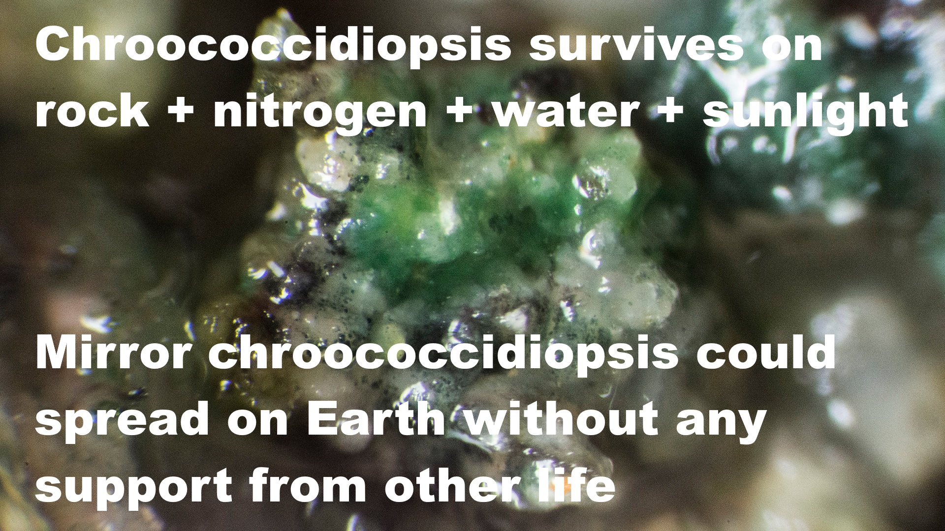

Chroococcidioopsis survives on rock + nitrogen + water + sunlight

Mirror chroococcidiopsis could spread on Earth without any support from other life.

Photograph shows chroococcidiopsis in a cave at Ares Station, Cantabria in the Iberian peninsula – with a transparent covering of other microbes – it can live on its own or in colonies with other life and it can also live inside rocks. Photo by Proyecto Agua on Flickr

Chroococcidiopsis is a “polyextremonphile” which over hundreds of millions of years hash accumulated numerous metabolic pathways and adaptations adaptations. A mirror life analogue from Mars might be similar. Like Chroococcidiopsis it may be able to survive almost anywhere on Earth from Antarctic cliffs to tropical oceans and reservoirs, and from hot sunny deserts such as the Atacama desert to darkness hundreds of meters below the sea floor. I cover this below in the section:

- Mirror life chroococcidiopsis as an example of a pioneer species that would have adaptations that let it survive almost anywhere on Earth if returned from Mars Error! Bookmark not defined.

This is an example worst case scenario that I consider in my paper. The mirror life could also be early life, even mirror life ribocells which may be able to pass through 0.02 micron filters. If it is independently evolved on Mars there is no particular reason to expect it to be normal rather than mirror life. Nanobes such as the ribocells are so small they escape protozoan grazing and they would also have a much higher surface to volume ratio which is an advantage in habitats with low nutrient availability – so they may have a competitive advantage with more advanced modern life. That was a motivation for searching for a shadow biosphere of nanobes on Earth. None was found but possibly life returned from Mars could establish such a shadow biosphere here.

Scenario based approach – in other scenarios life from another planet is harmless or indeed beneficial

I found many other scenarios, including some where life from another planet could be harmless, or indeed beneficial. The archaea are an example of an entire domain of life that is largely beneficial in it is interactions with other life on Earth. A domain is the highest level of classification, the other domains are the bacteria and Eukarya. All multicellular life belongs to the Eukarya.

On Earth though harmful invasive species get most publicity there are many species that are beneficial or have no effect when they spread to new regions – contributing to the biodiversityh.

It would be possible for Martian life to lead to a more biodiverse and even a more productive biosphere on Earth for instance if they can make better use of low light levels or of nutrient poor regions of the Earth’s surface or oceans.

See sections of my paper

- Could Martian microbes be harmless to terrestrial organisms?
- Enhanced Gaia - could Martian life be beneficial to Earth’s biosphere?

But we have no experience of what happens if two biospheres collide in this way. We need to know what is there, on Mars. We need to know if there is life there, and if so, if it is safe to return it or not. This example shows that we can’t assume it is safe until we know what it is.

I use a scenario based approach to explore this in my paper, explained in the introduction in the section:

- Scenario based approach to explore the consequences if Earth or Mars develops a mixed biosphere involving two forms of biochemistry or alien species from the other planet – such as mirror life, RNA world nanobes, early life cells that cooperate rather than compete before modern evolution, fungi and molds that our immune systems don’t recognize, or a new domain of life that is largely beneficial to terrestrial ecosystems similarly to the archaea

A single mission can’t resolve this question as it may not return life at all – and life that is safe for Earth may co-exist with other life that can never be returned safely which we could encounter in future missions on a planet with total surface area similar to the land area of Earth – it will take more future missions to resolve this question

We won’t be able to resolve this question of whether there is life on Mars or not and whether it is safe for Earth or not with a single mission such as Perseverance returning samples from selected spots from one location on Mars.

Even if we return familiar life, it could have new capabilities acquired on Mars so needs careful study. Even if we prove that the species we returned are safe, they might easily co-exist with other species that can never be returned to Earth such as mirror life, that we will discover with future missions, even the next mission to Mars.

See the sections of my paper:

- Early discovery of a familiar microbe from Mars such as chroococcidiopsis is not enough to prove the sample is safe – as familiar life can have new capabilities
- Discovery of a familiar microbe like chroococcidiopsis does not prove all life in the sample is familiar – if terrestrial life originated on Mars, it could have extra domains of life that never got to Earth
- Potential to discover multiple biochemistries such as mirror and non mirror life in the same sample – perhaps evolved in disconnected early Martian habitats – or unfamiliar life mixed with familiar life transferred from Earth to Mars in the past

Resolving this is a matter for future missions and surely needs to be a priority for space colonization enthusiasts and astrobiologists alike. In my paper I look at ways we may be able to do it:

- Resolving these issues with a rapid astrobiological survey, with astronauts teleoperating rovers from orbit around Mars

For space colonization enthusiasts, though discovery of a form of life that can never be returned to Earth such as mirror life would likely mean they can never colonize the Mars surface (at least not if they return to Earth) it would lead to huge interest in the planet which could be safely explored from orbit virtually via telepresence similarly to the way we explore computer game landscapes and from space settlements for instance on the moons Phobos and Deimos, and could be exploited also commercially using telerobotics to export materials to Earth.

A form of life that we can never return safely to Earth such as mirror life can also be one of the most exciting possibilities in terms of expanding knowledge. The mirror biology could easily be of great commercial value to us. There are many other places in the solar system to explore, settle and perhaps colonize.

I discuss this under:

- Discovery of extant life on Mars could lead to long term interest in the planet, including orbiting colonies using sterile robots as our mobile eyes and hands to explore the planet from orbit via telepresence, and perhaps develop it commercially too, making it more habitable for Martian life
- This could be a stepping stone to human outposts or colonies further afield such as Jupiter’s Callisto or Saturn’s Titan, and settlements in self contained habitats throughout the solar system, spinning slowly for artificial gravity and built from materials from asteroids and comets

If we want to conclude from the meteorite evidence that microbial species from Mars are safe for Earth we need ALL Martian species to get to Earth on meteorites – example of barn swallows that can cross the Atlantic and are native to North America, while European starlings can’t and are non native – natural processes can’t transfer the surface dust, dirt, ice and salts of Mars to Earth

This is a point I make in my paper which is not covered in the sample return studies to date to my knowledge. If certain species do sometimes get transferred to Earth from Mars it does NOT mean that all species on Mars are safe for Earth.

As an example, barn swallows cross the Atlantic from Europe to the USA, but starlings don’t.

Barn swallows are not an invasive species in the USA while starlings are. European starling is an invasive bird in the Americas (US DOA, 2017).
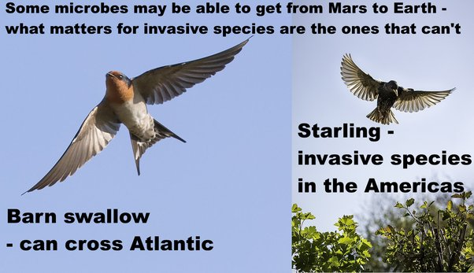
Some microbes may be able to get from Mars to Earth - what matters for invasive species are the ones that can’t.
Barn swallow - can cross Atlantic
Starling - invasive species in the Americas
Starling photo from: (Johnstone, 2017)
Barn swallow photo from (Batbander, 2017)
As an example, in 2012, starlings caused $189 million in damage to crops of blueberries, wine grapes, apples, sweet cherries and tart cherries in the USA (US DOA, 2017)..
Starlings also eat cattle feed and 1000 starlings can represent a loss of $200 to $400 in cattle feed. They can also transmit many diseases to cattle via the feeding troughs and their excrement corrodes iron structures including motor vehicles and iron roofs. They are also involved in thousands of bird strikes (US DOA, 2017)..
It’s the same for microbes, most are distributed globally and can cross oceans like the barn swallow. However we do have some invasive microbial species such as invasive diatoms. These only live in fresh water and can’t survive natural processes that could take them across our oceans. At least one of the invasive diatom in the Great Lakes is a nuisance species that clogs water works and introduces foul odours into the water, Stephanodiscus binderanus. There are other invasive diatoms that cause problems in New Zealand lakes such as Didymosphenia geminata, probably brought there from the northern hemisphere damp sports equipment (Spaulding et al, 2010).

Chroococcidiopsis as an example of a species that wouldn’t survive transfer by impacts from modern Mars based on an analysis by Charles Cockell
Some species will be better able than others to withstand the shock of ejection from Mars, the cold and dry and complete vacuum of the transition through space, then the fireball of re-entry to Earth. As an example, most photosynthetic life is killed in this process.
The first challenge is the shock of ejection. Microbes are suddenly accelerated from rest to escape velocity in a fraction of a second. The microbes can be destroyed by cell rupture or by DNA damage. All cells of Chroococcidiopsis are killed at 10 GPa (Nicholson, 2009). To put this in context, ALH84001 experienced a shock of ejection of ∼35 − 40 GPa. The Nahkalites were least shocked at 15 to 25 GPa. This is still too much for Chroococcidiopsis (Nyquist, 2001)

The microbe also has to survive the fireball of re-entry to Earth, Cockell inculcated an artificial gneiss rock with Chrooccoccidiopsis at a depth where it occurs naturally, and affixed it to the re-entry shield of a Soyuz rocket. None survived re-entry, nor did any organics. He concluded that it might not be impossible for photosynthetic life to get to Earth from Mars, but it would need an extraordinary combination of events (Cockell, 2008)

So in this analogy, most photosynthetic life on Mars would be more like the European starling than the Swallow, wouldn’t be able to get to Earth on meteorites except possibly in rare very large impacts, and most likely in the early solar system.

Then, the rocks we have in our Martian meteorite collections all come from at least three meters below the surface (Head et al, 2002) . They were probably thrown up into space after glancing collisions into the Elysium or Tharsis regions, high altitude southern uplands (Tornabene et al, 2006). The atmosphere for these high altitude regions on Mars is thin, making ejection to Earth easier. The subsurface below about 12 cms has a uniform temperature of around 200°K or -73°C (Möhlmann, 2005:figure 2). With such a thin atmosphere, present day life at those altitudes is unlikely (except perhaps for deep subsurface geothermal hot spots).

Larger impacts in the recent geological past could send material to Earth from other potentially more habitable parts of Mars. However:

- Many proposed habitats are in surface layers of dirt, ice and salts. These would likely never get into space
- Other proposed habitats are millimeters below the surface of rocks. These layers would ablate away during entry into the Earth's atmosphere
Life on Mars could be extremely localized to only a few square kilometers over the entire planet, for instance, only to the RSL's, or only above geological hot spots, making it less likely that the habitats are hit by an asteroid able to send material all the way to Earth in the large chunks needed for protection from cosmic radiation during the transfer.

Yet life from distant habitats on Mars may be able to get to Jezero crater in dust storms. Of course dust storms can’t transport Martian spores or propagules to Earth and the dust can’t be transported to Earth. We have no samples of Martian dust or Martian surface salts or ice in our meteorite collections and these couldn’t get to Earth even in the early solar system.

A mirror life chroococcidiopsis analogue as a worst case example of a pioneer species that would have adaptations that let it survive almost anywhere on Earth if returned from Mars and that could never be returned safely as it would risk transforming terrestrial organics to mirror organics that most life can’t use

We only need one pioneer species to get to Earth to set up a new ecosystem. Martian life would be likely to be able to survive on Earth. The Martian brines are highly oxidising, with perchlorates and hydrogen peroxides. They are so oxidizing that many terrestrial life forms would find hard to tolerate them. Recent research by Stamenković suggests the cold brines on Mars may be oxygenated too, even with the very low levels of oxygen, in the very cold conditions since oxygen is more soluble in cold water.
Then, though Mars gets very cold at night, in daytime it can sometimes reach above 20°C.
Microbes returned from Mars to Ear may be able to settle in on Earth as a "home from home" even more habitable for them than Earth.
For instance, suppose that Mars has mirror life, which is like the European starling, is not able to get here via panspermia. An example here is Chroococcidiopsis, a blue-green algae found in Antarctic cliffs, also in the Arizona desert near JPL, but also is ubiquitous through Earth, found in the sea, in tropical water supplies, both wet, dry, hot, cold, it's a polyextremophile that has numerous metabolic pathways that let it survive almost everywhere, and it is one of the top candidates for a form of life that could survive on Mars.

A mirror analogue of chroococcidiopsis from Mars could flourish almost anywhere from Antarctic cliffs to the Atacama desert (Bahl et al, 2011) or from Sri Lankan reservoirs (Magana-Arachchi et al, 2013) to the Chinese sea (Xu et al, 201q26:111), and form the foundation of a mirror ecosystem.

It is a pioneer species and a primary producer and doesn’t depend on any other life to survive.

Chroococcidiopsis,is an ancient polyextremophile with numerous alternative metabolic pathways it can utilize, including nitrogen fixation, methanotrophy, sulfate reduction, nitrate reduction etc (KEGG, n.d.), even able to grow in complete darkness using a hydrogen-based lithoautotrophic metabolism with viable populations found over 600 meters below the surface (Puente-Sánchez et al, 2018) and in another case 750 meters below the Atlantic sea bed (Li et al, 2020).

In the same way a mirror Martian polyextremophile might retain numerous metabolic pathways from its evolutionary history on Mars that it could use to colonize diverse habitats on Earth. The Martian history would include hydrothermal vents, oxygen rich lakes, and almost any climate condition it could encounter on Earth as well as some conditions not present here naturally such as ultra low temperatures and ultra low atmospheric pressures and far higher levels of UV and ionizing radiation than life encounters on Earth.

So, suppose there is a mirror chroococcidiopsis on Mars.. Or some other pioneer species including ultramicrobacteria, maybe even mirror life ribocells.

Once it was well established, other mirror life could build up a microbial ecosystem based on this and in this way mirror life could start to spread through our ecosystems.

NASA fail to consider at all the potential for microhabitats in Jezero crater not detectable from orbit

It’s the same for the second half of that INCORRECT paragraph from NASA’s MSR Safety fact sheet for the draft EIS (NASA, 2022msfs):

, and the fact that the Mars samples being gathered by NASA’s Perseverance Mars rover are from the first few inches of a planetary surface that is very dry and highly irradiated naturally by the Sun, which would sterilize all known active biology.

In the draft EIS itself they say:

Microbes can make use of habitats with small amounts of water and they may be able to modify them to make them habitable. The surface is indeed very dry but not totally dry. Curiosity found that brines form there regularly in the early morning or late in the evening.
The UV from sunlight is blocked by a few millimeters of dust and the ionizing radiation is only an issue for microbes that are dormant for millennia. Life in surface habitats would likely revive every year at the appropriate season for growth.
Curiosity has already found a cold brine layer in equatorial sand dunes (Martin-Torres et al, 2015) a few cm below the surface. Nilton Renno has suggested this could be habitable to a biofilm that can regulate its microhabitat, for instance, retain the water through to warmer conditions in daytime (Nilton Renno cited in Pires, 2015).
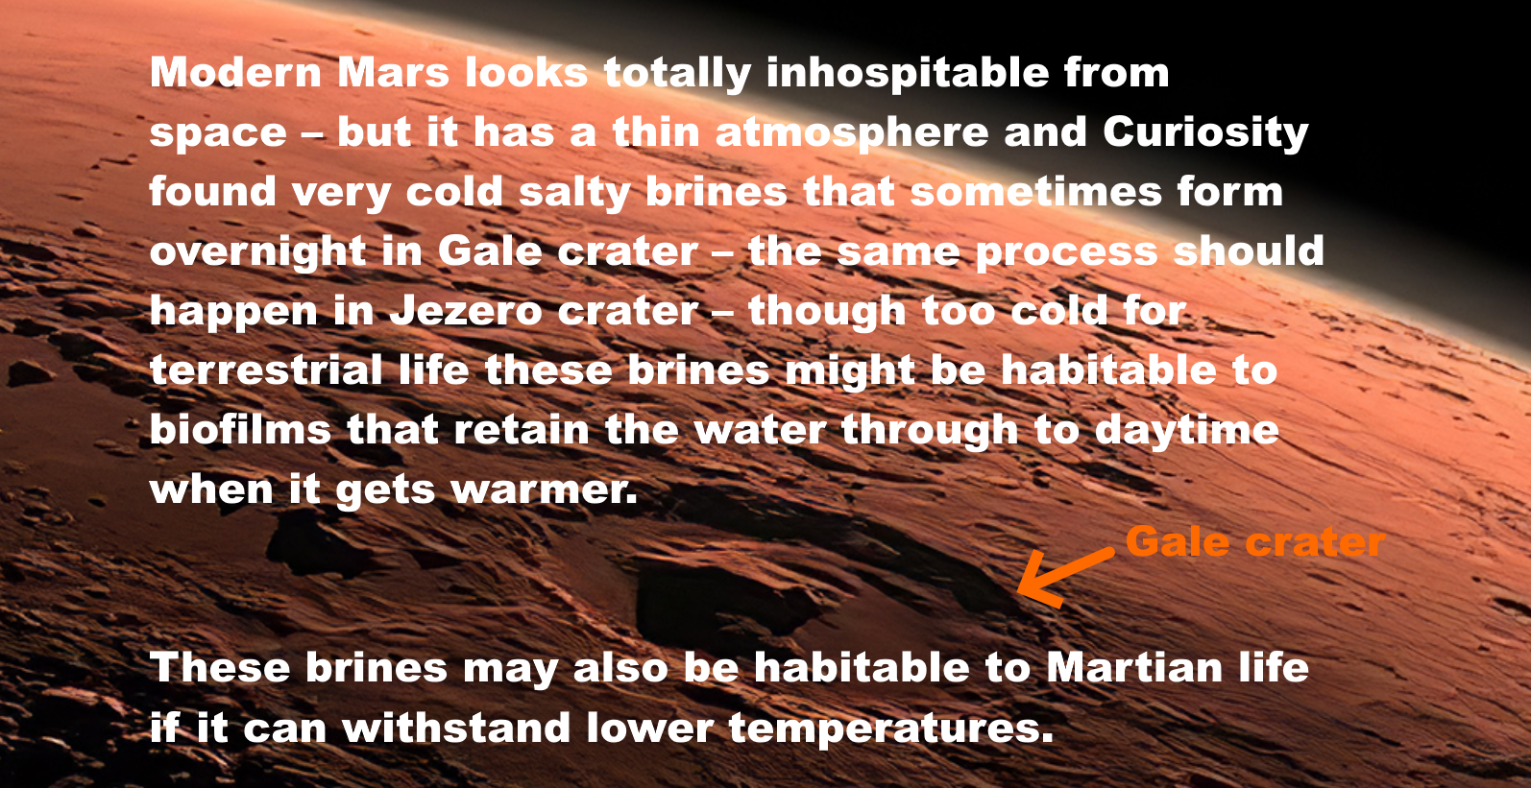
Modern Mars looks totally inhospitable from space – but it has a thin atmosphere and Curiosity found very cold salty brines that sometimes form overnight in Gale crater – the same process should happen in Jezero crater – though too cold for terrestrial life these brines might be habitable to biofilms that retain the water through to daytime when it gets warmer.
[Arrow points to Gale crater]
These brines may also be habitable to Martian life if it can withstand lower temperatures.
Image from (McKay et al, 2014)
I cover this in my paper in the sections:
- Detection by Curiosity rover of liquid water as perchlorate brines in Gale crater sand dunes and similar conditions are predicted in Jezero crater dune
- How Martian life could make perchlorate brines habitable when they only have enough water activity for life at -70 °C – biofilms retaining water at higher temperatures - chaotropic agents permitting normal life processes at lower temperatures – and novel biochemistry for ultra low temperatures
Then some think the Viking lander found life on Mars already in the 1970s. This was revived with the discovery of rhythms that resemble circadian rhythms in the carbon emission in gases (CO2 or methane) when the old data was re-analysed. They were offset by two hours, too much to explain easily with simple chemistry. It is either very complex and not well understood chemistry or biology. Either way it needs further study.
I cover this and other puzzles from the Viking landers in my paper under
- Puzzles from the Viking landers – why some think Viking detected life already in the 1970s – evolved gases in the labelled release experiment offset from temperature fluctuations by as much as two hours, more typical of a circadian rhythm than a chemical reaction
I go into some of the proposed habitats that could occur in Jezero crater in in my paper under
- Suggested sources for native life in equatorial regions such as Jezero crater include local microhabitats such as salty brines, and spores in windblown dust – while the dust and salts are not likely to be transferred to Earth via asteroid impacts
- Puzzles from the Viking landers – why some think Viking detected life already in the 1970s – evolved gases in the labelled release experiment offset from temperature fluctuations by as much as two hours, more typical of a circadian rhythm than a chemical reaction

The 2015 review overturned the suggestion from the 2014 review that areas not of Planetary Protection concern can be delineated using maps. A similar situation arose with the 2020 review which overtunred the suggestion from the 2019 review that these areas can be deliniated using maps.
These studies weren’t looking at Martian life particularly but rather at whether terrestrial life could survive on Mars. But Martian life if anything is likely to be more adapted to Martian conditions than terrestrial life.

I go into this in in my paper under:
- 2020 Review committee modified recommendations of 2019 report, saying our knowledge is not yet sufficient to classify parts of Mars as suitable for an unsterilized Category II mission in the forward direction – agrees on need to protect Earth in backwards direction
And

- Similar situation in 2014 / 2015: 2014 report said maps can identify areas of Mars of planetary protection concern in the forwards direction then 2015 review modified those recommendations, saying maps can’t yet be used – due to knowledge gaps on survival of terrestrial life in dust storms and potential for life to survive in microhabitats hard to detect from orbit

This is what the 2015 study says

First that terrestrial life could transfer to dispersed small-scale habitats on Mars. They might also be able to alter the local environmental parameters (this would include retaining water from night to day time as it gets warmer) and be able to get transferred to other parts of Mars. Microbes could also form communities where they exchange metabolites cooperatively to increase their survival. (Board, 2015)

In particular, the issues of translocation of terrestrial contamination and the behavior of multispecies populations in extreme environments, produce uncertainty in the determination of Special Regions, because such regions might not be isolated from the rest of the planet (translocation), because microbial communities could occupy dispersed, small-scale habitats or might be able to alter local environmental parameters and syntrophic consortial interactions
[syntrophic interactions: where microbes exchange metabolites in an overall combined metabolism that wouldn’t be feasible for either species individually (Seiber at al, 2010)
These issues, together with the present lack of knowledge about the limits of life on Earth and the uncertainty of the relationship between the large-scale and micro-scale environments at any given place make the definition of Special Regions difficult.
They also say that these potential small scale microbial habitats may not be detectable from orbit. They may be only a few cell layers thick in a biofilm, even with adverse and extreme conditions that surround the biofilm.
Detectability of Potential Small Scale Microbial Habitats
There are many examples of small-scale and microscale environments on Earth … that can host microbial communities, including biofilms, which may only be a few cell layers thick. The biofilm mode of growth, as noted previously, can provide affordable conditions for microbial propagation despite adverse and extreme conditions in the surroundings. On Earth, the heterogeneity of microbial colonization in extreme environments has become more obvious in recent years.
Also we need a better understanding of temperature and water activity of potential microenvironments. We still have very limited data on this, as the emphasis has been on study of geology, not microhabitats.
To identify Special Regions across the full range of spatial scales relevant to microorganisms, a better understanding of the temperature and water activity of potential microenvironments on Mars is necessary.
…
Craters, and even microenvironments underneath and on the underside of rocks, could potentially provide favorable conditions for the establishment of life on Mars, potentially leading to the recognition of Special Regions where landscape-scale temperature and humidity conditions would not enable it.
The Perseverance rover is studying rocks and geological specimens and it has a focus on past life. It is not doing the sort of survey would be needed to look for extant life, which would be carried out in a very different fashion and would depend on insitu life detection.

The papers by astrobiologists that I read were clear. If you want to search for life on Mars, whether present day or past life, you need a way to distinguish the organics from life from the organics from non life processes in situ. That is because most of the organics on Mars are expected to be from non living processes even if there is comparatively abundant life there. To find life and return it you need to be able to distinguish life from non life organics. You also need to be able to do a broad study to look at many potential habitiats that look similar geologically but may have minute differences in humidity, salinity, chemical gradients or any of the many things that can make it more or less habitable for extant or past life. There’s also the issue of preservation of past life to consider.

I cover some of this work in this section of my paper:

- Why it’s a major challenge to find samples from Jezero crater to help decide central questions in astrobiology until we can send in situ life detection instruments - most past biosignatures will be degraded beyond recognition – nearly all organics on Mars are expected to be abiotic - past and present day life is expected to be low in concentration and patchy in distribution – and all this is especially challenging if Martian life never developed photosynthesis or nitrogen fixation
In short, once we find life on Mars, if we know what we are looking for, we may be able to locate it without in situ life detection but at present we are in a situation where it is essential to send life detection instruments to Mars to look for it. Especially looking for another biology with unknown capabilities.

Our best chances for returning life from Mars with this mission is if it is likely low in concentration – but very abundant on Mars. If every few cubic cms have at least one viable microbe and we return several cubic cms of dirt, for instance, we may return life.

If Viking did find life on Mars, then we have a chance of returning it. Also if there are regions somewhere on Mars that produce spores or propagules, this may be easy to detect with a large enough sample of dust if the habitats are close to Jezero crater with an uneven plume of life that extends in its direction, or if there are distant very productive regions of Mars.
For a very crude estimate see the section in my paper:
- Searching for distant inhabited habitats on Mars through presence or absence of one originally living cell per gram – a rough first estimate assuming uniform mixing throughout Mars for a first estimate requires life to cover between 114,000 and 1,140 square kilometers with densities of life in the dust similar to an Antarctic RSL analogue in cell count, but less than a tenth of a square kilometer if any reach a billion cells per gram – these figures can be higher if any source habitats with high densities of cells are closer to the rover with uneven mixing

NASA fail to consider at all the potential for dust storms to transfer life to Jezero crater
Continuing to comment on the second half of that INCORRECT paragraph from NASA’s MSR Safety fact sheet for the draft EIS (NASA, 2022msfs):

, and the fact that the Mars samples being gathered by NASA’s Perseverance Mars rover are from the first few inches of a planetary surface that is very dry and highly irradiated naturally by the Sun, which would sterilize all known active biology.

NASA don’t mention that the sample tubes will also be covered in dust – indeed this is considered to be part of the sample return. NASA originally planned a dust sample, but instead decided to just rely on whatever dust gets attached to the outside of the sample tubes before collection.

The dust may come from distant parts of Mars and potentially might contain viable spores. The sample tubes are left on the surface for the sample fetch rover to pick up which means they will have at least one side in shadow not sterilized by the UV light. The windblown dust is protected from UV especially during dust storms as well as any microbes that are imbedded in cracks in the dust which is made of iron oxide and blocks out UV.

The 2015 study considers various ways that microbes could be transferred to distant regions of Mars. The most likely is through the dust (Board, 2015)

A potential problem with designating Special Regions on Mars is that viable microorganisms that survive the trip to Mars could be transported into a distant Special Region by atmospheric processes, landslides, avalanches (although this risk is considered minimal), meteorite impact ejecta, and lander impact ejecta. In addition to dilution effects, the flux of ultraviolet radiation within the martian atmosphere would be deleterious to most airborne microbes and spores.
The dust attenuates UV radiation (this is especially true during a dust strom when it can turn day into night).
Also microbes often grow in cell changes, clusters or aggregates and inner cells are protected against UV.
However, dust could attenuate this radiation and enhance microbial viability. In addition, for microbes growing not as single cells but as tetrades or larger cell chains, clusters, or aggregates, the inner cells are protected against ultraviolet radiation. Examples are methanogenic archaea like Methanosarcina, halophilic archaea like Halococcus, or cyanobacteria like Gloeocapsa. This is certainly something that could be studied and confirmed or rejected in terrestrial Mars simulation chambers where such transport processes for microbes (e.g., by dust storms) are investigated. The SR-SAG2 report does not adequately discuss the transport of material in the martian atmosphere.
These studies on transfer of microbial life in Martian dust storms in Mars simulation chambers don’t seem to have been done. At least I found almost nothing in my literature search and what I found has nothing new by way of citations. This seems to remain a recommendation to follow up in the future.
It is not easy to simulate a dust storm. Also it will be hard to do this accurately until we have samples of the dust to examine closely either on Mars in situ or nearer to home.
Also this is just for terrestrial life. Martian life may have developed special adaptations to spread in dust storms.

In in my paper, I look into this in the sections:
- Could Martian life be transported in dust storms or dust devils, and if so, could any of it still be viable when it reaches Perseverance?
- Native Martian propagules of up to half a millimeter in diameter (including spore aggregates and hyphal fragments) could travel long distances with repeated bounces (saltation) - if they can withstand the impacts of the bounces
- Martian spores could evolve extra protection such as a shell of agglutinated iron oxide particles to protect themselves from UV
- Martian life could also use iron oxides from the dust for protection from the impact stresses of the saltation bounces - or it might use chitin - a biomaterial which is extremely hard and also elastic and is found in terrestrial fungi and lichens

NASA plan to use a biosafety level 4 facility to handle the samples – but how can they know that a BSL-4 facility designed to contain infectious diseases of humans will work to protect Earth’s biosphere from extraterrestrial ultramicrobacteria or the potentially even smaller nanobes such as ribocells that may have preceded terrestrial life? The answer is they don’t – they seem unaware of the recommended size limits set in the 2012 ESF sample return study which make a BSL-4 facility inadequate
NASA show no awareness of the 2012 ESF report on a Mars sample return. This was the main point that I made in my submission to their first round of requests for comments from the general public as part of the NEPA process (Walker, 2022).

Are you aware of the ESF Mars Sample Return study (Ammann et al, 2012:14ff)? It said "The release of a single unsterilized particle larger than 0.05 μm is not acceptable under any circumstances”. This is to contain starvation limited ultramicrobacteria which pass through 0.1 micron filters (Miteva et al, 2005). Any Martian microbes may be starvation limited.
This 100% containment at 0.05 microns is well beyond capabilities of BSL4 facilities. Even ULPA level 17 filters only contain 99.999995 percent of particles tested only to 0.12 microns (BS, 2009:4).

The 2009 study by the National Research Council (NRC) set a limit of 0.25 microns diameter for released particles (National Research Council. 2009).
This was followed up by the 2012 study by the European Space Foundation (ESF) which reduced this to a limit of between 0.01 microns and 0.05 microns (Ammann et al, 2012:14ff).

NASA’s EIS mentions a 0.05 micron size limit – but only for the engineering for the earth entry capsule, not for sample handling facilities – and they don’t mention the ESF study in this section or their list of cites
However they show no awareness of this report. It’s not in their list of cites.
All they have relevant in their list of comments they responded to is: (NASA, 2022eis: 4-7):

What is the smallest Mars particle that is forbidden to be on the capsule carried to Earth? Dust level, bacteria level, virus level, prion level?

They respond that the minimum size is 50 nm – so for roughly similar reasoning they apply this size to the capsule on the journey back to Earth.

MSR engineering requirements are based on managing unsterilized particles 50 nm in size and larger. MSR selected this size limit because particle size distribution data indicate that the fraction of particles below 50 nm is small (less than 0.06%) and also because the physics of particle transport are such that measures taken to control or exclude particles of 50 nm are also effective for particles of smaller sizes.

A number of studies (National Research Council 1999, Heim et al. 2017) have estimated the minimum sizes for life forms from fundamental inputs such as the genetic material required to permit a cell to perform basic functions [e.g., (Glass et al. 2006)], observations in extreme environments [e.g., (Comoli et al. 2009)] or theoretical constraints that would apply to astrobiology investigations (Lingam 2021). Values from such studies have been used to inform findings on best ractices for sample return missions and MSR has considered those findings in selecting 50 nm for engineering requirements.

They don’t use the European Space Foundation as a source. Their first cite is the 1999 “Size limits” workshop which followed on from the discovery of possible small cells in the meteorite ALH 84001, which I’ve cited as (Board et al, 1999)

However this cite comes up with far smaller figures. Panel 4 for the 1999 “Size limits” workshop calculated that such a primitive free living lifeform could be as small as 0.014 microns in diameter and 0.12 µm in length, if there is an efficient mechanism for packing its RNA. (Board et al, 1999: 117). What size you get depends on which of the panels you look at. The one that looks at the biochemistry of early life came up with very small figures potentially.

They also use a very interesting but highly theoretical source on the minimum size of a microbe able to sense chemical gradients. This source says that a spherical microbe has to be 0.2 microns in diameter or larger (0.1 microns in radius) to sense chemical gradients (Lingam, 2021). I’m not sure how that is relevant to their figure of 0.05 microns. However it is a very interesting source and relevant to our topic.

Early life would be likely to use especially small cells. Lingam mentions that early life could be less than 0.2 microns in diameter if it had steeper gradients though it could lead to issues due to the size of sensor molecules such as rhodopsin and with the ability of the cell to move (that would be due to the effects of Brownian motion on very small cells), (Lingam, 2021:11) also the conclusion (Lingam, 2021: 8).

The presence of sharp gradients drives down Rmin and might therefore have aided in the early evolution of life. Thus, the search for biomarkers may benefit from prioritizing environments where such gradients exist today or were prevalent in the past; the Gusev crater on Mars with its opaline silica deposits reminiscent of hot springs on Earth is an intriguing example

Lingam briefly discusses non spherical cells (Lingam, 2021:3 ).

For starters, the organisms are taken to have spherical symmetry; changing the shape to ellipsoidal or cylindrical is anticipated to yield noteworthy benefits but also incur concomitant costs

Interestingly the ultramicrobacteria that the ESF cite that are able to pass through 0.1 micron nanopores in practical experiments are decidedly elongated. Less than 0.1 microns in diameter, but 0.2 microns in length. So they would be be compatible with this requirement to be at least 0.2 microns along one axis.

The putative smallest cell for the size limits workshop is 0.12 microns in length which is not that far from the 0.2 limit. On page 11, Lingam looks at diameters down to 0.05 nm (radii down to 0.025 nm) for phosphorous and 0.06 microns for high temperature thermal vents.

However when it comes to the design requirements for a filter what matters is the shortest rather than the longest diameter of a cell. Lingam’s theoretical argument says nothing about the shortest diameter.

Evidence used by the 2012 ESF study – practical experiments in which starvation limited ultramicrobacteria have been observed to pass through 0.1 nanopore filters and are viable after passing through the filter – these results have been multiply confirmed including with with scanning electron microscope images to show the scale of the cells lying on top of the nanopores they passed through - the cells are about 0.2 microns long but less than 0.1 microns in diameter when they pass through the nanopore

The ESF study considered evidence of free living microbes cultivated after passing through 0.1 micron filters (Miteva et al, 2005). Such small sizes may be an adaptation to starvation survival stresses, which makes this similar to situations one might expect on Mars.
The ESF study also found a similar theoretical minimum size for free living terrestrial life with their estimated minimal genome of 750 genes, concluding that such a theoretical microbe could have a width of less than 0.1 microns, and length greater than 0.2 microns (Ammann et al, 2012:15)
Example real life microbes match these figures. This is a SEM of a bacteria with width less than 0.1 microns and length about 0.2 microns:
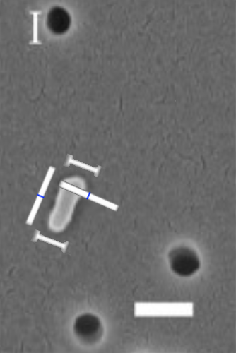
Figure 4: SEM of a bacterium that passed through a 100 nm filter (0.1 microns), larger white bar is 200 nm in length (Liu et al, 2019).

NASA’s EIS only refers to normal BSL-4 facilities including possibly building a mobile facility since there are only four such in the USA and NASA don’t have them - NASA show no awareness of the possibility that such a facility might not be considered adequate during assessment of their EIS or that it might be challenged by litigation
Puzzlingly, though NASA use a 0.05 limit to protect Earth from the Mars capsule during re-entry, their proposal doesn’t include any plans to use this same limit for their sample handling facilities once the sample is returned to Earth.
This may seem a minor detail, but as we’ll see it makes all the difference between technology we have today already, and technology that doesn’t exist yet even in the labs.

Example, the draft EIS says (NASA, 2022eis: S-4):

Nevertheless, out of an abundance of caution and in accordance with NASA policy and regulations, NASA would implement measures to ensure that the Mars material is fully contained (with redundant layers of containment) so that it could not be released into Earth’s biosphere and impact humans or Earth’s environment. The material would remain contained until examined and confirmed safe or sterilized for distribution to terrestrial science laboratories. NASA and its partners would use many of the basic principles that Biosafety Level 4 (BSL-4) laboratories use today to contain, handle, and study materials that are known or suspected to be hazardous.

Although not listed or designated as such under any regulatory definition, the Mars samples would be handled in a manner consistent with guidance from protocols for Biological Select Agents and Toxins (BSAT). BSAT are specific biological agents that fall under a congressionally mandated level of control. BSAT material requires the use of additional biosafety measures (e.g., a higher level of biocontainment).

For highly infectious or unknown materials, the highest level of biosafety (BSL-4) and biosecurity measures, in addition to specific measures for transport and inactivation, must be utilized. Because the samples would be treated as though potentially hazardous until demonstrated otherwise, they would be handled in a manner that provides the highest level of security and containment during the EES landing, recovery, transportation, sample storage, and receiving/curation mission phases and that is consistent with BSAT protocols in support of the planetary protection requirements. The samples would be stored and handled consistent with BSAT protocols until deemed safe for release.

It’s the same from the Mars Sample Return Planning Group 2 MSPG2 (Meyer et al, 2022) the design and construction of the Sample Receiving Facility is considered to be complete when it is certified to BSL-4 standard.

SRF commissioning (at least 2 years prior to Earth Return) –the design and construction of the SRF as a biocontainment facility ends with Biosafety Level 4 (BSL-4) certification; start of test and training phase for the SRF functionalities not related to the biocontainment function

NASA in their draft EIS say that NASA may consider using existing BSL-4 facilities or building or modifying one of their own buildings or building a modular containment facility (NASA, 2022eis: 2-16):

NASA may consider using existing BSL-4 containment facilities or building/modifying facilities, including a modular containment facility. There are currently only four operational BSL-4 laboratory suites in the United States: [list of the four BSL-4 laboratories in the USA]. However, all existing BSL-426 facilities have current operating missions and limited availability.

NASA may consider using existing BSL-4 containment facilities or building/modifying facilities, including a modular containment facility.

Sample return studies say that a purpose built facility is needed and that it likely takes 9 years from when the project starts to completion. I mention this in my comment to the last round of submissions but they don’t seem to have seen this (Walker, 2022).

NASA is required to provide preliminary design and engineering details for the Sample Return Facility before they start a build, and with a life-cycle cost over $250 million must also commit to Congress on cost and schedule (NASA, Science Engineering Handbook: section 3.5).
However, the legal process may change requirements, so should be completed before we launch the Earth return orbiter, Earth Entry Vehicle, and Mars Ascent Vehicle, or start to build the receiving facility.
Urhan et al estimate 9 years to build or repurpose the facility and 2 years to train scientists because of many lapses in Apollo sample handling. If the build starts in 2028, the earliest the facility could be ready is 2039.
The legal process might also conclude that the required technology doesn't exist yet.

There is no mention of the European Space Foundation report in their list of references or any justification for using BSL-4 to handle extraterrestrial samples.

Just argument by analogy that BSL-4 facilities are used for infectious diseases and toxic materials.

Containing infectious diseases is a very different situation from having to contain possibly starvation limited ultramicroabacteria and possibly even riobocells, RNA world cells with a different biology from terrestrial life.

A closer look reveals that the ESF requirement is not only well beyond BSL-4 standards.

The technology needed for the ESF limit doesn’t currently exist. It is well beyond the standards of any currently available technology, even in research experiments, except for some successful experiments infiltering out 0.05 micron particles from water at high pressure. For aerosols the technology is nowhere near this capability.

HEPA and ULPA filters are not tested for such small particles as 0.05 microns and not required to contain them
Example of best available nanofilter technology from 2020, not yet commercially available, filters out 88% of ambient aerosol particles at 0.05 microns - far short of the ESF requirement to filter out 100% at this size – though this standard can be met with nanoparticles in water under high pressure
Challenges for maintenance for future 0.05 micron compliant nanoscale filters – need to be designed for sterilization before any potential extraterrestrial biology is known, and may be easily damaged and hard to replace without risking release of nanoparticles

New technology will need to be developed to handle its requirements.

ESF study: “the release of a particle larger than 0.05 μm in diameter is not acceptable in any circumstances”

The European Space Foundation study summarizes their conclusions in this figure (Ammann et al, 2012:14ff). :
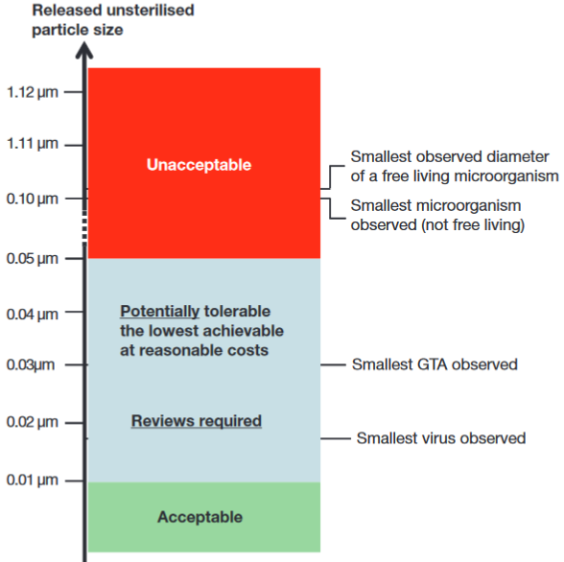
Figure 5: ESF summary of containment requirements
The report concluded that
“the release of a particle larger than 0.05 μm in diameter is not acceptable in any circumstances” (Ammann et al, 2012:21).

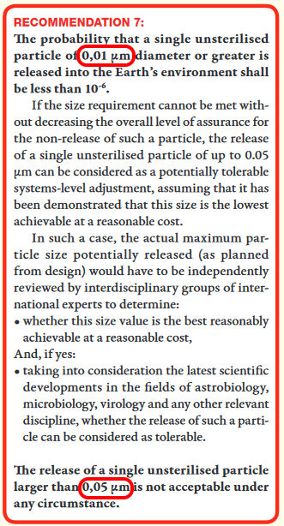
Figure 9: screenshot from the ESF report
“The probability that a single unsterilized particle of 0.01 micron diameter or greater is released into the Earth’s environment shall be less than one in a million”
“Release of a single unsterilized particle at 0.05 microns is not acceptable under any circumstances”
Note, the ESF defines their one in a million as the probability of release of A SINGLE UNSTERILIZED PARTICLE of 0.01 microns. This means over the ENTIRE LIFETIME of the facility.

A BSL-4 facility doesn’t comply with this limit – and the technology to filter out 100% of aerosol particles at 0.05 microns doesn’t yet exist except for nanoparticles in water under high pressure

A BSL-4 facility can’t comply with these requirements.

HEPA and ULPA filters are not tested for such small particles as 0.05 microns and not required to contain them
The standards for biosafety level III cabinets, or biosafety level 4 facilities are based on HEPA filters, for instance, a biosafety level III cabinet has to be exhausted to the outside air through two HEPA filters (Richmond et al, 2000:37). These HEPA filters are required to trap 99.97% of particles of 0.3 microns in diameter and 99.99% of particles of greater or smaller size (WHO, 2003:35). These requirements don’t set any minimum size above which escape of a single particle is unacceptable under any circumstances.
In the US, HEPA filters are tested down to 0.1- 0.2 microns (depending on the class of filter, some are tested only at 0.3 microns). In Europe they are tested at the most penetrating particle size which may vary depending on the filter. In both cases, the filters are tested according to probabilities (Zhou et al, 2007) (EMW n.d.).
ULPA level 17 filters are rated to filter out 99.999995 percent of particles (BS, 2009:8) in the range 0.12 microns to 0.25 microns (BS, 2009:4), according to BS EN 1822-1:2009, the British implementation of the European standard (BS, 2009).

This still doesn’t comply with the ESF standard of no release of a 0.05 micron particle in any circumstances. They are not even tested over this size range.

The filters are tested with challenge aerosols such as dioctylphthal (DOP) generated on the intake side of the filter, and measured with a photometer on the discharge side (Richmond et al, 2000:33). These photometers have limited sensitivity to nanoaerosols below the 100 nm limit. In a study of a DOP aerosol using TSI model 8130 Automated Filter Tester in 2008 (table III of Eninger et al, 2008), although particles below 100 nm (0.1 microns) constituted 10% of the count of particles in the test aerosol, and 0.3% of the mass, they provided almost none of the light scatter in the testing photometer (less than 0.01%)

So, is it possible to filter out particles down to 50 nm (0.05 microns)? And if so, how can such a filter be tested?.

Example of best available nanofilter technology from 2020, not yet commercially available, filters out 88% of ambient aerosol particles at 0.05 microns - far short of the ESF requirement to filter out 100% at this size – though this standard can be met with nanoparticles in water under high pressure
Aerosols are more of a challenge than water contaminants. It is possible to remove most or all nanoparticles from water with nanofilters under high pressure. A 2020 review of the literature found several studies that achieve a million fold reduction or more of small viruses in water. (Singh et al, 2020:6.3). Singh et al found one study using carbon nanotubes loaded with silver that achieved 100% removal of very small viruses such as the polio, noro and Coxsackie viruses (Kim et al, 2016) (Singh et al, 2020:6.3).. The poliovirus is only 0.03 microns in diameter (Hogle, 2002).
This fulfills the requirement to filter out 100% of particles at 0.05 microns in water. These tests don’t tell us how well the filters would perform with the ESF’s more stringent requirement to filter out almost all particles down to 0.01 microns from water.
However the sample handling facility would have to filter the nanoparticles from air, not water.For the state of the technology for aerosols, we can consider an experimental filter designed to contain SARS - Cov2, the virus that causes COVID19. This virus has a minimum diameter of 60 nm (0.06 microns) and could in principle be dispersed in an aerosol droplet not much larger than this (Leung et al, 2020). This is not far from the ESF requirement of 0.05 microns.
A single coronavirus is well below the limit for the current HEPA filters in respirators for intensive care, but the capability of HEPA filters to filter out most particles over 0.1 microns has been adequate for personal protection equipment for COVID19 (WHO, 2020tosi) (van Schaik, 2020).
COVID 19 personal protection equipment doesn’t currently use filters with the capability to filter out 100% of SARS-Cov2 particles from the air. Nevertheless, a more stringent way of filtering out viruses might be of some interest for the COVID19 response, and also to filter out ambient nanoaerosols at less than 0.1 microns from traffic (Leung et al, 2020). With this motivation, Leung et al constructed a 6-layer charged nanofiber filter.

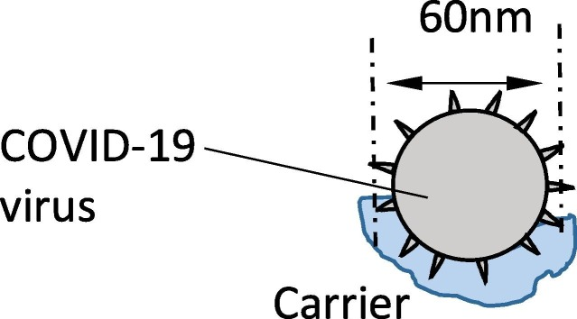
Figure 10: schematic illustration of coronavirus attached to a 60 nm (0.06 microns) diameter carrier water droplet which then becomes airborne (Schematic 1a, from (Leung et al, 2020).)
Leung et al found that their test filter was capable of filtering out 88% of ambient aerosol particles at 0.05 microns (50 nm) (Leung et al, 2020). This is a useful level of filtration for coronaviruses and for traffic fumes, but is still not not close to sufficient for the ESF study.
This suggests that best available technology is not yet able to comply with the ESF standard to contain 100% of particles at 0.05 microns and nearly 100% of particles at 0.01 microns (or this study would have used it). So, this requirement mandates development of a new design, which will then need to be developed, tested, manufactured and integrated into equipment such as suits and glove boxes for the facility.
In short, it is already technically possible, with an experimental filter, to filter out most particles at 0.05 microns.

However, ULPA filters can’t do this. Also, the standard tests for ULPA and HEPA filters can’t test a filter adequately with aerosols small enough to certify such a filter (previous section).

It doesn’t seem to be possible yet to filter out 100% of particles from the air at 0.05 microns with the best available filter technology

However if the particles are in water under high pressure, it is possible to filter out 100% of 0.05 micron particles using experimental nanofilters made of carbon nanofibers loaded with silver.

Challenges for maintenance for future 0.05 micron compliant nanoscale filters – need to be designed for sterilization before any potential extraterrestrial biology is known, and may be easily damaged and hard to replace without risking release of nanoparticles

In the future once these new 100% effective 0.05 micron compliant filters have been designed, developed, tested and proven to work, there will also be the need to show that they can be replaced and maintained, while still maintaining 100% containment at 0.05 microns. Biosafety level III cabinets need to be checked annually (Richmond et al, 2000:33) and equipment will sometimes need to be repaired.

HEPA filters often fail these annual tests and need replacement. When these filters are changed, the Biological Safety Cabinets (BSCs) must be decontaminated (WHO, 2003:35).

For Martian samples, decontaminating the filters or the cabinet before changing them is likely to be challenging, since properties of any viable life in an unsterilized Martian sample are not yet known. The method used for decontamination has to be capable of sterilizing not only known pathogens, not only all Earth life, but also capable of sterilizing any possible extraterrestrial extremophile with possibilities of increased resistance to the sterilizing agents compared to terrestrial life.
Meanwhile however the sample itself needs to be kept unsterilized while the cabinet housing it is sterilized to replace the filters. In addition the maintenance including replacing the filter must be carried out in such a way as to prevent the leak of a single particle larger than 0.05 microns.
The filters for smaller nanoparticles for water treatment are easily damaged, through chemical and biological deterioration by aging, scratches by particle like substances, or fouling of the membrane (Singh et al, 2020:8).
This suggests that once the technology is available for new filters to filter out 100% of particles from the air at 0.05 microns, these new aerosol nanofilters may have similar challenging maintenance requirements.
It seems that to comply with the ESF 0.05 micron standard will be a significant future scientific and technical challenge for filter technology, and filter maintenance and may involve major new learning curves for the technicians that run the facilities.
I have found no previous study of this issue of filter maintenance at 0.05 microns in the planetary protection literature.
Similar challenges with meeting this 0.05 micron standard could be expected for other aspects of maintenance, such as repairing the cabinet itself in the case of electrical fault. This also must be done in a way that doesn’t permit a single 0.05 micron particle to escape.
However, before this work on the new filter technology, we also have to review the minimum size requirements. This is recommended in the ESF study.

The ESF study says that the size limit needs to be reviewed regularly – at a decade later in 2022 it is definitely necessary to review a limit set in 2012 which dramatically reduced the 0.25 micron limit set in 2009 to 0.05 microns

The ESF study said that future reductions in the size limit are possible. They expected later reductions to happen at a slower pace, but say the size limit will need to be reviewed in the future, adding (Ammann et al, 2012:21):
Based on our current knowledge and techniques (especially genomics), one can assume that if the expected minimum size for viruses, GTAs or free-living microorganisms decreases in the future, and this is indeed possible, it will be at a slower pace than over the past 15 years

However, no one can disregard the possibility that future discoveries of new agents, entities and mechanisms may shatter our current understanding on minimum size for biological entities. As a consequence, it is recommended that the size requirement as presented above is reviewed and reconsidered on a regular basis.
[bolding as in original cited text]

The minimum size for filters to contain Marian biology was reduced from 0.25 microns to 0.05 microns / 0.01 microns in just three years from 2009 to 2012.
By 2020, eight years later, another review is certainly required.

NASA’s Environmental Impact Statement is vulnerable to litigation on the basis that it doesn’t consider impacts of a sample return properly, doesn’t take account of the main issues mentioned by the Sample Return Studies and say things that contradict their conclusions – potential remedies include stopping the mission altogether or an injunction, e.g. to sterilize all samples before they contact Earth’s biosphere
NEPA doesn’t provide for judicial review directly. But it’s often a ground for litigation on the basis that the process hasn’t been carried out properly, For instance judicial review can be requested because (Congressional Research Service, 2021).
- the agency failed to consider some of the impacts
- the agency failed to properly consider the weight of the impacts under review
During the litigation the court can issue injunctions that
- bar all or part of a proposed action
The result of the court case is usually
- referred back to the agency (such as NASA) for further proceedings - and the court can say what those are
- It can order equitable relief which vacates the action - i.e. stops the project going ahead
- Or issue some other action.
The courts can just stop the whole thing - or they could require some injunction on NASA.
In the case of the NASA proposals, if they don’t do a proper assessment, one likely injunction might be that NASA have to sterilize all samples returned to Earth until proven to be safe, if they assess that NASA haven’t taken account of all possible impacts or they haven’t sufficiently considered the weight of the impacts.
Then there is a similar process in Europe, which ESA will have to go through for their sample fetch rover. That starts with the Directive 2001/42/EC of the European Commission (EU, 2001)..
However I haven’t seen any academic papers on how the Mars sample return legal process would work out in Europe.
Generally it wouldn’t stop in the USA. If all domestic agencies were satisfied, and if the European Comission are satisfied, there are still many international treaties that are relevant.
I go into this in much more detail in my paper.
This time as it is directly relevant, I have copied over some of the sections here (and lightly edited)

The legal process is likely to extend well beyond 6 years with involvement of CDC, DOA , NOAA, OSHA etc., legislation of EU and members of ESA, international treaties, and international organizations like the World Health Organization – NASA don’t seem to be prepared for this or even mention potential international ramifications
There is potential for many delays in the legal process. Six years from filing the EIS is the bare minimum. The legal process in the USA starts with the EIS (EPA, n.d.). First, since there is a potential for damage to Earth’s environment, various executive orders mandate NASA itself, as a federal agency, to consider such matters as (NASA, 2012fdg):
- impact on the environment,
- impact on the oceans,
- impact on the great lakes,
- escape of invasive species,
- lab biosecurity against theft
After the environmental impact statement is filed, Uhran et al mention many other agencies likely to declare an interest such as the (Uhran et al, 2019) (Meltzer, 2012:454)
- CDC (for potential impact on human health),
- Department of Agriculture (for potential impact on livestock and crops),
- NOAA (for potential impact on oceans and fisheries after a splashdown in the sea)
- Occupational Safety and Health Administration, to consider questions of quarantine if a scientist or technician gets contaminated by a sample
- Department of Homeland Security,
- Federal Aviation Administration because the sample returns through the atmosphere
- Department of Transportation for bringing the sample to the receiving laboratory from where it touches down and to distribute to other laboratories
- Occupational Safety and Health Administration - for any rules about quarantine for technicians working at the facility
- U.S. Customs and Border Protection and the Coast Guard to bring back sample in case of an water landing or the Department of Defense if it lands on land, likely the Utah Test & Training Ranges
- Department of the Interior which is the steward for public land and wild animals which could be affected by release of Martian microbes
- Fish and Wildlife Service for the DoI who maintain an invasive species containment program and may see back contamination as a possible source of invasive species
- National Oceanic and Atmospheric Administration (NOAA)'s fishery program for sea landing in case it could affect marine life and NOAA fisheries
- Integrated Consortium of Laboratory Networks (ICLN) for laboratories that respond to disasters - a partnership of the Department of Agriculture, Department of Defense, Department of Energy, Department of Health and Human Services, Department of Homeland Security, Department of the Interior, Department of Justice, Department of State, and Environmental Protection Agency
- The state where the receiving laboratory is stationed may have regulations on invasive species, environmental impacts, disposal of waste, and possession of pathogens, similarly also for any states the sample may have to transit to from the landing site to the facility
As the process continues it is possible to stop the activity. It’s the same process that is used for instance. to stop oil pipelines across tribal lands in the USA or almost any US environmental legal action.

The Congressional Research Service explains (Congressional Research Service, 2021) that NEPA doesn’t provide for judicial review directly. But it’s often a ground for litigation on the basis that the process hasn’t been carried out properly.
For instance judicial review can be requested because
- the agency failed to consider some of the impacts
- the agency failed to properly consider the weight of the impacts under review
During the litigation the court can issue injunctions that
- bar all or part of a proposed action
The result of the court case is usually
- referred back to the agency (such as NASA) for further proceedings - and the court can say what those are
- It can order equitable relief which vacates the action - i.e. stops the project going ahead
- Or issue some other action.
The “ordinary” remedy is to just vacate the Federal action so it can’t go ahead, but the courts consider the “seriousness” of the deficiencies in the EIS and the “disruptive consequences” of vacating the action (Congressional Research Service, 2021).
So the courts can just stop the whole thing - or they could require some injunction on NASA. In this case, one example injunction might be that NASA have to sterilize all samples returned to Earth until proven to be safe, if they assess that NASA haven’t taken account of all possible impacts or they haven’t sufficiently considered the weight of the impacts.
Meanwhile, since this is a joint NASA / ESA mission, it involves ESA. Most of the ESA member states are in the EU (ESA, n.d.MS) so the EU will get involved.

This leads to a separate legal process in Europe, starting with the Directive 2001/42/EC (EU, 2001). I haven’t located any academic reviews for the European process, but as for the case in the USA, this would spin off other investigations which would involve the European Commission (Race, 1996).

The UK, as a member of ESA but not in the EU, might also be involved in a separate process with its domestic laws. Canada also sits on the governing council of ESA, so perhaps may get involved. These countries are all members of ESA and also all potentially impacted by an adverse outcome.

However it wouldn’t stop at the USA and ESA. All other countries are potentially impacted in the worst case. These potential impacts on the environment of Earth, and on human health world-wide bring many international treaties into play (Uhran et al, 2019),
In an address given to the Space Studies Board Task Group on Issues in Sample Return in 1996, attorney George Robinson presented a list of 19 treaties or international conventions and 10 domestic categories of law, including the rights of individual states and municipalities to quarantine, that may affect return missions
[Need to find out more details here]
Also several international organizations are likely to be involved such as the WHO (Uhran et al, 2019).
We will see below that the very worst case scenarios involve degradation of Earth’s environment (such as by mirror life).

It seems unlikely that these worst case scenarios would be ignored as the legal proceedings continue. If the legal discussions expand to focus on these scenarios, this could involve many other organizations.

The Food and Agriculture Organization (UN, 1945) could become involved, especially if the potential for alien exobiology such as mirror life is considered, because of potential impact on agriculture and fisheries and global food supplies, and the World Health Organization because of effects on human health globally if a new organism is returned that can be spread to other countries.

In the USA, the Environmental Protection Agency partners with the United Nations Environment Program (UNEP), and Arctic Council, so they’d likely get involved (EPA, n.d.pwio).

Indeed, there would be few aspects of human life that would not be relevant in some way in discussions of the very worst case scenarios. As the legal process continues, surely there would be open public debate about these scenarios, and if the discussion expands in this way, potentially it might lead to much wider involvement in the international community. It would be necessary to convince the public, and interested experts in all these agencies that this is a safe mission and that all their concerns have been answered.
Race (Race, 1996) says that experts will have challenges deciding in advance whether the sample should be classified as potentially:
- an infectious agent
- an exotic species outside its normal range
- a truly novel organism (as for genetic engineering)
- a hazardous material
The choices here would change which laws and agencies would be involved.
Presidential directive NSC-25 requires a review of large scale effects which is done after the NEPA process is completed. (Race, 1996)
There are numerous treaties conventions and international agreements relating to environmental protection or health that could apply.
Including those to do with (Race, 1996)
- protection of living resources of the sea
- air pollution (long range pollution that crosses country boundaries)
- world health, etc
Individual groups in other countries could invoke domestic laws such as laws on accidents at sea or on land if they argue back contamination of Earth can cause measurable damage. (Race, 1996)
Race says scientists are likely to focus on (Race, 1996)
- technical details
- mission requirements
- engineering details
- costs of the space operations and hardware
General public are likely to focus on
- risks and accidents
- whether NASA and other institutions can be trusted to do the mission
- worst case scenarios
- whether the methods of handing the sample, quarantine and containment of any Martian life are adequate
Six to seven years seems a bare minimum to complete all this. Any addition to the legal process would push the sample return date further back than 2039.

Uhran et al recommend an advanced planning and oversight agency set up two years before the start of the legal process – similarly Rummel et al recommend it should include experts in legal, ethical and social issues – and the ESF recommends an international framework should be set up, open to representatives from all countries - NASA don’t seem to have done any of this yet

NASA and ESA clearly didn’t ‘do this or they would have produced a much more thorough EIS and would have engaged in far more outreach to the general public before submitting the EIS.

With so much to be sorted out, Uhran et al recommended that an oversight agency should be set up long before the legal process starts. Uhran et al recommend this is done two years before filing the environmental impact statement to develop a consensus position on the margin of safety for sample containment (Uhran et al, 2019).
Since the aim is to develop a consensus position, this would need to be based on up to date information. So it would need to include the review of the size limits required in the ESF sample return study (Ammann et al, 2012:PG). The current paper suggests the need to review filter technology and provide a preliminary study of the technological advances needed to achieve the specified size limits, since the technology doesn’t seem to exist yet.

Similarly Rummel et al advise that clear communication with the public is essential from an early stage, for success of the mission. They recommend that this should avoid a NASA centric focus and include links with other government agencies and international partners and external organizations (Rummel et al, 2002).

Rummel et al warn that the mission might attract viral sharing of misinformation, a concern that now seems similar to the “infodemic” for COVID19. Potentially the sample return mission, and the facility, could also attract intentionally disruptive events, by bioterrorists, or by members of the public opposed to sample return (Rummel et al, 2002). Perhaps this may need to be managed based on the emerging discipline of infodemiology (WHO, 2020wic).
Rummel et al say that the oversight committee would need to contain experts in legal, ethical and social issues in addition to the experts in astrobiology, space engineering and mission planning. It should conduct ethical and public reviews. Broad acceptance by the public is essential at an early stage for success of the mission (Rummel et al, 2002).
Similarly the ESF recommends that since negative consequences from an unintended release could be borne by countries not involved in the program, a framework should be set up at the international level open to representatives of all countries, with mechanisms and fora dedicated to ethical and social issues of the risks and benefits from a sample return (Ammann et al, 2012:59). This again would be best done before the start of the legal process to make sure everyone is on the same page before it starts.
NASA did set up a review board for sample return missions on August 14th 2020 (NASA, 2020nebmsr). However, it is not clear yet what its scope is. It is not clear whether it will consider these wide ranging issues, or include experts in legal, ethical and social issues, as recommended by (Rummel et al, 2002).
From the content of the draft EIS and the reactions in comment replies, it seems unlikely that these issues have been considered.

The legal process and public debate for NASA’s mission as precedent for China’s mission to return a sample too – perhaps as soon as 2030 – with sterilization a likely solution for a country that wants to be first to return a sample
China currently plans to launch a mission possibly as soon as 2028, to return a sample by 2030. It would consist of two rockets, one with a lander and ascent vehicle, and the other with an orbiter and reentry capsule to return the sample to Earth, using two Long March rockets (Jones, 2021)

China had one of the most rigorous of all responses to the COVID pandemic. Professor Bruce Aylward, leader of the joint team that studied their response (McNeil, 2020) put it like this in the press briefing about their findings (United Nations, 2020)

They [the Chinese] approached a brand new virus [that] has never been seen before that was escalating and quite frightening in January … and they have taken very basic public health tools … and applied these with a rigor and an innovation of approach on a scale that we've never seen in history

If China considers the Mars sample return to be potentially hazardous it is likely to be especially careful just as it has been especially careful with COVID.

The debate that is sure to happen with the NASA mission will help bring widespread awareness of the issues of a sample return and the need to be careful.

China’s mission is far simpler than the NASA one and similar to the proposal for NASA by the astrobiologist Chris McKay for a mission that does no more than land, gather a scoop of dirt and immediately return,

I have a section about this in my paper under:

- Sample return as a valuable technology demo for astrobiology – and proposals to keep the first sample returns simple, a scoop of dirt or skimming the atmosphere to return micron sized dust samples

China's first mission may have a higher chance of returning present day life than the NASA mission as currently envisioned - because they plan to scoop up some dirt which could have viable spores from dust storms, or the life that Viking detected (if it did find life).

Perhaps China may be able to accelerate their legal process or bypass elements of it though they would still have the international treaties and responses of international organizations and other countries to deal with.

However, once this topic enters public debate widely, the public can be expected to raise many issues as NASA has already seen with the comments so far on their draft environmental impact statement (NASA, 2022msrc).

The general public in Chinese likely raise similar issues, which would get the attention of leaders in China, given their recent experience of COVID and the high level of importance they assign to matters of public health.

NASA can’t accelerate the legal process to achieve an unsterilized sample return before 2039 – but it could “win” this race with a sterilized return or unsterilized return to a safe orbit with sterilized subsamples returned to Earth – inspiring China and other nations to do the same
It’s possible this could turn into a space race similarly to the races between the Soviet Union and USA in the 1960s, but with an easy win available to China due to the complexity of the NASA mission and the comparative simplicity of the Chinese mission.

If this turns into a space race with NASA competing with China, NASA can't accelerate the legal process to “win the race” with an unsterilized return before 2030.

However, NASA can accelerate its timeline if they do a sterilized return or a return to a safe orbit and sterilized subsamples, as that has almost no legal process.

They could do that by 2033 with their current timetable.

Another way that NASA could “win” the race to return a sample of Mars would be to do a separate low cost sample return such as SCIM skimming the Mars atmosphere to return micron sized “Mars rocks” from dust storms, or Chris McKay’s “grab a sample of dirt and return”. NASA could have done either of those a decade ago or more.

It would likely be hard for NASA to find the budget for an extra sample return mission in competition with existing programs, but if Congress authorized the expenditure, they could do such a mission very quickly, and with their previous experience and expertise, surely faster than China, if they see China as “winning” the race to be first to return a sample.

See:

- Sample return as a valuable technology demo for astrobiology – and proposals to keep the first sample returns simple, a scoop of dirt or skimming the atmosphere to return micron sized dust samples

A fast sterilized sample return, or return to a safe orbit, might lead to China doing the same.

As a response to public concerns, China could use either of the solutions suggested here:

- to sterilize the sample during the return mission.
- to return it to a remotely operated satellite in a safe orbit, and sterilize some of the dirt to return to Earth for immediate study while the rest is tested for signs of life in orbit.

These wouldn’t significantly impact on the prestige value of returning the first samples from Mars and they are well within China’s capabilities.

For details see

- Sterilized sample return as aspirational technology demonstration for a future astrobiology mission
- Recommendation to return a sample for teleoperated ‘in situ’ study above Geosynchronous Equatorial Orbit (GEO)

If they do this, it could then become the norm for samples returned from another planet – that when you don't know if there is life in them or what form of biochemistry or exobiology might be involved, you return the samples to a safe orbit for preliminary study first, or sterilize them.

Both missions are likely to be of most interest as a technology demo to show we can return a sample from Mars, at a later stage, once we know how to select the samples intelligently. But it’s not impossible either mission might return viable present day life.

Sterilization or return to a safe orbit is the simplest solution both from a practical point of view and legally.

However, we need to look in more detail into the challenges involved in an unsterilized return, since that is NASA’s current proposal.

I cover this in my paper under:

- Public health challenges responding to release of an extraterrestrial pathogen of unfamiliar biology
  - Failure modes for sample containment
  - Complexities of quarantine for technicians accidentally exposed to sample materials
  - Vexing issue of authorizations to remove technicians from quarantine to treat life threatening medical incidents in hospital
  - Example of a technician in quarantine with acute respiratory distress and symptoms similar to Legionnaires’ disease – a disease of biofilms and amoebae that adventitiously infects humans – and sometimes mentioned in planetary protection discussions
  - Arbitrariness of technician’s quarantine period for an unknown pathogen – Carl Sagan gives the example of leprosy which can take 20 years or more to show symptoms
  - How do you quarantine a technician who could be a life-long symptomless super-spreader of an unknown Martian pathogen?
  - Martian microbes could participate harmlessly or even beneficially in the human microbiome but harm other terrestrial organisms when the technician exits quarantine - example of wilting Zinnia on the ISS
  - What if mirror life becomes part of the technician’s microbiome?
  - Potential for mirror life on Mars and survival advantages of mirror life competing with terrestrial life that can’t metabolize mirror organics
  - Similar considerations apply to astronauts returning from Mars - in some scenarios such as mirror Martian life, astronaut quarantine would be insufficient to protect Earth’s biosphere
  - A laboratory with the samples handled telerobotically as a solution to all these human quarantine issues – however the other problems remain and the safest way to do telerobotics is in an orbital facility with the robotics controlled remotely from Earth

NASA can greatly increase the astrobiological interest by using 100% sterile sample containers for bonus samples of atmosphere, dust and dirt on the ESA fetch rover

The result will be of far greater astrobiological interest if NASA return samples of dust, dirt and the atmosphere in sterile containers.

It is understandable that engineers were concerned about enclosing the sample tubes in some airtight sterile container that needed to be opened on Mars. If this failed then it would make the entire mission impossible.

However adding sterile containers for dust, dirt and atmospheric samples to the ESA fetch rover will have no impact on its capability to return those geological samples. For the geologists, this is a bonus sample. For astrobiologists, the returned dust, gas and dirt is of such greatly reduced interest in a non sterile container that it is worth the small risk to engineer for 100% sterility.

Also the far simpler sample collection system, especially the methods to collect a sample of atmosphere and dust, should make a sterile sample return container easier.

Perseverance’s sample tubes weren’t sterilized 100% leading to risk of false positives that may prevent distribution of unsterilized samples from containment – estimated 8.1 nanograms maximum organic contamination per sample tube are equivalent to 81,000 ultramicrobacteria or 160 million hypothetical RNA world mirror nanobes

Whether the unsterilized samples are returned to a safe location unconnected to Earth’s biosphere, or to a laboratory on Earth, the hope is that the samples eventually can be proved to not contain life. Once proven safe, they could be distributed to laboratories with no need for containment just as for the lunar samples.

However sadly Perseverance’s sample tubes weren’t sterilized sufficiently for this objective. As stated in the NASA guide Planetary protection provisions for robotic extraterrestrial missions (NASA, 2005ppp):

A "false positive" could prevent distribution of the sample from containment and could lead to unnecessary increased rigor in the requirements for all later Mars missions.

This seems likely to be the case for the Perseverance samples. The achieved levels of biosignatures and organics in the sample tubes are high enough to make it challenging for an astrobiologist to prove definitively that there is no viable life in the sample. See:

- Limitations on cleanliness of the Mars sample tubes - estimated 0.7 nanograms contamination per tube each for DNA, glycine, alanine, and 17 other biosignatures, 8.1 nanograms total organics, and a roughly 0.02% possibility of a viable microbe in at least one of the tubes – higher levels of sterilization needed to detect life unless Perseverance returns exceptionally well preserved life
- Perseverance’s estimated achieved levels of 8.1 nanograms of organic contamination per sample tube equals the amount of organics in 81,000 ultramicrobacteria, 160 million hypothetical minimal volume RNA world nanobes and between 2 trillion and 5.6 trillion terrestrial amino acids

For more about this see also:

- Permitted levels of contamination could make it impossible to prove absence of Martian life in Perseverance’s sample tubes – leading to an unnecessary requirement to sterilize Perseverance’s samples indefinitely

It is hard to see how these samples could be certified by experts to be free of any Martian life.

We might later be able to deduce that the samples are lifeless, as our understanding of Mars develops, but it would be challenging to prove this by direct measurement of the samples.

From this it seems that unlike the situation for the lunar samples, NASA and ESA need to plan for the Martian samples to be sterilized before distribution to normal laboratories for the indefinite future.

For all these options, most likely the end result of any legal process would be that the samples are only be permitted to be handled unsterilized in laboratories equipped to contain 0.05 ultramicrobacteria – or 0.01 micron diameter mirror life nanobes if that is considered to be a possibility - until we know more about Mars and whether there is any potential for viable native life in samples from Jezero crater.

Permitted levels of contamination could make it impossible to prove absence of Martian life in Perseverance’s sample tubes – leading to an unnecessary requirement to sterilize Perseverance’s samples indefinitely
Sadly, the Curiosity sample tubes are not 100% sterile. Their measurements to test success of their procedures to reduce contamination suggest they achieved a maximum of
- 8.1 nanograms of organics per tube
- 0.7 nanograms for each of the biosignatures they tested (e.g. DNA)
- 0.00048% chance of a single viable microbe per tube – this means a 0.02% chance that at least one tube has a viable terrestrial microbe in it.

For details see my paper under

- Limitations on cleanliness of the Mars sample tubes - estimated 0.7 nanograms contamination per tube each for DNA, glycine, alanine, and 17 other biosignatures, 8.1 nanograms total organics, and a roughly 0.02% possibility of a viable microbe in at least one of the tubes – higher levels of sterilization needed to detect life unless Perseverance returns exceptionally well preserved life

This is enough to make it challenging to prove that there is no viable life in the sample.

For details see my paper under

- Perseverance’s estimated achieved levels of 8.1 nanograms of organic contamination per sample tube equals the amount of organics in 81,000 ultramicrobacteria, 160 million hypothetical minimal volume RNA world nanobes and between 2 trillion and 5.6 trillion terrestrial amino acids

As stated in the NASA guide Planetary protection provisions for robotic extraterrestrial missions (NASA, 2005ppp):

A "false positive" could prevent distribution of the sample from containment and could lead to unnecessary increased rigor in the requirements for all later Mars missions.

There seems a significant possibility of a false positive which could delay certifying the samples as safe for Earth, or make it necessary to sterilize all samples returned indefinitely.

The level of contamination in the samples, though low, may still be high enough to make it hard to prove that there is no Martian life in the samples.

Proposals to modify the ESF lander and sample selections to increase potential for returning viable present day or identifiable past life with samples of the dirt, dust from the air during dust storms, and compressed large samples of Martian air collected in 100% sterile containers by the fetch lander – and to use Marscopters to search for freshly excavated young craters for Perseverance to sample

If there is extant life on Mars, is there a chance we can detect it using this sample return mission, perhaps modified in some way? One major improvement would be to return an additional sample in a 100% sterile container so that it is not confused by the permitted organics in the Perseverance sample tubes.

The current paper suggests we may spot life in Martian dust. Martian propagules adapted to the Martian conditions could be up to half a millimeter in diameter carried through the process of saltation - repeated bounces across the Martian sand-dunes similarly to motion of dust in desert sand dunes on Earth.

See the section of my paper:
- Native Martian propagules of up to half a millimeter in diameter (including spore aggregates and hyphal fragments) could travel long distances with repeated bounces (saltation) - if they can withstand the impacts of the bounces

Martian propagules may have evolved coatings of hard chitin-like substances or agglutinated particles of the iron oxide dust, to protect from UV and collisions with the Martian surface during saltation. Chitin is a hard substance common in fungi and in the fungal component of lichens, and also in insect exoskeletons and jaws.

See the section of my paper:

- Martian life could also use iron oxides from the dust for protection from the impact stresses of the saltation bounces - or it might use chitin - a biomaterial which is extremely hard and also elastic and is found in terrestrial fungi and lichens

The current paper finds that if there are small regions within reach of the dust storms as productive of spores as the coldest driest terrestrial deserts, small samples from the Martian dust could potentially contain detectable amounts of viable spores. Since the dust storms are sometimes global, it’s possible a dust sample could collect propagules that originated almost anywhere on Mars. On Earth, spores and fungal hyphal fragments from distant deserts can be detected thousands of miles away, for instance spores and propagules from the Gobi desert are detected in Japan.

Spores could be carried for similar long distances on Mars. It’s also possible that spores adapted to Mars could remain viable after transport for long distances in the dust storms, which block out most of the UV from the sun.

See the section of my paper:

- Potential for spores and other propagules from nearby or distant regions of Mars similarly to transfer of spores from the Gobi desert to Japan

The original plans for the Perseverance rover included a dust sample but this capability was later removed. The current paper recommends that the ESA fetch rover takes an extra sample tube to collect dust. Or better, it could use a rotary air sampler to collect and compress a sample of air.

A dust sample is of interest for human missions too, to have a sample of Martian dust to test with terrestrial spores to check the potential for terrestrial life to spread in Martian dust storms - for forward contamination risk evaluation. It is also useful to study chemical hazards in the dust that could impact on astronauts such as the chlorites, chlorates and perchlorates.

Such a sample also has some geological interest as a random sampling of wind-eroded rock fragments from distant parts of Mars.

See the sections of my paper:

- Recommendation: Extra sample of air and airfall dust to search for Martian life, assess forward contamination issues for terrestrial microbes, dust dangers for astronauts, and to return a random sample of wind-eroded rock from distant parts of Mars
- Proposal: magnets could be used to enhance dust collection
- Proposal: to use the sample return capsule as a dust collector – keep it open to the atmosphere before adding the sample tubes

The plans for Perseverance also originally included an atmospheric sample, another capability later dropped from the mission. Dust collection can be combined with an atmospheric sample which would be valuable for studying trace gases in the atmosphere.

As a capability dropped by Perseverance, it is in the scope of the mission. An atmospheric sample can’t be added to Perseverance now, but it can still be added to the ESA fetch rover or the Mars Ascent Vehicle.

Perserverance’s In Situ Resource Utilization experiment Moxie collects carbon dioxide in the air to split it into oxygen, which may be useful for fuel on Mars in the future. To collect the carbon dioxide it uses an atmospheric compressor.

Jakovsky et al propose sending a similar atmospheric compressor for Mars to the one already on Perseverance, but this time use it to collect an atmospheric sample and a dust sample to return to Earth. The compressor makes it possible to gather a much larger sample of air in the same size of sample container, and the dust is collected in a filter used to filter out dust from the atmospheric sample, which can then be run in an alternative mode venting back to the atmosphere to continue to collect dust once the atmospheric sample is complete.
This paper also recommends modifications to the ESA fetch rover to add an extra sample of dirt since this is of special interest to astrobiologists. Ideally this would include the brine layers at a temperature of -73°C (200°K) observed indirectly by Curiosity, which form in sand dunes at night - which might perhaps shed light on the puzzling Viking observations.

These brines could potentially be habitable to a native Martian biofilm if it can retain the liquid through to the warmer daytime temperatures, which reach temperatures above 0°C, to modify habitability of the layers at a microscale.

Another way they could be habitable to Martian life is if it can tolerate lower temperatures than terrestrial life using chaotropic agents such as the Martian perchlorates or chlorides to speed up metabolic processes by disrupting hydrogen bonding, or ice binding agents to keep the water liquid at higher temperatures, or novel biochemistry adapted to lower temperatures than terrestrial life.

See the section of my paper:

- How Martian life could make perchlorate brines habitable when they only have enough water activity at -70 °C – biofilms retaining water at higher temperatures - chaotropic agents permitting normal life processes at lower temperatures – and novel biochemistry for ultra low temperatures

They could also be of interest for novel chemistry in the Martian conditions.

See the section of my paper:

- Recommendation: modify ESA's sample fetch rover to grab a sample of the near surface temporary brine layers from sand dunes - perhaps Perseverance may be able to do this too with its regolith bit

These recommendations are all in the spirit of the mission as extra sample returns and are different from the “mission creep” of adding new instruments for other purposes.

The current paper also has a recommendation to increase the possibility for finding recognizable traces of early life. This doesn’t require any new instruments. It is a suggestion for a new way of using the Marscopter, if it remains operational, combined with satellite observations of the area.

Any ancient organics in surface layers are likely to be seriously degraded by cosmic radiation to the point where traces of life would be hard to recognize. The current paper suggests searching for young craters near to the Perseverance rover in Jezero crater.

We find that there is a near certainty of young craters within travel distance of Perseverance less than 50,000 years old which are also deep enough to excavate the subsurface to a depth of several meters. This could let us return organics exposed to no more than a few tens of thousands of years of surface levels of cosmic radiation. This would increase the possibility of finding clear signals of past life.

Also it’s possible that the preserved organics could make such layers more habitable to present day life.

They could be identified as targets from orbit and the Marscopter used to study them more closely if any are close enough to be photographed – this would involve driving the rover up to a high place and then flying the Marscopter as high as it can fly to photograph a large area of the landscape from above.

See the section of my paper:

- Recommendation: use of Marscopter and Perseverance to help identify young craters with sharp rims to help sample subsurface organics excavated by meteorites

References

Ammann, W., Barros, J., Bennett, A., Bridges, J., Fragola, J., Kerrest, A., Marshall-Bowman, K., Raoul, H., Rettberg, P., Rummel, J. and Salminen, M., 2012. Mars Sample Return backward contamination–Strategic advice and requirements - Report from the ESF-ESSC Study Group on MSR Planetary Protection Requirements.

Bahl, J., Lau, M.C., Smith, G.J., Vijaykrishna, D., Cary, S.C., Lacap, D.C., Lee, C.K., Papke, R.T., Warren-Rhodes, K.A., Wong, F.K. and McKay, C.P., 2011. Ancient origins determine global biogeography of hot and cold desert cyanobacteria. Nature communications, 2(1), pp.1-6.
Batbander, K., 2020, A Barn Swallow in Flight, Wikimedia Commons
Board, S.S. and National Research Council, 2009. Assessment of planetary protection requirements for Mars sample return missions. National Academies Press. page 48

5, Potential for Large Scale Effects

"Despite suggestions to the contrary, it is simply not possible, on the basis of current knowledge, to determine whether viable Martian life forms have already been delivered to Earth. Certainly in the modern era, there is no evidence for large-scale or other negative effects that are attributable to the frequent deliveries to Earth of essentially unaltered Martian rocks. However the possibility that such effects occurred in the distant past cannot be discounted.”

Board, S.S., European Space Sciences Committee and National Academies of Sciences, Engineering, and Medicine, 2015. Review of the MEPAG report on Mars special regions. National Academies Press.
10: “SR-SAG2 Finding 3-1: Cell division by Earth microbes has not been reported below –18°C (255K).
“Revised Finding 3-1: Cell division by Earth microbes has not been reported below –18°C (255K). The very low rate of metabolic reactions at low temperature result in doubling times ranging from several months to year(s). Current experiments have not been conducted on sufficiently long timescales to study extremely slow-growing microorganisms.”
Board, S.S., 2019. Planetary protection classification of sample return missions from the Martian moons, European Space Sciences Committee and National Academies of Sciences, Engineering, and Medicine

Carrier, B.L., Beaty, D.W., Meyer, M.A., Blank, J.G., Chou, L., DasSarma, S., Des Marais, D.J., Eigenbrode, J.L., Grefenstette, N., Lanza, N.L. and Schuerger, A.C., 2020. Mars Extant Life: What's Next? Conference Report. (html)
802: Future missions would therefore benefit from the development of instruments capable of direct and unambiguous detection of extant life in situ, and improvements are needed in capabilities for sample preparation to optimize biosignature detection. Spacecraft resources should support a sufficient number of sample analyses to support replicate analyses, positive and negative controls. Contamination control should be coupled with contamination knowledge so that Earth-sourced material can be eliminated as a possible source of any biological material discovered in Martian samples.
Congressional Research Service, 2021, National Environmental Policy Act: Judicial Review and Remedies
Deighton B., 2016, Life could exist on Mars today, bacteria tests show, Horizon, EU research and Innovation Magazine

EPA, n.d., What is the National Environmental Policy Act?
ESA, n.d.MS, ESA member states
EPA, n.d.pwio., Partnering with International Organizations.
EU, 2001, Directive 2001/42/EC of the European Parliament and of the Council of 27 June 2001 on the assessment of the effects of certain plans and programmes on the environment
Johnstone, J., 2017, Starling, Wikimedia Commons
Jones, A., 2021, China is planning a complex Mars sample return mission, SpaceNews

KEGG, n.d., Metabolic pathways - Chroococcidiopsis thermalis, Kyoto Encyclopedia of Genes and Genomes

Li, J., Mara, P., Schubotz, F., Sylvan, J.B., Burgaud, G., Klein, F., Beaudoin, D., Wee, S.Y., Dick, H.J., Lott, S. and Cox, R., 2020. Recycling and metabolic flexibility dictate life in the lower oceanic crust. Nature, 579(7798), pp.250-255.

Lingam, M., 2021. Theoretical constraints imposed by gradient detection and dispersal on microbial size in astrobiological environments. Astrobiology, 21(7), pp.813-830.

Magana-Arachchi, D.N. and Wanigatunge, R.P., 2013. First report of genus Chroococcidiopsis (cyanobacteria) from Sri Lanka: a potential threat to human health. Journal of the national science foundation of Sri Lanka, 41(1).

Martín-Torres, F.J., Zorzano, M.P., Valentín-Serrano, P., Harri, A.M., Genzer, M., Kemppinen, O., Rivera-Valentin, E.G., Jun, I., Wray, J., Madsen, M.B. and Goetz, W., 2015. Transient liquid water and water activity at Gale crater on Mars. Nature Geoscience, 8(5), p.357. Summary: "Evidence of liquid water found on Mars (BBC). NASA press release: NASA Mars Rover's Weather Data Bolster Case for Brine and University of Copenhagen press release, Mars might have liquid water, quotes Morten Bo Madsen, associate professor and head of the Mars Group at the Niels Bohr Institute at the University of Copenhagen. :

“We have discovered the substance calcium perchlorate in the soil and, under the right conditions, it absorbs water vapour from the atmosphere. Our measurements from the Curiosity rover’s weather monitoring station show that these conditions exist at night and just after sunrise in the winter. Based on measurements of humidity and the temperature at a height of 1.6 meters and at the surface of the planet, we can estimate the amount of water that is absorbed. When night falls, some of the water vapour in the atmosphere condenses on the planet surface as frost, but calcium perchlorate is very absorbent and it forms a brine with the water, so the freezing point is lowered and the frost can turn into a liquid. The soil is porous, so what we are seeing is that the water seeps down through the soil. Over time, other salts may also dissolve in the soil and now that they are liquid, they can move and precipitate elsewhere under the surface,” explains Morten Bo Madsen, associate professor and head of the Mars Group at the Niels Bohr Institute at the University of Copenhagen.

McKay, C et al, 2014, How to Search for Life on Mars, Scientific American
[Downloaded highest resolution graphic here: https://hdqwalls.com/mars-planet-view-4k-wallpaper, need to locate original source]
McNeil, D.G., 2020, Inside China’s All-Out War on the Coronavirus, New York Times.

Meltzer, M., 2012. When Biospheres Collide: A History of NASA's Planetary Protection Programs. Government Printing Office, After Splashdown: Plans To Safely Transport the Apollo Astronauts, Command Module, and Samples to the Recovery Ship, Page 217 and following

Meyer, M.A., Kminek, G., Beaty, D.W., Carrier, B.L., Haltigin, T., Hays, L.E., Agree, C.B., Busemann, H., Cavalazzi, B., Cockell, C.S. and Debaille, V., 2022. Final Report of the Mars Sample Return Science Planning Group 2 (MSPG2).
NASA, 2005odt, Opportunity Discovers Tiny Craters on Mars,

NASA, 2012fdg, NASA Facilities Design Guide

NASA, 2022eis, MSR Campaign Programmatic EIS, DRAFT Mars Sample Return (MSR) Campaign Programmatic Environmental Impact Statement

NASA, 2022msfs, MSR safety fact sheet ,MSR PEIS Fact Sheets

NASA, 2022msr, public comments, MSR, PEIS

NASA, 2020nebmsr, NASA Establishes Board to Initially Review Mars Sample Return Plans
NASA, n.d.pmm, Phoenix Mars Mission, Astrobiology Magazine

Nilton Renno, n.d.bio, faculty bio at the University of Michigan.

United Nations, 2020, Press Briefing: Coronavirus Outbreak (COVID - 19): WHO Update (25 February 2020) at 10:80

Pires, F. 2015, “Mars liquid water: Curiosity confirms favorable conditions”, Michigan news.
"Life as we know it needs liquid water to survive. While the new study interprets Curiosity's results to show that microorganisms from Earth would not be able to survive and replicate in the subsurface of Mars, Rennó sees the findings as inconclusive. He points to biofilms—colonies of tiny organisms that can make their own microenvironment."

Puente-Sánchez, F., Arce-Rodríguez, A., Oggerin, M., García-Villadangos, M., Moreno-Paz, M., Blanco, Y., Rodríguez, N., Bird, L., Lincoln, S.A., Tornos, F. and Prieto-Ballesteros, O., 2018. Viable cyanobacteria in the deep continental subsurface. Proceedings of the National Academy of Sciences, 115(42), pp.10702-10707

Race, M. S., 1996, Planetary Protection, Legal Ambiguity, and the Decision Making Process for Mars Sample Return Adv. Space Res. vol 18 no 1/2 pp (1/2)345-(1/2)350

Renno, N., 2014, How liquid water forms on Mars, YouTube video, University of Michigan Engineering (transcript from 1:48 onwards)

Rummel, J.D., Race, M.S., DeVinenzi, D.L., Schad, P.J., Stabekis, P.D., Viso, M. and Acevedo, S.E., 2002. A draft test protocol for detecting possible biohazards in Martian samples returned to Earth.
Plans should be developed well in advance in order to avoid a frenzied, reactive mode of communications between government officials, the scientific community, the mass media, and the public. Any plan that is developed should avoid a NASA-centric focus by including linkages with other government agencies, international partners, and external organizations, as appropriate. It will also be advisable to anticipate the kinds of questions the public might ask, and to disclose information early and often to address their concerns, whether scientific or non-scientific.
...

Evaluations of the proposal should be conducted both internal and external to NASA and Centre National d’Etudes Spatiale (CNES) and the space research communities in the nations participating in the mission. An ethical review should be conducted at least at the level of the Agencies participating and these reviews made public early in the process (in France, the national bioethics committee, Comité Consultatif National d'Ethique pour les Sciences de la Vie et de la Santé, CCNE, is the appropriate organization). The final protocol should be announced broadly to the scientific community with a request for comments and input from scientific societies and other interested organizations. Broad acceptance at both lay public and scientific levels is essential to the overall success of this research effort.
Rummel, J.D., Beaty, D.W., Jones, M.A., Bakermans, C., Barlow, N.G., Boston, P.J., Chevrier, V.F., Clark, B.C., de Vera, J.P.P., Gough, R.V. and Hallsworth, J.E., 2014. A new analysis of Mars “special regions”: findings of the second MEPAG Special Regions Science Analysis Group (SR-SAG2)
Sieber, J.R., McInerney, M.J., Plugge, C.M., Schink, B. and Gunsalus, R.P., 2010. Methanogenesis: syntrophic metabolism. In Handbook of Hydrocarbon and Lipid Microbiology.
Smith, D.H., Canup, R.M. and Christensen, P.R., 2022, May. Origins, Worlds, and Life: A Decadal Strategy for Planetary Science and Astrobiology. In 2022 Astrobiology Science Conference. AGU.

Uhran, B., Conley, C. and Spry, J.A., 2019. Updating Planetary Protection Considerations and Policies for Mars Sample Return. Space Policy, 49, p.101322.
UN, 1945, Constitution of the United Nations Food and Agriculture Organization (FAO)
US DOA, 2017, European Starling

Walker, R., 2022, Comment submitted on May 15th by Robert Walker to the first NASA draft EIS request for comments

WHO, 2020wic, 1st WHO Infodemiology Conference
Xu, Z., Chen, Y., Meng, X., Wang, F. and Zheng, Z., 2016. Phytoplankton community diversity is influenced by environmental factors in the coastal East China Sea. European Journal of Phycology, 51(1), pp.107-118.

