So many serious mistakes in NASA's Mars Samples Environmental Impact Statement it needs a clean restart - omits major impacts – uses old science later overturned – statements cited to sources that say the opposite – no response to significant public concerns – “Purpose and need” should permit a sterilized return as a reasonable alternative action - and size limit needs a new review first, a decade after the ESF in 2012 reduced the size of particle to contain from 0.2 to 0.05 microns

Author: Robert Walker (contact email robert@robertinventor.com). Do please contact me if you read this and happen to spot any mistakes, omissions or anything to fix however small, thanks!!
I am currently working on this document, so you can find the latest version here https://osf.io/2jfnv, doi 10.31219/osf.io/2jfnv
This version dated 13th December 2022.

Section titles are written like mini-abstracts. For a fast overview, read the headings, and drill down into sections of interest for more details
This preprint includes some sections from my preprint on the topic of planetary protection for the NASA Mars sample return mission, which I plan to submit to the astrobiology journals at some point in the future.

Current title for the main paper: NASA and ESA are likely to be legally required to sterilize Mars samples to protect the environment until proven safe – technology doesn't yet exist to comply with ESF study's requirement to contain viable starved ultramicrobacteria that are proven to pass through 0.1 micron nanopores - proposal to study samples remotely in a safe high orbit above GEO with miniature life detection instruments – and immediately return sterilized subsamples to Earth, Preprint DOI 10.31219/osf.io/rk2gd For latest version of the main paper preprint please visit: (url https://osf.io/rk2gd)
I also often refer to sections of my main paper for additional details for anyone who wants to follow something up (Walker, 2022b) (section title). I can’t link directly so just give the section title, and it’s a case of searching for the section title in the paper.
Colour coding. I use pale blue text for titles of sections in my main paper – I can’t link to as they are in a separate document, I also use this colour for quotes from my previous submissions for the NASA EIS comments process.
I use orange text for quotes from the NASA draft EIS and associated documents
All other quotes are black. This colour distinction should work for all forms of colourblindness except monochromats who will see both types of text as a pale gray according to this simulator – but they aren’t easily confused with each other.

Table of Contents
Abstract 11
Video summary 16
Introduction – significant risk the mission is stopped altogether or an injunction issued to NASA to sterilize all samples due to an inaccurate Environmental Impact Statement 17
Draft EIS says (MISTAKENLY) Mars life can get to Earth faster and be better protected in meteorites than sample tubes - their cites don’t support this - their main cite is about transfer from Mars to its innermost moon Phobos instead of Earth - and didn’t look at sterilization during ejection from Mars 18
Charles Cockell’s paper (which they don’t mention) said planetary exchange of photosynthesis might not be impossible but quite specific physical conditions and evolutionary adaptations are needed and the fireball of re-entry is the most important filter to stop photosynthetic life getting to Earth 20
Draft EIS says (MISTAKENLY) existing credible evidence suggests Mars hasn’t been habitable for life as we know it for millions of years - their cite says that we need to search for current habitats in a seemingly uninhabitable Mars 24
Draft EIS says (MISTAKENLY) Jezero crater is too inhospitable for life to survive there – their cite from 2014 only studied forward contamination by terrestrial life, and specifically says it didn’t study potential capabilities for Martian life 26
Draft EIS says MISTAKENLY that the 2014 cite represents a consensus opinion within the astrobiology scientific community – it was not a consensus even for forwards contamination as it was overturned by a 2015 review commissioned by ESA and NASA which emphasized potential for microhabitats within apparently uninhabitable regions, and transport of life on dust 28
Review of the MEPAG report says maps made from orbit only provide information at the scale of the map - and “can only represent the current (and incomplete) state of knowledge for a specific time” 29
2015 Review of the 2014 MEPAG report has a long section about how biofilms with many microbes working together can make microhabitats in regions that are otherwise inhospitable for life - Nilton Renno has suggested the Curiosity brines could be inhabitable in this way 30
Many other changes in the 2015 review in the direction of increasing the potential for habitability of Mars for terrestrial life 35
2015 review of the 2014 MEPAG report recommends further research into detectability of potential small-scale microbial habitats on Mars as a knowledge gap to be looked at in the future 37
2015 review of the 2014 MEPAG report recommends further research into viability of terrestrial microbes transported in the dust storms on Mars as a knowledge gap to be looked at in the future 38
The Grant et al cite in the Draft EIS isn’t about planetary protection, just supports the statement that the main aim for the mission was to search for past life 39
Draft EIS says (MISTAKENLY) potential environmental impacts would not be significant – 2009 NRC study says risk of large scale effects appears to be low but not demonstrably zero, and they can’t rule out the possibility of large scale effects on the Earth’s biosphere from martian life in the distant past 40
Potential for large scale effects should be re-assessed based on many new potential microhabitats on Mars both for Jezero crater and elsewhere on Mars - not known at the time of the 2009 report 42
Our understanding of the Martian surface and potential for life has changed so much in the last decade - NASA needs a new study to revisit the question before they can evaluate the potential for returning life from Jezero crater properly 44
Draft EIS OMITS the 2012 European Space Foundation study which reduced the size limit to 0.05 microns from the previous value of 0.2 microns – a serious omission since containment at 0.05 microns is well beyond the capability of BSL-4 facilities 45
The 2012 European Space Foundation study says its 0.05 micron size limit needs to be reviewed regularly – this alone is sufficient reason to halt this EIS process until the new size limits review is done 48
NASA’s draft EIS has no mention of quarantine or other precautions for accidental release on Earth – just sterilization of the landing site 50
All these inaccurate cites and omissions make the draft EIS easy to challenge in courts – and they didn’t respond to significant concerns raised by the public such as my own comment alerting them to the European Space Foundation study limit of 0.05 microns which is still not cited in the draft EIS 51
An environmental impact statement needs to look at alternatives - and the need and purpose should NOT be defined so narrowly as to exclude “reasonable alternatives” by Simmons v. U.S. Army Corps of Engineers 55
NASA’s purpose and need is too narrowly defined - it requires the samples to be returned to Earth for safety analysis - which prevents them considering a sterilized sample return even though a sterilized sample return wouldn’t need a safety analysis 56
How would they prove the samples are safe on Earth? Permitted levels of biosignatures from contamination by terrestrial life guarantee false positives 58
Most terrestrial microbes can’t be cultivated in the laboratory so it’s not possible to test for viable martian life by trying to cultivate it 60
This mission “as is” is just a technology demo for astrobiology - chance it returns anything impacted by sterilization is low - complete sterilization is an easy way to keep Earth 100% safe and retain just about all science value - and at far less mission cost 62
Simplest alternative is complete sterilization, retains geological interest and if there is present day martian life in the sample will retain some astrobiological interest 62
First 100% safe alternative to the proposal, and simplest solution: sterilize all the samples on the journey from Mars to Earth or capture and sterilized in Earth orbit using ionizing radiation – this is not likely to impact on geological studies, and after sterilization it would still be possible to recognize biosignatures of present day life 63
Perseverance’s mission is designed around geology and “as is” is unlikely to return anything that would benefit from searches for biosignatures – the permitted levels of contamination are too high and would swamp the very degraded signal of past life or the low concentrations of present life if present 64
Second 100% safe alternative, NASA’s proposal can be greatly enhanced in astrobiological value by adding simple capabilities with 100% sterile containers to return a sample of dirt, a highly compressed sample of gas from the atmosphere to detect minute traces of biologically relevant gases and a sample of dust from dust storms trapped in the filters for the air compressor – these can also be returned sterilized 67
Proposal to add an atmospheric compressor / dust collector to the Orbital Sample Container based on the moxie design to return up to two grams of compressed martian atmosphere and a few grams of martian dust in sterile containers 69
Modification to ESA fetch rover sample retrieval arm to dig an extra sample of dirt as for the Viking scoop and add it to a smaller 100% sterile container within the Orbital Sample Container 70
Proposal to use the Marscopters to search for young undegraded craters that could have exposed rocks from 2 meters or more below the surface in the last few tens of thousands of years – this greatly increases the chance of a sample of past life of enough interest to be of astrobiological value 73
Third 100% safe alternative to this mission: return geological sample tubes sterilized to Earth – and return unsterilized astrobiological samples to a high orbit to study remotely using miniature life detection instruments like those designed by astrobiologists to send to Mars – even a microbe as risky to Earth’s biosphere as mirror life can be studied and cultivated safely in a suitable high orbit 74
Graphical abstract for third 100% safe alternative 76
Suggestion: the geological samples can be sterilized and returned directly to Earth and the suggested dust, atmosphere and dirt samples collected in 100% sterile containers can be returned to a satellite above GEO for the astrobiological studies 77
Why quarantine can’t work to protect Earth using an orbital station with human technicians – example of wilted Zinniae which went moldy due to a crop pathogen likely brough to the ISS as part of an astronaut’s microbiome 78
Arbitrariness of technician’s quarantine period for an unknown pathogen – Carl Sagan gives the example of leprosy which can take 20 years or more to show symptoms 80
No period of quarantine is long enough to quarantine a technician who could be a life-long symptomless super-spreader of an unknown Martian pathogen similarly to Typhoid Mary 81
What if mirror life becomes part of the technician’s microbiome? – quarantine can’t be used to protect Earth from extraterrestrial life with unknown capabilities 82
Potential for mirror life on Mars and survival advantages of mirror life competing with terrestrial life that can’t metabolize mirror organics 83
Value of preliminary in situ measurement on Mars for future missions – and how this also helps with preliminary studies in orbit of samples returned from Mars 85
Potential fourth 100% safe alternative – sketch for a biosafe laboratory on Earth protected by a sump with no atmospheric connection to the outside and the samples enclosed in a titanium sphere before return to Earth 89
NASA have made no significant changes in their safety assessments in response to objections in previous requests for comments that highlighted these issues 92
NASA fail to adequately consider the potential for life on the Martian surface – they claim that the Martian surface is too inhospitable for life – but why would they need to take precautions if there is no risk? – it’s not surprising the general public aren’t convinced by these claims and from the comments clearly they are not convinced 94
NASA’s source Rummel et al is about habitability of Mars for terrestrial life not about its habitability for possibly more capable martian life – and it also doesn’t say that the Martian surface is inhospitable for terrestrial life in its entirety 95
Rummel et al’s thesis that it is possible to decide from orbit which regions of Mars are habitable to terrestrial life was overthrown by the 2015 review commissioned due to concerns about the 2014 report which said that a map can only represent our incomplete state of knowledge at a particular time 97
Views of astrobiologists in the planetary protection literature – some think there is a high chance Mars is inhospitable but none go as far as certainty – and others say it may have small niches for microbial life over much of the surface 98
NASA’s summary by comparison – “existing credible evidence suggests that conditions on Mars have not been amenable to supporting life as we know it for millions of years” – is this because they associate life with large amounts of water rather than the minute transient biofilms, droplets and even high humidity without water, all microhabitats that microbes can make use of? Renno’s “Swimming pools foo a bacteria” 102
NASA make statements that contradict important conclusions from previous studies by the National Research Council and others - and as a result fail to properly consider the weight of the impacts under review 107
NASA fail to adequately consider the risks from life that can’t get to Earth on meteorites - in 2009, the National Research Council examined the possibility of life transferred on meteorites said the risk is significantly greater in a sample return mission - and said they can’t rule out the possibility of large scale effects in the past due to life from Mars – NASA’s EIS instead claims microbes will survive transfer from Mars to Earth more easily in a meteorite than in a sample return mission but their sources don’t back this up 109
NRC 2009 report emphasizes that large scale effects can’t be ruled out – it says potential hazards from microbes returned in a sample return mission are significantly greater than hazards from microbes in meteorites and that though there have certainly been no recent large scale effects that could be due to microbes from Mars, the possibility of large scale effects in the distant past can’t be disproved – draft EIS says potential environmental effects would not be significant 111
NASA’s draft EIS has no mention of ANY need for quarantine or other precautions for potential effects on humans or other lifeforms of accidental release on Earth – just sterilization of the landing site 113
NASA’s draft EIS gives no quantitative answer to concerned questions from the general public about how low the risk is for large scale effects from a sample return from Mars handled according to the methods they have outlined – is it 1 in thousand or 1 in a million or 1 in a billion? They just say it is impossible to give a 100% guarantee 117
The draft EIS shows clearly the results of not setting up any advanced planning and oversight agency with experts in legal, ethical and social issues tasked with interfacing NASA decisions and the general public’s questions as the top priority – as recommended in numerous papers on Mars sample return missions 118
Answer to the question about how low the risk is - it can’t be quantified but is likely very low for the proposed action – since Perseverance is not searching for microhabitats in Jezero crater and will return hardly any dust – level of risk is similar to the risk of building a house without a smoke detector – rather than the risk off outdoor fireworks in your kitchen – but for a house NASA share with nearly 8 billion other people when almost all don’t know NASA is considering removing the smoke detectors and they have no say in the decision 119
The Great Oxygenation Event which transformed Earth’s atmosphere and oceans chemically gives a practical example of a way life from another Mars-like planet could in principle cause large scale changes to an Earth-like planet 123
If Mars has mirror life, returning it could potentially cause a similar large scale transformation of terrestrial ecosystems by gradually converting organics to mirror organics – an example worst case scenario 125
Scenario based approach – in other scenarios life from another planet is harmless or indeed beneficial 127
A single mission can’t resolve this question as it may not return life at all – and life that is safe for Earth may co-exist with other life that can never be returned safely which we could encounter in future missions on a planet with total surface area similar to the land area of Earth – it will take more future missions to resolve this question 128
If we want to conclude from the meteorite evidence that microbial species from Mars are safe for Earth we need ALL Martian species to get to Earth on meteorites – example of barn swallows that can cross the Atlantic and are native to North America, while European starlings can’t and are non native – natural processes can’t transfer the surface dust, dirt, ice and salts of Mars to Earth 129
Example of fresh water diatoms that can’t cross oceans on Earth 130
We might even find diatoms on Mars – either preserved in gypsum, or perhaps living in the lakes our orbiters found beneath the polar ice 132
Chroococcidiopsis as an example of a species that wouldn’t survive transfer by impacts from modern Mars based on an analysis by Charles Cockell 132
A mirror life chroococcidiopsis analogue as a worst case example of a pioneer species that would have adaptations that let it survive almost anywhere on Earth if returned from Mars and that could never be returned safely as it would risk transforming terrestrial organics to mirror organics that most life can’t use 134
Enhanced Gaia - could Martian life be beneficial to Earth’s biosphere? 135
NASA fail to consider at all the potential for microhabitats in Jezero crater not detectable from orbit such as the Curiosity brines which could be habitable to biofilms or martian life able to tolerate conditions too old for terrestrial life 137
NASA fail to consider at all the potential for winds to transfer microbes imbedded in a grain of dust to Jezero crater shielded from the UV by the global dust storms 142
NASA plan to use a biosafety level 4 facility to handle the samples – but how can they know that a BSL-4 facility designed to contain infectious diseases of humans will work to protect Earth’s biosphere from extraterrestrial ultramicrobacteria or the potentially even smaller nanobes such as ribocells that may have preceded terrestrial life? The answer is they don’t – they seem unaware of the recommended size limits set in the 2012 ESF sample return study which make a BSL-4 facility inadequate 144
NASA’s EIS mentions a 0.05 micron size limit – but only for the engineering for the earth entry capsule, not for the BSL-4 sample handling laboratories – and they don’t mention the ESF study in this section or in their list of references 145
Evidence used by the 2012 ESF study – practical experiments in which starvation limited ultramicrobacteria have been observed to pass through 0.1 nanopore filters and are viable after passing through the filter – these results have been multiply confirmed including with with scanning electron microscope images to show the scale of the cells lying on top of the nanopores they passed through - the cells are about 0.2 microns long but less than 0.1 microns in diameter when they pass through the nanopore 147
Though NASA’s EIS uses a 0.05 micron limit for reentry, for sample handling on the ground they rely on normal BSL-4 facilities – NASA show no awareness of the possibility that such a facility might not be considered adequate or might be challenged by litigation – or that they might be required to build a custom designed facility for this 149
ESF study: “the release of a particle larger than 0.05 μm in diameter is not acceptable in any circumstances” – and they required a chance of less than 1 in a million for the release of a single particle of 0.01 microns over the lifetime of the facility. 151
A BSL-4 facility doesn’t comply with this limit – and the technology to filter out 100% of aerosol particles at 0.05 microns doesn’t yet exist except for nanoparticles in water under high pressure 154
HEPA and ULPA filters are not tested for such small particles as 0.05 microns and not required to contain them 154
Example of best available nanofilter technology from 2020, not yet commercially available, filters out 88% of ambient aerosol particles at 0.05 microns - far short of the ESF requirement to filter out 100% at this size – though this standard can be met with nanoparticles in water under high pressure 155
Challenges for maintenance for future 0.05 micron compliant nanoscale filters – need to be designed for sterilization before any potential extraterrestrial biology is known, and may be easily damaged and hard to replace without risking release of nanoparticles 157
The ESF study says that the size limit needs to be reviewed regularly – at a decade later in 2022 it is definitely necessary to review a limit set in 2012 which dramatically reduced the 0.2 micron limit set in 1999 to 0.05 microns 158
A size limits review board can be expected to consider research into synthetic minimal cells, and protocells – and ideas for simpler RNA world “ribocells” without ribosomes or proteins would be revisited as a result of research since 2012 159
NASA’s Environmental Impact Statement is vulnerable to litigation on the basis that it doesn’t consider impacts of a sample return properly, doesn’t take account of the main issues mentioned by the Sample Return Studies and say things that contradict their conclusions – potential remedies include stopping the mission altogether or an injunction, e.g. to sterilize all samples before they contact Earth’s biosphere 160
NASA procedural requirements for mission planners to develop a clear vision of problems, show it’s feasible and cost-effective, develop technology with engineering details and show it will meet requirements before build starts – because of significant costs involved in modifying designs at later stages in the build 161
Examples of how sample return facility requirements might change during the legal process – more stringent filter requirements than for BSL-4 – quarantine to be replaced by telerobotics – and required safety levels far higher than the one in a million “gold standard” for a BSL-4 facility 163
UPDATE – new streamlined NEPA process means NSAA can hope to complete the EIS in spring / summer 2023 with no more review if the EIS is not challenged – the presidential directive however would still apply and is needed even if the agency doesn’t believe alleged large scale or long term effects can happen. 164
Minimum timeline: 2 years to develop consensus legal position, less than one year to complete EIS, 9 years to build sample return facility and 2 years to train scientists and technicians in its use 165
Need for legal clarity before build starts - NASA has reached keypoint A for the budget for entire program, but not for the facility – they can’t know what they will be legally required to build for the facility – perhaps they can pass keypoint A without legal clarity – but keypoint B requires detailed engineering knowledge of what to build 166
Need for legal clarity before launch of ESA’s Earth Return Orbiter, Earth Entry Vehicle, and NASA’s Mars Ascent Vehicle 167
The legal process is likely to extend by many more years with involvement of CDC, DOA , NOAA, OSHA etc., legislation of EU and members of ESA, international treaties, and international organizations like the World Health Organization – NASA don’t seem to be prepared for this or even mention potential international ramifications [unless this inaccurately cited EIS gets used to bypass this stage altogether] 168
Rummel et al recommend a planning agency set up in advance with experts in legal, ethical and social issues - Uhran et al recommend an advanced planning and oversight agency set up two years before the start of the legal process – and the ESF recommends an international framework should be set up, open to representatives from all countries - NASA don’t seem to have done any of this yet 173
The legal process and public debate for NASA’s mission as precedent for China’s mission to return a sample too – perhaps as soon as 2030 – with sterilization a likely solution for a country that wants to be first to return a sample 179
NASA can’t accelerate the legal process to achieve an unsterilized sample return faster – but it could “win” this race with a sterilized return or unsterilized return to a safe orbit with sterilized subsamples returned to Earth – inspiring China and other nations to do the same 180
NASA can greatly increase the astrobiological interest by using 100% sterile sample containers for bonus samples of atmosphere, dust and dirt on the ESA fetch rover 183
Sadly, Perseverance’s sample tubes weren’t 100% sterilized - permitted levels of organic contamination is enough for thousands of ultramicrobacteria (at a tenth of a cubic micron each) and millions of putative RNA-world ribocells, and could make it impossible to prove absence of Martian life in Perseverance’s sample tubes – leading to a likely unnecessary requirement to sterilize Perseverance’s samples indefinitely 183
Problem of microbial dark matter - we don’t have a census even of all the RNA and DNA that we sent to Mars in the Perseverance sample tubes - which likely contain many genes from species we haven’t yet sequenced 187
Many entire phylae are only known through a small rRNA fragment of their protein factory - specifically the rRNA component of the 16s ribosome subunit 188
The Perseverance clean room had many uncultivable species, 36 out of the 41 species identified by their 16s ribosome subunits were found in only one location - and 4 had ribosomes that didn’t closely resemble any previously known ribosome 191
If this level of diversity can be generalized to the tubes, each sample tube could contain unique 16s subunits not found in any of the other sample tubes and out of 38 sample tubes three or four of them may contain subunits that don’t closely resemble any ribosomes so far known on earth, although originating from earth 192
This leads to motivation to modify the mission to return additional samples in 100% sterile containers of much greater interest to astrobiology 192
Potential third 100% safe alternative? a sketch for a biosafe laboratory on Earth designed for 100% containment of even nanoscale mirror life using telerobotics, a sump heated to 300°C with heat and vacuum stable light oil, and built in heat sterilization at end of life of the facility - could this be a safe way to open “Pandora’s box”? 194
Call for action to NASA to cancel this draft EIS, to review the ESF size limit, to put in place independent reviewers for the next EIS, to ensure international public understanding and support before resubmitting and to design the EIS to permit consideration of actions that keep Earth 100% safe such as sterilizing all the samples or returning unsterilized samples to a safe orbit while retaining as much science return as possible 205
References 209

Abstract
The cites for this draft NASA EIS are so flawed that it’s unsalvageable. The statements they make contradict the findings of numerous panels of experts in the Mars sample return studies including the ones they themselves cite. If NASA uses this as their final EIS, and it gets taken to the courts, NASA won’t have a case, It will fail basic review, just checking the EIS’s own cites. As Rummel at al wrote (Rummel et al, 2002:96).,

“Broad acceptance at both lay public and scientific levels is essential to the overall success of this research effort.”
However, I suggest with some changes the proposed action can go ahead in a way that is safe for the environment and maximizes return for astrobiology and geology.

What this EIS proposes is similar to building a house without smoke detectors. But a house for nearly 8 billion people, most of whom are not aware that this decision is being made for them by NASA. This smoke detector analogy is from Margaret Race from her contribution "No Threat? No Way" (Rummel et al., 2000)

We need to examine this properly and if it is needed we need to install those smoke detectors. To do this requires an adequate EIS that uses the sources correctly and it needs to consider alternatives designed to protect Earth with 100% safety, and not just “no action”

In this proposal NASA plan to return unsterilized Mars samples to a biosafety level 4 facility on Earth – and to examine them for life sciences using BSL-4 precautions and then sterilize samples that are taken out of the BSL-4 facility.

The European Space Foundation determined in 2012 that Mars samples should be contained to far higher standards than BSL-4 to protect Earth. This draft EIS doesn’t cite the ESF report which reduced the size limit from 0.2 to 0.05 microns. Even a decade later the technology the ESF require doesn’t yet exist even for experimental filters in laboratories, today. For details see this section and the following sections (below):

- NASA plan to use a biosafety level 4 facility to handle the samples – but how can they know that a BSL-4 facility designed to contain infectious diseases of humans will work to protect Earth’s biosphere from extraterrestrial ultramicrobacteria or the potentially even smaller nanobes such as ribocells that may have preceded terrestrial life? The answer is they don’t – they seem unaware of the recommended size limits set in the 2012 ESF sample return study which make a BSL-4 facility inadequate

Particularly:

- ESF study: “the release of a particle larger than 0.05 μm in diameter is not acceptable in any circumstances”
And
- Example of best available nanofilter technology from 2020, not yet commercially available, filters out 88% of ambient aerosol particles at 0.05 microns - far short of the ESF requirement to filter out 100% at this size – though this standard can be met with nanoparticles in water under high pressure

We do know how to contain known hazards such as anthrax safely. However until we know what’s in the sample we can’t discount the possibility of something far harder to contain than anthrax.

An example worst case scenario from the European Space Foundation study in 2012 is that the sample contains starvation limited ultramicrobacteria, which have been observed to pass through 0.1 micron nanopores. After their recommended size limit review we might even need to contain hypothetical ribocells that can pass through a 0.02 micron nanopore. Research since 2012 makes ribocells more plausible than it was before.

NASA haven’t commissioned a new size limits review and they haven’t consulted the 2012 review. In this EIS they are relying on a review conducted in 2009 by the National Research council. A lot has changed in scientific understanding of microbes, extremophiles and the possibilities for extraterrestrial life in those 13 years.

This proposal surely shouldn’t go ahead until we have had an updated review of what is needed. It is impossible to evaluate the technology requirements until we know the size limit that needs to be targeted.

- The ESF study says that the size limit needs to be reviewed regularly – at a decade later in 2022 it is definitely necessary to review a limit set in 2012 which dramatically reduced the 0.2 micron limit set in 1999 to 0.05 microns

NASA can do just about all the geology with sterilized samples. The astrobiology and life sciences work can be done in orbit with no risk to Earth. As currently planned the mission is unlikely to return recognizable past or present day life especially given the large amounts of terrestrial contamination, equivalent to thousands of ultramicrobacteria per cell.

So the simplest way to install Margaret Race’s “smoke detectors” to keep Earth safe is to sterilize all the samples during the return journey.

This will bypass any risk of litigation, and to avoid the need for further reviews or new technology. It is also a good precedent for other countries such as China that may wish to do a simple sample return from Mars without the elaborate procedures NASA currently plan.

However it would be possible to make this into a mission of far greater astrobiological interest by adding samples of dirt, dust and the Martian atmosphere to the Orbital Sample Container. These could be returned in 100% sterile containers making it possible to do astrobiological research on them. This can give a first indication of how prevalent present day life is on Mars. We detect spores and propagules from the Gobi desert in Japan and in the same way can use dust collection for a first attempt to detect distant surface biology on Mars. An extensive sample of dust can also help answer questions about whether terrestrial life could be transferred in the forwards direction. The dirt can help us to understand the extremely cold brines that Curiosity found through indirect measurements, and be the first return of the astrobiologically interesting salts on the surface of Mars. The dirt may include many surprises of importance to astronauts / space colonists too. We also need to know whether Viking discovered life or complex chemistry, as the chemistry can confuse future searches for life on Mars.

This leads to the second way to install Margaret Race’s “smoke detectors”. We can return any UNSTERILIZED materials and potentially viable martian microbes to a location unconnected with Earth's biosphere, such as a high orbit around Earth – and keep it there unless we can prove that
- there is no life in the sample OR
- the life can’t harm Earth in any way OR
- we know how to contain the life after return to Earth with truly zero risk.

This lab has to have no chain of contact with Earth’s biosphere.

- Quarantine of humans can’t protect Earth from, say, a mold that is harmless to humans but attacks crops, or mirror ultramicrobacteria that may gradually transform all terrestrial organics to mirror organics.

So, with the aim to keep Earth 100% safe, wherever the lab is:

- all sample handling of unsterilized samples will have to be done remotely using telerobotics.

Scientists are able to study samples in situ on Mars by commanding the spacecraft. This is a slow process on Mars but it can be done faster in orbit but with almost no latency. Astrobiologists have designed numerous miniature life detection instruments intended for Mars missions but never accepted or descoped. These could be sent to orbit to do this search. I give a list of them in my preprint (Walker, 2022b) in the section:

- Modern miniaturized instruments designed to detect life in situ on Mars - could also be used to examine returned samples in an orbital telerobotic laboratory

New instruments can be designed and sent to the orbital facility and we can already send multi-ton instruments to above GEO. By the 2030s we can likely send instrument suites with a mass of tens of tons.

Sterilized samples can return to Earth and be studied in normal labs

This leads to 100% safe sample return. Why have less than 100% safety when there is even a tiny chance of large scale effects for the whole Earth in an ultra low probability worst case?

As Carl Sagan once put it (Sagan, 1973:130)

The likelihood that such pathogens exist is probably small, but we cannot take even a small risk with a billion lives.
For more on this see the section of my preprint (Walker, 2022b):

- Formulating Sagan’s statement that “we cannot take even a small risk with a billion lives” as a criterion for the prohibitory version of the precautionary principle

NASA’s EIS only has “no action” as an alternative to return to biosafety labs on Earth.

We need a new EIS with public involvement at an early stage, with peer review at a level suitable for an academic journal by relevant and uninvolved researchers, and one that includes alternatives where samples returned to Earth are sterilized to protect our biosphere and compare those with “no action” and with the proposed action. The two main alternatives are to sterilize everything, and to sterilize only sub samples leaving unsterilized samples in orbit.

I cover this material in these sections below:

- Draft EIS only presents No Action as an alternative to the proposal, despite members of the public and academic papers presenting numerous alternatives that would completely eliminate any possibility of harm to Earth’s biosphere while still retaining nearly all the science interest of the mission
- First 100% safe alternative to the proposal, and simplest solution: sterilize all the samples on the journey from Mars to Earth or captured and sterilized in Earth orbit using ionizing radiation – this is not likely to impact on geological studies, and after sterilization it would still be possible to recognize biosignatures of present day life – this may be an acceptable solution because the current mission has low chance of returning present day life even if there is life in Jezero crater
- Second 100% safe alternative to this mission: sterilize samples that contact Earth’s biosphere – and study unsterilized samples in a high orbit remotely using miniature life detection instruments such as the onese astrobiologists have designed to send to Mars so that there is no loss of information for astrobiology - viable cells from Mars can be cultivated safely in a high orbit even in the case of something as risky to Earth’s biosphere as mirror life

Video summary

NASA’s Mars Sample Return Environmental Impact Statement can’t be defended in courts - many mistakes (click to watch on YouTube)

For a less technical overview see also my blog post and video summary of the blog post:
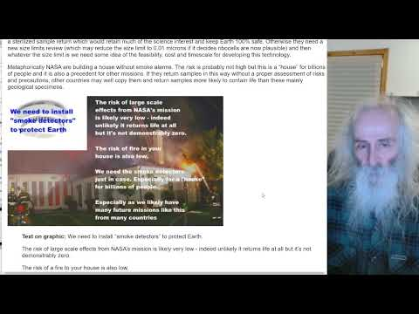

Video: Many Serious Errors In NASA's Samples From Mars Environmental Impact Statement - A Way Forward
Blog post: Many Serious Errors In NASA's Samples From Mars Environmental Impact Statement - A Way Forward

Introduction – significant risk the mission is stopped altogether or an injunction issued to NASA to sterilize all samples due to an inaccurate Environmental Impact Statement

As a result of this incomplete EIS, there is a significant risk that the mission is stopped altogether, or that the decision is made that NASA have to sterilize all samples from Mars to keep humans, other species and Earth’s environments safe.

This EIS s full of inaccurate cites which misrepresent the sources.

Often a sentence in the EIS will says "x" linked to a source of high reputation but without page numbers making it hard to check.

When you do locate the mention, it either says "not x" or it says “did not study x”.

Other sentences are linked to old science that’s overturned, so the sentence in the EIS says “x”, links to a source that says “x” but omits a later source that corrected “x” to “not x”.

These are not niggling details. As a result of this inaccurate citing, amongst other things the EIS says
- That credible sources say Mars has been uninhabitable for life for millions of years - MISTAKEN
- That there is no significant possibility of large scale effects on Earth's environment - MISTAKEN
- That samples can be handled in a standard BSL-4 facility - MISTAKEN
- That there is no real risk to the human technicians handling them - MISTAKEN
- That life from Mars can get to Earth faster and better protected in meteorites than in their sample tubes - MISTAKEN
The general public are not accepting these statements. They are reacting to this by saying with nearly every public comment either "stop this mission" or "Test first" but NASA are ignoring these concerns.

I will go through some examples. The aim here is to show that the draft EIS needs extensive peer review, not just of a few details and that the whole thing needs to be rewritten.

This is not in itself a review article. Others will need to do that. But the errors are so clear anyone can see them.

If you click through to the cites I give I think the reader can quickly confirm that indeed this draft EIS is inaccurately cited and would never pass peer review in any academic journal of repute.

Draft EIS says (MISTAKENLY) Mars life can get to Earth faster and be better protected in meteorites than sample tubes - their cites don’t support this - their main cite is about transfer from Mars to its innermost moon Phobos instead of Earth - and didn’t look at sterilization during ejection from Mars
This is a central point in their argument (NASA, 2022eis: 3-3):

The natural delivery of Mars materials can provide better protection and faster transit than the current MSR mission concept.
Indeed, if they were able to establish this, there would be no need for containment. For example, the last question in the decision tree for returning samples from small bodies is (NASEM, 1998:17)
Does the preponderance of scientific evidence indicate that there has been a natural influx to Earth, e.g., via meteorites, of material equivalent to a sample returned from the target body?
If the answer is yes, no special precautions are needed. This has been used correctly on other sample return missions, for instance with Hayabusa 1 & 2 the second sample from an artificially induced impact crater was similar to material transferred to Earth through natural processes, and so needed no special treatment (Kminek et al, 1999) (Yano et al, n.d.).
But sadly they don’t establish this due incorrect use of their cites. The draft EIS says that potential Mars microbes would be expected to survive ejection forces and pressure (NASA, 2022eis: 3-3):
First, potential Mars microbes would be expected to survive ejection forces and pressure (National Academies of Sciences, Engineering, and Medicine and the European Science Foundation 2019), …

But the paper from 2019 which they cite to support that claim is first of all, a study on ejection of materials from Mars to its innermost moon Phobos, not to Earth.

To get from the Martian surface to Phobos requires an escape velocity of 3.8 km/s according to their cite (Board, 2019 : 26). So the shock of ejection would be far less than for materials ejected with enough velocity to reach Earth of 5.03 km / sec (NASA, n.d.mfs).

It’s worse than that though. The paper they cite says explicitly that the team did NOT study sterilization during Mars ejecta formation in their analysis (Board, 2019 : 26) :

The SterLim team did not include any sterilization during Mars ejecta formation in its analysis because such investigations were not requested in its study’s statement of work.

So, the draft NASA EIS is using this 2019 paper as their only source - on a topic which the cite itself explicitly says it does NOT cover. Their cite does briefly look at heating during ejection but does NOT look at the far more important effects of shock.

So the pattern here is:

Draft EIS says x

Cite to support x says "didn't study x"

This is not just a niggling detail. This cite is central to their argument that transfer by a sample return mission is more difficult than transfer via meteorite impact and that the risk of a sample return is minimal even if there is life in it.

There are many sources they could have used that have studied this topic of survival of microbes in ejecta from Mars in depth.

For more about this see (below):

- NASA fail to adequately consider the risks from life that can’t get to Earth on meteorites - in 2009, the National Research Council examined the possibility of life transferred on meteorites said the risk is significantly greater in a sample return mission - and said they can’t rule out the possibility of large scale effects in the past due to life from Mars – NASA’s EIS instead claims microbes will survive transfer from Mars to Earth more easily in a meteorite than in a sample return mission but their sources don’t back this up

Another issue they don’t mention is that all the martian meteorites we have in our collections come came from at least 3 meters below the Martian surface (Head et al, 2002:1355),. The zzz subsurface below about 12 cms has a uniform temperature of around 200°K or -73°C (Möhlmann, 2005:figure 2). They were probably thrown up into space after glancing collisions into the Elysium or Tharsis regions, high altitude southern uplands (Tornabene et al, 2006). With such a thin atmosphere, and the low temperatures at 3 meters below the surface, present day life at those altitudes is unlikely (except perhaps for deep subsurface geothermal hot spots).

I cover this in of my preprint (Walker, 2022b) under

- Could Martian life have got to Earth on meteorites? Our Martian meteorites come from at least 3 m below the surface in high altitude regions of Mars

They also don’t look at the fireball of re-entry when it reaches Earth, which is the biggest hurdle for photosynthetic life. Although life inside the rock is shielded from the fireball, any photosynthetic life would be on the surface, not inside.

One of the papers they cite (Fajardo-Cavazos et al, 2005) was about re-entry by bacillus subtilis in this passage:

Thus, if potentially harmful microbes were abundant on the Martian surface it is likely they already would have been transferred to Earth by this natural process (Fajardo-Cavazos et al. 2005, Horneck et al. 2008, Howaxrd et al. 2013).

These though are papers on panspermia. What matters for sample return is whether there could be species on Mars that do NOT get to Earth. For panspermia what matters is if ANY species get from Mars to Earth. Charles Cockell showed that photosynthetic life, for instance, has many challenges getting from Mars to Earth and wouldn’t survive re-entry in typical position on or near the surface of the rock.

Charles Cockell’s paper (which they don’t mention) said planetary exchange of photosynthesis might not be impossible but quite specific physical conditions and evolutionary adaptations are needed and the fireball of re-entry is the most important filter to stop photosynthetic life getting to Earth

Charles Cockell, professor of astrobiology at Edinburgh university and author or co-author of numerous papers on astrobiology, is one of many authors who HAVE looked at this question.

Charles Cockell looks at Chroococcidiopsis, a blue-green algae that is astonishingly resistant to UV, dessicationk that can remake its DNA even when chopped to pieces by ionizing radiation, that can live almost anywhere on Earth from the hottest driest deserts to Antarctica, tropical reservoirs, or even over 100 meters below the sea level (it has many alternative metabolic pathways that let it survive without light). It’s also one of the top candidates for an Earth microbe that could survive on Mars.
Yet he concluded that Chroococcidiopsis would find it very hard to get from Mars to Earth. This very versatile polyextremophile still can’t do it easily.
Charles Cockell concludes that though some shock resistant life can be ejected from Mars and survive, that most photosynthetic life can’t get to Earth from Mars in this way on present day Mars though he leaves open the possibility that it could get here in unusual circumstances.
QUOTE Few ecological dispersal filters are completely effective. Each of the filters described above could be survived on account of specific physical factors or evolutionary innovations.
He found that it could survive ejection from Mars but only at the lower end of the range. Chroococcidiopsis doesn’t form spores and that makes it far harder for it to resist the shock of ejection from Mars than other hardier spore forming microbes.
...In the case of ejection from the planetary surface, the experiments with Chroococcidiopsis sp. show that even these vegetative cells could survive shock pressures at the lower end of that documented in Martian meteorites (∼5 GPa).
To put this in context just about all the meteorites in our collections have ejection shock pressures larger than 5 GPa. Normally 15 GPa or larger. But from modelling about 1 in 50 should be less than 1 GPa.
Unlike the draft EIS, Cockell refers to planetary ejection as a “potentially strong dispersal filter” - many of the microbes would be killed by ejection. But at lower levels then they can be survivable.
... Thus, although planetary ejection is shown experimentally to be a potentially strong dispersal filter, these same experiments show that shock pressures close to those required to achieve escape velocity, at least for Mars-like planets, can be survived even for vegetative phototrophs without special protection.
But for those that survive the shock of ejection, then there’s the fireball of re-entry. It’s going to be hard for any photosynthetic life to survive that as they would be living on the surface or else maybe in cracks but still within reach of plasma that would get deep inside the meteorite.
... The dispersal filter of atmospheric transit is the most effective dispersal filter for photosynthesis.
... Thus, the planetary exchange of photosynthesis might not be impossible, but quite specific physical situations and/or evolutionary innovations are required to create conditions where a photosynthetic organism happens to be buried deep within a rock during ejection to survive atmospheric transit.

His argument here looks specifically at Chroococcidiopsis, one of the top candidates for a terrestrial microbe that might be able to survive on present day Mars.

See below:
- Chroococcidiopsis as an example of a species that wouldn’t survive transfer by impacts from modern Mars based on an analysis by Charles Cockell
- A mirror life chroococcidiopsis analogue as a worst case example of a pioneer species that would have adaptations that let it survive almost anywhere on Earth if returned from Mars and that could never be returned safely as it would risk transforming terrestrial organics to mirror organics that most life can’t use

There isn’t anything here to support the thesis of the draft EIS that it is easier for Martian microbes to get to Earth on a meteorite than in a sample tube. (NASA, 2022eis: 3-3):

The natural delivery of Mars materials can provide better protection and faster transit than the current MSR mission concept.

So Chroococcidiopsis is an example that shows that a species can be returned via a sample return far more easily than it could get here on a meteoroid ejected from Mars.

The principle is fine. It goes back to Greenberg (Greenberg et. al, 2001)

"As long as the probability of people infecting other planets with terrestrial microbes is substantially smaller than the probability that such contamination happens naturally, exploration activities would, in our view, be doing no harm. We call this concept the natural contamination standard."
But it is applied incorrectly in this draft EIS.

Here our attention should be on the species that are NOT able to get from Mars to Earth or not get here easily. As an example, Barn swallows are not an invasive species in the USA while starlings are. European starling is an invasive bird in the Americas (US DOA, 2017).
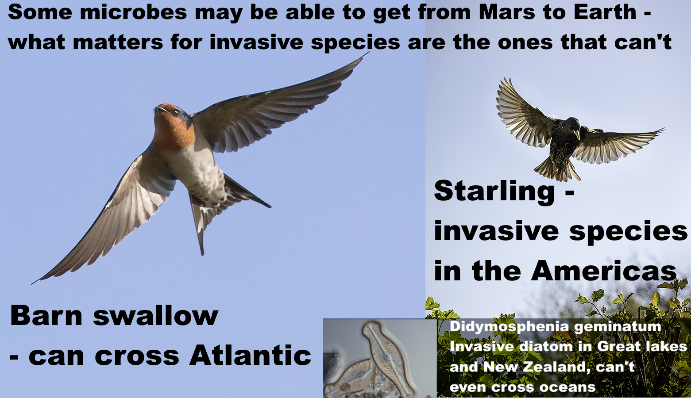
Text on graphic: Some microbes may be able to get from Mars to Earth - what matters for invasive species are the ones that can’t.
Barn swallow - can cross Atlantic
Starling - invasive species in the Americas
Didymosphenia geminatum invasive diatom in Great Lakes and New Zealand, can’t even cross oceans.
Starling photo from: (Johnstone, 2017)
Barn swallow photo from (Batbander, 2017)
Didymosphenia geminata (Lyngb.) from (Schmidt, n.d.)
It’s not only birds. You might think microbes can surely all cross the Atlantic. But no. It’s far harder for a microbe that can only survive in fresh water to cross an ocean. There are diatoms in the sea too, but diatoms can’t survive long when dried out and fresh water diatoms can’t survive in the sea. I cover the diatom examples below:

- Example of fresh water diatoms that can’t cross oceans on Earth
- We might even find diatoms on Mars – either preserved in gypsum, or perhaps living in the lakes our orbiters found beneath the polar ice
Fresh water diatoms are microbes that not only can’t get to Mars on a meteorite. They can’t even cross the Atlantic. Salt water diatoms can’t survive being dried out for long. It’s highly implausible that a diatom from Mars could get to Earth.
So, just as there are many species on Earth that could never get to Mars on a meteorite, if Mars has a diversity of microbial species, there are likely to be many species on Mars that could never get to Earth that way.
Mars is very inhospitable to us but to some microbes on Mars, the microhabitats there are what they are adjusted to. The little brine seeps are like an ocean to them. They may have great difficulties even transferring from place to place on Mars. They may only be able to get from one habitat to another occasionally in the dust storms shielded from the UV. Perhaps it takes a thousand years to get to another nearby brine seep.

Would a microbe adapted to microhabitats on the surface of Mars, living in the dirt, brines, or just beneath the crust of a rock, or in pores in salt, be more like the starling or barn swallow?

There might be reason to suppose it would be more like the starling. Also there could be completely different forms of life on Mars with different biochemistries, for instance there could potentially be nanobe mirror life unable to get to Earth on a meteorite co-existing with other species related to terrestrial life that are able to get here
It is not totally impossible life could get into the Martian meteorites, but would require a high measure of luck. Some Martian volcanoes have been active in the geologically recent past, as recent as 2 million years ago. Olympus Mons shows signs of glacial activity as recent as four million years ago which suggests it likely has ice protected beneath the dust on its slopes (Neukam et al., 2004).
A lucky asteroid impact on Mars could throw up material from a subsurface cave, or a geothermal hot spot, or fumarole. But such events would surely be rare. A very versatile polyextremophile species might be present almost everywhere on Mars and also get to Earth on a meteorite but a more specialist species like the diatoms might never get here.

More on this in my section here (below):

- If we want to conclude from the meteorite evidence that microbial species from Mars are safe for Earth we need ALL Martian species to get to Earth on meteorites – example of barn swallows that can cross the Atlantic and are native to North America, while European starlings can’t and are non native – natural processes can’t transfer the surface dust, dirt, ice and salts of Mars to Earth

The bottom line here is we have no examples of life that got to Earth from Mars. It may have happened but we don’t know for sure that it ever happened. We are reasoning theoretically about something we can’t currently study through observation.

The reasoning we have is based on the capabilities of terrestrial life. We can test various terrestrial microbes extensively. However we know nothing specific about the capabilities of Martian life such as its ability to withstand the shock of ejection, the vacuum of space, and the fireball of re-entry or how likely it is to be able to get onto a meteorite that heads for Earth.

Draft EIS says (MISTAKENLY) existing credible evidence suggests Mars hasn’t been habitable for life as we know it for millions of years - their cite says that we need to search for current habitats in a seemingly uninhabitable Mars

Another central argument in the draft EIS is that Mars is lifeless anyway and that they are doing the sample return precautions just out of an “abundance of caution”. The draft EIS says that “conditions on Mars have not been amenable to supporting life as we know it for millions of years” (NASA, 2022eis: 1-6):

Existing credible evidence suggests that conditions on Mars have not been amenable to supporting life as we know it for millions of years (iMARS Working Group 2008, National Research Council 2011, Beaty et al. 2019, National Research Council 2022).

But their most recent 2022 source for this “existing credible evidence” says the opposite from their summary.

Their source says that exploration of Mars will help establish whether localised habitable regions currently exist. It refers to Mars as “seemingly uninhabitable”, not “uninhabitable. See: (Smith et al, 2022: 393):

This is in the section titled:

“Are There Chemical, Morphological and / or Physiologic / Metabolic or Other Biosignatures in Currently Habitable Environments in the Solar System

[Emphasis on “currently” mine]

The exploration of … Mars (Curiosity, Perseverance) will help establish whether localised habitable regions currently exist within these seemingly uninhabitable worlds.

Their source continues to say that once habitable environments are identified, the greatest challenge is the search for evidence of life and it warns about the need for inclusivity, not relying solely on what life on Earth can do as a guide. (Smith et al, 2022: 393):

Once habitable environments are identified, the search for evidence of life represents the logical next step, and also the greatest challenge.
…
Inclusivity emphasizes consideration of a wide range of possible alien biosignatures (chemical, morphological and / or physiologic/ metabolic), not relying solely on Earth life as a guide, as well as their prevalence and detectability in the given environment. As such, inclusivity seeks to minimize potential false negative results where life could be “missed” for lack of the ability to detect or recognize it.

Here is a screenshot.
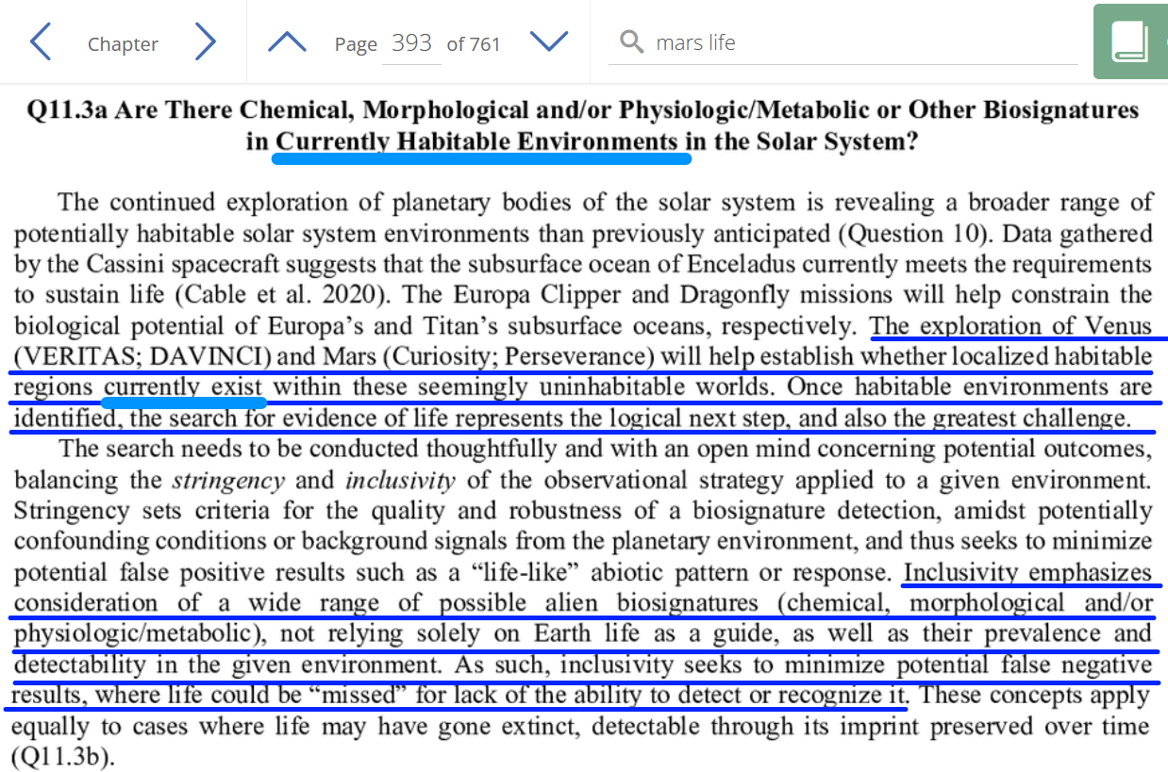
(Smith et al, 2022: 393):

This is an excellent source but sadly it is cited in an inaccurate way.

The EIS statement is that existing credible evidence suggests Mars has been uninhabitable for million years (cite)

The cite to support this says that Mars exploration will establish whether there are localised habitable regions on Mars

So the pattern here is:

EIS says x
Cite to support x says: not x

For more on this see the sections below:

- Views of astrobiologists in the planetary protection literature – some think there is a high chance Mars is inhospitable but none go as far as certainty – and others say it may have small niches for microbial life over much of the surface
- NASA’s summary by comparison – “existing credible evidence suggests that conditions on Mars have not been amenable to supporting life as we know it for millions of years” – is this because they associate life with large amounts of water rather than the minute transient biofilms, droplets and even high humidity without water, all microhabitats that microbes can make use of? Renno’s “Swimming pools foo a bacteria”

Draft EIS says (MISTAKENLY) Jezero crater is too inhospitable for life to survive there – their cite from 2014 only studied forward contamination by terrestrial life, and specifically says it didn’t study potential capabilities for Martian life
Another central part of the reasoning is they claim that there is no life in Jezero crater where Perseverance is collecting samples even if there is life elsewhere. Again they falsely claim a consensus on this. (NASA, 2022eis: S-4)

Consensus opinion within the astrobiology scientific community supports a conclusion that the Martian surface is too inhospitable for life to survive there today, particularly at the location and shallow depth (6.4 centimeters [2.5 inches]) being sampled by the Perseverance rover in Jezero Crater, which was chosen as the sampling area because it could have had the right conditions to support life in the ancient past, billions of years ago (Rummel et al. 2014, Grant et al. 2018).

Their first cite here is (Rummel et al , 2014) which is a study of Mars special regions. But Rummel et al looked at forward contamination, to try to delineate areas where missions TO Mars risk introducing terrestrial life that might be able to replicate on Mars. Rummel et al is NOT an attempt to explore possible locations for extant native martian life returned FROM Mars.

Rummel et al say this explicitly that they are not going to discuss habitats for extant Martian life. (Rummel et al , 2014:888)

Special Regions are regions ‘‘within which terrestrial organisms are likely to replicate’’ as well as ‘‘any region which is interpreted to have a high potential for the existence of extant martian life.’’
…
At present there are no Special Regions defined by the existence of extant martian life, and this study concentrates only on the first aspect of the definition.

The issue here is that martian life might have capabilities terrestrial life doesn’t have through a different biochemistry or even just by having a different salt in the intercellular fluid instead of sodium chloride. We may not need to consider this in much depth for a study on forward contamination but it is essential to consider the possibility of martian life with capabilities different from terrestrial life for backward contamination.

So this is the pattern

EIS: x
Cite to support x: didn’t study x.

For more on this see (below)

- NASA fail to consider at all the potential for microhabitats in Jezero crater not detectable from orbit such as the Curiosity brines which could be habitable to biofilms or martian life able to tolerate conditions too old for terrestrial life
I cover some of the literature on this topic in my preprint (Walker, 2022b) in the section:

- How Martian life could make perchlorate brines habitable when they only have enough water activity for life at -70 °C – biofilms retaining water at higher temperatures - chaotropic agents permitting normal life processes at lower temperatures – and novel biochemistry for ultra low temperatures

[title only, please visit my preprint and search for the section by title, I’ve copied only the most relevant sections over to this document]

Draft EIS says MISTAKENLY that the 2014 cite represents a consensus opinion within the astrobiology scientific community – it was not a consensus even for forwards contamination as it was overturned by a 2015 review commissioned by ESA and NASA which emphasized potential for microhabitats within apparently uninhabitable regions, and transport of life on dust

Here is the cite again: (NASA, 2022eis: S-4)

Consensus opinion within the astrobiology scientific community supports a conclusion that the Martian surface is too inhospitable for life to survive there today, particularly at the location and shallow depth (6.4 centimeters [2.5 inches]) being sampled by the Perseverance rover in Jezero Crater, which was chosen as the sampling area because it could have had the right conditions to support life in the ancient past, billions of years ago (Rummel et al. 2014, Grant et al. 2018).

Their source (Rummel et al , 2014) is not a consensus position. Even as that 2014 report by Rummel et al was in publication, NASA and ESA commissioned a review which overturned many of its findings.

The NASA EIS relies on (Rummel et al , 2014) with many cites.

It is a serious omission to not mention (Board, 2015) which reversed or corrected many of its findings.

This is the pattern

EIS: x
Cite: x
Later source not cited: corrects x to not x.

This serious omission is especially important as it lead to an omission of any discussion of microhabitats in Jezero crater or of spores or propagules that could be brought there in the dust.

(Board, 2015). found microhabitats and transport of microbes in dust storms were knowledge gaps that need to be addressed and weren’t adequately covered by (Rummel et al , 2014).

In particular Jezero crater could have microhabitats that can’t be detected from orbit or by Perseverance, and also spores in the dust that couldn’t be detected from orbit, or indeed by Perseverance’s science objectives. This is especially so for any putative native martian life perhaps using a different salt from sodium chloride for its intercellular fluid or in other ways having a greater tolerance for extremely cold brines.

They don’t consider this issue because they only cited (Rummel et al , 2014) and didn’t cite (Board, 2015).

See:
- NASA fail to consider at all the potential for microhabitats in Jezero crater not detectable from orbit
- NASA fail to consider at all the potential for dust storms to transfer life to Jezero crater

Review of the MEPAG report says maps made from orbit only provide information at the scale of the map - and “can only represent the current (and incomplete) state of knowledge for a specific time”
The biggest change between on (Rummel et al , 2014) and (Board, 2015) was on the utility of maps to map out the special regions. The review board said that maps made from orbit can only provide information at the scale of the map and so are a generalization. They say that maps can only represent the current (and incomplete) state of knowledge for a specific time.
They say that this knowledge is subject to change as new information is obtained: (Board, 2015 : 28) (page number here links directly to the relevant page on the site).
Another potential source of misinterpretation related to the use of maps in Special Region studies is the issue of scale. Identification of a Special Region needs a multiscale approach (see also the discussion in Chapter 2, “Detectability of Potential Small Scale Microbial Habitats,” and thus, as far as missions to Mars are concerned, conservatism demands that each landing ellipse be scrutinized on a case-by-case basis.
Maps, which come necessarily at a fixed scale, can only provide information at that scale and are, therefore, generalizations
…
In general, the review committee contends that the use of maps to delineate regions with a lower or higher probability to host Special Regions is most useful if the maps are accompanied by cautionary remarks on their limitations. Maps that illustrate the distribution of specific relevant landforms or other surface features can only represent the current (and incomplete) state of knowledge for a specific time—knowledge that will certainly be subject to change or be updated as new information is obtained.
In more detail, (Board, 2015 :12) the temperature and humidity is only measured on large scales, and microhabitas can be substantially different physically and chemically.
The definition of Mars Special Regions is based on temperature and humidity conditions that are measured on spatial scales that do not reflect these conditions within microscale niches that can be potential habitats for microbial communities. Physical and chemical conditions in microenvironments can be substantially different from those of larger scales. Although the SR-SAG2 report considered the microenvironment (Finding 3-10), the implications of the lack of knowledge about microscale conditions was only briefly considered.
There are many examples of these small-scale and microscale environments with microbial communities on Earth. The biofilm, a mix of many species of microbes, can make the conditions suitable for microbial propagation despite adverse and extreme surrounding conditions.
There are many examples of small-scale and microscale environments on Earth (see e.g., Lindsay and Brasier 2006) that can host microbial communities, including biofilms, which may only be a few cell layers thick. The biofilm mode of growth, as noted previously, can provide affordable conditions for microbial propagation despite adverse and extreme conditions in the surroundings.
This is something that has become more obvious on Earth in recent years. We need a better understanding of this for Mars.
On Earth, the heterogeneity of microbial colonization in extreme environments has become more obvious in recent years (e.g., Azúa-Bustos et al. 2015). To identify Special Regions across the full range of spatial scales relevant to microorganisms, a better understanding of the temperature and water activity of potential microenvironments on Mars is necessary.
They give examples of microenvironments - craters, and even microenvironments underneath rocks could become special regions when the temperature and humidity on the larger landscape-scale doesn’t permit terrestrial life to flourish on Mars.
For instance, the interior of the crater Lyot in the northern mid-latitude has been described as an optimal microenvironment with pressure and temperature conditions that could lead to the formation of liquid water solutions during periods of high obliquity (Dickson and Head 2009). Craters, and even microenvironments underneath and on the underside of rocks, could potentially provide favorable

2015 Review of the 2014 MEPAG report has a long section about how biofilms with many microbes working together can make microhabitats in regions that are otherwise inhospitable for life - Nilton Renno has suggested the Curiosity brines could be inhabitable in this way

The 2015 review also has a long section about biofilms and the ability of microbes to modify microhabitats by surrounding themselves with “extrapolymeric substances” - proteins, polysaccharides, lipids, DNA and other molecules.
These EPS can modify the microhabitat and make it much more habitable for microbes and help them cope with stressors in the environment. (Board, 2015 :11)
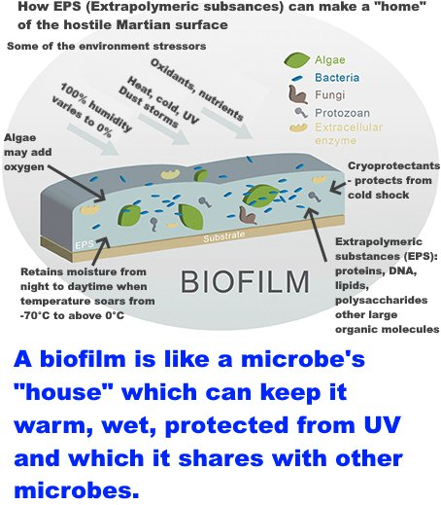
How EPS (extrapolymeric substances) can make a “home” of the hostile Martian surface.
Some of the environment stressors
100% humidity varies to 0%
Heat, cold, UV, dust storms
Oxidants, nutrients
Algae may add oxygen
Retains moisture from night to daytime when temperature soars from -70°C to above 0°C.
Cryoprotectants - protects from cold shock
Extrapolymeric substances (EPS): proteins, DNA, lipids, polysaccharides, other large organic moleculese.
A biofilm is like a microbe’s “house” which can keep it warm, wet, protected from UV and which it shares with other mirobes.
I got the metaphor of a "house" from this paper (Flemming et al, 2007):
If biofilms can be metaphorically called a “city of microbes” (24), the EPS represent the “house of the biofilm cells.” The EPS determine the immediate conditions of life of biofilm cells living in this microenvironment by affecting porosity, density, water content, charge, sorption properties, hydrophobicity, and mechanical stability (6).
While reading this we need to bear in mind also that this is a study of forward contamination, and they don’t consider native Martian life which might be pre-adapted to withstand stressors terrestrial microbes can’t and might have a different biochemistry from terrestrial microbes.
They first observe that microorganisms typically live and proliferate in communities [of many different species] rather than single cells or unispecies populations
In nature, microorganisms typically live and proliferate as members of communities rather than as single cells or populations.
Biofilms are very common where the many species of microbes surround themselves with a self-produced matrix of various macromolecules such as proteins, polysaccharides, lipds and DNA, the EPS (Extrapolymeric substances). These protect them from stresses like dessication, radiation, harmful chemical agents and predators.
A widespread growth form of life in natural habitats occurs as multispecies biofilms where the cells are embedded in a self-produced extracellular matrix consisting of polysaccharides and proteins, which includes other macromolecules such as lipids and DNA. These so-called extrapolymeric substances (EPS) provide protection against different environmental stressors (e.g., desiccation, radiation, harmful chemical agents, and predators). Biofilms are highly organized structures that enable microbial communication via signaling molecules, disperse cells and EPS, distribute nutrients and release metabolites, and facilitate horizontal gene transfer.
The majority of known microbial communities on Earth are able to do this.
The majority of known microbial communities on Earth are able to produce EPS, and the protection provided by this matrix enlarges their physical and chemical limits for metabolic processes and replication.
These EPS also make the microbial commuities more tolerant to multiple simultaneous stressors (ex. on Mars there’s the UV, dessication, ionizing radiation, extreme cold, the high salt concentrations, perchlorates, hydrogen peroxide amongst other stressors, but a biofilm could protect the community from all of those).
EPS also enhances their tolerance to simultaneously occurring multiple stressors and enables the occupation of otherwise uninhabitable ecological niches in the microscale and macroscale. The presence of EPS within a microbial community has implications for several aspects of the SR-SAG2 report, including the physical and chemical limits for life, the dimension of habitable niches versus the actual resolution capability of today’s instruments in Mars orbit, colonization of brines, and tolerance to multiple stressors.
The EPS are also excellent for protection against extreme cold (cryoprotectant).
In extreme cold and salty habitats (e.g., brines of sea ice and cryopegs in permafrost), EPS has been found to be an excellent cryoprotectant (Goordial et al. 2013). For instance, production of EPS by the marine psychrophilic bacterium Colwellia psychrerythraea increases in response to low temperatures, to high pressure, and to salinity (Marx et al. 2009). Another example is the EPS produced by hypolithic microbial communities that develop on the undersides of translucent rocks in the Dry Valleys of Antarctica, which is thought to facilitate the water-holding capacity of cells and promote microbial survival, growth, and succession (Makhalanyane et al. 2013; de los Ríos et al. 2014).
The production of EPS lets microbial communities survive in nearly any undisturbed environment with enough water and nutrients.
The production of EPS enhances the resistance of cells to a wide variety of environmental stresses, when compared to their resistance in planktonic growth mode, and enables microbial communities to thrive in nearly any undisturbed environment that receives sufficient water and nutrients.
Microbial stowaways to Mars would likely need to develop biofilms to establish themselves on Mars.
Given the wide distribution and advantages that communities of organisms have when they live as biofilms enmeshed in copious amounts of EPS, it is likely that any microbial stowaways that could survive the trip to Mars would need to develop biofilms to be able to establish themselves in clement microenvironments in Special Regions so that they could grow and replicate.
So when asking if spacecraft could be sources of forward contamination on Mars a central question is whether the spacecraft has enough terrestrial life on it to be able to establish a biofilm on Mars. It’s not about the species only but about how many microbes there are to establish a “beachhead” on the martian surface for terrestrial life to start growing there.
They say the experiments hadn’t yet been done to establish this.
This consideration raises a fundamental question about the probability of a successful colonization by microbial contaminants from Earth in martian habitats, one recently formulated in an essay by Siefert et al. (2012). Studies have been conducted to determine the bioburden found on spacecraft and their assembly facilities (e.g., Satomi et al. 2006; Rettberg et al. 2006; Moissl-Eichinger et al. 2012, 2015). But, to date, there have been no experimental attempts to determine whether the number and type of cells that remain on spacecraft after sterilization and/or after launch and travel through space (e.g., even in low Earth orbit) are sufficient to establish a population and/or community of microorganisms within a Mars Special Region.
That last paragraph is quite encouraging that our spacecraft may well not have sent enough life to Mars for it to start to colonise the surface.
However, the brines Curiosity found in Gale Craters (which they didn’t know about at the time) would seem to fit their description of conditions that could be made habitable by a biofilm of terrestrial life.
Nilton Renno, amongst other things was part of the team that found evidence of liquid water for the Phoenix lander project, and the droplets on the Phenix lander legs, who runs the REMs weather station on Curiosity, and who has written a big review of the possibilities for liquid water on Mars.
Nilton Renno has suggested the very cold brines found by Curiosity in Gale crater (and probably also present in Jezero crater) could be habitable to a biofilm that can regulate its microhabitate (Nilton Renno, as reported in Pires, 2015).
"Life as we know it needs liquid water to survive. While the new study interprets Curiosity's results to show that microorganisms from Earth would not be able to survive and replicate in the subsurface of Mars, Rennó sees the findings as inconclusive. He points to biofilms—colonies of tiny organisms that can make their own microenvironment."
As an example, a biofilm could retain the liquid water from the night when it is too cold for life but has enough water activity for life, through to the day time when the temperatures can reach above 0 °C close to the surface where these brines form (Yin et al, 2019).

Throughout environmental changes, biofilm can act as a “protective clothing” to provide a suitable habitat for their survival and metabolism. In the extreme temperature environment, the biofilm serves more as a “smart garment” when dealing with such high temperatures: it can resist the external high temperature and render the interior suitable for growth and reproduction. On the other hand, biofilm can also stabilize the internal environment when it is extremely cold outside, causing no freeze of the cells and enabling them to survive.
…
In extreme environments, microorganisms regulate the expression of a series of biofilm-forming genes through QS, nucleotide second messenger-based signaling, etc., to endow microorganisms with the capability of becoming resistant to various extreme environments such as UV radiation, extreme temperature and pH, high salinity, high pressure, poor nutrients, antibiotics, etc.
I am not sure what this means by “stabilize the internal environment”. But biofilms would also modify the thermal inertia of the soil. Could this reduce the day - night variation in temperature? Soil moisture does reduce variability in semi-arid regions by evaporation feedbacks, and by thermal inertia (Cheruy et al, 2017). Anyone reading this know?

Many other changes in the 2015 review in the direction of increasing the potential for habitability of Mars for terrestrial life
Here are some of the other changes the 2015 study made relevant to the detection of life: (Board, 2015 : Appendix B)
Terrestrial life that depends on other life could find a home on Mars, not just life that is able to produce all its own organics, because of the organics present on Mars:
Finding 2-1: Modern Mars environments may contain molecular fuels and oxidants that are known to support metabolism and cell division of chemolithoautotrophic microbes on Earth.
Revised Finding 2-1: Modern Mars environments may contain chemical compounds that are used as electron donors and electron acceptors by chemolithoautotrophic microbes. If organic compounds are also present on Mars, then heterotrophic microbes may also find a home there.
The methane on Mars could be produced by processes that involve liquid water and source regions for methane should be considered as uncertain regions for terrestrial ife to inhabit.
Finding 2-4: Organic compounds are present on Mars (or in the martian subsurface); although in very low concentrations in samples studied to date. Such detections are not used to distinguish Special Regions on Mars.
Revised Finding 2-4: Organic compounds are present on Mars (or in the martian subsurface); although in very low concentrations in samples studied to date. Abiotic or potentially biotic processes can explain the detection of episodic plumes of methane at various latitudes. In both cases, liquid water solutions would be involved. Therefore, the source regions of methane are considered as Uncertain Regions, even if the methane production is abiotic.
In this next quote the RSLs are Recurrent Slope Lineae - streaks that form in spring, grow and expand through the summer and fade away later in the year on steep sun facing slopes on Mars. These can be found anywhere on Mars including where Curiosity was and potentially could be in Jezero crater.
They were originally thought to be due to liquid water. Then evidence turned up suggesting that they are due to dust / dirt flowing down the slopes, but then problems turned up with the “dry granular flow” models and they don’t seem to explain everything. The 2015 study said that water could still be involved.
There are some problems with the dry granular flow models for RSLs, so processes involving liquid water can’t be definitively excluded.
Finding 4-8: The 2006 Special Regions analysis did not consider dark/light slope streaks to be definitive evidence for water. Recent results have strengthened that conclusion for non-RSL slope streaks.
Revised Finding 4-8: The 2006 Special Regions analysis did not consider dark/light slope streaks to be definitive evidence for liquid (saline) water. Although some recent results have strengthened that conclusion for non-RSL slope streaks, other recent reports suggest that there are problems explaining all dark slope streaks by dry granular flow, and therefore aqueous processes cannot be definitely excluded for all dark slope streaks.
This is about distant habiats on Mars, not directly relevant but it could be a source for life in dust storms. The polar dark streaks are streaks that form in the debris of CO2 geysers especially in Richardson crater in the southern hemsisphere. The revised report says that they could involve liquid water through a solid-state greenhouse effect while the 2014 report said they most likely don’t involve liquid water at all.
Finding 4-9: Polar dark dune streaks are considered extremely unlikely to involve liquid water warmer than 253 K (–20°C), and most likely do not involve liquid water at all, given the low surface temperatures present when they are active.
Revised Finding 4-9: A conservative interpretation of the evidence suggests that polar dark dune streaks could potentially involve liquid brines but only in the presence of heating mechanisms such as solid-state greenhouse effects.
The revised report says there could be buried ice less than 1 meter below the surface in pole facing slopes in the tropics and mid latitudes and a detailed analysis is needed to see if there is ice at a particular site.
Finding 5-3: Depths to buried ice deposits in the tropics and mid-latitudes are considered to be >5 m.
Revised Finding 5-3: In general, depths to buried ice deposits in the tropics are considered to be >5 m. However, there is evidence that water ice is present at depths of <1 m on pole-facing slopes in the tropics and mid latitudes. Thus, a local detailed analysis for a particular area is necessary to determine if it could be a Special Region.
Detailed analysis is needed to see if the mid-latitude mantle is dessicated or may have transient liquid water.
Finding 5-4: The mid-latitude mantle is thought to be desiccated, with low potential for the possibility of modern transient liquid water.
Revised Finding 5-4: The mid-latitude mantle is thought to be desiccated, with low potential for the possibility of modern transient liquid aqueous solutions. However, a local detailed analysis for a particular area is necessary to determine if it could be a Special Region.
It’s not actually certain that terrestrial life has a limit of -18 C for cell division. There’s possibility that cells can divide well below that temperature but very slowly, on timescales too slow to detect in most eperiments done in the laboratory.
“Finding 3-1: Cell division by Earth microbes has not been reported below –18°C (255K).
“Revised Finding 3-1: Cell division by Earth microbes has not been reported below –18°C (255K). The very low rate of metabolic reactions at low temperature result in doubling times ranging from several months to year(s). Current experiments have not been conducted on sufficiently long timescales to study extremely slow-growing microorganisms.”

2015 review of the 2014 MEPAG report recommends further research into detectability of potential small-scale microbial habitats on Mars as a knowledge gap to be looked at in the future
This is in their Appendix A. (Board, 2015 : 46)
The need for more research into detectability of potential small-scale microbial habitats
Detectability of Potential Small-Scale Microbial Habitats
Perform in situ investigations in extreme environments on Earth to deepen our knowledge about microbial processes and habitability at micron scales. Adapt and optimize existing technologies and develop new ones to undertake the kind of investigations which may be used in the future exploratory missions to other planets and moons of astrobiological relevance.

2015 review of the 2014 MEPAG report recommends further research into viability of terrestrial microbes transported in the dust storms on Mars as a knowledge gap to be looked at in the future
Need for more research into microbial viability of terrestrial life when transported in dust storms
Translocation of Terrestrial Contamination
Undertake investigations of transport mechanisms and microbial viability in Mars simulation chambers—e.g., the Mars Surface Wind Tunnel facility at NASA’s Ames Research Center or the low-pressure recirculating wind tunnels in the Mars Simulation Laboratory at Aarhus University—wherein microbes and spores are exposed to Mars-relevant levels of ultraviolet radiation, desiccation, nutrient deficit, and air movement, to assess the likelihood of survival during transport by, for example, dust storms.
As far as I can tell this research hasn’t been done, at least I find no recent studies that cite the older studies on the topic.
In more detail on dust the 2015 report says dust can block UV and make microbes more viable, and microbes often occur in cell clusters and the inner cells would be protected against UV in dust storms
: (Board, 2015 : 12)
Atmospheric transport can move microbial cells and spores over long distances, as is known from investigations of foreign microbes delivered to North America from Africa via Saharan dust (Chuvochina et al. 2011; Barberàn et al. 2014) and Asia (Smith et al. 2012).
…
In addition to dilution effects, the flux of ultraviolet radiation within the martian atmosphere would be deleterious to most airborne microbes and spores.
However, dust could attenuate this radiation and enhance microbial viability. In addition, for microbes growing not as single cells but as tetrades or larger cell chains, clusters, or aggregates, the inner cells are protected against ultraviolet radiation. Examples are methanogenic archaea like Methanosarcina, halophilic archaea like Halococcus, or cyanobacteria like Gloeocapsa. This is certainly something that could be studied and confirmed or rejected in terrestrial Mars simulation chambers where such transport processes for microbes (e.g., by dust storms) are investigated. The SR-SAG2 report does not adequately discuss the transport of material in the martian atmosphere.
Also this is all about forwards contamination by terrestrial life. What about Martian life adapted to the dust storms over billions of years? Could it develop adaptations to survive transport in dust storms that terrestrial life doesn’t have? I suggest native Martian life could propagate via much larger grains up to half a millimeter in diameter if it can survive the impact shocks of repeated bounces across the Martian landscape.
I cover this in my preprint (Walker, 2022b) in the sections:
- Native Martian propagules of up to half a millimeter in diameter (including spore aggregates and hyphal fragments) could travel long distances with repeated bounces (saltation) - if they can withstand the impacts of the bounces
- Martian spores could evolve extra protection such as a shell of agglutinated iron oxide particles to protect themselves from UV
- Martian life could also use iron oxides from the dust for protection from the impact stresses of the saltation bounces - or it might use chitin - a biomaterial which is extremely hard and also elastic and is found in terrestrial fungi and lichens

The Grant et al cite in the Draft EIS isn’t about planetary protection, just supports the statement that the main aim for the mission was to search for past life

Their second cite (Grant et al, 2018) seems to be just to support the sentence

which was chosen as the sampling area because it could have had the right conditions to support life in the ancient past, billions of years ago

It doesn’t have anything about whether there is life there except to say it’s not a “special region” where terrestrial life could propagate in the forwards direction. It refers to another paper for the detailed assessment (Grant et al, 2018):

Moreover, planetary protection considerations warrant the exclusion of “special regions” where liquid water may exist at the surface (e.g., recurring slope lineae (RSL) (McEwen et al., 2014)), where there is evidence for water or ice within 1 m of the surface (Rummel et al., 2014; Golombek et al., 2015), or possibly other induced special region. (e.g., Shotwell et al., 2017).

The paper continues by saying it’s not a paper about planetary protection:

These atmospheric and planetary protection assessments are described in separate publications (e.g., Shotwell et al., 2017), whereas this manuscript focuses mostly on the terrain.

And Shotwell at al is on “The potential for the off-nominal landing of an RTG-1491 powered spacecraft on Mars to induce and [sic] artificial special region”

Curiosity’s Gale crater is an excellent example to show that this method of modelling and trying to assess habitability from orbit has limitations. AFTER Curiosity landed, orbital missions spotted one of the RSL’s only a few kilometres from Curiosity’s route. It was close enough for Curiosity to reach, but Curiosity is not sufficiently sterilized to study them close up, leading to debates about how close is safe to go (JPL, 2016).

Also another unexpected find was the discovery of of brines in Gale crater that form briefly in the early morning and late evening as a result of the salts taking up water from the atmosphere – with enough water activity for life, though too cold for terrestrial life (Martin-Torres et al, 2015). Nilton Renno has suggested this could be habitable to a biofilm that can regulate its microhabitat, for instance, retain the water through to warmer conditions in daytime (Nilton Renno cited in Pires, 2015).

Draft EIS says (MISTAKENLY) potential environmental impacts would not be significant – 2009 NRC study says risk of large scale effects appears to be low but not demonstrably zero, and they can’t rule out the possibility of large scale effects on the Earth’s biosphere from martian life in the distant past

Then in the draft EIS they say that the potential environmental impacts from a sample release would not be significant (NASA, 2022eis: 3-16):

The relatively low probability of an inadvertent reentry combined with the assessment that samples are unlikely to pose a risk of significant ecological impact or other significant harmful effects support the judgement that the potential environmental impacts would not be significant.

This sentence is not cited. However in the discussion of large scale effects, the 2009 National Research Foundation study they use as a source elsewhere says that it is simply not possible to discount such effects in the distant past from Martian life transferred to Earth. (Board et al, 2009: 48).

“Although such exchanges are less common today, they would have been particularly common during the early history of the solar system when impact rates were much higher....

“Despite suggestions to the contrary, it is simply not possible, on the basis of current knowledge, to determine whether viable Martian life forms have already been delivered to Earth.

Certainly in the modern era, there is no evidence for large-scale or other negative effects that are attributable to the frequent deliveries to Earth of essentially unaltered Martian rocks. However the possibility that such effects occurred in the distant past cannot be discounted

... Thus it is not appropriate to argue that the existence of martian meteorites on Earth negate the need to treat as potentially hazardous any samples returned from Mars by robotic spacecraft. ... A prudent planetary protection policy must assume a biological hazard exists from Mars sample return and that every precaution should be taken to ensure the complete isolation of any deliberately returned samples, until it can be determined that no hazard exists.”

They don’t give any examples there but the Great Oxygenation Event is a natural one to consider – see the sections below:

- NRC 2009 report emphasizes that large scale effects can’t be ruled out – it says potential hazards from microbes returned in a sample return mission are significantly greater than hazards from microbes in meteorites and that though there have certainly been no recent large scale effects that could be due to microbes from Mars, the possibility of large scale effects in the distant past can’t be disproved – draft EIS says potential environmental effects would not be significant
- The Great Oxygenation Event which transformed Earth’s atmosphere and oceans chemically gives a practical example of a way life from another Mars-like planet could in principle cause large scale changes to an Earth-like planet
The committee concludes that the risk appears to be low but not demonstrably zero.

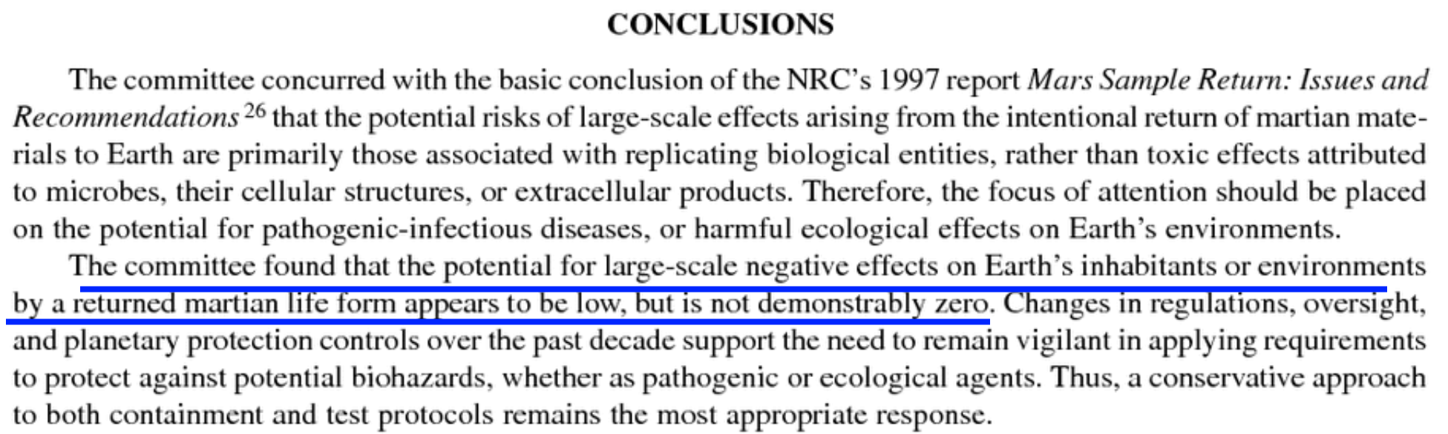

The committee found that the potential for large-scale negative effects on Earth’s inhabitants or environments by a returned martian life form appears to be low, but is not demonstrably zero (Board et al, 2009: 48).

Potential for large scale effects should be re-assessed based on many new potential microhabitats on Mars both for Jezero crater and elsewhere on Mars - not known at the time of the 2009 report

The 2009 report was written before
- Direct observation of what appear to be water droplets on the legs of the Phoenix lander (Gronstall, 2014)
- Discovery that water droplets like the ones seen on the Phoenix lander leg form rapidly whenever salt overlays ice on Mars (Fischer et al., 2014).
As Nilton Renno put it (Renno, 2014)
"This is a small amount of liquid water. But for a bacteria, that would be a huge swimming pool - a little droplet of water is a huge amount of water for a bacteria. So, a small amount of water is enough for you to be able to create conditions for Mars to be habitable today'. And we believe this is possible in the shallow subsurface, and even the surface of the Mars polar region for a few hours per day during the spring."

- Discovery of the Recurring Slope Lineae which grow through the summer and spread out and fade as the year closes – they are now thought to be partly caused by dust cascades but this doesn’t explain everything and they are likely to be a mix of the dry and wet formation models (Stillman, E., 2018:81).
- Detection of a possible RSL in Gale Crater (JPL, 2016)

- Curiosity’s discovery of brines in Gale crater that form briefly in the early morning and late evening as a result of the salts taking up water from the atmosphere – with enough water activity for life, though too cold for terrestrial life (Martin-Torres et al, 2015).

- Nilton Renno has suggested this could be habitable to a biofilm that can regulate its microhabitat, for instance, retain the water through to warmer conditions in daytime (Nilton Renno cited in Pires, 2015).

- Discovery of a seasonal excess of oxygen in spring / summer and deficit in winter atmosphere (Shekhtman, 2019) (Trainer et al, 2019)
- modelling shows some of the Martian brines could be oxygen rich, taking up oxygen from the atmosphere in the very cold conditions on Mars, permitting aerobes or even primitive sponges or other forms of multicellularity - Stamenković‘s oxygen-rich briny seeps model (Stamenković et al, 2018)
- Discovery of a seasonal methane cycle and methane spikes (Yung et al, 2018) (Klusman et al, 2022)

- Some lichens (de Vera et al, 2014) , cyanobacteria, a black yeast and microcolonial fungi (Zakharova et al, 2014) have been shown to be able to use the humidity of the air directly in Mars simulation conditions without need for any liquid water forming.
- Discovery that terrestrial microbes can use micropores in salt deposits as a source of humidity when the air is otherwise too dry for them (Vítek et al, 2010). Cassie Conley and, separately, Paul Davies have suggested these micropores as potential habitats on present day Mars (Conley, 2016) (Davies, 2014). Salt deposits however may be rare in Jezero crater - it doesn’t have the large bright salt deposits of Mount Sharp (Lerner, 2019), but it's still a potential microhabitat there.
- Discovery through radar imaging of large lakes of liquid water deep below the polar ice (though there is likely no communication with the surface) (Davis, 2018) (Orosei et al, 2018)
These discoveries have lead to many proposed microhabitats on Mars that weren’t known at the time of the 2009 or 2012 studies. The potential for large scale changes in Earth’s environment from a sample return needs to be re-assessed based on an increased potential for returning Martian life.
Some of these are discoveries or suggestions for potential habitats in Jezero crater itself. I cover these in my preprint in the sections:

- Detection by Curiosity rover of liquid water with enough water activity for life though too cold for terrestrial life - as ephemeral perchlorate brines in the Gale crater sand dunes - similar conditions are predicted in Jezero crater dunes
- How Martian life could make perchlorate brines habitable when they only have enough water activity at -70 °C – biofilms retaining water at higher temperatures - chaotropic agents permitting normal life processes at lower temperatures – and novel biochemistry for ultra-low temperatures
- Life could also exploit enhanced humidity in micropores in salt deposits - but these may be rare in Jezero crater
- Melting frosts - and potential for a temperature inversion to trap a near surface cool humid layer at dawn as the air warms, perhaps permitting thin films of water to form briefly
- Experiments with black yeasts, fungi and lichens in Mars simulation conditions suggest life could use the night time humidity directly without liquid water

- Some Martian brines could be oxygen-rich, permitting aerobes or even primitive sponges or other forms of multicellularity - Stamenković‘s oxygen-rich briny seeps model

- Could seasonal oxygen excess in spring and summer and deficit in winter be a possible signal of photosynthesis maintaining a Swansong Gaia homeostasis on Mars?

Also there could be recurring slope lineae in Jezero crater as these can be hard to detect from orbit and one site was found in Gale crater after Curiosity landing. See:

- Could local RSL’s be habitable and a source of wind dispersed microbial spores? Both dry and wet mechanisms leave unanswered questions - may be a combination of both or some wet and some dry

Also all of these could be habitable elsewhere on Mars if not in Jezero crater, and there are many new discoveries since then that could lead to habitats elsewhere on Mars that could be a source for viable spores or propagules that can reach Jezero crater in the dust storms

- Proposed surface microhabitats on Mars outside Jezero crater – droplets on the legs of the Phoenix lander, brines that form rapidly when salt overlays ice at high latitudes, caves that vent to the surface, fumaroles, and fresh water melting around heated grains of dust trapped in polar ice layers through the solid state greenhouse effect – these could achieve higher densities of life and be a source for propagules in the dust

Our understanding of the Martian surface and potential for life has changed so much in the last decade - NASA needs a new study to revisit the question before they can evaluate the potential for returning life from Jezero crater properly

With so many new discoveries in the last 13 years, a cite from 2009 (National Research Council. 2009) is not likely to give a well-informed view of the potential effects of returning life from Mars in a Mars sample return.

NASA needs a new study to revisit the question now, 13 years later, before they can evaluate what the potential is for returning life in this sample.

Even the more recent 2012 ESF Mars sample return study was written before most of these discoveries, and doesn’t look at this particular topic in depth (Ammann et al, 2012).
We don’t have any comprehensive sample return study that takes account of the new science since the 2009 NRC report.

Draft EIS OMITS the 2012 European Space Foundation study which reduced the size limit to 0.05 microns from the previous value of 0.2 microns – a serious omission since containment at 0.05 microns is well beyond the capability of BSL-4 facilities

It is a rather similar omission when they cite the 2009 NRC report on a Mars sample return (National Research Council. 2009) but don't cite the 2012 ESF (Ammann et al, 2012) which said

“the release of a particle larger than 0.05 μm in diameter is not acceptable in any circumstances”
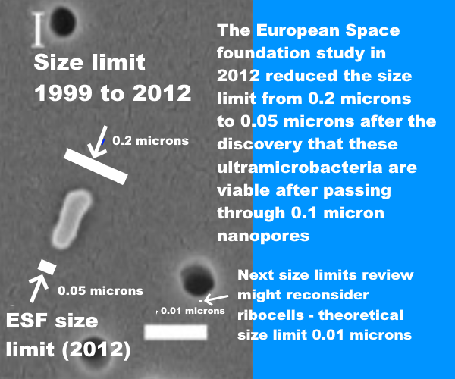
Size limit 1999 to 2012: 0.2 microns
ESF Size limit (2012): 0.05 microns
The European Space Foundation study in 2012 reduced the limit from 0.2 microns to 0.05 microns after the discovery that these ultramicrobacteria are viable after passing through 0.1 micron nanopores
Next size limits review might reconsider ribocells – theoretical size limit 0.01 microns
SEM of a bacterium that passed through a 100 nm filter (0.1 microns), larger white bar is 200 nm in length (Liu et al, 2019).

There were two very significant new discoveries that greatly reduced the minimum size limits required for filters to contain Marian biology. First was the discovery of ultramicrobacteria that could pass through 0.1 micron nanopores. This actually goes back to 2005 (Miteva et al, 2005) but wasn’t considered in the 2009 report.. The other was a discovery that unrelated species of archaea can share capabilities with each other very readily using the very small gene transfer agents (GTAs). They were able to transfer antibiotic resistance to each other overnight in sea water. (Maxmen, 2010). (McDaniel, 2010) zzz

That’s why the ESF study (Ammann et al, 2012) reduced the NRC limit (National Research Council. 2009) from 0.2 microns to 0.05 microns / 0.01 microns in just three years from 2009 to 2012. NASA are presumably still using the old 0.2 microns figure.
This is how the 2012 ESF report explained its decision at the time study (Ammann et al, 2012:3):
The value for the maximum particle size was derived from the NRC-SSB 1999 report ‘Size Limits of Very Small Microorganisms: Proceedings of a Workshop’, which declared that 0.25 ± 0,05 μm was the lower size limit for life as we know it (NRC, 1999). However, the past decade has shown enormous advances in microbiology, and microbes in the 0.10–0,15 μm range have been discovered in various environments. Therefore, the value for the maximum particle size that could be released into the Earth’s biosphere is revisited and re-evaluated in this report. Also, the current level of assurance of preventing the release of a Mars particle is reconsidered.

For more on this see these sections (below) and following sections after them:

- NASA plan to use a biosafety level 4 facility to handle the samples – but how can they know that a BSL-4 facility designed to contain infectious diseases of humans will work to protect Earth’s biosphere from extraterrestrial ultramicrobacteria or the potentially even smaller nanobes such as ribocells that may have preceded terrestrial life? The answer is they don’t – they seem unaware of the recommended size limits set in the 2012 ESF sample return study which make a BSL-4 facility inadequate
- NASA’s EIS mentions a 0.05 micron size limit – but only for the engineering for the earth entry capsule, not for the BSL-4 sample handling laboratories – and they don’t mention the ESF study in this section or in their list of references
- Evidence used by the 2012 ESF study – practical experiments in which starvation limited ultramicrobacteria have been observed to pass through 0.1 nanopore filters and are viable after passing through the filter – these results have been multiply confirmed including with with scanning electron microscope images to show the scale of the cells lying on top of the nanopores they passed through - the cells are about 0.2 microns long but less than 0.1 microns in diameter when they pass through the nanopore
- Though NASA’s EIS uses a 0.05 micron limit for reentry, for sample handling on the ground they rely on normal BSL-4 facilities – NASA show no awareness of the possibility that such a facility might not be considered adequate or might be challenged by litigation – or that they might be required to build a custom designed facility for this
- ESF study: “the release of a particle larger than 0.05 μm in diameter is not acceptable in any circumstances”

The 2012 European Space Foundation study says its 0.05 micron size limit needs to be reviewed regularly – this alone is sufficient reason to halt this EIS process until the new size limits review is done

This point alone seems sufficient reason to put a halt to this process until the size limits review has been done to take account of the advances in knowledge in the field of astrobiology and limits of sizes of small organisms in the last decade.

I go into this in the section:

- The ESF study says that the size limit needs to be reviewed regularly – at a decade later in 2022 it is definitely necessary to review a limit set in 2012 which dramatically reduced the 0.2 micron limit set in 1999 to 0.05 microns

[Or go back to contents list]

Also the review board could be expected to revisit the idea of a ribocell, an early form of life without proteins or robosomes which could in theory be much smaller than a modern cell.
That could lead to an even smaller size limit of 0.01 microns. I’ve added it to the graphic to show how much more of a challenge it would be to contain ribocells if that was the decision:
Size limit 1999 to 2012: 0.2 microns
ESF Size limit (2012): 0.05 microns
The European Space Foundation study in 2012 reduced the limit from 0.2 microns to 0.05 microns after the discovery that these ultramicrobacteria are viable after passing through 0.1 micron nanopores
Next size limits review might reconsider ribocells – theoretical size limit 0.01 microns
SEM of a bacterium that passed through a 100 nm filter (0.1 microns), larger white bar is 200 nm in length (Liu et al, 2019).
See below under:
- A size limits review board can be expected to consider research into synthetic minimal cells, and protocells – and ideas for simpler RNA world “ribocells” without ribosomes or proteins would be revisited as a result of research since 2012

NASA’s draft EIS has no mention of quarantine or other precautions for accidental release on Earth – just sterilization of the landing site

They don't consider issues of quarantine of technicians or of anyone contaminated during sample retrieval. There is an extensive literature on the topic. Then they just say (NASA, 2022eis: S-11)

Tier II analyses for determination of impacts associated with health and safety would consider the location of the proposed facility and surrounding community/land use type, health and safety system requirements associated with a BSL-4 equivalent facility, and risk analysis involving failure of containment systems that results in a release

Indeed, the draft EIS is inconsistent on this topic. It mentions potential for health issues as a reason not to retrieve the sample to an orbital space station and yet they don't consider health issues for technicians within the facility on Earth. Yet once the sample reaches Earth, they decontaminate the landing site with chlorine dioxide and aldehydes and that is it by way of precautions, they only consider a possibility of hazards around the landing site. The Apollo mission used quarantine of technicians who were exposed to lunar samples in the sample receiving laboratory - and though they mention this they don’t discuss it as a possibility for the Mars sample return.

See the section below:

- NASA’s draft EIS has no mention of ANY need for quarantine or other precautions for potential effects on humans or other lifeforms of accidental release on Earth – just sterilization of the landing site

One thing my preprint contributes to this discussion of quarantine is that you can't contain, for instance, a crop disease with quarantine of human astronauts. There is a clear example of that, the two Zinnia plants that died on the ISS due to disease of plants brought there in the microbiome of an astronaut.

Also for some reason none of the planetary protection literature back to the origins of the topic ever considers the issue of a symptomless carrier like Typhoid Mary who had to be isolated through to the end of hr life to protect others from typhoid despite never having symptoms herself. In that particular example the astronaut was not made sick but rarely the mold they carried to the ISS can make people sick. Based on these examples as well as the possibility of returning mirror life in the astronauts microbiome, I conclude that quarantine can’t be used to protect Earth from Martian samples. This seems to be something that should be at least considered.

This research is not yet peer reviewed because I haven’t yet submitted it to the journals but I think it needs to be considered. I cover this in the sections (below) starting from:

- Why quarantine can’t work to protect an orbital station with human technicians – example of wilted Zinniae which went moldy due to a crop pathogen likely brough to the ISS as part of an astronaut’s microbiome

All these inaccurate cites and omissions make the draft EIS easy to challenge in courts – and they didn’t respond to significant concerns raised by the public such as my own comment alerting them to the European Space Foundation study limit of 0.05 microns which is still not cited in the draft EIS

As I hope the reader can see, all these very inaccurate cites and omissions make the draft EIS extremely vulnerable to litigation.

Based on the comments from the general public so far, I can’t see this going through the NEPA process unchallenged.

I mentioned many of these issues in my previous comments before they wrote the draft EIS itself, based on the preliminary documents. My first sentence cites the ESF Mars Sample Return study (Walker, 2022a)

Are you aware of the ESF Mars Sample Return study (Ammann et al, 2012:14ff)? It said "The release of a single unsterilized particle larger than 0.05 μm is not acceptable under any circumstances”. This is to contain starvation limited ultramicrobacteria which pass through 0.1 micron filters (Miteva et al, 2005). Any Martian microbes may be starvation limited.
This 100% containment at 0.05 microns is well beyond capabilities of BSL4 facilities. Even ULPA level 17 filters only contain 99.999995 percent of particles tested only to 0.12 microns (BS, 2009:4).

They still don’t cite (Ammann et al, 2012) in the draft EIS. Nor do they give any reason for not citing it in the draft EIS or in the materials provided. I can also confirm that they never contacted me in response to my comment though I did provide my email address in the form.

NASA show no indication of having read the first sentence of my comment. They also show no indication of having read many other issues raised in the comments of others that said similar things during the previous round in May (NEPA, 2022).

More precisely, in this EIS, they say they read our comments. But in their summary of what they say we said, they don’t mention many of the things we raised as issues. NASA can’t have given the public comments a thorough examination as required for the EIS process.

If I understand right, this will also count against them in a court case as it would show they haven’t considered objections by the public.

For details see the sections below starting with: (internal link):

- NASA have made no significant changes in their safety assessments in response to objections made in previous requests for comments

[Or go back to contents list]

It’s my understanding that if litigation happens the likely outcome is that

- it is likely that the justice would grant an injunction to pause the entire project during the court cases, for instance the future launches to Mars might be paused
- If the litigation succeeds as seems very likely for this draft EIS, the justice will refer it back to the agency but can do so with a requirement for the project to be halted altogether
- Or the justice can refer it back to the agency with an injunction, for instance a requirement to put in place precautions sterilize all samples from Mars before they can contact Earth’s biosphere – which would require intercepting the Earth Entry vehicle and sterilizing the sample if it has already been launched to Mars and can’t be redesigned to sterilize the samples on the return journey.

I am not a lawyer and I would welcome input from legal experts on what would actually happen if this cite is litigated and the litigation failed, to help improve this document. If anyone reading this is expert on this topic and wants to help do contact me about it and I’ll fix it, and upload a new version of this document if I get a correction before this period ends.

I do know that cases under the NEPA process are often halted altogether or injunctions are given that constrain what is permitted.

For details see the section below:

- NASA’s Environmental Impact Statement is vulnerable to litigation on the basis that it doesn’t consider impacts of a sample return properly, doesn’t take account of the main issues mentioned by the Sample Return Studies and say things that contradict their conclusions – potential remedies include stopping the mission altogether or an injunction, e.g. to sterilize all samples before they contact Earth’s biosphere

That would be a great shame.

We can transform this mission into a mission of far greater interest for astrobiology and at the same time a mission with zero risk to the environment of Earth.

That should be the alternative to the mission. Not “no action” but a safe mission of great astrobiological interest.

However the sooner we do this the less the expense and the less the risk of unnecessary litigation.

My main concern here isn’t that the mission will go ahead and not be safe. With such a flawed EIS, at some point these issues WILL be raised. Even after the decision is made, there’s the presidential directive NSC-25 (Whitehouse, 1977), which would surely overturn the decision given how flawed the EIS is. By writing this I feel that I’m just helping to make sure the issues are raised sooner rather than later, giving more time to act on them and reducing the costs involved.

My main concern is about a risk of public responses that may not only derail this mission as proposed but also cause problems for future well conducted safe missions we may try to do by modifying it. As Rummel at al wrote (Rummel et al, 2002:96).,

“Broad acceptance at both lay public and scientific levels is essential to the overall success of this research effort.”

Draft EIS only presents No Action as an alternative to the proposal, even though there are alternatives which eliminate any possibility of harm to Earth’s biosphere while still retaining nearly all the science interest

Another issue is that the draft EIS presents only one alternative to the proposed action, and that is no action.
No action naturally has many negatives for planetary science. But there are numerous other alternative actions.
The document mentions only three alternative that were presented via scoping comments.

This is on page 4-1.

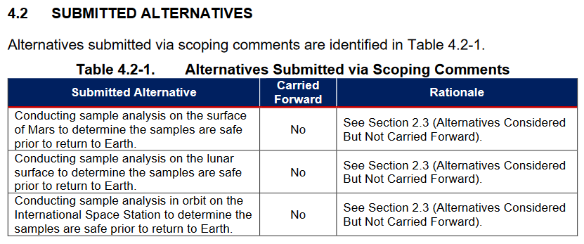
- Conducting sample analysis on the surface of Mars to determine the samples are safe prior to return to Earth
- Conducting sample analysis on the lunar surface to determine the samples are safe prior to return to Earth
- Conducting sample analysis in orbit on the International Space Station to determine the samples are safe prior to return to Earth
They all involved conducting the entire sample analysis somewhere else, on the surface of Mars, in lunar orbit or in a high or low terrestrial orbit and determine the sampes are safe before returning to Earth.
However there is another alternative. That is to return sterilized samples for geological studies.
So why didn’t they consider this?
NASA didn’t consider these alternatives because the Environment Impact Statement said in its “Needs and purpose” section that the samples need a safety test. They then argue that this safety test can’t be done anywhere else except on Earth.
But a sterilized sample return is MADE safe by sterilization. So it doesn’t need an extra safety test.
This seems to be a reasonably clear case where the “needs and purpose” is so narrowly defined it excludes “reasonable alternatives” such as sterilization of all the samples which we’ll see can achieve nearly all the mission goals.
All the samples could be sterilized. Or a sterilized geological sample return can be combined with continuing life science studies either on the surface of Mars, on the Moon or in high or low orbit on samples that are left in orbit in order to keep Earth safe and never returned unless proven safe.
There isn’t any guarantee that a sample that contains viable life will ever be proven safe to contact Earth’s biosphere unsterilized in worst case scenarios (such as mirror life). In that case the simplest solution is to keep them in orbit. Those are two reasonable alternatives which we’ll look at in detail . But first let’s take a brief look at the law. Is what NASA did here legal in the US?

An environmental impact statement needs to look at alternatives - and the need and purpose should NOT be defined so narrowly as to exclude “reasonable alternatives” by Simmons v. U.S. Army Corps of Engineers
This was decided in the U.S. Court of Appeals for the Seventh Circuit in Simmons v. U.S. Army Corps of Engineers This is not permitted by a seventh circuit case (7th Circuit, 1997).
It is contrary to NEPA for agencies to
“contrive a purpose so slender as to define competing `reasonable alternatives' out of consideration (and even out of existence).”
In context:
When a federal agency prepares an Environmental Impact Statement (EIS), it must consider "all reasonable alternatives" in depth. 40 C.F.R. § 1502.14. No decision is more important than delimiting what these "reasonable alternatives" are. That choice, and the ensuing analysis, forms "the heart of the environmental impact statement." 40 C.F.R. § 1502.14. To make that decision, the first thing an agency must define is the project's purpose. See Citizens Against Burlington, Inc. v. Busey, 938 F.2d 190, 195-96 (D.C. Cir. 1991). The broader the purpose, the wider the range of alternatives; and vice versa. The "purpose" of a project is a slippery concept, susceptible of no hard-and-fast definition.
One obvious way for an agency to slip past the strictures of NEPA is to contrive a purpose so slender as to define competing "reasonable alternatives" out of consideration (and even out of existence). The federal courts cannot condone an agency's frustration of Congressional will. If the agency constricts the definition of the project's purpose and thereby excludes what truly are reasonable alternatives, the EIS cannot fulfill its role. Nor can the agency satisfy the Act. 42 U.S.C. § 4332(2)(E).
…
Not least among the flaws — and the most glaring in hindsight — was the Corps' failure to consider reasonable alternatives. Judge Foreman deemed the environmental assessment "incomplete and flawed," and found no hint "that the Corps gave independent thought to the feasibility of alternatives."
…
The opinion of the district court is REVERSED and the case REMANDED with instructions to enter summary judgment for the plaintiffs and to vacate the permit.
“Vacate the permit” there means the project was not permitted to go ahead.
A properly drawn purpose and need statement should permit considering reasonable alternatives. By 40 CFR 1508.1(z) :
Reasonable alternatives means a reasonable range of alternatives that are technically and economically feasible, and meet the purpose and need for the proposed action.

NASA’s purpose and need is too narrowly defined - it requires the samples to be returned to Earth for safety analysis - which prevents them considering a sterilized sample return even though a sterilized sample return wouldn’t need a safety analysis
If we look at the “purpose and need” it says that the samples must be returned to Earth to a biosafety laboratory for a “comprehensive sample safety assessment”.
This is what NASA’S EIS says,
, (NASA, 2022eis: 3-3)
An important aspect of this is that many critical measurements can only be done on samples that have been through intricate sample preparation processes, and most of those processes are not able to be automated.
These same principles regarding the importance of using terrestrial laboratories to enable the best scientific return also apply to the care and attention to detail that would be required to conduct a proper and comprehensive sample safety assessment in a proposed SRF.
So the purpose and need section says that the samples have to be returned to Earth to do a comprehensive sample safety assessment.
This narrowly defined “needs and purpose” prevents them from considering the possibility of sterilizing the samples on the way back from Mars, because they wouldn’t be able to do this safety assessment on Mars.
If we check the submitted alternatives, this is indeed the argument they use to rule out the alternatives to “no action” proposed during scoping. If we go to section 2–3 (Alternatives considered but not carried forward) it says (NASA, 2022eis: 2-24):
–24:
Alternatives must be able to accommodate the equipment required to conduct the proper analysis to meet MSR Campaign objectives (which include not only science but also a properly rigorous assessment of the biological safety of the samples).
So they use the narrow scope of the needs and purpose to exclude any alternative that doesn’t permit a safety assessment of the sample to detect if there is life in it or not before it is returned.
But if I understand right, they shouldn’t define the purpose and need so narrowly.
Even if this was permitted, it is ethically questionable to use this technical method to remove any possibility of considering an alternative that keeps Earth 100% safe. But I don’t think it is legally permitted either.
So for instance, they should consider a sterilized sample return. This would preserve almost all the geological interest of the study by their own assessment. They don’t do this, the only alternative to return to a biosafety laboratory on Earth is “no action”.
I am not a lawyer and I welcome comments from lawyers on whether my understanding here is correct.
An important aspect of this is that many critical measurements can only be done on samples that have been through intricate sample preparation processes, and most of those processes are not able to be automated.
These same principles regarding the importance of using terrestrial laboratories to enable the best scientific return also apply to the care and attention to detail that would be required to conduct a proper and comprehensive sample safety assessment in a proposed SRF.
So the purpose and need section says that the samples have to be returned to Earth to do a comprehensive sample safety assessment.
This narrowly defined “needs and purpose” prevents them from considering the possibility of sterilizing the samples on the way back from Mars, because they wouldn’t be able to do this safety assessment on Mars.
If we check the submitted alternatives, this is indeed the argument they use to rule out the alternatives to “no action” proposed during scoping. If we go to section 2–3 (Alternatives considered but not carried forward) it sayss, DRAFT Environmental Impact Statement: page 2–24:
Alternatives must be able to accommodate the equipment required to conduct the proper analysis to meet MSR Campaign objectives (which include not only science but also a properly rigorous assessment of the biological safety of the samples).
So they use the narrow scope of the needs and purpose to exclude any alternative that doesn’t permit a safety assessment of the sample to detect if there is life in it or not before it is returned.
But if I understand right, they shouldn’t define the purpose and need so narrowly.
Even if this was permitted, it is ethically questionable to use this technical method to remove any possibility of considering an alternative that keeps Earth 100% safe. But I don’t think it is legally permitted either.
So for instance, they should consider a sterilized sample return. This would preserve almost all the geological interest of the study by their own assessment. They don’t do this, the only alternative to return to a biosafety laboratory on Earth is “no action”.
Another alternative action is to return a sterilized geological sample return can be combined with continuing life science studies either on the surface of Mars, on the Moon or in high or low orbit on samples that are left in orbit in order to keep Earth safe and never returned unless proven safe.
In that case there is no need for the safety assessment for the samples in orbit either because they are never returned to Earth unless proven safe.
As we’ll see, although in the best case scenarios life from Mars may be safe for Earth, there isn’t any guarantee that a sample that contains viable life will ever be proven safe to contact Earth’s biosphere unsterilized in worst case scenarios (such as mirror life).
If it is not safe for the life to contact Earth’s biosphere, the simplest solution is to keep it in orbit. Those are two reasonable alternatives which we’ll look at in detail.
It seems clear that the EIS must consider actions that keep Earth’s biosphere 100% safe in addition to its current alternatives of BSL-4 laboratories and no action:
I am not a lawyer and I welcome comments from lawyers on whether my understanding here is correct.

How would they prove the samples are safe on Earth? Permitted levels of biosignatures from contamination by terrestrial life guarantee false positives
Then finally, there are issues with the whole idea of proving the samples safe on Earth too. In the section "Planetary Protection in the Sample Receiving Facility" in the DRAFT Environmental Impact Statement: page 2-21 they cite Kiminek.
Ultimately, the SSAP Working Group findings, through an external independent peer reviewed process, will evolve over time as knowledge of sample constituents evolves and scientists identify certain requirements and protocols that should be implemented to ensure sample safety throughout the sample management, handling, and curation process (Kminek et al. 2022).

But their cite says that it is practically impossible to predict the effect of introducing life in new environments. So the only safety testing they can do is to check if there is extant life there at all (Kminek et al., 2022).
During the Working Group’s deliberations, it became clear that a comprehensive assessment to predict the effects of introducing life in new environments or ecologies is difficult and practically impossible, even for terrestrial life and certainly more so for unknown extraterrestrial life.
To manage expectations, the scope of the SSAF was adjusted to evaluate only whether the presence of martian life can be excluded in samples returned from Mars.
If the presence of martian life cannot be excluded, a Hold & Critical Review must be established to evaluate the risk management measures and decide on the next steps.
From table 3 (Kminek et al., 2022:S-200) they do that by checking for biosignatures and can only say there is no life if they find no biosignatures and even then need to consider martian life that may not be obvious with tests for terrestrial biosignatures.
We’ll see that Perseverance’s permitted levels of contamination, though low for geologists, are so high for astrobiology that it is guaranteed to generate false positives. They permit enough DNA or of any paraticular amino acid or any other biosignature to completely fill thousands of ultramicrobacteria with just that biosignature.
The measurements to test success of their procedures to reduce contamination suggest they achieved a maximum of (Boeder et al, 2020: table 6),
- 8.1 nanograms of organics per tube
- 0.7 nanograms for each of the biosignatures they tested (e.g. DNA)
- hance of a single viable microbe per tube
– this means a 0.02% chance that at least one tube has a viable terrestrial microbe in it.
That is impressively low for geological studies of past life. But it is impossibly high for astrobiological studies.
See more about this below:
- Sadly, Perseverance’s sample tubes weren’t 100% sterilized - permitted levels of organic contamination is enough for thousands of ultramicrobacteria (at a tenth of a cubic micron each) and millions of putative RNA-world ribocells, and could make it impossible to prove absence of Martian life in Perseverance’s sample tubes – leading to a likely unnecessary requirement to sterilize Perseverance’s samples indefinitely
So, it will likely be impossible to prove that there is no life from Mars in the tubes using biosignatures.

Most terrestrial microbes can’t be cultivated in the laboratory so it’s not possible to test for viable martian life by trying to cultivate it
It’s not possible to test for viable life from Mars by trying to cultivate it as most microbes on Earth can’t be cultivated either since we can’t duplicate the conditions they need. Most microbes even of terrestrial life are uncultivable, can't grow in the laboratory though they grow perfectly well in the wild often in very difficult hostile conditions.
It's frustrating for microbiologists, there is their microbe growing in very difficult conditions in the wild but they can't get it to grow, say, on an agar solution, turns its nose up at their best nutrients in the lab.
The main reasons microbes can’t be cultivated are (Solden et al, 2015).:
- They may depend on other microbes for their amino acids and even nucleotides, they may not have much by way of ribosomes to make proteins and some use strands, phyla to extract nutrients from other bacteria in biofilms.
- Others have very long generation times of six months or more, which makes it hard to sequence in a laboratory. This is very relevant to Mars. In those cold conditions it’s possible some have generation times of years to centuries or more.
- Others only survive in nutrient poor situations. They do very well in natural conditions but when you put them in a laboratory on an agar solution they die quickly. Again this may be very relevant to Mars given that nearly all habitats will be nutrient poor.
- Some produce hydrogen as a biproduct and they depend on other microbes to remove the hydrogen or they die.
So we can’t test by trying to cultivate the life.
For more about this see below:
- Problem of microbial dark matter - we don’t have a census even of all the RNA and DNA that we sent to Mars in the Perseverance sample tubes - which likely contain many genes from species we haven’t yet sequenced
From the previous section, we won’t be able to test for life by looking for biosignatures.
So how are astrobiologists expected to prove the samples are safe?
As stated in the NASA guide Planetary protection provisions for robotic extraterrestrial missions (NASA, 2005ppp):
A "false positive" could prevent distribution of the sample from containment and could lead to unnecessary increased rigor in the requirements for all later Mars missions.
There seems a significant possibility of a false positive here, which could delay certifying the samples as safe for Earth, or make it necessary to sterilize all samples returned indefinitely. Indeed, it is hard to see how these samples could be certified by experts to be free of any Martian life.
If the samples can’t be tested in any way to see if they are safe, that takes away this need to return them to Earth for testing.
Because of the decision to not sterilize the sample tubes, the geology samples will just have to be kept contained or sterilized indefinitely - or until we know more about whether there is life on Mars in other ways.
The only way to perhaps obtain samples we know don’t have martian life in them is to use 100% sterile containers. Those samples then could be tested properly to see if there is life in them.
Even with sterile containers, given how sparse present day life is expected to be on Mars, it might still be problematical to prove that there is NO life in them. The question will be, could there be a single viable cell or spore or propagule in a section of the sample that hasn’t been examined yet?
We might later be able to deduce that the samples are lifeless, as our understanding of Mars develops, but it would be challenging to prove this by direct measurement of biosignatures in the samples.
From this it seems that unlike the situation for the lunar samples, NASA and ESA need to plan for the Martian samples to be sterilized before distribution to normal laboratories for the indefinite future.
For all these options, most likely the end result of any legal process that looks into this thoroughly will be that samples are only be permitted to be handled unsterilized in laboratories equipped to contain 0.05 ultramicrobacteria - or whatever the final size limit is after review, 0.001 microns for ribocells if that’s considered possible - until we know more about Mars and whether there is any potential for viable native life in samples from Jezero crater.

This mission “as is” is just a technology demo for astrobiology - chance it returns anything impacted by sterilization is low - complete sterilization is an easy way to keep Earth 100% safe and retain just about all science value - and at far less mission cost
It’s clear from these permitted level of contamination in the tubes that this is a mission designed around geological rather than astrobiological priorities. We do have the technology to achieve 100% sterile containers.
Engineers were concerned that the container would have to be kept enclosed and only opened after launch and the engineers worried that it would add one extra failure point. If the sterile container didn’t open it would be mission critical and no samples could be taken.

Simplest alternative is complete sterilization, retains geological interest and if there is present day martian life in the sample will retain some astrobiological interest
The simplest alternative to both the proposal and to no action is complete sterilization of the samples during the return journey or before they are delivered to Earth, without any life sciences on Mars or in orbit or on the Moon. This alternative action retains geological interest and some astrobiological interest.

The reason for considering this alternative is to fully protect Earth’s biosphere, environments, habitats, biodiversity, other species, crops, fisheries, and humans to the maximum extent of 100% protection.

This should be included as an option alongside No Action. Even if it has less science return it is better than no action.

Also if the mission is unlikely to return life from Mars, even if present, this may be a reasonable choice to make.

This choice will find evidence of life if the sample does return it, but is simpler, lower cost and can be done with no risk to Earth’s biosphere. On the perhaps remote chance it finds life, some life sciences can still be done, with a top priority for a follow up mission to Mars to find out more.

After looking at sterilization I look at another option that has greater life science return which is more suitable if there is considered to be a good chance of life in the sample

The proposed second alternative course of action is still 100% safe for the biosphere of Earth no matter what might be in the samples but it would cost more to implement it. But first, complete sterilization.

First 100% safe alternative to the proposal, and simplest solution: sterilize all the samples on the journey from Mars to Earth or capture and sterilized in Earth orbit using ionizing radiation – this is not likely to impact on geological studies, and after sterilization it would still be possible to recognize biosignatures of present day life
This may be an acceptable solution because the current mission has no in situ detection and isn’t searching microhabitats even in Jezero crater and so has a low chance of returning present day life even if there is life in Jezero crater.

Sterilization is the simplest solution. If present day life is unlikely in the samples and if the past life samples are seriously degraded already by exposure to surface cosmic radiation, we find the extra radiation to sterilize the samples is not likely to impact on geological studies, while any extant life, while not viable, would still be recognizable as such by astrobiologists. As far as extant life is concerned, the mission would then be a technology demonstration, preparing for a future mission that is more likely to return any viable Martian microbes.

From the Mars Sample Return Planning Group 2 MSPG2 (Meyer et al, 2022) most of the Mars Sample Return science could and should be done on samples that are deemed safe.

Summary-3. Most aspects of MSR sample science could, and should, be effectively performed on samples deemed safe (either by test or by sterilization) in uncontained laboratories outside of the SRF. However, other aspects of MSR sample science would be both time-sensitive and sterilization-sensitive, including the search for life, assessment of habitability, and volatile exchange processes, and would need to be carried out in the SRF.

I cover this in my preprint (Walker, 2022b) under
- Sterilized sample return as aspirational technology demonstration for a future astrobiology mission

This is a possible solution if the samples are believed to be unlikely to be of great astrobiological interest. Sterilizing the samples will have little effect on the geological interest as I cover in my preprint (Walker, 2022b) under:

- Experimental data on effects of sterilizing doses of gamma radiation – preserves the geological interest of rock samples - need to test effects of X-ray

Perseverance’s mission is designed around geology and “as is” is unlikely to return anything that would benefit from searches for biosignatures – the permitted levels of contamination are too high and would swamp the very degraded signal of past life or the low concentrations of present life if present
The permitted levels of contamination in the samples tubes may seem impressively low for an engineer and they are very low by geological standards.

But an ultramicrobacteria has a volume of 0.1 cubic microns. If the same density as water that’s a ten thousandth of a nanogram. So the nanograms of permitted contamination is enough for thousands of ultramicrobacteria. The theoretical RNA world ribocell would be even smaller, around 20,000 of those to a picogram or twenty million to a nanogram.

The achieved level of organics contamination of around 8.1 nanograms per gram of returned rock sample, and they think they achieved at most 0.7 nanograms per biosignature. So for instance it could have 0.7 nanograms of glycine or 0.7 nanograms of DNA. Sadly, this would swamp the very faint signal expected from past life degraded by the Martian conditions if they did return any. It would also swamp present day life at low concentrations – for instance if there is viable present day life there might be as little as one viable spore per gram. Astrobiologists design instruments to send to Mars that can detect a single amino acid per gram.

See more about this below:
- Sadly, Perseverance’s sample tubes weren’t 100% sterilized - permitted levels of organic contamination is enough for thousands of ultramicrobacteria (at a tenth of a cubic micron each) and millions of putative RNA-world ribocells, and could make it impossible to prove absence of Martian life in Perseverance’s sample tubes – leading to a likely unnecessary requirement to sterilize Perseverance’s samples indefinitely

So, the achieved level of cleanliness of the Perseverance sample tubes is useless for detecting the very faint traces expected for past life or for present day life searches on Mars. It may look good. It's far beyond normal standards of cleanliness, e.g. for surgical tools. And they had good reasoning for it, but reasoning that makes sense geologically rather than astrobiologically.

Their reasoning was to try to get to levels similar to the lowest levels of organics in the Martian meteorites we have today but what that misses is that those organics are due to abiotic processes.

This is a level of contamination enough to learn more about abiotic processes on Mars but not to learn about past life.

The organics from past life would be bound to be degraded and the issues is distinguishing them from abiotic organics. Mars gets a significant influx of organics from comets, asteroids and interplanetary dust. Since the surface of Mars isn’t very habitable with only occasional microhabitats if they exist, any present day life there is limited more by issues of availability of water, shelter from UV, maybe shortages of nitrogen and so on. Nearly all the Martian organics is likely to be completely free of life even on the most optimistic assumptions about present day life on Mars. This might have been the case in the past also.

For both past and present day life it is likely to be very patchy (heterogenous) even if Mars was very habitable and had photosynthetic life (best case for finding past life). The chance this mission returns any evidence of past life is about zero.

A worst case example for finding past life might be life that is still confined to hydrothermal vents and that hasn’t yet developed the adaptations needed to get from one vent to another. In between you have various examples such as past life that can’t do nitrogen fixation, and can’t photosynthesize, and is limited to regions with biologically available nitrogen and abiotically produced organics.,

Then, most biosignatures are erased completely in surface rocks over timescales of hundreds of millions of years to billions of years so most surface organics will have all traces of biosignatures removed even if they did have life originally

The past life also has to be preserved - which requires unusual conditions - then it has to be buried quickly - the ionizing degradation can happen in the past before burial, not exposed in between, it has to avoid being chemically altered and then be exposed quickly with little chance of degradation. And then the life signal has to be there originally too, and we don't know where past life was on Mars or what its capabilities were e.g. obviously if it only lived in hydrothermal vents at the time of jeer crater we have almost no chance of finding it and it might have lived only in particular hydrothermal vents and not yet evolved the ability to survive the long journeys between vents so that's an example of one of the most difficult scenarios for past life.

Jezero crater is a delta which should increase the chance of finding past life. But even in a delta you need to look for places where the life accumulates. In other places it is not accumulating but eroded - those places are unlikely to return signals of life. That depends on the details of the flow patterns of the water billions of years ago. So there are lots of minutiae. It's not like geology.

The astrobiologists say you need to sample many locations that are geologically similar - a suite of samples across many identical seeming locations to have a decent chance of finding past life. This is much better done in situ as it would take centuries to millennia to return so many samples to Earth.

This is why most astrobiologist see the mission as more of a technology demo than a mission that is going to lead to significant immediate advances in their discipline. I have read many papers by astrobiologists and they ALL say we need to do in situ searches first and they have designed many miniature instruments to send to Mars. I haven’t found any papers by astrobiologists who are keen and excited about this sample return.

However NASA is run by engineers and geologists who don't appreciate / understand these nuances of the very different discipline of astrobiology. For them if the rock looks the same, has the same geological history - that's all you need to return.

The idea of examining many geologically identical samples of rock in situ on Mars makes little sense to a geologist. Sadly, astrobiologists have never been able to convince them of the case for in situ exploration first.

For these reasons most astrobiologists would see this as a technology demo for astrobiology, to be followed up later with other samples selected intelligently using in situ searches on Mars. So they would likely support the idea of simply sterilizing the samples on the return journey. The life would still be recognizable on the remote chance that this mission returns enough by way of present day life or past life to overwhelm the signal from contamination from Earth though this seems unlikely.

I suggest in my preprint (Walker, 2022b) a way to improve on our chance of finding past life if it is abundant (e.g. past photosynthetic life) and well preserved and that is to look for recent Martian craters that have excavated the surface to at least 2 meters. I work out they should exist, and there is even a small but not insignificant chance of such a crater forming during the mission itself - and they could use the marscopters to look for them sending the marscopters up to maximum altitude to search the landscape below for uneroded small craters. The craters would be visible from orbit but at that small size it would be hard to tell if they were young or old craters from orbit.

If they do that there is a chance of unearthing organics that have been exposed to just a few tens or hundreds of thousands of years of surface organics which may have more detectable biosignatures.

Even if they do that, it’s not very likely they find such well preserved samples as to be easy to detect above the permitted level of contamination.

However some astrobiologists think there is a significant possibility of present day life that is not just rare but almost ubiquitous on Mars. Not in high concentrations. But there might be, say, one spore per gram over much of the surface mixed in with the dust. Or there might be biofilms in the Curiosity brines. Living cells if they can be transported in the dust storms – or dead cells, both would be of interest to astrobiology.

Although many other astrobiologists would see this as unlikely, still it is an interesting and testable hypothesis. If we return a scoop of dirt, and a dust sample in STERILE containers so sterile you’d detect that single amino acid, we’d get very good information to decide between the hypothesis that life is present almost everywhere and the hypothesis that surface life on Mars is rare. And the pay-off would be huge if it does return life.

So this leads to the next suggestion.

Second 100% safe alternative, NASA’s proposal can be greatly enhanced in astrobiological value by adding simple capabilities with 100% sterile containers to return a sample of dirt, a highly compressed sample of gas from the atmosphere to detect minute traces of biologically relevant gases and a sample of dust from dust storms trapped in the filters for the air compressor – these can also be returned sterilized

Now I’ll present another alternative. This is a mission with some changes, mainly design changes to the Orbital Sample Container and the ESF sample retrieval rover. This would make it of much greater astrobiological interest. Design of this components are still at an early stage and could be modified.

NASA’s mission is designed for geology not astrobiology. All the astrobiology papers I have found on the topic say that an astrobiology mission needs to do in situ life detection to make an intelligent choice of the samples to return. Even if there is abundant life on Mars, in condition similar to the harshest terrestrial deserts, most samples may well be lifeless. It is hard to return life when you can’t see it. Also most of the organics on Mars are expected to be from comets, meteorites, interplanetary dust and chemical processes on the Mars surface and in its atmosphere, unlike the situation for Earth. This makes it a challenge to detect life and it needs biosignature detection on Mars to do this.

Astrobiologists have designed numerous miniature life detection instruments that could be sent to Mars. The aim of these instruments isn’t to do a complete analysis on Mars. The aim is simply to locate samples of interest to life studies at all.

See the section in my preprint (Walker, 2022b):

- Perseverance can’t search for life in situ, which is why we won’t even know if the samples contain life until they get back to Earth.

Sadly the advice of astrobiologists to proceed in this way hasn’t been followed. However we still have a chance to return samples of present day life from Mars if it is abundant, for instance if it is present at small concentrations in the dust or dirt everywhere on Mars, spread by the dust storms. This would be of interest whether the life is viable or dead.

We could recognize this so long as it is returned in sterile containers even if the life is sterilized during the journey back from Mars. We’d see biosignatures such as chlorophyll, sequences of DNA, chirality of all these and proteins, sugars etc.

If we can return a few grams of dust or dirt, this can return a few dead cells or living propagules or spores if they are present at concentrations as low as one propagule or cell per gram, which is a very low concentration for living cells. If no life is found we can begin to make a first estimate of an upper bound on quantities of native martian biological material transported in dust storms.

The geological nature of this mission is most clear in the permitted levels of contamination in the sample tubes which will make it near impossible for astrobiologists to tell if it has traces for past or present day life unless very obvious.

The permitted levels of biosignatures are so high that we wouldn't notice if the sample contained tens of thousands of terrestrial ultramicrobacteria or tens of millions of hypothetical minimal RNA world ribocells.

See below: (an internal link to another section of this page)

- Sadly, Perseverance’s sample tubes weren’t 100% sterilized - permitted levels of organic contamination is enough for thousands of ultramicrobacteria (at a tenth of a cubic micron each) and millions of putative RNA-world ribocells, and could make it impossible to prove absence of Martian life in Perseverance’s sample tubes – leading to a likely unnecessary requirement to sterilize Perseverance’s samples indefinitely
It would also be impossible to detect individual cells or propagules at such low concentration as one cell per gram with so much biological contamination unless they can be revived and the life is recognizably different from terrestrial life.
We also see this geological focus in the decisions to not take a compressed atmosphere sample or dust sample, and not to take a sample of the dirt – these are all materials of high interest to astrobiologists and of less interest to geology.
It will be impossible to detect small trace amounts of biologically relevant gases in the atmosphere with their small uncompressed atmospheric sample, and with the high levels of permitted contamination of the tubes.
Also the only dust they plan to collect is any that accidentally gets stuck to the sample tubes. This is not enough dust to have a reasonable chance to return spores or viable propagules even if there are large numbers of them transported every year in the dust storms.
We need a dedicated dust collector, to either collect propagules or to produce a first realistic bound on the amount of material transported in the dust storms in this way and a first bound on the potential for distant habitats on Mars to transport spores to landing sites.

Proposal to add an atmospheric compressor / dust collector to the Orbital Sample Container based on the moxie design to return up to two grams of compressed martian atmosphere and a few grams of martian dust in sterile containers
NASA did send an atmospheric compressor to Mars on Perseverance but it is used for Moxie, an independent experiment to test options for creating fuel from the atmosphere, not connected with the sampling experiments.
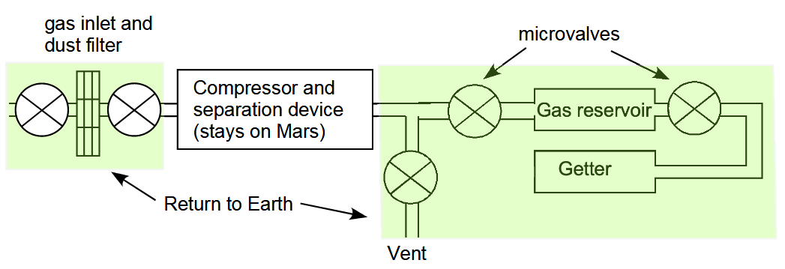
Jakovsky et al propose sending a similar experiment to Mars in a small sample tube sized container or alternatively a larger container to return 100 cc of atmosphere. This is how it works.
First it uses the getter to remove evolved gases from the container wall. Then it closes one microvalve and opens another to get an atmospheric sample. Finally it closes both microvalves to the gas container and opens the vent to run more atmosphere through the compressor to collect dust in the filter (Jakovsky et al, 2021)
Assuming a volume of, say, 50 cc of dust, and a dust density of 0.5 grams per cc, it could return up to 25 grams of dust.
This is enough to detect life at around one cell per gram or less. This is also a useful first upper bound of the amount of life in the dust if none is returned.

See the section of my preprint (Walker, 2022b):

- Searching for distant inhabited habitats on Mars through presence or absence of one originally living cell per gram – a rough first estimate assuming uniform mixing throughout Mars for a first estimate requires life to cover between 114,000 and 1,140 square kilometers with densities of life in the dust similar to an Antarctic RSL analogue in cell count, but less than a tenth of a square kilometer if any reach a billion cells per gram – these figures can be higher if any source habitats with high densities of cells are closer to the rover with uneven mixing
They present four options. Of their four options, two are of special interest here which I’ll label A and B to avoid confusion (Swindle et al, 2021):
- Collecting gas in a newly-designed, valved, sample-tube-sized vessel
They propose flying this customized sample-tube-sized vessel to Mars on the sample fetch rover.
- Adding a larger (50-100 cc) dedicated gas sampling volume to the Orbiting Sample container (OS) that can be filled with compressed martian atmosphere.
These are of special interest since the sample-tube-sized vessel or the dedicated gas sampling volume can be 100% sterilized in advance making it possible to return a dust sample of far greater interest for astrobiology than one with large amounts of permitted biosignatures.
For details see the section of my preprint (Walker, 2022b):
- Proposal: by Jakovsky et al from the 2020 NASA decadal survey to combine a dust sample with a compressed sample of the Martian atmosphere
.

Modification to ESA fetch rover sample retrieval arm to dig an extra sample of dirt as for the Viking scoop and add it to a smaller 100% sterile container within the Orbital Sample Container
The dirt on Mars is of great interest to astrobiologists, because of the discovery by Curiosity of brines that form in the evening and early morning and the intriguing Viking results not yet fully explained. The Viking results may be complex chemistry rather than astrobiology, but we need to know what is going on there in order to help shape future searches for life on the planet.

My preprint (Walker, 2022b) recommends modifications to the ESA fetch rover to add an extra sample of dirt since this is of special interest to astrobiologists. Ideally this would include the brine layers at a temperature of -73°C (200°K) observed indirectly by Curiosity, which form in sand dunes at night - which might perhaps shed light on the puzzling Viking observations.

These brines could potentially be habitable to a native Martian biofilm if it can retain the liquid through to the warmer daytime temperatures, which reach temperatures above 0°C, to modify habitability of the layers at a microscale. Another way they could be habitable to Martian life is if it can tolerate lower temperatures than terrestrial life using chaotropic agents such as the Martian perchlorates or chlorides to speed up metabolic processes by disrupting hydrogen bonding, or ice binding agents to keep the water liquid at higher temperatures, or novel biochemistry adapted to lower temperatures than terrestrial life.

See the section of my preprint (Walker, 2022b):

- How Martian life could make perchlorate brines habitable when they only have enough water activity at -70 °C – biofilms retaining water at higher temperatures - chaotropic agents permitting normal life processes at lower temperatures – and novel biochemistry for ultra low temperatures

A sample of dirt could also be of interest for novel chemistry in the Martian conditions.

This shows the sample collection tool for the ESA fetch rover and shows how it resembles the digging tool for Viking and could be adapted to take a sample of dirt from the surface after it has already picked up and stored the geological samples.

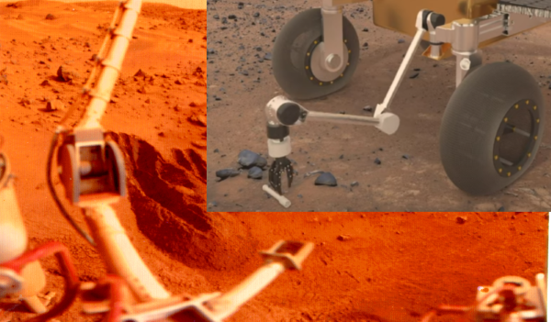
Figure 44: The digging tool, lower center, was used by Viking to scoop up material from the surface soil for the Viking experiments (NASA, 2015).
Inset: Frame at 17 seconds from video of an artist’s impression of the ESA fetch rover collecting a sample left on the surface by Perseverance (ESA, 2020)
If this is feasible, then ESA’s Sample Fetch Rover could grab a small amount of dirt from the region around the Mars Ascent Vehicle (ESA, 2018), to a depth of five or ten centimeters or so and load it into the return container after adding the samples from Perseverance’s cache.
The sample tubes are sealed, so the dirt could just be poured directly into the capsule container on top of them and around them. Another possibility might be to place a horizontal plate on top of the container after inserting the sample tubes, then place a small scoop of dirt in the center of it before adding the enclosing lid.
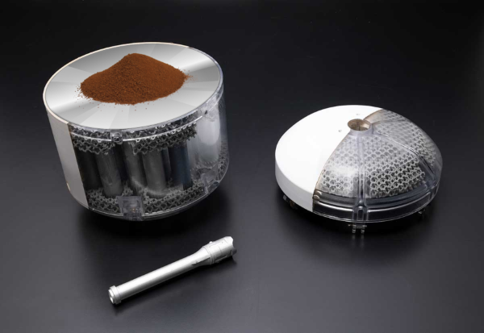
Figure 45: Added proposal for extra dust sample to concept design for the Orbiting Sample Container
- there seems to be space between the top of the sample tubes and the cover. Perhaps an extra circular plate could be added.
Then a sample of dirt dug from the nearby soil loaded onto the center of the plate before enclosing the capsule for launch.
Analysing this extra sample may help resolve questions about the Viking results and if Viking did find life, it could return that life for study.
Image combines the NASA graphic (NASA, 2020msros) with an photograph of a small pile of Martian regolith simulant JSC MARS-1A (ZZ2, 2014), and a clipart image of a CD (OpenClipArt, n.d.)
This suggestion to grab some dirt and load it onto the sample container at the end is similar to a suggestion for a minimal sample return mission once made by Chris McKay to just “grab a sample of dirt” (McKay, 2015).
However it would need to be loaded into a 100% sterile container to be of most astrobiological interest. So perhaps there can be room for a small 100% sterile container between the sample tubes and the lid of the sample return container.
I suggest modifications to the ESA fetch rover to rectify these omissions. If not, some other nation, perhaps the Chinese, could return a mission of far more interest to astrobiology at far less expense, just a sample of the dust, atmosphere and a scoop of dirt, and can do it far faster than the USA can.
All of these would need to use sterile containers. For astrobiologists the small risk of a container not opening on Mars is worth it for the very high pay off of avoiding terrestrial contamination of the samples altogether by using enclosed sterilized containers to collect the samples.

These recommendations are all in the spirit of the mission as extra sample returns and are different from the “mission creep” of adding new instruments for other purposes.

Proposal to use the Marscopters to search for young undegraded craters that could have exposed rocks from 2 meters or more below the surface in the last few tens of thousands of years – this greatly increases the chance of a sample of past life of enough interest to be of astrobiological value

The current paper also has a recommendation to increase the possibility for finding recognizable traces of early life. This doesn’t require any new instruments. It is a suggestion for a new way of using the Marscopter, if it remains operational, combined with satellite observations of the area.

Any ancient organics in surface layers are likely to be seriously degraded by cosmic radiation to the point where traces of life would be hard to recognize. The current paper suggests searching for young craters near to the Perseverance rover in Jezero crater.

We find that there is a near certainty of young craters within travel distance of Perseverance less than 50,000 years old which are also deep enough to excavate the subsurface to a depth of several meters. This could let us return organics exposed to no more than a few tens of thousands of years of surface levels of cosmic radiation. This would increase the possibility of finding clear signals of past life.

Also it’s possible that the preserved organics could make such layers more habitable to present day life.

They could be identified as targets from orbit and the Marscopter used to study them more closely if any are close enough to be photographed – this would involve driving the rover up to a high place and then flying the Marscopter as high as it can fly to photograph a large area of the landscape from above.

See the section of my preprint (Walker, 2022b):

- Recommendation: use of Marscopter and Perseverance to help identify young craters with sharp rims to help sample subsurface organics excavated by meteorites

If any such samples turn out to be of interest for astrobiology, perhaps we could consider ways for the ESA fetch rover to visit such a crater, if it is within reach and look for a way to pick up a small rock of interest perhaps weathered out of any exposed outcrops.

Third 100% safe alternative to this mission: return geological sample tubes sterilized to Earth – and return unsterilized astrobiological samples to a high orbit to study remotely using miniature life detection instruments like those designed by astrobiologists to send to Mars – even a microbe as risky to Earth’s biosphere as mirror life can be studied and cultivated safely in a suitable high orbit
These bonus samples could make the mission of enough astrobiological interest to return the samples for preliminary study in a location not connected to Earth's biosphere. This solution is a way to avoid the need to sterilize native life in the sample, so that it can be cultivated, if cultivable, or studied with less damage to the organics than in a sterilized return.

This is made far easier due to the astonishing advances in instruments for life sciences in the last couple of decades. Geologists still need some very large instruments, especially the particle accelerators. But most instruments for biology can now be miniaturized. If they are just sent to a satellite in a high orbit then we can send many instruments we aren’t limited to the 5 or 10 for an astrobiology mission to Mars.

We can also send multi-ton instruments to high orbits above Earth already as we do that with the satellites for GEO. Also – as this decade continues we will develop the capability to lift far greater masses to high orbit at lower cost. By the early 2030s when the samples are returned it will be far easier to send large astrobiological life detection instruments to orbit to study the samples remotely in situ.
We can then sterilize sub samples which can be returned for immediate study in terrestrial laboratories, while the unsterilized materials are studied in a safe location off-planet until we know what is in them. Future decisions then are made based on what we find in the samples.

Most of the extra cost of this option actually is incurred AFTER the samples are returned to the orbiting space laboratory and it is offset by the absence of need to take elaborate precautions with the samples returned to Earth.

This is one of the main topics of my preprint (Walker, 2022b).

This is the graphical abstract for my preprint which gives an overview of the idea (next page);

Graphical abstract for third 100% safe alternative
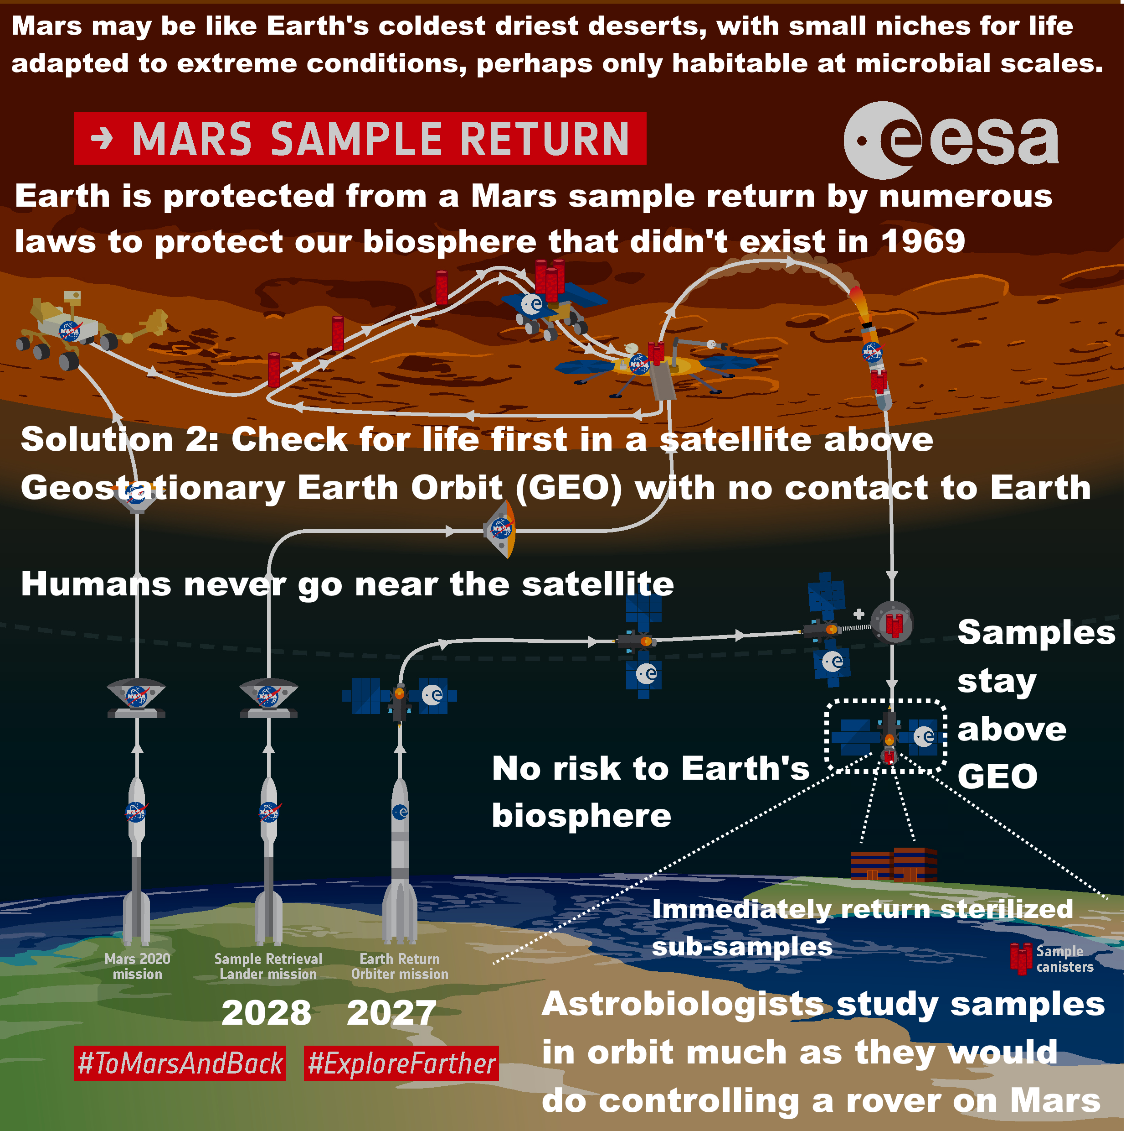
How to keep Earth 100% safe with minimal impact on science or cost – technology doesn’t exist to contain ultramicrobactieria.

So we can
1. sterilize all samples or
2. check for life first - to do this, return samples to a safe orbit above GEO to study remotely with miniature instruments like those designed by astrobiologists to search for life on Mars.

With 2. we can return sterilized sub-samples from the orbital facility immediately.

In 2, a return to the ISS doesn't break the chain of containment with Mars and COSPAR decided the Moon must be kept free of contamination for future astronauts and tourists. Above GEO solves both these issues.

1. and 2. both have simple legal processes.

By NASA regulations, build can't start until technology is decided. Build estimate: 9+ years + 2 years to train technicians.

Earliest date ready: 2023 + 11 = 2034

However, the technology doesn't exist yet for the 2012 European Space Foundation requirement of 100% containment of 0.05 micron particles even a decade later. This limit may also be reduced further on review.

Figure 1: Text added to ESA graphic (Oldenburg, 2019) showing current proposed timeline (NASA, 2022mpfs) and time until the facility is ready to receive sample
Text on graphic:
Mars may resemble Earth's coldest driest deserts: small niches for life adapted to extreme conditions, perhaps habitable at microbial scales only.

Earth is protected from a Mars sample return by numerous laws to protect Earth's biosphere that didn't exist in 1969.

Solution 2: study in a safe orbit above Geostationary Earth Orbit (GEO) first.

Humans never go near the satellite.

Samples stay above GEO.

No risk to Earth's biosphere.
Astrobiologists study samples in orbit much as they would do controlling a rover on Mars.
Sterilized subsamples can be returned immediately.

I cover this proposal in detail in my preprint (Walker, 2022b) under this section and following

- Recommendation to return a sample for teleoperated ‘in situ’ study above Geosynchronous Equatorial Orbit (GEO)

My preprint also recommends a particular orbit – the orbits in the Laplace Plane where the balance of the pressure of sunlight and of gravity is such as to keep debris from satellites in the same orbit as for a ring plane. I cover this in my preprint (Walker, 2022b) under

- An orbit within the Laplace plane above GEO contains debris in event of an off nominal explosion or other event

Suggestion: the geological samples can be sterilized and returned directly to Earth and the suggested dust, atmosphere and dirt samples collected in 100% sterile containers can be returned to a satellite above GEO for the astrobiological studies
It seems unlikely any evidence of life can be found in the geological samples because

- The surface has been sterilized of biosignatures over hundreds of millions or billions of years with ionizing radiation and Perseverance didn’t have the ability to dig
- The permitted levels of contamination are so high it would most likely be impossible to pick up the signature of past or present day life even if it is there.
- This mission is not likely to return a sample of past life because astrobiologists say that it’s necessary to have the ability to detect biosignatures in situ to have a reasonable chance of returning a sample of past life from Mars.

So, why not just sterilize them all. If there is recognizable past life, highly unlikely – but something as rich as a coal seam say, it would still be recognizable after sterilization.

This then deals with the issues of opening and reclosing sample tubes to split up the geology samples which concerns the geologists.

Then the unsterilized dirt, dust and gas remains in orbit studied remotely. Sterilized subsamples of the dirt and dust could be sent down to Earth right away.

There could be individual sample tubes of more interest to astrobiology, for instance, if Perseverance is able to get a rapidly exposed deep subsurface geological sample, for instance as a result of a newly formed crater, and suppose that turned up something really interesting such as a thick seam of organics - that sample tube could perhaps be considered for examining in orbit. Apart from that, most of the geological samples are likely to be of little interest for astrobiology.

Why quarantine can’t work to protect Earth using an orbital station with human technicians – example of wilted Zinniae which went moldy due to a crop pathogen likely brough to the ISS as part of an astronaut’s microbiome

Martian microbes could also be harmless or even beneficial to humans but potentially harmful to other organisms or to ecosystems. They could join the diverse microbial communities of bacteria, archaea and fungi inhabiting the sweat glands, hair follicles, dermal layers etc of our skin (Byrd et al, 2018), in our mouths (Deo et al, 2019), sinuses (Sivasubramaniam et al, 2018), and respiratory tracts (Kumpitsch et al, 2019). They could make use of many sources of food from our bodies in the form of dead skin cells, hair, and secretions such as sweat, sebum, saliva and mucus.

An example of this happened on the ISS, which because of its natural isolation from the terrestrial biosphere makes such issues particularly easy to study (Avila-Herrera et al, 2020). In 2018 the Zinnia Hybrida plants in a plant growth experiment on the ISS wilted. Two of the plants that displayed stress died and two survived (NASA, 2016hmossf).

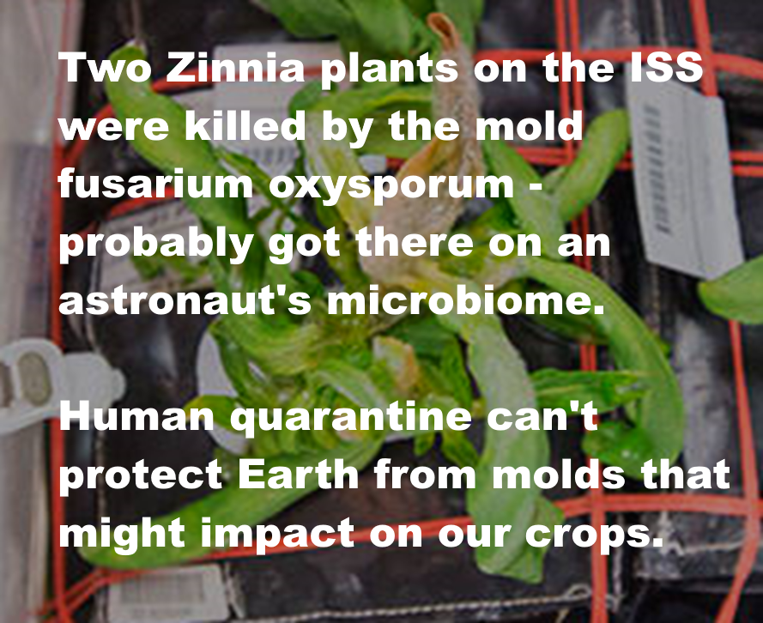
Text on graphic: Two Zinnia plants on the ISS were killed by the mold fusarium oxysporum - probably got there on an astronaut's microbiome

Human quarantine can't protect Earth from molds that might impact on our crops.

Figure 15: Mold growing on a Zinnia plant in the ISS. The mold fusarium oxysporum is thought to have got to the ISS in the microbiome of an astronaut (Urbaniak et al, 2018). Two of the four infected plants died (NASA, 2016hmossf). It would be impossible to keep a pathogen of terrestrial plants out of the terrestrial biosphere with quarantine of technicians or astronauts.

The cause was a fungal pathogen Fusarium oxysporum probably brought to the ISS in an astronaut's microbiome (Urbaniak et al, 2018). The same fungus was cultured from an isolate from the astronaut’s dining table (Urbaniakt al, 2019). The composition of the populations of microbes colonizing surfaces in the ISS seems to vary depending on the composition of the microbiome of crew members (Avila-Herrera et al, 2020).

All the astronauts have two weeks preflight “health stabilization” in quarantine. This is intended to reduce the risk of preventable infectious diseases of humans. It is not designed to keep out a fungus that can infect plants (NASA, n.d.hsp).

This is actually another example of a symptomless carrier too like Typhoid Mary. Fusarium oxysporum can be an opportunistic human pathogen, however, on this occasion it was only harmful to the plants. In this quote their cite 45 is a fatal case (Urbaniakt al, 2019)..

F. oxysporum, though a well-known plant pathogen, may cause various infections in humans and is a cause of emerging infections in immunodeficient patients (44 - 46)

In the same way an opportunistic human pathogen from Mars might be harmless to the astronauts that first encounter it.

That disease of plants was brought to the ISS by humans and there is no way they could have been sterilized of all plant diseases.

So in the same way a disease of plants could be brought back from an orbital Mars sample laboratory and there would be no way to know.

And no way to test the samples against all Earth life. For a more detailed discussion of these and many other examples, see the section in my preprint (Walker, 2022b):
- Could present day Martian life harm terrestrial organisms?

Arbitrariness of technician’s quarantine period for an unknown pathogen – Carl Sagan gives the example of leprosy which can take 20 years or more to show symptoms
Apollo’s three week quarantine period was arbitrary. Carl Sagan observed that we do not know the necessary quarantine period for a sample return. He gave the example of leprosy (Sagan, 1973:130)
There is also the vexing question of the latency period. If we expose terrestrial organisms to Martian pathogens, how long must we wait before we can be convinced that the pathogen-host relationship is understood? For example, the latency period for leprosy is more than a decade.
We now know that leprosy can take 20 years or more to show symptoms (WHO, 2019).
Also, prion diseases can have very long incubation periods of anything from 13 years for a study of vCJD in France (ECDC, n.d.), to over 50 years for Kuru in South Fore where the native population have a mutation that gives them protection against it (Collinge et al, 2006).
It would be hard to justify any particular quarantine period for a technician who has been exposed to a Martian sample. For a known and well characterized Martian pathogen, quarantine periods might work, depending on the disease. However, for an unknown pathogen, in a situation where we don’t know if they were exposed to anything, never mind what the potential pathogens are from Mars, there is no way to calculate a suitable quarantine period.
However there is another even more recalcitrant issue that needs to be looked at.

No period of quarantine is long enough to quarantine a technician who could be a life-long symptomless super-spreader of an unknown Martian pathogen similarly to Typhoid Mary
I can’t find any previous discussions of asymptomatic carriers in the planetary protection literature. However, infectious disease specialists such as the WHO experts are certain to raise this issue once they become involved in the legal review process. Typhoid Mary (Korr, 2020) is a famous example of an asymptomatic carrier of a disease. She was healthy, symptomless, but transmitted typhoid to the people she cooked meals for.
Typhoid Mary had no endpoint to her isolation either, no isolation period. She continued as a symptomless carrier capable of spreading typhoid throughout her life. Her isolation only ended with death. This shows that no quarantine period could be long enough to contain typhoid.
Although we won’t find typhoid on Mars, Legionnaire’s disease is used as an analogue for a disease we could get from a Martian biofilm. It is symptomless in many individuals or at least, subclinical (Boshuizen et al, 2001). By analogy, a technician whose lungs are infected by a Martian microbial disease of biofilms might be asymptomatic, yet on release from quarantine they might then spread it to others who are worse affected by this microbe.
I cover these issues in my preprint (Walker, 2022b) in the sections:
- Example of a technician in quarantine with acute respiratory distress and symptoms similar to Legionnaires’ disease – a disease of biofilms and amoebae that adventitiously infects humans – and sometimes mentioned in planetary protection discussions
- Arbitrariness of technician’s quarantine period for an unknown pathogen – Carl Sagan gives the example of leprosy which can take 20 years or more to show symptoms
- How do you quarantine a technician who could be a life-long symptomless super-spreader of an unknown Martian pathogen?
For another example, Serratia liquefaciens is one of the best candidates to survive in the low atmospheric pressures on Mars (Schuerger et al, 2013) (Fajardo-Cavazos et al., 2018). It is an opportunistic pathogen of humans which is occasionally fatal (Mahlen, 2011). A Martian analogue could survive in a human carrier without causing symptoms yet add to the opportunistic pathogens of humans in our biosphere.
I cover this and many other examples in my preprint under:
- Could present day Martian life harm terrestrial organisms?
.

What if mirror life becomes part of the technician’s microbiome? – quarantine can’t be used to protect Earth from extraterrestrial life with unknown capabilities
For another example, let’s suppose we return mirror microalgae Or, suppose nanobacteria mirror life was to become part of the human microbiome, perhaps on our skin or in our respiratory tracts. This mirror life could be harmless or benign for humans, and co-exist with the numerous other species in the human microbiome, yet might cause major issues once released to the external world.
There might be no way to “break the chain of containment” to let the technician leave isolation without spreading this mirror nanobacteria to the environment of Earth, with consequences that may be hard to predict. This is a problem for any situation where technicians enter the chain of contact with the sample, whether in orbit or a laboratory on Earth.
On average we shed one layer of our skin from the surface each day in the form of corneocytes, replaced by new keratinocytes at the base of the layer (Wickett et al, 2006:S101). The average turnover time for an individual cell is about 28 days (Abdo et al, 2020) though with a lot of individual variation depending on the location (e.g. the forearm sheds faster than the thigh), age (young people shed skin faster than older people), and individual variation (Roberts et al, 1980) (Grove et al, 1983)..
In one study, children in a classroom released approximately 14 million bacteria and 14 million fungal spores per child per hour, for a total of 22 mg per child per hour (Hospodsky et al, 2015).
If mirror life did become part of a human microbiome, able to grow on our skin, potentially large quantities of mirror life could be shed into the environment, thousands or millions of spores a day.

Once the technician leaves quarantine, they would shed mirror life into the environment. It could then spread through any terrestrial microhabitats that it encounters.

If we found we need to eliminate an alien biochemistry from the human microbiome, to keep Earth safe, there is no guarantee that we would succeed, even once we understand it. In the worst case there might be no way to break the chain of containment to let the technician safely leave the facility.

So, if a technician has been infected with a strain of microbe that we know would harm the terrestrial biosphere and there is no way to eradicate it - they might have to stay in isolation for the rest of their life like Typhoid Mary (Korr, 2020). That’s the same whether they are in orbit or on Earth when they are infected with mirror life.

Mirror life might be harmless to humans in a laboratory in orbit, take part in the human microbiome, be not even noticed amongst all the other microbes - but then returned to Earth enter the oceans and gradually adapt and spread and turn all terrestrial organics to mirror organics over a period of decades to centuries with no way to reverse it.

So, could the samples contain mirror life and could such life be harmful to other creatures or the environment of Earth? We look at this in the next section.

Potential for mirror life on Mars and survival advantages of mirror life competing with terrestrial life that can’t metabolize mirror organics
It’s not known how terrestrial homochirality evolved, with many proposed mechanisms (Blackmond, 2019). Some experts such as Blackmond and Vlieg have expressed the view that it is just the “luck of the draw” and that we could find another planet out there with mirror life (Brazil, 2015). So we have to consider the possibility that technicians could be contaminated by mirror bacteria.

Mirror bacteria are likely to have a survival advantage on Earth. Most terrestrial life would be unable to metabolize most mirror organics such as starches, proteins, and fats (Dinan et al, 2007) (Bohannon, 2010).

Some species of terrestrial microbes might develop the ability to metabolize mirror organics. Our biosphere already has a few species of microbes that can express the isomerases and racemases needed to flip organics into their mirror molecules, to metabolize mirror organics (Pikuta et al, 2006) (Pikuta et al, 2010) (Pikuta et al, 2016).

However, most terrestrial microbes would not be able to do anything with mirror organics. Meanwhile, Martian life could already have the equivalent enzymes to metabolize normal organics. This has to be a possibility, given that some terrestrial microbes can already metabolize mirror organics.

One way this could happen is if Mars already has a biosphere where mirror and non mirror life co-exist. They might for instance have evolved separately in different habitats on early Mars and then two forms of life encounter each other later. Each form of life might then evolve the enzymes to metabolize organics from the other form of life. The result could be that mirror life from Mars is already able to metabolize non mirror starches, proteins and fats, giving it an initial competitive advantage over terrestrial life that has never been exposed to mirror organics.

Mirror Martian life might also need these enzymes to metabolize organics from the infall of meteorites, as these have both normal and mirror forms of carbohydrates, amino acids and other organics.

Most organics on Mars may well come mainly from the infall of meteorites, comets and interplanetary dust (Frantseva et al, 2018) rather than from life processes even if there is life there. If there was no degradation of the organics, Mars should have 60 ppm of organics deposited into the regolith, averaged over its entire surface to a depth of a hundred meters (Goetz et al, 2016:247).

This would lead to a strong selection advantage for life able to make maximal use of both isomers of sugars and amino acids in meteoritic material.

The outcomes for terrestrial ecosystems from release of such a lifeform could be serious, as mirror life gradually converts terrestrial organics to indigestible mirror organics through one ecosystem after another. See the section in my preprint (Walker, 2022b)

- Example of a mirror life analogue of chroococcidiopsis, a photosynthetic nitrogen fixing polyextremophile

Martian life might also be of mixed chirality itself, with organics of both chiralities in a single cell. This is a proposal for early life, that it might use something like Joyce’s enzyme, a ribozyme that can catalyze replication of its mirror image, possibly permitting “ambidextrous” life (Joyce, 2007).
Ambidextrous life might also transform half the organics in an ecosystem to mirror organics. Similarly to mirror life, this could reduce the habitability of ecosystems for terrestrial life, and give a selection advantage to the ambidextrous life.
Then if either the mirror life or ambidextrous life has a simpler biochemistry it could be able to shrink to nanobacteria as small as the hypothetical RNA world nanobacteria. For instance it might be mirror RNA world cells, and this would give it all the same selection advantages as the nanobes of the shadow biosphere hypothesis. See the section in my preprint (Walker, 2022b)
- Could the postulated RNA world nanobacteria 0.014 microns in diameter spread through Earth’s environment (or other simpler forms of life)? Answer seems yes, possibly, with similar advantages to the postulated nanobes of the shadow biosphere hypothesis

If there is mirror life or ambidextrous life in the sample, it could find a niche as a minor component in the human microbiome of technicians, almost undetectable and harmless to humans. Nothing would happen until the technician exits quarantine and the mirror life starts to spread through the terrestrial biosphere.

It is hard to see how this risk could be prevented by legal work on the duration of quarantine or conditions for quarantine of technicians.

Value of preliminary in situ measurement on Mars for future missions – and how this also helps with preliminary studies in orbit of samples returned from Mars

The NASA draft EIS says they don’t consider in situ analysis on Mars as an alternative to the sample return because it is possible to do a much more thorough analysis of a sample on Earth than on Mars. (NASA, 2022eis::2-25)

In situ missions to date have been limited to 5 to 10 scientific instruments. However, terrestrial labs could analyze returned samples using at least 50 to 100 instruments, including future instruments that have not yet been designed. This could significantly amplify the ability of scientists to make initial discoveries and to respond to initial or unexpected discoveries with follow-up tests that are not currently able to be envisioned. Such complementary measurements would significantly increase the degree of definitiveness to which a scientific question could be answered (which commonly is dependent on whether a preliminary result could be confirmed by a different kind of measurement).

They have similar responses for the reason they don’t consider the other locations, the Moon, and low or high orbit.

This is true for geological samples. They are best returned to Earth for study rather than studied in orbit or on Mars.

But when it comes to samples for astrobiological research this reasoning doesn’t work. This is missing an essential difference between astrobiological and geological sample collection.

With a geological specimen – you know that you have a sample of the geology from a particular time and place, by the simple fact you drilled into a rock and stored it in the sample tube.

With astrobiology you do NOT know that you have a sample of life from a particular time and place.

I cover this in detail in this section of my preprint (Walker, 2022b):

- Why it’s a major challenge to find samples from Jezero crater to help decide central questions in astrobiology until we can send in situ life detection instruments - most past biosignatures will be degraded beyond recognition – nearly all organics on Mars are expected to be abiotic - past and present day life is expected to be low in concentration and patchy in distribution – and all this is especially challenging if Martian life never developed photosynthesis or nitrogen fixation

But here, I’ll just do a summary of the basic points without cites, a sort of abstract for that part of my longer paper.

Macroscopic life is usually not hard to detect. But for the closest analogues to microscopic life in Mars we need to look at Mars analogue terrestrial deserts such as the arid core of the Atacama desert or the McMurdo dry valleys in Antarctica. Life there is very patchy (heterogenous). You drill just one cm away from a patch of life and if you don’t know it is there and can’t see it you won’t return it.

All the astrobiological papers I have seen on the topic of a Mars sample return, whether for past or present day life stress the importance of in situ study first.

The difference from geology is that the aim isn’t to do a complete analysis of the life. The aim is to detect life at all so that you know if you have a sample that is interesting for astrobiology. If not, you keep searching on Mars until you do. With geology you don’t need to do rock detection. You don’t need to test to see if there is rock in your sample. But with life you do. It’s a bit like trying to do geology when you don’t know if the samples you return contain rock or not and you are pretty certain the first samples won’t contain any rock.

The reason for doing it this way is that it is far easier to drive a rover around on Mars to different potential microhabitats or past habitat exposures than it is to return samples from all those candidate habitats all the way back to Earth. You can test thousands, tens of thousands of samples for life. It would take centuries to do the same analysis with sample returns.

Then there is another issue about the search for life on Mars which we don’t face on Earth. Any life on Mars, past or present, is expected to be overwhelmed by a huge signal of organics from comets, asteroids, interplanetary dust and various indigenous organics preparing abiotic processes on Mars itself.

Most of the organics on Mars are expected to be abiotic even if Mars has significant levels of extant life.

Martian life would make use of organics delivered to Mars in all these ways. But most of the organics would be unusable by native life, the life would only be present in places where the organics are combined with liquid water and other conditions that are conducive for life to make use of it.

So on Mars, most of the organics Perseverance finds is expected to be delivered by those processes or produced locally on Mars by abiotic processes, unlike the situation on Earth were almost any organics are likely to have life or traces of life in them and the organics from meteorites are rare and from comets or interplanetary dust non existent.
This is not just the situation for present day life. This may happen even with past Martian life, that most organics from the time are not just degraded but were always abiotic even with our knowledge that Mars had a vey habitable past with liquid oceans.

That is especially so if past life never developed photosynthesis or never developed the ability to fix nitrogen or the ability to fix carbon dioxide.

If past life remained at an early stage of evolution most deposits of organics from the past would also be abiotic, always were, as life hadn’t yet evolved with the ability to exploit it.

To find the weak signal of past life at an early stage of evolution, it might be necessary to find a hydrothermal vent, even perhaps particular hydrothermal vents. Or a clay layer on a tidal beach, or whatever habitats were conducive to early life before it was able to spread widely.

We don’t know enough about early life to know how long it remained at this stage. Then if it never developed the ability to photosynthesize, even much later, much of the surface of past Mars would be inaccessible to it.

There’s also the issue that past life could be geographically isolated to small parts of Mars if it didn’t have the ability to survive in between some habitability “islands”. Even with the northern hemisphere a global ocean, that doesn’t mean that past life could spread easily anywhere within that ocean depending on its capabilities.

It also depends on its ability to form spores or resting states that can be carried from one habitat to another. All of these are unknowns

This is also true for present day life. If there is life on Mars it may never have developed photosynthesis. It may also be limited to places where there are sources of nitrogen. In the hardest to find case, it could be independently evolved a few hundred million years ago and still linger somewhere on Mars as a very primitive form of early life. This is not impossible if life on Mars frequently goes extinct and then re-evolves.

For more about all this see this section of my preprint (Walker, 2022b):

- Why it’s a major challenge to find samples from Jezero crater to help decide central questions in astrobiology until we can send in situ life detection instruments - most past biosignatures will be degraded beyond recognition – nearly all organics on Mars are expected to be abiotic - past and present day life is expected to be low in concentration and patchy in distribution – and all this is especially challenging if Martian life never developed photosynthesis or nitrogen fixation
As I cover there too, for past life also there’s the issue of preservation. Even if there are abundant organics from past life, they may then lose all the signatures that make them recognizably biotic through the processes of deposition, chemical alteration and then also later exposure and surface ionizing radiation.

In short though astrobiologists do expect there to be traces of past life if it existed, the chance of finding those traces in this first mission may be very low indeed. It is the same for present day life.

Adding in situ life detection of biosignatures makes it possible to detect life in situ. The aim would be to examine as wide a range of locations on Mars which are geologically identical but may differ significantly in microclimates, chemical gradients, and exposure to influence that can kill microbes.

It’s necessary to have multiple independent biosignatures.

We may find life with this mission. But if we do it will be because it can bd found almost anywhere on Mars. If we don’t find life with this mission here is no way to know if it might even exist on Mars in Jezero crater. Perseverance rover could drive over a microhabitat of native Martian life with biofilms mms below the surface and nobody would know about it because it doesn’t have the capability to search for life in situ.

For this reason the sample return mission is seen by astrobiologists as a technology demo, not a mission that is expected to answer central questions in their field. Though if life is very common on Mars and is found almost everywhere in the present- or if it was extremely common in the past, there is a possibility that Perseverance detects it.

With the proposed modifications of the ESA fetch rover it would hopefully be more likely to return life from Mars if it is very common. Either as spores in the dust or in the sample of dirt.

Then it can be studied in a preliminary way in the orbital facility. Then based on that decisions made on what to do next.

Sadly it will probably be impossible to prove that the geological samples are lifeless if the preliminary investigation doesn’t find life – because the contamination levels are too high to be able to prove definitively that there is no life in the sample.

So it would seem we are going to have to sterilize all samples returned to Earth even with preliminary testing in orbit.,

However we COULD design the sample collection containers for the ESA fetch rover to be 100% sterile for the dirt, dust and atmospheric samples (for instance heated to 300 C during transit to Mars for long enough to eliminate any traces of organics and maybe with CO2 snow on arrival at Mars). If we do that, it may be possible to certify those samples as not having native life in them, in the case where they do turn out to be lifeless.

Again this is a difference between geology and astrobiology. It is not of such huge importance for geological samples to eliminate traces of organics from Earth. But the permitted levels for the sample tubes are enough so it would be impossible based on just the organics to detect up to many thousands of ultramicrobacteria or millions of early life ribocells per tube.

See (below):
- NASA can greatly increase the astrobiological interest by using 100% sterile sample containers for bonus samples of atmosphere, dust and dirt on the ESA fetch rover
- Sadly, Perseverance’s sample tubes weren’t 100% sterilized - permitted levels of organic contamination is enough for thousands of ultramicrobacteria (at a tenth of a cubic micron each) and millions of putative RNA-world ribocells, and could make it impossible to prove absence of Martian life in Perseverance’s sample tubes – leading to a likely unnecessary requirement to sterilize Perseverance’s samples indefinitely

Potential fourth 100% safe alternative – sketch for a biosafe laboratory on Earth protected by a sump with no atmospheric connection to the outside and the samples enclosed in a titanium sphere before return to Earth

This is an example that might suggest other possibilities to NASA that would also be 100% safe.

The basic idea is to return the unsterilized sample inside a titanium sphere. This much we can do and it would be safe, there wouldn’t be any risk to Earth from a sample inside a titanium sphere. We could even do end of experiment sterilization without opening it by simply heating it up to 300 C and keeping it at that temperature for hours or weeks as needed.

The issue is, how can we then get it out of the sphere with 100% safety to study and what kind of facility could contain it?

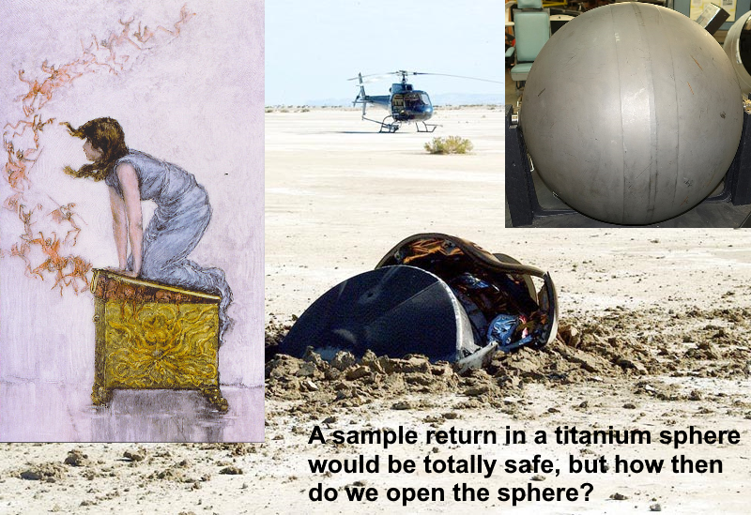
A sample return in a titanium sphere would be totally safe, but how then do we open the sphere? Top right image shows a titanium sphere that survived re-entry. Top left image shows Pandora trying to close the box that she opened in the Greek legend.

Main image - Genesis return capsule on the ground after it crashed (NASA, 2008grcg).
Top left, Opening Pandora’s box (Church, n.d.)
Top right - space ball after re-entry - probably from the equipment module of Gemini 3, 4 or 5. (Daderot, 2017)

So the next step is that the sphere is brought to the facility which is built inside a former nuclear bunker, It is also built inside a large oven for end of facility lifetime complete sterilization, in case something is returned that can’t be permitted to make any contact with Earth’s biosphere, like mirror life.

Finally instead of a conventional airlock it has two airlocks at positive air pressure which are only connected via sump filled with vacuum stable high temperature light oil which is kept at 300 C and irradiated with ionizing radiation., That should keep in even mirror life nanobes

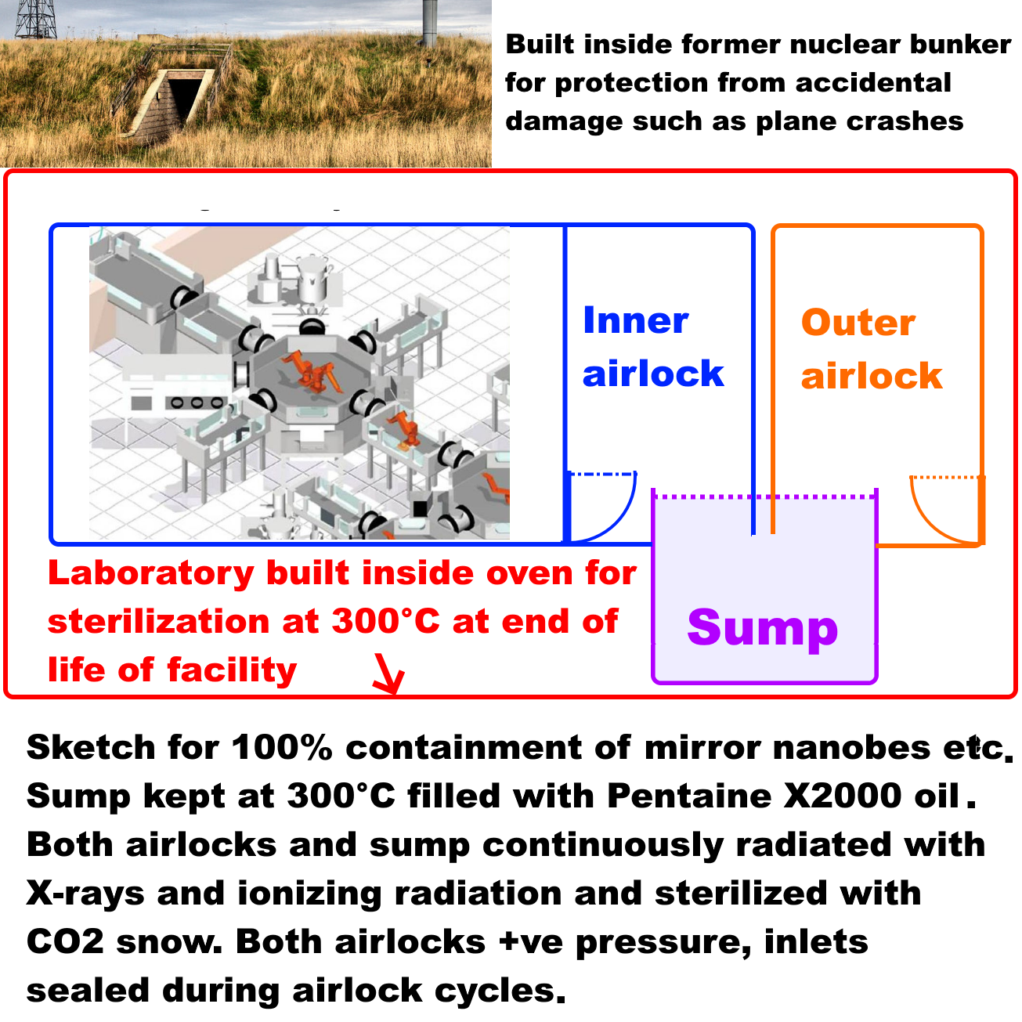

Figure ??: the LAS fully robotic floor plan for a Mars sample receiving facility placed inside an oven for end of laboratory lifetime sterilization of the facility and accessed via two airlocks and a sump for 100% containment of even mirror life nanobes.
Sketch of telerobitic facility Credit NASA / LAS (Hsu, 2009)
Photo of Cultybraggan nuclear bunker (Clark, 2009)
I go into details below:

- Potential third 100% safe alternative? a sketch for a biosafe laboratory on Earth designed for 100% containment of even nanoscale mirror life using telerobotics, a sump heated to 300°C with heat and vacuum stable light oil, and built in heat sterilization at end of life of the facility - could this be a safe way to open “Pandora’s box”?

NASA have made no significant changes in their safety assessments in response to objections in previous requests for comments that highlighted these issues

So far NASA don’t seem to have made any modifications of their plans as a result of the comments on the previous round of NEPA comments including my own previous comment (Walker, 2022a) and many others (NEPA, 2022).

This latest submission doesn’t include any changes to their assessments of the risks.

Compare the “Safety of MSR” in the Nov 4 project fact sheets
With: MSR Safety Fact Sheet 4-18-22 in the April 18th project fact sheets.

The changes are only cosmetic, minute changes in grammar and phrasing. This is the part I’ll focus on here, which in a short paragraph has many serious omissions that I mentioned in the uploaded paper attached to my previous comment as part of the NEPA process (Walker, 2022a). Other commentators there also pointed out some of these omissions.

The one on the left is the one from April 18, the one on the right is from Nov 4.

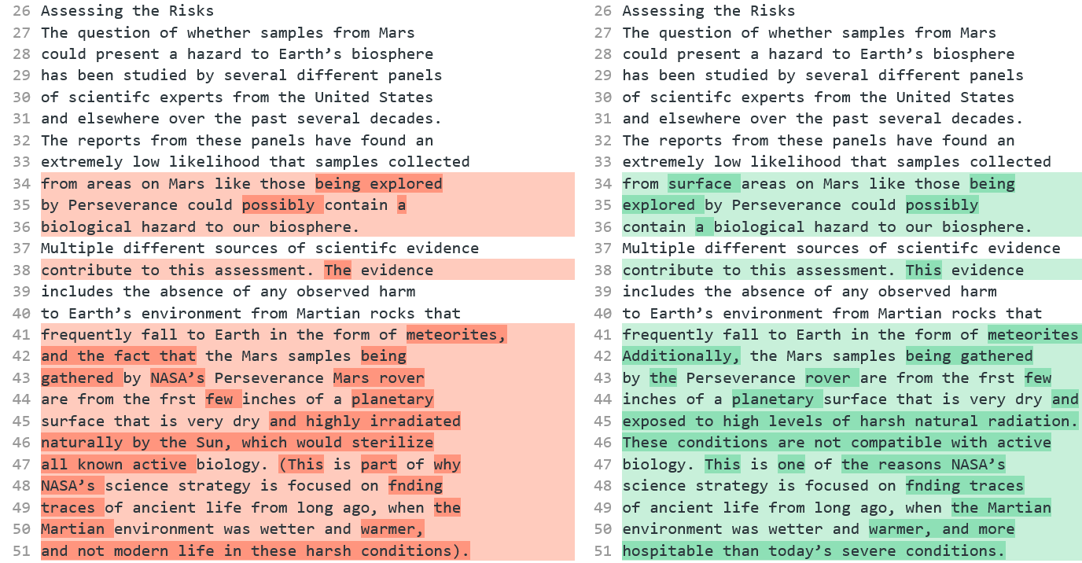
I used the diff tool here to highlight the differences in the text obtained with copy / paste from the pdfs.

In the draft for the Environmental Impact Statement, NASA claim to have addressed all the concerns we raised in the previous round of comments (NASA, 2022eis: 4-7):.

But they have not, as we’ll see.

If NASA continue ignore objections they will be stopped just as for projects that push through a new pipeline on tribal lands in the USA or any other project where Federal agencies don’t do a proper risk assessment and ignore objections.

The usual way projects are stopped is because (Congressional Research Service, 2021)
- the agency failed to consider some of the impacts
- the agency failed to properly consider the weight of the impacts under review
NASA seem to be failing on both of those.

For details of how the project is likely to be stopped if this EIS goes ahead in its current form, see below under:

- NASA’s Environmental Impact Statement is vulnerable to litigation on the basis that it doesn’t consider impacts of a sample return properly, doesn’t take account of the main issues mentioned by the Sample Return Studies and say things that contradict their conclusions – potential remedies include stopping the mission altogether or an injunction, e.g. to sterilize all samples before they contact Earth’s biosphere

NASA fail to adequately consider the potential for life on the Martian surface – they claim that the Martian surface is too inhospitable for life – but why would they need to take precautions if there is no risk? – it’s not surprising the general public aren’t convinced by these claims and from the comments clearly they are not convinced

From their NEPA announcement, (NASA, 2022nepa), NASA seem to be of the impression that the consensus amongst scientists is that the Martian surface is too inhospitable for life

“The general scientific consensus is that the Martian surface is too inhospitable for life to survive there today. It is a freezing landscape with no liquid water that is continually bombarded with harsh radiation.”

In the draft EIS itself, they say (NASA, 2022eis: S-4)

Consensus opinion within the astrobiology scientific community supports a conclusion that the Martian surface is too inhospitable for life to survive there today, particularly at the location and shallow depth (6.4 centimeters [2.5 inches]) being sampled by the Perseverance rover in Jezero Crater, which was chosen as the sampling area because it could have had the right conditions to support life in the ancient past, billions of years ago (Rummel et al. 2014, Grant et al. 2018).
…
Nevertheless, out of an abundance of caution and in accordance with NASA policy and regulations, NASA would implement measures to ensure that the Mars material is fully contained (with redundant layers of containment) so that it could not be released into Earth’s biosphere and impact humans or Earth’s environment.

It’s no wonder the general public find this unconvincing. If NASA need to take precautions “out of an abundance of caution” this means there IS a possibility of returning life. That is how most people think.

The two statements contradict each other as ordinarily understood.

From the first 18 comments on the November 4th request, two were off topic and the 16 on topic responses were:

- Test first: 5
- Stop mission: 5
Then one each of
- Study in space or not at all
- Don't return until we know it is 100% safe
- Are you certain the mission is safe?
- Return to above GEO and return sterilized subsamples immediately [my comment]
- Need clarity about security measures

The general public naturally don’t find their statement convincing, and nor should they be. In reality NASA are NOT sure, or they wouldn’t need to take all these elaborate precautions.

So what is the true situation here? Clearly it can’t be literally a zero chance of life on Mars or they wouldn’t need to do anything.

First, the main source there, (Rummel et al , 2014) is study of the Mars special regions which is a concept in forward contamination, a special region is one where rovers need high levels of sterilization due to the risk of contaminating habitats there with terrestrial life.

This is NOT a sample return study. They do cite the NRC study from 2009 in this draft EIS but not for this passage. They don’t cite the more recent ESF sample return study from 2012 at all – the ESF study set much more stringent requirements due to advances in science between 2009 and 2022 (Ammann et al, 2012). It is a serious omission not to cite it. Both sample return studies are clear that we need to take precautions

Their source (Rummel et al , 2014) is not a consensus position. Even as that 2014 report by Rummel et al was in publication, NASA and ESA commissioned a review which overturned many of its findings.

Again it is a serious omission to cite (Rummel et al , 2014) and not to mention (Board, 2015).

NASA’s source Rummel et al is about habitability of Mars for terrestrial life not about its habitability for possibly more capable martian life – and it also doesn’t say that the Martian surface is inhospitable for terrestrial life in its entirety
NASA don’t give a cite for the “consensus opinion” in this statement. Or at least if Rummel et al is meant as a source then it is falsely summarized.

Consensus opinion within the astrobiology scientific community supports a conclusion that the Martian surface is too inhospitable for life to survive there today, particularly at the location and shallow depth (6.4 centimeters [2.5 inches]) being sampled by the Perseverance rover in Jezero Crater …

Their source (Rummel et al , 2014) doesn’t say this. The study is about “special regions” for forwards contamination and NOT about the locations and capabilities of putative martian life:

“Special Regions on Mars as places where terrestrial organisms might replicate”

Their source (Rummel et al , 2014) goes through many factors that could be a limit for life but find none of them make it totally uninhabitable. In their conclusion Rummel at al say that there are locations with high enough water activity for life, and with a high enough temperature for life, but that it is unknown if terrestrial contamination from missions sent from Earth can use these conditions in this discontinuous fashion: (Rummel et al , 2014:945)

Special Regions on Mars continue to be best determined by locations where both of the parameters (without margins added) of temperature (above 255 K) and water activity (aw ; > 0.60) are attained. There are places/times on Mars where both of these parameters are attained within a single sol, but it is unknown whether terrestrial organisms can use resources in this discontinuous fashion.

Rummel et al’s study is not about backward contamination. Regions with a “high potential for the existence of extant martian life” are classified as “Special regions” but they dismiss this part of the definition of a special region on the basis that we don’t know of any extant martian life.

On that basis they don’t discuss it any further. So this can’t be used as a source for the potential for habitats for extant martian life as it doesn’t even discuss the literature on the topic (Rummel et al , 2014:888)

Special Regions are regions ‘‘within which terrestrial organisms are likely to replicate’’ as well as ‘‘any region which is interpreted to have a high potential for the existence of extant martian life.’’
…
At present there are no Special Regions defined by the existence of extant martian life, and this study concentrates only on the first aspect of the definition.

Other sources have suggested that if there is extant martian life it may be adapted, for instance to be able to use the salty brines there at far lower temperatures, either through use of chaotropic agents or even a different biochemistry that is able to function down to lower temperatures, for instance perhaps with hydrogen peroxide as a component of their biology.

I cover some of the literature on this topic in my preprint (Walker, 2022b) in the section:

- How Martian life could make perchlorate brines habitable when they only have enough water activity for life at -70 °C – biofilms retaining water at higher temperatures - chaotropic agents permitting normal life processes at lower temperatures – and novel biochemistry for ultra low temperatures

In short, NASA’s source is a study of how regions can be delineated where terrestrial organisms might replicate. It is not a study of regions where extant martian life might replicate. It is NOT a source for a statement that the Martian surface is too inhospitable for life.

Rummel et al’s thesis that it is possible to decide from orbit which regions of Mars are habitable to terrestrial life was overthrown by the 2015 review commissioned due to concerns about the 2014 report which said that a map can only represent our incomplete state of knowledge at a particular time

It is also a controversial source, as the whole concept that it is possible to delineate a special region where no terrestrial life could replicate was called in question by the 2015 report (Board, 2015)

In particular, the 2015 review overturned the suggestion from the 2014 review that areas not of Planetary Protection concern can be delineated using maps, saying a map of RSLs with buffer zones can only represent our incomplete state of knowledge at a particular time (Board, 2015 : Ch 5, p 28)

While it is helpful to provide a general overview of regions that may be favorable for the formation of RSL, it is of limited use in the identification of Uncertain or Special Regions. The same applies to other maps that also may be updated soon.
…
Another potential source of misinterpretation related to the use of maps in Special Region studies is the issue of scale. … (see also the discussion in Chapter 2, “Detectability of Potential Small Scale Microbial Habitats”)
… Maps, which come necessarily at a fixed scale, can only provide information at that scale and are, therefore, generalizations.
…
Maps that illustrate the distribution of specific relevant landforms or other surface features can only represent the current (and incomplete) state of knowledge for a specific time—knowledge that will certainly be subject to change or be updated as new information is obtained.
The reason is that the surface can have microhabitats that can’t be detected from orbit. Also that life can be transported by dust from other parts of Mars, for instance to Jezero crater.
See below:
- NASA fail to consider at all the potential for microhabitats in Jezero crater not detectable from orbit
- NASA fail to consider at all the potential for dust storms to transfer life to Jezero crater

So the correct position here is that we don’t know. Jezero crater could have microhabitats for terrestrial life that haven’t yet been detected, and it could have spores or propagules from other regions of Mars.

Rather than a consensus that the entirety of Mars is hostile to life, I have been unable to find one astrobiologist in the literature who says as definitive things about impossibility of present day life on Mars as NASA do in this EIS.

Views of astrobiologists in the planetary protection literature – some think there is a high chance Mars is inhospitable but none go as far as certainty – and others say it may have small niches for microbial life over much of the surface

Many astrobiologists have expressed a view that present day Mars may well be habitable to terrestrial life in part. This need not mean that there is life there, it could have uninhabited habitats i.e. which life could colonize but with nothing left by way of early Martian life to colonize them (Cockell, 2014). Some astrobiologists do say that Mars has a high chance to be inhospitable but not certainty and many think Mars may have small niches suitable for life, similar to niches found in the soil or rocks of our driest coldest deserts which often have small communities of microbes, even if they are only habitable at microbial scales.

Many astrobiologists also think it could have extant Martian life. A few think there is a possibility that Viking discovered life in the 1970s.

There is no consensus for any of these positions. But so far I haven’t found NASA’s supposed “consensus” as a published point of view of any astrobiologist in any of the papers I’ve looked at. I am interested if anyone knows of such a source from a reputable peer reviewed journal so I can add it to the range of points of view of astrobiologists.

This quote is from a paper about planetary protection in the forwards direction by Rummel and Conley, both former planetary protection officers for NASA (Rummel et al, 2017)

"Claims that reducing planetary protection requirements wouldn't be harmful, because Earth life can't grow on Mars, may be reassuring as opinion, but the facts are that we keep discovering life growing in extreme conditions on Earth that resemble conditions on Mars. We also keep discovering conditions on Mars that are more similar—though perhaps only at microbial scales—to inhabited environments on Earth, which is where the concept of Special Regions initially came from."

Here are a few example statements:

Davila et al. (Davila et al, 2010).

"We argue that the strategy for Mars exploration should center on the search for extant life. By extant life, we mean life that is active today or was active during the recent geological past and is now dormant. As we discuss below, the immediate strategy for Mars exploration cannot focus only on past life based on the result of the Viking missions, particularly given that recent analyses call for a re-evaluation of some of these results. It also cannot be based on the astsumption that the surface of Mars is uniformly prohibitive for extant life, since research contributed in the past 30 years in extreme environments on Earth has shown that life is possible under extremes of cold and dryness."

Westall (Westall , 2013:192)

"This presupposes that the ephemeral surface habitats could be colonized by viable life forms, that is, that a subsurface reservoir exists in which microbes could continue to metabolize and that, as noted above, the viable microbes could be transported into the short-lived habitat

.... Although there are a large number of constraints on the continued survival of life in the subsurface of Mars, the astonishing biomass in the subsurface of Earth suggests that this scenario as a real possibility."

Morozova (Morozova et al, 2006)

"The observation of high survival rates of methanogens under simulated Martian conditions supports the possibility that microorganisms similar to the isolates from Siberian permafrost could also exist in the Martian permafrost"

Crisler et al (Crisler et al, 2012)

Our results indicate that terrestrial microbes might survive under the high-salt, low-temperature, anaerobic conditions on Mars and present significant potential for forward contamination. Stringent planetary protection requirements are needed for future life-detection missions to Mars

Renno (Renno, 2014):
"This is a small amount of liquid water. But for a bacteria, that would be a huge swimming pool - a little droplet of water is a huge amount of water for a bacteria. So, a small amount of water is enough for you to be able to create conditions for Mars to be habitable today'. And we believe this is possible in the shallow subsurface, and even the surface of the Mars polar region for a few hours per day during the spring."

Stamenković (Wall, 2018)

There is still so much about the Martian habitability that we do not understand, and it's long overdue to send another mission that tackles the question of subsurface water and potential extant life on Mars, and looks for these signals

De Vera et al (de Vera et al, 2014)

"This work strongly supports the interconnected notions
(i) that terrestrial life most likely can adapt physiologically to live on Mars (hence justifying stringent measures to prevent human activities from contaminating / infecting Mars with terrestrial organisms);
(ii) that in searching for extant life on Mars we should focus on "protected putative habitats"; and
(iii) that early-originating (Noachian period) indigenous Martian life might still survive in such micro-niches despite Mars' cooling and drying during the last 4 billion years"

Cockell (Deighton, 2016)

Most microbes can grow in different types of extremes and the extremes that we are looking at, things like radiation, perchlorate salts and also sulphate salts (found on Mars), they will grow in that. It’s just a question of trying to determine what the limits are and that’s the work we're doing at the moment. Anywhere where we’ve gone to the deep subsurface (on earth) today, where there is liquid water, there is a high chance that environments are habitable,

Simply because Mars is a planet of volcanic rock, and when volcanic rock weathers that provides an environment for microbes to grow and reproduce, I think we can already say there is a high chance there are habitable environments.

‘At the moment we just don’t know what the origin of life requires, going from simple chemicals to self-replicating microbe,’ Edinburgh’s Prof. Cockell said. ‘If we looked at many planets, many environments and didn’t find life, then that would tell us that life is extremely rare and that early spark was an unusual event.
‘And then we’d have to try and find out exactly why it was, and what happened in those early stages of life that was unusual on the earth.’.

Cabrol (Cabrol, 2021)

Arguably, dispersal does not imply seeding, but it provides the potential for it and, if life started on Mars, odds are that not only is it still there, but it is everywhere it can be where conditions allow dormancy or metabolic activity. Here, terrestrial analogues in extreme environments show that ‘everywhere it can be’ does not, however, mean easy to see. Hidden oases are often measured in centimetres to micrometres, their presence intimately linked to the subtle interplay and feedback mechanisms between living things and their environment.

Bianciardi et al (Bianciardi et al, 2012)

"These analyses support the interpretation that the Viking LR experiment did detect extant microbial life on Mars"

Miller et al (Miller et al, 2002).

"Did Viking Lander biology experiments detect life on Mars? ... Recent observations of circadian rhythmicity in microorganisms and entrainment of terrestrial circadian rhythms by low amplitude temperature cycles argue that a Martian circadian rhythm in the LR experiment may constitute a biosignature."

Levin et al (Levin et al, 2016)

"It is concluded that extant life is a strong possibility, that abiotic interpretations of the LR data are not conclusive, and that, even setting our conclusion aside, biology should still be considered as an explanation for the LR experiment. Because of possible contamination of Mars by terrestrial microbes after Viking, we note that the LR data are the only data we will ever have on biologically pristine martian samples"

In the 2020 conference Mars extant life: what's next? (Carrier et al, 2020) a significant fraction of the participants thought that there is a possibility Mars has extant life.

Primary conclusions are as follows: A significant subset of conference attendees concluded that there is a realistic possibility that Mars hosts indigenous microbial life. A powerful theme that permeated the conference is that the key to the search for martian extant life lies in identifying and exploring refugia (“oases”), where conditions are either permanently or episodically significantly more hospitable than average. Based on our existing knowledge of Mars, conference participants highlighted four potential martian refugium (not listed in priority order): Caves, Deep Subsurface, Ices, and Salts.

NASA’s summary by comparison – “existing credible evidence suggests that conditions on Mars have not been amenable to supporting life as we know it for millions of years” – is this because they associate life with large amounts of water rather than the minute transient biofilms, droplets and even high humidity without water, all microhabitats that microbes can make use of? Renno’s “Swimming pools foo a bacteria”

It is hard to see how NASA can read those statements by astrobiologists and come to such radically different conclusions about what astrobiologists believe. But this is what they say in the draft EIS (NASA, 2022eis: 1-6):

Existing credible evidence suggests that conditions on Mars have not been amenable to supporting life as we know it for millions of years (iMARS Working Group 2008, National Research Council 2011, Beaty et al. 2019, National Research Council 2022). The surface of Mars, particularly for the area/region/middle latitudes being sampled by the Perseverance rover, is too cold (an average surface temperature of -55 degrees Celsius [°C] [-67 degrees Fahrenheit (°F)]) for water to exist in a liquid form in other than optimal circumstances and then often only transiently on or near the surface in isolated pockets.

Let’s look at their most recent cite, the National Research Council Decadal Strategy for Planetary Science and Astrobiology, published in 2022. Since they don’t give page numbers for any of their cites and this is a cite to a book of hundreds of pages it’s impossible to know which page exactly they are referring to there. But this is what they say on page 393 about Mars (Smith et al, 2022: 393):

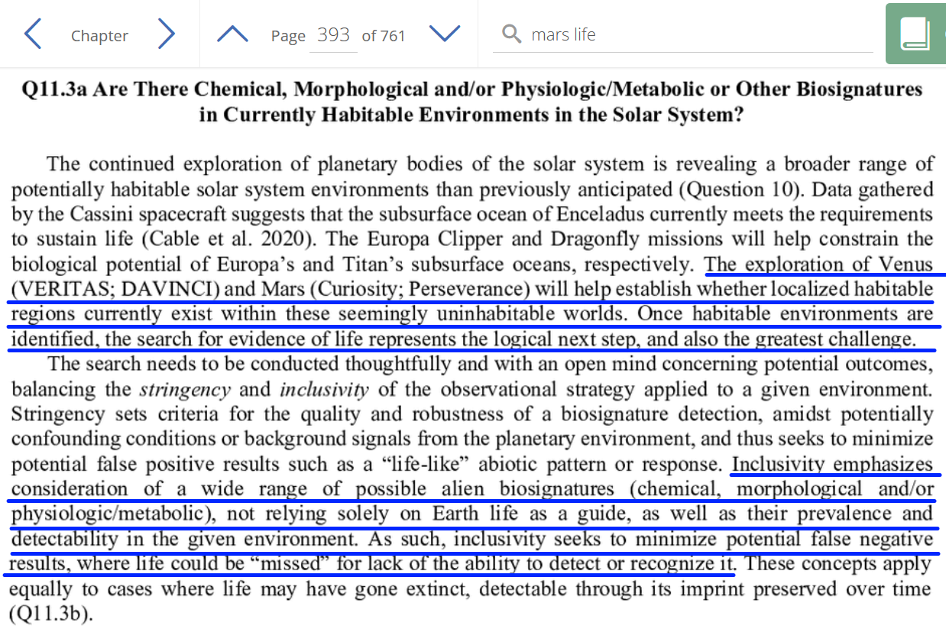

The exploration of … Mars (Curiosity, Perseverance) will help establish whether localised habitable regions currently exist within these seemingly uninhabitable worlds. Once habitable environments are identified, the search for evidence of life represents the logical next step, and also the greatest challenge.
…
Inclusivity emphasizes consideration of a wide range of possible alien biosignatures (chemical, morphological and / or physiologic/ metabolic), not relying solely on Earth life as a guide, as well as their prevalence and detectability in the given environment. As such, inclusivity seeks to minimize potential false negative results where life could be “missed” for lack of the ability to detect or recognize it.

They also warn about biological oases. Since Perseverance isn’t looking for present day life it isn’t trying to map out where these biological oases might be if there is extant life in Jezero crater: (Smith et al, 2022: 396):

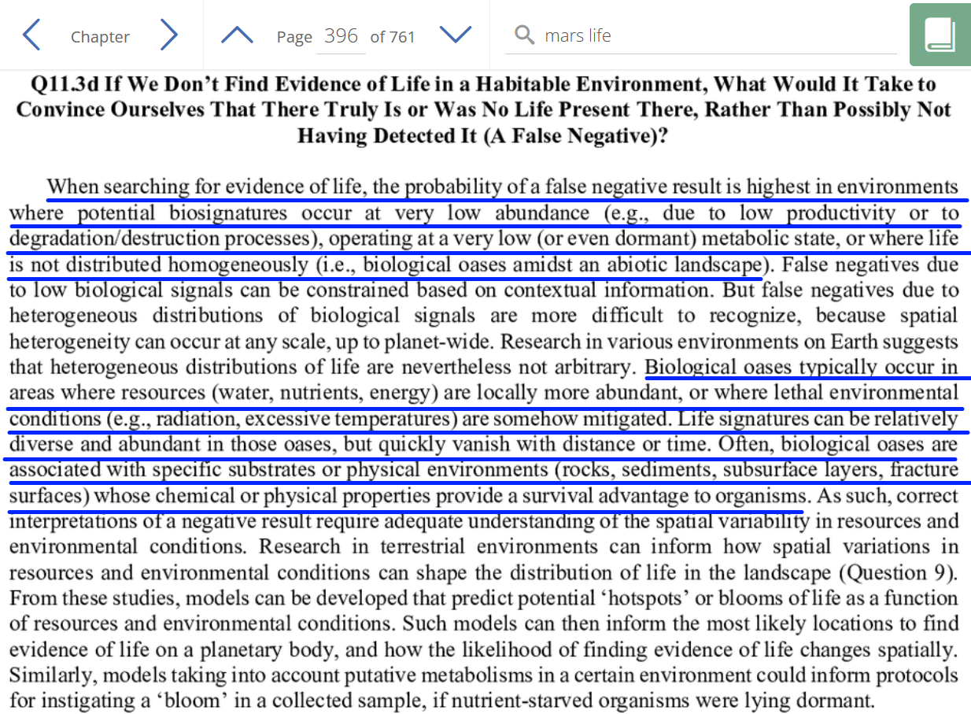

As we’ll see there is some potential for biological oases in Jezero crater especially for extant martian life that might have the capability to use colder brines than terrestrial life.

This is indeed a credible source, of the highest order. But it is incorrectly cited in the NASA draft EIS

NASA’s draft EIS summarizes all this research as (NASA, 2022eis: 1-6):

Existing credible evidence suggests that conditions on Mars have not been amenable to supporting life as we know it for millions of years (iMARS Working Group 2008, National Research Council 2011, Beaty et al. 2019, National Research Council 2022).

I find it hard to understand how such an inaccurate citation could get into the NASA draft EIS.

Perhaps Nilton Renno’s video can help us to understand? This is him reporting on the discovery using the Michigan Mars Environmental Chamber which he helped to develop. Their aim was to understand what appeared to be droplets of liquid that formed on the legs of the Phoenix lander. Nilton Renno was the leader of the team that discovered those droplets (Nilton, n.d.bio).

They came to the conclusion that the higher latitudes with surface ice may be a promising location for microhabitats for present day life. This includes salt lying on ice (Fischer et al., 2014) which can form liquid brines within hours, and could lead to microhabitats throughout the higher latitudes of Mars. This could be an explanation of the droplets seen on the legs of the Phoenix lander which grew, merged, and eventually vanished, believed to have fallen off the leg (Gronstall, 2014)

Figure 33 Possible droplets on the legs of the Phoenix lander - they appeared to merge and sometimes fall off. In this sequence of frames, the rightmost of the two droplets - highlighted in green on this black and white image - grows and seems to do so by taking up the water from its companion to the left, which shrinks (Gronstall, 2014)

In December 2013, Nilton Renno and his team used the Michigan Mars Environmental Chamber (Fischer et al., 2013) to simulate the conditions at the Phoenix landing site. They were able to trigger formation of droplets similar to the ones on the Phoenix lander’s legs. In their experiment, salty brines formed within a few tens of minutes when salt overlaid ice (Fischer et al., 2014). The team concluded that suitable conditions for brine droplets may be widespread in the polar regions

The very minute amounts of water they are talking about there would be useless to higher life like ourselves, or even plants, animals, insects, most macroscopic life. But for a microbe it’s a swimming pool. It is a very different perspective (Renno, 2014):

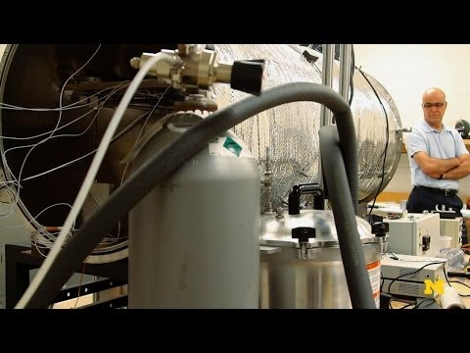

"This is a small amount of liquid water. But for a bacteria, that would be a huge swimming pool - a little droplet of water is a huge amount of water for a bacteria. So, a small amount of water is enough for you to be able to create conditions for Mars to be habitable today'. And we believe this is possible in the shallow subsurface, and even the surface of the Mars polar region for a few hours per day during the spring."

Nilton Renno also runs the REMS weather station on Curiosity and is co-author of a major review study on the potential for liquid water on the surface of Mars night (Martínez et al., 2016).. Renno was also the main astrobiologist co-investigator for the Phoenix mission and investigated the water droplets at the time (NASA, n.d.pmm) (Nilton, n.d.bio)

I’m saying all this because NASA said (NASA, 2022eis: 1-6):

Existing credible evidence suggests that conditions on Mars have not been amenable to supporting life as we know it for millions of years

You could hardly have a more credible source on the habitability of present day Mars than Nilton Renno, an astrobiologist who was co-investigator for Phoenix, who runs the Curiosity REMS weather station on Mars, who has written the most comprehensive review there is on the potential for water on Mars and whose team developed and runs the Michigan Mars Simulation Chamber.

I don’t think it is necessary to go into any more details to try to find out why the NASA EIS somehow gives this false impression of no credible source. It’s simpler to just present one very credible source to show clearly that their conclusion is mistaken and compare it with their most recent cite which is of high credibility.

As for why and how they managed to make a draft EIS with such inaccurate citations in it, that’s for NASA to answer, especially if they ignore this comment too and it ends up in the courts.

If that happens at least this comment is on record as an attempt to do something about it.

Also if this does end up in the courts at some point, and this comment is included in that case I hope it can persuade the litigators to look at other alternatives than no action or sterilization of all the samples as a way for the mission to go ahead.

NASA make statements that contradict important conclusions from previous studies by the National Research Council and others - and as a result fail to properly consider the weight of the impacts under review

NASA don’t cite the European Space Foundation study from 2012, or the US’s National Research Council study. What’s more, their submitted documents don’t have any cites.

Not only that, the submitted documents make statements that go against the conclusions of the peer reviewed literature on the topic which suggests they haven’t read it or they ignore it.

Example, let’s look at this passage from the MSR safety fact sheet for the h Draft Environmental Impact Statement (NASA, 2022msfs):

The question of whether samples from Mars could present a hazard to Earth’s biosphere has been studied by several different panels of scientific experts from the United States and elsewhere over the past several decades.

[this much is true]

The reports from these panels have found an extremely low likelihood that samples collected from areas on Mars like those being explored by Perseverance could possibly contain a biological hazard to our biosphere.

The most recent of the thorough Mars sample return studies, from the European Space Foundation in 2012:

“The risks of environmental disruption resulting from the inadvertent contamination of Earth with putative martian microbes are still considered to be low. But since the risk cannot be demonstrated to be zero, due care and caution must be exercised in handling any martian materials returned to Earth”

NASA’s MSR Safety fact sheet for the draft EIS again (NASA, 2022msfs):

The evidence includes the absence of any observed harm to Earth’s environment from Martian rocks that frequently fall to Earth in the form of meteorites,

National Research Council report in 2009 said (Board et al, 2009: 48).:
Section: Potential for large scale effects [of a Mars Sample Return]
“The potential hazards posed for Earth by viable organisms surviving in samples is significantly greater with a Mars sample return than if the same organisms were brought to Earth via impact-mediated ejection from Mars

…Certainly in the modern era, there is no evidence for large-scale or other negative effects that are attributable to the frequent deliveries to Earth of essentially unaltered Martian rocks. However the possibility that such effects occurred in the distant past cannot be discounted.”

NASA’s MSR Safety fact sheet for the draft EIS again (NASA, 2022msfs):

and the fact that the Mars samples being gathered by NASA’s Perseverance Mars rover are from the frst few inches of a planetary surface that is very dry and highly irradiated naturally by the Sun, which would sterilize all known active biology.

The Review from 2015: (Board, 2015)

There are many examples of small-scale and microscale environments on Earth … that can host microbial communities, including biofilms, which may only be a few cell layers thick. The biofilm mode of growth, as noted previously, can provide affordable conditions for microbial propagation despite adverse and extreme conditions in the surroundings.
So, let’s go into this in more detail

NASA fail to adequately consider the risks from life that can’t get to Earth on meteorites - in 2009, the National Research Council examined the possibility of life transferred on meteorites said the risk is significantly greater in a sample return mission - and said they can’t rule out the possibility of large scale effects in the past due to life from Mars – NASA’s EIS instead claims microbes will survive transfer from Mars to Earth more easily in a meteorite than in a sample return mission but their sources don’t back this up

Let’s look at the first of these two statements NASA use to support their conclusion that the activity is very low risk, from the MSR safety fact sheet from this page:

The evidence includes the absence of any observed harm to Earth’s environment from Martian rocks that frequently fall to Earth in the form of meteorites,

Then in the draft EIS:

One of the reasons that the scientific community thinks the risk of pathogenic effects from the release of small amounts (less than 1 kilogram [2.2 pounds]) of Mars samples is very low is that pieces of Mars have already traveled to Earth as meteorites.

…

The natural delivery of Mars materials can provide better protection and faster transit than the current MSR mission concept.

They cite the NRC report from 2009 but not on this point. The National Research Council DID look into this question in their "Assessment of Planetary Protection Requirements for a Mars Sample Return". However their conclusion was the opposite of NASA’s draft EIS summary.

They were unable to rule out the possibility that life from Mars could have caused past mass extinctions on Earth

The NRC found that most of the meteorites that get to Mars are sterilized during transit. But about 1% get here within 16,000 years and 0.01 percent within 100 years (note none of the meteoirites we have from Mars left the planet less than hundreds of thousands of years ago)

This is from Earth (Board et al, 2009: 48).

"Transit to Earth may present the greatest hazard to the survival of any microbial hitchhikers. Cosmic-ray-exposure ages of the meteorites in current collections indicate transit times of 350,000 to 16 million years. However theoretical modeling suggests that about 1 percent of the materials ejected from Mars are captured by Earth within 16,000 years and that 0.01 percent reach Earth within 100 years.

NRC continue that survival of organisms in meteorites is plausible. If they can be shown to survive ejection, entry and impact they can be expected to transfer from Mars to Earth (Board et al, 2009: 48)..

“Thus, survival of organisms in meteorites, where they are largely protected from radiation, appears plausible. If microorganisms could be shown to survive conditions of ejection and subsequent entry and impact, there would be little reason to doubt that natural interplanetary transfer of organisms is possible and has, in all likelihood, already occurred.

However that is the big unknown. Can life from present day Mars get onto the meteorites, be ejected from Mars, and then survive the fireball of re-entry to Earth.

The NASA EIS says this (NASA, 2022eis: 3-3):

First, potential Mars microbes would be expected to survive ejection forces and pressure (National Academies of Sciences, Engineering, and Medicine and the European Science Foundation 2019), and, within the interior portions of the rocks, would be protected from elevated radiation levels, and large temperature variations that meteorite surfaces experience during the transit from Mars to Earth (Mileikowsky 2000).

The big hurdles for transfer of life from Mars are the shock of ejection, the fireball of exit from Mars the cold, vacuum and ionizing radiation of the passage to Earth, and the fireball of re-entry.

Their cite on ejection pressures is about transport of materials from Mars to the Martian moons for an assessment of sample return missions from those moons. It does NOT look at sterilization during Mars ejecta formation. This is what they say (Board, 2019 : 26). :

The SterLim team did not include any sterilization during Mars ejecta formation in its analysis because such investigations were not requested in its study’s statement of work.

It also looks at only one impact, the ejection from Zunil crater as any ejection from more than a million year ago would not leave surviving microbes close to the surface of the Martian moons due to the ionizing radiation.

It does mention shock heating. It didn’t look at the acceleration during ejection from Mars. But the sudden acceleration actually kills most microbes. I cover that below

Second, a significant fraction of natural transits occur on trajectories that require as little as 6 months where the material returned by the MSR mission concept would be in flight for Mars Sample Return Campaign Programmatic EIS over 18 months (Gladman 1997). Thus, if potentially harmful microbes were abundant on the Martian surface it is likely they already would have been transferred to Earth by this natural process (Fajardo-Cavazos et al. 2005, Horneck et al. 2008, Howard et al.2013).

Actually the meteorites we have on Earth all came from at least 3 meters below the surface of Mars. The proposed habitats for present day Mars are on the surface in dust and brine layers. How is life in those layers going to get into a rock at least 3 meters below the surface?

Then there’s the shock of ejection and the fireball of re-entry to Earth.

I go into that in my preprint (Walker, 2022b) in the section:

- Could Martian life have got to Earth on meteorites? Our Martian meteorites come from at least 3 m below the surface in high altitude regions of Mars

NRC 2009 report emphasizes that large scale effects can’t be ruled out – it says potential hazards from microbes returned in a sample return mission are significantly greater than hazards from microbes in meteorites and that though there have certainly been no recent large scale effects that could be due to microbes from Mars, the possibility of large scale effects in the distant past can’t be disproved – draft EIS says potential environmental effects would not be significant

Going back to the NRC report, they continue that any microbes in martian materials transported to Earth in a sample return mission face very different conditions from those in meteorites (Board et al, 2009: 48)..

It should be noted that martian materials transported to Earth via a sample return mission will spend a relatively short time (less than a year) in space - all the while protected in containers. (Note that researchers have yet to discover compelling evidence of life in any meteorite, martian or otherwise.) Thus the potential hazards posed for Earth by viable organisms surviving in samples is significantly greater with a Mars sample return than if the same organisms were brought to Earth via impact-mediated ejection from Mars."

They go on to say that it is simply not possible to determine whether viable Martian life forms have already been delivered to Earth.

They also say that though there is no evidence of large scale or other negative effects (such as extinctions) in the modern era due to the frequent deliveries of Martian rocks, that it is not possible to discount such effects in the distant past. (Board et al, 2009: 48).

"Despite suggestions to the contrary, it is simply not possible, on the basis of current knowledge, to determine whether viable Martian life forms have already been delivered to Earth. Certainly in the modern era, there is no evidence for large-scale or other negative effects that are attributable to the frequent deliveries to Earth of essentially unaltered Martian rocks. However the possibility that such effects occurred in the distant past cannot be discounted.”

That’s in their section 5, Potential for Large Scale Effects, page 48:

I discuss this passage below in:

- The Great Oxygenation Event which transformed Earth’s atmosphere and oceans chemically gives a practical example of a way life from another Mars-like planet could in principle cause large scale changes to an Earth-like planet

NASA’s draft EIS summarizes this INCORRECTLY as (NASA, 2022eis: 3-3):

The reports from these panels have found an extremely low likelihood that samples collected from areas on Mars like those being explored by Perseverance could possibly contain a biological hazard to our biosphere.

…

The evidence includes the absence of any observed harm to Earth’s environment from Martian rocks that frequently fall to Earth in the form of meteorites

Then in the draft EIS they say that the potential environmental impacts from a sample release would not be significant (NASA, 2022eis: 3-16):

The MSR Campaign is the first sample return mission to be classified as Restricted Earth Return, since the term was defined. (The Apollo 11, 12, and 14 missions were subjected to quarantine upon return until lunar samples were assessed and found to pose no hazard.) Prior mission sample return missions at the UTTR (e.g., Stardust, Genesis, and the upcoming return of OSIRIS-Rex) were all classified as Unrestricted Earth Return.

The human health and safety analysis focuses on the precautions taken to provide backward planetary protection. However, the probability of inadvertent or off-39
nominal reentry would be similarly small as those evaluated for these earlier missions (NASA 1998, NASA 2001, NASA 2013), and as stated previously, the samples are unlikely to pose a risk of significant ecological impact or other significant harmful effects should there be a sample release. The relatively low probability of an inadvertent reentry combined with the assessment that samples are unlikely to pose a risk of significant ecological impact or other significant harmful effects support the judgement that the potential environmental impacts would not be significant.

This is all that they say on the topic. There is no further discussion of the potential for large scale effects and this particular sentence isn’t cited to any other source.

NASA’s draft EIS has no mention of ANY need for quarantine or other precautions for potential effects on humans or other lifeforms of accidental release on Earth – just sterilization of the landing site

Another striking omission is that there is no mention of potential effects of accidental release on humans or animals or plants or any other life even locally.

This is extensively studied in the literature on the topic (Pugel et al, 2020):

An extraterrestrial pathogen lacks existing diagnostic testing and medical management protocols. Future health emergency response measures may need to incorporate knowledge deficits into plans and exercises, and all those responding, including healthcare workers and first responders, will need education and training in advance of the spacecraft's return.
The lack of knowledge surrounding extraterrestrial pathogens, from disinfection to incubation periods, presents a novel situation for which current public health and healthcare emergency preparedness efforts have not been developed. The spectrum of biological threats (natural outbreak, intentional attack, and laboratory accident) does not include a novel pathogen of unknown biological makeup.
There is no discussion of precautions to be taken if there is an accidental release, or if a technician in the facility is accidentally exposed to the samples.

This is all they say on the matter (NASA, 2022eis :3-18)

Overall Health and Safety Impacts

Health and safety impacts are mitigated through the prevention of backward contamination, which is provided by the low probability of failure of the engineered containment systems intended to provide containment of the Mars sample material under all circumstances. Implementation of actions that are in line with accepted procedures used for the isolation of biohazard materials provides additional protection against the release and spread of such material. Given implementation of these precautions and given that Mars materials are not expected to have significant pathological impacts if released into the Earth’s biosphere, on-site mission preparation (to include testing, rehearsals, and landing site preparation), EES landing, and EES recovery operations are expected to have minimal direct and/or indirect impacts on human health at the UTTR, the Det-1 location, or in general.

Yet when considering the possibility of studying the samples with humans in orbit they say there is concern about potential health impact (NASA, 2022eis: 2-26):

Additionally, a positive result from the SSAP (Site Safety Assessment Protocol) represents a potential hazard to crew health within a small, enclosed system, plus a contaminated facility that will eventually need to be returned to Earth (or will fall to Earth if there is a system failure).

So they claim a potential hazard to crew health if the samples are studied in orbit, but minimal hazard to human health in case of an accidental release once the samples are returned to Earth.

The only occurrence of the word quarantine is in a reference to the Apollo mission (NASA, 2022eis: 3-15):

The MSR Campaign is the first sample return mission to be classified as Restricted Earth Return, since the term was defined. (The Apollo 11, 12, and 14 missions were subjected to quarantine upon return until lunar samples were assessed and found to pose no hazard.)

During the Apollo sample returns, there were several times technicians were accidentally exposed to the samples and had to isolate (Mangus et al, 2004:51). For instance, two technicians had to go into isolation after a leak was found in a sample handling glove for Apollo 11 (Meltzer, 2012:485), and then 11 technicians had to go into isolation in 1969 when a small cut was found in one of the gloves during preliminary examination of one of the samples returned by Apollo 12 (Meltzer, 2012:241).
The draft EIS doesn’t discuss what happens if technicians are similarly exposed to the sample materials on Earth, even though they raise it as an issue for astronauts studying the samples in orbit.
A carefully peer reviewed EIS wouldn’t have internal inconsistencies like this.

The draft EIS does however describe a need to take precautions at the landing site. They plan to decontaminate the landing site with chlorine dioxide such as is used in drinking water and aldehydes (NASA, 2022eis: 3-35):

After removal of the EES, the entire landing site (consisting of the impact area and extent of ejecta) may be decontaminated as a precautionary measure

The process of retrieving the EES and placing it into the vault would be assumed to generate potentially hazardous biological waste until demonstrated otherwise. As described earlier, the process of placing the EES into containment and then inserting it into the vault would be conducted as in past missions. All the systems used, including personnel protective gear, would be assumed to be contaminated and would either be decontaminated or simply discarded as hazardous waste. Wastes could include plastics and clothing. Any liquids used in the decontamination process would be absorbed onto solids prior to disposal.

Chlorine dioxide is a disinfectant. When added to drinking water, it helps destroy bacteria, viruses and some types of parasites.

Aldehydes are highly effective, broad-spectrum disinfectants, which typically achieve sterilization by damaging proteins. Aldehydes are effective against bacteria, fungi, viruses, mycobacteria and spores.

They explain (NASA, 2022eis: 3-35):

NASA believes these types of decontaminates would be effective given the assumption that any putative Mars life forms would be similar to “life as we know it” with a water-mediated carbon-based biochemistry, and that there would not be any “unique” biohazards associated with the Mars samples

This surely needs more thorough study for the special case of extra-terrestrial life from Mars.

These methods rarely achieve 100% reduction. From their cite, this shows the effect of 24 hours of high concentrations of CLO2. It has almost no effect on the top soil or below a depth of one inch below the surface. It is much more effective on clay or sand with a 100 million fold reduction (EPA, 207:36)

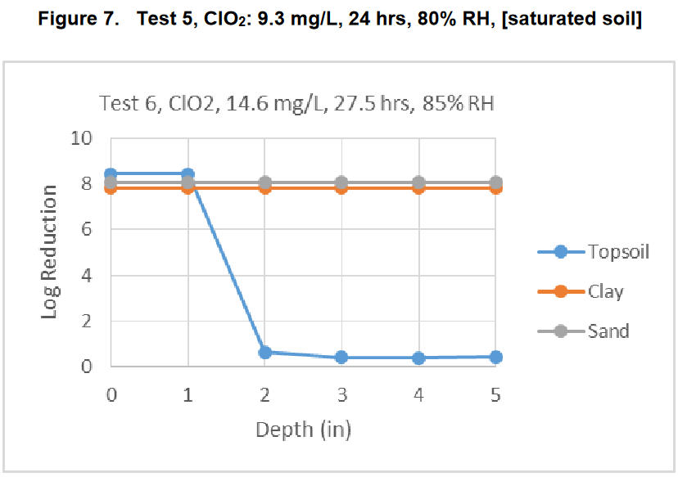

Also this is for reduction in “colony forming units” in other words cultivable spores. Many microbes are uncultivable. Also Martian life is adapted to surface conditions with high concentrations of perchlorate. They may well be more resistant to chlorine dioxide than terrestrial life.

Also, what are the contingency plans if Martian life has got into the microbiome of a human, or an insect flies away with it, or it gets blown away from the site in dust in the atmosphere, or into groundwater?

And then – if these precautions are needed for the landing site, why are they not also needed in case of an accidental breach of containment at the BSL-4 facility?

This raises many questions that would likely be asked during a peer review of the draft EIS by independent experts.

I cover issues of effect of release of the sample on humans and of quarantine in in my preprint (Walker, 2022b) under:

- Public health challenges responding to release of an extraterrestrial pathogen of unfamiliar biology
- Failure modes for sample containment
- Complexities of quarantine for technicians accidentally exposed to sample materials

NASA’s draft EIS gives no quantitative answer to concerned questions from the general public about how low the risk is for large scale effects from a sample return from Mars handled according to the methods they have outlined – is it 1 in thousand or 1 in a million or 1 in a billion? They just say it is impossible to give a 100% guarantee

This is one of the main questions from the public. Yet NASA don’t give anything like a satisfactory answer to it. This answer alone is likely to lead to litigation once the document reaches general public awareness if NASA can’t improve on it.

Example, the draft EIS gives this as one of the main questions from the public (NASA, 2022eis: 3-3):

When the consequences of a failure are so great, a 100% guarantee should be required.

The NASA factsheet “The Safety of Mars Sample Return” does address this issue. “Panels have found an extremely low likelihood that samples collected from areas on Mars like those being explored by Perseverance could possibly contain a biological hazard to our biosphere.”

Just how low is “low likelihood”? Is NASA’s goal specification to prevent accidental release of the Mars samples 1 in a thousand? 1 in a million? 1 in a billion?

This is their answer to that question:

No outcome in science and engineering processes can be predicted with 100% certainty. The safety case for MSR safety is based on redundant containment supported by rigorous testing and analysis, the extensive experience of NASA and ESA with very similar activities over the past three decades, as well as independent reviews of program plans by external expert

The draft EIS shows clearly the results of not setting up any advanced planning and oversight agency with experts in legal, ethical and social issues tasked with interfacing NASA decisions and the general public’s questions as the top priority – as recommended in numerous papers on Mars sample return missions

Margaret Race made a relevant point here. She says scientists are likely to focus on (Race, 1996)
- technical details
- mission requirements
- engineering details
- costs of the space operations and hardware
General public are likely to focus on
- risks and accidents
- whether NASA and other institutions can be trusted to do the mission
- worst case scenarios
- whether the methods of handing the sample, quarantine and containment of any Martian life are adequate
We see the results of this different focus in the report. It is just not something that greatly occupies the minds of the engineers and scientists who work on space projects, yet it is the main thing on the minds of members of the public.
This shows up clearly the issues with their failure to set up the mechanism to deal with public responses recommended by numerous sample return studies.

- Rummel et al recommend a planning agency set up in advance with experts in legal, ethical and social issues - Uhran et al recommend an advanced planning and oversight agency set up two years before the start of the legal process – and the ESF recommends an international framework should be set up, open to representatives from all countries - NASA don’t seem to have done any of this yet

Again it’s understandable that engineers whose minds are focused on solving numerous complex technical difficulties with the mission might not understand why there is need to set up a planning and oversight agency two years before the start of the legal process. This wouldn’t help solve their engineering problems in any way whatsoever.
But for the general public, it is absolutely essential for the issues that matter most to them.

Answer to the question about how low the risk is - it can’t be quantified but is likely very low for the proposed action – since Perseverance is not searching for microhabitats in Jezero crater and will return hardly any dust – level of risk is similar to the risk of building a house without a smoke detector – rather than the risk off outdoor fireworks in your kitchen – but for a house NASA share with nearly 8 billion other people when almost all don’t know NASA is considering removing the smoke detectors and they have no say in the decision
I can help here based on my experience working full time (on my own initiative) as a voluntary fact checker for scared people. I am doing this to help anyone who might read this document and panic and expect the worst. E.g. jump instantly to fear of human extinction.

A good analogy, it's more of the order of building a house without a smoke detector - but a house you share with nearly 8 billion people - than setting off outdoor fireworks in the kitchen. This smoke detector analogy is from Margaret Race from her contribution "No Threat? No Way" in the Planetary Report. She is responding to Robert Zubrin, president of the Mars society who thinks we don’t need to protect Earth from a Mars sample return. She wrote in 2000:
"He's confident in our impressive technological prowess; he's raring to go and doesn't want anything to slow down or stop our exploration of Mars - especially not burdensome regulations based on very small risks and scientific uncertainty. Yet when he suggests that there's no need for back contamination controls on Mars sample return missions, he's advocating an irresponsible way to cut corners. If he were an architect, would he suggest designing buildings without smoke detectors or fire extinguishers?

There are many hurdles for life on Mars to jump to get to Earth.
- The chance of present day life in the geological samples or in the few dust spores attached to the containers is very low.

- The ultramicrobacteria has to be dislodged from the sample
- Then to escape from a BSL-4 facility it has to be a very small microbe such as an ultramicrobacteria – or escape due to improper handling. The habitats on Mars may favour ultramicrobacteria because of the low levels of nutrients, ultramicrobacteria have a higher surface to volume ratio so can take up more nutrients per volume with nutrients that diffuse at the same rate through the cell membrane.
- Then there's whether it is pre-adapted to survive on Earth.
An example of a worst case microbe to escape is one that can survive in the rivers and the sea and ends up in water outside the facility, or one that can spread in viable spores in airborne dust.
The easiest case to contain is a microbe with very specialist capabilities that has almost no habitats on Earth it can survive in. It may be possible to stop it spreading even if it escapes.

You can argue both ways.

Mars has conditions sufficiently like Earth on Mars so it's not impossible and the environment would encourage polyextremophiles able to withstand almost anything it encounters. And for a microbe a droplet of brine may be much the same whether it is on Mars or on Earth.

On the other hand Earth has nothing that closely resembles the Martian habitats and it might be that Martian life depends on things Mars has and Earth doesn't such as the perchlorates, say.

As an example, suppose Martian life depends on perchlorates or chlorates in its habitat just as sea life depends on salty water on Earth. In that case it will be easy to stop.

Suppose though that we return a polyextremophile such as an analogue of Chroococcidiopsis which can survive almost anywhere on Earth and can probably survive in almost any Martian habitat suitable for terrestrial life if such exist. That would be impossible to stop once it leaves containment.

Most astrobiologists seem to say things like the chance of returning harmful life is low but not impossible.

I don't see any reasoning for it being a high probability.

But low could be 1 in 10 or 1 in 1000 or anything between or more or less

Large scale effects will be low probability, though nobody can attach a number to it due to us never encountering any other form of life other than terrestrial life.

Cockell has suggested (amongst other possible scenarios) that if early Martian life went extinct, Mars could now have uninhabited habitats, i.e. which life could colonize but with nothing left by way of early Martian life to colonize them (Cockell, 2014).

For Jezero crater there are several proposed microhabitats but one example would be the possibility of biofilms using the Curiosity brines. For this, see:

- NASA fail to consider at all the potential for microhabitats in Jezero crater not detectable from orbit such as the Curiosity brines which could be habitable to biofilms or martian life able to tolerate conditions too old for terrestrial life

The other main possibility is life transferred in the dust, see:

- NASA fail to consider at all the potential for winds to transfer microbes imbedded in a grain of dust to Jezero crater shielded from the UV by the global dust storms
The main reason this mission is low risk is:
- The mission isn't designed to look for present day life
- If there are microhabitats in Jezero crater for Martian life with greater capability than terrestrial life or even for terrestrial life in biofilms - they may be uninhabited
- If these potential microhabitats for martian life are inhabited, this mission is still not likely to return life because it is not going to return the brines Curiosity discovered or any other likely microhabitats
- There might be viable spores in the dust but they are returning hardly any of the dust from the surface. Unless spores are very abundant they are not likely to return a spore in a few grains of dust
- They aren't returning a sample of dirt. So - if Viking did find life, they likely won't return it
Then you can go on to consider what kind of life might be on Mars.

- Mars could be potentially habitable to life in some form or uninhabitable.
- Assuming Mars is potentially habitable to life in some form, the habitats could be inhabited or uninhabited
- If there is life it may survive the transfer back to Earth or not survive (as it is significantly different from Martian conditions)
- If there is life, it might spread easily if released on Earth, or it might require a specialist habitat (e.g. chlorates or perchlorates) and be containable.
- It might be early life, at a similar level of evolution to terrestrial life or have evolved further to more complex genomes.
- It might be beneficial, or harmless or harmful.
- If harmful it might be a minor nuisance (e.g. can make cheese mouldy in a freezer or algal blooms covering lakes), a major nuisance (e.g. harmful to an important agricultural crop), an opportunistic pathogens for humans or animals or plants, or finally, cause major chemical or biological changes to Earth’s important ecosystems or biosphere

You can argue that early life in most cases would be made extinct by whatever made it extinct on Earth. But early life on Mars could be

- Related to Earth life
- Unrelated.
If unrelated it could be
- Same chirality
- Mirror chirality.

The combination of unrelated and mirror chirality could give it a competitive advantage even if early life

There is no rigorous way really to assign any probabilities to any of these options though many astrobiologists will have opinions about which ones are most likely. So, just as a way to get started thinking about this, let’s make them all equal probability.
First, once more, we have the unknown chance of returning life at all given that Perseverance is not searching for present day life and the site was selected based on past rather than present day life. That is likely low already.
Add to that:

- Habitable ½
- Inhabited ½
- Survives ½
- Can spread on Earth and can’t be contained ½
- Not early life 2/3 (will do separate list for early life)
- Harmful 1/3
- Causes widespread effects ¼
So we get 1/16 for the first four points. Then it’s an extra 1/72 for it to be harmful. Then another ¼ for large scale effects.

So we get 1 chance in 16 * 72 * 4 = 1 chance in 4,608 that life returned from Mars has large scale effects. We get 1 chance in 16 * 72 or one chance in 1,152 for some harmful effects all the way down to minor nuisances.

However we haven’t accounted for the mirror life so let’s do that one.
1/16 for the first four points again – returning life that can spread on Earth and can’t be contained once released.

Then mirror life is of concern whether early or recent.
- ½ that it is unrelated
- ½ that it’s mirror life

So that then becomes 1 in 64 that we return mirror life that is able to spread on Earth and can’t be contained.

This depends very much on how you evaluate the chance that Martian life is unrelated to terrestrial life and how you evaluate the chance that unrelated life is mirror life.

But it does seem a reason for particular care about mirror life even if the chance of it is rather lower than this suggest.

So those are the chances if they tried really hard to return life.

But they aren’t, they are returning samples of geological interest with any present day life only there incidentally. The chance of returning life if they do absolutely no changes to the mission - is quite low it depends on whether life is almost everywhere on Mars.,

If the Viking missions did find life on Mars it has a chance. Not a high chance since they aren't planning a scoop of dirt which is what Viking did, but a chance since some of the dirt and dust may get onto the sample tubes.

If the Viking missions didn't find life it's almost no chance since they aren't trying to sample any potential microhabitats in Jezero crater.

Just the very remote chance of a viable spore in the dust. But they don't have a dedicated dust collector so there will be few dust grains, any that get stuck to the outside of the tubes by chance.

And then you have the BSL-4 facility to reduce the risk further.

I don’t for a moment want to suggest there is anything rigorous about this calculation. Rather it’s like the Drake Equation which tries to work out how many civilizations there are in the galaxy. The aim isn’t really to get an answer but for a framework to start to think about the topic.

The Great Oxygenation Event which transformed Earth’s atmosphere and oceans chemically gives a practical example of a way life from another Mars-like planet could in principle cause large scale changes to an Earth-like planet

In the quote from the National Research Council, they give no examples when they say “the possibility that such effects occurred in the distant past cannot be discounted.” (Board et al, 2009: 48).
:

Certainly in the modern era, there is no evidence for large-scale or other negative effects that are attributable to the frequent deliveries to Earth of essentially unaltered Martian rocks. However the possibility that such effects occurred in the distant past cannot be discounted.”

See above:

- NRC 2009 report emphasizes that large scale effects can’t be ruled out – it says potential hazards from microbes returned in a sample return mission are significantly greater than hazards from microbes in meteorites and that though there have certainly been no recent large scale effects that could be due to microbes from Mars, the possibility of large scale effects in the distant past can’t be disproved – draft EIS says potential environmental effects would not be significant

There are many past extinctions in the geological record that are not well understood. However the Great Oxygenation Event could be relevant. Chroococcidiopsis may be partially responsible for the oxygenation of our atmosphere. One minority view explains the unusual ionizing radiation resistance of Chroococcidiopsis as a natural adaptation of Martian organisms (Pavlov et al, 2006).

This is weak evidence since the ionizing radiation resistance of chroococcidiopsis could be a byproduct of the repair mechanisms that chroococcidiopsis uses for UV resistance and desiccation resistance. Cyanobacteria originated in the Precambrian era. It could have developed these mechanisms back then, when, with no oxygen in the atmosphere, there was no ozone layer to shield out UV radiation (Casero et al, 2020) (Rahman et al, 2014)

However, the early Martian atmosphere was rich in oxygen (Lanza et al, 2016) before Earth and though much of that may well be due to ionizing radiation from solar storms splitting the water it’s not impossible that it had photosynthetic life.as well.

Some astrobiologists have hypothesized that terrestrial life originated on Mars. If so, photosynthesis could have developed on Mars first too then transferred to Earth. Whether this happened for Mars and Earth, it does give a practical example of a way that life from another planet such as Mars could in principle cause large scale changes to an Earth-like planet.

So was this an extinction event? The Great Oxygenation Event might have forced rapid evolution rather than extinction. Early anaerobes may have retreated to anaerobic habitats as obligate anaerobes, which we still have today (Lane, 2015).

However, there is some evidence suggesting extinctions. There is evidence of exceptionally large sulfur reducing bacteria from this time, 20 to 265 µm in size, which also occasionally occur in short chains of cells. This may be part of a diverse ecosystem that predated the GOE (Czaja et al, 2016). If such an ecosystem existed, most traces of it are gone now. However it seems not impossible that the GOE had major impacts on a prior diverse ecosystem.

There are many other confirmed mass extinctions in the fossil record. In many cases the cause is not fully known or debated leaving it not impossible that microbial transfer from Mars could be part of the explanation.

Whether or not this ever happened in the past, this worked example of the Great Oxygenation Event shows how in the worst case scenario, independently evolved life from another planet could lead to large scale transformations of the chemistry of Earth’s atmosphere or oceans, climate and ecosystems. Humans with modern technology would surely survive a gradual transformation of our atmosphere and oceans but it could make the planet significantly less habitable in the short term for humans and other species.

If Mars has mirror life, returning it could potentially cause a similar large scale transformation of terrestrial ecosystems by gradually converting organics to mirror organics – an example worst case scenario

An example of a possible large scale transformation could be return of mirror life, if such exists on Mars and has never got to Earth. If it exists on Mars it is likely able to make use of both normal and mirror organics since most of the organics on Mars likely comes from meteorites and comets and interplanetary dust which has organics of both types.

Only a few terrestrial microbes can digest mirror organics so this would be a competitive advantage for the invasive mirror microbe species from Mars. Over time, this single species could diversify and could gradually transform nearly all the organics on Earth to mirror organics and make Earth significantly less habitable for terrestrial life.

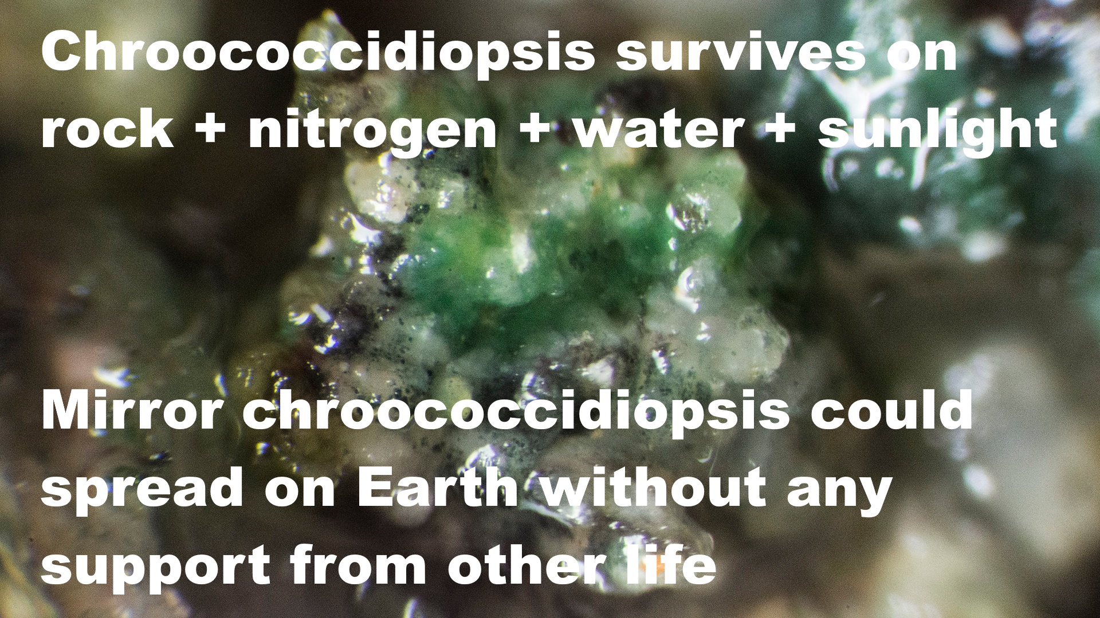

Chroococcidioopsis survives on rock + nitrogen + water + sunlight

Mirror chroococcidiopsis could spread on Earth without any support from other life.

Photograph shows chroococcidiopsis in a cave at Ares Station, Cantabria in the Iberian peninsula – with a transparent covering of other microbes – it can live on its own or in colonies with other life and it can also live inside rocks. Photo by Proyecto Agua on Flickr

Chroococcidiopsis is a “polyextremonphile” which over hundreds of millions of years hash accumulated numerous metabolic pathways and adaptations adaptations. A mirror life analogue from Mars might be similar. Like Chroococcidiopsis it may be able to survive almost anywhere on Earth from Antarctic cliffs to tropical oceans and reservoirs, and from hot sunny deserts such as the Atacama desert to darkness hundreds of meters below the sea floor. I cover this below in the section:

- A mirror life chroococcidiopsis analogue as a worst case example of a pioneer species that would have adaptations that let it survive almost anywhere on Earth if returned from Mars and that could never be returned safely as it would risk transforming terrestrial organics to mirror organics that most life can’t use

This is an example worst case scenario that I consider in my preprint (Walker, 2022b). The mirror life could also be early life, even mirror life ribocells which may be able to pass through 0.02 micron filters. If it is independently evolved on Mars there is no particular reason to expect it to be normal rather than mirror life. Nanobes such as the ribocells are so small they escape protozoan grazing and they would also have a much higher surface to volume ratio which is an advantage in habitats with low nutrient availability – so they may have a competitive advantage with more advanced modern life. That was a motivation for searching for a shadow biosphere of nanobes on Earth. None was found but possibly life returned from Mars could establish such a shadow biosphere here.

Scenario based approach – in other scenarios life from another planet is harmless or indeed beneficial

I found many other scenarios, including some where life from another planet could be harmless, or indeed beneficial. The archaea are an example of an entire domain of life that is largely beneficial in it is interactions with other life on Earth. A domain is the highest level of classification, the other domains are the bacteria and Eukarya. All multicellular life belongs to the Eukarya.

On Earth though harmful invasive species get most publicity there are many species that are beneficial or have no effect when they spread to new regions – contributing to the biodiversityh.

It would be possible for Martian life to lead to a more biodiverse and even a more productive biosphere on Earth for instance if they can make better use of low light levels or of nutrient poor regions of the Earth’s surface or oceans.

See sections of my preprint (Walker, 2022b)

- Could Martian microbes be harmless to terrestrial organisms?
- Enhanced Gaia - could Martian life be beneficial to Earth’s biosphere?

But we have no experience of what happens if two biospheres collide in this way. We need to know what is there, on Mars. We need to know if there is life there, and if so, if it is safe to return it or not. This example shows that we can’t assume it is safe until we know what it is.

I use a scenario based approach to explore this in my preprint (Walker, 2022b), explained in the introduction in the section:

- Scenario based approach to explore the consequences if Earth or Mars develops a mixed biosphere involving two forms of biochemistry or alien species from the other planet – such as mirror life, RNA world nanobes, early life cells that cooperate rather than compete before modern evolution, fungi and molds that our immune systems don’t recognize, or a new domain of life that is largely beneficial to terrestrial ecosystems similarly to the archaea

A single mission can’t resolve this question as it may not return life at all – and life that is safe for Earth may co-exist with other life that can never be returned safely which we could encounter in future missions on a planet with total surface area similar to the land area of Earth – it will take more future missions to resolve this question

We won’t be able to resolve this question of whether there is life on Mars or not and whether it is safe for Earth or not with a single mission such as Perseverance returning samples from selected spots from one location on Mars.

Even if we return familiar life, it could have new capabilities acquired on Mars so needs careful study. Even if we prove that the species we returned are safe, they might easily co-exist with other species that can never be returned to Earth such as mirror life, that we will discover with future missions, even the next mission to Mars.

See the sections of my preprint (Walker, 2022b):

- Early discovery of a familiar microbe from Mars such as chroococcidiopsis is not enough to prove the sample is safe – as familiar life can have new capabilities
- Discovery of a familiar microbe like chroococcidiopsis does not prove all life in the sample is familiar – if terrestrial life originated on Mars, it could have extra domains of life that never got to Earth
- Potential to discover multiple biochemistries such as mirror and non mirror life in the same sample – perhaps evolved in disconnected early Martian habitats – or unfamiliar life mixed with familiar life transferred from Earth to Mars in the past

Resolving this is a matter for future missions and surely needs to be a priority for space colonization enthusiasts and astrobiologists alike. In my preprint (Walker, 2022b) I look at ways we may be able to do it:

- Resolving these issues with a rapid astrobiological survey, with astronauts teleoperating rovers from orbit around Mars

For space colonization enthusiasts, though discovery of a form of life that can never be returned to Earth such as mirror life would likely mean they can never colonize the Mars surface (at least not if they return to Earth) it would lead to huge interest in the planet which could be safely explored from orbit virtually via telepresence similarly to the way we explore computer game landscapes and from space settlements for instance on the moons Phobos and Deimos, and could be exploited also commercially using telerobotics to export materials to Earth.

A form of life that we can never return safely to Earth such as mirror life can also be one of the most exciting possibilities in terms of expanding knowledge. The mirror biology could easily be of great commercial value to us. There are many other places in the solar system to explore, settle and perhaps colonize.

I discuss this under:

- Discovery of extant life on Mars could lead to long term interest in the planet, including orbiting colonies using sterile robots as our mobile eyes and hands to explore the planet from orbit via telepresence, and perhaps develop it commercially too, making it more habitable for Martian life
- This could be a stepping stone to human outposts or colonies further afield such as Jupiter’s Callisto or Saturn’s Titan, and settlements in self contained habitats throughout the solar system, spinning slowly for artificial gravity and built from materials from asteroids and comets

If we want to conclude from the meteorite evidence that microbial species from Mars are safe for Earth we need ALL Martian species to get to Earth on meteorites – example of barn swallows that can cross the Atlantic and are native to North America, while European starlings can’t and are non native – natural processes can’t transfer the surface dust, dirt, ice and salts of Mars to Earth
This is a point I highlight in my preprint (Walker, 2022b). If certain species do sometimes get transferred to Earth from Mars it does NOT mean that all species on Mars are safe for Earth.

As an example, barn swallows cross the Atlantic from Europe to the USA, but starlings don’t.

Barn swallows are not an invasive species in the USA while starlings are. European starling is an invasive bird in the Americas (US DOA, 2017).
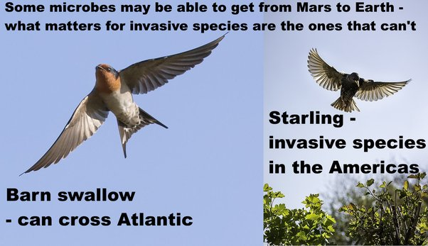
Some microbes may be able to get from Mars to Earth - what matters for invasive species are the ones that can’t.
Barn swallow - can cross Atlantic
Starling - invasive species in the Americas
Starling photo from: (Johnstone, 2017)
Barn swallow photo from (Batbander, 2017)
As an example, in 2012, starlings caused $189 million in damage to crops of blueberries, wine grapes, apples, sweet cherries and tart cherries in the USA (US DOA, 2017)..
Starlings also eat cattle feed and 1000 starlings can represent a loss of $200 to $400 in cattle feed. They can also transmit many diseases to cattle via the feeding troughs and their excrement corrodes iron structures including motor vehicles and iron roofs. They are also involved in thousands of bird strikes (US DOA, 2017)..

Example of fresh water diatoms that can’t cross oceans on Earth
We have invasive diatoms in the Great Lakes. Stephanodiscus binderanus is a nuisance species that clogs water works and introduces foul odours into the water (Spaulding et al, 2010).
The diatom Didymosphenia geminata is an invasive species in New Zealand, possibly brought there on damp sports equipment. (Spaulding et al, 2010). The long stalked version of Didymosphenia geminata is also an invasive species in the Great Lakes. The short stalked version doesn’t form mats and is presumed to be native to the Great Lakes. There were no records of the long stalked version in the Great Lakes until around 1990. After that this long stalked variant started to spread. It can survive and remain viable for up to 40 days in cool dark damp conditions, so it can be spread place to place on angling equipment, boot tops, neopreme waders and felt-soles.
The mats can be up to 20 cm thick and they trap stream sediment. These can cover the bottom of the stream and smother native plants, insects, mollusks and algae. Streams impacted outside of the Great lakes see the insects decrease and an absence of fish. This may be due to a new genetic variant that started to spread but if so, it hasn’t been identified. These two paragraphs summarize / paraphrase some of the information from (Schmidt, n.d.)
This is an example sign in New Zealand warning sailors about the risk of carrying didymo to another lake in New Zealand.
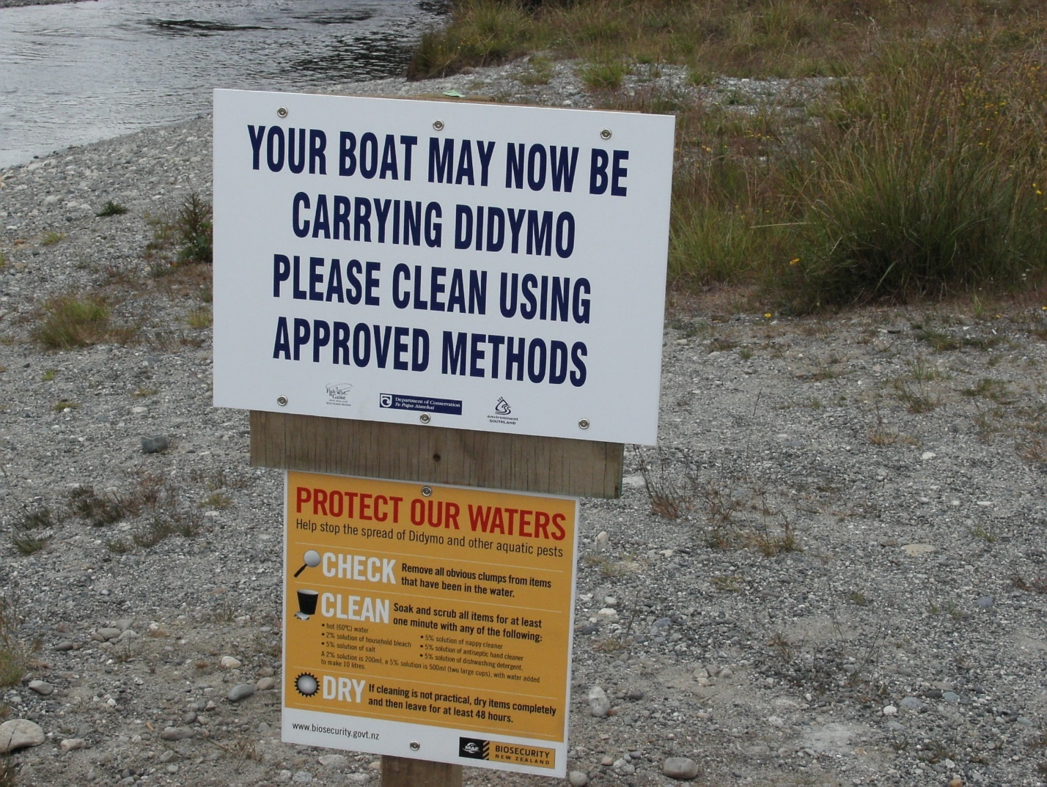
Text on sign: Your boat may now be carrying didymo. Please clean using approved methods. Protect our waters …
Image from: (Thorney¿?. 2006)
As you can see Didymo can’t even move from one lake to another in New Zealand without help from humans carrying it in wet gear. There is no way it could travel between planets. There are salt water diatoms too. But they couldn’t travel between planets on meteorites either. If there are diatoms on Mars they have evolved independently and can’t be directly related to terrestrial diatoms.

We might even find diatoms on Mars – either preserved in gypsum, or perhaps living in the lakes our orbiters found beneath the polar ice
Perseverance has found gypsum, as did Curiosity (Scheller et al, 2022)., and on Earth, gypsum can preserve viable diatoms for tens of thousands of years and maybe hundreds of millions of years (Benison et al, 2014). Diatoms evolved late on Earth which could be a reason to suppose they are unlikely to have evolved on Mars (Cabrol et al, 2009). However it isn’t impossible as it is hard to generalize given only one example from one planet.
So, even the idea that some day we find a viable diatom on Mars is not as far fetched as it might seem though it would need diatoms to evolve on Mars and for a lake to form with enough water for diatoms to inhabit it in the recent enough past for the diatoms to still be viable today. Such lakes actually do exist in present day Mars but they are deep below the ice at the poles (Orosei et al, 2018). David Wiliams, diatom researcher at the Natural History Museum said that technically diatoms could survive there though he says a more interesting question is whether we’d even be able to identify it as life if it originated on Mars (Davis, 2018):
'Yes, technically tiny life forms such as diatoms and cyanobacteria could survive in these environments. But that is not the question we should be asking.
'A more interesting question is whether we would know what we're looking at, even if we did find something in the lake. Would we even be able to identify it as life, if it originated on Mars itself?'

So, though it’s not the most likely example for Jezero crater, it’s not impossible we eventually find diatoms on Mars, or maybe some other form of life adapted to a similar life style, and the chance it is able to get to Earth on a meteorite may be very low.

Chroococcidiopsis as an example of a species that wouldn’t survive transfer by impacts from modern Mars based on an analysis by Charles Cockell
Some species will be better able than others to withstand the shock of ejection from Mars, the cold and dry and complete vacuum of the transition through space, then the fireball of re-entry to Earth. As an example, most photosynthetic life is killed in this process.
The first challenge is the shock of ejection. Microbes are suddenly accelerated from rest to escape velocity in a fraction of a second. The microbes can be destroyed by cell rupture or by DNA damage. All cells of Chroococcidiopsis are killed at 10 GPa (Nicholson, 2009). To put this in context, ALH84001 experienced a shock of ejection of ∼35 − 40 GPa. The Nahkalites were least shocked at 15 to 25 GPa. This is still too much for Chroococcidiopsis (Nyquist, 2001)

The microbe also has to survive the fireball of re-entry to Earth.

Cockell inculcated an artificial gneiss rock with Chrooccoccidiopsis at a depth where it occurs naturally, and affixed it to the re-entry shield of a Soyuz rocket. None survived re-entry, nor did any organics.

Cockell concluded that it might not be impossible for photosynthetic life to get to Earth from Mars, but it would need an extraordinary combination of events (Cockell, 2008)

So in this analogy, most photosynthetic life on Mars would be more like the European starling than the Swallow, wouldn’t be able to get to Earth on meteorites except possibly in rare very large impacts, and most likely in the early solar system.

Then, the rocks we have in our Martian meteorite collections all come from at least three meters below the surface (Head et al, 2002) . They were probably thrown up into space after glancing collisions into the Elysium or Tharsis regions, high altitude southern uplands (Tornabene et al, 2006). The atmosphere for these high altitude regions on Mars is thin, making ejection to Earth easier. The subsurface below about 12 cms has a uniform temperature of around 200°K or -73°C (Möhlmann, 2005:figure 2). With such a thin atmosphere, present day life at those altitudes is unlikely (except perhaps for deep subsurface geothermal hot spots).

Larger impacts in the recent geological past could send material to Earth from other potentially more habitable parts of Mars. However:

- Many proposed habitats are in surface layers of dirt, ice and salts. These would likely never get into space
- Other proposed habitats are millimeters below the surface of rocks. These layers would ablate away during entry into the Earth's atmosphere
Life on Mars could be extremely localized to only a few square kilometers over the entire planet, for instance, only to the RSL's, or only above geological hot spots, making it less likely that the habitats are hit by an asteroid able to send material all the way to Earth in the large chunks needed for protection from cosmic radiation during the transfer.

Yet life from distant habitats on Mars may be able to get to Jezero crater in dust storms. Of course dust storms can’t transport Martian spores or propagules to Earth and the dust can’t be transported to Earth. We have no samples of Martian dust or Martian surface salts or ice in our meteorite collections and these couldn’t get to Earth even in the early solar system.

A mirror life chroococcidiopsis analogue as a worst case example of a pioneer species that would have adaptations that let it survive almost anywhere on Earth if returned from Mars and that could never be returned safely as it would risk transforming terrestrial organics to mirror organics that most life can’t use

We only need one pioneer species to get to Earth to set up a new ecosystem. Martian life would be likely to be able to survive on Earth. The Martian brines are highly oxidising, with perchlorates and hydrogen peroxides. They are so oxidizing that many terrestrial life forms would find hard to tolerate them. Recent research by Stamenković suggests the cold brines on Mars may be oxygenated too, even with the very low levels of oxygen, in the very cold conditions since oxygen is more soluble in cold water.
Then, though Mars gets very cold at night, in daytime it can sometimes reach above 20°C.
Microbes returned from Mars to Ear may be able to settle in on Earth as a "home from home" even more habitable for them than Earth.
For instance, suppose that Mars has mirror life, which is like the European starling, is not able to get here via panspermia. An example here is Chroococcidiopsis, a blue-green algae found in Antarctic cliffs, also in the Arizona desert near JPL, but also is ubiquitous through Earth, found in the sea, in tropical water supplies, both wet, dry, hot, cold, it's a polyextremophile that has numerous metabolic pathways that let it survive almost everywhere, and it is one of the top candidates for a form of life that could survive on Mars.

A mirror analogue of chroococcidiopsis from Mars could flourish almost anywhere from Antarctic cliffs to the Atacama desert (Bahl et al, 2011) or from Sri Lankan reservoirs (Magana-Arachchi et al, 2013) to the Chinese sea (Xu et al, 201q26:111), and form the foundation of a mirror ecosystem.

It is a pioneer species and a primary producer and doesn’t depend on any other life to survive.

Chroococcidiopsis,is an ancient polyextremophile with numerous alternative metabolic pathways it can utilize, including nitrogen fixation, methanotrophy, sulfate reduction, nitrate reduction etc (KEGG, n.d.), even able to grow in complete darkness using a hydrogen-based lithoautotrophic metabolism with viable populations found over 600 meters below the surface (Puente-Sánchez et al, 2018) and in another case 750 meters below the Atlantic sea bed (Li et al, 2020).

In the same way a mirror Martian polyextremophile might retain numerous metabolic pathways from its evolutionary history on Mars that it could use to colonize diverse habitats on Earth. The Martian history would include hydrothermal vents, oxygen rich lakes, and almost any climate condition it could encounter on Earth as well as some conditions not present here naturally such as ultra low temperatures and ultra low atmospheric pressures and far higher levels of UV and ionizing radiation than life encounters on Earth.

So, suppose there is a mirror chroococcidiopsis on Mars.. Or some other pioneer species including ultramicrobacteria, maybe even mirror life ribocells.

Once it was well established, other mirror life could build up a microbial ecosystem based on this and in this way mirror life could start to spread through our ecosystems.

This is a worst case scenario. This does not mean it is inevitable that Martian life would harm Earth. Indeed there are other scenarios where Marian life can be harmless or even beneficial to Earth’s biosphere.

Enhanced Gaia - could Martian life be beneficial to Earth’s biosphere?
So far we’ve focused on situations where biosphere collisions are harmful, since the topic is planetary protection, so we need to focus on scenarios where there is indeed a need to protect Earth. However we should also recognize that the introduction of extraterrestrial life to our biosphere could also be beneficial, as Rummel mentioned in his foreword to “When Biospheres Collide” (Meltzer, 2012)

We have examples from multicellular life to show that invasive species aren’t always harmful. Schlaepfer et al did a survey of invasive species and in their table 1 they find many non native species that are actually beneficial. Some were deliberately introduced for their value for conservation, but many of the best examples were introduced unintentionally (Schlaepfer et al, 2011).

Schlaepfer doesn’t list any microbial examples. What could benign interactions with terrestrial life look like for Martian microbes? Here are a few suggestions:

- More efficient photosynthetic life from Mars could increase the rate of sequestration of CO₂ in the sea and on land, improve soil organic content, and perhaps help with reduction of CO₂ levels in the atmosphere
- More efficient photosynthesis could increase the productivity of oceans
- Most of the surface layers of our oceans are deserts, except near to the coasts, because of the limitation of nitrogen, phosphorus, iron and silica (needed for diatom shells) (Bristow et al, 2017). If extraterrestrial life has different nutrient requirements, it may be able to inhabit these deserts and form the basis of an expanded food web.
- Martian microbes could be better at nitrogen fixation, phosphorus and iron mobilization, and so improve our soils, and help with crop yields as endophytes. Just as Martian microbes could enter the human microbiome, they could also enter plant microbiomes as endophytes and those interactions need not be harmful, many could be beneficial. (Afzal et al, 2019)
- New forms of yeast could be of interest in the food industry (Sarmiento et al, 2015).
- Martian life could increase species richness by gene transfer to Earth microbes, leading to more biodiverse microbial populations.
- Martian extremophiles could colonize microhabitats in deserts and eroded landscapes barely habitable to terrestrial life, helping with reversal of desertification
- More efficient Martian microbes might be useful to generate biofuels from sunlight and water (Schenk et al, 2008)
- Martian life might be accidentally toxic and control harmful microbes or insects
- Martian life might aid digestion or enter into other beneficial forms of symbiosis.
- Martian life could produce beneficial bioactive molecules as part of the human microbiome. These could include molecules that are antiviral, antibacterial, antifungal, insecticides, molecules that kill cancer cells, immunosuppressants, and antioxidants - we get all of those from beneficial microbes that are already in our microbiome.
(Borges et al, 2009).
- It could add a new domain of life with almost entirely beneficial interactions similarly to the Archaea
- It could add new forms of multicellular life based on a different biochemistry, or multicellular life in a different domain of life from the eukaryotes, with a more ancient common ancestor.

However even if introducing terrestrial life is largely beneficial we still need caution. There would be not just one encounter in one ecosystem. Martian conditions may well favour polyextremophiles able to survive in a wide range of conditions.

Chroococcidiopsis is perhaps our best analogue for a Martian cyanobacteria and it is a polyextremophile and found in many habitats throughout the world. Also the microbes would evolve eventually, and perhaps quickly, or change gene expression, and eventually find new habitats that they can colonize.

Maybe some of these encounters would be beneficial in some ecosystems, while other ecosystems are degraded, possibly even by the same interactions with the same microbe. Similarly for organisms, some organisms may be benefited and others harmed.

The same Martian microbe may also have both harmful and beneficial effects on the same organism, or in the same ecosystem. Generally there might well be a mix of some beneficial and some harmful interactions.

On the other hand the interactions could all be beneficial. To take an example, our planet is not necessarily optimal for global biomass (Kleidon, 2002). Perhaps extraterrestrial life with additional capabilities could do the opposite of triggering a Swansong Gaia.

Return of Martian life might create a new enhanced Gaia system that has significantly more surface biomass and biodiversity than the one we have today. It might even add new beneficial domains of life like the archaea or a new form of multicellularity which only enhances the diversity of our biosphere.

We have nothing by way of previous experience to guide us here.

Amongst a million extraterrestrial civilizations that return a sample from a nearby biosphere with limited technological capabilities to contain it, we don’t know how many would find they have harmed the biosphere of their home world. It might be that

- it is never seriously harmful, it usually leads to an enhanced Gaia, and is almost always a beneficial process.
- Or even that most extraterrestrial biospheres are seriously degraded after their first unsterilized sample return from a nearby independently evolved biosphere

There is no way to know.

NASA fail to consider at all the potential for microhabitats in Jezero crater not detectable from orbit such as the Curiosity brines which could be habitable to biofilms or martian life able to tolerate conditions too old for terrestrial life

It’s the same for the second half of that INCORRECT paragraph from NASA’s MSR Safety fact sheet for the draft EIS (NASA, 2022msfs):

, and the fact that the Mars samples being gathered by NASA’s Perseverance Mars rover are from the first few inches of a planetary surface that is very dry and highly irradiated naturally by the Sun, which would sterilize all known active biology.
The UV from sunlight is blocked by a few millimeters of dust and the ionizing radiation is only an issue for microbes that are dormant for millennia.

In the draft EIS itself they say:

Consensus opinion within the astrobiology scientific community supports a conclusion that the Martian surface is too inhospitable for life to survive there today, particularly at the location and shallow depth (6.4 centimeters [2.5 inches]) being sampled by the Perseverance rover in Jezero Crater, which was chosen as the sampling area because it could have had the right conditions to support life in the ancient past, billions of years ago (Rummel et al. 2014, Grant et al. 2018).

Microbes can make use of habitats with small amounts of water and they may be able to modify them to make them habitable. The surface is indeed very dry but not totally dry. Curiosity found that brines form there regularly in the early morning or late in the evening.
Life in surface habitats would likely revive every year at the appropriate season for growth.
Curiosity has already found a cold brine layer in equatorial sand dunes (Martin-Torres et al, 2015) a few cm below the surface. Nilton Renno has suggested this could be habitable to a biofilm that can regulate its microhabitat, for instance, retain the water through to warmer conditions in daytime (Nilton Renno cited in Pires, 2015).
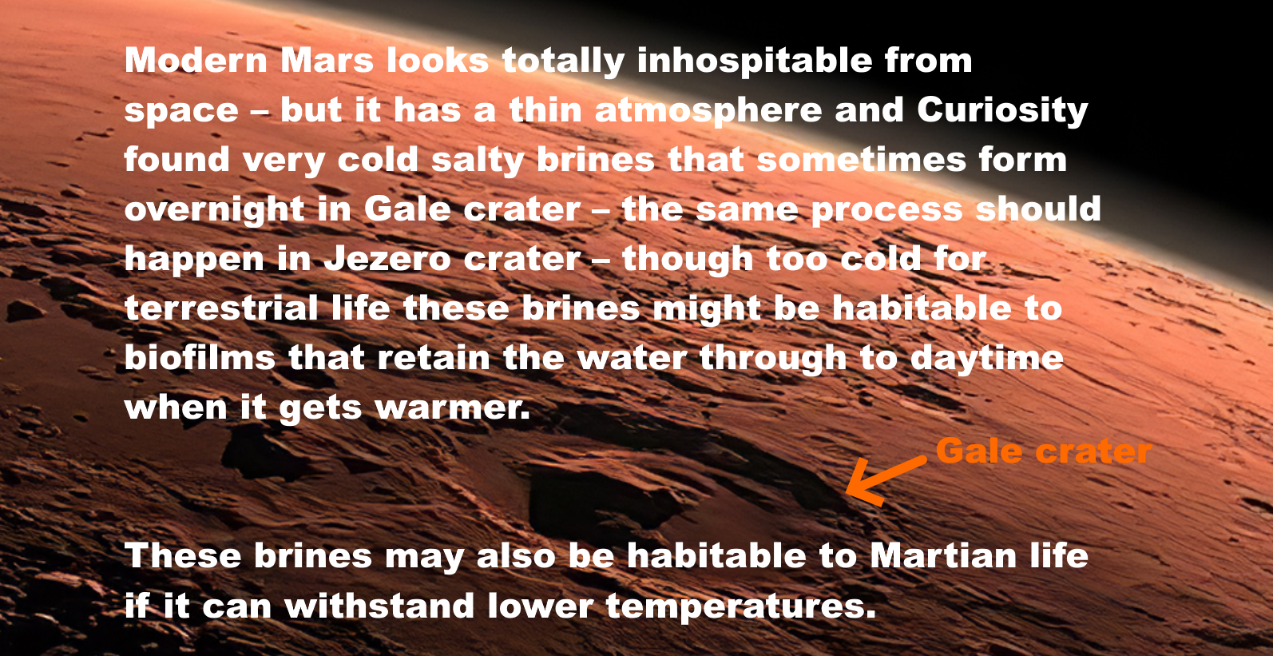
Modern Mars looks totally inhospitable from space – but it has a thin atmosphere and Curiosity found very cold salty brines that sometimes form overnight in Gale crater – the same process should happen in Jezero crater – though too cold for terrestrial life these brines might be habitable to biofilms that retain the water through to daytime when it gets warmer.
[Arrow points to Gale crater]
These brines may also be habitable to Martian life if it can withstand lower temperatures.
Image from (McKay et al, 2014)
I cover this in my preprint (Walker, 2022b) in the sections:
- Detection by Curiosity rover of liquid water as perchlorate brines in Gale crater sand dunes and similar conditions are predicted in Jezero crater dune
- How Martian life could make perchlorate brines habitable when they only have enough water activity for life at -70 °C – biofilms retaining water at higher temperatures - chaotropic agents permitting normal life processes at lower temperatures – and novel biochemistry for ultra low temperatures
The 2015 report made much the same point as Nilton Renno
This is what the 2015 study says
- First that terrestrial life could transfer to dispersed small-scale habitats on Mars.
- They might also be able to alter the local environmental parameters (this would include retaining water from night to day time as it gets warmer) and be able to get transferred to other parts of Mars.
- Microbes could also form communities where they exchange metabolites cooperatively to increase their survival. (Board, 2015)
This is the quote:

In particular, the issues of translocation of terrestrial contamination and the behavior of multispecies populations in extreme environments, produce uncertainty in the determination of Special Regions, because such regions might not be isolated from the rest of the planet (translocation), because microbial communities could occupy dispersed, small-scale habitats or might be able to alter local environmental parameters and syntrophic consortial interactions
[there by syntrophic interactions it means: where microbes exchange metabolites in an overall combined metabolism that wouldn’t be feasible for either species individually (Seiber at al, 2010)
They continue that these issues make it difficult to define the Special Regions on Mars, together with lack of knowledge about the limits of life on Earth, and and uncertainty of relationship of large scale and micro-scale environments.
These issues, together with the present lack of knowledge about the limits of life on Earth and the uncertainty of the relationship between the large-scale and micro-scale environments at any given place make the definition of Special Regions difficult
I go into some of the proposed habitats that could occur in Jezero crater in in my preprint (Walker, 2022b) under
- Suggested sources for native life in equatorial regions such as Jezero crater include local microhabitats such as salty brines, and spores in windblown dust – while the dust and salts are not likely to be transferred to Earth via asteroid impacts
The 2015 review overturned the suggestion from the 2014 review that areas not of Planetary Protection concern can be delineated using maps. I go into this in in my preprint (Walker, 2022b) under:
- Similar situation in 2014 / 2015: 2014 report said maps can identify areas of Mars of planetary protection concern in the forwards direction then 2015 review modified those recommendations, saying maps can’t yet be used – due to knowledge gaps on survival of terrestrial life in dust storms and potential for life to survive in microhabitats hard to detect from orbit

These studies weren’t looking at Martian life particularly but rather at whether terrestrial life could survive on Mars. But if maps can’t be used to delineate the regions terrestrial life can occupy – then even more so they can’t delineate regions for martian life when we don’t even yet know what its capabilities might be if it exists.

A similar situation happened in 2019 and 2020, the 2019 report that recommended using maps, then the 2020 review committee overturned this recommendation. I go into this in in my preprint (Walker, 2022b) under:
- 2020 Review committee modified recommendations of 2019 report, saying our knowledge is not yet sufficient to classify parts of Mars as suitable for an unsterilized Category II mission in the forward direction – agrees on need to protect Earth in backwards direction
Some think the Viking lander found life on Mars already in the 1970s. This was revived with the discovery of rhythms that resemble circadian rhythms in the carbon emission in gases (CO2 or methane) when the old data was re-analysed. These emissions were offset by two hours, too much to explain easily with simple chemistry.
What Viking found is either very complex and not well understood chemistry or biology. Either way it needs further study. If it is not well understood chemistry we need to understand it so that we know what to look out for and not be confused by it in searches for life in the future. And – if Viking didn’t discover life, this may tell us a bit about the complexities of surface chemistry on Mars like planets.
I cover this and other puzzles from the Viking landers in my preprint (Walker, 2022b) under
- Puzzles from the Viking landers – why some think Viking detected life already in the 1970s – evolved gases in the labelled release experiment offset from temperature fluctuations by as much as two hours, more typical of a circadian rhythm than a chemical reaction
The 2015 study also say that these potential small scale microbial habitats may not be detectable from orbit. They may be only a few cell layers thick in a biofilm, even with adverse and extreme conditions that surround the biofilm (Board, 2015:11).
Detectability of Potential Small Scale Microbial Habitats
There are many examples of small-scale and microscale environments on Earth … that can host microbial communities, including biofilms, which may only be a few cell layers thick. The biofilm mode of growth, as noted previously, can provide affordable conditions for microbial propagation despite adverse and extreme conditions in the surroundings. On Earth, the heterogeneity of microbial colonization in extreme environments has become more obvious in recent years.
Also they say we need a better understanding of temperature and water activity of potential microenvironments. We still have very limited data on this, as the emphasis has been on study of geology, not microhabitats (Board, 2015:11).
To identify Special Regions across the full range of spatial scales relevant to microorganisms, a better understanding of the temperature and water activity of potential microenvironments on Mars is necessary.
…
Craters, and even microenvironments underneath and on the underside of rocks, could potentially provide favorable conditions for the establishment of life on Mars, potentially leading to the recognition of Special Regions where landscape-scale temperature and humidity conditions would not enable it.
The Perseverance rover is not doing the sort of survey would be needed to look for extant life, which would be carried out in a very different fashion and would depend on insitu life detection. Instead it is studying rocks and geological specimens and it has a focus on past habitability but not really on past life as an astrobiologist would search for it.

The papers by astrobiologists that I read were clear. If you want to search for life on Mars, whether present day or past life, you need a way to distinguish the organics from life from the organics from non life processes in situ. That is because most of the organics on Mars are expected to be from non living processes even if there is comparatively abundant life there. To find life and return it you need to be able to distinguish life from non life organics. You also need to be able to do a broad study to look at many potential habitiats that look similar geologically but may have minute differences in humidity, salinity, chemical gradients or any of the many things that can make it more or less habitable for extant or past life. There’s also the issue of preservation of past life to consider.

I cover some of this work in this section of my preprint (Walker, 2022b):

- Why it’s a major challenge to find samples from Jezero crater to help decide central questions in astrobiology until we can send in situ life detection instruments - most past biosignatures will be degraded beyond recognition – nearly all organics on Mars are expected to be abiotic - past and present day life is expected to be low in concentration and patchy in distribution – and all this is especially challenging if Martian life never developed photosynthesis or nitrogen fixation
In short, once we find life on Mars, if we know what we are looking for, we may be able to locate it without in situ life detection but at present we are in a situation where it is essential to send life detection instruments to Mars to look for it. Especially looking for another biology with unknown capabilities.

Our best chances for returning life from Mars with this mission is if it is likely low in concentration – but very abundant on Mars. If every few cubic cms have at least one viable microbe and we return several cubic cms of dirt, for instance, we may return life.

If Viking did find life on Mars, then we have a chance of returning it. Also if there are regions somewhere on Mars that produce spores or propagules, this may be easy to detect with a large enough sample of dust if the habitats are close to Jezero crater with an uneven plume of life that extends in its direction, or if there are distant very productive regions of Mars.
For a very crude estimate see the section in my preprint (Walker, 2022b):
- Searching for distant inhabited habitats on Mars through presence or absence of one originally living cell per gram – a rough first estimate assuming uniform mixing throughout Mars for a first estimate requires life to cover between 114,000 and 1,140 square kilometers with densities of life in the dust similar to an Antarctic RSL analogue in cell count, but less than a tenth of a square kilometer if any reach a billion cells per gram – these figures can be higher if any source habitats with high densities of cells are closer to the rover with uneven mixing

NASA fail to consider at all the potential for winds to transfer microbes imbedded in a grain of dust to Jezero crater shielded from the UV by the global dust storms
Continuing to comment on the second half of that INCORRECT paragraph from NASA’s MSR Safety fact sheet for the draft EIS (NASA, 2022msfs):

, and the fact that the Mars samples being gathered by NASA’s Perseverance Mars rover are from the first few inches of a planetary surface that is very dry and highly irradiated naturally by the Sun, which would sterilize all known active biology.

NASA don’t mention that the sample tubes will also be covered in dust – indeed this is considered to be part of the sample return. NASA originally planned a dust sample, but instead decided to just rely on whatever dust gets attached to the outside of the sample tubes before collection.

The dust may come from distant parts of Mars and potentially might contain viable spores. The sample tubes are left on the surface for the sample fetch rover to pick up which means they will have at least one side in shadow not sterilized by the UV light. The windblown dust is protected from UV especially during dust storms as well as any microbes that are imbedded in cracks in the dust which is made of iron oxide and blocks out UV.

The 2015 study considers various ways that microbes could be transferred to distant regions of Mars. The most likely is through the dust (Board, 2015:12)

A potential problem with designating Special Regions on Mars is that viable microorganisms that survive the trip to Mars could be transported into a distant Special Region by atmospheric processes, landslides, avalanches (although this risk is considered minimal), meteorite impact ejecta, and lander impact ejecta. In addition to dilution effects, the flux of ultraviolet radiation within the martian atmosphere would be deleterious to most airborne microbes and spores.
The dust attenuates UV radiation (this is especially true during a dust strom when it can turn day into night).
Also microbes often grow in cell changes, clusters or aggregates and inner cells are protected against UV (Board, 2015:12)
However, dust could attenuate this radiation and enhance microbial viability. In addition, for microbes growing not as single cells but as tetrades or larger cell chains, clusters, or aggregates, the inner cells are protected against ultraviolet radiation. Examples are methanogenic archaea like Methanosarcina, halophilic archaea like Halococcus, or cyanobacteria like Gloeocapsa. This is certainly something that could be studied and confirmed or rejected in terrestrial Mars simulation chambers where such transport processes for microbes (e.g., by dust storms) are investigated. The SR-SAG2 report does not adequately discuss the transport of material in the martian atmosphere.
These studies on transfer of microbial life in Martian dust storms in Mars simulation chambers don’t seem to have been done. At least I found almost nothing in my literature search and what I found has nothing new by way of citations. This seems to remain a recommendation to follow up in the future.
It is not easy to simulate a dust storm. Also it will be hard to do this accurately until we have samples of the dust to examine closely either on Mars in situ or nearer to home.
Also this is just for terrestrial life. Martian life may have developed special adaptations to spread in dust storms.

In in my preprint (Walker, 2022b), I look into this in the sections:
- Could Martian life be transported in dust storms or dust devils, and if so, could any of it still be viable when it reaches Perseverance?
- Native Martian propagules of up to half a millimeter in diameter (including spore aggregates and hyphal fragments) could travel long distances with repeated bounces (saltation) - if they can withstand the impacts of the bounces
- Martian spores could evolve extra protection such as a shell of agglutinated iron oxide particles to protect themselves from UV
- Martian life could also use iron oxides from the dust for protection from the impact stresses of the saltation bounces - or it might use chitin - a biomaterial which is extremely hard and also elastic and is found in terrestrial fungi and lichens

NASA plan to use a biosafety level 4 facility to handle the samples – but how can they know that a BSL-4 facility designed to contain infectious diseases of humans will work to protect Earth’s biosphere from extraterrestrial ultramicrobacteria or the potentially even smaller nanobes such as ribocells that may have preceded terrestrial life? The answer is they don’t – they seem unaware of the recommended size limits set in the 2012 ESF sample return study which make a BSL-4 facility inadequate
NASA show no awareness of the 2012 ESF report on a Mars sample return. This was the main point that I made in my submission to their first round of requests for comments from the general public as part of the NEPA process (Walker, 2022a) :

Are you aware of the ESF Mars Sample Return study (Ammann et al, 2012:14ff)? It said "The release of a single unsterilized particle larger than 0.05 μm is not acceptable under any circumstances”. This is to contain starvation limited ultramicrobacteria which pass through 0.1 micron filters (Miteva et al, 2005). Any Martian microbes may be starvation limited.
This 100% containment at 0.05 microns is well beyond capabilities of BSL4 facilities. Even ULPA level 17 filters only contain 99.999995 percent of particles tested only to 0.12 microns (BS, 2009:4).

The limit from 1999 to 2012 was 0.2 microns. This was followed up by the 2012 study by the European Space Foundation (ESF) which reduced this to a limit of between 0.01 microns and 0.05 microns (Ammann et al, 2012:14ff).
This is how the 2012 ESF report explained its decision at the time study (Ammann et al, 2012:3):
The value for the maximum particle size was derived from the NRC-SSB 1999 report ‘Size Limits of Very Small Microorganisms: Proceedings of a Workshop’, which declared that 0.25 ± 0,05 μm was the lower size limit for life as we know it (NRC, 1999). However, the past decade has shown enormous advances in microbiology, and microbes in the 0.10–0,15 μm range have been discovered in various environments. Therefore, the value for the maximum particle size that could be released into the Earth’s biosphere is revisited and re-evaluated in this report. Also, the current level of assurance of preventing the release of a Mars particle is reconsidered..

NASA’s EIS mentions a 0.05 micron size limit – but only for the engineering for the earth entry capsule, not for the BSL-4 sample handling laboratories – and they don’t mention the ESF study in this section or in their list of references
However they show no awareness of this report. It’s not in their list of cites.
All they have relevant in their list of comments they responded to is: (NASA, 2022eis: 4-7):

What is the smallest Mars particle that is forbidden to be on the capsule carried to Earth? Dust level, bacteria level, virus level, prion level?

They respond that the minimum size is 50 nm – so for roughly similar reasoning they apply this size to the capsule on the journey back to Earth.

MSR engineering requirements are based on managing unsterilized particles 50 nm in size and larger. MSR selected this size limit because particle size distribution data indicate that the fraction of particles below 50 nm is small (less than 0.06%) and also because the physics of particle transport are such that measures taken to control or exclude particles of 50 nm are also effective for particles of smaller sizes.

A number of studies (National Research Council 1999, Heim et al. 2017) have estimated the minimum sizes for life forms from fundamental inputs such as the genetic material required to permit a cell to perform basic functions [e.g., (Glass et al. 2006)], observations in extreme environments [e.g., (Comoli et al. 2009)] or theoretical constraints that would apply to astrobiology investigations (Lingam 2021). Values from such studies have been used to inform findings on best ractices for sample return missions and MSR has considered those findings in selecting 50 nm for engineering requirements.

They don’t use the European Space Foundation as a source. Their first cite is the 1999 “Size limits” workshop which followed on from the discovery of possible small cells in the meteorite ALH 84001, which I’ve cited as (Board et al, 1999)

However this cite comes up with far smaller figures. Panel 4 for the 1999 “Size limits” workshop calculated that such a primitive free living lifeform could be as small as 0.014 microns in diameter and 0.12 µm in length, if there is an efficient mechanism for packing its RNA. (Board et al, 1999: 117). What size you get depends on which of the panels you look at. The one that looks at the biochemistry of early life came up with very small figures potentially.

They also use a very interesting but highly theoretical source on the minimum size of a microbe able to sense chemical gradients. This source says that a spherical microbe has to be 0.2 microns in diameter or larger (0.1 microns in radius) to sense chemical gradients (Lingam, 2021). I’m not sure how that is relevant to their figure of 0.05 microns. However it is a very interesting source and relevant to our topic.

Early life would be likely to use especially small cells. Lingam mentions that early life could be less than 0.2 microns in diameter if it had steeper gradients though it could lead to issues due to the size of sensor molecules such as rhodopsin and with the ability of the cell to move (that would be due to the effects of Brownian motion on very small cells), (Lingam, 2021:11) also the conclusion (Lingam, 2021: 8).

The presence of sharp gradients drives down Rmin and might therefore have aided in the early evolution of life. Thus, the search for biomarkers may benefit from prioritizing environments where such gradients exist today or were prevalent in the past; the Gusev crater on Mars with its opaline silica deposits reminiscent of hot springs on Earth is an intriguing example

Lingam briefly discusses non spherical cells (Lingam, 2021:3 ).

For starters, the organisms are taken to have spherical symmetry; changing the shape to ellipsoidal or cylindrical is anticipated to yield noteworthy benefits but also incur concomitant costs

Interestingly the ultramicrobacteria that the ESF cite that are able to pass through 0.1 micron nanopores in practical experiments are decidedly elongated. Less than 0.1 microns in diameter, but 0.2 microns in length. So they would be be compatible with this requirement to be at least 0.2 microns along one axis.

The putative smallest cell for the size limits workshop is 0.12 microns in length which is not that far from the 0.2 limit. On page 11, Lingam looks at diameters down to 0.05 nm (radii down to 0.025 nm) for phosphorous and 0.06 microns for high temperature thermal vents.

However when it comes to the design requirements for a filter what matters is the shortest rather than the longest diameter of a cell. Lingam’s theoretical argument says nothing about the shortest diameter.

Evidence used by the 2012 ESF study – practical experiments in which starvation limited ultramicrobacteria have been observed to pass through 0.1 nanopore filters and are viable after passing through the filter – these results have been multiply confirmed including with with scanning electron microscope images to show the scale of the cells lying on top of the nanopores they passed through - the cells are about 0.2 microns long but less than 0.1 microns in diameter when they pass through the nanopore

The ESF study considered evidence of free living microbes cultivated after passing through 0.1 micron filters (Miteva et al, 2005). Such small sizes may be an adaptation to starvation survival stresses, which makes this similar to situations one might expect on Mars.
The ESF study also found a similar theoretical minimum size for free living terrestrial life with their estimated minimal genome of 750 genes, concluding that such a theoretical microbe could have a width of less than 0.1 microns, and length greater than 0.2 microns (Ammann et al, 2012:15)
Example real life microbes match these figures. This is a SEM of a bacteria with width less than 0.1 microns and length about 0.2 microns:
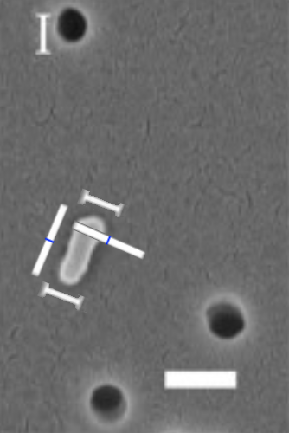
SEM of a bacterium that passed through a 100 nm filter (0.1 microns), larger white bar is 200 nm in length (Liu et al, 2019).

Though NASA’s EIS uses a 0.05 micron limit for reentry, for sample handling on the ground they rely on normal BSL-4 facilities – NASA show no awareness of the possibility that such a facility might not be considered adequate or might be challenged by litigation – or that they might be required to build a custom designed facility for this
Puzzlingly, though NASA use a 0.05 limit to protect Earth from the Mars capsule during re-entry, their proposal doesn’t include any plans to use this same limit for their sample handling facilities once the sample is returned to Earth.
This may seem a minor detail, but as we’ll see it makes all the difference between technology we have today already, and technology that doesn’t exist yet even in the labs.

Example, the draft EIS says (NASA, 2022eis: S-4):

Nevertheless, out of an abundance of caution and in accordance with NASA policy and regulations, NASA would implement measures to ensure that the Mars material is fully contained (with redundant layers of containment) so that it could not be released into Earth’s biosphere and impact humans or Earth’s environment. The material would remain contained until examined and confirmed safe or sterilized for distribution to terrestrial science laboratories. NASA and its partners would use many of the basic principles that Biosafety Level 4 (BSL-4) laboratories use today to contain, handle, and study materials that are known or suspected to be hazardous.

Although not listed or designated as such under any regulatory definition, the Mars samples would be handled in a manner consistent with guidance from protocols for Biological Select Agents and Toxins (BSAT). BSAT are specific biological agents that fall under a congressionally mandated level of control. BSAT material requires the use of additional biosafety measures (e.g., a higher level of biocontainment).

For highly infectious or unknown materials, the highest level of biosafety (BSL-4) and biosecurity measures, in addition to specific measures for transport and inactivation, must be utilized. Because the samples would be treated as though potentially hazardous until demonstrated otherwise, they would be handled in a manner that provides the highest level of security and containment during the EES landing, recovery, transportation, sample storage, and receiving/curation mission phases and that is consistent with BSAT protocols in support of the planetary protection requirements. The samples would be stored and handled consistent with BSAT protocols until deemed safe for release.

It’s the same from the Mars Sample Return Planning Group 2 MSPG2 (Meyer et al, 2022) the design and construction of the Sample Receiving Facility is considered to be complete when it is certified to BSL-4 standard.

SRF commissioning (at least 2 years prior to Earth Return) –the design and construction of the SRF as a biocontainment facility ends with Biosafety Level 4 (BSL-4) certification; start of test and training phase for the SRF functionalities not related to the biocontainment function

NASA in their draft EIS say that NASA may consider using existing BSL-4 facilities or building or modifying one of their own buildings or building a modular containment facility (NASA, 2022eis: 2-16):

NASA may consider using existing BSL-4 containment facilities or building/modifying facilities, including a modular containment facility. There are currently only four operational BSL-4 laboratory suites in the United States: [list of the four BSL-4 laboratories in the USA]. However, all existing BSL-426 facilities have current operating missions and limited availability.

NASA may consider using existing BSL-4 containment facilities or building/modifying facilities, including a modular containment facility.

Sample return studies say that a purpose built facility is needed and that it likely takes 9 years from when the project starts to completion. I mention this in my comment to the last round of submissions but they don’t seem to have seen this (Walker, 2022a):

NASA is required to provide preliminary design and engineering details for the Sample Return Facility before they start a build, and with a life-cycle cost over $250 million must also commit to Congress on cost and schedule (NASA, Science Engineering Handbook: section 3.5).
However, the legal process may change requirements, so should be completed before we launch the Earth return orbiter, Earth Entry Vehicle, and Mars Ascent Vehicle, or start to build the receiving facility.
Urhan [sic] et al estimate 9 years to build or repurpose the facility and 2 years to train scientists because of many lapses in Apollo sample handling. If the build starts in 2028, the earliest the facility could be ready is 2039.
The legal process might also conclude that the required technology doesn't exist yet.

[I mistyped Uhran as Urhan in my previous comment]

There is no mention of the European Space Foundation report in their list of references or any justification for using BSL-4 to handle extraterrestrial samples.

Just argument by analogy that BSL-4 facilities are used for infectious diseases and toxic materials.

Containing infectious diseases is a very different situation from having to contain possibly starvation limited ultramicroabacteria and possibly even riobocells, RNA world cells with a different biology from terrestrial life.

A closer look reveals that the ESF requirement is not only well beyond BSL-4 standards.

The technology needed for the ESF limit doesn’t currently exist. It is well beyond the standards of any currently available technology, even in research experiments, except for some successful experiments infiltering out 0.05 micron particles from water at high pressure. For aerosols the technology is nowhere near this capability.

- HEPA and ULPA filters are not tested for such small particles as 0.05 microns and not required to contain them
- Example of best available nanofilter technology from 2020, not yet commercially available, filters out 88% of ambient aerosol particles at 0.05 microns - far short of the ESF requirement to filter out 100% at this size – though this standard can be met with nanoparticles in water under high pressure
- Challenges for maintenance for future 0.05 micron compliant nanoscale filters – need to be designed for sterilization before any potential extraterrestrial biology is known, and may be easily damaged and hard to replace without risking release of nanoparticles

New technology will need to be developed to handle its requirements.

ESF study: “the release of a particle larger than 0.05 μm in diameter is not acceptable in any circumstances” – and they required a chance of less than 1 in a million for the release of a single particle of 0.01 microns over the lifetime of the facility.

The European Space Foundation study summarizes their conclusions in this figure (Ammann et al, 2012:14ff). :
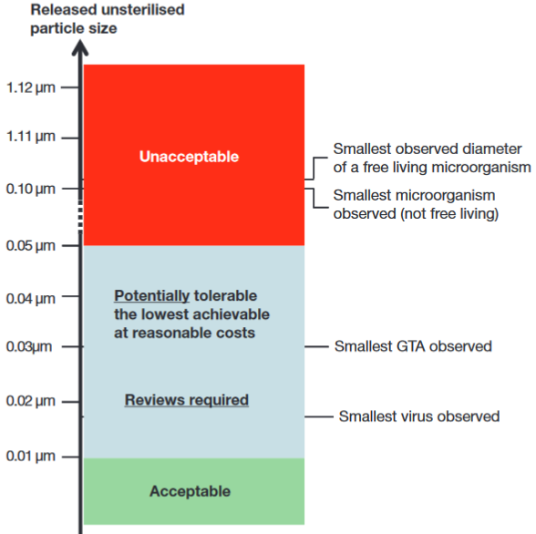
Figure 5: ESF summary of containment requirements
The report concluded that
“the release of a particle larger than 0.05 μm in diameter is not acceptable in any circumstances” (Ammann et al, 2012:21).
The ESF study also considered Gene Transfer Agents (GTAs) with a minimum size of 0.03 microns, which transfer properties to unrelated microbes rapidly overnight in sea water

This was used for their 1 in a million limit at 0.01 microns (Maxmen, 2010) (McDaniel, 2010).

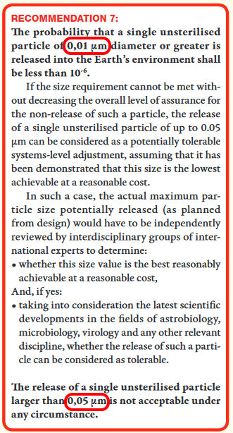
Figure 9: screenshot from the ESF report
“The probability that a single unsterilized particle of 0.01 micron diameter or greater is released into the Earth’s environment shall be less than one in a million”
“Release of a single unsterilized particle at 0.05 microns is not acceptable under any circumstances”
Note, the ESF defines their one in a million as the probability of release of A SINGLE UNSTERILIZED PARTICLE of 0.01 microns. This means over the ENTIRE LIFETIME of the facility.

A BSL-4 facility doesn’t comply with this limit – and the technology to filter out 100% of aerosol particles at 0.05 microns doesn’t yet exist except for nanoparticles in water under high pressure

A BSL-4 facility can’t comply with these requirements.

HEPA and ULPA filters are not tested for such small particles as 0.05 microns and not required to contain them
The standards for biosafety level III cabinets, or biosafety level 4 facilities are based on HEPA filters, for instance, a biosafety level III cabinet has to be exhausted to the outside air through two HEPA filters (Richmond et al, 2000:37). These HEPA filters are required to trap 99.97% of particles of 0.3 microns in diameter and 99.99% of particles of greater or smaller size (WHO, 2003:35). These requirements don’t set any minimum size above which escape of a single particle is unacceptable under any circumstances.
In the US, HEPA filters are tested down to 0.1- 0.2 microns (depending on the class of filter, some are tested only at 0.3 microns). In Europe they are tested at the most penetrating particle size which may vary depending on the filter. In both cases, the filters are tested according to probabilities (Zhou et al, 2007) (EMW n.d.).
ULPA level 17 filters are rated to filter out 99.999995 percent of particles (BS, 2009:8) in the range 0.12 microns to 0.25 microns (BS, 2009:4), according to BS EN 1822-1:2009, the British implementation of the European standard (BS, 2009).

This still doesn’t comply with the ESF standard of no release of a 0.05 micron particle in any circumstances. They are not even tested over this size range.

The filters are tested with challenge aerosols such as dioctylphthal (DOP) generated on the intake side of the filter, and measured with a photometer on the discharge side (Richmond et al, 2000:33). These photometers have limited sensitivity to nanoaerosols below the 100 nm limit. In a study of a DOP aerosol using TSI model 8130 Automated Filter Tester in 2008 (table III of Eninger et al, 2008), although particles below 100 nm (0.1 microns) constituted 10% of the count of particles in the test aerosol, and 0.3% of the mass, they provided almost none of the light scatter in the testing photometer (less than 0.01%)

So, is it possible to filter out particles down to 50 nm (0.05 microns)? And if so, how can such a filter be tested?.

Example of best available nanofilter technology from 2020, not yet commercially available, filters out 88% of ambient aerosol particles at 0.05 microns - far short of the ESF requirement to filter out 100% at this size – though this standard can be met with nanoparticles in water under high pressure
Aerosols are more of a challenge than water contaminants. It is possible to remove most or all nanoparticles from water with nanofilters under high pressure. A 2020 review of the literature found several studies that achieve a million fold reduction or more of small viruses in water. (Singh et al, 2020:6.3). Singh et al found one study using carbon nanotubes loaded with silver that achieved 100% removal of very small viruses such as the polio, noro and Coxsackie viruses (Kim et al, 2016) (Singh et al, 2020:6.3).. The poliovirus is only 0.03 microns in diameter (Hogle, 2002).

This fulfils the requirement to filter out 100% of particles at 0.05 microns in water. These tests don’t tell us how well the filters would perform with the ESF’s more stringent requirement to filter out almost all particles down to 0.01 microns from water.

However the sample handling facility would have to filter the nanoparticles from air, not water.
For the state of the technology for aerosols, we can consider an experimental filter designed to contain SARS - Cov2, the virus that causes COVID19. This virus has a minimum diameter of 60 nm (0.06 microns) and could in principle be dispersed in an aerosol droplet not much larger than this (Leung et al, 2020). This is not far from the ESF requirement of 0.05 microns.
A single coronavirus is well below the limit for the current HEPA filters in respirators for intensive care, but the capability of HEPA filters to filter out most particles over 0.1 microns has been adequate for personal protection equipment for COVID19 (WHO, 2020tosi) (van Schaik, 2020).
COVID 19 personal protection equipment doesn’t currently use filters with the capability to filter out 100% of SARS-Cov2 particles from the air. Nevertheless, a more stringent way of filtering out viruses might be of some interest for the COVID19 response, and also to filter out ambient nanoaerosols at less than 0.1 microns from traffic (Leung et al, 2020). With this motivation, Leung et al constructed a 6-layer charged nanofiber filter.

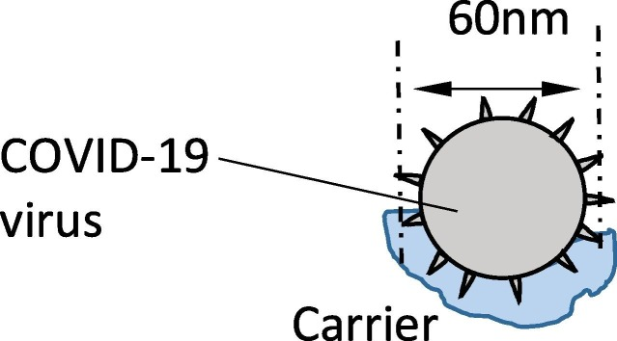
Figure 10: schematic illustration of coronavirus attached to a 60 nm (0.06 microns) diameter carrier water droplet which then becomes airborne (Schematic 1a, from (Leung et al, 2020).)
Leung et al found that their test filter was capable of filtering out 88% of ambient aerosol particles at 0.05 microns (50 nm) (Leung et al, 2020). This is a useful level of filtration for coronaviruses and for traffic fumes, but is still not not close to sufficient for the ESF study.
These electrospun nanofibre filters rely mainly on Brownian motion below 0.1 microns. The nanoparticles are far smaller than the gaps, but many get deflected out of the air flow and hit the fibers by the random jostling from individual air molecules hitting them. See section 4.3 and figure 5 from (Borojeni et al, 2022:7). These filters can achieve high efficiencies but aren't aiming to reach the ESF study requirement that "The release of a single unsterilized particle larger than 0.05 μm is not acceptable under any circumstances”.
Borojeni, I.A., Gajewski, G. and Riahi, R.A., 2022. Application of Electrospun Nonwoven Fibers in Air Filters. Fibers, 10(2), p.15.
I haven't yet found research into 100% containment at any size range for air filters. That's a decade after the ESF study. It's not clear the technology either exists or is known to be feasible.
This suggests that best available technology is not yet able to comply with the ESF standard to contain 100% of particles at 0.05 microns and nearly 100% of particles at 0.01 microns (or this study would have used it). So, this requirement mandates development of a new design, which will then need to be developed, tested, manufactured and integrated into equipment such as suits and glove boxes for the facility.
In short, it is already technically possible, with an experimental filter, to filter out most particles at 0.05 microns.

However, ULPA filters can’t do this. Also, the standard tests for ULPA and HEPA filters can’t test a filter adequately with aerosols small enough to certify such a filter (previous section).

It doesn’t seem to be possible yet to filter out 100% of particles from the air at 0.05 microns with the best available filter technology

However if the particles are in water under high pressure, it is possible to filter out 100% of 0.05 micron particles using experimental nanofilters made of carbon nanofibers loaded with silver.

Challenges for maintenance for future 0.05 micron compliant nanoscale filters – need to be designed for sterilization before any potential extraterrestrial biology is known, and may be easily damaged and hard to replace without risking release of nanoparticles
In the future once these new 100% effective 0.05 micron compliant filters have been designed, developed, tested and proven to work, there will also be the need to show that they can be replaced and maintained, while still maintaining 100% containment at 0.05 microns. Biosafety level III cabinets need to be checked annually (Richmond et al, 2000:33) and equipment will sometimes need to be repaired.

HEPA filters often fail these annual tests and need replacement. When these filters are changed, the Biological Safety Cabinets (BSCs) must be decontaminated (WHO, 2003:35).

For Martian samples, decontaminating the filters or the cabinet before changing them is likely to be challenging, since properties of any viable life in an unsterilized Martian sample are not yet known. The method used for decontamination has to be capable of sterilizing not only known pathogens, not only all Earth life, but also capable of sterilizing any possible extraterrestrial extremophile with possibilities of increased resistance to the sterilizing agents compared to terrestrial life.
Meanwhile however the sample itself needs to be kept unsterilized while the cabinet housing it is sterilized to replace the filters. In addition the maintenance including replacing the filter must be carried out in such a way as to prevent the leak of a single particle larger than 0.05 microns.
The filters for smaller nanoparticles for water treatment are easily damaged, through chemical and biological deterioration by aging, scratches by particle like substances, or fouling of the membrane (Singh et al, 2020:8).
This suggests that once the technology is available for new filters to filter out 100% of particles from the air at 0.05 microns, these new aerosol nanofilters may have similar challenging maintenance requirements.
It seems that to comply with the ESF 0.05 micron standard will be a significant future scientific and technical challenge for filter technology, and filter maintenance and may involve major new learning curves for the technicians that run the facilities.
I have found no previous study of this issue of filter maintenance at 0.05 microns in the planetary protection literature.
Similar challenges with meeting this 0.05 micron standard could be expected for other aspects of maintenance, such as repairing the cabinet itself in the case of electrical fault. This also must be done in a way that doesn’t permit a single 0.05 micron particle to escape.
However, before this work on the new filter technology, we also have to review the minimum size requirements. This is recommended in the ESF study.

The ESF study says that the size limit needs to be reviewed regularly – at a decade later in 2022 it is definitely necessary to review a limit set in 2012 which dramatically reduced the 0.2 micron limit set in 1999 to 0.05 microns

The ESF study said that future reductions in the size limit are possible. They expected later reductions to happen at a slower pace, but say the size limit will need to be reviewed in the future, adding (Ammann et al, 2012:21):
Based on our current knowledge and techniques (especially genomics), one can assume that if the expected minimum size for viruses, GTAs or free-living microorganisms decreases in the future, and this is indeed possible, it will be at a slower pace than over the past 15 years

However, no one can disregard the possibility that future discoveries of new agents, entities and mechanisms may shatter our current understanding on minimum size for biological entities. As a consequence, it is recommended that the size requirement as presented above is reviewed and reconsidered on a regular basis.
[bolding as in original cited text]

The minimum size for filters to contain Marian biology was reduced from 0.2 microns to 0.05 microns / 0.01 microns in just three years from 2009 to 2012.
By 2022, a decade later, another review is certainly required.
The ESF also said the chance of release of even a single unsterilized particle at 0.01 micron must be less than 1 in a million, to stop gene transfer agents which readily transfer novel capabilities to unrelated species of archaea overnight in sea water (Maxmen, 2010) (McDaniel, 2010).

A size limits review board can be expected to consider research into synthetic minimal cells, and protocells – and ideas for simpler RNA world “ribocells” without ribosomes or proteins would be revisited as a result of research since 2012

A review board could consider research since 2012 into small synthetic minimal cells (Lachance, 2019) and protocells (Joyce et al, 2018). Also, ideas for simpler “RNA world” cells without ribosomes or proteins (Benner et al, 2010: 37) could be revisited using new research on ribocells (Kun, Á., 2021). Panel 4 for the 1999 “Size limits” workshop calculated that such a primitive free living lifeform could be as small as 0.014 microns in diameter and 0.12 µm in length, if there is an efficient mechanism for packing its RNA. (Board et al, 1999: 117).

Biologists have searched for a shadow biosphere of nanobes (Cleland, 2019, pp 213 - 214) which could co-exist with modern life. They didn't find these nanobes, but they are biologically credible, because such small cells have an advantage in an environment with low nutrient concentrations, as they have a larger surface to volume ratio, and so take up nutrients more efficiently. They would also avoid protozoan grazing (Ghuneim et al, 2018).

If Mars has early life nanobes, even with less sophisticated biology, they might be able to compete in a shadow biosphere on Earth. In a worst case scenario, mirror numbers with the right enzymes (isomerases) would convert normal organics in an ecosystem into mirror organics that only mirror life can use, or rare terrestrial microbes with the ability to metabolize mirror organics.

This size limit review, and the following legal process, may change requirements. They are best completed before we launch the Earth return orbiter, Earth Entry Vehicle, and Mars Ascent Vehicle or build the return facility.

NASA’s Environmental Impact Statement is vulnerable to litigation on the basis that it doesn’t consider impacts of a sample return properly, doesn’t take account of the main issues mentioned by the Sample Return Studies and say things that contradict their conclusions – potential remedies include stopping the mission altogether or an injunction, e.g. to sterilize all samples before they contact Earth’s biosphere
NEPA doesn’t provide for judicial review directly. But it’s often a ground for litigation on the basis that the process hasn’t been carried out properly, For instance judicial review can be requested because (Congressional Research Service, 2021).
- the agency failed to consider some of the impacts
- the agency failed to properly consider the weight of the impacts under review
During the litigation the court can issue injunctions that
- bar all or part of a proposed action
The result of the court case is usually
- referred back to the agency (such as NASA) for further proceedings - and the court can say what those are
- It can order equitable relief which vacates the action - i.e. stops the project going ahead
- Or issue some other action.
The courts can just stop the whole thing - or they could require some injunction on NASA.
In the case of the NASA proposals, if they don’t do a proper assessment, one likely injunction might be that NASA have to sterilize all samples returned to Earth until proven to be safe, if they assess that NASA haven’t taken account of all possible impacts or they haven’t sufficiently considered the weight of the impacts.
Then there is a similar process in Europe, which ESA will have to go through for their sample fetch rover. That starts with the Directive 2001/42/EC of the European Commission (EU, 2001)..
However I haven’t seen any academic papers on how the Mars sample return legal process would work out in Europe.
Generally it wouldn’t stop in the USA. If all domestic agencies were satisfied, and if the European Comission are satisfied, there are still many international treaties that are relevant.
I go into this in much more detail in my preprint (Walker, 2022b).
This time as it is directly relevant, I have copied over some of the sections here (and lightly edited)

NASA procedural requirements for mission planners to develop a clear vision of problems, show it’s feasible and cost-effective, develop technology with engineering details and show it will meet requirements before build starts – because of significant costs involved in modifying designs at later stages in the build
NASA has a procedural requirement for mission planners to do an Earth Safety Analysis Plan to present to the Planetary Protection Officer (NASA, 2005npr: 2.7.4.1)

The Mars Receiving Facility is likely to be built in the US by NASA (Carrier et al, 2019). All NASA facility project managers are mandated by NPR 8820.2G to comply with NASA-required best practices.(NASA, 2014fpr:10)

In pre-phase A they need to develop a clear vision of the problems and how they can be solved (NASA, n.d.SEH:3.3):

It is important in Pre-Phase A to develop and mature a clear vision of what problems the proposed program will address, how it will address them, and how the solution will be feasible and cost-effective.

In phase A the technical risks are examined in more detail (NASA, n.d.SEH: section 3.4):

Technical risks are identified in more detail, and technology development needs become focused.
… Develop breadboards, engineering units or models identify and reduce high risk concepts

Then in phase B, the design is set out in more engineering detail and shown to comply with requirements. (NASA, n.d.SEH: section 3.5):

The project demonstrates that its planning, technical, cost, and schedule baselines developed during Formulation are complete and consistent; that the preliminary design complies with its requirements; that the project is sufficiently mature to begin Phase C; and that the cost and schedule are adequate to enable mission success with acceptable risk. For projects with a Life Cycle Cost (LCC) greater than $250 million, this commitment is made with the Congress and the U.S. Office of Management and Budget (OMB). This external commitment is the Agency Baseline Commitment (ABC). Systems engineers are involved in this phase to ensure the preliminary designs of the various systems will work together, are compatible, and are likely to meet the customer expectations and applicable requirements.

All these phases have to be completed before the start of the build. The issue here is that there are significant costs involved in modifying a design later on. It can cost 500 to 1000 times more to modify a design at a late stage in the process.

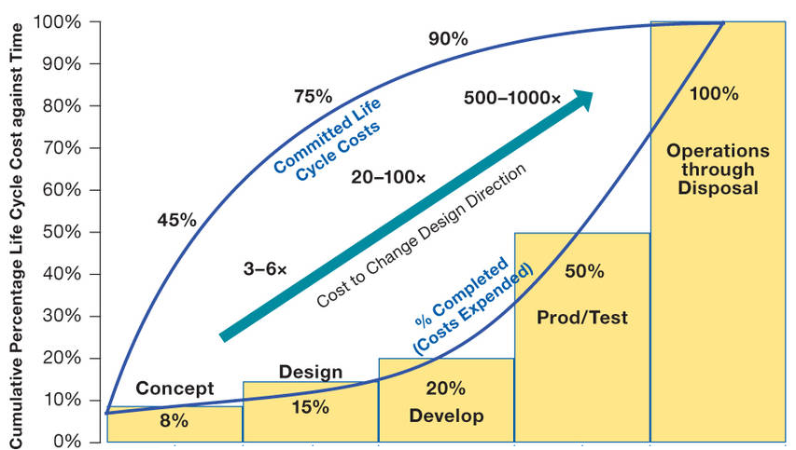

Figure 13: Life-Cycle cost impacts from early phase decision making
(from figure 2-5-1 of NASA, n.d.SEH: section 2.5)

The design requirements for the Mars Sample Receiving Facility will not be known until the legal process is complete.

Small discretionary funds are made available for concept studies before the budget request. However, the budget itself depends on the design requirements.

A study in 2010 estimated the cost of the facility as $471 million in 2015 US dollars, see Table 5-1 of (Mattingly, 2010:20). This is from before the ESF study, and so the cost is likely to be higher with the newer 0.05 micron requirements. Adjusted to 2021 dollars allowing for inflation, this is already over half a billion dollars, and informal cost estimates today are similar, $500 million per facility. NASA would need legal clarity before allocating such a budget.

It is also possible that ESA might build a second facility to contain the samples (Andrews, 2020) which could bring the total cost up to a billion dollars.

Examples of how sample return facility requirements might change during the legal process – more stringent filter requirements than for BSL-4 – quarantine to be replaced by telerobotics – and required safety levels far higher than the one in a million “gold standard” for a BSL-4 facility

NASA’s recommendation has to go through legal review and the requirements may well change as a result of legal considerations. Here are some examples of changes that may be required

- NASA’s recommendation is for a BSL-4 facility
Legal review might lead to a requirement of 100% containment at 0.05 microns after consideration of the ESF sample return study or even a smaller 0.01 or 0.005 microns after the size limits review - and NASA may be legally required to fulfil those requirements as already covered above in NASA plan to use a biosafety level 4 facility to handle the samples – but how can they know that a BSL-4 facility designed to contain infectious diseases of humans will work to protect Earth’s biosphere from extraterrestrial ultramicrobacteria or the potentially even smaller nanobes such as ribocells that may have preceded terrestrial life? The answer is they don’t – they seem unaware of the recommended size limits set in the 2012 ESF sample return study which make a BSL-4 facility inadequate
- NASA don’t include any provision for isolation of contaminated technicians to protect Earth’s biosphere
Legal review might find that quarantine is not sufficient (this has never been legally tested). If so, the facility might be required to be telerobotic. There are many potential issues with quarantine as a way to protect Earth’s biosphere, not least, that organisms from Mars such as mirror life could be harmless to humans but harmful to the biosphere or to other species, crops etc.
See the section in my preprint (Walker, 2022b): Complexities of quarantine for technicians accidentally exposed to sample materials
- Levels of security for a biosafety level 4 facility are based on a one in a million chance of escape
Some synthetic biologists consider the 1 in a million level of assurance for a biosafety level 4 laboratory to be insufficient for synthetic mirror biology - as there are occasional leaks from even high biosecurity laboratories.
Instead they design synthetic life so it is dependent on chemicals only available in the laboratory. This solution is not available for extraterrestrial life. It is possible the outcome of the legal process is that no unsterilized sample return is possible until we know what is in the sample.
See the section in my preprint (Walker, 2022b): A requirement for similar levels of safety to those used for experiments with synthetic life would lead to the Prohibitory version of the Precautionary Principle and make unsterilized sample return impossible with current technology and current understanding of Mars

There is no precedent for these decisions. So the legal outcome is not known in advance.

Though preliminary studies for the facility can be done early on, it seems that the overall design (e.g. human operated or teleoperated) and engineering details (e.g. filter technology) may be modified during the legal process and can’t be known in advance.

UPDATE – new streamlined NEPA process means NSAA can hope to complete the EIS in spring / summer 2023 with no more review if the EIS is not challenged – the presidential directive however would still apply and is needed even if the agency doesn’t believe alleged large scale or long term effects can happen.

The new streamlined NEPA process means that NASA can complete the EIS in less than a year (CEQ, n.d.)

QUOTE On June 12, 2020, CEQ issued an updated report on the length of time Federal agencies spent to complete EISs under NEPA. CEQ found that over the past decade, the average time for agencies to complete an EIS was 4.5 years. CEQ’s current guidance suggests that this process, even for complex projects, should not take more than one year.

All the cites here date back to 2019 and earlier and so didn’t take account of this. My preprint originally didn’t take account of it either but I’ve now updated most of it.

NASA say they hope to issue the record of decision in Spring / Summer 2023. That is the conclusion of the NEPA EIS process (FDA, n.d.).

“The Record of Decision (ROD) is the conclusion of the NEPA EIS process.”

There are several other stages after that such as the Presidential directive NSC-25 requires a review of large scale effects which is done after the NEPA process is completed. (Race, 1996)

This directive says (Whitehouse, 1977):

“It should be understood that experiments which by their nature could be reasonably expected to result in domestic or foreign allegations that they might have major or protracted effects on the physical or biological environment or other areas of public or private interest, are to be included under this policy even though the sponsoring agency feels confident that such allegations would in fact prove to be unfounded.

Then there are many international laws would be triggered and many other US agencies would be affected with the potential for large scale effects. See below:

- The legal process is likely to extend by many more years with involvement of CDC, DOA , NOAA, OSHA etc., legislation of EU and members of ESA, international treaties, and international organizations like the World Health Organization – NASA don’t seem to be prepared for this or even mention potential international ramifications [unless this inaccurately cited EIS gets used to bypass this stage altogether]

Minimum timeline: 2 years to develop consensus legal position, less than one year to complete EIS, 9 years to build sample return facility and 2 years to train scientists and technicians in its use
Race doesn’t give a timeline to complete the legal process, although it is clear from her analysis that it would take many years (Race, 1996). Uhran et al however have mapped out a minimum timeline (Uhran et al, 2019). From table 2, their estimate is:
- Preparation including founding the oversight agency and developing consensus position on containment margin of safety (2 years)
- File environmental Impact statement, approximately 6-7 years, may be significantly longer if challenged in court.
However as a result of the streamlining of NEPA under trump, it is now less than one year for the EIS.
See: UPDATE – new streamlined NEPA process means NSAA can hope to complete the EIS in spring / summer 2023 with no more review if the EIS is not challenged (above)
Total: 2 to 3 years for legal process (including preparation)
[was 8 to 9 years]
- NASA have already started their EIS process in 2022
So that makes
- 2023 earliest date to complete the legal process if the EIS isn’t challenged.
For the Sample Receiving Facility, they have to
- Build or repurpose containment facility - 9 years
- Train scientists and technicians, 2 years
[this is because of the many lapses in sample handling for the Apollo facility]
Total: 11 years for the build
Note, the NRC in 2009 estimated a similar 10 to 16 years for the build, before the facility is ready for samples (National Research Council. 2009 : 59)
Going by the lowest of these estimates, if the build started in 2022, the facility could be ready to receive samples by 2033, as required for the planned mission. The legal process could be complete by 2023 if there were no delays.

However, as we saw in the previous section (NASA procedural requirements for mission planners), NASA need to have a clear account of what they will build, and how to service it, before they can go ahead with such an expensive build project. These will not be possible until the legal status is clear and the details of what is required are settled.

Need for legal clarity before build starts - NASA has reached keypoint A for the budget for entire program, but not for the facility – they can’t know what they will be legally required to build for the facility – perhaps they can pass keypoint A without legal clarity – but keypoint B requires detailed engineering knowledge of what to build
NASA’s planetary protection office has started to think in depth about the implementation of backwards planetary protection. They reached key decision point (KDP A) for the budget for the program in December 2020 (Foust, 2020) (NASA, 2021nmttm) (Gramling et al., 2021) However this is for the whole program including the orbiter, earth return vehicle, mars ascent vehicle, fetch rover etc. The sample receiving facility will need an architectural plan and dedicated budget at some point in the future.
It is hard to see how a build can go ahead when Mars sample return facility design requirements have not yet been legally approved. Perhaps they can pass keypoint A for the sample return facility without this legal clarity, but the more stringent keypoint B, which also has to be passed before the build starts, requires detailed engineering knowledge of what they are required to build.
They can’t know this for as long as it remains possible the design will need to be modified during the legal process. The recommended design could be challenged at any point until near the end of the legal process which as we saw is not likely to be completed before 2028, six years after the EIS filing (NASA, 2022nic),.

Need for legal clarity before launch of ESA’s Earth Return Orbiter, Earth Entry Vehicle, and NASA’s Mars Ascent Vehicle
There would be similar issues for the launch of ESA’s Earth Return Orbiter and NASA’s.Mars Ascent Vehicle. Before these missions are finalized, ESA and NASA need to know the legal requirements for the Earth Return Orbiter, Earth Entry Vehicle (which will be launched in the same payload) and Mars Ascent Vehicle. There is no way to modify them post launch.
ESA and NASA also need to know what’s required well before the launch dates, as unexpected legal requirements may impact on the design and construction of the Earth Return Orbiter (ERO) and Mars Ascent Vehicle (MAV).
To take an example, the ERO as currently conceived transfers the capsule to an Earth Entry Vehicle which then uses a direct flight back from Mars to Earth followed by aerocapture using an aeroshell to protect the contents (Huesing et al, 2019).
So – will the final legal decision approve use of an aeroshell?.
This has planetary protection implications and needs to be considered as part of the legal process.
The legal process will also need to look at how the mission is designed to break the chain of contact with Mars when the Earth Entry Vehicle is opened to retrieve the sample.
The legal requirements on the Earth Return Orbiter could change through to the end of the legal process.
This also may have implications on the capsule design and the design for the Mars Ascent Vehicle.
As well as the risk of delaying the launch, until the legal process is complete, ESA may need to consider to what extent they can risk public funds to design, build and test spacecraft that may need expensive redesign, modifications and retesting to comply with the final legal requirements.
Then – it may well become clear during the legal process that the build won’t be completed in time.
- If NASA decide to sterilize the samples during the return mission – they need to build in the capacity to do this before they launch the Earth Return Orbiter. It can’t be sterilized on a return journey from Mars unless this has already been planned for, and s, the aeroshell would be unnecessary weight as it would need to be captured in Earth orbit by some other spacecraft before it can be sterilized.
- If NASA decide to return the samples to another location such as above GEO, again the aeroshell is unnecessary weight, that could be used for extra fuel to help the satellite to reach its intended final orbit

The legal process is likely to extend by many more years with involvement of CDC, DOA , NOAA, OSHA etc., legislation of EU and members of ESA, international treaties, and international organizations like the World Health Organization – NASA don’t seem to be prepared for this or even mention potential international ramifications [unless this inaccurately cited EIS gets used to bypass this stage altogether]

UPDATE – IF THE EIS ISN’T CHALLENGED IN THE COURTS, IT’S POSSIBLE THAT NONE OF THIS HAPPENS – SEE UPDATE – new streamlined NEPA process means NSAA can hope to complete the EIS in spring / summer 2023 with no more review if the EIS is not challenged
(above) The EIS as it stands now essentially says that they are certain there is no life on Mars and that they are doing these precautions out of an “abundance of caution”. If this is the final decision, other agencies in the USA as well as other countries and international organizations will likely conclude that there is nothing here for the DOA, CDC. NOAA, OSHA, WHO, FOA, UNEP etc. to look at.

There is still the presidential directive NSC-25 requires a review of large scale effects which is done after the NEPA process is completed. (Race, 1996)

This directive says (Whitehouse, 1977):

“It should be understood that experiments which by their nature could be reasonably expected to result in domestic or foreign allegations that they might have major or protracted effects on the physical or biological environment or other areas of public or private interest, are to be included under this policy even though the sponsoring agency feels confident that such allegations would in fact prove to be unfounded.

So these other agencies may develop an interest as a result of that directive if the EIS isn’t challenged and goes through.

There is potential for many delays in the legal process after the filling of the EIS (EPA, n.d.). First, since there is a potential for damage to Earth’s environment, various executive orders mandate NASA itself, as a federal agency, to consider such matters as (NASA, 2012fdg):
- impact on the environment,
- impact on the oceans,
- impact on the great lakes,
- escape of invasive species,
- lab biosecurity against theft
After the environmental impact statement is filed, Uhran et al mention many other agencies likely to declare an interest such as the (Uhran et al, 2019) (Meltzer, 2012:454)

- CDC (for potential impact on human health),
- Department of Agriculture (for potential impact on livestock and crops),
- NOAA (for potential impact on oceans and fisheries after a splashdown in the sea)
- Occupational Safety and Health Administration, to consider questions of quarantine if a scientist or technician gets contaminated by a sample
- Department of Homeland Security,
- Federal Aviation Administration because the sample returns through the atmosphere
- Department of Transportation for bringing the sample to the receiving laboratory from where it touches down and to distribute to other laboratories
- Occupational Safety and Health Administration - for any rules about quarantine for technicians working at the facility
- U.S. Customs and Border Protection and the Coast Guard to bring back sample in case of an water landing or the Department of Defense if it lands on land, likely the Utah Test & Training Ranges
- Department of the Interior which is the steward for public land and wild animals which could be affected by release of Martian microbes
- Fish and Wildlife Service for the DoI who maintain an invasive species containment program and may see back contamination as a possible source of invasive species
- National Oceanic and Atmospheric Administration (NOAA)'s fishery program for sea landing in case it could affect marine life and NOAA fisheries
- Integrated Consortium of Laboratory Networks (ICLN) for laboratories that respond to disasters - a partnership of the Department of Agriculture, Department of Defense, Department of Energy, Department of Health and Human Services, Department of Homeland Security, Department of the Interior, Department of Justice, Department of State, and Environmental Protection Agency
- The state where the receiving laboratory is stationed may have regulations on invasive species, environmental impacts, disposal of waste, and possession of pathogens, similarly also for any states the sample may have to transit to from the landing site to the facility
As the process continues it is possible to stop the activity. It’s the same process that is used for instance. to stop oil pipelines across tribal lands in the USA or almost any US environmental legal action.

The Congressional Research Service explains (Congressional Research Service, 2021) that NEPA doesn’t provide for judicial review directly. But it’s often a ground for litigation on the basis that the process hasn’t been carried out properly.
For instance judicial review can be requested because
- the agency failed to consider some of the impacts
- the agency failed to properly consider the weight of the impacts under review
During the litigation the court can issue injunctions that
- bar all or part of a proposed action
The result of the court case is usually
- referred back to the agency (such as NASA) for further proceedings - and the court can say what those are
- It can order equitable relief which vacates the action - i.e. stops the project going ahead
- Or issue some other action.
The “ordinary” remedy is to just vacate the Federal action so it can’t go ahead, but the courts consider the “seriousness” of the deficiencies in the EIS and the “disruptive consequences” of vacating the action (Congressional Research Service, 2021).
So the courts can just stop the whole thing - or they could require some injunction on NASA. In this case, one example injunction might be that NASA have to sterilize all samples returned to Earth until proven to be safe, if they assess that NASA haven’t taken account of all possible impacts or they haven’t sufficiently considered the weight of the impacts.
Meanwhile, since this is a joint NASA / ESA mission, it involves ESA. Most of the ESA member states are in the EU (ESA, n.d.MS) so the EU will get involved.

This leads to a separate legal process in Europe, starting with the Directive 2001/42/EC (EU, 2001). I haven’t located any academic reviews for the European process, but as for the case in the USA, this would spin off other investigations which would involve the European Commission (Race, 1996).

The UK, as a member of ESA but not in the EU, might also be involved in a separate process with its domestic laws. Canada also sits on the governing council of ESA, so perhaps may get involved. These countries are all members of ESA and also all potentially impacted by an adverse outcome.

However it wouldn’t stop at the USA and ESA. All other countries are potentially impacted in the worst case. These potential impacts on the environment of Earth, and on human health world-wide bring many international treaties into play (Uhran et al, 2019),
In an address given to the Space Studies Board Task Group on Issues in Sample Return in 1996, attorney George Robinson presented a list of 19 treaties or international conventions and 10 domestic categories of law, including the rights of individual states and municipalities to quarantine, that may affect return missions.
These lists include treaties governing the use of the air and sea, environmental protection treaties, the constitution of the World Health Organization (WHO), and treaties related to outer space as well as the Administrative Procedure Act (Robinson, 1996).
[Need to find out more details here]
Also several international organizations are likely to be involved such as the WHO (Uhran et al, 2019).
We will see below that the very worst case scenarios involve degradation of Earth’s environment (such as by mirror life).

It seems unlikely that these worst case scenarios would be ignored as the legal proceedings continue. If the legal discussions expand to focus on these scenarios, this could involve many other organizations.

The Food and Agriculture Organization (UN, 1945) could become involved, especially if the potential for alien exobiology such as mirror life is considered, because of potential impact on agriculture and fisheries and global food supplies, and the World Health Organization because of effects on human health globally if a new organism is returned that can be spread to other countries.

In the USA, the Environmental Protection Agency partners with the United Nations Environment Program (UNEP), and Arctic Council, so they’d likely get involved (EPA, n.d.pwio).

Indeed, there would be few aspects of human life that would not be relevant in some way in discussions of the very worst case scenarios. As the legal process continues, surely there would be open public debate about these scenarios, and if the discussion expands in this way, potentially it might lead to much wider involvement in the international community. It would be necessary to convince the public, and interested experts in all these agencies that this is a safe mission and that all their concerns have been answered.
Race (Race, 1996) says that experts will have challenges deciding in advance whether the sample should be classified as potentially:
- an infectious agent
- an exotic species outside its normal range
- a truly novel organism (as for genetic engineering)
- a hazardous material
The choices here would change which laws and agencies would be involved.
Presidential directive NSC-25 requires a review of large scale effects which is done after the NEPA process is completed. (Race, 1996)
There are numerous treaties conventions and international agreements relating to environmental protection or health that could apply.
Including those to do with (Race, 1996)
- protection of living resources of the sea
- air pollution (long range pollution that crosses country boundaries)
- world health, etc
Individual groups in other countries could invoke domestic laws such as laws on accidents at sea or on land if they argue back contamination of Earth can cause measurable damage. (Race, 1996)
Race says scientists are likely to focus on (Race, 1996)
- technical details
- mission requirements
- engineering details
- costs of the space operations and hardware
General public are likely to focus on
- risks and accidents
- whether NASA and other institutions can be trusted to do the mission
- worst case scenarios
- whether the methods of handing the sample, quarantine and containment of any Martian life are adequate
Six to seven years seems a bare minimum to complete all this. Any addition to the legal process would push the sample return date further back than 2039.

Rummel et al recommend a planning agency set up in advance with experts in legal, ethical and social issues - Uhran et al recommend an advanced planning and oversight agency set up two years before the start of the legal process – and the ESF recommends an international framework should be set up, open to representatives from all countries - NASA don’t seem to have done any of this yet

NASA and ESA clearly didn’t ‘do this or they would have produced a much more thorough EIS and would have engaged in far more outreach to the general public before submitting the EIS.

With so much to be sorted out, Uhran et al recommended that an oversight agency should be set up long before the legal process starts. Uhran et al recommend this is done two years before filing the environmental impact statement to develop a consensus position on the margin of safety for sample containment (Uhran et al, 2019).
Since the aim is to develop a consensus position, this would need to be based on up to date information. So it would need to include the review of the size limits required in the ESF sample return study (Ammann et al, 2012:PG). The current paper suggests the need to review filter technology and provide a preliminary study of the technological advances needed to achieve the specified size limits, since the technology doesn’t seem to exist yet.

Rummel et al say that the oversight committee would need to contain experts in legal, ethical and social issues in addition to the experts in astrobiology, space engineering and mission planning. It should conduct ethical and public reviews. Broad acceptance by the public is essential at an early stage for success of the mission (Rummel et al, 2002).
In more detail, Rummel et al advise that clear communication with the public is essential from an early stage, for success of the mission. (Rummel et al, 2002).

Pages 94-5: As part of sample return planning, it will be important to develop an organized communication plan which will lay a strong foundation in public understanding and acceptance prior to the mission, and allow for an open dialogue with all sectors of the public. Such a plan should include consideration of the diverse questions, concerns, and issues likely to be raised, including those related to the mission and spacecraft operations, the sample return and Biohazard testing, the administrative and legal matters associated with the effort, and to the potential implications of discovering extraterrestrial life.
Plans should be developed well in advance in order to avoid a frenzied, reactive mode of communications between government officials, the scientific community, the mass media, and the public.
They recommend that this should avoid a NASA centric focus and include links with other government agencies and international partners and external organizations
Any plan that is developed should avoid a NASA-centric focus by including linkages with other government agencies, international partners, and external organizations, as appropriate. It will also be advisable to anticipate the kinds of questions the public might ask, and to disclose information early and often to address their concerns, whether scientific or non-scientific.
...
Evaluations of the proposal should be conducted both internal and external to NASA and Centre National d’Etudes Spatiale (CNES) and the space research communities in the nations participating in the mission.
They talk about the need for an ethical review which needs to be made publici early in the process.
An ethical review should be conducted at least at the level of the Agencies participating and these reviews made public early in the process (in France, the national bioethics committee, Comité Consultatif National d'Ethique pour les Sciences de la Vie et de la Santé, CCNE, is the appropriate organization).
They talk about the need to announce the final protocol broadly to the scientific community and they say broad acceptance at both lay public and scientific levels is essential for success.
The final protocol should be announced broadly to the scientific community with a request for comments and input from scientific societies and other interested organizations.
Broad acceptance at both lay public and scientific levels is essential to the overall success of this research effort.
They highlight the issues that could arise later on if extraterrestrial life is discovered. Including legal ownership questions
In the long term, the discovery of extraterrestrial life, whether extant or extinct, in situ or within returned sample materials, will also have implications beyond science and the SRF per se. Such a discovery would likely trigger a review of sample return missions, and plans for both robotic and human missions. Legal questions could arise about ownership of the data, or of the entity itself, potentially compounded by differences in laws between the United States and the countries of international partners.
Ethical, legal and social issues should be considered seriously. I think here where it says “in any event” it means whether or not they find life?
In any event, ethical, legal and social issues should be considered seriously. Expertise in these areas should be reflected in the membership on appropriate oversight committee(s).
They say that a central question is whether any protocol can be guaranteed to be risk free [I argue in my paper that study above GEO in a telerobotic facility fulfils this condition as does sterilizing all samples] and ask what counts as an acceptable level of risk
Page 96: Central to an understanding of the arguments is the question of risk, i.e., Can any protocol be guaranteed to be absolutely risk-free? If not, what is an acceptable level of risk (for example, one that approximates the risk from the natural influx of martian materials into Earth’s biosphere)?
And, is there any treatment method that can eliminate all risks from the returned samples, while preserving them for the detailed scientific study envisaged by the scientific community?
They also talk about the need to have a communication plan to address concerns and perceptions about the associated risks:
Page 101: Communications Unusual or unprecedented scientific activities are often subject to extreme scrutiny at both the scientific and political levels. Therefore, a communication plan must be developed as early as possible to ensure timely, and accurate dissemination of information to the public about the sample return mission, and to address concerns and perceptions about associated risks.
They talk about how the public and stakeholders need to be able to participate in an open, honest dialogue.
The communication plan should be pro-active and designed in a manner that allows the public and stakeholders to participate in an open, honest dialogue about all phases of the mission with NASA, policy makers, and international partners. Risk management and planetary protection information should be balanced with education/outreach from the scientific perspective about the anticipated benefits and uncertainties associated with Mars exploration and sample return.
They go on to talk about the process of informing the public of any discoveries. This must be decided well in advance
The communication plan should also address how the public and scientific community will be informed of results and findings during Life Detection and Biohazard testing, including the potential discovery of extraterrestrial life. Because of the intense interest likely during initial sample receipt, containment, and testing, procedures and criteria should be developed in advance for determining when and how observations or data may be designated as “results suitable for formal announcement.”
Details about the release of SRF information, the management of the communication plan, and its relationship to the overall communications effort of the international Mars exploration program should be decided well in advance of the implementation of this protocol
They warn that potentially the sample return mission, and the facility, could also attract intentionally disruptive events, by bioterrorists, or by “radical” groups opposed to sample return (Rummel et al, 2002).

Page 93: Concerns about security should also be reconsidered, especially in view of the potential disruptive activities of any terrorists or ‘radical’ groups that may be opposed to sample return.
[NOTE] I can’t find it now, I thought Rummel at al warned about the sharing of viral misinformation. Maybe it was someone else. Does anyone reading this know the cite? That clearly is a concern after what happened in the COVID pandemic whoever it was that said it. Perhaps this may need to be managed based on the emerging discipline of infodemiology (WHO, 2020wic).

Similarly the ESF recommends that since negative consequences from an unintended release could be borne by countries not involved in the program, a framework should be set up at the international level open to representatives of all countries, with mechanisms and fora dedicated to ethical and social issues of the risks and benefits from a sample return (Ammann et al, 2012:59).
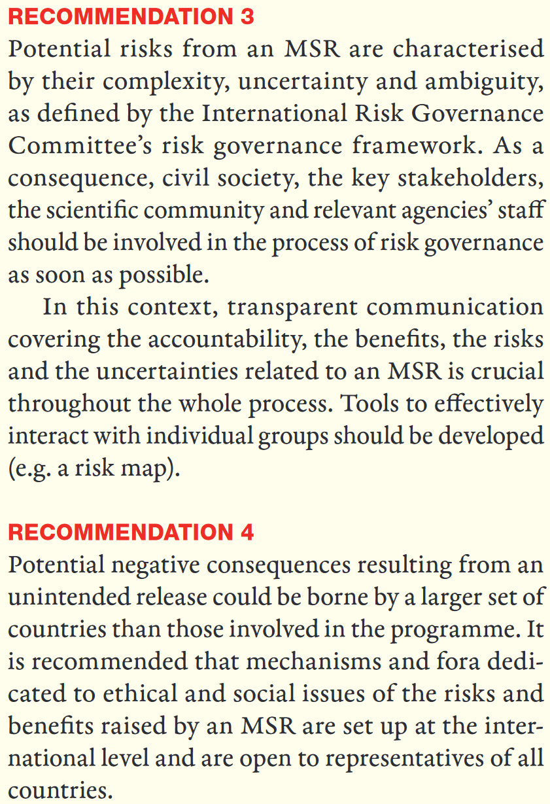
RECOMMENDATION 3
Potential risks from an MSR are characterised by their complexity, uncertainty and ambiguity, as defined by the International Risk Governance Committee’s risk governance framework. As a consequence, civil society, the key stakeholders, the scientific community and relevant agencies’ staff should be involved in the process of risk governance as soon as possible.
In this context, transparent communication covering the accountability, the benefits, the risks and the uncertainties related to an MSR is crucial throughout the whole process. Tools to effectively interact with individual groups should be developed (e.g. a risk map).
RECOMMENDATION 4
Potential negative consequences resulting from an unintended release could be borne by a larger set of countries than those involved in the programme. It is recommended that mechanisms and fora dedicated to ethical and social issues of the risks and benefits raised by an MSR are set up at the interational level and are open to representatives of all countries
This again would be best done before the start of the legal process to make sure everyone is on the same page before it starts.
. As Randolph put it (Randolph, 2009:292).

The risk of back contamination is not zero. There is always some risk. In this case, the problem of risk - even extremely low risk - is exacerbated because the consequences of back contamination could be quite severe. Without being overly dramatic, the consequences might well include the extinction of species and the destruction of whole ecosystems. Humans could also be threatened with death or a significant decrease in life prospects
In this situation, what is an ethically acceptable level of risk, even if it is quite low? This is not a technical question for scientists and engineers. Rather it is a moral question concerning accepting risk. Currently, the vast majority of the people exposed to this risk do not have a voice or vote in the decision to accept it. Most of the literature on back contamination is framed as a discourse amongst experts in planetary protection. Yet, as I've already argued, space exploration is inescapably a social endeavor done on behalf of the human race. Astronauts and all the supporting engineers and scientists work as representatives of all human persons.
…
In this situation to treat persons with dignity and justice means that everyone should have the opportunity to voice their opinion concerning whether humans should accept the risk.
…
    - The best practices of planetary protection must be followed. … Yet pursuing best practices by itself does not necessarily guarantee an ethically acceptable level of risk.
    - There should be opportunities for open comment by those individuals or groups that have concerns about the risks of back contamination. These comments should be taken seriously and NASA should publicly respond to these concerns.
    - A committee of neutral or disinterested persons should review the planetary protection measures for return of spacecraft and samples. This committee should include persons with a diversity of expertise, including ecology, biology, chemistry, specialists in risk analysis, and ethicists. The ethicists should represent a diversity of philosophical and religious perspectives.
    - The entire process of soliciting comment, analysing the risk factors and deciding on whether the risk levels are ethically acceptable should be transparent to the interested public.

NASA did set up a review board for sample return missions on August 14th 2020 (NASA, 2020nebmsr). However, from the draft EIS and the responses to the public within it, it is clear that it can’t have been set up to consider these wide ranging issues, or include experts in legal, ethical and social issues, as recommended by (Rummel et al, 2002) and (Randolph, 2009:292).
Indeed, from the content of the draft EIS and the reactions in comment replies, it seems unlikely that these issues have been considered at all in the process of developing the EIS.

The legal process and public debate for NASA’s mission as precedent for China’s mission to return a sample too – perhaps as soon as 2030 – with sterilization a likely solution for a country that wants to be first to return a sample
China currently plans to launch a mission possibly as soon as 2028, to return a sample by 2030. It would consist of two rockets, one with a lander and ascent vehicle, and the other with an orbiter and reentry capsule to return the sample to Earth, using two Long March rockets (Jones, 2021)

China had one of the most rigorous of all responses to the COVID pandemic. Professor Bruce Aylward, leader of the joint team that studied their response (McNeil, 2020) put it like this in the press briefing about their findings (United Nations, 2020)

They [the Chinese] approached a brand new virus [that] has never been seen before that was escalating and quite frightening in January … and they have taken very basic public health tools … and applied these with a rigor and an innovation of approach on a scale that we've never seen in history

If China considers the Mars sample return to be potentially hazardous it is likely to be especially careful just as it has been especially careful with COVID.

The debate that is sure to happen with the NASA mission will help bring widespread awareness of the issues of a sample return and the need to be careful.

China’s mission is far simpler than the NASA one and similar to the proposal for NASA by the astrobiologist Chris McKay for a mission that does no more than land, gather a scoop of dirt and immediately return,

I have a section about this in my preprint (Walker, 2022b) under:

- Sample return as a valuable technology demo for astrobiology – and proposals to keep the first sample returns simple, a scoop of dirt or skimming the atmosphere to return micron sized dust samples

China's first mission may have a higher chance of returning present day life than the NASA mission as currently envisioned - because they plan to scoop up some dirt which could have viable spores from dust storms, or the life that Viking detected (if it did find life).

Perhaps China may be able to accelerate their legal process or bypass elements of it though they would still have the international treaties and responses of international organizations and other countries to deal with.

However, once this topic enters public debate widely, the public can be expected to raise many issues as NASA has already seen with the comments so far on their draft environmental impact statement (NASA, 2022msrc).

The general public in Chinese likely raise similar issues, which would get the attention of leaders in China, given their recent experience of COVID and the high level of importance they assign to matters of public health.

NASA can’t accelerate the legal process to achieve an unsterilized sample return faster – but it could “win” this race with a sterilized return or unsterilized return to a safe orbit with sterilized subsamples returned to Earth – inspiring China and other nations to do the same
It’s possible this could turn into a space race similarly to the races between the Soviet Union and USA in the 1960s, but with an easy win available to China due to the complexity of the NASA mission and the comparative simplicity of the Chinese mission.

If this turns into a space race with NASA competing with China, NASA can't accelerate the legal process to “win the race” with an unsterilized return before 2030.

However, NASA can accelerate its timeline if they do a sterilized return or a return to a safe orbit and sterilized subsamples, as that has almost no legal process.

They could do that by 2033 with their current timetable.

Another way that NASA could “win” the race to return a sample of Mars would be to do a separate low cost sample return such as SCIM skimming the Mars atmosphere to return micron sized “Mars rocks” from dust storms, or Chris McKay’s “grab a sample of dirt and return” (McKay, 2015). NASA could have done either of those a decade ago or more.
It would likely be hard for NASA to find the budget for an extra sample return mission in competition with existing programs, but if Congress authorized the expenditure, they could do such a mission very quickly, and with their previous experience and expertise, surely faster than China, if they see China as “winning” the race to be first to return a sample.

See:

- Sample return as a valuable technology demo for astrobiology – and proposals to keep the first sample returns simple, a scoop of dirt or skimming the atmosphere to return micron sized dust samples

A fast sterilized sample return, or return to a safe orbit, might lead to China doing the same.

As a response to public concerns, China could use either of the solutions suggested here:

- to sterilize the sample during the return mission.
- to return it to a remotely operated satellite in a safe orbit, and sterilize some of the dirt to return to Earth for immediate study while the rest is tested for signs of life in orbit.

These wouldn’t significantly impact on the prestige value of returning the first samples from Mars and they are well within China’s capabilities.

For details see

- Sterilized sample return as aspirational technology demonstration for a future astrobiology mission
- Recommendation to return a sample for teleoperated ‘in situ’ study above Geosynchronous Equatorial Orbit (GEO)

If they do this, it could then become the norm for samples returned from another planet – that when you don't know if there is life in them or what form of biochemistry or exobiology might be involved, you return the samples to a safe orbit for preliminary study first, or sterilize them.

Both missions are likely to be of most interest as a technology demo to show we can return a sample from Mars, at a later stage, once we know how to select the samples intelligently. But it’s not impossible either mission might return viable present day life.

Sterilization or return to a safe orbit is the simplest solution both from a practical point of view and legally.

However, we need to look in more detail into the challenges involved in an unsterilized return, since that is NASA’s current proposal.

I cover this in my preprint (Walker, 2022b) under:

- Public health challenges responding to release of an extraterrestrial pathogen of unfamiliar biology
  - Failure modes for sample containment
  - Complexities of quarantine for technicians accidentally exposed to sample materials
  - Vexing issue of authorizations to remove technicians from quarantine to treat life threatening medical incidents in hospital
  - Example of a technician in quarantine with acute respiratory distress and symptoms similar to Legionnaires’ disease – a disease of biofilms and amoebae that adventitiously infects humans – and sometimes mentioned in planetary protection discussions
  - Arbitrariness of technician’s quarantine period for an unknown pathogen – Carl Sagan gives the example of leprosy which can take 20 years or more to show symptoms
  - How do you quarantine a technician who could be a life-long symptomless super-spreader of an unknown Martian pathogen?
  - Martian microbes could participate harmlessly or even beneficially in the human microbiome but harm other terrestrial organisms when the technician exits quarantine - example of wilting Zinnia on the ISS
  - What if mirror life becomes part of the technician’s microbiome?
  - Potential for mirror life on Mars and survival advantages of mirror life competing with terrestrial life that can’t metabolize mirror organics
  - Similar considerations apply to astronauts returning from Mars - in some scenarios such as mirror Martian life, astronaut quarantine would be insufficient to protect Earth’s biosphere
  - A laboratory with the samples handled telerobotically as a solution to all these human quarantine issues – however the other problems remain and the safest way to do telerobotics is in an orbital facility with the robotics controlled remotely from Earth

NASA can greatly increase the astrobiological interest by using 100% sterile sample containers for bonus samples of atmosphere, dust and dirt on the ESA fetch rover

The result will be of far greater astrobiological interest if NASA return samples of dust, dirt and the atmosphere in sterile containers.

It is understandable that engineers were concerned about enclosing the sample tubes in some airtight sterile container that needed to be opened on Mars. If this failed then it would make the entire mission impossible.

However adding sterile containers for dust, dirt and atmospheric samples to the ESA fetch rover will have no impact on its capability to return those geological samples. For the geologists, this is a bonus sample. For astrobiologists, the returned dust, gas and dirt is of such greatly reduced interest in a non sterile container that it is worth the small risk to engineer for 100% sterility.

Also the far simpler sample collection system, especially the methods to collect a sample of atmosphere and dust, should make a sterile sample return container easier.

Sadly, Perseverance’s sample tubes weren’t 100% sterilized - permitted levels of organic contamination is enough for thousands of ultramicrobacteria (at a tenth of a cubic micron each) and millions of putative RNA-world ribocells, and could make it impossible to prove absence of Martian life in Perseverance’s sample tubes – leading to a likely unnecessary requirement to sterilize Perseverance’s samples indefinitely

Whether the unsterilized samples are returned to a safe location unconnected to Earth’s biosphere, or to a laboratory on Earth, the hope is that the samples eventually can be proved to not contain life (or if any life is found, that safe ways are found to handle it). Once proven safe, they could be distributed to laboratories with no need for containment just as for the lunar samples.

However, sadly, the Perseverance sample tubes are not 100% sterile which will cause significant issues for this objective. We do have the technology to achieve 100% sterile containers. The issue was integration into the spacecraft, that the container would have to be kept enclosed and only opened after launch and the engineers worried that it would add one extra failure point. If the sterile container didn’t open it would be mission critical and no samples could be taken.

Their measurements to test success of their procedures to reduce contamination suggest they achieved a maximum of (Boeder et al, 2020: table 6),
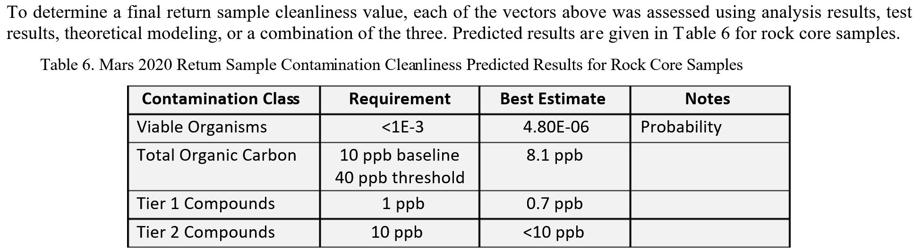
- 8.1 nanograms of organics per gram of returned rock sample.
- 0.7 nanograms per gram for each of the biosignatures they tested (e.g. DNA)
- 0.00048% chance of a single viable microbe per tube
– this means a 0.02% chance that at least one tube has a viable terrestrial microbe in it.
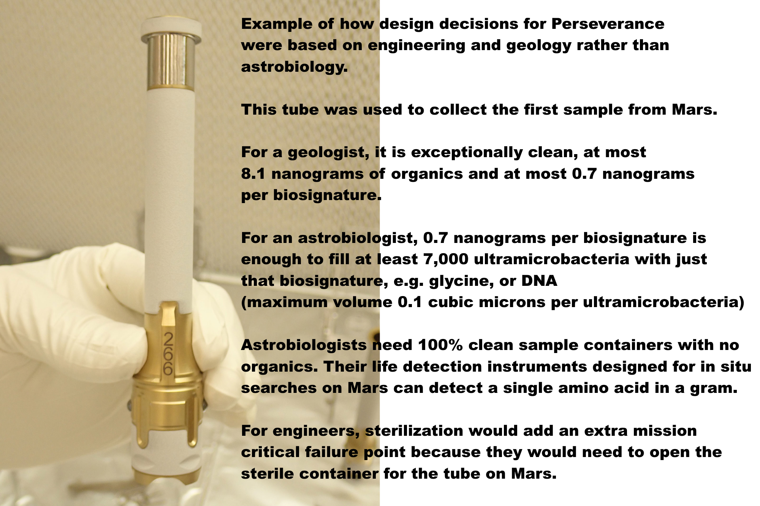
Text on image: Example of how design decisions for Perseverance were based on engineering and geology rather than astrobiology.

This tube was used to collect the first sample from Mars.

For a geologist, it is exceptionally clean, at most 8.1 nanograms of organics and at most 0.7 nanograms per biosignature.

For an astrobiologist, 0.7 nanograms per biosignature is enough to fill at least 7,000 ultramicrobacteria with just that biosignature, e.g. glycine, or DNA (maximum volume 0.1 cubic microns per ultramicrobacteria)

Astrobiologists need 100% clean sample containers with no organics. Their life detection instruments designed for in situ searches on Mrs can detect a single amino acid in a gram.

For engineers, sterilization would add an extra mission critical failure point because they would need to open the sterile container for the tube on Mars.

Sample tube photo from (NASA, n.d.pst)

This is their list of biosignatures they tested for

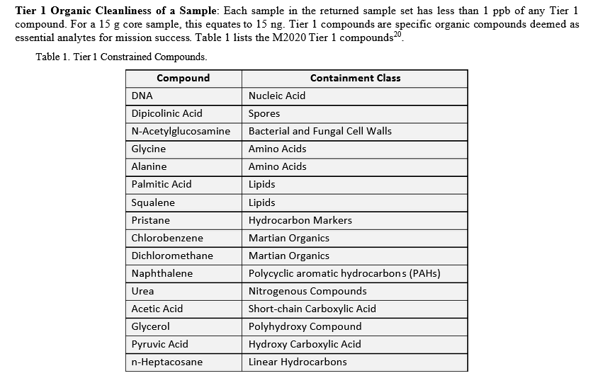

The 0.7 nanograms for Glyine or Alanine isn’t a total for all amino acids, just the total for that one. The didn’t test any other amino acids but believe they are all less than 0.7 nanograms per gram per amino acid.

For details see my preprint (Walker, 2022b) under

- Limitations on cleanliness of the Mars sample tubes - estimated 0.7 nanograms contamination per tube each for DNA, glycine, alanine, and 17 other biosignatures, 8.1 nanograms total organics, and a roughly 0.02% possibility of a viable microbe in at least one of the tubes – higher levels of sterilization needed to detect life unless Perseverance returns exceptionally well preserved life

8.1 nanograms seems a very small amount of contamination for an engineer and the team went to a lot of effort to achieve it. But an ultramicrobacteria by definition has a volume of less than 0.1 cubic microns. There are 10,000 microns in a centimeter so one gram (cubic centimeter) of water has a volume of a trillion cubic microns.

So a nanogram (billionth of a gram) of water has the same volume as 1000 cubic microns, or 10,000 to 50,000 ultramicrobacteria or ultramicrocells. This isn’t taking account of the water content which would likely multiply these figures by 3 or 4, as water content is typically 70% or more of the cell’s mass (Cooper et al, 2007).

Assuming Martian microbes have a density similar to water. the estimated level of 8.1 nanograms per tube for total organics is enough mass for 81,000 ultramicrobacteria at 0.1 cubic microns.

As for the hypothetical minimal volume RNA world nanobes, now referred to as ribocells, we can use an estimated volume of 50,000 nm³ (Board et al, 1999: 117), or 0.00005 cubic microns. Even a picogram, the mass of a cubic micron of water, is enough mass for 20,000 of those hypothetical ribocells and the 8.1 nanograms are the same mass as 162 million of those hypothetical ribocells.

They also believe they achieved a limit of 0.7 nanograms per biosignature. That is enough for 7,000 ultramicrobacteria and 14 million hypothetical minimal volume ribocells

The sample could contain thousands of ultramicrobacteria and millions of ribocells and they wouldn’t be detected as contributed unusual levels of biosignatures.

For details see my preprint (Walker, 2022b) under

- Perseverance’s estimated achieved levels of 8.1 nanograms of organic contamination per sample tube equals the amount of organics in 81,000 ultramicrobacteria, 160 million hypothetical minimal volume RNA world nanobes and between 2 trillion and 5.6 trillion terrestrial amino acids

As stated in the NASA guide Planetary protection provisions for robotic extraterrestrial missions (NASA, 2005ppp):

A "false positive" could prevent distribution of the sample from containment and could lead to unnecessary increased rigor in the requirements for all later Mars missions.

There seems a significant possibility of a false positive which could delay certifying the samples as safe for Earth, or make it necessary to sterilize all samples returned indefinitely. Indeed, it is hard to see how these samples could be certified by experts to be free of any Martian life.

Problem of microbial dark matter - we don’t have a census even of all the RNA and DNA that we sent to Mars in the Perseverance sample tubes - which likely contain many genes from species we haven’t yet sequenced
We don’t have a census of the DNA or RNA in the sample tubes. That’s impossible because of the problem of microbial dark matter. Every time we do a survey of clean rooms the isolates contain numerous RNA sequences and DNA sequences that aren’t recognized as belonging to any known microbe.
This is the problem of Microbial Dark Matter. Yes we would recognize a known sequence, we’d recognize anthrax from Mars, but of course that’s not a likely Martian organism.
If we find chroococcidiopsis on Mars we’d be able to tell if it is a known strain from Earth. But there are many strains of Chroociccidiopsis with differing capabilities. Any microbe in this species from Mars is likely to be adapted in many ways - for instance it might have developed the capability to metabolize mirror organics from meteorites and comets, and it might have developed even greater ionizing radiation resistance than Chroociccidiopsis if it has evolved separately on Mars. It likely hasn’t got to Earth in the last 20 million years to the oldest ejection ages of our martian meteorites since none of them come from likely sources for ap hotosynthetic lifeform (at 3 meters or more below the surface)
Most likely if we do find a strain of chroococcidiopsis on Mars, it hasn’t got to Earth for tens or hundreds of millions of years, indeed if it got here at all it probably got here well before the great oxygenation event half a billion years ago since Mars didn’t have much by way of lakes or seas at that time and there would be the same problem of transfer of surface layers as today.
So - unless it comes from Earth as contamination in our spacecraft, any martian choroococcidiopsis most likely has evolved for many tens or hundreds of millions of years on Mars and so is not likely to be identical to any known strain on Earth and its capabilities would be unknown.
But more than that we have the problem of microbial dark matter. Microbes that can’t be cultivated in the laboratory for various reasons.
See Most terrestrial microbes can’t be cultivated in the laboratory so it’s not possible to test for viable martian life by trying to cultivate it (above)

Many entire phylae are only known through a small rRNA fragment of their protein factory - specifically the rRNA component of the 16s ribosome subunit
Many entire phylae of microbes are only known through fragments of RNA from their ribosomes, specifically from an RNA strand in the smaller of two subunits that fit together to make their protein factory or ribosome. This is used as a marker to get an estimate of the diversity of the phyla of microbes that can’t be cultivated and most of which aren’t yet sequenced.
This shows how the large and small subunits fit together.
The RNA strands are shown in red.
The small unit is called the 16 S subunit in the papers.
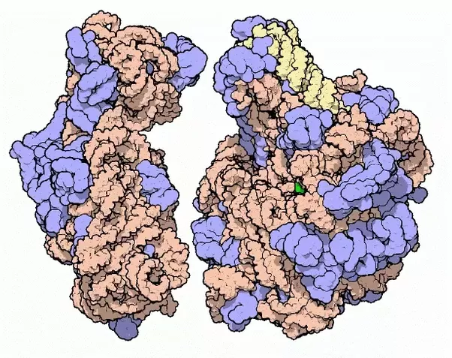
You can see animations of them spinning here PDB101: Learn: Videos: Ribosomal Subunits
Here is a particular view on it which shows the hole that the mRNA enters through as it is translated into proteins.
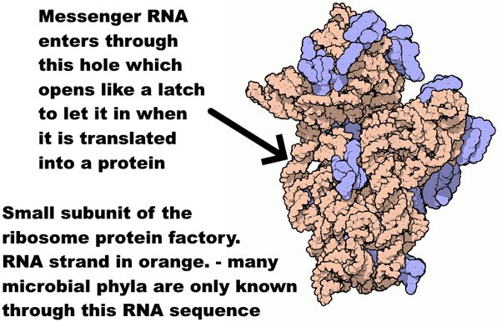
Messenger RNA enters through this hole which opens like a latch to let it in when it is translated into a protein.
Small subunit of the ribosome protein factory.
.RNA strand in orange. - many microbial phyla are only known through this RNA sequence
Graphics and details (Goodsell, 2000)
As of 2016 there were at least 89 phyla of bacteria and 20 of archaea that are recognized only by RNA databases of the small ribosome subunit, though the true count of phylae for the bacteria could be far higher with estimates of up to 1,500 bacteria phylae (Solden et al, 2015).
Now that we have single cell genomics there are partial and sometimes complete gene sequences for many of the phyla but these represent only a small fraction of the total species in each phyla. We know very little about them and they may use novel metabolic pathways that we haven’t yet studied.
This part of the ribosome is very stable
This remains the situation as of 2022. Most of the microbial biomass hasn’t yet been cutulrured and the genetic sequences can’t be used to characterize them (Hoarfrost et al, 2022).
The majority of microbial genomes have yet to be cultured, and most proteins identified in microbial genomes or environmental sequences cannot be functionally annotated. As a result, current computational approaches to describe microbial systems rely on incomplete reference databases that cannot adequately capture the functional diversity of the microbial tree of life, limiting our ability to model high-level features of biological sequences.

The Perseverance clean room had many uncultivable species, 36 out of the 41 species identified by their 16s ribosome subunits were found in only one location - and 4 had ribosomes that didn’t closely resemble any previously known ribosome
In a 2021 study of clean room samples from the clean room used to assemble Perseverance, , 16 genera could be cultivated and 51 genera could not be cultivated as identified by this ribosome subunit.
They found 49 identified species using 16S mRNA sequencing.
Of those there were 4 novel species that had less than 98.7% similarity to any previously sequenced 16S RNA ribosome subunit.
36 of the species were unique, found in only one of their samples (Hendrickson et al., 2021).
QUOTE The 130 NSA isolates were represented by 16 bacterial genera, ofwhich 97% were identified as spore-formers via Sanger sequencing. … The 16S rRNA gene-targeted amplicon sequencing detected 51 additional genera not found in the NSA [ASA standard spore assay] method.
Sanger sequencing of the full-length 16S rRNA gene on the NSAisolates from the 98 samples resulted in 130 isolates, be-longing to 16 genera and 49 species
When analysed spatially, 36 of the 49 identified species were not ubiquitous and isolated only once in a given SAF location
… four isolates representing potentially novel species as they had ≤ 98.7% sequences similarity to the 16S rRNA sequence of any validly described species

If this level of diversity can be generalized to the tubes, each sample tube could contain unique 16s subunits not found in any of the other sample tubes and out of 38 sample tubes three or four of them may contain subunits that don’t closely resemble any ribosomes so far known on earth, although originating from earth
This doesn’t mean that these were the only novel species, just the ones they found in that particular survey. Also it doesn’t mean they sequenced them either. All they have is the sequence of the 16S RNA ribosome subunit (Hendrickson et al., 2021).
So we can be pretty certain that the sample tubes have DNA or RNA from microbes that can’t be cultivated and they may very well have 16S ribosome subunits that don’t closely resemble any ribosomes previously sequenced.
Also the sterilization wasn’t sufficient to rule out viable microbes. The requirement was a 0.1% chance of a viable microbe per tube. They believe they achieved a 0.00048% chance of a viable microbe per tube. This would make the chance that at least one tube contains a viable terrestrial microbe around 0.02% which would mean that if just one tube yields a viable microbe, it won’t be possible to conclude that it is Martian without further analysis. 0.02% corresponds to 3.09 sigma which would not be enough to prove life from Mars for a discovery of such importance.

This leads to motivation to modify the mission to return additional samples in 100% sterile containers of much greater interest to astrobiology

If there is extant life on Mars, is there a chance we can detect it using this sample return mission, perhaps modified in some way? One major improvement would be to return an additional sample in a 100% sterile container so that it is not confused by the permitted organics in the Perseverance sample tubes.

The current paper suggests we may spot life in Martian dust. Martian propagules adapted to the Martian conditions could be up to half a millimeter in diameter carried through the process of saltation - repeated bounces across the Martian sand-dunes similarly to motion of dust in desert sand dunes on Earth.

See the section of my preprint (Walker, 2022b):
- Native Martian propagules of up to half a millimeter in diameter (including spore aggregates and hyphal fragments) could travel long distances with repeated bounces (saltation) - if they can withstand the impacts of the bounces

Martian propagules may have evolved coatings of hard chitin-like substances or agglutinated particles of the iron oxide dust, to protect from UV and collisions with the Martian surface during saltation. Chitin is a hard substance common in fungi and in the fungal component of lichens, and also in insect exoskeletons and jaws.

See the section of my preprint (Walker, 2022b):

- Martian life could also use iron oxides from the dust for protection from the impact stresses of the saltation bounces - or it might use chitin - a biomaterial which is extremely hard and also elastic and is found in terrestrial fungi and lichens

The current paper finds that if there are small regions within reach of the dust storms as productive of spores as the coldest driest terrestrial deserts, small samples from the Martian dust could potentially contain detectable amounts of viable spores. Since the dust storms are sometimes global, it’s possible a dust sample could collect propagules that originated almost anywhere on Mars. On Earth, spores and fungal hyphal fragments from distant deserts can be detected thousands of miles away, for instance spores and propagules from the Gobi desert are detected in Japan.

Spores could be carried for similar long distances on Mars. It’s also possible that spores adapted to Mars could remain viable after transport for long distances in the dust storms, which block out most of the UV from the sun.

See the section of my preprint (Walker, 2022b):

- Potential for spores and other propagules from nearby or distant regions of Mars similarly to transfer of spores from the Gobi desert to Japan

This is why unsterilized alternative to “no action” would add the capability to return samples of great astrobiological interest in 100% sterile containers

See sections above:
- NASA’s proposal can be greatly enhanced in astrobiological value by adding simple capabilities to the ESA fetch rover or Mars ascent vehicle to use 100% sterile containers to return a sample of dirt, a highly compressed sample of gas from the atmosphere to detect minute traces of biologically relevant gases and a large returned sample of dust from the dust storms which can be trapped in the filters for the air compressor
- Proposal to add an atmospheric compressor / dust collector to the ESA fetch rover based on the moxie design to return up to two grams of compressed martian atmosphere and a few grams of martian dust in sterile containers
- Modification to ESA fetch rover sample retrieval arm to dig an extra sample of dirt like the Viking scoop and add it to a smaller 100% sterile container within the Orbital Sample Container
- Proposal to use the Marscopters to search for young undegraded craters that could have exposed rocks from 2 meters or more below the surface in the last few tens of thousands of years – this greatly increases the chance of a sample of past life of enough interest to be of astrobiological value

These recommendations are all in the spirit of the mission as extra sample returns and are different from the “mission creep” of adding new instruments for other purposes.

Potential third 100% safe alternative? a sketch for a biosafe laboratory on Earth designed for 100% containment of even nanoscale mirror life using telerobotics, a sump heated to 300°C with heat and vacuum stable light oil, and built in heat sterilization at end of life of the facility - could this be a safe way to open “Pandora’s box”?
With studies of xenobiology in the labs they do hope to achieve high levels of containment well beyond a BSL-4 to make sure that mirror life can’t survive outside the laboratory if they do succeed in “flipping” it – or for any other XNA (new type of life not based on DNA) (Schmidt, 2010)

The ultimate goal would be a safety device with a probability to fail below 10⁻⁴⁰, which equals approximately the number of cells that ever lived on earth (and never produced a non-DNA non-RNA life form). Of course, 10⁻⁴⁰ sounds utterly dystopic (and we could never test it in a life time), maybe 10⁻²⁰ is more than enough. The probability also needs to reflect the potential impact, in our case the establishment of an XNA ecosystem in the environment, and how threatening we believe this is.

The most important aspect, however, is that the new safety mechanism should be several orders of magnitude safer than any contemporary biosafety mechanism.

With a Mars sample return we can’t use the same methods xenobiologists plan to use, to design the life itself so it can’t survive outside the laboratory.

But perhaps we need to look at this more closely. Could there be a way that we might be able to achieve 100% containment on Earth to the same degree of safety as an orbital facility above GEO?

We could do the re-entry. Spherical fuel tanks from rockets typically survive re-entry into our atmosphere undamaged. This is because of the high area to mass ratio, the high melting point of titanium of 1,668 °C, and the resistance to ablation of a spherical structure.

Figure 67, A sample return in a titanium sphere would be totally safe, but how then do we open the sphere? Top right image shows a titanium sphere that survived re-entry. Top left image shows Pandora trying to close the box that she opened in the Greek legend.

Main image - Genesis return capsule on the ground after it crashed (NASA, 2008grcg).
Top left, Opening Pandora’s box (Church, n.d.)
Top right - space ball after re-entry - probably from the equipment module of Gemini 3, 4 or 5. (Daderot, 2017)

We can do the same today. Enclose the samples in a sealed titanium sphere, and it can then be delivered safely to the Earth’s surface, so long as the outer surface is sterilized, or had no chain of contact with the Martian surface. However, if we wish to open the sample, and study it within our own biosphere, containment is far harder.

How do we open the sphere to study its contents? Previous studies have said that there doesn’t seem to be any way to do this that guarantees this same high level of certainty that we can protect the biosphere of Earth (Ammann et al, 2012:25).

The ESF study (Ammann et al, 2012:25) said it’s impossible to demonstrate that a Mars sample return presents no appreciable risk of harm.

It is not possible to demonstrate that the return of a Mars sample presents no appreciable risk of harm. Therefore, if applied, the Prohibitory Precautionary Principle approach would simply lead to the cancellation of the MSR mission.

But – that was with conventional designs with normal air filters. Perhaps we can after all with some “out of the box” thinking?

This is my proposal for a way to do this, which also uses present day technology, so that the facility build can start right away. This is not yet peer reviewed. But perhaps NASA might be intrigued and look into it? It could be used for a comparison study to get an idea of how much it would cost to return a sample to Earth that’s 100% safe.

It would cost a fair bit more than their current plans. However a plus side is that it is mostly a one off cost. The facility could then be used for all future sample returns from around the solar system – that is if it can indeed be done in a way that is truly 100% safe.

The aim would be to make a design that can be approved in advance by all interested agencies and international organizations. This could be a sufficient guarantee to start on the build even before the legal process is underway.

Then the sample can be returned in the early 2030s as NASA could start the legal process with a high level of confidence that their design can withstand all legal challenges.

My aim here is to show that such a design may be feasible, but not to try to minimize costs. So this design will be over engineered and can surely be done with less cost once it is looked at closely. The aim here is just to show it seems to be possible within the limits of not just physics but current engineering capabilities.

The first step is to return the samples to a safe orbit in the Laplace plane above GEO as in the section:

- Recommendation to return a sample for teleoperated ‘in situ’ study to above Geosynchronous Equatorial Orbit (GEO) in the Laplace plane, where particles in a ring system would orbit

This ensures that no contamination can get from the receiving satellite to Earth. So we don’t need to be concerned about life that gets to the outside of the re-entry capsule.

Then the unsterilized sample that we wish to return to Earth is enclosed in a presterilized titanium sphere that can be inspected from the outside, as described in A simple titanium sphere could contain an unsterilized sample for safe return to Earth’s surface even with the technology of 1969 - but how do you open this “Pandora's box”?

We could find ways to get the samples into the sphere in the vacuum of space with no way for any materials from inside the samples to contact the exterior of the sphere.

For extra precautions the titanium sphere is covered in a multi-layer Whipple shield to protect from space debris and micrometeorite impacts, or an aluminium honeycomb shield or foam shield.

This is the basic idea of the Whipple shield:

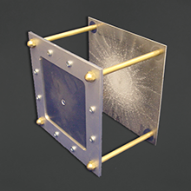

NASA describes the Whipple shield like this (NASA, n.d.sd)

“The Whipple bumper shocks the projectile and creates a debris cloud containing smaller, less lethal, bumper and projectile fragments. The full force of the debris cloud is diluted over a larger area on the spacecraft rearwall”

More advanced designs have replaced the Whipple shield in many modern spacecraft. These other possibilities they mention include a honeycomb sandwich, metallic foam panel and a compressible foam used for the proposed Mars Module shield for future Mars missions.

For the Mars sample return, a honeycomb sandwich or metallic foam might be easier to use, as it would give a simple way to enclose a spherical container.

Only a large meteoroid could penetrate it, larger than any meteoroid that has ever impacted on the ISS in its lifetime. For additional assurance, acoustic sensors could be used to detect impacts, and the sample returned on an orbit that is biased away from Earth’s atmosphere and then a thruster used to bias it to the impact trajectory if there are no detected impacts in the few hours of the return journey from GEO to Earth’s atmosphere.

A large sphere will quickly slow down during re-entry and never reach temperatures that could melt titanium. For additional protection, it could be protected with a spherical ballute, as suggested for crew emergency re-entry vehicles.

This is not needed to protect Earth’s biosphere, but will help to prevent heating of the sample, to reduce any chance of alteration, e.g. driving off volatiles, also will reduce the terminal velocity as it falls through the atmosphere, and the shock of impact as it hits the ground, and can help keep the interior at the cold temperatures of the Martian surface. This is a design that was engineered to allow a human being to return safely from space without a parachute so should enable a reasonably soft landing for the sample (Jones et al. 2004).

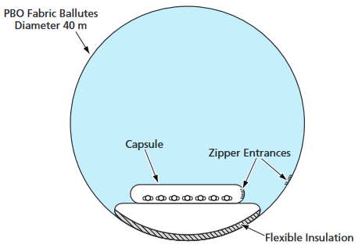
Figure ??: Design for an inflatable spherical ballute for an emergency crewed atmospheric-entry vehicle.

ESA demonstrated an inflatable ballute for re-entry in 2000 (Marraffa et al, 200). This was a partial success, because of impact with the ballute by one of the components that didn’t separate cleanly, there was some localized heating to 200 ° C but the ballute remained inflated, and the interior temperature wasn’t changed (Marraffa et al, 200).

For the next stage, to transfer the sample from the landing site to the research laboratory, we use the mature technology for black box flight recorders. These use insulating materials to make sure that they can survive an aircraft crash.

These can withstand (ATSB, n.d.):

  - an impact producing a 3,400-g deceleration for 6.5 milliseconds (equivalent to an impact velocity of 270 knots and a deceleration or crushing distance of 45 cm)
  - a penetration force produced by a 227 kilograms (500 pounds) weight which is dropped from a height of 3 metres (10 feet)
  - a static crush force of 22.25 kN (5,000 pounds) applied continuously for five minutes
  - a fire of 1,100 degrees Celsius for 60 minutes.

So, before transport the returned capsule is enclosed in insulating materials and a final outer shell similarly to a black box. It’s possible that the Whipple shield could be designed to double as heat insulation for this stage.

So now we need a receiving facility to study the samples.

In this proposal, the facility itself is built inside a decommissioned nuclear bunker so that there is no possibility of harm even by a direct hit by a plane or explosives, nuclear weapons or a meteorite impact up to 10s of meters in diameter.

We need to design in end of lifetime total sterilization of the facility.

This is because the facility has to be safe even for hazards like mirror life which can never be released during our lifetime or even during the lifetimes of any future generations on Earth. So, there needs to be a way to sterilize the sample and the entire facility when the facility is decommissioned.

To make sure this is possible, the facility is built inside an oven capable of dry heat to 300°C. This oven is designed so that it can be maintained externally, with the lab inside the oven. This means that the oven can be turned on at any time if there is some breach of containment that can’t be resolved in any other way.

300°C is enough to destroy most of the nucleobases and amino acids in minutes. For details see section of my preprint (Walker, 2022b) :

- Design specifications for 100% sterile rovers for fast safe astrobiological surveys throughout the solar system
So, when the facility is decommissioned, after all the science is done, the entire facility is heated to 300°C for as long as needed - it could be heat sterilized for six months if that was thought necessary.

Now we need to get the titanium sphere with the unsterilized sample into the facility. T
he only concern at this stage is terrestrial contamination. There should be no terrestrial contamination inside the titanium sphere, and it would be possible to unpack everything down to the titanium sphere outside the facility.

The outside of the titanium sphere would be cleaned first with ethanol, then placed inside the facility, perhaps in an airlock first. Once in the airlock, the outside of it can be treated with carbon dioxide snow (which is ideal for cleaning flat surface, removing all organics), and hydrogen peroxide or in whatever way is thought necessary to remove any traces of contamination with Earth life.

It would then be opened inside the facility using telerobotically controlled equipment to cut it open.

The simplest way to design the facility is as a hermetically sealed facility which doesn’t need any airlocks. Or perhaps it has a single use airlock just for getting the sample into it originally.

Instead it is built with everything that will ever be needed to study the sample inside the facility, including everything that will ever be needed to repair the equipment, similarly to the design of a space mission to another planet.

Once the sample is placed inside the facility, it is hermetically sealed from the outside. All the work after that is done telerobotically, and nothing leaves the facility until the end of life when the entire facility is sterilized.

The advantage of building even a hermetically sealed facility on Earth rather than placing it in orbit or sending it to Mars would be to include heavy equipment such as particle accelerators.

So that’s the simplest design of all, with not much to go wrong with it.

However – one of the main reasons to bring samples back to Earth is to distribute the samples to multiple laboratories for independent research. It’s also important to have the capability to bring new equipment into the facility, either new technology, or equipment designed specifically to follow up observations made by earlier experiments on the samples.

In the forwards direction, we need to be able to bring in new equipment, replacement parts, reagents, growth media etc. In this direction, the aim is to make sure they are free of any terrestrial life.

In the backwards direction we need to be able to remove fragments of the original samples, and perhaps other materials e.g. growth media with mirror life in it. This time the aim is to make sure that it is sterile of any life that could harm Earth’s biosphere.

We also need to remove any equipment that is no longer functional, packaging and so on.

To move materials in and out with no risk of release to Earth’s biosphere, the design uses two airlocks kept at positive pressure and a sump.

Mercury boils at 356.7°C. Big equipment could be pushed through a mercury sump and out of the building. However the density of mercury would make it hard to push objects through it and the vapors are toxic.

So, instead, this proposed design uses a vacuum stable high temperature oil such as Pentane X2000 which is used in space applications.

Pentane X2000 has a fire point of 335 C and flash point of 315 C (flash point is when the vapour from the oil has a risk of igniting). Density 0.85, vapor pressure 10-12 torr (13- 16 millibars) so it can be used in vacuum conditions with almost no loss of oil through evaporation (Venier et al., 2003)

Figure ??: the LAS fully robotic floor plan for a Mars sample receiving facility placed inside an oven for end of laboratory lifetime sterilization of the facility and accessed via two airlocks and a sump for 100% containment of even mirror life nanobes.
Sketch of telerobitic facility Credit NASA / LAS (Hsu, 2009)
Photo of Cultybraggan nuclear bunker (Clark, 2009)

The oil sump is kept at a constant 300°C – this ensures that no viable spores can survive in it. It’s also irradiated constantly with ionizing radiation from cobalt gamma ray emitters placed in the oil, or X-rays or both.

The airlocks are also irradiated constantly with ionizing radiation or X-rays or both, and cycled with carbon dioxide snow to make sure that no biofilms can form in them. The oil in the sump is replenished from outside while keeping it at 300°C throughout.

Any materials to be removed are placed into the inner airlock. This is then pressurized to a positive pressure to keep out any mirror life and the pump’s outlet into the airlock is then sealed – the pump doesn’t operate beyond that point. The pump for pressurizing the inner airlock is operated from inside the facility, with no air connection with the outside.

Similarly the outer airlock is pressurized to a positive pressure and sealed with no air connection from the outer airlock to the inside.

In this way there is no way for air to pass between the inside and the outside of the facility.

For large objects that aren’t heat sensitive, the object is placed in one airlock and the airlocks are heated to 300°C to sterilize both the airlocks and the object of any amino acids or sensitive organic.

The object is then moved through the oil sump to the outer airlock and then both airlocks allowed to cool down – but the oil sump is kept at 300°C to remain as an impenetrable barrier to mirror life and covered with an insulating cover between uses.

The same method is used in the opposite direction to bring any objects into the facility that aren’t heat sensitive.

For heat sensitive objects, first they need a heat insulating container which is sterilized at 300°C along with the airlocks – and then everything is allowed to cool down.

The heat sensitive object is then placed into one of the airlocks, which is then pressurized above atmospheric pressure, and sterilized with ionizing radiation, X-rays, and carbon dioxide snow (for flat surfaces / optical components) as appropriate.

For the carbon dioxide snow see section of my preprint (Walker, 2022b) :
- Carbon dioxide snow sterilization – final 100% sterilization stage for pre-cleaned components that doesn’t need high temperatures but can remove even trace amounts of organics from surfaces – especially useful for microsats and microrovers / gliders

The object is then placed in the heat insulating container, all this done telerobotically. The container is then moved through the oil sump which remains at 300°C to the other airlock and then removed.

As before, this works in the same way in both directions.

The whole process would be automated with security fail safes so that no human being can override the process.

If there needs to be a way to override this lockout, perhaps for maintenance, this could be done using security keys that are not made available to the technicians who operate the facility normally so that there is no possibility of anyone trying to take shortcuts.

Instead, staff would need to call in an independent technician who has no involvement in the experiment, who has no motive to rush proceedings. They would then override the airlock opening mechanism, for instance if it gets stuck and can't be opened normally.

In the worst case, if an issue arises in the mechanisms that can’t be fixed in a way that preserves biological containment, experiments continue but nothing can be moved in or out any more and in worst case, if necessary the facility is decommissioned and heat sterilized.

If it becomes clear early on that the design is acceptable to everyone, it might be possible for NASA to start the build on a facility like this well before the end of the legal process, perhaps as early as 2024.

That would leave perhaps the same 9 years estimate for the build and the sample could be returned by 2033. However this assumes everything goes smoothly without any delays.

It would be important to communicate to the public clearly from the start of the legal process, to explain why the plans eliminate any appreciable risk of harm. To do this, it’s important to have the plans independently scrutinized by multiple experts in all the relevant agencies - the CDC, WHO, FAO, etc at an early stage, ideally before starting the legal process.

Pre-vetting like this by multiple experts would help make it clear in communications with the public that it is not just NASA's plan but is a coordinated plan of world experts in all relevant agencies that they all agree it would work. They would all need to agree that this means that there is no appreciable risk of harm to the Earth’s biosphere.

Even in this case 2033 seems to be optimistic, as there would be likely to be delays with such a complex new facility never built before. However, it seems an idea that deserves consideration that could perhaps be completed by the 2030s, would lead to a much simpler accelerated legal process.

It would be understandable if such an elaborate facility is not suitable for Perseverance's samples. However, it could be used later on for other samples from Mars or Europa and other locations.

Perhaps some day we find confirmed exotic life such as mirror life in our solar system. If so, at some point we will surely need a facility like this on Earth to study it, unless by then we have such advanced facilities in space that we never need to return the samples to Earth.

Call for action to NASA to cancel this draft EIS, to review the ESF size limit, to put in place independent reviewers for the next EIS, to ensure international public understanding and support before resubmitting and to design the EIS to permit consideration of actions that keep Earth 100% safe such as sterilizing all the samples or returning unsterilized samples to a safe orbit while retaining as much science return as possible
This is a proposed statement for signature by astrobiologists and other concerned experts if NASA continue to go ahead with this proposal. Do contact me if you are interested in signing it or if you think it should be modified. Bear in mind that it is in draft form and isn’t yet open for signature.

We, the undersigned, call on NASA to cancel this draft EIS in order to:

- Fix the inaccurate cites to bring the draft EIS (or any future EIS) up to the standard of a peer reviewed paper in Nature or Astrobiology.
- The revisions also need to add the missing cites (Ammann et al, 2012) and (Board, 2015) and take into account their corrections of the earlier cites.

- The revised EIS must pass peer review by astrobiologists of high standing not directly involved in planning this mission, former planetary protection officers, and members of the boards that carried out the ESF and NRC sample return studies.

- The Environmental Impact Statement “Needs and Purpose” must permit alternatives to “no action” that keep Earth 100% safe while preserving as much as possible of the science return.

We also warn NASA that

- quarantine of humans in a space station or laboratory can’t protect Earth, for instance from a disease of crops or mirror life, or a symptomless spreader of an opportunistic pathogen of humans.

.

- the permitted levels of terrestrial contamination in the sample tubes, enough for thousands of ultramicrobacteria per tube, make it exceedingly unlikely astrobiologists can use them to make progress with central questions in their field.
- the permitted levels of biosignatures per tube also make a false positive life detection from Mars a certainty, and make it unlikely that astrobiologists will be able to certify the sample tubes as free from Martian life
- since unsterilized samples with this level of forward contamination by terrestrial lfe can’t be certified free of Martian life they can’t be certified safe for Earth until we know much more about Mars and the capabilities of any life there might be there.

This also means Perseverance’s geological samples need to be sterilized through to the indefinite future, or until later missions give us a better understanding of the planet.

As a first step to addressing astrobiological priorities:

- we call on NASA and ESA to add capabilities to add samples of dust, atmosphere and dirt to the Orbital capsule
- – we also request that these samples are collected in 100% sterile containers with no traces of terrestrial biosignatures (this is technologically feasible if the containers are opened only on Mars)

These would only detect life on Mars with high estimates of abundance of extant life. But they can give a first limit and also lead to better understanding of potential for life to be transferred in dust storms and give better understanding of the potential for microhabitats on Mars.

Before the next draft EIS is submitted,
- We call on NASA to investigate the method of sterilization needed for a potentially more radioresistant microbe than radiodurans while optimizing science return

Unless the decision is made to keep Earth 100% safe e.g. through sterilization

- We call on NASA to commission a review of the ESF size limit of 0.05 microns as the report itself says is needed commission a review

- Based on the new size limit, we call on NASA to investigate the feasibility of the technology, timescale and cost before resubmitting the EIS.

- We call on NASA to take account of the new research since 2009 on the potential for liquid water on Mars including the brines found by Curiosity in Gale crater, and the methane emissions and consequence for potential martian life which may have capabilities terrestrial life doesn’t have, such as able to inhabit colder brines

We ask for the alternative actions considered in the EIS to keep Earth 100% safe to include at least the following 3 options:
- Sterilize all samples
- Add bonus samples of interest to astrobiology such as dirt, atmosphere and dust collected in sterile containers and sterilize these too.
- Return the bonus samples unsterilized to a safe orbit such as above GEO to study remotely from Earth much as scientists study samples on Mars remotely – while the geological samples can be sterilized and returned immediately

These options don’t require safety testing as the sterilization keeps Earth safe.

NASA can add other options to consider that keep Earth 100% safe such as to investigate whether it is possible to achieve 100% safe return of unsterilized material to a laboratory on Earth

Whatever decision is made about sterilization we call on NASA to:
- set up the recommended planning and oversight agency with the participation of ethicists, lawyers and social scientists and open to representatives from all countries, as recommended by Rummel et al, the ESF and others
This is necessary even if the decision is made to keep Earth 100% safe through sterilization of all samples returned to Earth
As Rummel at al wrote (Rummel et al, 2002:96).,
“Broad acceptance at both lay public and scientific levels is essential to the overall success of this research effort.”
- We ask NASA to only resubmit the new EIS after NASA’s actions are well understood and accepted internationally

We don’t think it is acceptable to continue with this EIS until NASA’s actions are more widely accepted

Looking to the future, we ask NASA to plan for in situ life detection since most organics will not have present day life associated with it, and most past life is likely to be degraded beyond recognition by ionizing radiation, so it’s essential to be able to detect life in situ.

Astrobiologists see Perseverance’s geological samples as a technology demo for a future sample return of more interest to astrobiology. There is currently no reason to expect them to have recognizable evidence of past or present day life. The bonus samples would only detect life if it is towards the high range of estimates of how much present day life there may be on Mars or with a measure of luck. However if they don’t ‘contain life they will still be of great interest for preliminary astrobiological study for complex chemistry, to simulate surface conditions and as a first datapoint towards refining future searches.

This is a draft statement, and is not yet open for signature - please contact me if you are interested to sign it when ready or have suggestions, comments, questions or see anything to fix however small, Thanks!

References
7th Circuit, 1997, Simmons v. U.S. Army Corps of Engineers, 120 F.3d 664
Abdo, J.M., Sopko, N.A. and Milner, S.M., 2020. The applied anatomy of human skin: a model for regeneration. Wound Medicine, 28, p.100179.
Approximately every 28 days, fully differentiated cuboidal basal keratinocytes with large nuclei, abundant organelles, and a phospholipid membrane migrate apically from the basal layer through the spinous and granular layers [4]. During this turnover process, an accumulation of keratin and lipids ensues which then undergoes terminal differentiation to form the stratum corneum
…
Skin is an active immunological organ, and dysfunctional innate defenses have serious clinical implications. Products of the stratum corneum, including free fatty acids, polar lipids, and glycosphingolipids accumulate in the intercellular spaces and horny layer, exhibiting antimicrobial properties, and functioning as a first line of defense. Antimicrobial peptides (AMPs) exhibit potent and targeted resistance against a wide spectrum of common pathogens. When this barrier is breached, second lines of protection are provided by inflammatory cascades in the subepithelial tissue. Approximately sixteen AMPs have been shown to be expressed in the skin (Table 1)

Afzal, I., Shinwari, Z.K., Sikandar, S. and Shahzad, S., 2019. Plant beneficial endophytic bacteria: Mechanisms, diversity, host range and genetic determinants. Microbiological research, 221, pp.36-49

Ammann, W., Barros, J., Bennett, A., Bridges, J., Fragola, J., Kerrest, A., Marshall-Bowman, K., Raoul, H., Rettberg, P., Rummel, J. and Salminen, M., 2012. Mars Sample Return backward contamination–Strategic advice and requirements - Report from the ESF-ESSC Study Group on MSR Planetary Protection Requirements.

ATSB (Australian Transport Safety Beaureau), n.d., Black box flight recorders fact sheet

Avila-Herrera, A., Thissen, J., Urbaniak, C., Be, N.A., Smith, D.J., Karouia, F., Mehta, S., Venkateswaran, K. and Jaing, C., 2020. Crewmember microbiome may influence microbial composition of ISS habitable surfaces. PloS one, 15(4), p.e0231838.
.

Bahl, J., Lau, M.C., Smith, G.J., Vijaykrishna, D., Cary, S.C., Lacap, D.C., Lee, C.K., Papke, R.T., Warren-Rhodes, K.A., Wong, F.K. and McKay, C.P., 2011. Ancient origins determine global biogeography of hot and cold desert cyanobacteria. Nature communications, 2(1), pp.1-6.
Batbander, K., 2020, A Barn Swallow in Flight, Wikimedia Commons

Benison, K.C. and Karmanocky III, F.J., 2014. Could microorganisms be preserved in Mars gypsum? Insights from terrestrial examples. Geology, 42(7), pp.615-618.

Some clusters of dozens of diatoms appear pristine, suggesting that they had been living in the salar pool immediately before being trapped as the gypsum crystal grew.

Could microfossils and/or viable microorganisms be trapped in gypsum on Mars as they are in gypsum on Earth? It is likely that abundant sulfate sand grains on Mars contain fluid inclusions similar to those in the acid-precipitated bottom-growth and reworked gypsum we discuss here.

We suggest that gypsum on Mars would have entrapped, as solid inclusions and within fluid inclusions, any microorganisms and/or organic compounds that were present in its parent waters. Therefore, fluid inclusions and solid inclusions hosted by salt minerals may be the best place to continue the search for life on Mars.

Some of these entrapped microorganisms remain viable for at least tens of thousands of years ... and possibly for hundreds of millions of years

Benner, S. and Davies, P. , 2010, ‘Towards a Theory of Life’, in Impey, C., Lunine, J. and Funes, J. eds., Frontiers of astrobiology. Cambridge University Press.

Bilen, M., Dufour, J.C., Lagier, J.C., Cadoret, F., Daoud, Z., Dubourg, G. and Raoult, D., 2018. The contribution of culturomics to the repertoire of isolated human bacterial and archaeal species. Microbiome, 6(1), pp.1-11.

Blackmond, D.G., 2019. The origin of biological homochirality. Cold Spring Harbor perspectives in biology, 11(3), p.a032540.

Bianciardi, G., Miller, J.D., Straat, P.A. and Levin, G.V., 2012. Complexity analysis of the Viking labelled release experiments. International Journal of Aeronautical and Space Sciences, 13(1), pp.14-26.

Board, S.S. and National Research Council, 1999. Size limits of very small microorganisms: proceedings of a workshop. National Academies Press.
Board, S.S. and National Research Council, 2009. Assessment of planetary protection requirements for Mars sample return missions. National Academies Press. page 48

5, Potential for Large Scale Effects

"Despite suggestions to the contrary, it is simply not possible, on the basis of current knowledge, to determine whether viable Martian life forms have already been delivered to Earth. Certainly in the modern era, there is no evidence for large-scale or other negative effects that are attributable to the frequent deliveries to Earth of essentially unaltered Martian rocks. However the possibility that such effects occurred in the distant past cannot be discounted.”

Board, S.S., European Space Sciences Committee and National Academies of Sciences, Engineering, and Medicine, 2015. Review of the MEPAG report on Mars special regions. National Academies Press. 10: “SR-SAG2 Finding 3-1: Cell division by Earth microbes has not been reported below –18°C (255K).
“Revised Finding 3-1: Cell division by Earth microbes has not been reported below –18°C (255K). The very low rate of metabolic reactions at low temperature result in doubling times ranging from several months to year(s). Current experiments have not been conducted on sufficiently long timescales to study extremely slow-growing microorganisms.”
Board, S.S., 2019. Planetary protection classification of sample return missions from the Martian moons, European Space Sciences Committee and National Academies of Sciences, Engineering, and Medicine

Boeder, P.A. and Soares, C.E., 2020, August. Mars 2020: mission, science objectives and build. In Systems Contamination: Prediction, Control, and Performance 2020 (Vol. 11489, p. 1148903). International Society for Optics and Photonics

Bohannon, J., 2010. Mirror-image cells could transform science-or kill us all. Wired, Accessed at: https://www.wired.com/2010/11/ff_mirrorlife/
Kasting: “After doing some rough calculations on the effects of a mirror cyanobacteria invasion, Jim Kasting isn’t sure which would kill us first—the global famine or the ice age. “It would quickly consume all the available nutrients,” he says. “This would leave fewer or perhaps no nutrients for normal organisms.” That would wipe out the global ocean ecology and starve a significant portion of the human population. As the CO₂ in the ocean was incorporated into inedible mirror cells, they would “draw down” CO₂ from the atmosphere, Kasting says. For a decade or two, you would have a cure for global warming. But Kasting predicts that in about 300 years the bugs would suck down half of Earth’s atmospheric CO₂. Photosynthesis of most land plants would fail. “All agricultural crops other than corn and sugar cane would die,” he says. (They do photosynthesis a little differently.) “People might be able to subsist for a few hundred years, but things would be getting pretty grim much more quickly than that.” After 600 years, we’d be in the midst of a global ice age. It would be a total evolutionary reboot—both Kasting and Church think mirror predators would evolve, but whatever life existed on Earth by that point wouldn’t include us..

Borges, W.D.S., Borges, K.B., Bonato, P.S., Said, S. and Pupo, M.T., 2009. Endophytic fungi: natural products, enzymes and biotransformation reactions. Current Organic Chemistry, 13(12), pp.1137-1163.

Borojeni, I.A., Gajewski, G. and Riahi, R.A., 2022. Application of Electrospun Nonwoven Fibers in Air Filters. Fibers, 10(2), p.15.

Boshuizen, H.C., Neppelenbroek, S.E., van Vliet, H., Schellekens, J.F., Boer, J.W.D., Peeters, M.F. and Conyn-van Spaendonck, M.A., 2001. Subclinical Legionella infection in workers near the source of a large outbreak of Legionnaires disease. The Journal of infectious diseases, 184(4), pp.515-518.

Brazil, R., 2015, The origin of homochirality, Chemistry World.

Bristow, L.A., Mohr, W., Ahmerkamp, S. and Kuypers, M.M., 2017. Nutrients that limit growth in the ocean. Current Biology, 27(11), pp.R474-R478.

BS, 2009, BS EN 1822-1:2009 High efficiency air filters (EPA, HEPA and ULPA), Part 1: Classification, performance testing, marking

Byrd, A.L., Belkaid, Y. and Segre, J.A., 2018. The human skin microbiome. Nature Reviews Microbiology, 16(3), p.143.
5).

Cabrol, N.A., McKay, C.P., Grin, E.A., Kiss, K.T., Ács, É., Tóth, B., Grigorszky, I., Szabó-Taylor, K., Fike, D.A., Hock, A.N. and Demergasso, C., 2009. Signatures of habitats and life in Earth’s high-altitude lakes: clues to Noachian aqueous environments on Mars.
Diatoms-like organisms are unlikely to have ever evolved on Mars as they appeared late in Earth’s biological history. However, by their rate of mutation, adaptation, and or extinction, they, and other microorganisms, can provide important clues for the search for life on Mars. Both habitat and life are can leave characteristic geo- and biosignatures that we might learn to recognize on distant Martian shores

Cabrol, N.A., 2021. Tracing a modern biosphere on Mars. Nature Astronomy, 5(3), pp.210-212.

Carrier, B.L., Bass, D., Gaubert, F., Grady, M.M., Haltigin, T., Harrington, A.D., Liu, Y., Martin, D., Marty, B., Mattingly, R. and Siljeström, S., 2019. Science-Driven Contamination Control Issues Associated with the Receiving and Initial Processing of the MSR Samples
Carrier, B.L., Beaty, D.W., Meyer, M.A., Blank, J.G., Chou, L., DasSarma, S., Des Marais, D.J., Eigenbrode, J.L., Grefenstette, N., Lanza, N.L. and Schuerger, A.C., 2020. Mars Extant Life: What's Next? Conference Report. (html)
802: Future missions would therefore benefit from the development of instruments capable of direct and unambiguous detection of extant life in situ, and improvements are needed in capabilities for sample preparation to optimize biosignature detection. Spacecraft resources should support a sufficient number of sample analyses to support replicate analyses, positive and negative controls. Contamination control should be coupled with contamination knowledge so that Earth-sourced material can be eliminated as a possible source of any biological material discovered in Martian samples.

Cheruy, F., Dufresne, J.L., Aït Mesbah, S., Grandpeix, J.Y. and Wang, F., 2017. Role of soil thermal inertia in surface temperature and soil moisture‐temperature feedback. Journal of Advances in Modeling Earth Systems, 9(8), pp.2906-2919.

Church, F.S., n.d. Opened up a Pandora's box

Clark, B., 2009, Cultybraggan nuclear bunker

Cleland, C.E., 2019. The Quest for a Universal Theory of Life: Searching for Life as we don't know it (Vol. 11). Cambridge University Press.

Cockell, C.S., 2008. The Interplanetary Exchange of Photosynthesis. Origins of Life and Evolution of Biospheres, 38(1), pp.87-104.

Cockell, C.S., 2014. Trajectories of Martian habitability. Astrobiology, 14(2), pp.182-203.

Congressional Research Service, 2021, National Environmental Policy Act: Judicial Review and Remedies

Conley, C (2016), interviewed by Straus, M., for National Geographic, Going to Mars Could Mess Up the Hunt for Alien Life. Available at: https://www.nationalgeographic.com/news/2016/09/mars-journey-nasa-alien-life-protection-humans-planets-space/ (accessed 1 July 2020)
From the perspective of planetary protection, Conley is also concerned about terrestrial organisms that can absorb water from the air. She recalls fieldwork she did in the Atacama Desert in Chile, which is one of the driest places on Earth, with less than 0.04 inch of rain a year.
Even in this dessicated place, she found life: photosynthetic bacteria that had made a home in tiny chambers within halite salt crystals. There’s a small amount of water retained inside the halite and, at night, it cools down and condenses both on the walls of the chambers and on the surface of the organisms that are sitting there.

Council on Environmental Quality, n.d. NEPA Modernization

Crisler, J.D.; Newville, T.M.; Chen, F.; Clark, B.C.; Schneegurt, M.A., 2012. "Bacterial Growth at the High Concentrations of Magnesium Sulfate Found in Martian Soils". Astrobiology. 12 (2): 98–106

Daderot, 2017, Oregon Space Ball, probably from the equipment module of Gemini 3, 4, or 5 mission, titanium - Oregon Air and Space Museum - Eugene, Oregon

Davies, P.C., Benner, S.A., Cleland, C.E., Lineweaver, C.H., McKay, C.P. and Wolfe-Simon, F., 2009. Signatures of a shadow biosphere. Astrobiology, 9(2), pp.241-249.

Davies, P., 2014, The key to life on Mars may well be found in Chile, The Guardian

Davila, A.F., Skidmore, M., Fairén, A.G., Cockell, C. and Schulze-Makuch, D., 2010. New priorities in the robotic exploration of Mars: the case for in situ search for extant life. Astrobiology, 10(7), pp.705-710.

Davis, J., 2018, Liquid water found beneath the surface of Mars, Natural History Museum,
The conditions in the lake are expected to be extreme. To stay liquid beneath more than a kilometre of ice, it is likely that the water is hypersaline (very salty). Usually this would make it difficult for life to exist - but it's not beyond the realms of possibility.
Dr David Williams, a Researcher of Diatoms at the Museum, says 'Yes, technically tiny life forms such as diatoms and cyanobacteria could survive in these environments. But that is not the question we should be asking.
'A more interesting question is whether we would know what we're looking at, even if we did find something in the lake. Would we even be able to identify it as life, if it originated on Mars itself?'

Deighton B., 2016, Life could exist on Mars today, bacteria tests show, Horizon, EU research and Innovation Magazine

Deo, P.N. and Deshmukh, R., 2019. Oral microbiome: Unveiling the fundamentals. Journal of oral and maxillofacial pathology: JOMFP, 23(1), p.122.

de Vera, J.P., Schulze-Makuch, D., Khan, A., Lorek, A., Koncz, A., Möhlmann, D. and Spohn, T., 2014. Adaptation of an Antarctic lichen to Martian niche conditions can occur within 34 days. Planetary and Space Science, 98, pp.182-190. See also summary Koh Xuan Yang, 2014, Adaptation of Antarctic Lichens to Conditions on Mars, Beyond Earthly Skies

Dinan, F.J. and Yee, G.T., 2007. An adventure in stereochemistry: Alice in mirror image land. New York: National Center for Case Study Teaching in Science, University at Buffalo, State University of New York.
EMW, ISO 29463 - New test standard for HEPA Filters At: https://www.emw.de/en/filter-campus/iso29463.html Accessed on 7 July 2020
In 1998 EN 1822 came into effect. This was the first standard, which established a filter classification system for HEPA filters based on filtration process theory. EN 1822 also introduced the evaluation criterion MPPS (Most Penetrating Particle Size). MPPS is the particle size at which the air filter has its lowest arrestance. Not just a whim of nature, MPPS relates directly to physical mechanisms in the filtration process.
The U.S. takes a different approach for filter classification of HEPA filters. The mother of all test procedures for these filters in the U.S. is MIL-STD-282, which was introduced in 1956. Other test procedures include e.g. IEST-RP-CC001 and IEST-RP-CC007. Each test procedure specifies certain particle sizes at which efficiency is evaluated. Depending on the filter class evaluated, this is done at 0.3 µm, 0.1 - 0.2 µm or 0.2 - 0.3 µm.
Eninger, R.M., Honda, T., Reponen, T., McKay, R. and Grinshpun, S.A., 2008. What does respirator certification tell us about filtration of ultrafine particles?. Journal of occupational and environmental hygiene, 5(5), pp.286-295.
EPA. 2017, Assessment of the Decontamination of Soil Contaminated with Bacillus anthracis Spores Using Chlorine Dioxide Gas, Methyl Bromide, or Activated Sodium Persulfate. EPA/600/R-17/343. U.S. Environmental Protection Agency.

EPA, n.d., What is the National Environmental Policy Act?
ESA, n.d.MS, ESA member states
EPA, n.d.pwio., Partnering with International Organizations.
EU, 2001, Directive 2001/42/EC of the European Parliament and of the Council of 27 June 2001 on the assessment of the effects of certain plans and programmes on the environment

Fajardo-Cavazos, Patricia, Lindsey Link, H. Jay Melosh, and Wayne L. Nicholson, 2005,. "Bacillus subtilis spores on artificial meteorites survive hypervelocity atmospheric entry: implications for lithopanspermia." Astrobiology 5, no. ; 726-736.

Fajardo-Cavazos, P., Morrison, M.D., Miller, K.M., Schuerger, A.C. and Nicholson, W.L., 2018. Transcriptomic responses of Serratia liquefaciens cells grown under simulated Martian conditions of low temperature, low pressure, and CO 2-enriched anoxic atmosphere. Scientific reports, 8(1), pp.1-10.

Federal Transit Administration, n.d., Record of Decision.
Fischer, E., Martinez, G., Elliott, H.M., Borlina, C. and Renno, N.O., 2013, December. The Michigan Mars Environmental Chamber: Preliminary Results and Capabilities. In AGU Fall Meeting Abstracts (Vol. 2013, pp. P41C-1928).

.Fischer, E., Martínez, G.M., Elliott, H.M. and Rennó, N.O., 2014. Experimental evidence for the formation of liquid saline water on Mars. Geophysical research letters, 41(13), pp.4456-4462.

Flemming, H.C., Neu, T.R. and Wozniak, D.J., 2007. The EPS matrix: the "house of biofilm cells". Journal of bacteriology, 189(22), pp.7945-7947.

Frantseva, K., Mueller, M., ten Kate, I.L., van der Tak, F.F. and Greenstreet, S., 2018. Delivery of organics to Mars through asteroid and comet impacts. Icarus, 309, pp.125-133

Goetz, W., Brinckerhoff, W.B., Arevalo, R., Freissinet, C., Getty, S., Glavin, D.P., Siljeström, S., Buch, A., Stalport, F., Grubisic, A. and Li, X., 2016. MOMA: the challenge to search for organics and biosignatures on Mars. International Journal of Astrobiology, 15(3), pp.239-250
Goodsell, D., 2000 PDB101: Molecule of the Month: Ribosomal Subunits

Greenberg, R. and Tufts, B.R., 2001. Macroscope: Infecting Other Worlds. American Scientist, 89(4), pp.296-299
Grant, J.A., Golombek, M.P., Wilson, S.A., Farley, K.A., Williford, K.H. and Chen, A., 2018. The science process for selecting the landing site for the 2020 Mars rover. Planetary and Space Science, 164, pp.106-126.

Gronstall, A., 2014, Liquid Water from Ice and Salt on Mars, NASA astrobiology magazine.

Grove, G.L. and Kligman, A.M., 1983. Age-associated changes in human epidermal cell renewal. Journal of Gerontology, 38(2), pp.137-142.

Ghuneim, L.A.J., Jones, D.L., Golyshin, P.N. and Golyshina, O.V., 2018. Nano-sized and filterable bacteria and archaea: biodiversity and function. Frontiers in microbiology, 9, p.1971.
See section: Selective Pressures for Small Size

Head, J.N., Melosh, H.J. and Ivanov, B.A., 2002. Martian meteorite launch: High-speed ejecta from small craters. Science, 298(5599), pp.1752-1756.
Page 1355: Nishiizumi et al. (1986) found that all cosmogenic nuclide data indicate that the shergottites were ejected from>3 m depth. This conclusion was supported by Reedy (1989) stating that the Shergottite-Nakhdite-Chassignite group meteorites (SNCs), especially the shergottites, must have been buried >5 m in any previous parent object (corresponding to a shielding depth of >I500 glcm²)

Hendrickson, R., Urbaniak, C., Minich, J.J., Aronson, H.S., Martino, C., Stepanauskas, R., Knight, R. and Venkateswaran, K., 2021. Clean room microbiome complexity impacts planetary protection bioburden. Microbiome, 9(1), pp.1-17.

Hoarfrost, A., Aptekmann, A., Farfañuk, G. and Bromberg, Y., 2022. Deep learning of a bacterial and archaeal universal language of life enables transfer learning and illuminates microbial dark matter. Nature communications, 13(1), pp.1-12.

Hoff, B., Thomson, G. and Graham, K., 2007. Ontario: Neurotoxic cyanobacterium (blue-green alga) toxicosis in Ontario. The Canadian Veterinary Journal, 48(2), p.147.

Hogle, J.M., 2002. Poliovirus cell entry: common structural themes in viral cell entry pathways. Annual Reviews in Microbiology, 56(1), pp.677-702.
Hospodsky D, Yamamoto N, Nazaroff W, Miller D, Gorthala S, Peccia J. Characterizing airborne fungal and bacterial concentrations and emission rates in six occupied children’s classrooms. Indoor air. 2015;25(6):641–52.

Hsu, J., 2009, Keeping Mars Contained, NASA Astrobiology Magazine.
Johnstone, J., 2017, Starling, Wikimedia Commons

Jones, A., 2021, China is planning a complex Mars sample return mission, SpaceNews

Joyce, G.F., 2007. A glimpse of biology's first enzyme. Science, 315(5818), pp.1507-1508.

Joyce, G.F. and Szostak, J.W., 2018. Protocells and RNA self-replication. Cold Spring Harbor Perspectives in Biology, 10(9), p.a034801.

JPL, 2016, NASA Weighs Use of Rover to Image Potential Mars Water Sites, available at: https://www.jpl.nasa.gov/news/news.php?feature=6542, accessed on: July 18, 2020

KEGG, n.d., Metabolic pathways - Chroococcidiopsis thermalis, Kyoto Encyclopedia of Genes and Genomes

Kim, H.J., Kim, H.N., Raza, H.S., Park, H.B. and Cho, S.O., 2016. An intraoral miniature X-ray tube based on carbon nanotubes for dental radiography. Nuclear Engineering and Technology, 48(3), pp.799-804.,
The tube voltage is 50 kV and the electron beam current is 200 μA in the calculation

Kleidon, A., 2002. Testing the effect of life on Earth's functioning: how Gaian is the Earth system?. Climatic Change, 52(4), pp.383-389.

Klusman, R.W., Luo, Y., Chen, P., Yung, Y.L. and Tallapragada, S., 2022. Seasonality in Mars atmospheric methane driven by microseepage, barometric pumping, and adsorption. Icarus, p.115079.
-

Kminek, G., Fellous, J.L., Rettburg, P., Moissl-Eichinger, C., Sephton, M.A., Royle, S.H., Spry, A., Yano, H., Chujo, T., Margheritis, D.B. and Brucato, J.R., 2019. The international planetary protection handbook. See: section "Case Study Planetary Protection Category V Unrestricted Earth Return: Hayabusa-1&2"
Kminek, G., Benardini, J.N., Brenker, F.E., Brooks, T., Burton, A.S., Dhaniyala, S., Dworkin, J.P., Fortman, J.L., Glamoclija, M., Grady, M.M. and Graham, H.V., 2022. COSPAR Sample Safety Assessment Framework (SSAF).

Korr, M., 2020. Mary Mallon: First Asymptomatic Carrier of Typhoid Fever. Rhode Island Medical Journal, 103(4), pp.73-73.

Kumpitsch, C., Koskinen, K., Schöpf, V. and Moissl-Eichinger, C., 2019. The microbiome of the upper respiratory tract in health and disease. BMC biology, 17(1), p.87.

Kun, Á., 2021. Maintenance of Genetic Information in the First Ribocell. Ribozymes, 1, pp.387-417.

Lachance, J.C., Rodrigue, S. and Palsson, B.O., 2019. Synthetic biology: minimal cells, maximal knowledge. Elife, 8, p.e45379.

Lerner, L, 2019, Salt deposits on Mars hold clues to sources of ancient water, University of Chicago news.

Leung, W.W.F. and Sun, Q., 2020. Charged PVDF multilayer nanofiber filter in filtering simulated airborne novel coronavirus (COVID-19) using ambient nano-aerosols. Separation and Purification Technology, 245, p.116887.

Levin, G.V. and Straat, P.A., 2016. The case for extant life on Mars and its possible detection by the Viking labelled release experiment. Astrobiology, 16(10), pp.798-810.

Li, J., Mara, P., Schubotz, F., Sylvan, J.B., Burgaud, G., Klein, F., Beaudoin, D., Wee, S.Y., Dick, H.J., Lott, S. and Cox, R., 2020. Recycling and metabolic flexibility dictate life in the lower oceanic crust. Nature, 579(7798), pp.250-255.

Lingam, M., 2021. Theoretical constraints imposed by gradient detection and dispersal on microbial size in astrobiological environments. Astrobiology, 21(7), pp.813-830.

Liu, J., Li, B., Wang, Y., Zhang, G., Jiang, X. and Li, X., 2019. Passage and community changes of filterable bacteria during microfiltration of a surface water supply. Environment international, 131, p.104998
McDaniel, L.D., Young, E., Delaney, J., Ruhnau, F., Ritchie, K.B. and Paul, J.H., 2010. High frequency of horizontal gene transfer in the oceans. Science, 330(6000), pp.50-50.

McKay, C et al, 2014, How to Search for Life on Mars, Scientific American
McKay, C., (2015) interviewed by David, L. for Space News Q&A with Chris McKay, Senior Scientist at NASA Ames Research Center. Available at: https://spacenews.com/qa-with-chris-mckay-senior-scientist-at-nasa-ames-research-center/

[Downloaded highest resolution graphic here: https://hdqwalls.com/mars-planet-view-4k-wallpaper, need to locate original source]
McNeil, D.G., 2020, Inside China’s All-Out War on the Coronavirus, New York Times.
Magana-Arachchi, D.N. and Wanigatunge, R.P., 2013. First report of genus Chroococcidiopsis (cyanobacteria) from Sri Lanka: a potential threat to human health. Journal of the national science foundation of Sri Lanka, 41(1).

Mahlen, S.D., 2011. Serratia infections: from military experiments to current practice. Clinical microbiology reviews, 24(4), pp.755-791.

Mangus, S. and Larsen, W., 2004. Lunar Receiving Laboratory Project History
Marraffa, L., Kassing, D., Baglioni, P., Wilde, D., Walther, S., Pitchkhadze, K. and Finchenko, V., 2000. Inflatable re-entry technologies: flight demonstration and future prospects. ESA bulletin, pp.78-85.

Martínez, G.M. and Renno, N.O., 2013. Water and brines on Mars: current evidence and implications for MSL. Space Science Reviews, 175(1-4), pp.29-51. Section numbers refer to the pdf rather than the online html version of the article.

Martín-Torres, F.J., Zorzano, M.P., Valentín-Serrano, P., Harri, A.M., Genzer, M., Kemppinen, O., Rivera-Valentin, E.G., Jun, I., Wray, J., Madsen, M.B. and Goetz, W., 2015. Transient liquid water and water activity at Gale crater on Mars. Nature Geoscience, 8(5), p.357. Summary: "Evidence of liquid water found on Mars (BBC). NASA press release: NASA Mars Rover's Weather Data Bolster Case for Brine and University of Copenhagen press release, Mars might have liquid water, quotes Morten Bo Madsen, associate professor and head of the Mars Group at the Niels Bohr Institute at the University of Copenhagen. :

“We have discovered the substance calcium perchlorate in the soil and, under the right conditions, it absorbs water vapour from the atmosphere. Our measurements from the Curiosity rover’s weather monitoring station show that these conditions exist at night and just after sunrise in the winter. Based on measurements of humidity and the temperature at a height of 1.6 meters and at the surface of the planet, we can estimate the amount of water that is absorbed. When night falls, some of the water vapour in the atmosphere condenses on the planet surface as frost, but calcium perchlorate is very absorbent and it forms a brine with the water, so the freezing point is lowered and the frost can turn into a liquid. The soil is porous, so what we are seeing is that the water seeps down through the soil. Over time, other salts may also dissolve in the soil and now that they are liquid, they can move and precipitate elsewhere under the surface,” explains Morten Bo Madsen, associate professor and head of the Mars Group at the Niels Bohr Institute at the University of Copenhagen.

Mattingly, R, 2010, Mission Concept Study, Planetary Science Decadal Survey, MSR Orbiter Mission (Including Mars Returned Sample Handling)
Maxmen, A., 2010. Virus-like particles speed bacterial evolution. Nature doi:10.1038/news.2010.507

Meltzer, M., 2012. When Biospheres Collide: A History of NASA's Planetary Protection Programs. Government Printing Office, After Splashdown: Plans To Safely Transport the Apollo Astronauts, Command Module, and Samples to the Recovery Ship, Page 217 and following

Meyer, M.A., Kminek, G., Beaty, D.W., Carrier, B.L., Haltigin, T., Hays, L.E., Agree, C.B., Busemann, H., Cavalazzi, B., Cockell, C.S. and Debaille, V., 2022. Final Report of the Mars Sample Return Science Planning Group 2 (MSPG2).

Miller, J.D., Straat, P.A. and Levin, G.V., 2002, February. Periodic analysis of the Viking lander Labelled Release experiment. In Instruments, Methods, and Missions for Astrobiology IV (Vol. 4495, pp. 96-108). International Society for Optics and Photonics.

A temperature-regulated change in CO₂ solubility could at least partially account for the amplitude of the LR oscillation. However, the HT oscillation phase leads the LR oscillation by as much as two hours, an unusual circumstance if this were simply a chemical oscillation driven by thermal fluctuation.

(Admittedly there is uncertainty concerning the delay between change in temperature at the head end assembly, perhaps one inch over the 0.5 cc soil sample, and soil sample temperature per se. However, a two-hour lag seems quite long for what is presumably a convective and radiative process. Similarly, thermal-induced movement of gas between the soil sample and the beta detector requires only about 20 minutes.)
Furthermore, the LR oscillation does not slavishly follow the thermal variation; rather, it seems that the LR rhythm is extracted from the HT oscillation, while high frequency noise is not. This is very common in terrestrial organisms in which a low frequency periodic stimulus (i.e., a zeitgeber) such as a 12:12 light/dark cycle can entrain a circadian rhythm, while high frequency transients in the same stimulus are ignored (e.g., turning on the light in the bathroom at night for a minute or two does not alter normal entrainment to the light/dark cycle).

Furthermore, there is abundant evidence that as little as a 2º C temperature cycle can entrain circadian rhythms in terrestrial organisms such as lizards, fruit flies, and bread molds and entrainment can be preferential to the diminution phase of the temperature cycle, in analogy to the temperature fall that occurs at sunset on Mars).

Miteva, V.I. and Brenchley, J.E., 2005. Detection and isolation of ultrasmall microorganisms from a 120,000-year-old Greenland glacier ice core. Applied and Environmental Microbiology, 71(12), pp.7806-7818.
Möhlmann, D., 2005. Adsorption water-related potential chemical and biological processes in the upper Martian surface. Astrobiology, 5(6), pp.770-777.

Morozova, Daria; Möhlmann, Diedrich; Wagner, Dirk (2006). "Survival of Methanogenic Archaea from Siberian Permafrost under Simulated Martian Thermal Conditions" (PDF). Origins of Life and Evolution of Biospheres. 37 (2): 189–200

National Research Council. 2009. Assessment of Planetary Protection Requirements for Mars Sample Return Missions (Report). p. 59.
"It has been estimated that the planning, design, site selection, environmental reviews, approvals, construction, commissioning, and pre-testing of a proposed SRF will occur 7 to 10 years before actual operations begin. In addition, 5 to 6 years will likely be required for refinement and maturation of SRF-associated technologies for safely containing and handling samples to avoid contamination and to further develop and refine biohazard-test protocols. Many of the capabilities and technologies will either be entirely new or will be required to meet the unusual challenges of integration into an overall (end-to-end) Mars sample return program."

NASA, 2005npr, NPR 8020.12D, Planetary Protection Provisions for Robotic Extraterrestrial Missions. Washington , DC: Office of Safety and Mission Assurance
`
NASA, 2005odt, Opportunity Discovers Tiny Craters on Mars,

NASA, 2008grcg, Genesis Return Capsule on the Ground

NASA, 2012fdg, NASA Facilities Design Guide

NASA, 2016hmossf, How Mold on Space Station Flowers is Helping Get Us to Mars

NASA, 2022eis, MSR Campaign Programmatic EIS, DRAFT Mars Sample Return (MSR) Campaign Programmatic Environmental Impact Statement

NASA, 2022msfs, MSR safety fact sheet ,MSR PEIS Fact Sheets

NASA, 2022msr, public comments, MSR, PEIS

NASA, 2020nebmsr, NASA Establishes Board to Initially Review Mars Sample Return Plans

NASA, n.d.hsp, Health Stabilization Program

NASA, n.d.mfs, Mars Fact Sheet

NASA, n.d.pmm, Phoenix Mars Mission, Astrobiology Magazine

NASA, n.d.pst, Perseverance Sample Tube 266

NASA, n.d.,SEH,, System Engineering Handbook, see particularly
2.5 Cost Effectiveness considerations
3.3 Project Pre-Phase A: Concept Studies
3.4 Project Phase A: Concept and Technology Development
3.5 Project Phase B: Preliminary Design and Technology Completion

National Academies of Sciences, Engineering, and Medicine. 1998. Evaluating the Biological Potential in Samples Returned from Planetary Satellites and Small Solar System Bodies: Framework for Decision Making. Washington, DC: The National Academies Press..
This is the decision tree:
https://nap.nationalacademies.org/read/6281/chapter/3#18
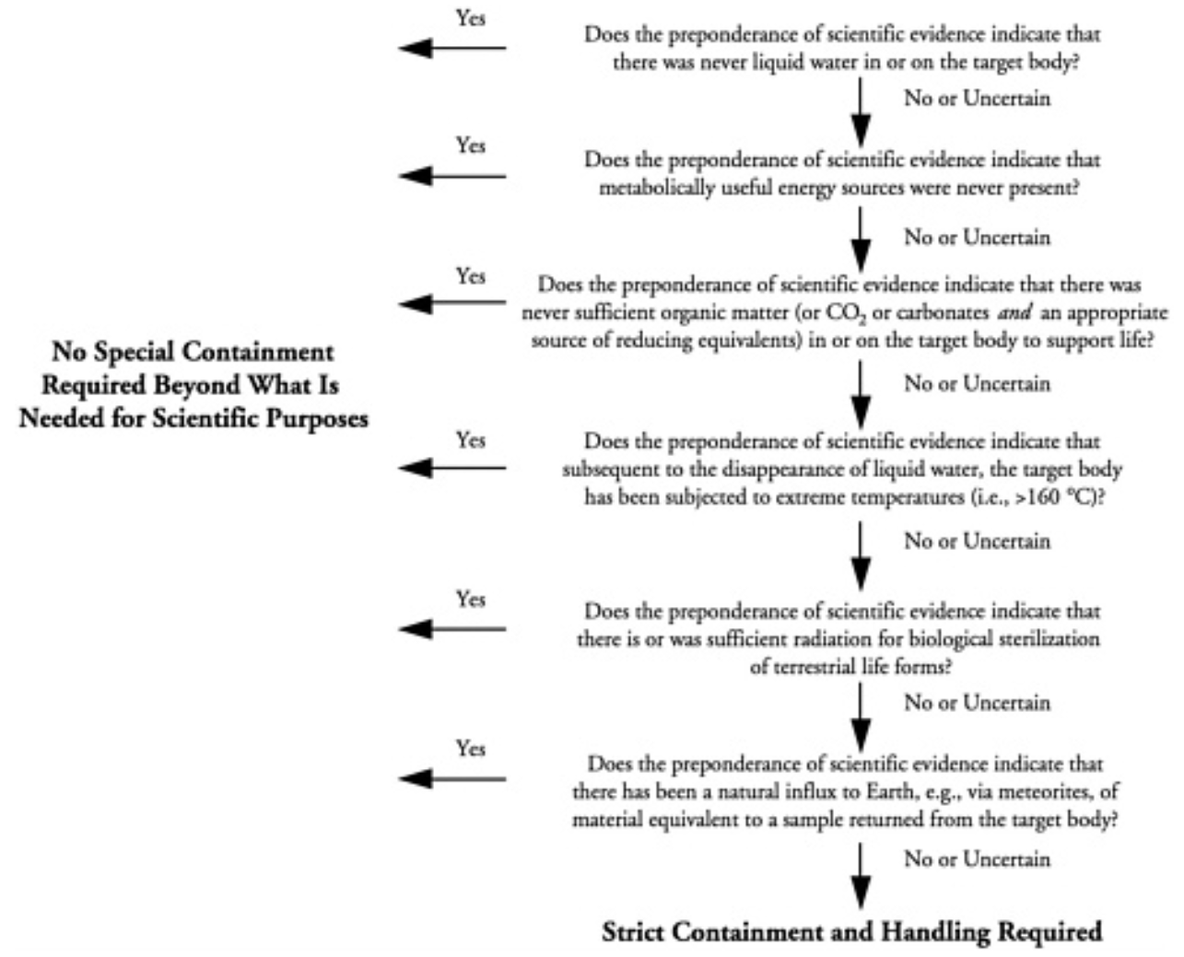

NEPA, 2022, Comments submitted in May in response to NASA’s first request for comments on their plans
Neukum, G., Jaumann, R., Hoffmann, H., Hauber, E., Head, J.W., Basilevsky, A.T., Ivanov, B.A., Werner, S.C., Van Gasselt, S., Murray, J.B. and McCord, T., 2004.. Recent and episodic volcanic and glacial activity on Mars revealed by the High Resolution Stereo Camera. Nature, 432(7020), pp.971-979.
Orosei, R., Lauro, S.E., Pettinelli, E., Cicchetti, A.N.D.R.E.A., Coradini, M., Cosciotti, B., Di Paolo, F., Flamini, E., Mattei, E., Pajola, M.A.U.R.I.Z.I.O. and Soldovieri, F., 2018. Radar evidence of subglacial liquid water on Mars. Science, 361(6401), pp.490-493.

Pikuta, E.V., Hoover, R.B., Klyce, B., Davies, P.C. and Davies, P., 2006, September. Bacterial utilization of L-sugars and D-amino acids. In Instruments, Methods, and Missions for Astrobiology IX (Vol. 6309, p. 63090A). International Society for Optics and Photonics.

Pikuta, E.V. and Hoover, R.B., 2010, September. Utilization of alternate chirality enantiomers in microbial communities. In Instruments, Methods, and Missions for Astrobiology XIII (Vol. 7819, p. 78190P). International Society for Optics and Photonics.

Pikuta, E.V., Menes, R.J., Bruce, A.M., Lyu, Z., Patel, N.B., Liu, Y., Hoover, R.B., Busse, H.J., Lawson, P.A. and Whitman, W.B., 2016. Raineyella antarctica gen. nov., sp. nov., a psychrotolerant, d-amino-acid-utilizing anaerobe isolated from two geographic locations of the Southern Hemisphere. International journal of systematic and evolutionary microbiology, 66(12), pp.5529-5536.

Pires, F. 2015, “Mars liquid water: Curiosity confirms favorable conditions”, Michigan news.
"Life as we know it needs liquid water to survive. While the new study interprets Curiosity's results to show that microorganisms from Earth would not be able to survive and replicate in the subsurface of Mars, Rennó sees the findings as inconclusive. He points to biofilms—colonies of tiny organisms that can make their own microenvironment."

Puente-Sánchez, F., Arce-Rodríguez, A., Oggerin, M., García-Villadangos, M., Moreno-Paz, M., Blanco, Y., Rodríguez, N., Bird, L., Lincoln, S.A., Tornos, F. and Prieto-Ballesteros, O., 2018. Viable cyanobacteria in the deep continental subsurface. Proceedings of the National Academy of Sciences, 115(42), pp.10702-10707

Pugel, B., Popescu, S. and Madad, S., 2020. Restricted and Uncontained: Health Considerations in the Event of Loss of Containment During the Restricted Earth Return of Extraterrestrial Samples. Health security, 18(2), pp.132-138.

Race, M. S., 1996, Planetary Protection, Legal Ambiguity, and the Decision Making Process for Mars Sample Return Adv. Space Res. vol 18 no 1/2 pp (1/2)345-(1/2)350

Randolph, R. 2009, Chapter 10, A Christian Perspective, in Bertka, C.M. ed., 2009. Exploring the Origin, Extent, and Future of Life: Philosophical, Ethical and Theological Perspectives (Vol. 4),. Cambridge University Press.

Renno, N., 2014, How liquid water forms on Mars, YouTube video, University of Michigan Engineering (transcript from 1:48 onwards)
Renno, N. n.d.bio, faculty bio at the University of Michigan.

Richmond, J.Y. and McKinney, R.W., 2000. Primary containment for biohazards: selection, installation and use of biological safety cabinets.
Roberts, D. and Marks, R., 1980. The determination of regional and age variations in the rate of desquamation: a comparison of four techniques. Journal of Investigative Dermatology, 74(1), pp.13-16. See figures 3-4.

Rummel, J., Race, M., Nealson, K., "No Threat? No Way", The Planetary Report Nov/Dec. 2000

Contains:
- A Case for Caution by John Rummel, NASA'S planetary protection officer at the time, and previously, NASA senior scientist for Astrobiology
- Hazardous Until Proven Otherwise, by Margaret Race, a biologist working on planetary protection and Mars sample return for the SETI Institute and specialist in environment impact analysis
- Practical Safe Science by Kenneth Nealson, Director of the Center of Life Detection at NASA's JPL at the time.
Rummel, J.D., Race, M.S., DeVinenzi, D.L., Schad, P.J., Stabekis, P.D., Viso, M. and Acevedo, S.E., 2002. A draft test protocol for detecting possible biohazards in Martian samples returned to Earth.
Rummel, J.D., Beaty, D.W., Jones, M.A., Bakermans, C., Barlow, N.G., Boston, P.J., Chevrier, V.F., Clark, B.C., de Vera, J.P.P., Gough, R.V. and Hallsworth, J.E., 2014. new analysis of Mars “special regions”: findings of the second MEPAG Special Regions Science Analysis Group (SR-SAG2)

Rummel, J. D., Conley C. A, 2017,.Four fallacies and an oversight: searching for Martian life Astrobiology, 17(10), pp. 971-974.

Sarmiento, F., Peralta, R. and Blamey, J.M., 2015. Cold and hot extremozymes: industrial relevance and current trends. Frontiers in bioengineering and biotechnology, 3, p.148.
While isolating psychrophilic strains would likely provide a better analog for the Martian surface, the generation times are prohibitively slow for research purposes in such exploratory experiments
Scheller, E.L., Hollis, J.R., Cardarelli, E.L., Steele, A., Beegle, L.W., Bhartia, R., Conrad, P., Uckert, K., Sharma, S., Ehlmann, B. and Asher, S., 2022, March. First-results from the Perseverance SHERLOC Investigation: Aqueous Alteration Processes and Implications for Organic Geochemistry in Jezero Crater, Mars. In LPSC 2022.

The observed carbonates co-occur with hydrated materials, gypsum, and potentially aqueously-formed phases, amorphous silicates and phosphate

Schenk, P.M., Thomas-Hall, S.R., Stephens, E., Marx, U.C., Mussgnug, J.H., Posten, C., Kruse, O. and Hankamer, B., 2008. Second generation biofuels: high-efficiency microalgae for biodiesel production. Bioenergy research, 1(1), pp.20-43.
page 37: Normal wild-type algae have large chlorophyll-bindingLHCII antenna systems and consequently the culture is dark green. Cell lines with small LHCII antenna systems yield cultures which are a much lighter green at the same cell density (Fig.7a). In the wild-type case, algal cells at the illuminated surface of the bioreactor that are exposed to high light levels capture the bulk of the light, but waste upto∼90% of the energy as fluorescence and heat [122,134].
As a result the wild-type cells located deeper in the culture are exposed to ever decreasing levels of light the further they are from the illuminated surface (see“Open PondSystems”section). These shaded cells are prevented from capturing enough solar energy to drive photosynthesis efficiently. This in turn drastically reduces the efficiency of the overall culture.In contrast, small antenna cell lines with reduced LHCIIlevels have the advantage that they improve the light penetration into the bioreactor (Fig.7a) and better match itto the energy requirements of each photosynthesizing cell. Thus small antenna cells at the bioreactor surface absorb only the light that they need, largely eliminating fluores-cence of excess energy. This in turn allows more light (i.e.the light wasted in wild-type as fluorescence and heat) to penetrate into the bioreactor so that even cells deeper in the culture have a near optimal exposure to light

Schlaepfer, M.A., Sax, D.F. and Olden, J.D., 2011. The potential conservation value of non‐native species. Conservation Biology, 25(3), pp.428-437.

Shekhtman, L., 2019, With Mars methane mystery unsolved, Curiosity serves scientists a new one: Oxygen

Schuerger, A.C., Ulrich, R., Berry, B.J. and Nicholson, W.L., 2013. Growth of Serratia liquefaciens under 7 mbar, 0 C, and CO₂-enriched anoxic atmospheres. Astrobiology, 13(2), pp.115-131

Sieber, J.R., McInerney, M.J., Plugge, C.M., Schink, B. and Gunsalus, R.P., 2010. Methanogenesis: syntrophic metabolism. In Handbook of Hydrocarbon and Lipid Microbiology.
Schmidt, M., n.d. Species Profile - Didymosphenia geminata , aquatic non indigenous species, Great Lakes Information system.
Historically the species was restricted to low-nutrient waters but has recently seen large range expansions reportedly occurring in eutrophic rivers, showing much greater tolerance for nutrient and flow conditions than previously expected. This may be attributed to a genetic variant with broader tolerances than the original species.
Means of Introduction: Didymosphenia geminata has been shown to survive outside of the stream environment. Cells are able to survive and remain viable for 40 days in cool, dark, damp conditions. Angling equipment, boot tops, neoprene waders, and felt-soles provide a particularly suitable environment for cells to remain viable. Cells can hitchhike on this equipment and other recreational equipment into new bodies of water (Spaulding and Elwell 2007). Freshwater diatoms are dispersed through the flow of water and transport by other organisms, primarily waterfowl (Kristiansen 1996).
Blooms of Didymosphenia geminata form mats which can be over 20 cm thick. Extracellular stalks trap fine sediment, changing the nature of substrate and have potential long lasting effects due to the apparent resistance of stalks to degradation by bacteria and fungi
…
These mats are capable of engulfing the stream bottom, smothering native species of plants, insects, mollusks, and algae, and reducing habitat for insects for aquatic insects and fis
Streams outside the Great Lakes region harshly impacted by these mats have seen invertebrate populations decrease, macrophyte elimination, and absence of fish
It has been hypothesized that a new strain of Didymosphenia geminata is now dominant (Bothwell et al., 2006), and is responsible for the invasive behaviour. However, the presence of a new genetic strain has not been established….

Some clusters of dozens of diatoms appear pristine, suggesting that they had been living in the salar pool immediately

before being trapped as the gypsum crystal grew.

Could microfossils and/or viable microorganisms be trapped in gypsum on Mars as they are in gypsum on Earth? It is likely that abundant sulfate sand grains on Mars contain fluid inclusions similar to those in the acid-precipitated bottom-growth and reworked gypsum we discuss here.
We suggest that gypsum on Mars would have entrapped, as solid inclusions and within fluid inclusions, any microorganisms and/or organic compounds that were present in its parent waters. Therefore, fluid inclusions and solid inclusions hosted by salt minerals may be the best place to continue the search for life on Mars.

Some of these entrapped microorganisms remain viable for at least tens of thousands of years ... and possibly for hundreds of millions of years

Singh, R., Bhadouria, R., Singh, P., Kumar, A., Pandey, S. and Singh, V.K., 2020. Nanofiltration technology for removal of pathogens present in drinking water. In Waterborne Pathogens (pp. 463-489). Butterworth-Heinemann.

Sivasubramaniam, R. and Douglas, R., 2018. The microbiome and chronic rhinosinusitis. World journal of otorhinolaryngology-head and neck surgery, 4(3), pp.216-221.

Solden, L., Lloyd, K. and Wrighton, K., 2016. The bright side of microbial dark matter: lessons learned from the uncultivated majority. Current opinion in microbiology, 31, pp.217-226.

Stamenković, V., Ward, L. M., Mischna. M., Fischer. W. W.. "O₂ solubility in Martian near-surface environments and implications for aerobic life" — Nature, October 22, 2018 - see also Vlada Stamenkovic. "Origins of Life & Habitability - authors website with bibliography - and author shared link to the article", sharing is via Nature Sharedit — Habilabs

Stillman, E, 2018, Chapter 2 - Unraveling the Mysteries of Recurring Slope Lineae in Soare, R.J., Conway, S.J. and Clifford, S.M. eds., 2018. Dynamic Mars: Recent and Current Landscape Evolution of the Red Planet. Elsevier.
Page 81: “No proposed RSL mechanism can adequately describe all the observations … We suggest RSLs that are scored excellent and very good and sites that do not typographically preclude aquifer fed springs are likely caused by a wet-dominated mechanism while numerous other sites are caused by dry granular flow”
Thorney¿?, 2006, Didymo signage on Waiau river , Wikipedia
Tornabene, L.L., Moersch, J.E., McSween Jr, H.Y., McEwen, A.S., Piatek, J.L., Milam, K.A. and Christensen, P.R., 2006. Identification of large (2–10 km) rayed craters on Mars in THEMIS thermal infrared images: Implications for possible Martian meteorite source regions. Journal of Geophysical Research: Planets, 111(E10).

Trainer, M.G., Wong, M.H., Mcconnochie, T.H., Franz, H.B., Atreya, S.K., Conrad, P.G., Lefèvre, F., Mahaffy, P.R., Malespin, C.A., Manning, H.L. and Martín‐Torres, J., 2019. Seasonal variations in atmospheric composition as measured in Gale Crater, Mars. Journal of Geophysical Research: Planets, 124(11), pp.3000-3024. See also Supporting information

Surprisingly, however, we have found that O₂ does not demonstrate the predictable seasonal behavior of the other major components. Surface O₂ measurements by SAM yield abundances that vary between 1300 and 2200 ppmv; when corrected for the annual global mean pressure, O₂ varies from 1300 to 1900 ppmv. Despite large instrument backgrounds, these are the first precise in situ measurements of O2, revealing a surprising seasonal and interannual variation that cannot be accounted for in current chemical models. Though Mars has the potential to generate significant O₂ release due to abundances of oxidants in/at its surface, the mechanisms by which O₂ could be quickly generated and then quickly destroyed are completely unknown. As with all surprising results, we hope that continued in situ, experimental, and theoretical results may shed light on this intriguing observation.

United Nations, 2020, Press Briefing: Coronavirus Outbreak (COVID - 19): WHO Update (25 February 2020) at 10:80

Urbaniak, C., Massa, G., Hummerick, M., Khodadad, C., Schuerger, A. and Venkateswaran, K., 2018. Draft genome sequences of two Fusarium oxysporum isolates cultured from infected Zinnia hybrida plants grown on the international space station. Genome announcements, 6(20).

Venier, C.G., Jones Jr, W.R., Jansen, M.J. and Marchetti, M., 2003, September. Comparative physical and tribological properties of three Pennzane® fluids, SHF X-1000, SHF X-2000, and SHF X-3000. In 10th European Space Mechanisms and Tribology Symposium (Vol. 524, pp. 337-340).

Wall, M., 2018, "Salty Martian Water Could Have Enough Oxygen to Support Life"
— Space.com,

WhiteHouse, 1977, NSC-25: Scientific or Technological Experiments with Possible Large-Scale Adverse Environmental Effects and Launch of Nuclear Systems into Space

Wickett, R.R. and Visscher, M.O., 2006. Structure and function of the epidermal barrier. American journal of infection control, 34(10), pp.S98-S110.
In SC [stratum corneum] that is desquamating at its normal rate, corneocytes persist in the SC for approximately 2 weeks, depending on body site, before being shed into the environment. On average, about one layer of corneocytes is shed each day from the surface and replaced by keratinocytes at the SG. The corneocytes that are shed each day can have a significant bacterial load and may be a source of contamination of the environment.

WHO, 2020tosi, Transmission of SARS-CoV-2: implications for infection prevention precautions, Science Brief
Smith, D.H., Canup, R.M. and Christensen, P.R., 2022, May. Origins, Worlds, and Life: A Decadal Strategy for Planetary Science and Astrobiology. In 2022 Astrobiology Science Conference. AGU.

Spaulding, S.A., Kilroy, C.A.T.H.Y. and Edlund, M.B., 2010. Diatoms as non-native species. The diatoms: applications for the environmental and earth sciences, pp.560-569.

Uhran, B., Conley, C. and Spry, J.A., 2019. Updating Planetary Protection Considerations and Policies for Mars Sample Return. Space Policy, 49, p.101322.
UN, 1945, Constitution of the United Nations Food and Agriculture Organization (FAO)
US DOA, 2017, European Starling
van Schaik, W. (2020) interviewed by Science Media Centre, expert reaction to questions about COVID-19 and viral load, accessed at: https://www.sciencemediacentre.org/expert-reacti

Vítek, P., Edwards, H.G.M., Jehlička, J., Ascaso, C., De los Ríos, A., Valea, S., Jorge-Villar, S.E., Davila, A.F. and Wierzchos, J., 2010. Microbial colonization of halite from the hyper-arid Atacama Desert studied by Raman spectroscopy. Philosophical Transactions of the Royal Society of London A: Mathematical, Physical and Engineering Sciences, 368(1922), pp.3205-3221.

Walker, R., 2022a, Comment submitted on May 15th by Robert Walker to NASA’s first request for comments on their plans.
Later updated with:
- Comment submitted on November 28^{h} by Robert Walker to NASA’s second request for comments on their draft EIS.
- Comment submitted December 5th
- Comment submitted December 13th

Walker, R., 2022b, NASA and ESA are likely to be legally required to sterilize Mars samples to protect the environment until proven safe – technology doesn't yet exist to comply with ESF study's requirement to contain viable starved ultramicrobacteria that are proven to pass through 0.1 micron nanopores - proposal to study samples remotely in a safe high orbit above GEO with miniature life detection instruments – and immediately return sterilized subsamples to Earth, (preprint, not peer reviewed)

Westall, F., Loizeau, D., Foucher, F., Bost, N., Betrand, M., Vago, J. and Kminek, G., 2013. Habitability on Mars from a microbial point of view. Astrobiology, 13(9), pp.887-897.

WHO, 2003, Laboratory Biosafety Manual Second Edition (Revised)
WHO, 2020wic, 1st WHO Infodemiology Conference

Winn, W.C., 1988. Legionnaires disease: historical perspective. Clinical Microbiology Reviews, 1(1), pp.60-81

Xu, Z., Chen, Y., Meng, X., Wang, F. and Zheng, Z., 2016. Phytoplankton community diversity is influenced by environmental factors in the coastal East China Sea. European Journal of Phycology, 51(1), pp.107-118.

Yano, H., Chujo, T. JAXA/ISAS, Case Study Planetary Protection Category V Unrestricted Earth Return: Hayabusa-1&2 Japan and the Hayabusa-1 and Hayabusa-2 Teams

Yin, W., Wang, Y., Liu, L. and He, J., 2019. Biofilms: The Microbial “Protective Clothing” in Extreme Environments. International journal of molecular sciences, 20(14), p.3423.

Yung, Y.L., Chen, P., Nealson, K., Atreya, S., Beckett, P., Blank, J.G., Ehlmann, B., Eiler, J., Etiope, G., Ferry, J.G. and Forget, F., 2018. Methane on Mars and habitability: challenges and responses. Astrobiology, 18(10), pp.1221-1242.

Zakharova, K., Marzban, G., de Vera, J.P., Lorek, A. and Sterflinger, K., 2014. Protein patterns of black fungi under simulated Mars-like conditions. Scientific reports, 4, p.5114.

Zhou, B. and Shen, J., 2007. Comparison Of HEPA/ULPA Filter Test Standards Between America And Europe. In Proceedings of Clima.

